OVERVIEW
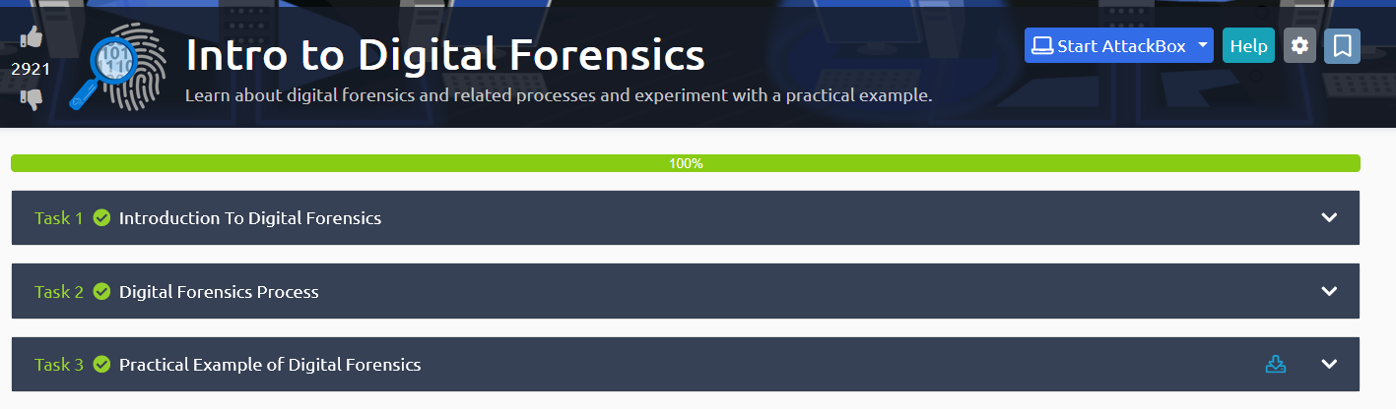

TASK1 : Introduction To Digital Forensics
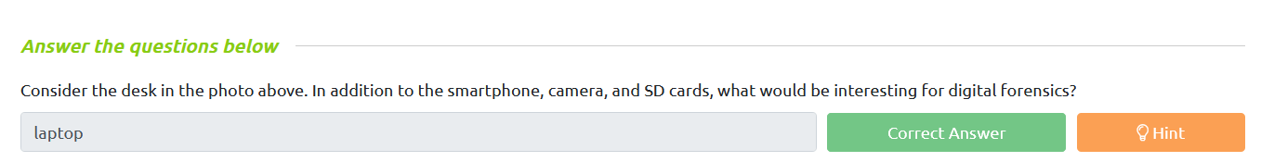

TASK2 : Digital Forensics Process

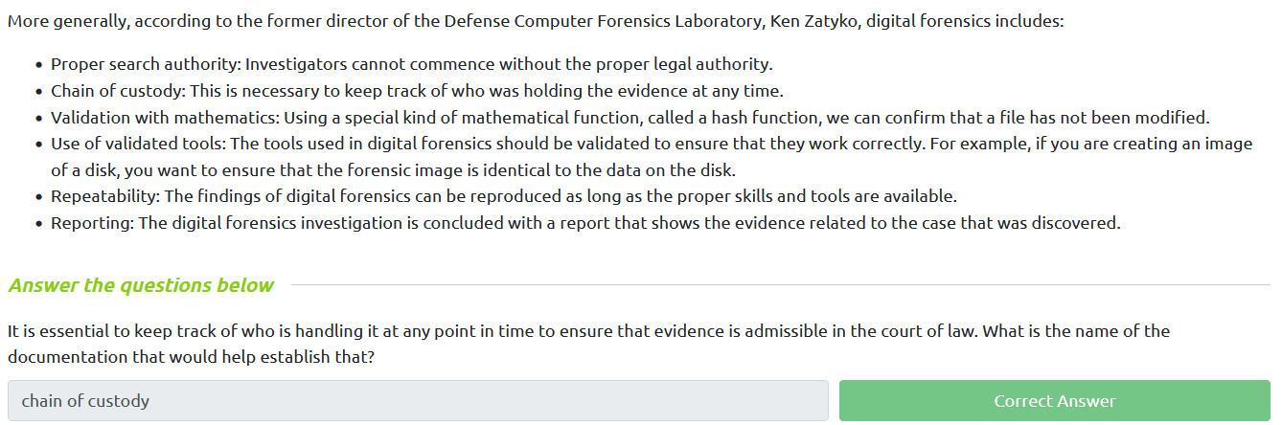

TASK 3 : Practical Example of Digital Forensics
