EXERCICE 1 :
https://learn.microsoft.com/en-us/training/modules/introduction-microsoft-365-threat-protection/

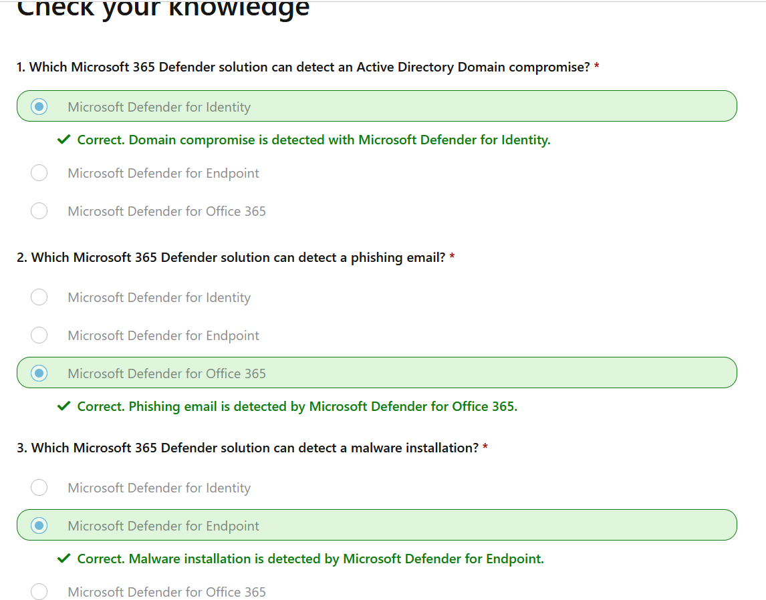

EXERCICE 2 :
https://learn.microsoft.com/en-us/training/modules/mitigate-incidents-microsoft-365-defender/

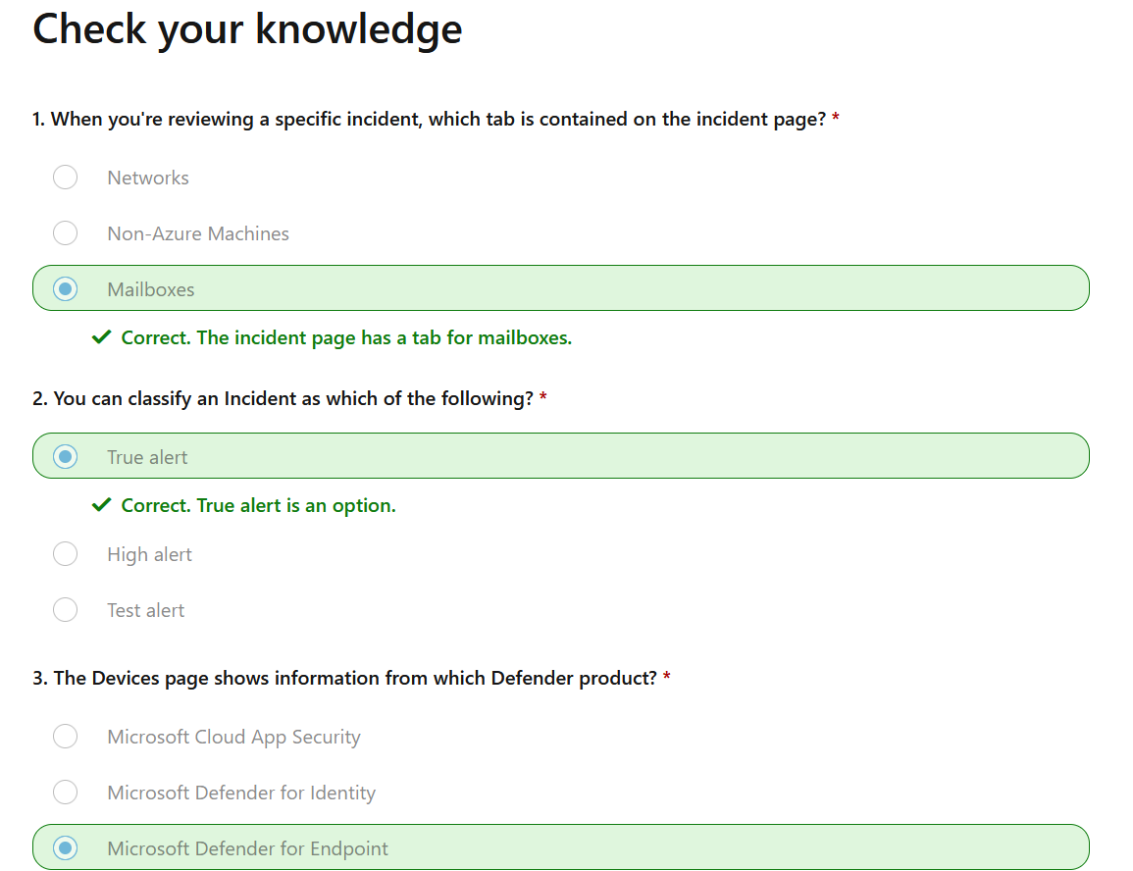

Exercice 3 :
https://learn.microsoft.com/en-us/training/modules/m365-threat-remediate/
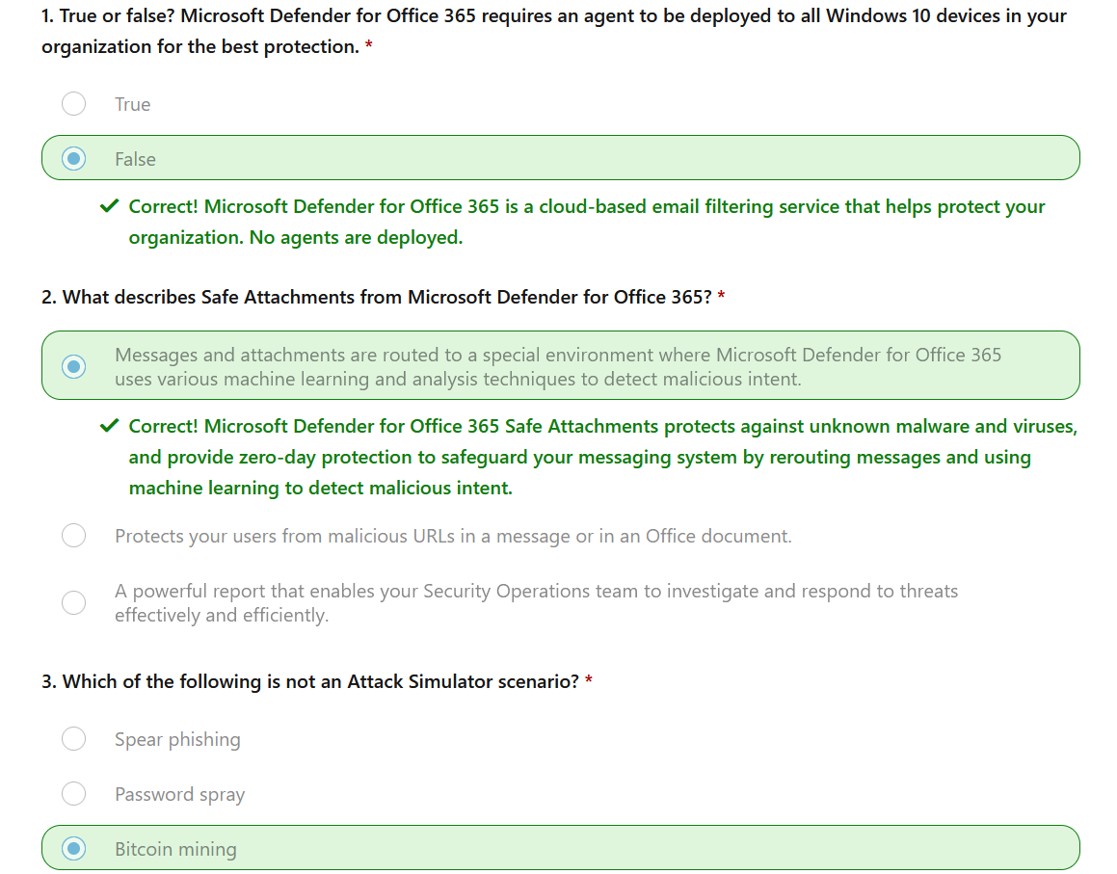

Exercice 4 :
https://learn.microsoft.com/en-us/training/modules/m365-threat-safeguard/

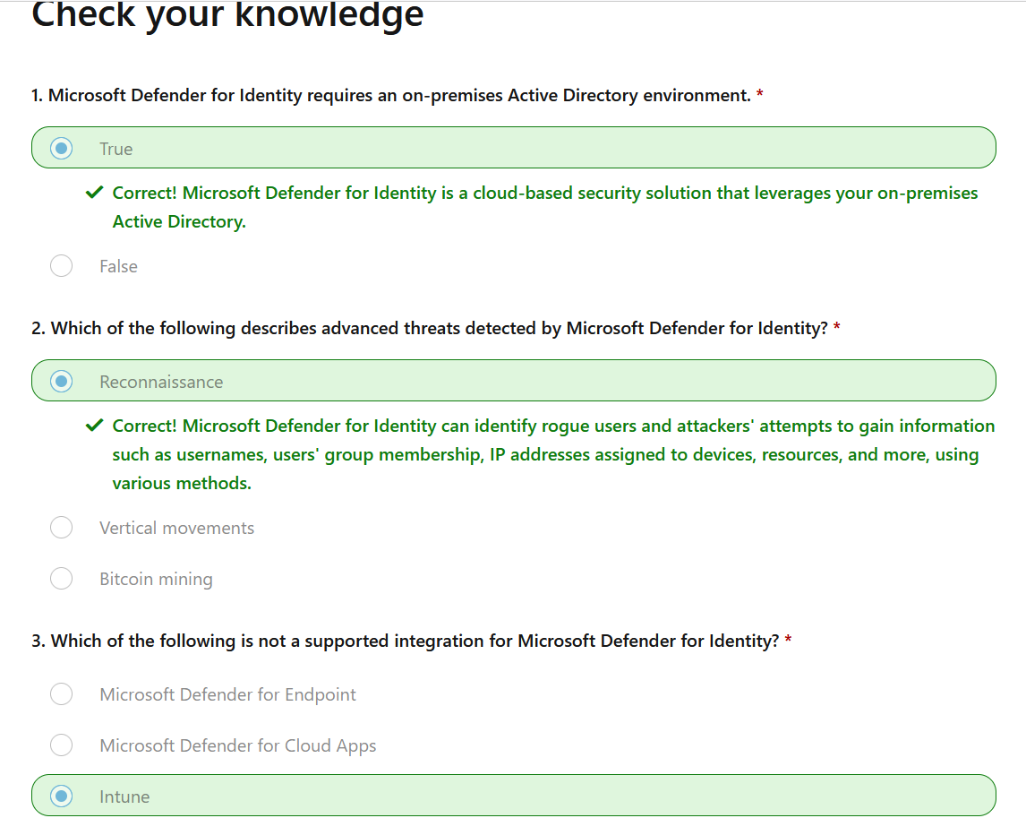

Exercice 5 :
https://learn.microsoft.com/en-us/training/modules/microsoft-cloud-app-security/
