OVERVIEW
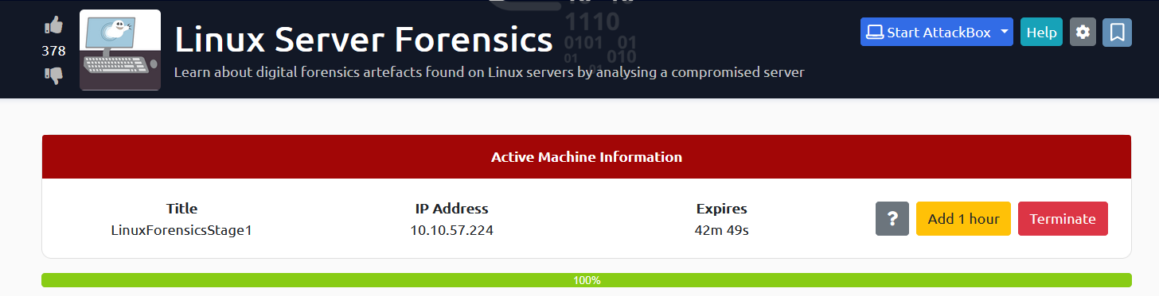

TASK1 : DEPLOY THE FIRST VM
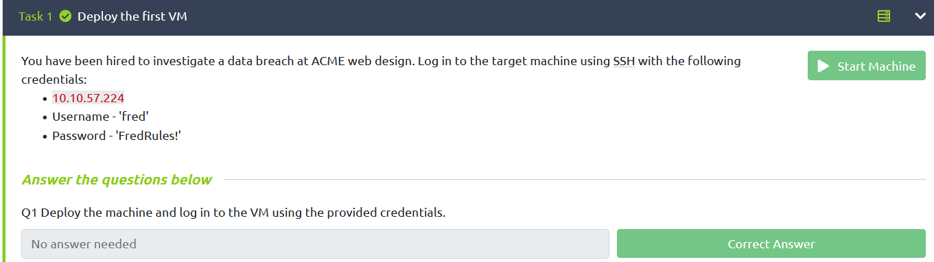

TASK2 : APACHE LOG ANALYSIS
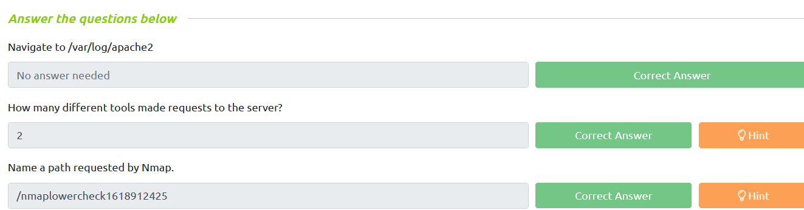

TASK3 : WEB SERVER ANALYSIS
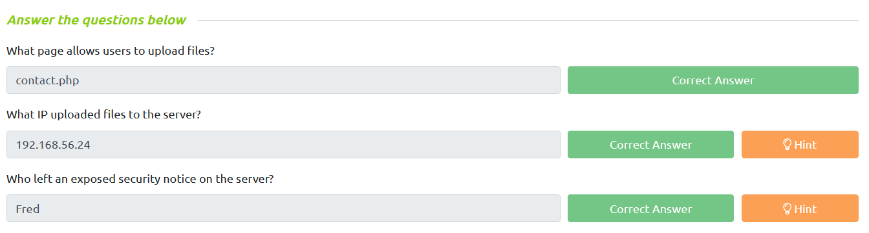

TASK4 : PERSISTENCE MECHANISMS
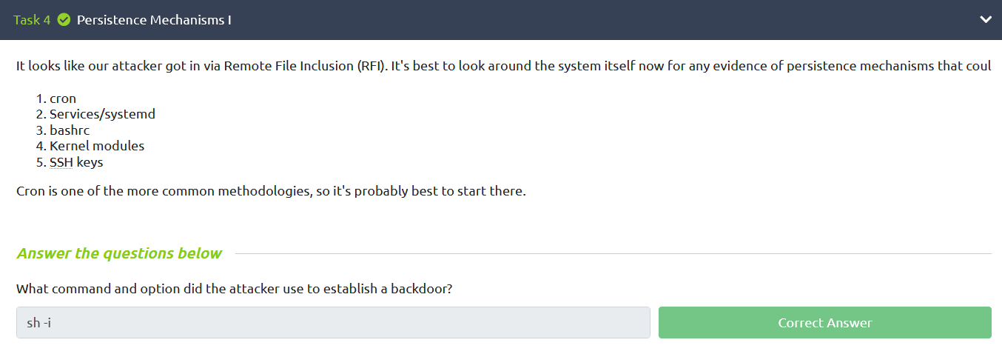

TASK5 : USER ACCOUNTS
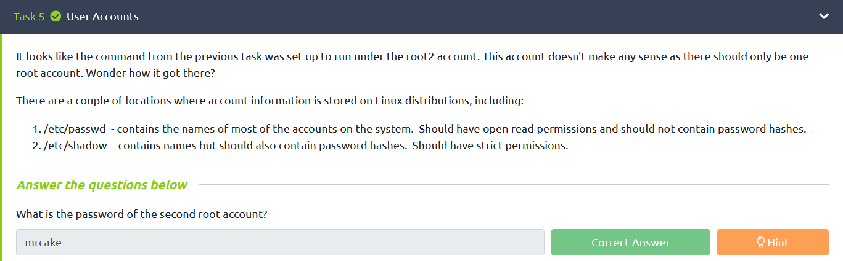

TASK6 : DEPLOY THE SECOND VM
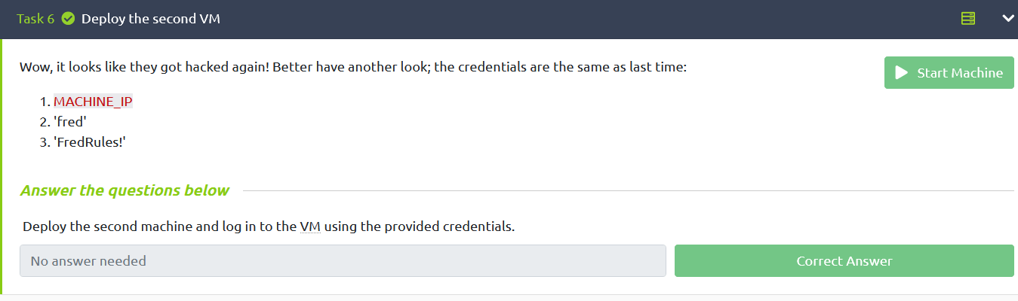

TASK7 : APACHE LOG ANALYSIS II
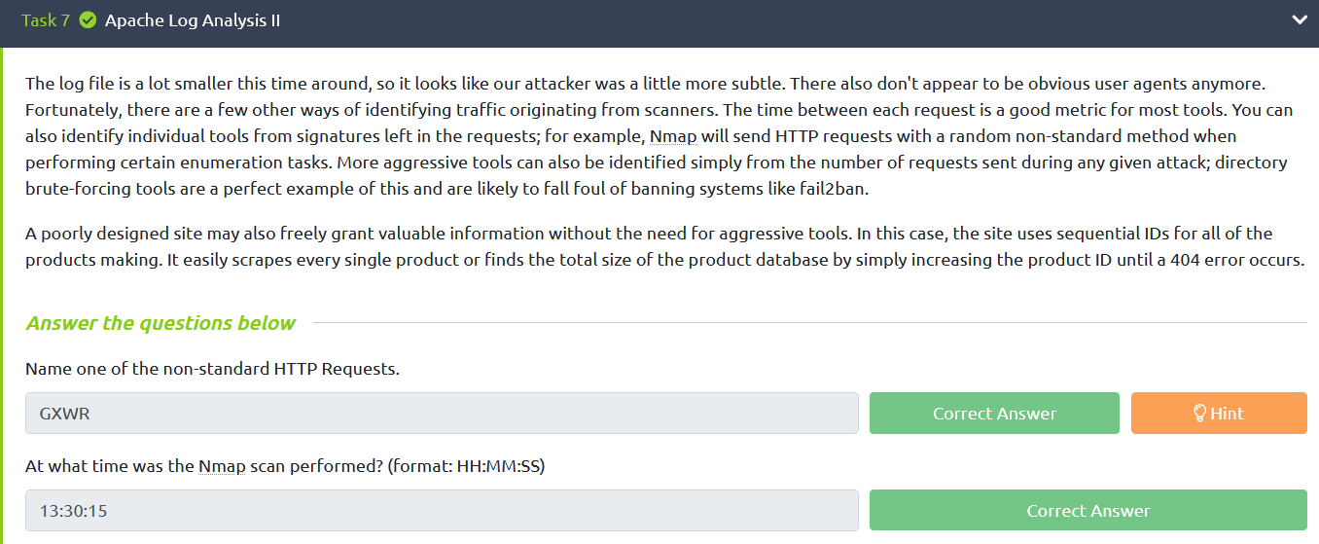

TASK8 : PERSISTENCE MECHANISMS II
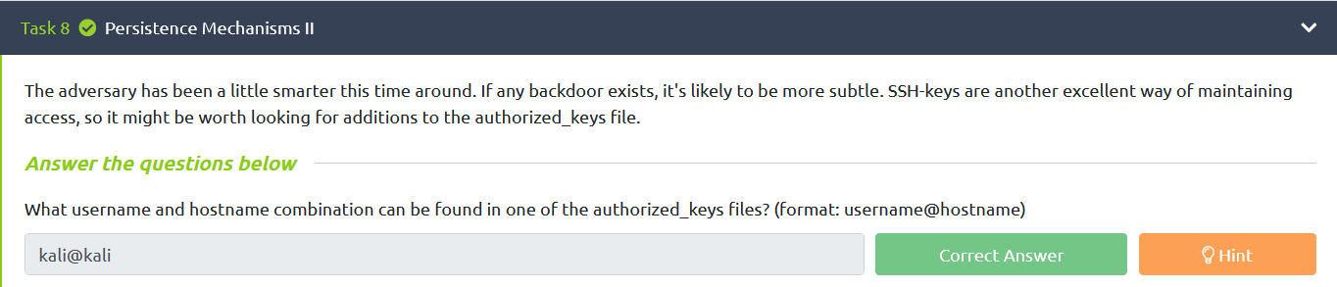

TASK9 : PROGRAM EXECUTION HISTORY
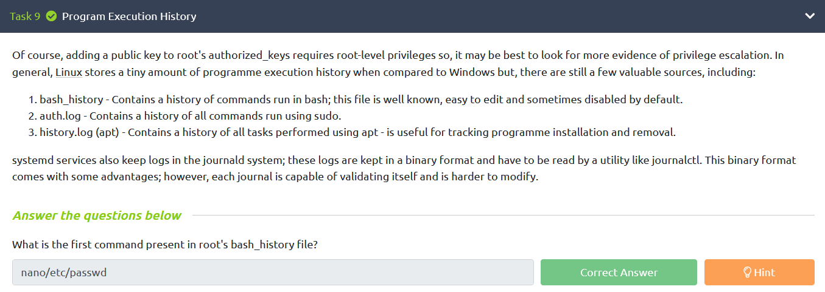

TASK10 : DEPLOY THE FINAL VM
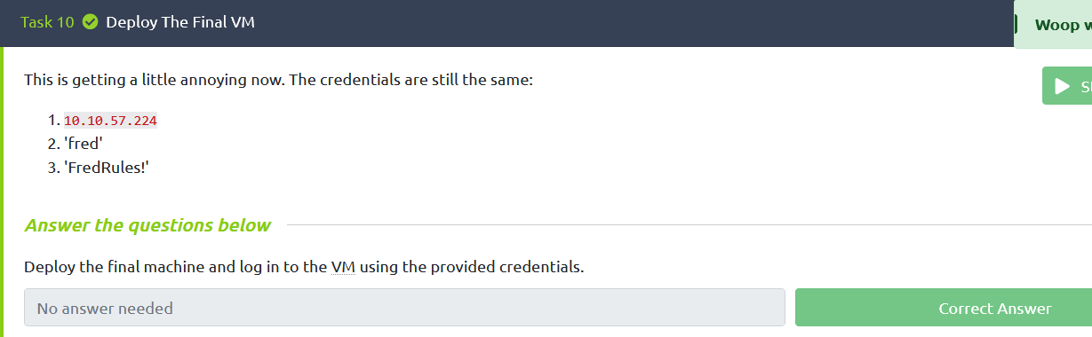

TASK11 : PERSISTENCE MECHANISMS III
