OVERVIEW
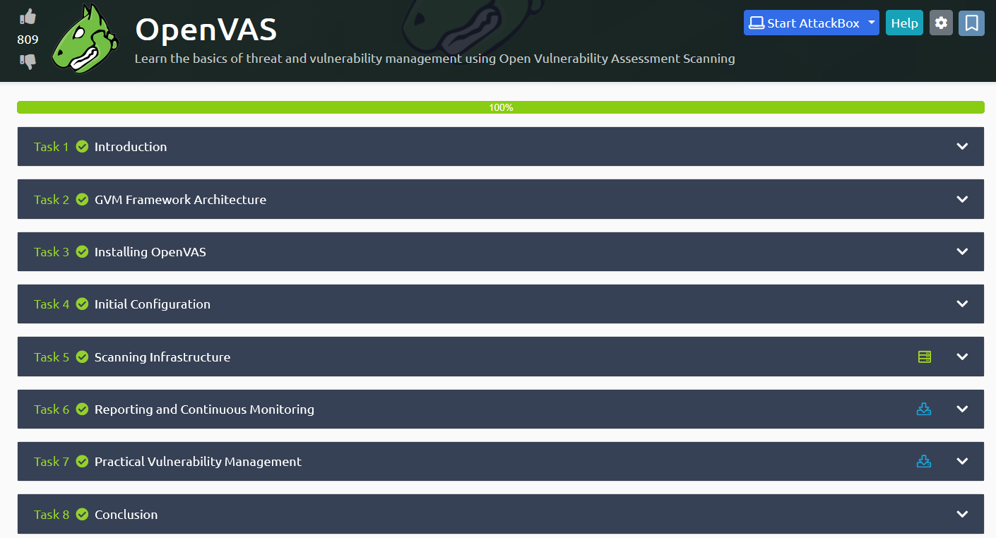

TASK1 : Introduction
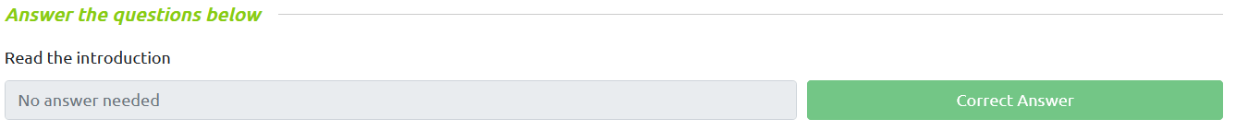

TASK2 : GVM Framework Architecture
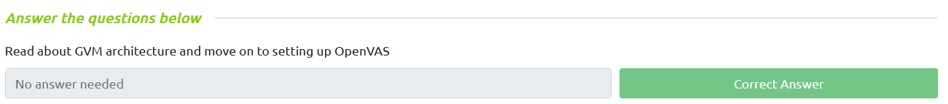

TASK3 : Installing OpenVAS
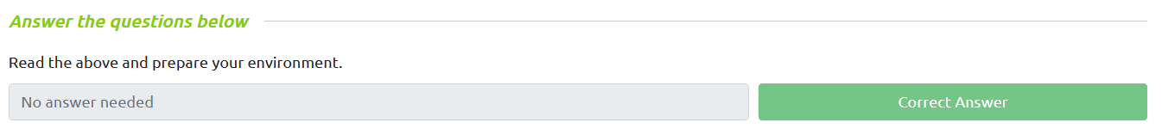

TASK4 : Initial Configuration
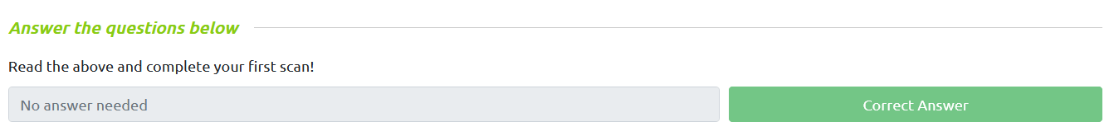

TASK5 : Scanning Infrastructure
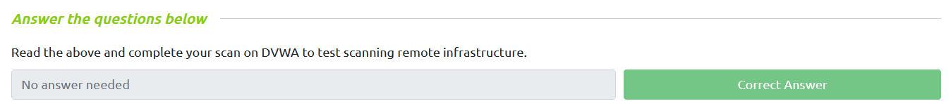

TASK6 : Reporting and Continuous Monitoring
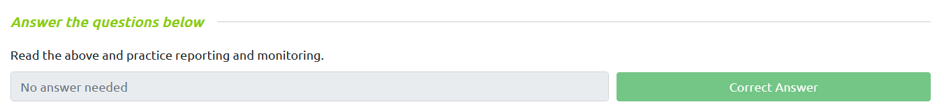

TASK7 : Practical Vulnerability
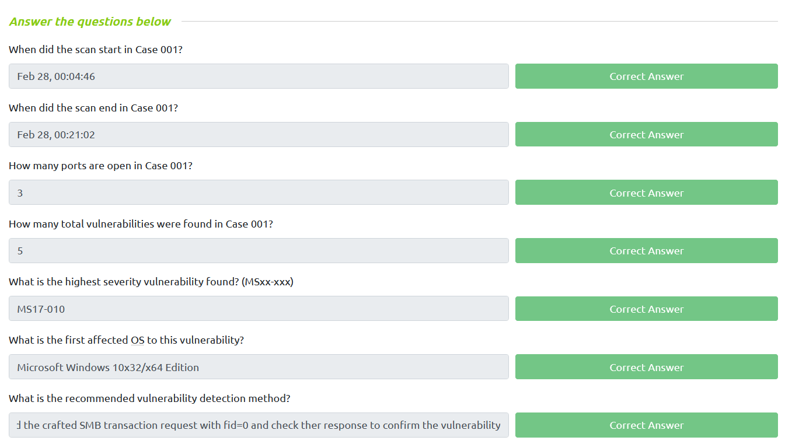
TASK8 : Conclusion
