OVERVIEW
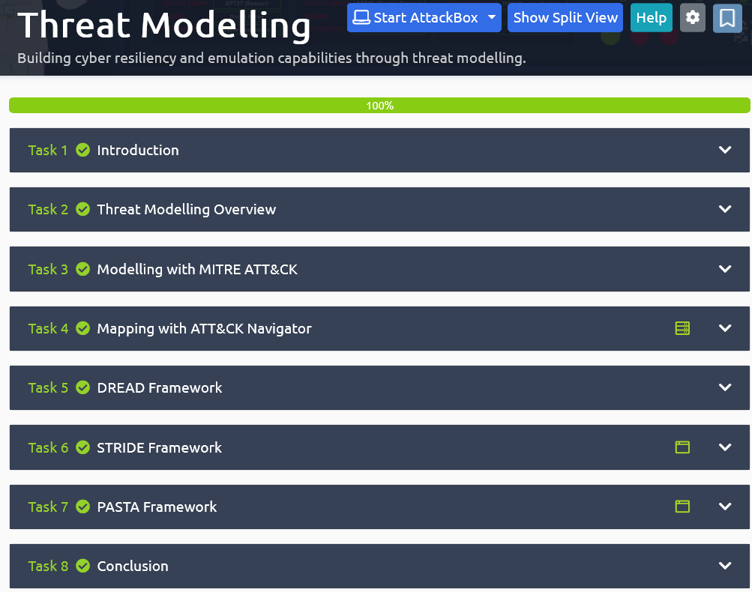

TASK1 : INTRODUCTION
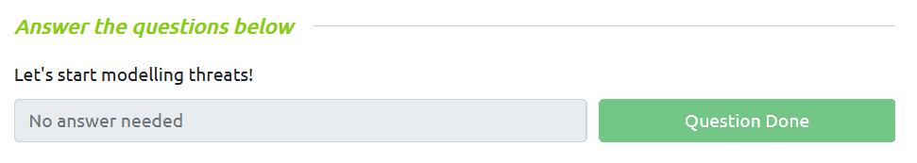
TASK2 : Threat Modelling Overview
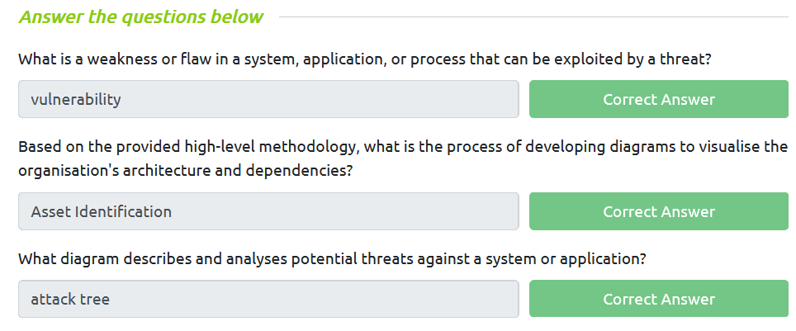
TASK3 : Modelling with MITRE ATT&CK
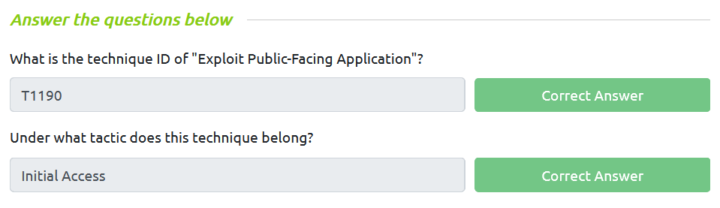

TASK4 : Mapping with ATT&CK Navigator
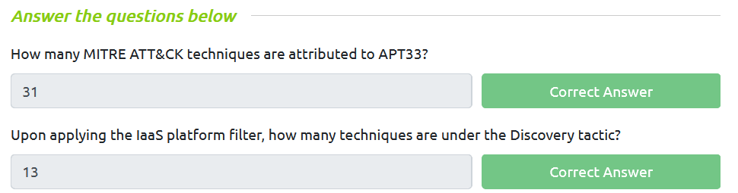

TASK5 : DREAD Framework
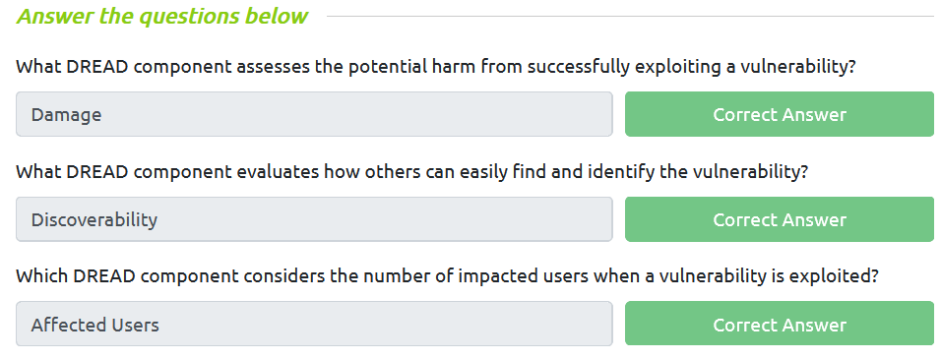

TASK6 : STRIDE Framework
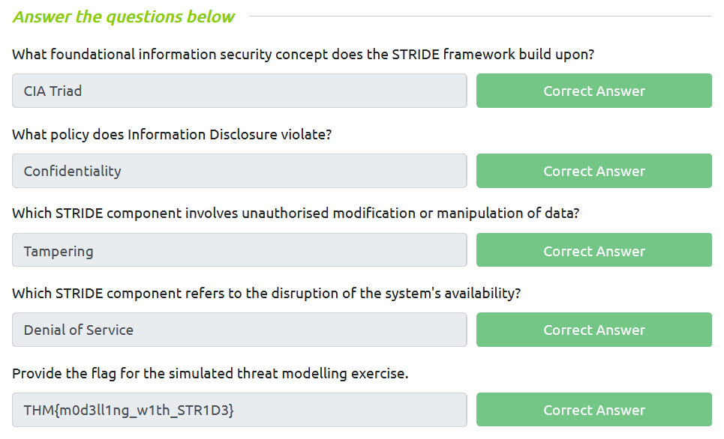

TASK7 : PASTA Framework
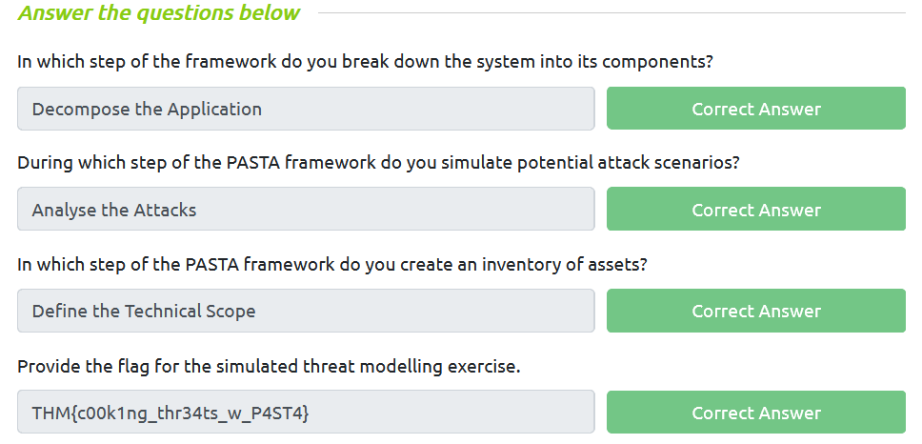

TASK8 : Conclusion


