OVERVIEW :
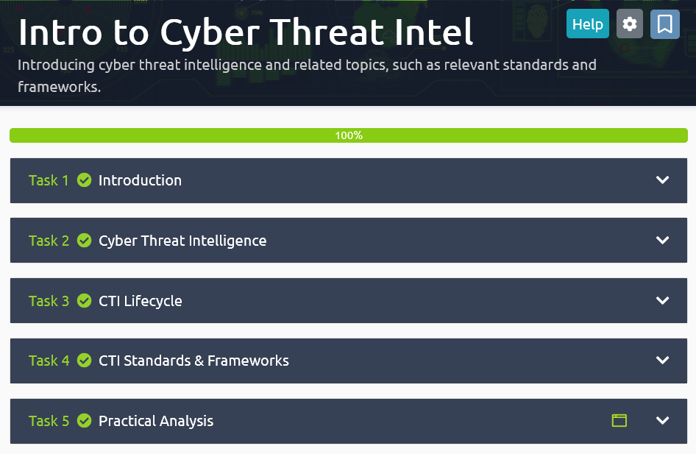
TASK 1 : Introduction
TASK 2 : Cyber Threat Intelligence

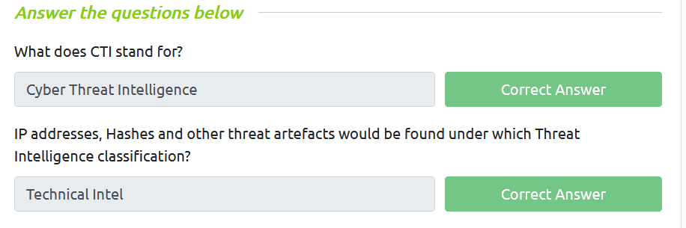

TASK 3 : CTI Lifecycle
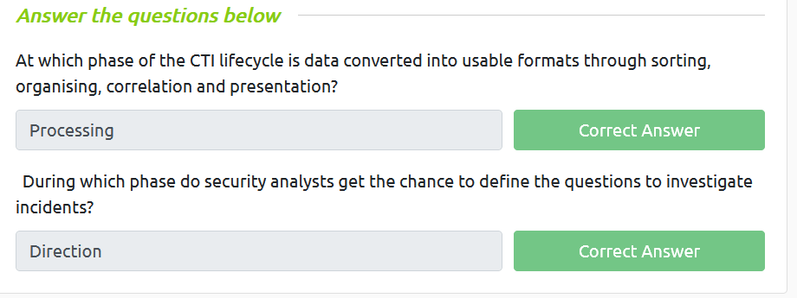
TASK 4 : CTI Standards & Frameworks
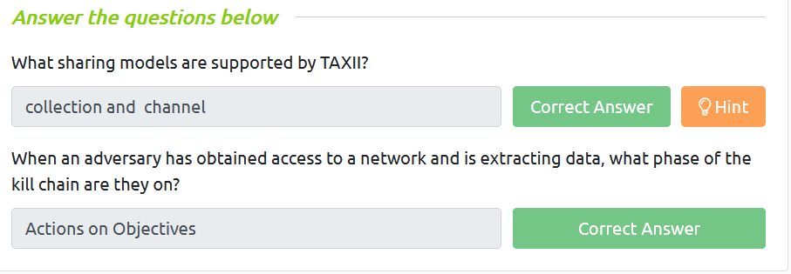

TASK 5 : Pratice Analysis
