Step 1 : Create PerfMon Collector

Open Perfmon_Setup powerShell script as admin.

Edit parameters $Server and $InstanceName if Instance name is used instead of default instance

Param(

[string]$Server = $env:ComputerName, #name of targeted server, default to the current server

[string]$InstanceName, #Use if named instance is targeted.

[bool]$DCS_Update=0, #the Data Collectors Set will be Removed if exists, and new one will be created

[bool]$Start=1 , #the Data Collectors Set will be started

[string]$DCSName = "SQLPerfMon" #Name of Data Collector Set.

)

Run script. Successful execution should show messages :



Collector is created and running, you can check perfmon tool

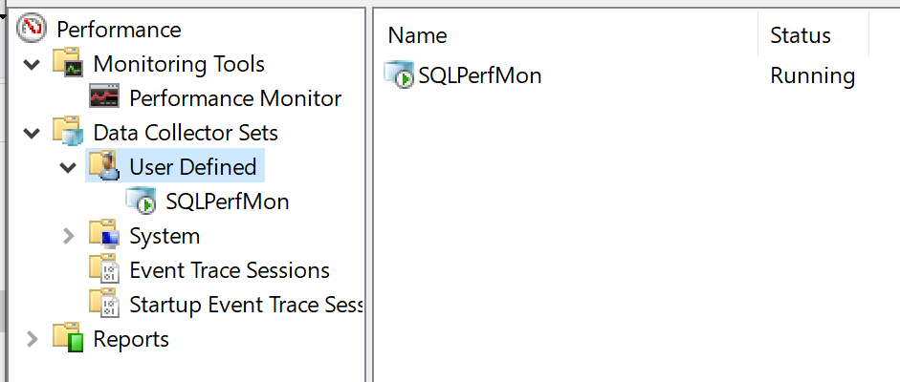

**Step2 : Prepare file**

When collection is done, extract file to local machine, and run PerfMon_Fix_Header PowerShellScript.

Script is just going to standardize first column name and create zipped copy of original file

Step 3: Refresh PowerBI File

Open Perfmon_Dashboard.pbix with PowerBI desktop.

Click on Edit Queries > Data Source Settings:

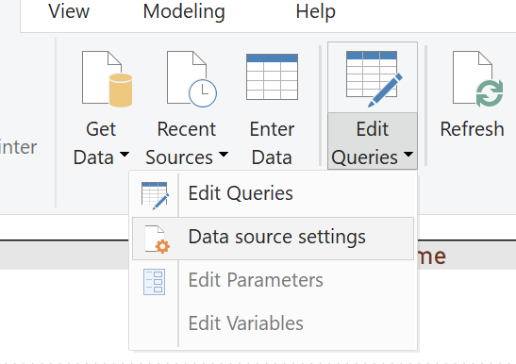

In the dialog click Change Source, and in new dialog click Browse and point to your extracted file

