# How to Build an Affordable SQL Server 2012 Lab – Part 1

By Todd Kleinhans (todd.kleinhans at gmail.com)

## Scope of Document

“How to Build an Affordable SQL Server 2012 Lab – Part 1” is limited in scope to creating a Windows Server 2012 lab environment as specified in the Introduction of the 70-462 Training Kit using VMware Workstation 9. Part2 will cover actual items contained in the book’s Chapters lessons and exercises like Group Policy Objects, Windows Firewall configurations, enabling ping, iSCSI disks for Windows Failover Clustering (FCI) and installing SQL Server 2012.

## Host Hardware

I have a both a desktop and a laptop with these labs on them. Both machines are running Windows 7 64-bit w/ SP1. The desktop only has 6GB of RAM and the laptop has 8GB of RAM. The laptop also has a SSD drive which allows the lab to run much faster than on my desktop. This document was built using screenshots from both but any changes in the screenshots are incidental and do not prevent the successful completion of building the SQL Lab.

## Introduction

As the time-honored trite cliché states, “Necessity is the mother of invention”. In reading the introduction to the Microsoft Press book Training Kit (Exam 70-462): Administering Microsoft SQL Server 2012 Databases, the book states you will need six (!) machines in order to complete the lessons and exercises. If you don’t build the lab as specified- it becomes difficult to follow along.

Since I don’t have access to six physical 64-bit machines either at home or at work on their own domain, I needed a viable alternative that was affordable.

Enter my dive into the world of virtual machines (vms) to build an affordable lab. In the past I have used other virtual machine software options from different vendors at work but never for myself. This was going to be a first.

The good news is that virtualization software has been out for quite some time now and there are several mature options available to choose from.

The main article that sold me on using VMware Workstation is by Denny Cherry and can be found [here](http://www.sqlmag.com/blog/troubleshooting-sql-server-storage-problems-51/storage/making-large-virtual-lab-minimal-space-hard-drive-space-140289).

The version used in this document is VMware Workstation 9. I paid $250 for an electronic software download (ESD) and was able to start using it right away.

I used Denny’s article as a starting point and with the requirements for the 70-462 Kit at hand and came up with the idea of the document you are reading now.

## Hardware Requirements (for a physical host)

Host: x64 processor, 8GB of RAM, 80GB of hard disk space (if using differencing virtual hard disks), DVD-ROM drive, connection to the Internet.

## Software Requirements (for guest virtual machines)

Windows Server 2008 R2 .iso file is available [here](http://www.microsoft.com/en-us/download/details.aspx?id=11093). (NOTE!!! Not used in this document)

Or

Windows Server 2012 .iso file is available [here](http://technet.microsoft.com/en-us/evalcenter/hh670538.aspx).

And of course SQL Server 2012 .iso file is available [here](http://www.microsoft.com/en-us/download/details.aspx?id=29066).

Later in the book the authors mention in passing that the contents will be eventually updated to reflect Windows Server 2012. I choose to use this opportunity to learn about Windows Server 2012 and that is the version I am using in this document.

The new sweet spot: SQL Server 2012 running on Windows Server 2012!

## Technical Review Frustrations

Someday I hope to write technical books so what I am about to say I realize could easily come back to haunt to me.

<RANT>

I hate glaring technical errors in books! Especially in the frickin’ set-up and introduction!

If you blindly following the printed instructions in the Training Kit, you would be re-building your lab all over again from scratch after you built the last machine according to their instructions.

Of the six virtual servers built, ask yourself the following, what is the correct domain name?

|  |  |
| --- | --- |
| **Machine Name** | **Domain** |
| DC (domain controller, 1st server built) | CONTSO.COM |
| SQL-A | CONTSO.COM |
| SQL-B | CONTSO.COM |
| SQL-C | CONTOSO.COM (will fail attempting to join) |
| SQL-D | CONTOSO.COM (will fail attempting to join) |
| SQL-CORE | CONTSO.COM |

Turns out, CONTOSO.COM is the correct domain name. I blindly followed the instructions and choose to re-build the entire lab with the correct domain as I didn’t want to add yet another domain, set up trusts between domains, etc. It is a lab so I just re-built it.

In addition- they had the WRONG ip address for the SQL-CORE box.

Lesson number #1- ALWAYS CHECK THE ERRATA OF ANY TECHNICAL BOOK BEFORE STARTING!!!

<http://oreilly.com/catalog/errata.csp?isbn=0790145345134>

And hope your fellow technical professionals have been able to successfully post corrections and save you some grief. On the link above, you might be surprised at the number of errors. I fully understand that a printed technical book will always have errors of some kind. And part of your technical education should be to NEVER TRUST THE OBVIOUS, QUESTION EVERYTHING. Finding and overcoming errors is frustrating at times but honestly is part of the experience.

But I still have to say that even on the pdf on the disk with the book? Easily corrected but it wasn’t? FAIL. Is it too much to ask for a free pdf with all of the corrections in it on the link for the companion content? Might not help them sell books but some of these errors just make you scratch your head.

It really makes me wonder- did the technical reviewers submit corrections and either the authors or publisher blew them off before printing? And at what level of quality was it technically reviewed?

</RANT>

## Virtual Machine Overview

In order to minimize the amount of disk space used, we are going to take advantage of what are called snapshots and linked clones. The idea behind this is to create “gold masters” of everything that is common to all of the virtual machines. By doing this one is going to minimize the amount of disk space the linked clones will occupy once they are created. Once the gold masters are built, snapshotted, and linked servers created from them, the lab will be ready for configuration according to the Training Kit.

We are going to create two gold masters- Windows Server 2012 Standard and Windows Server 2012 Server Core.

The following virtual machines will be built based on those two gold masters:

DC, SQL-A, SQL-B, SQL-C, SQL-D and SQL-CORE

## Sysprep Overview

Documentation on sysprep can be found [here](http://technet.microsoft.com/en-us/library/hh824816.aspx).

When it comes to virtual machines and using the .iso files from Microsoft for the operating system, sysprep has already been run once. Re-running it won’t hurt anything but it will consume a little bit of disk space. You really only have to run it on the 2nd and higher virtual machines based on a snapshot.

CAVEAT EMPTOR – Be sure you choose the Generalize option!!! If you don’t you run the risk of odd behavior on your virtual machines like not being able to join it to a domain because of conflicts with the MAC address on the network interface.

## VMware Workstation 9 Installation

Is really simple- after a handful of screens and entering in your key, you are done and can start using it. I chose Typical, installed at default location, check for product updates on startup, etc.

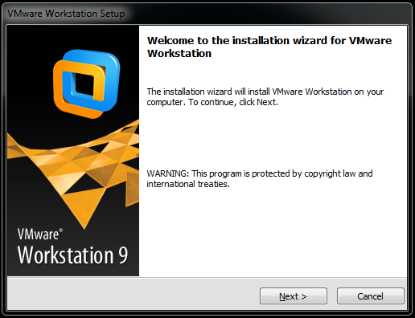

I like to re-boot after any installation, so re-boot if you like. Upon launching VMware Workstation, you will need to accept the license agreement and then you will see the default screen:

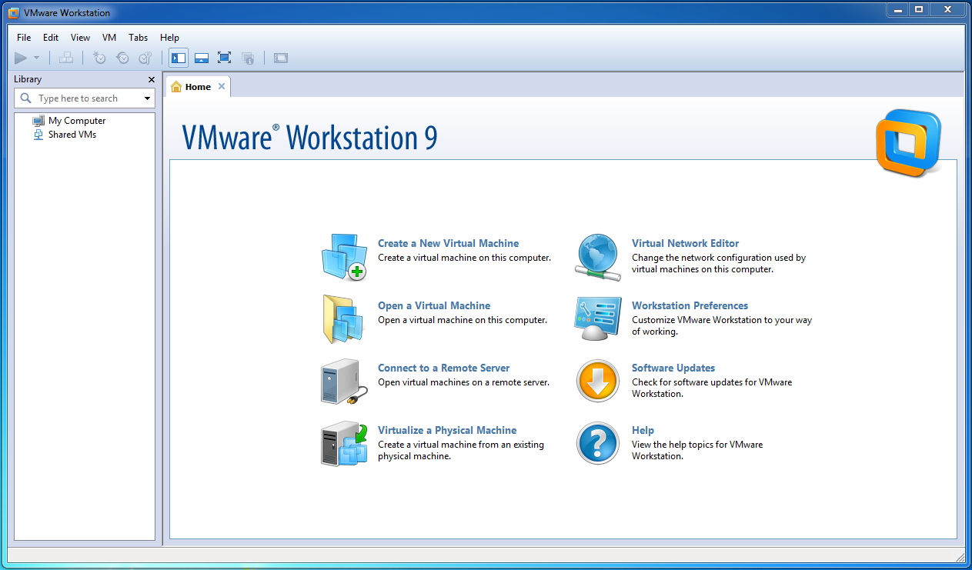

## Gold Master #1 – Windows Server 2012 Standard

Create a New Virtual Machine:

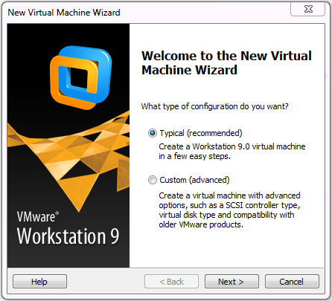

And switch

Install from:

To

I will install the operating system later.

Reason? On some .iso files for evaluation copies of Windows, you have to type in a key on system startup. The problem is that the value of the key that you need is embedded- which you don’t have because it is embedded. So you don’t have the key to type in. The workaround for this is to just create a virtual machine but get it set-up to use the .iso file you downloaded from above.

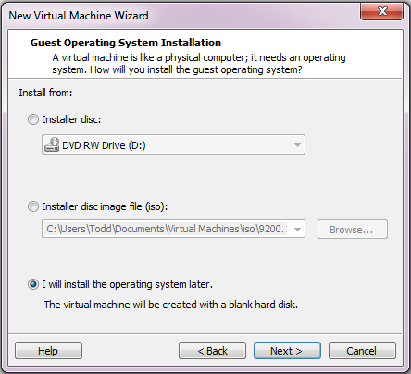

And choose Microsoft Windows: Windows Server 2012

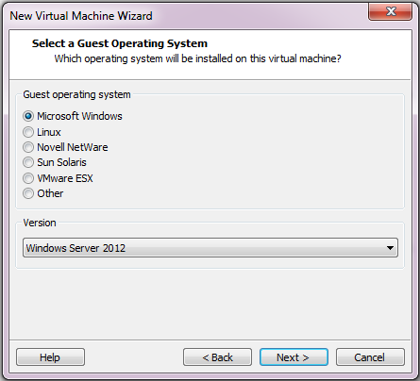

Change the name of the Virtual machine name to Windows Server 2012 Standard:

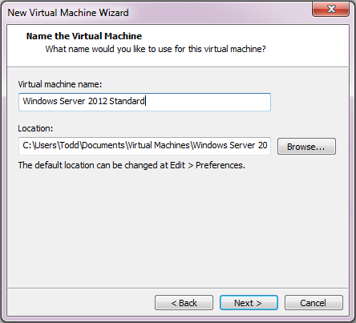

Since I won’t be moving these machines around I choose to Store virtual disk as a single file:

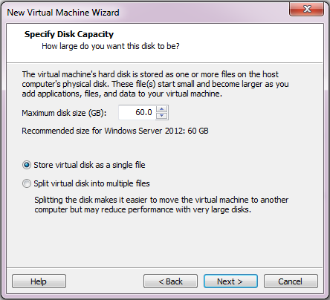

NOTE!!! Even though it shows 60GB of space for the vm, it really doesn’t use that much space as it uses a storage technology called thin provisioning- it doesn’t grab space until it needs to actually write data to it. At the end of this document, we’ll look at just how much hard drive space this entire SQL Lab takes up- I think you will be pleasantly surprised.

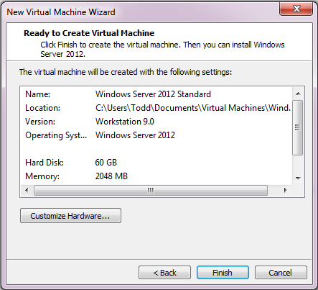

Click on Customize Hardware:

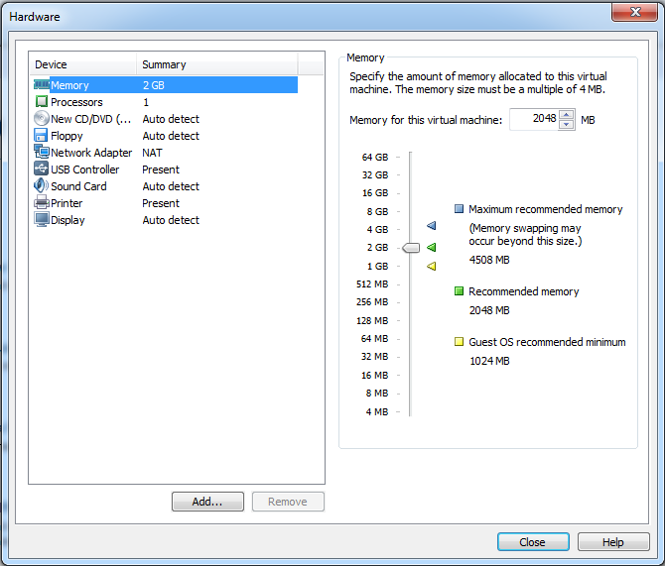

For my system, I changed the Memory setting down to 1024MB and changed the New CD/DVD setting to point to the .iso file for the operating system (I moved my .iso file to the Shared Virtual Machines folder to simplify things):

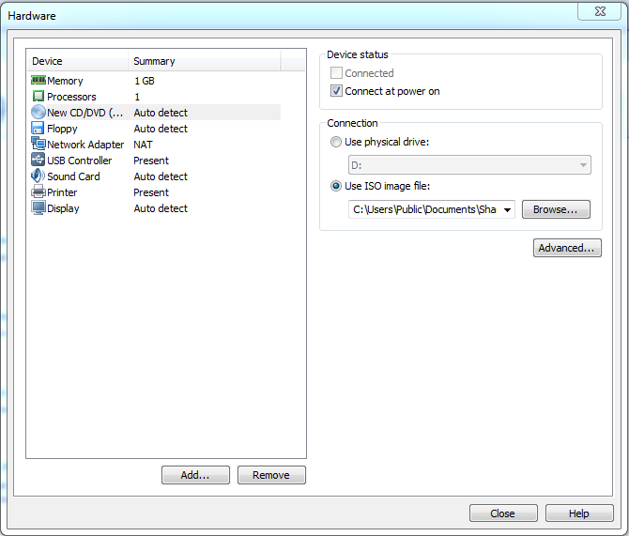

The Network Adapter defaults to Network Address Translation (NAT)- which is fine for now. Click Close then Finish.

Your first virtual machine of the lab has been created. Now it is time to Power on this virtual machine and to begin the operating system install:

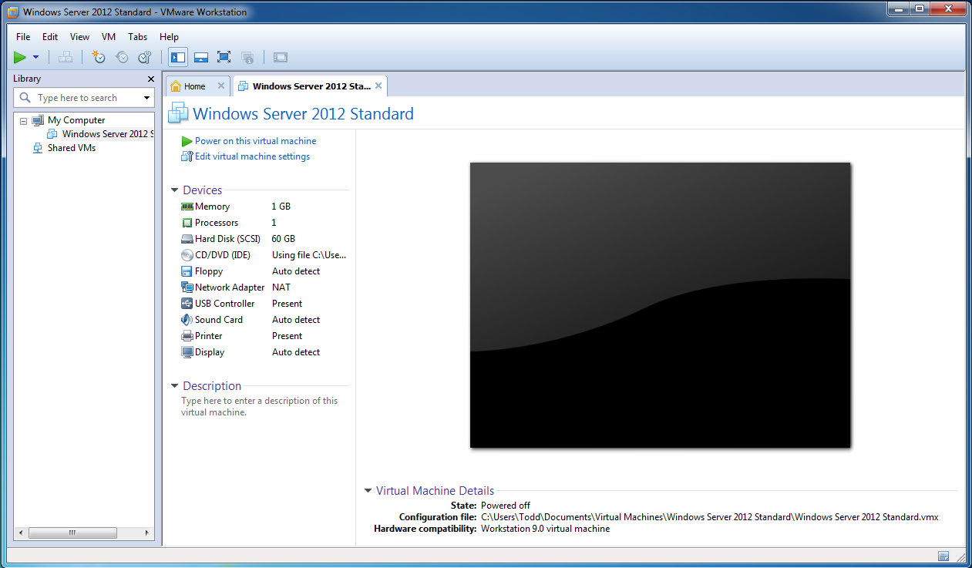

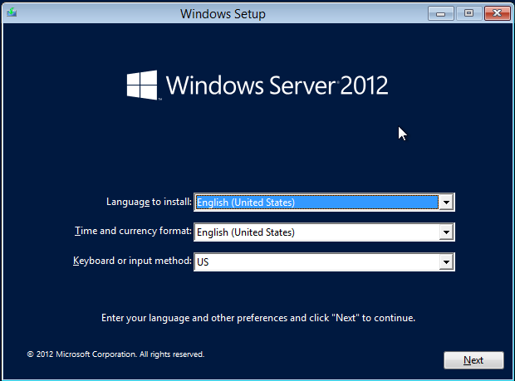

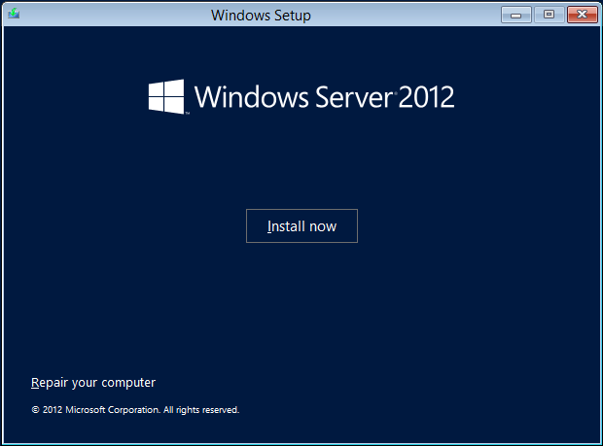

Partial rant #1- Be sure to select the SECOND option- it will default to CORE installation- you want Server with GUI for this first vm:

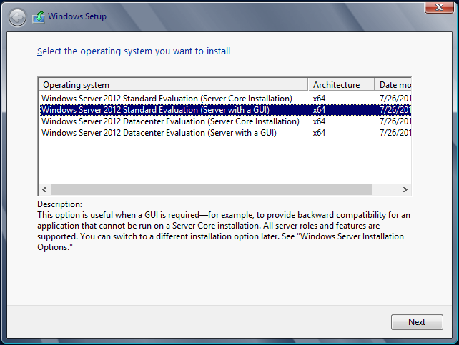

Of course you’ll accept! Otherwise you can’t continue.

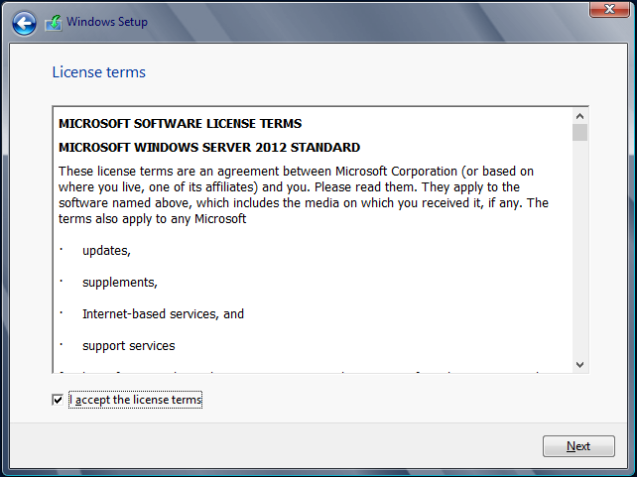

Partial rant #2 - Choose the Custom Install- don’t know why it defaults to Upgrade here- why would it default to upgrade? There is no previous operating system installed!

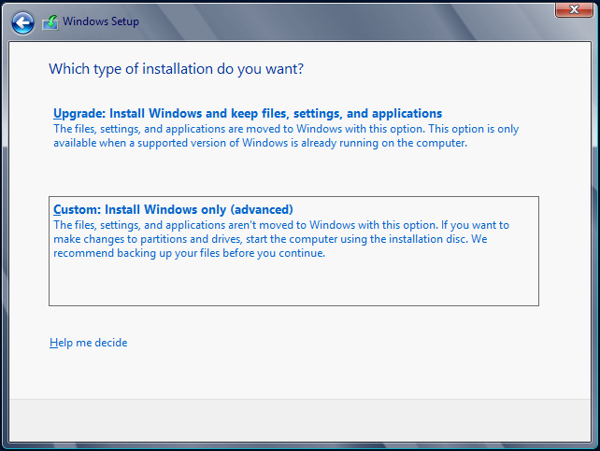

Default disk is ok:

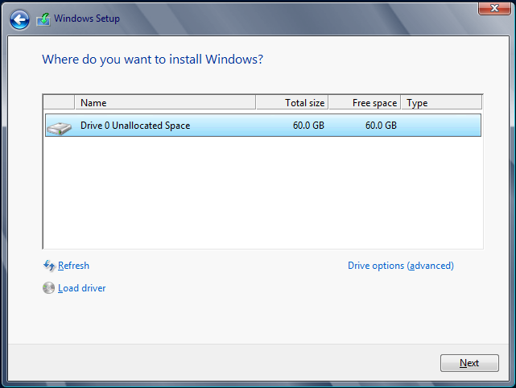

And away it goes:

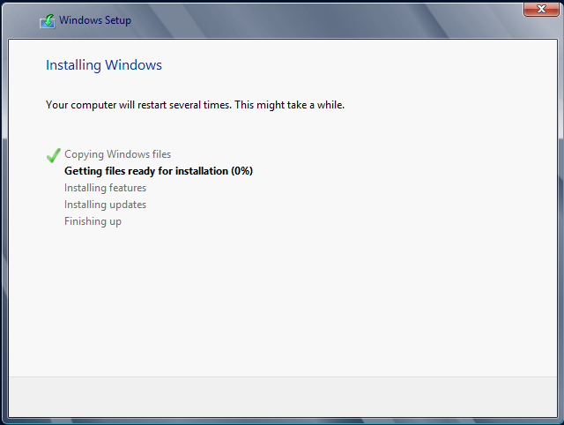

On my solid-state disk drive (SSD), the entire process only takes about 7 minutes. On a non-SSD, it will take longer. After the vm automatically re-boots, enter the password from the Training Kit: Pa$$w0rd (yes, that is a zero not the letter o)

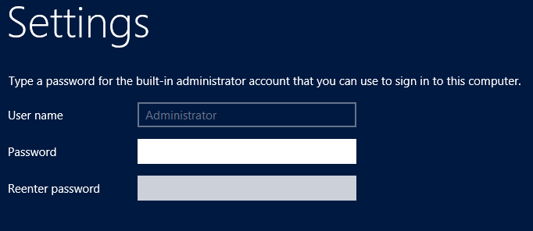

And then login. In the upper left of the VMware Workstation window, you will see three buttons- this will issue a Ctrl+Alt+Delete to the virtual machine- otherwise if you just tried to do it from your keyboard, you would actually issue that command to the host computer which is not what you want:

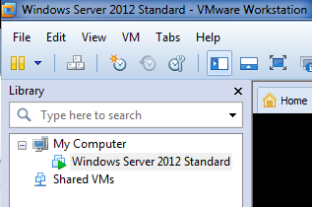

At the bottom of the virtual machine screen, you will see this helpful message:



Once the vm fully logs in as Administrator for the first time and Server Manager has fully loaded, click on the I Finished Installing button. Also- you might notice the following in the lower left of your screen:



Also- Ctrl+Alt can return control back to the host if your mouse pointer disappears.

### Installing the VMware Tools

The VMware tools will allow you to directly copy and paste from your host desktop into the vm in addition to other software capabilities.

Click on the Windows Explorer folder in the toolbar and go to Computer:

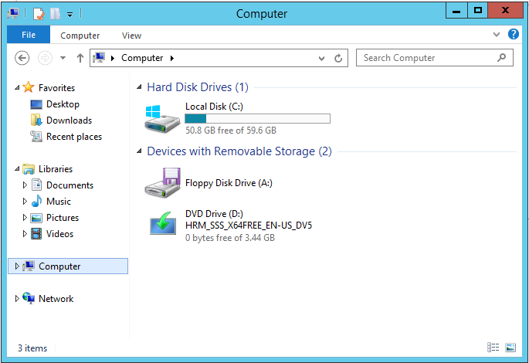

In VMware Workstation: VM: Install VMware Tools. You will then see that the D: has been temporarily hijacked in order to install the tools:

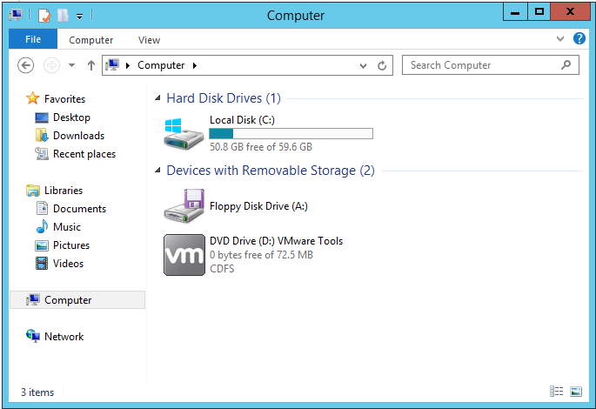

And you may see a dialog box in the vm asking you what action do you want to take- either click that or run the install from the disk:

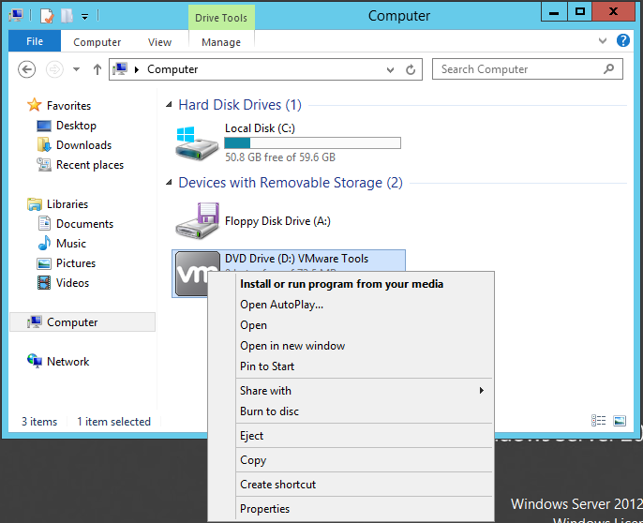

The actual install dialog sometimes hides behind other windows so look for it on the taskbar. I choose to go with all of the defaults. The vm will need to re-start so go ahead when prompted:

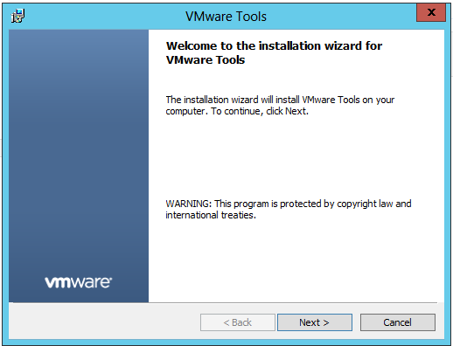

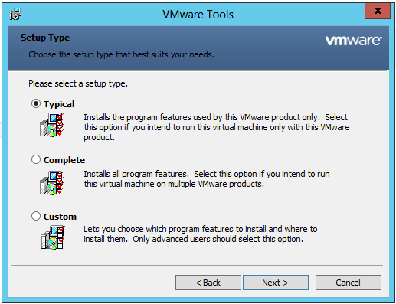

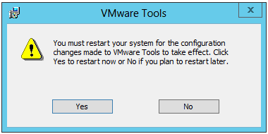

### .NET Framework 3.5 Features Installation

You will need to install .NET Framework 3.5 as a requirement for SQL Server 2012. Although .NET 4.0 comes installed by default in Windows Server 2012, 3.5 does not.

Server Manager: Manage:

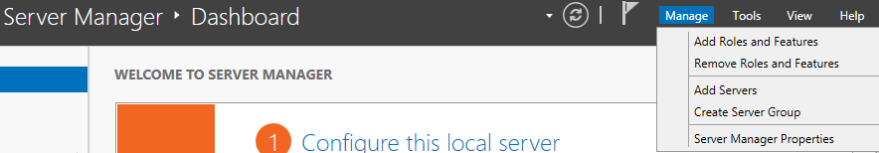

Add Roles and Features:

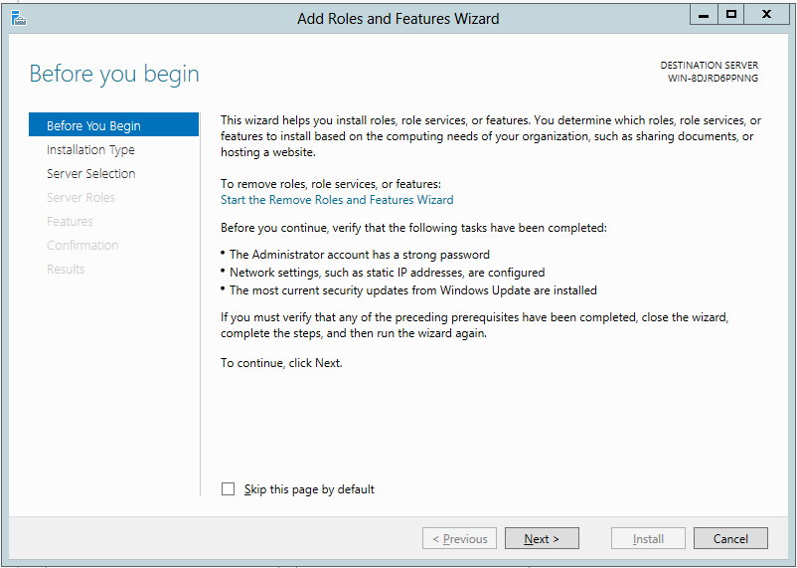

FYI- notice the machine name in the upper right corner- this will get changed when you begin to build linked clones. Your default .iso will probably show a different name.

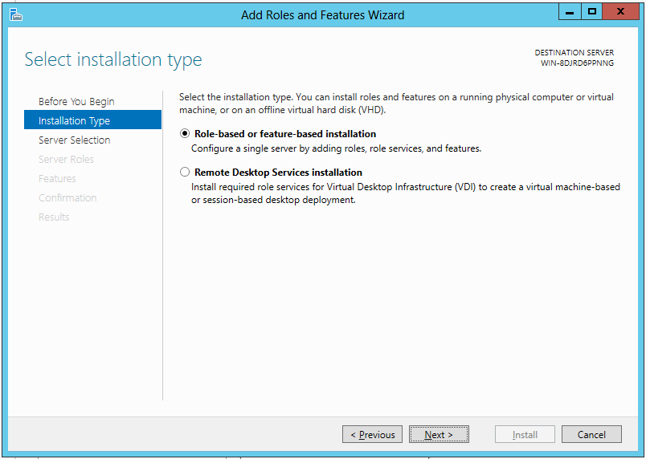

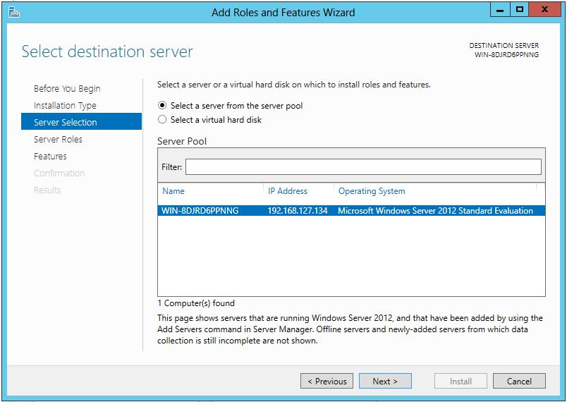

Keep going:

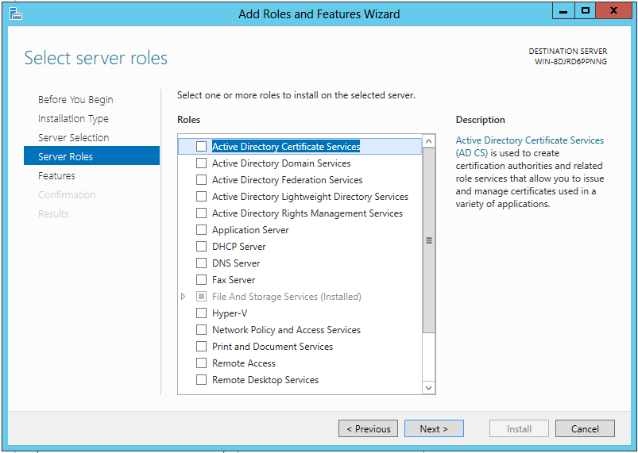

Finally, select the .NET Framework 3.5 Features:

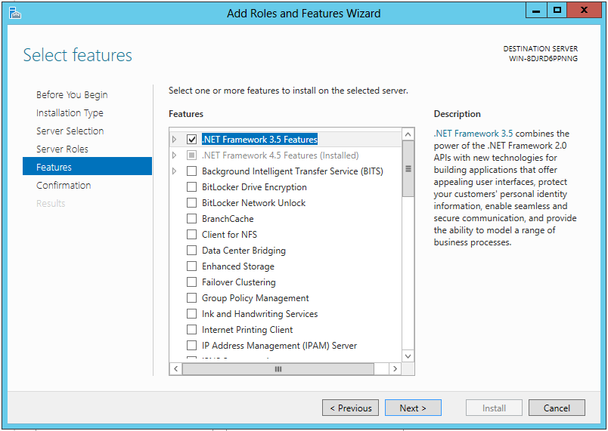

I love the warning as you WILL need to change the path:

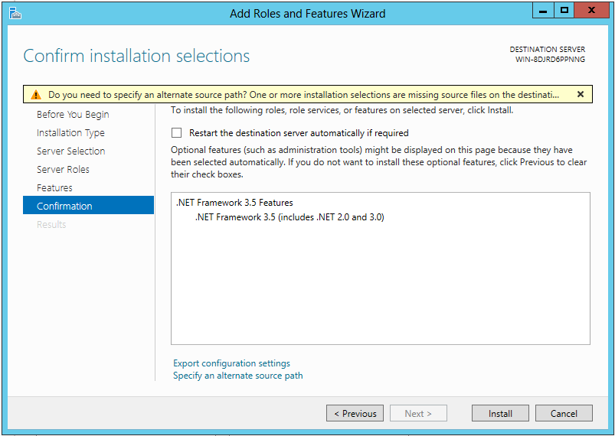

Click the link to Specify an alternate source path:

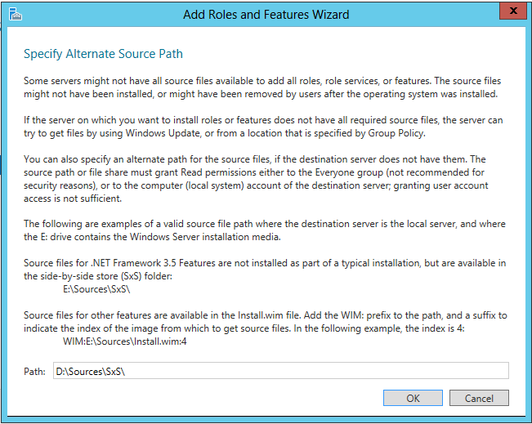

On my machine, I used the path the CD/DVD is mapped to on the .iso file (notice w/ the VMware Tools installed, you can copy and paste the path below into the vm):

D:\Sources\SxS\

OK and Install:

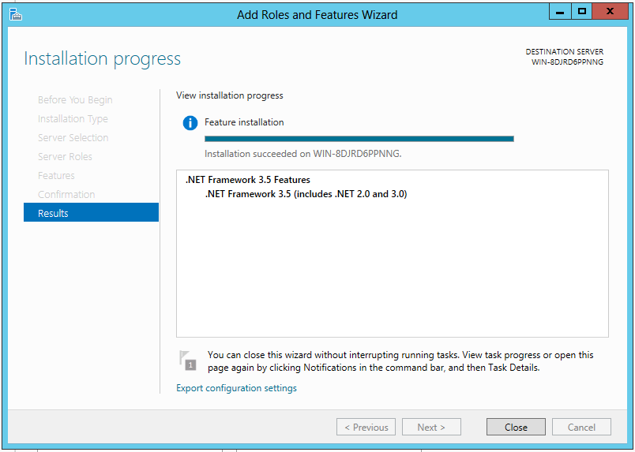

Close.

And power down the virtual machine. You can either launch PowerShell from the taskbar or Windows Key + R for a command shell and issue:

Shutdown /s /t 0 (that is a zero meaning do it right now!)

Or use the Windows Key + c to launch the charms: Settings: Power: Shut down.

Gold Master #1 is complete.

## Gold Master #2 – Windows Server 2012 Standard Core

You will follow a lot of the same steps that you just did for Gold Master #1 with a few changes as noted.

Create a new virtual machine (use the Home tab in Workstation) as before but call it Windows Server 2012 Standard Core.

When you power on the vm and get to the OS to install, this time select Standard Server Core:

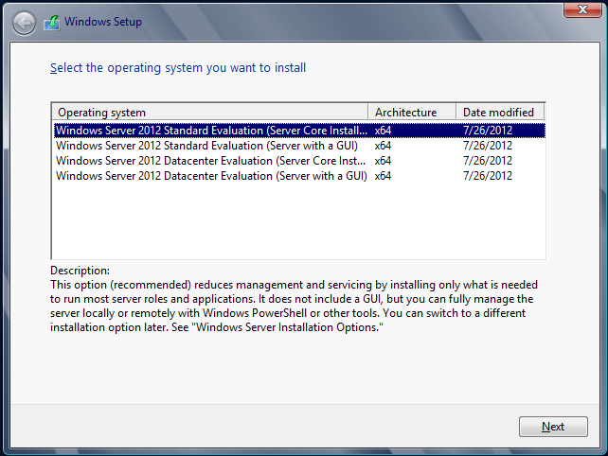

And follow the other steps as before. You should notice that Server Core installs faster than Standard with a GUI.

After setting the password, go ahead click I finished installing and then install the VMWare Tools as before from VM: Install VMware Tools.

I have noticed on Server Core, you may or may not see a dialog box after issuing the command to install. Go ahead and path out to the D:, issue a dir command, and then manually run setup.exe:

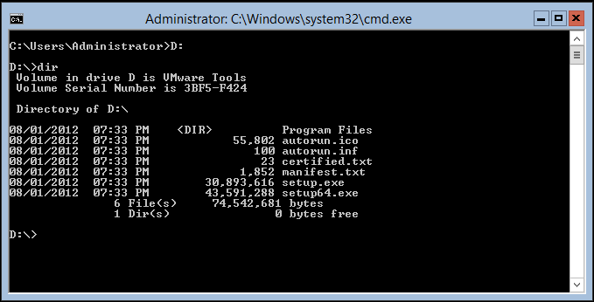

Again, be aware the dialog box to install the software might disappear behind the console window.

Login, launch PowerShell at command prompt and paste the following:

Install-WindowsFeature NET-Framework-Core –Source D:\Sources\SxS\

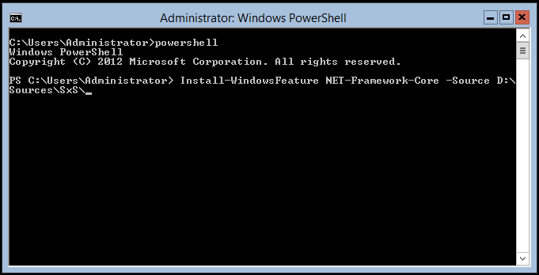

Enter. Upon completion you will probably see a warning- ignore for now. Shutdown with shutdown /s /t 0:

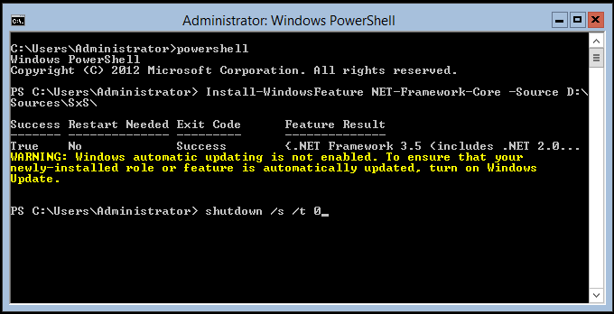

Golden Master #2 is complete.

## Snapshotting Virtual Machines Overview

With both golden masters powered off, you are now able to create a snapshot. Select the machine name on the left (Windows Server 2012 Standard) under My Computer and go to Snapshot: Snapshot Manager:

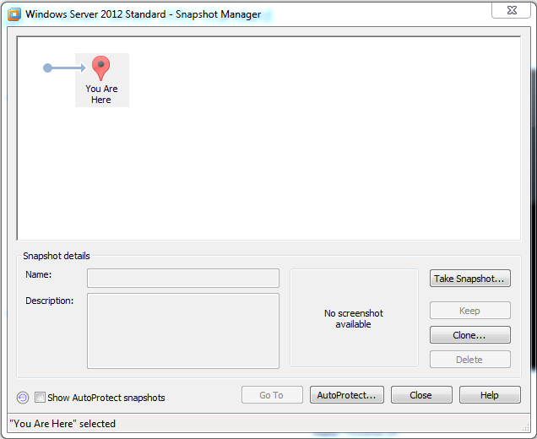

Click Take Snapshot and I called mine Windows Server 2012 Standard:

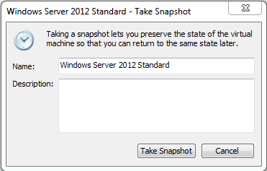

And now you can click on Clone:

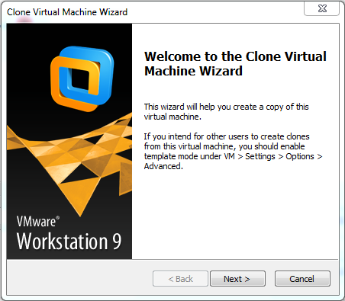

And choose An existing snapshot (powered off only):

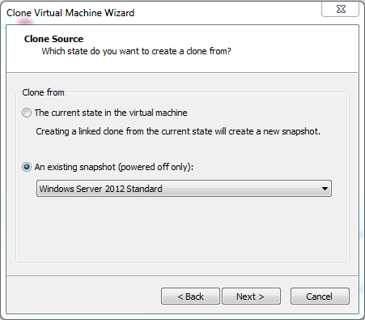

And now the secret in the secret sauce- Create a linked clone:

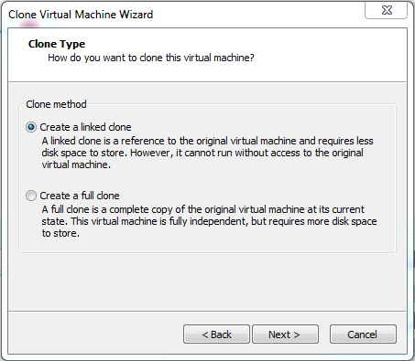

For the first linked clone, call it DC:

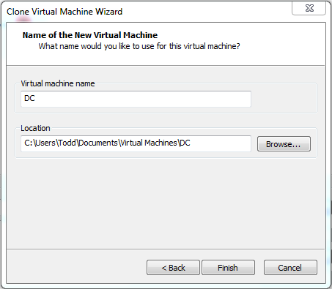

And you are done with the first linked clone!

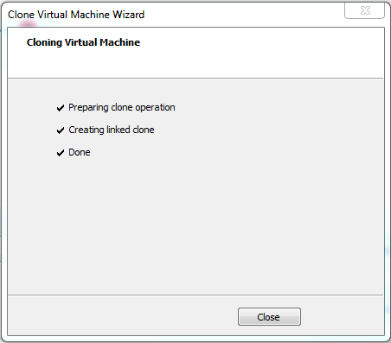

While you are still in Snapshot Manager, go ahead and create the following linked clones from the existing snapshot too:

SQL-A, SQL-B, SQL-C, and SQL-D

Then select the vm Windows Server 2012 Standard Core and repeat the process for Core. Be sure to select the correct snapshot (Core). Create a linked clone called SQL-CORE

When you are done, VMware Workstation should look like:

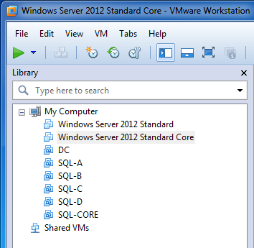

## Configuration Overview

The following steps will perform the following: run sysprep with generalize as needed, re-name all servers, configure IP addresses, install and configure the CONTOSO.COM domain, and join all servers to the domain. I would like to point out that depending on your hardware, having more than a few virtual machines running can impact performance so if you are not actively using them go ahead and power them down.

### DC Configuration

Go ahead and power on the DC vm and login.

You have some choices on how to proceed from here. You can manually configure a lot of settings via command line/PowerShell and/or via the GUI. I do a mixture of both.

Bring up a command prompt using Windows Key + R : cmd. Using the Virtual_SQL_Lab_machines.zip file associated with this document, locate the file called DC.txt, open it, copy and paste the text into the command window and Enter (notice the first line will already execute) and answer Y to proceed:

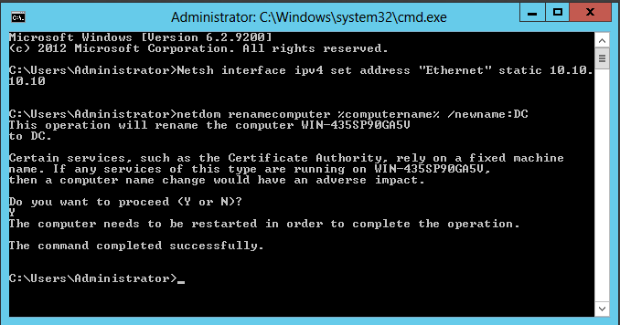

And re-start using shutdown /r /t 0

When the server comes back up, you will notice the network interface in the lower right of the taskbar shows a warning- this is ok as these vms will only need to talk to one another within the domain.

If you want to be able to connect out to the Internet from your vms, you can add an additional network interface to the vm and make it Bridged. I would only do this temporarily as having other vms using your physical host connection can cause other problems- so I’d only recommend building, using, then tearing down the second network adapter as needed:

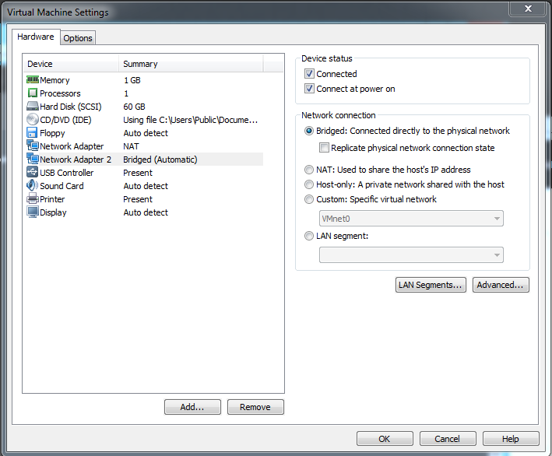

Note that if you change any settings while the vm is powered on, it will re-set the vm dynamically then it will be available.

Server Manager: Add Roles and Features:

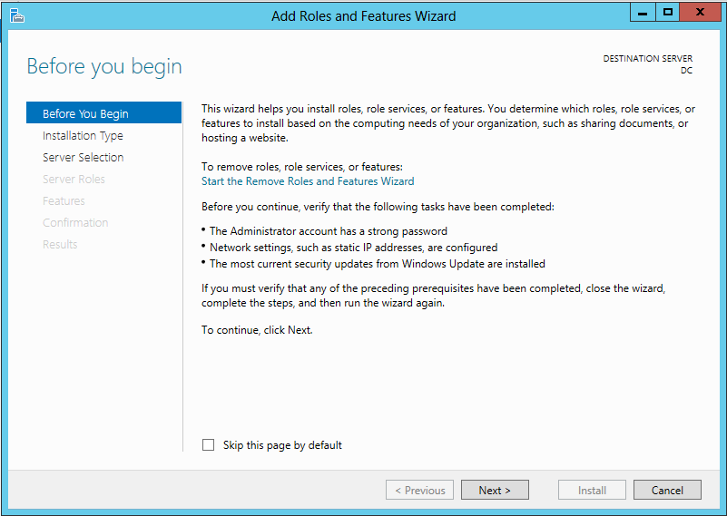

Next:

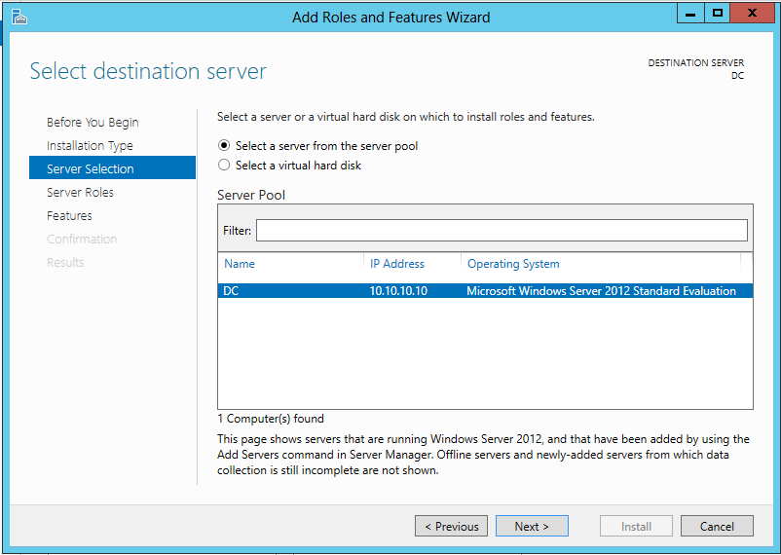

Next:

Add Active Directory Domain Services. It will prompt you to install additional services and features too:

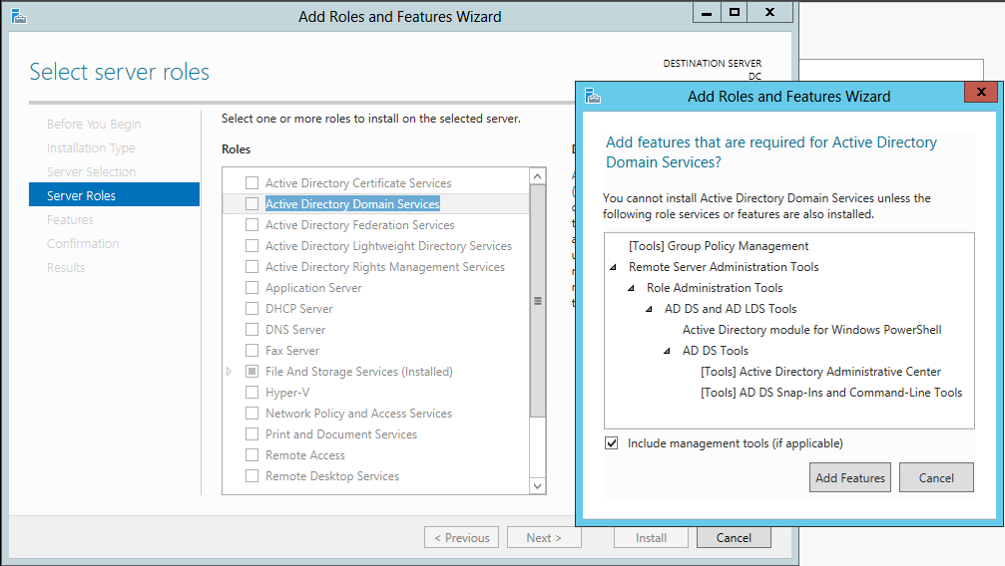

Click Add Features. Also check DNS Server, Add Features and Next (notice Group Policy Management has been added for you:

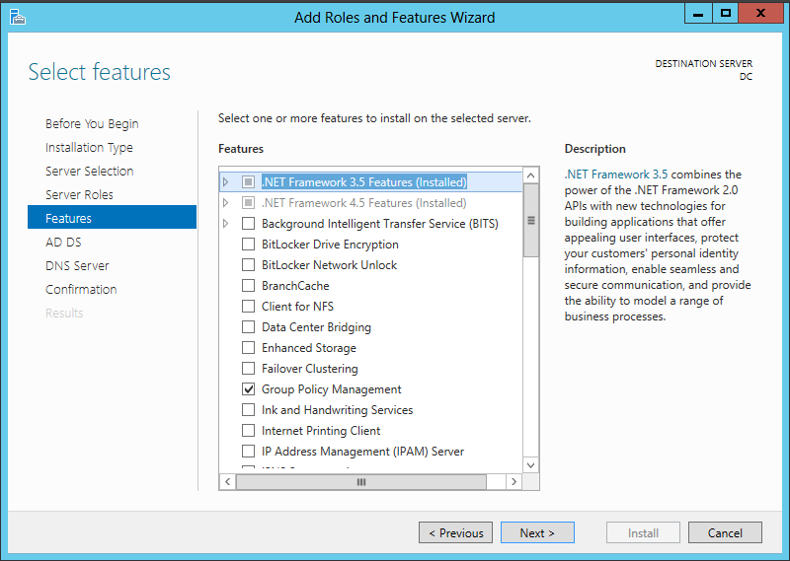

Next:

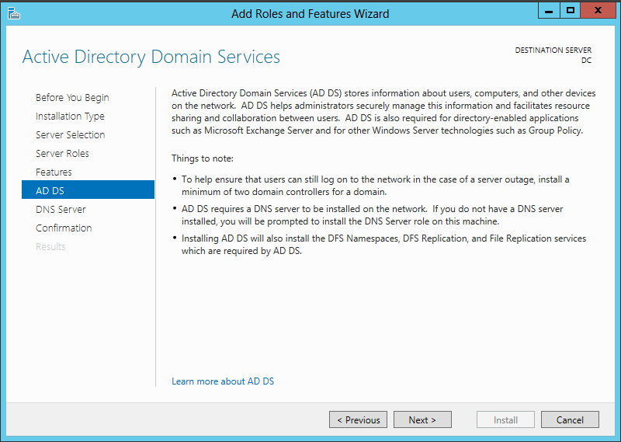

Next:

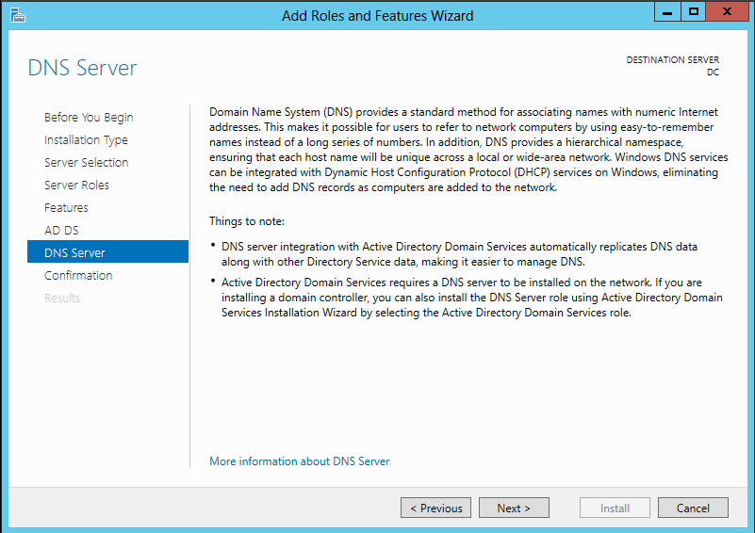

Next:

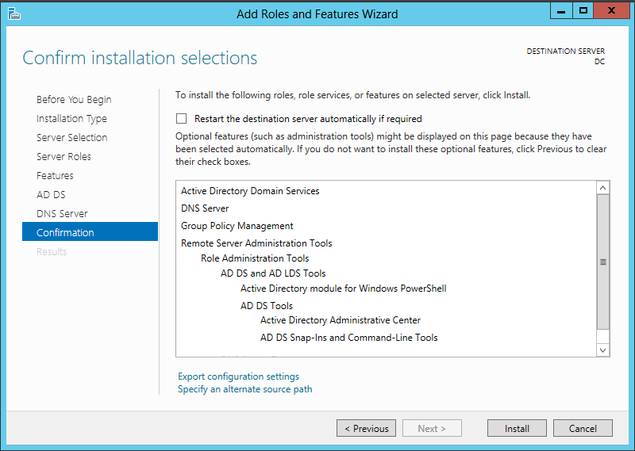

And double check the Specify an alternate source path; be sure it is set to D:\Sources\SxS\

I’ve noticed that I haven’t had to re-start upon installing all of this software even though the option is there to do so. However, we WILL need to re-boot after domain configuration is complete. Click Install. This will take approximately 5 minutes.

Once installation is complete, the software needs to be configured. Click on the link in the middle to Promote this server to a domain controller:

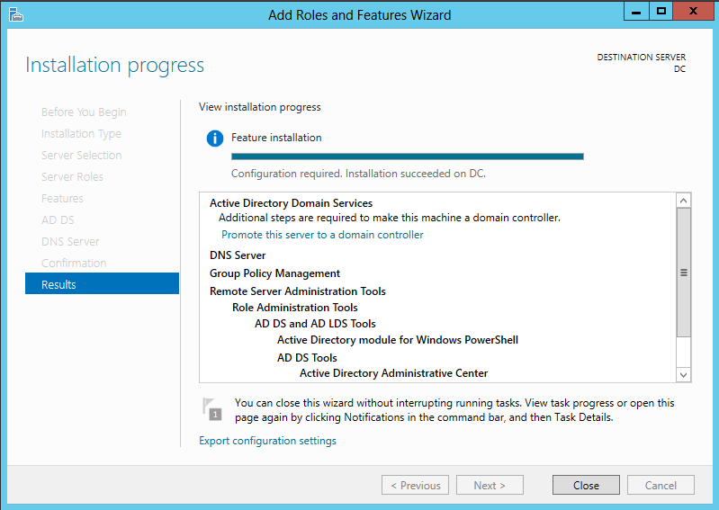

And you want to Add a new forest with the correct domain name: CONTOSO.COM

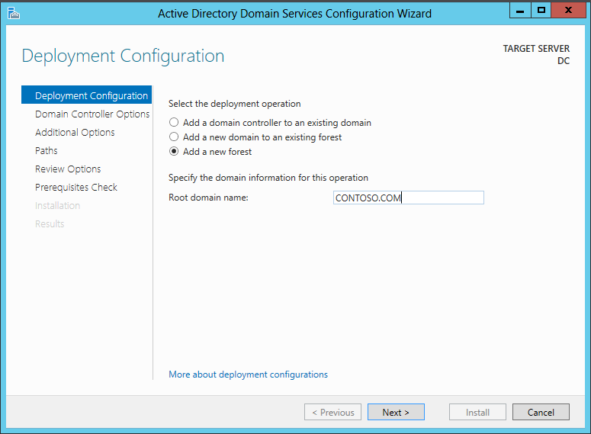

Next and enter the same password as above: Pa$$w0rd

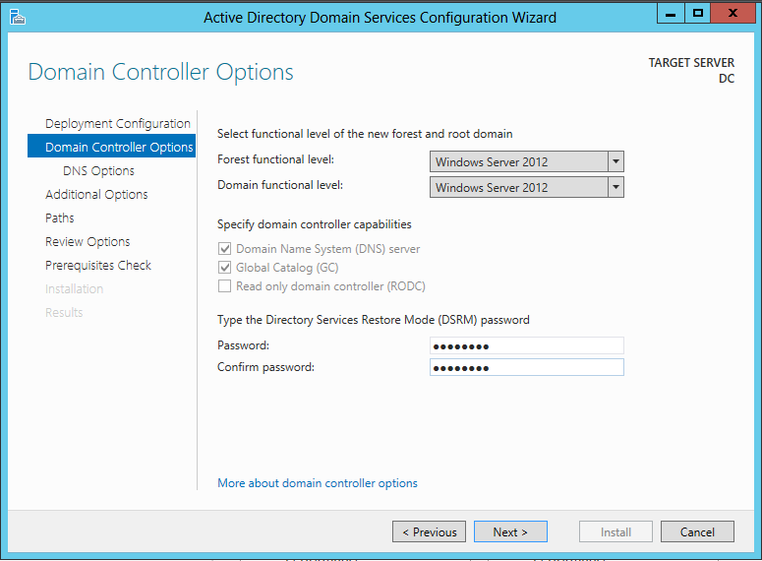

Next:

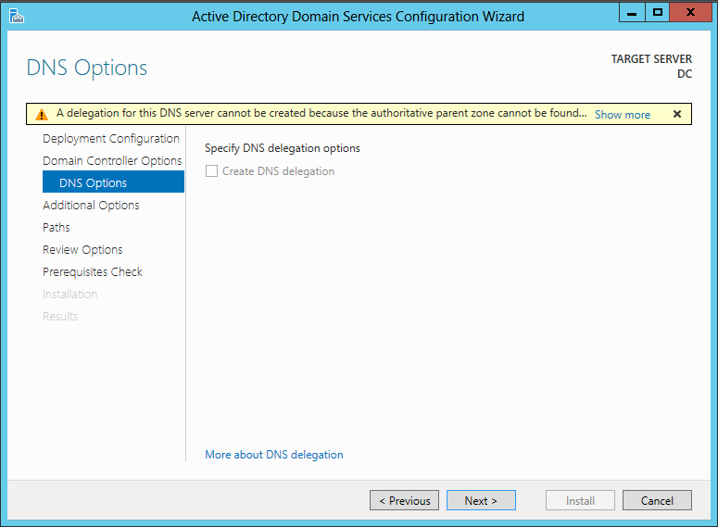

Next:

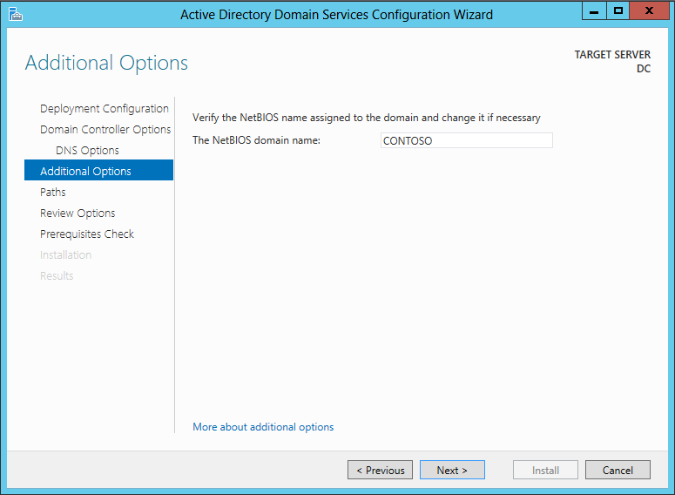

Next: And for you database administrators out there, does this look familiar? I wonder how many domain controllers in this world (including this one!) get everything installed to the C: - I also wonder how many domain controllers are optimized for data/log/sysvol layout like a real database server?

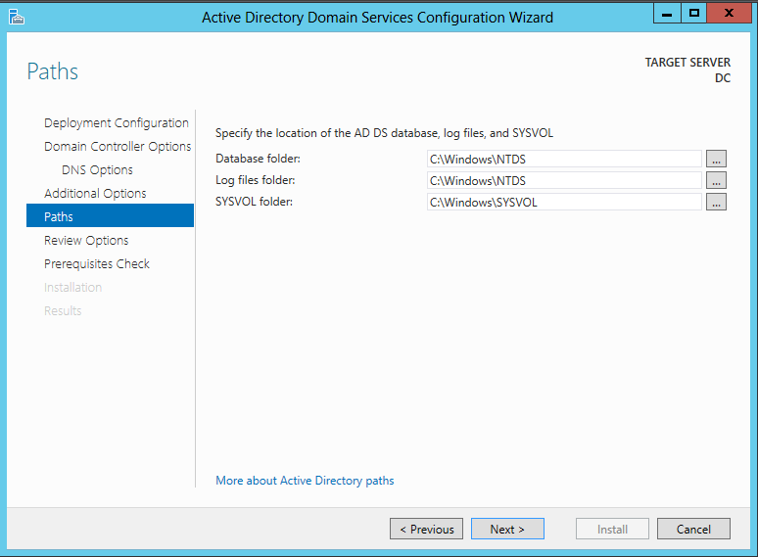

Next (note that you can view the script it will generate if you like):

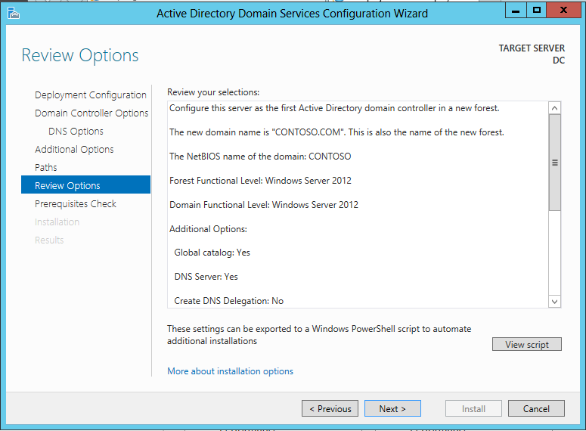

Next – you will some warnings but all of them should pass successfully. Install:

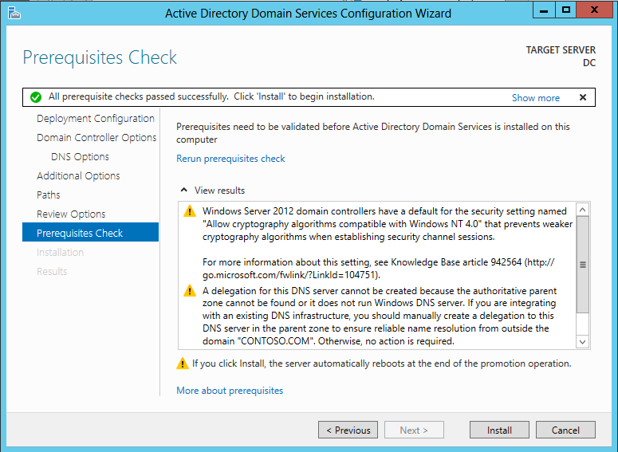

The final installation and configuration will take approximately 5 minutes and will automatically re-boot when done. Now that more services are running on DC, start-ups will take a little longer.

You can now login to your new domain:

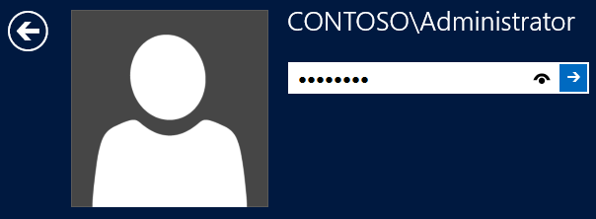

Per the set-up instructions in the Training Kit, go to Server Manager: Tools: Active Directory Users and Computers. Expand the domain, right click on Users: New User. Enter the info for the Kim_Akers account:

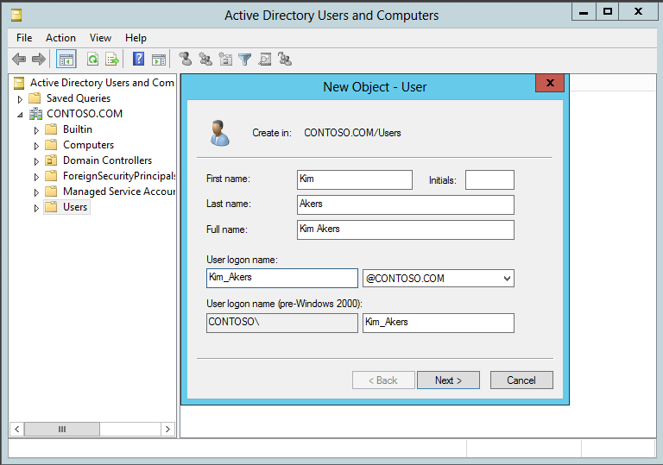

Next (set password to same one as above, uncheck User must change password at next login and check Password never expires):

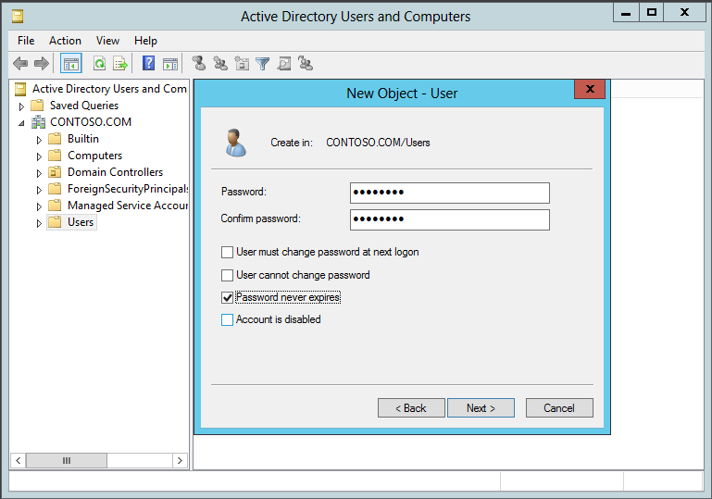

Next and Finish. Select the Users folder under the domain and double click on the Kim Akers account. Switch the tab to Member Of and click the Add button:

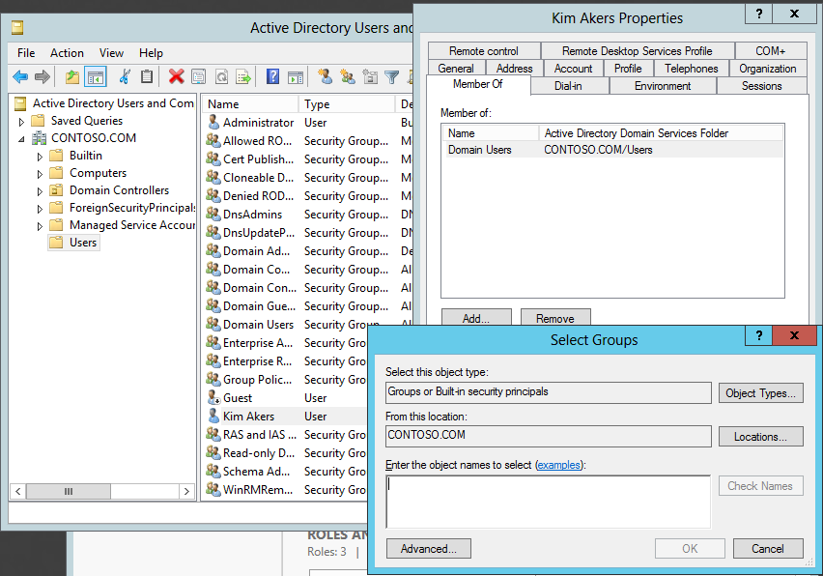

Add the following and then click on Check Names (to verify and resolve):

Enterprise Admins; Domain Admins; Schema Admins;

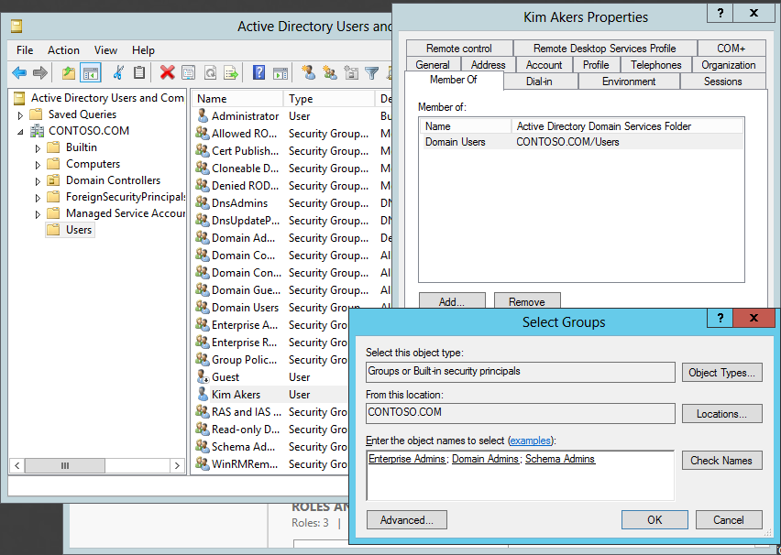

Click OK and OK.

Configuration for DC is complete.

## Remaining Server Configurations

Depending on your host resources, you can do the rest of the configurations one at a time or in parallel. Just realize that when you need to join a server to the domain, the DC needs to be running.

### SQL-A Configuration

Power on the vm and login. Bring up a command prompt and paste in the text from the SQL-A_Part1.txt file and Enter:

C:\Windows\System32\Sysprep\Sysprep.exe

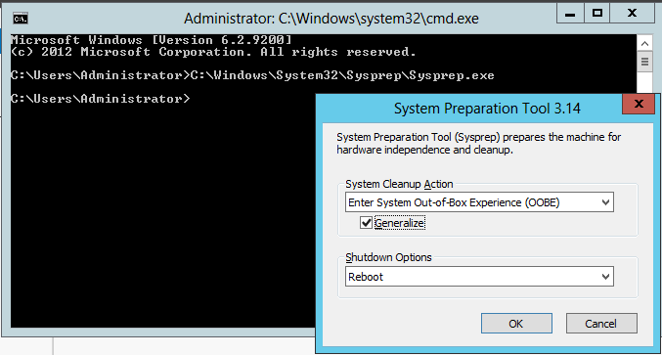

BE SURE YOU CLICK GENERALIZE!!! It will take a few minutes and then it will re-boot.

Login again. Note that after running sysprep with the oobe setting, you will need to accept the license agreement and also re-enter the password twice.

Copy the text from the file SQL_A_Part2.txt or below:

Netsh interface ipv4 set address "Ethernet" static 10.10.10.20

Netsh interface ipv4 set dnsservers "Ethernet" static 10.10.10.10 primary

netdom renamecomputer %computername% /newname:SQL-A

Choose Y to rename the server. Then issue a re-boot: shutdown /r /t 0

NOTE!!! You will see an error that the configured DNS server is incorrect or does not exist- that is ok and will be fixed when you join the server to the domain.

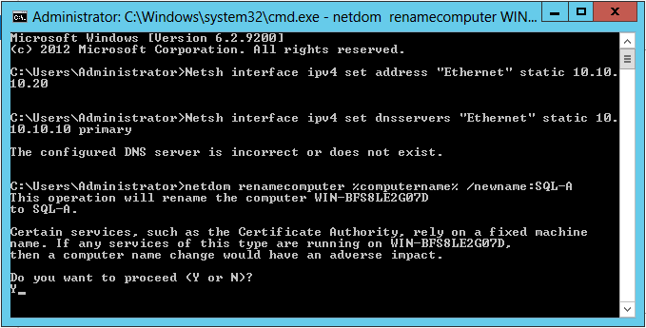

Last step. Login again. Copy the text from the file SQL_A_Part3.txt or below:

netdom join SQL-A /domain:contoso.com

Re-boot and then login and double check on DC; Server Manager: Tools: Active Directory Users and Computers. Under Computers, you should now see SQL-A:

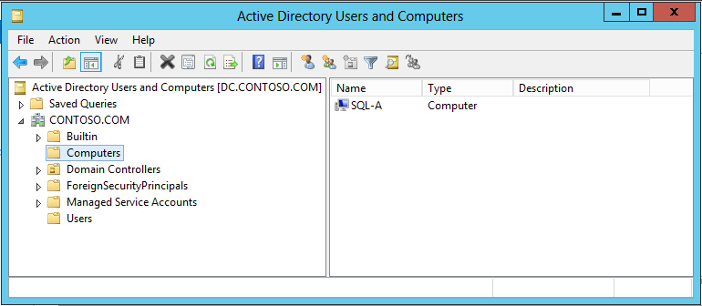

Go ahead and login using CONTOSO\Kim_Akers (click the arrow on the left to switch to a different user) and then power it down using shutdown /s /t 0

SQL-A Configuration is now complete.

### SQL-B, -C, -D Configuration

Follow all of the steps for the SQL-A configuration and use the named files in the order provided; don’t copy from the text above as it is specific to SQL-A only. Power down vms when complete.

### SQL-CORE Configuration

Since like the DC, this is the first linked clone from a sysprepped .iso file so you don’t have to run sysprep on it. Run through the files provided then power it down.

## Wrap-Up

How much hard drive space did building this 70-462 Lab take prior to installing SQL Server 2012? On my desktop, for six virtual machines and two gold masters, I show:

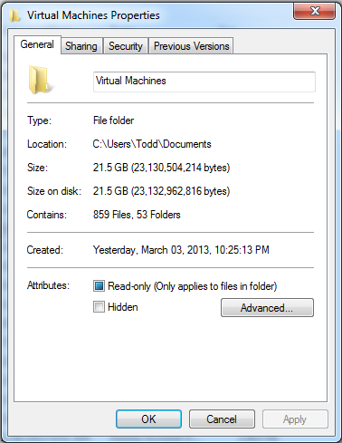

Realize that the golden masters are still being accessed by all of the servers and can create potential hotspots on the drive which could be a long-term issue on SSD(s). So when you are not using a vm, be sure to power it off.

Part 2 Heads-up; if you have to get running fast, you might consider disabling Windows Firewall on all of your servers and enable ICMP IPv4 so ping can work.

## Future Directions

Using vmrun.exe and some scripts, someone could literally build a one-click “Build a SQL Lab” If you have to re-build your lab on a regular basis, this could be a huge time-saver.

I hope this document has been helpful- please feel free to e-mail me with any questions (todd.kleinhans at gmail.com)

Thanks!

--Todd Kleinhans