Env
- 74.0.3729.131, 64 bit as well as current Edge
- MSAL 1.0.0

Code
The code i staken from the msal js samples.

<html>

<head>
<title>Calling a Web API as a user authenticated with Msal.js app</title>
<style>
body {
font-family: 'Arial Narrow', Arial, sans-serif
}

button {
background-color: blue;
color: whitesmoke;
border-style: solid;
border-width: 1px;
padding: 10px;
border-radius: 3px;
}

button:hover {
background-color: #8181ee;
}

hr {
margin-top: 20px;
}

.hidden {
display: none;
visibility: hidden
}

.visible {
visibility: visible
}

.response {
border-style: none;
border-width: thin;
background-color: rgb(255, 228, 198);
padding: 0px;
border-radius: 2px;
}

.blockTitle {
font-size: 130%;
font-weight: bold;
margin-right: 25px;
}
</style>
</head>

<body style="background-color: lightblue">
<!-- bluebird only needed if this page needs to run on Internet Explorer -->
<script src="https://cdnjs.cloudflare.com/ajax/libs/bluebird/3.3.4/bluebird.min.js" class="pre"></script>
<script src="https://secure.aadcdn.microsoftonline-p.com/lib/1.0.0/js/msal.js"></script>
<script src="https://code.jquery.com/jquery-3.2.1.min.js" class="pre"></script>

<h2>Test Authentication with Azure AD B2C</h2>
<div>
<div id="label">Not logged in</div>
<br />

<span class="blockTitle">Azure AD B2C Authentication</span>
<button id="auth" onclick="login()">Login with azure ADB2C</button>
<button id="callApiButton" class="hidden" onclick="getTokenSilently()">Test get token silently</button>
<hr>

<!-- Credentials - User/PW - Not used at the moment
<span class="blockTitle">Authentication with username/pw</span>
<button id="loginWithCredentialsButton" onclick="loginWithCredentials()">
Login with username/pw (user@test.com/password)
</button>
<button id="callApiWithSessionButton" class="hidden" onclick="callApiWithLoggedInSession()">
Call Web API with Session User
</button>
<hr>
-->

<span class="blockTitle">Logout</span>
<button id="logoutButton" class="hidden" onclick="logout()">Logout</button>
<hr>

</div>

<pre class="response"></pre>

<script>
console.info(`Start script: history.length: %s`, history.length);

const b2bScopesAuthTest = ["https://tgwdsb2c.onmicrosoft.com/xxx/demo.read"];
const userFlowPolicy = "B2C_1_Test";
const clientIDTGWAuthTest = "the apps my client id";

// azure B2C config.
let applicationConfig = {
clientID: clientIDTGWAuthTest,
authority: `https://tgwdsb2c.b2clogin.com/tgwdsb2c.onmicrosoft.com/${userFlowPolicy}`,
// OLD!!! authority: "https://login.microsoftonline.com/tfp/tgwdsb2c.onmicrosoft.com/B2C_1_Test",
b2cScopes: b2bScopesAuthTest,
webApi: 'http://localhost:5000/api/test',
loginApi: 'http://localhost:5000/login',
logoutApi: 'http://localhost:5000/api/logout',
};

let curAuthStrategy;
let authenticated = false;
let clientApplication;
let AuthStrategy = {};
AuthStrategy[AuthStrategy.PassportToken = 1] = "PassportToken";
AuthStrategy[AuthStrategy.Credentials = 2] = "Credentials";
let mockUser = {
email: "user@test.com",
password: "password"
};
let loggedInUser = undefined;

window.onload = doIt;

/**
* Start test.
*/
async function doIt() {
updateUI();
console.info(`doIt: appConfig: %O, history.length: %s`, applicationConfig, history.length);

clientApplication = new Msal.UserAgentApplication(
{
auth: {
clientId: applicationConfig.clientID,
authority: applicationConfig.authority,
validateAuthority: false
},
cache: {
cacheLocation: "localStorage",
storeAuthStateInCookie: true
}
}
);

/**
* Try to get access token silently without interaction.
* => Try to automatically login when app starts.
*/
// let account = clientApplication.getAccount();
// if (account) {
// console.info("******* Found account in client app.");
// try {
// let tokenRequest = { scopes: applicationConfig.b2cScopes };
// let accessToken = await clientApplication.acquireTokenSilent(tokenRequest);
// authenticated = true;
// curAuthStrategy = AuthStrategy.PassportToken;
// updateUI()
// } catch (e) {
// logMessage("Error acquiring the token silently:\n" + e);
// }
// }
}

/* azure AD B2C.
----------------------------------------------------------------------------------------*/

/**
* Login to azure AD.
*/
function login() {
let loginRequest = { scopes: applicationConfig.b2cScopes };
clientApplication.loginPopup(loginRequest)
.then(function (authResponse) {
console.log(`After loginPopup, authResponse == %O`, authResponse);
console.info(`login: history.length: %s`, history.length);
if (authResponse.accessToken) {
curAuthStrategy = AuthStrategy.PassportToken;
authenticated = true;
console.info(`login: history.length: %s`, history.length);
updateUI();
} else {
let tokenRequest = { scopes: applicationConfig.b2cScopes };
clientApplication.acquireTokenSilent(tokenRequest)
.then(function (accessToken) {
console.info("After login & acquireTokenSilent, token == %O", accessToken);
console.info(`login: history.length: %s`, history.length);
curAuthStrategy = AuthStrategy.PassportToken;
authenticated = true;
updateUI();
}, function (error) {
clientApplication.acquireTokenPopup(tokenRequest)
.then(function (accessToken) {
console.info("After login & acquireTokenPopup, token == %O", accessToken);
console.info(`login: history.length: %s`, history.length);
curAuthStrategy = AuthStrategy.PassportToken;
authenticated = true;
updateUI();
}, function (error) {
logMessage("Error acquiring the token silently:\n" + error);
});
})
}
}, function (error) {
logMessage("Error during loginPopup:\n" + error);
});
}

/**
* Update the UI according to the state of login etc.
*/
function updateUI() {
console.info("Update UI");
if (authenticated) {
let userName = clientApplication && clientApplication.getAccount() ? clientApplication.getAccount().name : loggedInUser ? loggedInUser.email : "no logged in user";
logMessage("User '" + userName + "' logged-in");
let authButton = document.getElementById('auth');
authButton.setAttribute("class", "hidden");
// Not used: let loginWithCredButton = document.getElementById('loginWithCredentialsButton');
// Not used: loginWithCredButton.setAttribute("class", "hidden");
let logoutButton = document.getElementById('logoutButton');
logoutButton.setAttribute("class", "visible");
let label = document.getElementById('label');
label.innerText = "Hello " + userName;

if (curAuthStrategy === AuthStrategy.PassportToken) {
let callWebApiButton = document.getElementById('callApiButton');
callWebApiButton.setAttribute('class', 'visible');
// Not used: let callApiWithSessionButton = document.getElementById('callApiWithSessionButton');
// Not used: callApiWithSessionButton.setAttribute('class', 'hidden');
} else {
let callWebApiButton = document.getElementById('callApiButton');
callWebApiButton.setAttribute('class', 'hidden');
// Not used: let callApiWithSessionButton = document.getElementById('callApiWithSessionButton');
// Not used: callApiWithSessionButton.setAttribute('class', 'visible');
}
} else {
let logoutButton = document.getElementById('logoutButton');
logoutButton.setAttribute("class", "hidden");
let authButton = document.getElementById('auth');
authButton.setAttribute("class", "visible");
// Not used: let loginWithCredButton = document.getElementById('loginWithCredentialsButton');
// Not used: authButton.setAttribute("class", "visible");
}
}

/**
* Test getting a token silently.
*/
function getTokenSilently() {
let tokenRequest = { scopes: applicationConfig.b2cScopes };
clientApplication.acquireTokenSilent(tokenRequest).then(function (authResponse) {
logMessage(`getTokenSilently: got token silently: ${authResponse.accessToken}`);
console.info(`getTokenSilently: history.length: %s`, history.length);
}, function (error) {
clientApplication.acquireTokenPopup(tokenRequest).then(function (authResponse) {
logMessage(`getTokenSilently: got token from popup: ${authResponse.accessToken}`);
console.info(`getTokenSilently: history.length: %s`, history.length);
}, function (error) {
logMessage("Error acquiring the access token to call the Web api:\n" + error);
});
})
}

Remainder of code not relevant…

Register SPA in azure ADB2C portal
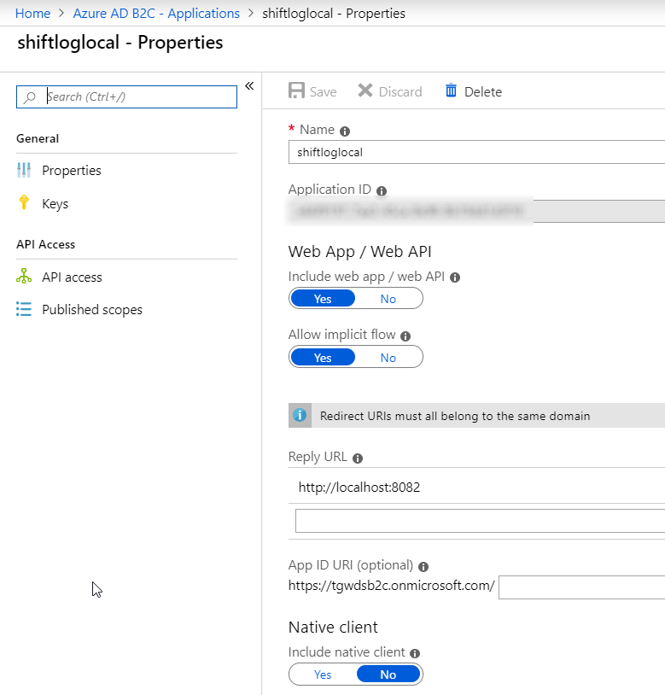

Load app (index.html) in new tab
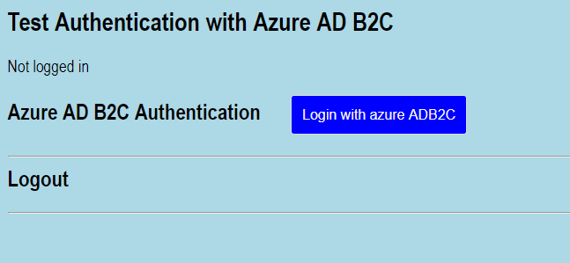

Console log:
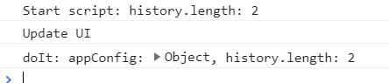

Click „Login…“
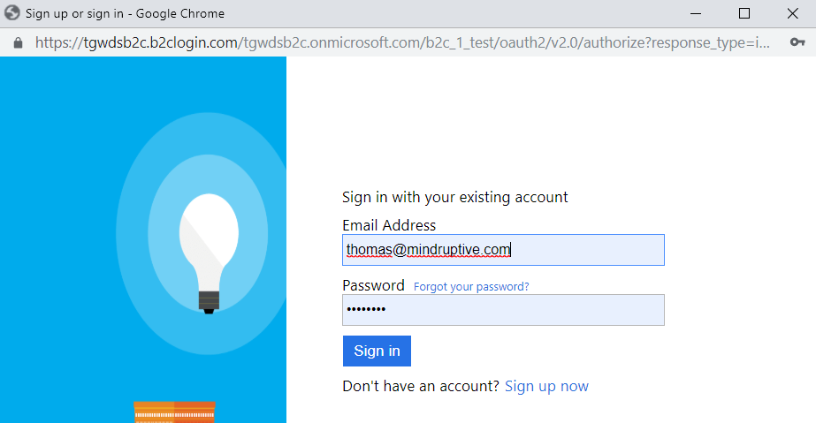

Click „Sign in“
The login-window closes, the app (main window) gets reloaded in the JS context of the hidden iframe:
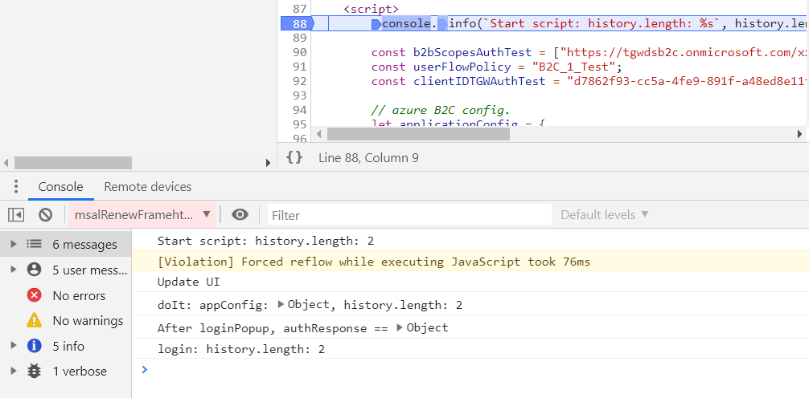

Console log after sign in:
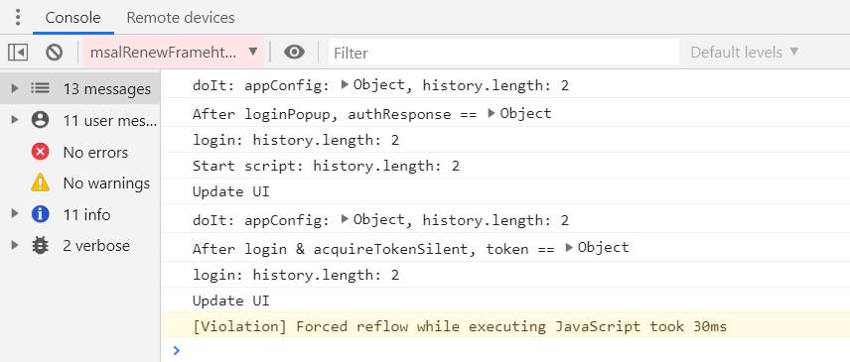

Click „Test get token silently“
Now, immediately after sign in (without any refresh/F5), click the button.
Before the call:
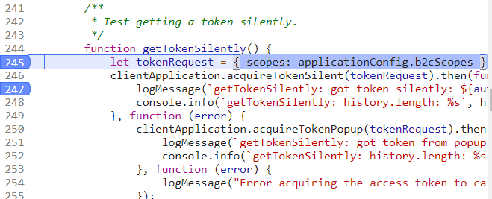

During the call, the app reloads againin iframe:
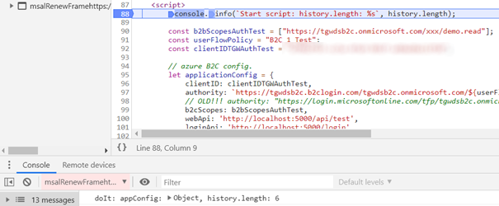

After the call, we log the result:
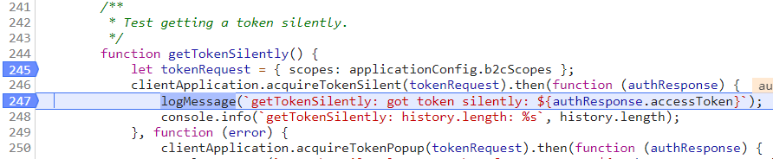

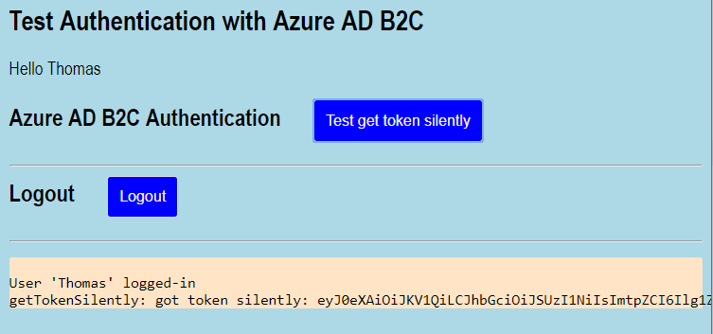

Bugs/Questions

Reload is not feasible in many situations
- The msal js samples are simple: A small web-page, which can be reloaded without any startup-cost.
- How can I prevent the app to fully initialize when ist loaded in the iframe?
  - Reason: Our real SPAs are quite. They load ~30 webpack modules on start. So the reload in the iframe takes a lot of time. Besides, I don’t want to tamper with the state of my app. Strange things might happen if it is fully loaded in an iframe.
I use the popups exactly for that reason: Don’t mess wit the app’s state.

Why does „loginPopup“ cause reloads?
- Why does „loginPopup“ cause the app to reload? It opens a popup window and/or iframe which can communicate with the identity-provider (ADB2C).

Why does „acquireTokenSilent“ cause a reload
- Why does „acquireTokenSilent“ cause a reload in an iframe, even after login? The login process should have cached the token. The strange thing: If I refresh (F5) the app and get the token silently once (the commented code at the beginning), all subsequent calls to „acquireTokenSilent“ work immediately, without an iframe-reload.
- Reloading the app can be very time-consuming in general

Problems with our „real“ SPA

App gets loaded in popup
We’ve used the same mechanism to authenticate in our SPAs. But even stranger things happen there: The app gets relaoded in the opopup window. Since the app takes a few seconds to load, one can watch it appear in the popup window.

History state messed up
The history state get messed up. Our app uses history.push and pop. But the state after the login and „aquireTokenSilently“ contains 3-4 extra entries.

Hash urls not useable
Our SPAs used hash URLs in ordert o support deep linking, even without server roundrips.
E.g.: „https://myapp.domain.com/#todos
The popup-redirect flow uses hashes, e.g. for error „interaction_required“ or „state“.

