实验五：综合应用程序设计
1、实验目的与要求
（1）学会结构体类型的声明与应用；
（2）学会使用文件组织、存储数据；
（3）学会运用模块化思想分析问题；
（4）针对实际问题能按照“分析、设计、实现”等步骤进行程序设计；
（5）提高代码编写规范。
2、实验内容
利用 C 语言三种基本控制结构、函数、结构体、数组、指针、文件等知识设计实现一个简单信息管理类系统，能实现主要功能，并具备一定的实用性、可靠性。



问题陈述
实现一个具有实际应用能力与价值的学生管理系统。使用链表作为数据结构，包含数据增、删、改、查以及排序等功能，实现数据永久化存储能力。

输入、输出描述
【输入】根据提示输入。
【输出】输出相应内容。

演算示例
- 查询人员
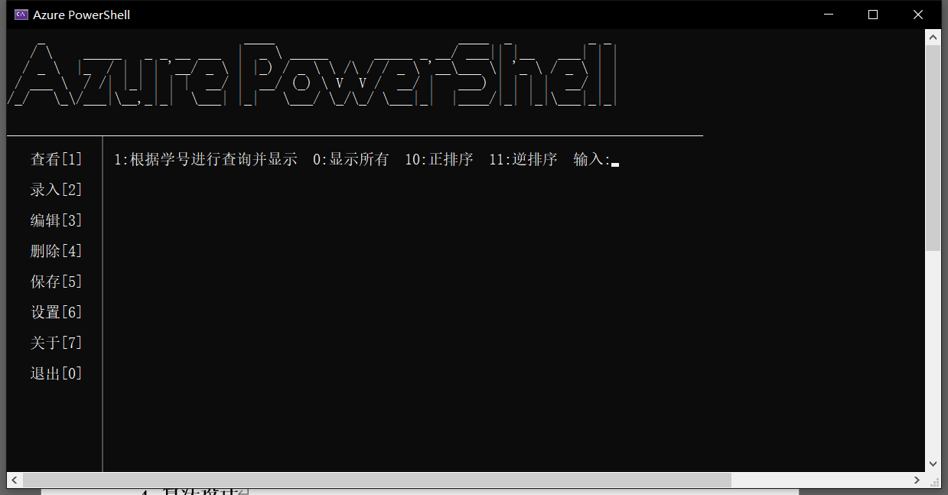
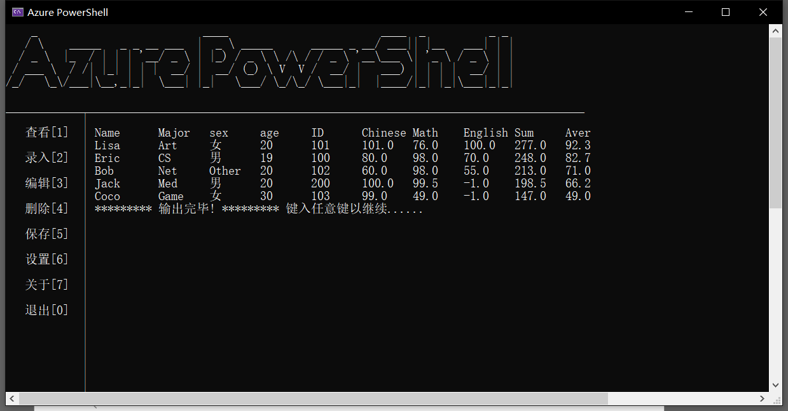

- 录入
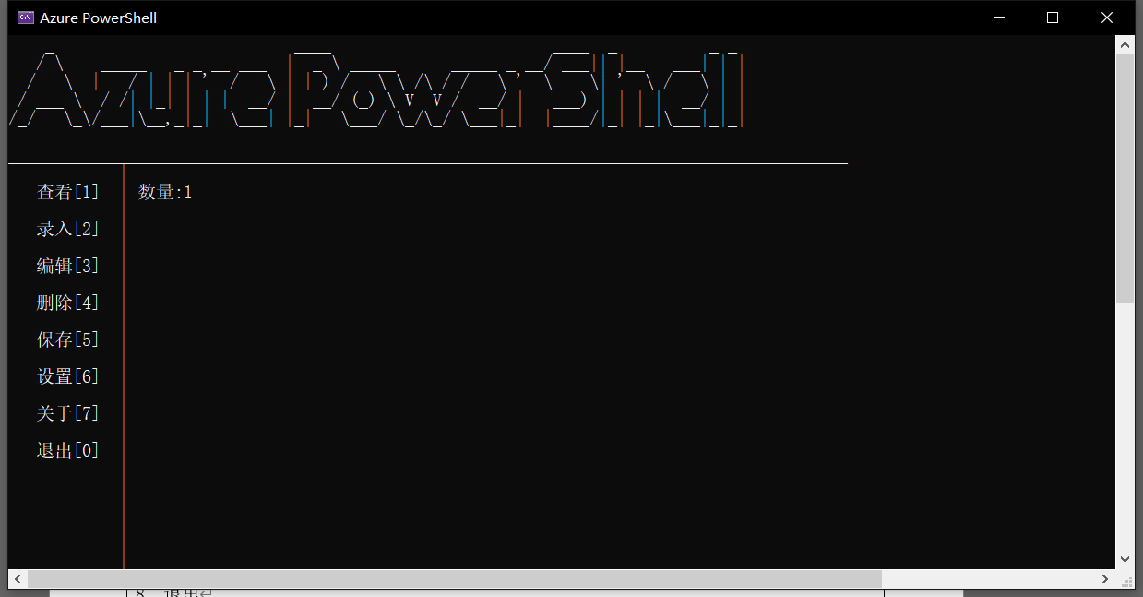
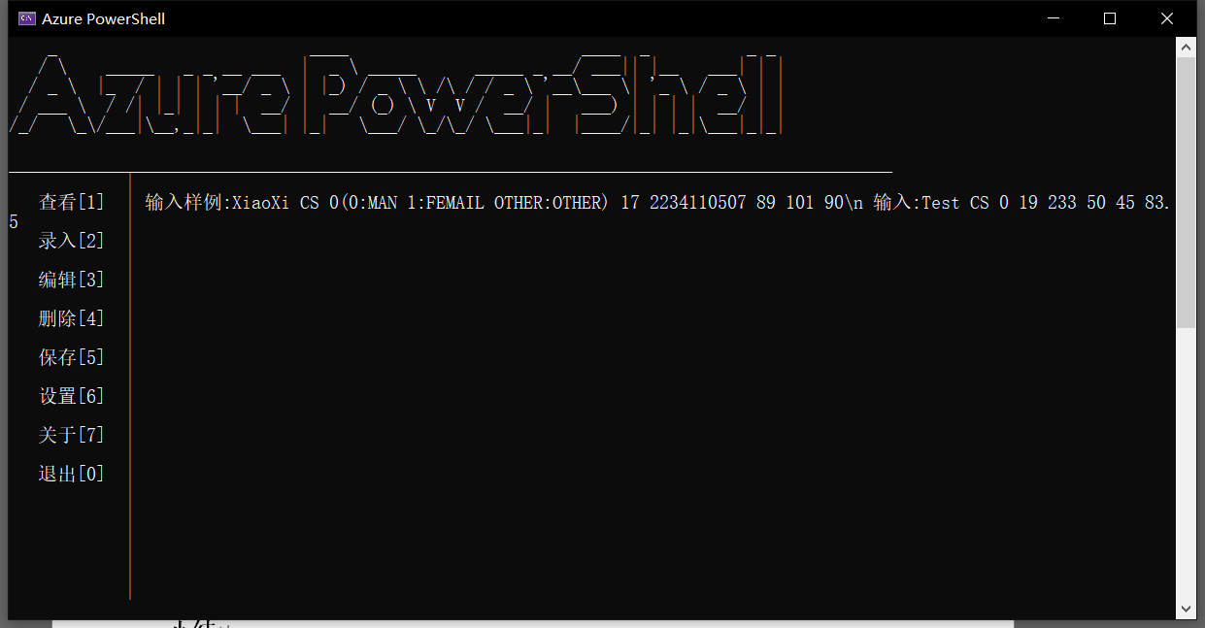
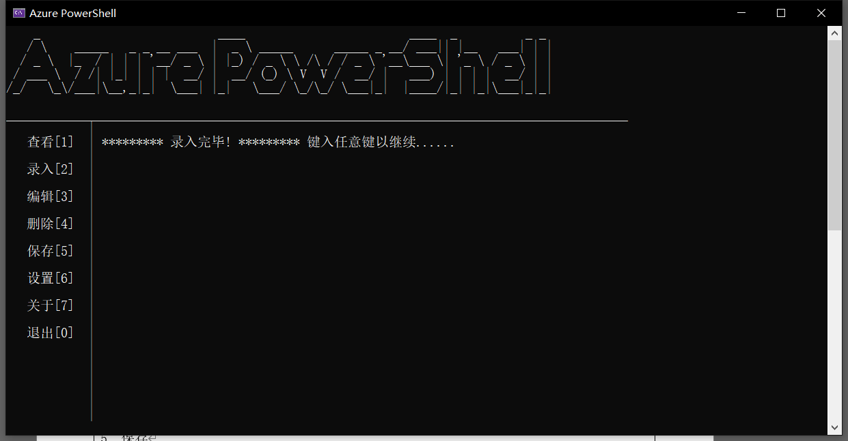

验证：
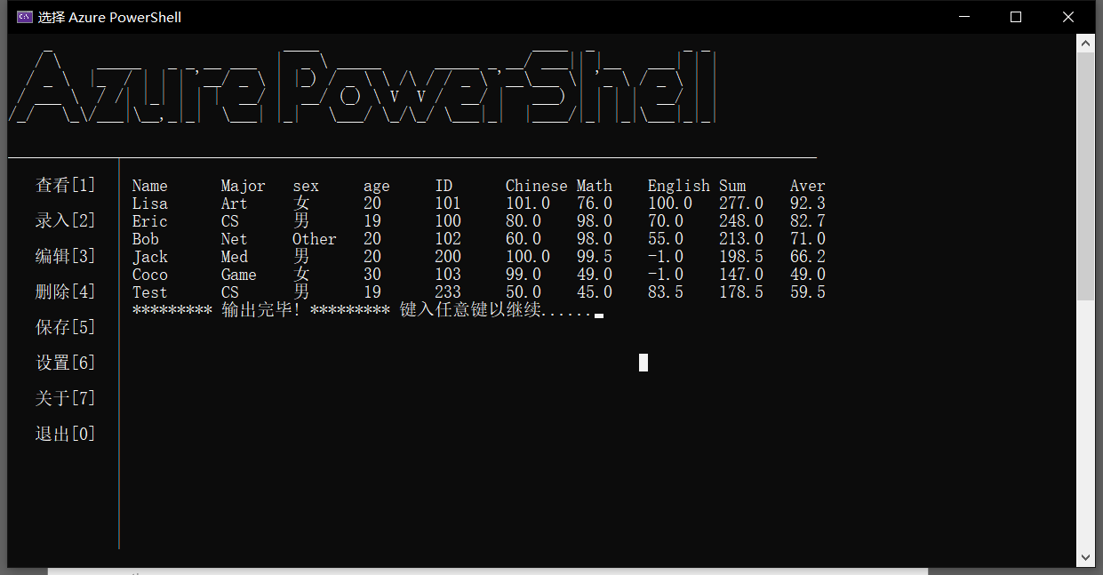
- 删除
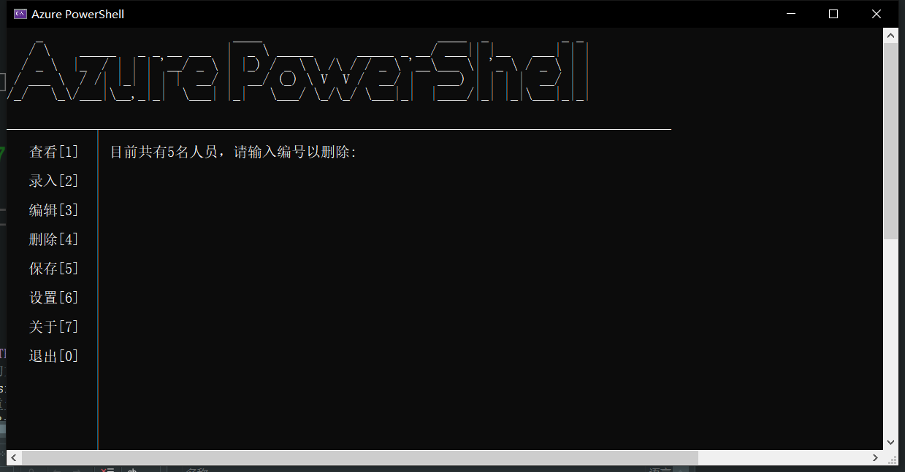
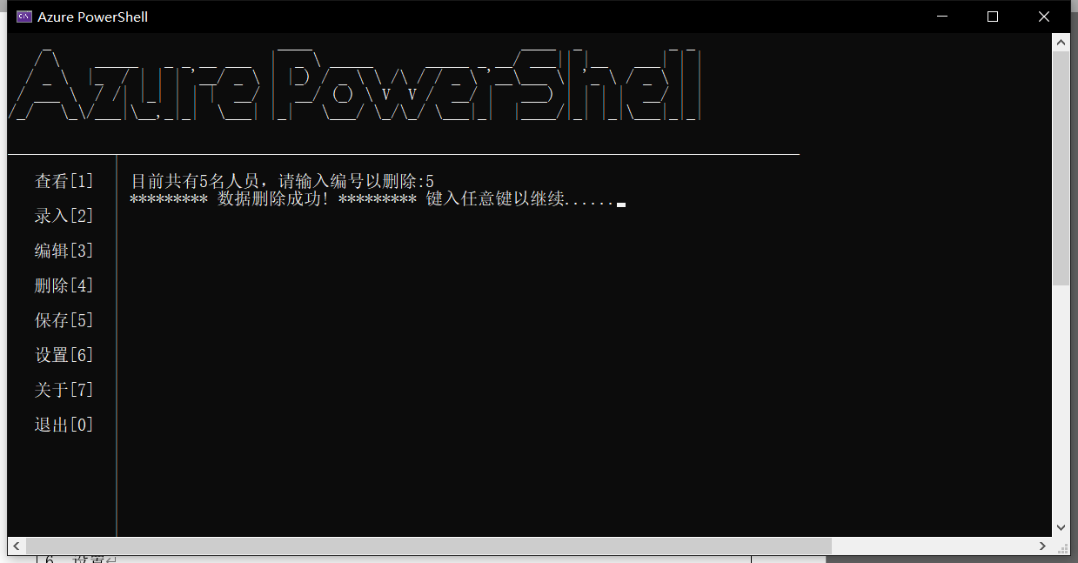

- 编辑
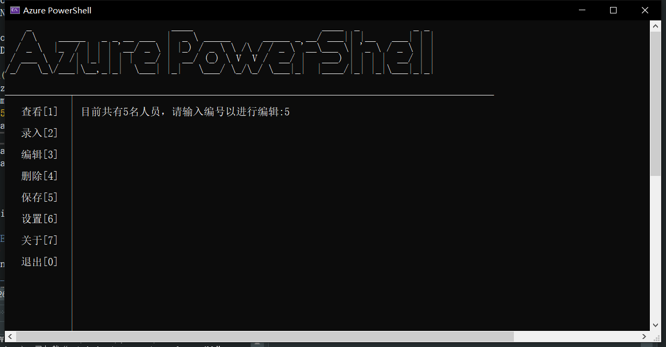
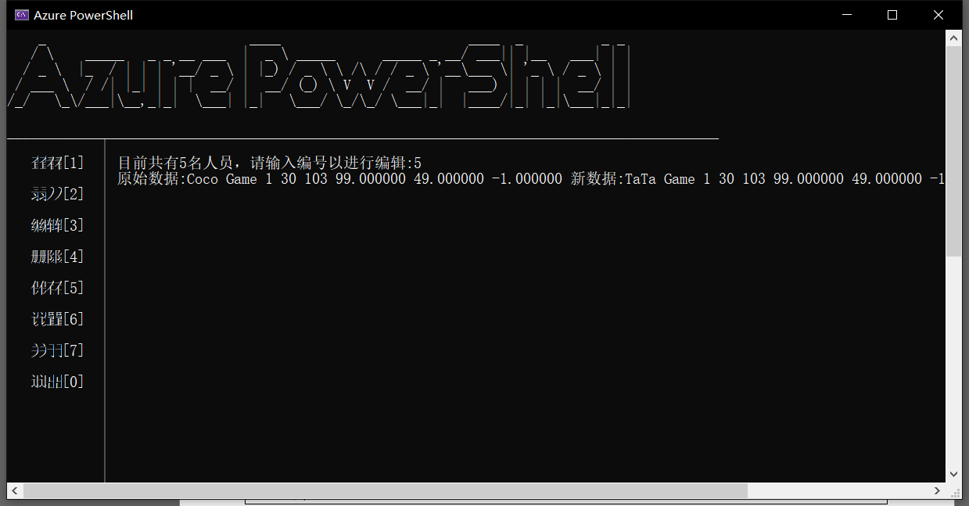
成功将Coco更名为TaTa：
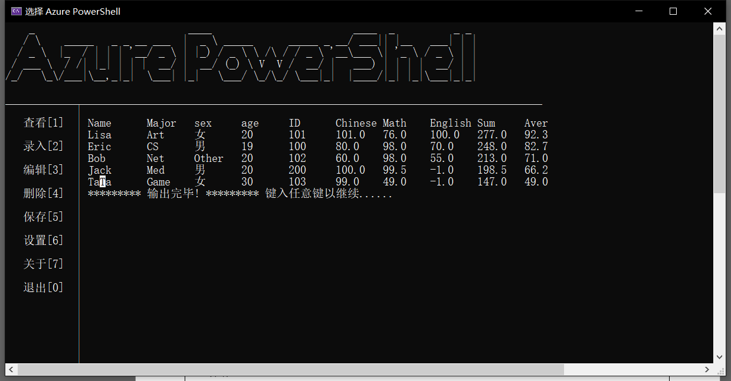

- 保存
一键极速保存：

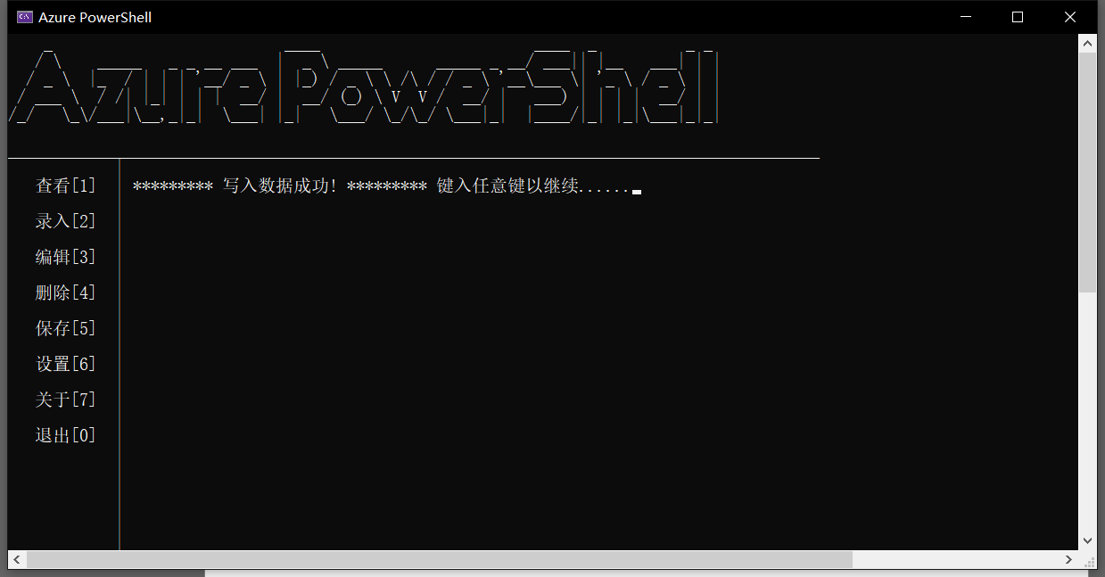
重启程序，发现数据被成功保存并读取：
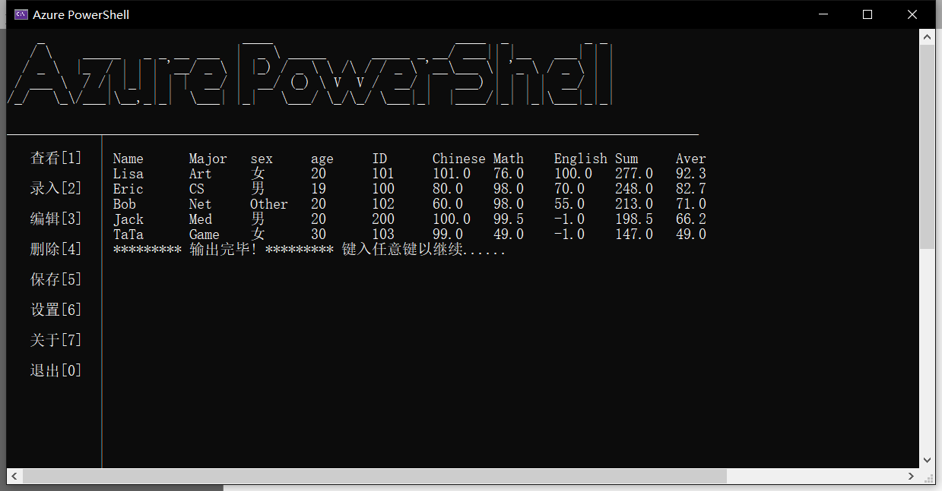
- 设置(BETA)
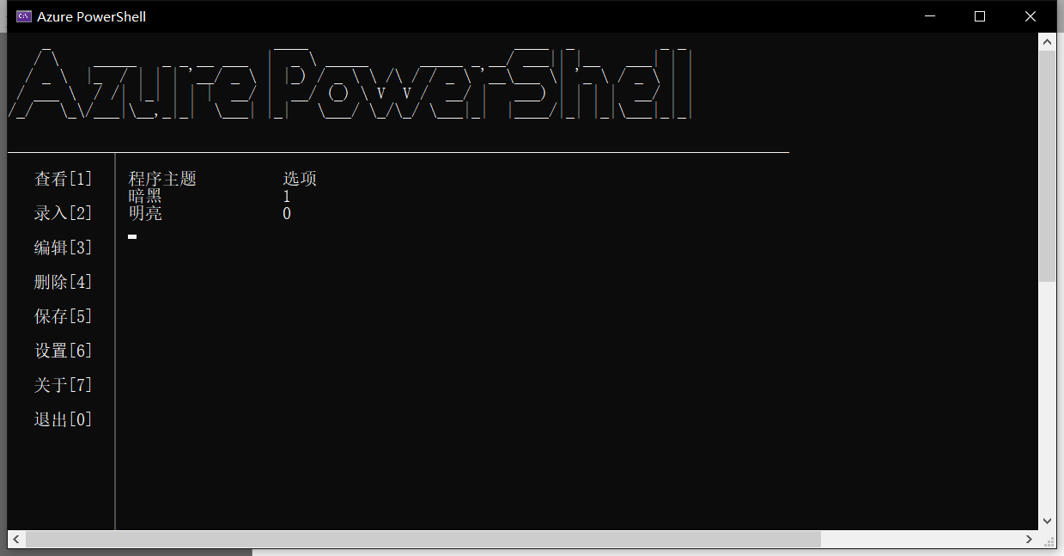
程序提供了切换主题的功能，重启程序会恢复至暗黑主题：
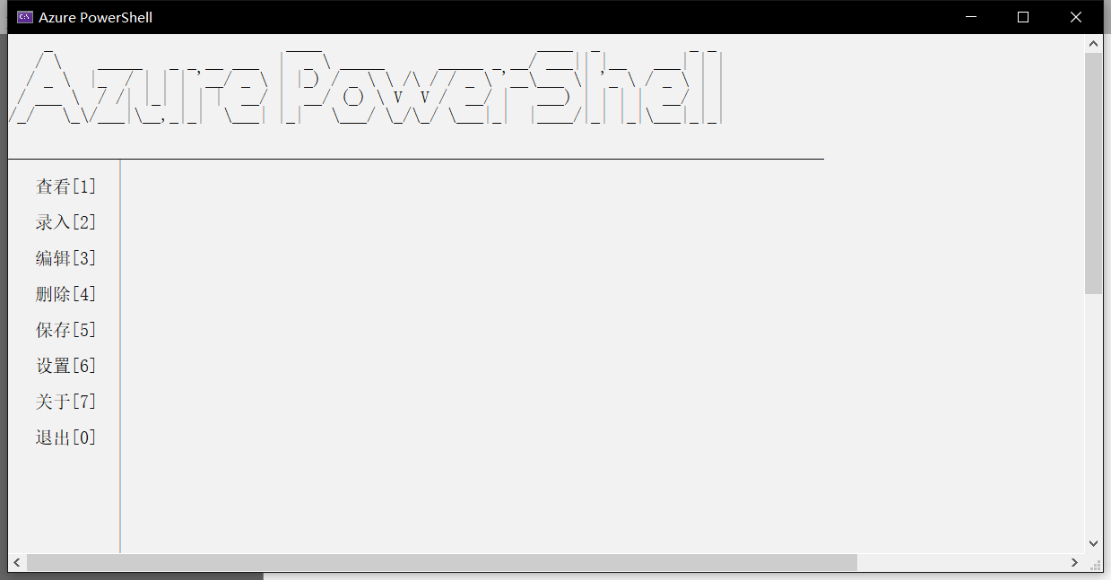
- 关于
主要是程序的相关信息，以及源代码仓库的地址：
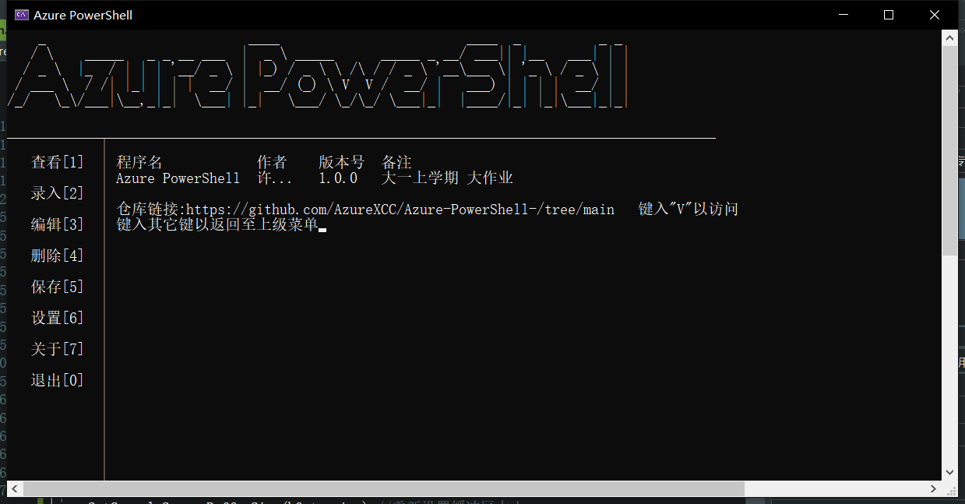
- 退出
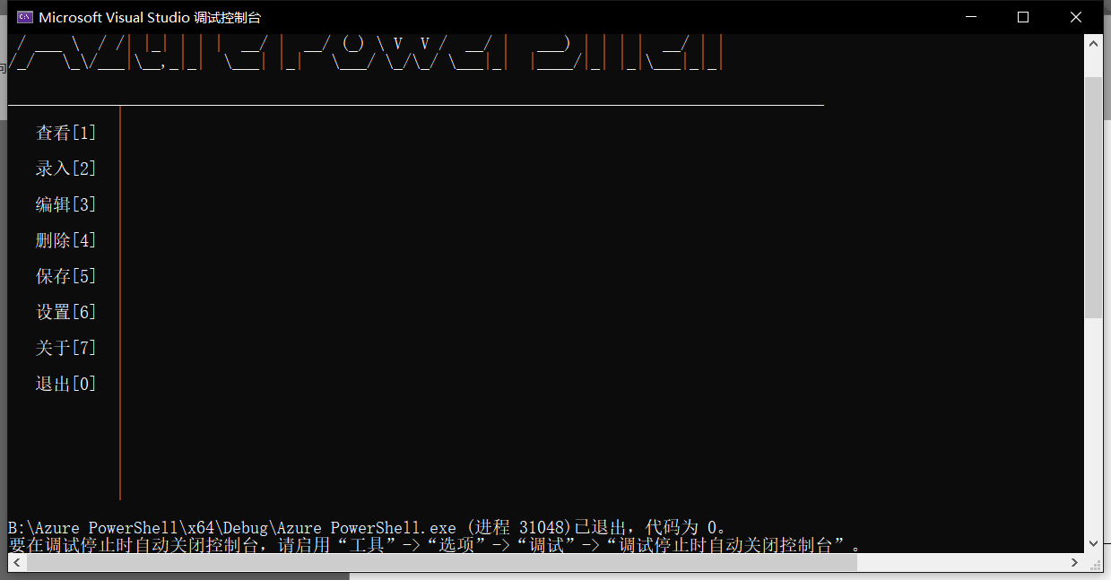

项目结构
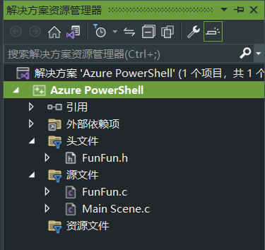
环境：Visual Studio 2022

代码
仓库地址：AzureXCC/Azure-PowerShell- (github.com)
Main Scene.c
#include <stdio.h>
#include "FunFun.h"

int main(int argc, char const* argv[])
{
Load();//创建头结点并读取存档
DisplayMenu();//显示界面并调用指令枢纽

return 0;
}

FunFun.h
#pragma once
#include <stdio.h>

typedef struct Student
{
char name[16], major[32];
int sex, age;
long int ID;

float Chinese, Math, English;

struct Student* next;
}Stu;

void Load();
void CursorJump(int x, int y);
int DisplayMenu();
int DisplayMenu_noHub();
void InstructionHub();
void LoadData();
//Stu * CreateHeadNode();
Stu * CreateNode(Stu* head, char nameT[16], char majorT[32], int sexT, int ageT, long int ID_t,float chi,float mat,float eng);
int Input();
int AddPerson();
void View(Stu* head);
void Edit(Stu* head);
void Delete(Stu* head);
void About();
void Setting();
void Save(Stu* head);
void SetSize_window(int w, int h);
FunFun.c
#pragma warning(disable:4996)
#include <stdio.h>
#include <conio.h>
#include <Windows.h>
#include <stdlib.h>
#include "FunFun.h"

#define SOP(str) printf("********* %s ********* 键入任意键以继续......",str);getch();

int nodeCount = 0,color = 1;
Stu* headNode;

void CursorJump(int x, int y)
{
COORD pos;
pos.X = x;
pos.Y = y;
HANDLE handle = GetStdHandle(STD_OUTPUT_HANDLE);
SetConsoleCursorPosition(handle, pos);
}
void LoadData() {
headNode = (Stu*)malloc(sizeof(Stu));
headNode->next = NULL;

char sex[4], age[4];
char ID[20];

//读取数据
FILE* fp = fopen("DATA\\NodeCount.txt", "r");
fscanf(fp, "%d", &nodeCount);
int n = nodeCount;
nodeCount = 0;

for (int i = 0; i < n; i++)
{
CreateNode(headNode, " ", " ", -1, -1, -1,-1,-1,-1);
}
if (n > 0) {
fp = fopen("DATA\\Inf.txt", "r");
Stu* p = headNode->next;
while (p!=NULL)
{
fscanf(fp, "%s %s %d %d %ld %f %f %f ", p->name, p->major, &p->sex, &p->age, &p->ID,&p->Chinese,&p->Math,&p->English);
p = p->next;
}
}
printf("■■■■■■■■■■■■■■■■■■■■■■■■■■■■■■■■■■■■■■■■■■■■■■■\n");
SOP("读取数据成功!");

DisplayMenu();
}

void Load() {
SetSize_window(150, 60);
system("title Azure PowerShell");
Beep(523, 500);
LoadData();
}
int DisplayMenu() {
system("cls");
if(color == 1)
system("color 0F");
else {
system("color F0");
}
printf(
" _ ____ ____ _ _ _\n"
" / \\ _____ _ _ __ ___ | _ \\ _____ _____ _ __/ ___|| |__ ___| | |\n"
" / _ \\ |_ / | | | '__/ _ \\ | |_) / _ \\ \\ /\\ / / _ \\ '__\\___ \\| '_ \\ / _ \\ | |\n"
" / ___ \\ / /| |_| | | | __/ | __/ (_) \\ V V / __/ | ___) | | | | __/ | |\n"
"/_/ \\_\\/___|\\__,_|_| \\___| |_| \\___/ \\_/\\_/ \\___|_| |____/|_| |_|\\___|_|_|\n"
" \n"
);
printf("___________________________________________________________________________________________\n");

printf("%*s", 14, "|\n");
printf("%*s", 14, "查看[1] |\n");
printf("%*s", 14, "|\n");

printf("%*s", 14, "录入[2] |\n");
printf("%*s", 14, "|\n");

printf("%*s", 14, "编辑[3] |\n");
printf("%*s", 14, "|\n");

printf("%*s", 14, "删除[4] |\n");
printf("%*s", 14, "|\n");

printf("%*s", 14, "保存[5] |\n");
printf("%*s", 14, "|\n");

printf("%*s", 14, "设置[6] |\n");
printf("%*s", 14, "|\n");

printf("%*s", 14, "关于[7] |\n");
printf("%*s", 14, "|\n");

printf("%*s", 14, "退出[0] |\n");
printf("%*s", 14, "|\n");
printf("%*s", 14, "|\n");
printf("%*s", 14, "|\n");
printf("%*s", 14, "|\n");
printf("%*s", 14, "|\n");
printf("%*s", 14, "|\n");

InstructionHub();

}
int DisplayMenu_noHub() {
system("cls");
if (color == 1)
system("color 0F");
else {
system("color F0");
}
printf(
" _ ____ ____ _ _ _\n"
" / \\ _____ _ _ __ ___ | _ \\ _____ _____ _ __/ ___|| |__ ___| | |\n"
" / _ \\ |_ / | | | '__/ _ \\ | |_) / _ \\ \\ /\\ / / _ \\ '__\\___ \\| '_ \\ / _ \\ | |\n"
" / ___ \\ / /| |_| | | | __/ | __/ (_) \\ V V / __/ | ___) | | | | __/ | |\n"
"/_/ \\_\\/___|\\__,_|_| \\___| |_| \\___/ \\_/\\_/ \\___|_| |____/|_| |_|\\___|_|_|\n"
" \n"
);
printf("___________________________________________________________________________________________\n");

printf("%*s", 14, "|\n");
printf("%*s", 14, "查看[1] |\n");
printf("%*s", 14, "|\n");

printf("%*s", 14, "录入[2] |\n");
printf("%*s", 14, "|\n");

printf("%*s", 14, "编辑[3] |\n");
printf("%*s", 14, "|\n");

printf("%*s", 14, "删除[4] |\n");
printf("%*s", 14, "|\n");

printf("%*s", 14, "保存[5] |\n");
printf("%*s", 14, "|\n");

printf("%*s", 14, "设置[6] |\n");
printf("%*s", 14, "|\n");

printf("%*s", 14, "关于[7] |\n");
printf("%*s", 14, "|\n");

printf("%*s", 14, "退出[0] |\n");
printf("%*s", 14, "|\n");
printf("%*s", 14, "|\n");
printf("%*s", 14, "|\n");
printf("%*s", 14, "|\n");
printf("%*s", 14, "|\n");
printf("%*s", 14, "|\n");

//InstructionHub();

}

//int test() {
// CursorJump(14,8);
// printf("123\n");
// printf("123\n");
// getchar();
//}

void SetSize_window(int w, int h)
{
HANDLE hOut = GetStdHandle(STD_OUTPUT_HANDLE);//获取标准输出的句柄
COORD size = { w, h };//设置窗口的大小。
SetConsoleScreenBufferSize(hOut, size);//重新设置缓冲区大小。
SMALL_RECT rc = { 1,1, w, h };//重置窗口位置和大小。
SetConsoleWindowInfo(hOut, TRUE, &rc);//重置窗口大小
system("cls");//清理屏幕
}
Stu* CreateNode(Stu* head, char nameT[16], char majorT[32], int sexT, int ageT, long int ID_t, float chi, float mat, float eng) {
Stu* p = head;
while (p->next!=NULL)
{
p = p->next;
}
Stu* newNode = (Stu*)malloc(sizeof(Stu)); nodeCount++;
p->next = newNode;
strcpy(newNode->name, nameT);
strcpy(newNode->major, majorT);
newNode->sex = sexT;
newNode->age = ageT;
newNode->ID = ID_t;
newNode->Chinese = chi;
newNode->Math = mat;
newNode->English = eng;
newNode->next = NULL;

/*printf(" 1 1 1 1 1 %s %s %d %d %ld", newNode->name,newNode->major,newNode->sex, newNode->age,newNode->ID);
getch();*/

}
int Input() {
char nameT[16]; char majorT[32]; int sexT = 0; int ageT = 0; long int ID_t = 0;
float chi = 0, mat = 0, eng = 0;

printf("输入样例:XiaoXi CS 0(0:MAN 1:FEMAIL OTHER:OTHER) 17 2234110507 89 101 90\\n 输入:");
scanf("%s%s%d%d%ld%f%f%f", nameT,majorT,&sexT,&ageT,&ID_t,&chi,&mat,&eng);
CreateNode(headNode, nameT, majorT, sexT, ageT, ID_t,chi,mat,eng);

return 0;
}
int AddPerson() {
int n = 0;

CursorJump(14, 8);
printf("数量:");
scanf("%d", &n);

if (n > 0) {
DisplayMenu_noHub();
for (int i = 0; i < n; i++)
{
CursorJump(14, 8+i);
Input();
}
DisplayMenu_noHub();
CursorJump(14, 8);
SOP("录入完毕!");

DisplayMenu();
}
else
{
CursorJump(14, 8);
SOP("数值错误!");
DisplayMenu();
}
}

void View(Stu* head) {
int n = 0;
CursorJump(14, 8);
printf("1:根据学号进行查询并显示 0:显示所有 10:正排序 11:逆排序 输入:");
scanf("%d", &n);

if (n==1) {
CursorJump(14, 9);
printf("目标学号:");
long int target = 0;
scanf("%ld", &target);

DisplayMenu_noHub();
Stu* p = head->next;
while (p!=NULL)
{
if (p->ID == target) {
CursorJump(14, 10);
printf("Name\tMajor\tsex\tage\tID\tChinese\tMath\tEnglish\tSum\tAver\t");
CursorJump(14, 11);
printf("%s\t%s\t", p->name, p->major);
switch (p->sex)
{
case 0:printf("男\t"); break;
case 1:printf("女\t"); break;
default:printf("Other\t"); break;
}
float sum = p->Chinese + p->Math + p->English, aver = sum / 3.0;
printf("%d\t%ld\t%.1f\t%.1f\t%.1f\t%.1f\t%.1f\t", p->age, p->ID, p->Chinese, p->Math, p->English, sum, aver);

CursorJump(14, 12);
SOP("查询结束!");
DisplayMenu();
}
else {
p = p->next;
}
}
CursorJump(14, 12);
SOP("查询结束!没有寻找到目标人员!");
DisplayMenu();
}
else if (n == 10) {
//选择排序
Stu* p1 = head->next;
Stu* p2 = p1->next;

while (p1!=NULL)
{
while (p2 != NULL) {
float p1_sum = p1->Chinese + p1->Math + p1->English;
float p2_sum = p2->Chinese + p2->Math + p2->English;
if (p1_sum > p2_sum) {
//临时变量
char name[16], major[32];
int sex = 0, age = 0;
long int ID = 0;
float Chinese = 0, Math = 0, English = 0;

strcpy(name, p1->name);
strcpy(major, p1->major);
sex = p1->sex;
age = p1->age;
ID = p1->ID;
Chinese = p1->Chinese;
Math = p1->Math;
English = p1->English;

strcpy(p1->name, p2->name);
strcpy(p1->major, p2->major);
p1->sex = p2->sex;
p1->age = p2->age;
p1->ID = p2->ID;
p1->Chinese = p2->Chinese;
p1->Math = p2->Math;
p1->English = p2->English;

strcpy(p2->name, name);
strcpy(p2->major, major);
p2->sex = sex;
p2->age = age;
p2->ID = ID;
p2->Chinese = Chinese;
p2->Math = Math;
p2->English = English;
}

p2 = p2->next;
}
p1 = p1->next;
if (p1 != NULL)
p2 = p1->next;
}
CursorJump(14, 12);
SOP("排序结束!");
DisplayMenu();
}
else if (n == 11) {
//选择排序
Stu* p1 = head->next;
Stu* p2 = p1->next;

while (p1 != NULL)
{
while (p2 != NULL) {
float p1_sum = p1->Chinese + p1->Math + p1->English;
float p2_sum = p2->Chinese + p2->Math + p2->English;
if (p1_sum < p2_sum) {
//临时变量
char name[16], major[32];
int sex = 0, age = 0;
long int ID = 0;
float Chinese = 0, Math = 0, English = 0;

strcpy(name, p1->name);
strcpy(major, p1->major);
sex = p1->sex;
age = p1->age;
ID = p1->ID;
Chinese = p1->Chinese;
Math = p1->Math;
English = p1->English;

strcpy(p1->name, p2->name);
strcpy(p1->major, p2->major);
p1->sex = p2->sex;
p1->age = p2->age;
p1->ID = p2->ID;
p1->Chinese = p2->Chinese;
p1->Math = p2->Math;
p1->English = p2->English;

strcpy(p2->name, name);
strcpy(p2->major, major);
p2->sex = sex;
p2->age = age;
p2->ID = ID;
p2->Chinese = Chinese;
p2->Math = Math;
p2->English = English;
}

p2 = p2->next;
}
p1 = p1->next;
if (p1 != NULL)
p2 = p1->next;
}
CursorJump(14, 12);
SOP("排序结束!");
DisplayMenu();
}else
{
DisplayMenu_noHub();

int i = 0;
if (head->next != NULL) {
Stu* p = head->next;

CursorJump(14, 8);
printf("Name\tMajor\tsex\tage\tID\tChinese\tMath\tEnglish\tSum\tAver\t");
while (p != NULL)
{
CursorJump(14, 9 + i);
i++;
printf("%s\t%s\t", p->name, p->major);
switch (p->sex)
{
case 0:printf("男\t"); break;
case 1:printf("女\t"); break;
default:printf("Other\t"); break;
}
float sum = p->Chinese + p->Math + p->English, aver = sum / 3.0;

printf("%d\t%ld\t%.1f\t%.1f\t%.1f\t%.1f\t%.1f\t", p->age, p->ID, p->Chinese, p->Math, p->English, sum, aver);
p = p->next;
}
}
else {
CursorJump(14, 8);
SOP("无数据!");
DisplayMenu();
}
CursorJump(14, 9 + i);
SOP("输出完毕!");
DisplayMenu();
}
}

void Edit(Stu* head) {
int n = 0;
Stu* p = head;
CursorJump(14, 8);
printf("目前共有%d名人员，请输入编号以进行编辑:", nodeCount);
scanf("%d", &n);
if (n > 0 && n <= nodeCount) {
for (int i = 0; i < n; i++)
{
p = p->next;
}
CursorJump(14, 9);
printf("原始数据:%s %s %d %d %ld %f %f %f 新数据:", p->name, p->major, p->sex, p->age, p->ID,p->Chinese,p->Math,p->English);
scanf("%s%s%d%d%ld%f%f%f", p->name, p->major, &p->sex, &p->age, &p->ID, &p->Chinese, &p->Math, &p->English);
CursorJump(14, 10);
SOP("数据编辑成功!");
DisplayMenu();
}
else
{
CursorJump(14, 10);
SOP("数据编辑失败!非法编号!");
DisplayMenu();
}

}

void Delete(Stu* head) {
int n = 0;
Stu* p = head;
CursorJump(14, 8);
printf("目前共有%d名人员，请输入编号以删除:", nodeCount);
scanf("%d", &n);
for (int i = 0; i < n-1; i++)
{
p = p->next;
}
Stu* del = p->next;
p->next = del->next;
free(del);
nodeCount--;
CursorJump(14, 9);
SOP("数据删除成功!");
DisplayMenu();

}
void About() {
CursorJump(14, 8);
printf("程序名\t\t作者\t版本号\t备注\t");
CursorJump(14, 9);
printf("Azure PowerShell\t许...\t1.0.0\t大一上学期 大作业\t");
CursorJump(14, 11);
printf("仓库链接:%s 键入\"V\"以访问","https://github.com/AzureXCC/Azure-PowerShell-/tree/main");
CursorJump(14, 12);
printf("键入其它键以返回至上级菜单");
char ch = getch();
if (ch == 'V'||ch =='v') {
system("start https://github.com/AzureXCC/Azure-PowerShell-/tree/main");
DisplayMenu();
}
else {
DisplayMenu();
}

}
void Setting() {
CursorJump(14, 8);
printf("程序主题\t\t选项\t\t");
CursorJump(14, 9);
printf("暗黑\t\t1\t\t");
CursorJump(14, 10);
printf("明亮\t\t0\t\t");
CursorJump(14, 11);
scanf("%d", &color);

CursorJump(14, 12);
SOP("颜色主题变更成功!");
DisplayMenu();
}
void Save(Stu* head) {
Stu* p = head->next;
FILE* fp = fopen("DATA\\Inf.txt","w");
char nodeCountArr[20];

while (p!=NULL)
{
fprintf(fp, "%s %s %d %d %ld %f %f %f ", p->name, p->major, p->sex, p->age, p->ID,p->Chinese,p->Math,p->English);

p = p->next;
}

//写入人数
remove("DATA\\NodeCount.txt");
fp = fopen("DATA\\NodeCount.txt", "w");
fprintf(fp,"%d",nodeCount);

CursorJump(14, 8);
SOP("写入数据成功!");
DisplayMenu();
}
void InstructionHub() {
char ch = getch();
switch (ch)
{
case '1':View(headNode); break;
case '2':AddPerson(); break;
case '3':Edit(headNode); break;
case '4':Delete(headNode); break;
case '5':Save(headNode); break;
case '6':Setting(); break;
case '7':About(); break;
case '0':exit(0); break;
default:DisplayMenu(); break;
}
}

测试
运行结果与预期相符，测试通过。

小结
增强了对链表与文件读写的理解，并对过往知识点进行了整体性的回顾。程序为多文件结构，使项目结构更加整洁与易读，代码间的逻辑复用较合理，在可读性与复用性之间作了权衡。整体为高耦合与低内聚性状，体现出了程序之禅。

