Step 1:

Put all the excel files you want to merge to a folder

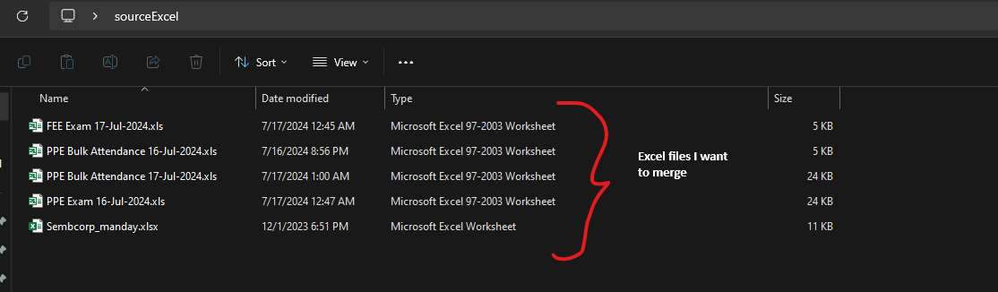

Step 2:

Create a new folder to put your merged file



Step 3:

Copy the file path of the folder which contains the files you want to merge to somewhere else(notepad/word)



Step 4:

Copy the file path of the folder which the merged excel file will appear to somewhere else(notepad/word)



Step 5:

Unzip the **MergeSingleSheetExcelsTool.zip**

Step 6:

Run the **MergeSingleSheetExcelsTool.exe**

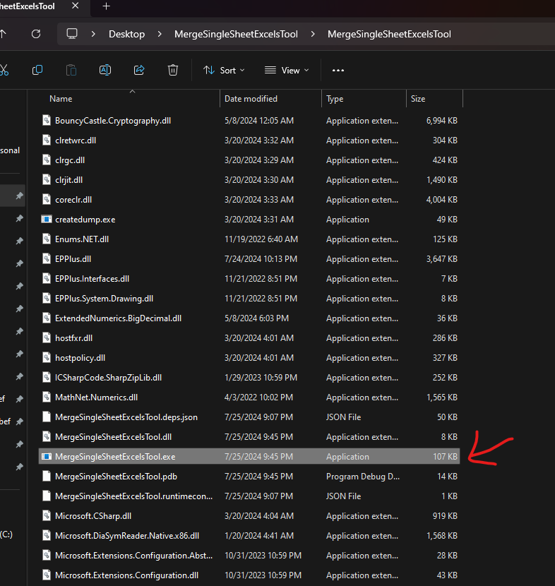

Step 7:

Paste the path you copy at step 3 and press Enter



Step 8:

Paste the path you copy at step 4 and press Enter



Step 9:

Input the file name you want the merged file call and press Enter



**\*\***Take note that **MUST** include **.xlsx** or **.xls** behind, see example

Step 10:

Check the folder you create in step 2. The merged file should be there.

