EVENT

MANAGER

APPLICATION

**By**

**RACHIT SHAH**

**14BCE110**

**SHRIDHAR SHAH**

**14BCE111**



**DEPARTMENT OF COMPUTER ENGINEERING**

**Ahmedabad 382481**

**EVENT MANAGER APP**

**Mini Project - II**

Submitted in fulfillment of the requirements

For the degree, of

**Bachelor of Technology in Computer Engineering**

**By**

**RACHIT SHAH**

**14BCE110**

**SHRIDHAR SHAH**

**14BCE111**

Guided By

**PROF. AJAY PATEL**

**[DEPARTMENT OF COMPUTER ENGINEERING]**



**DEPARTMENT OF COMPUTER ENGINEERING**

**Ahmedabad 382481**

CERTIFICATE

This is to certify that the project entitled “EVENT MANAGER APP” submitted by RACHIT SHAH(14BCE110) and SHRIDHAR SHAH(14BCE111), towards the partial fulfillment of the requirements for the degree of Bachelor of Technology inComputer Engineering of Nirma University is the record of work carried out by him under my supervision and guidance. In my opinion, the submitted work has reached a level required for being accepted for examination.

Prof. Ajay Patel Dr. Sanjay Garg

[Assistant Professor] Dept. of Computer Engg.,

Department of Computer Engg., Institute of Technology,

Institute of Technology, Nirma University,

Nirma University, Ahmedabad

Ahmedabad

**ACKNOWLEDGEMENT**

The Mini Project: “EVENT MANAGER APP” was well guided byProf. Ajay Patel I am highly thankful to our guide for their constant effort to bring correction and make our project successful. I need to welcome the idea of introducing this course which has enhanced my skills to consider real life problem into account on account of their thought and advancement.

**ABSTRACT**

Our Mini project i.e. Event Manager App is developed in Android platform with SQL database connectivity and storing the events for particular events such as meetings, birthday, anniversary, etc.

# Contents

Certificate

Acknowledgement

Abstract

Table of Contents

1) Introduction: 1

1) About Event Manager App 1

2) Programming Environment 1

2) Literature survey: 2

1) Use of Event Manager App 2

2) Android Database Connectivity-SQLite 2

3) Details of project: 3

1) Android graphics 3

2) Sqlite database 5

3) Alarm 6

4) User registration 7

4) Summary and Conclusion: 9

1) Summary 9

2) Conclusion 9

References 10

# 1) Introduction:

## 1) About Event Manager App

Event manager app is used to store the events using fragments along with the user validation and stores various events such as birthday, anniversary, etc.

It is used as reminder of events using alarm feature. Occasion director application for the Android OS that accomplishes more than go about as a schedule administrator.

Each gathering has various clients and every client can make occasions that will be unmistakable to individuals from the gathering

## 2) Programming Environment

Event manager is made in android programming environment which includes making design of android app in xml and java to control the actions along with the SQLite database.

Use of android studio to create the app properly.

Why Android?

• Simple and effective SDK, no authorizing charges and a flourishing designer group.

• Offers a great endeavor stage by utilizing a famous undertaking programming dialect, for example, Javas.

# 2) Literature survey:

## 1) Use of Event Manager App

First we have to add the events such as birthday, meeting, pay bills, etc. with the details of event along with the time of the event for which we have to run the scheduler.

The events are added in the SQLite database and shown in my-events page.

The principle thought for building up app in light of android application which will keep up information of all occasions held in the school.

This android application helps the headliner co-originator/administrator to timetable undertakings and speak with them adequately.

The occasion supervisor can make utilization of telling cautions about specific undertakings or work routine to key volunteers of the occasions so more individuals can get to the important data effortlessly.

## 2) Android Database Connectivity-SQLite

Here first the database is created using the following code: The tables are created such as events, name of event, type, details.

SQLite is an Open Source database. SQLite underpins standard social database highlights like SQL sentence structure, exchanges and arranged proclamations. The database requires restricted memory at runtime (approx. 250 Kbyte) which makes it a decent applicant from being inserted into different runtimes.

SQLite underpins the information sorts TEXT (like String in Java), INTEGER (like long in Java) and REAL (like twofold in Java). Every other sort must be changed over into one of these fields before getting spared in the database. SQLite itself does not approve if the sorts kept in touch with the segments are really of the characterized sort, e.g. you can compose a whole number into a string section and the other way around.

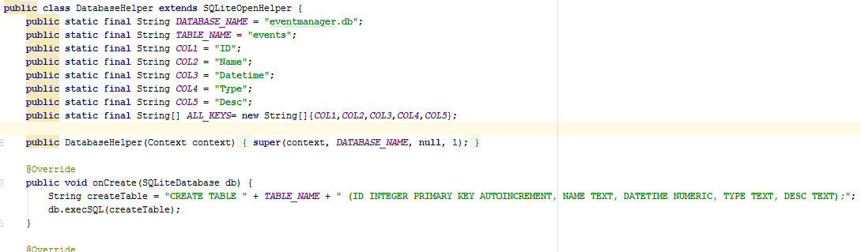

# 3) Details of project:

## 1) Android graphics

* Fragments are used to have effective sliding windows for adding new events, showing events and showing calendar.
* To have nice GUI design and is faster compared to visiting events by clicking button.

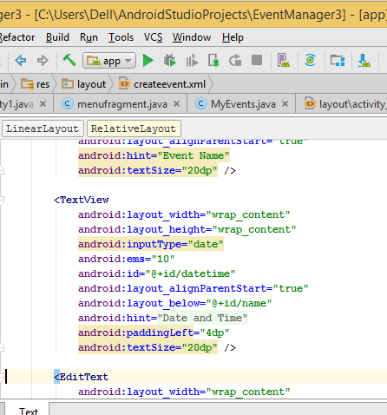

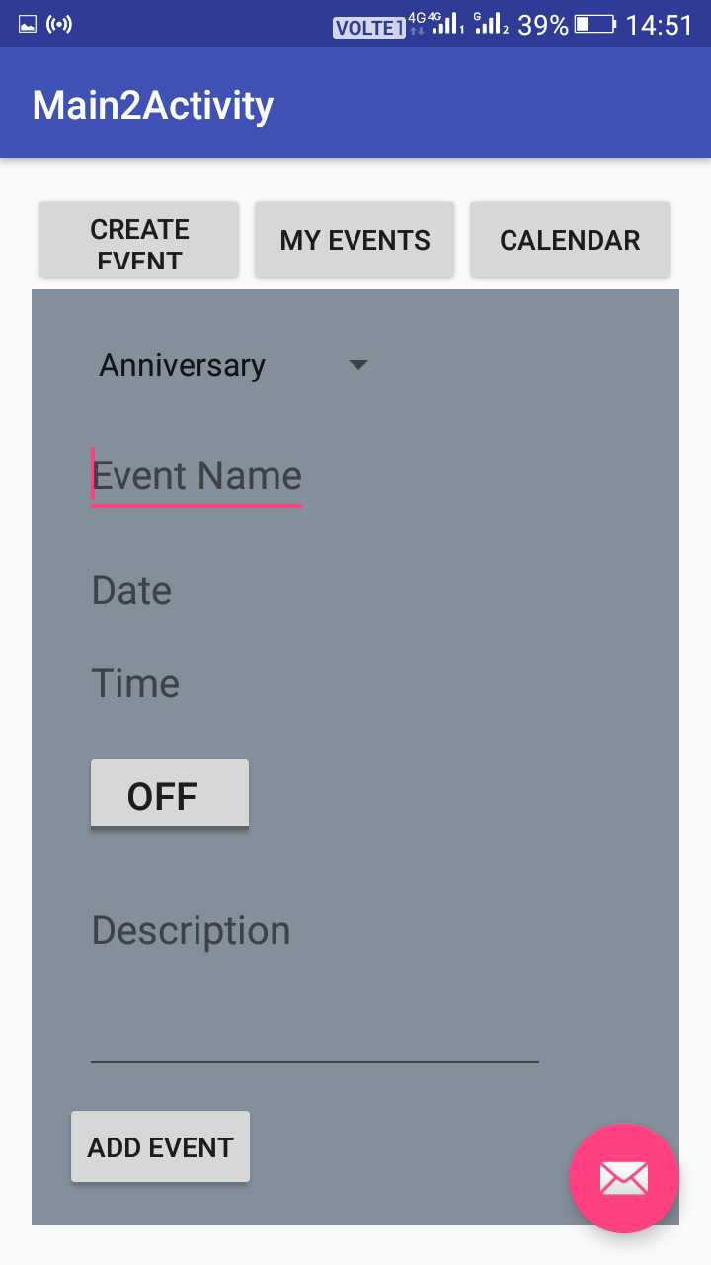

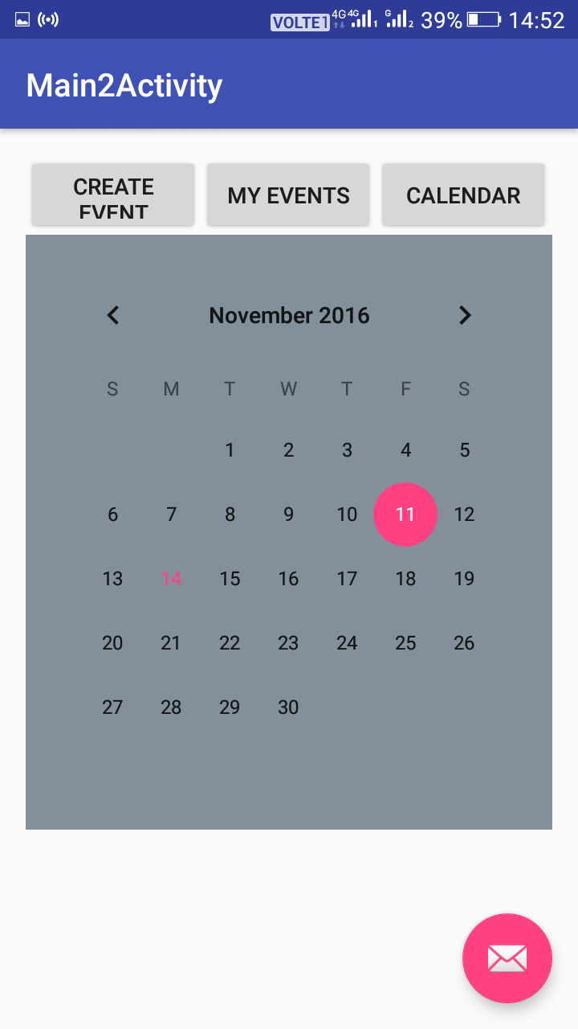

## 2) Sqlite database

The tables are created such as events ,name of event,type,details.The fragment of the my events is shown here which displays the stored event.

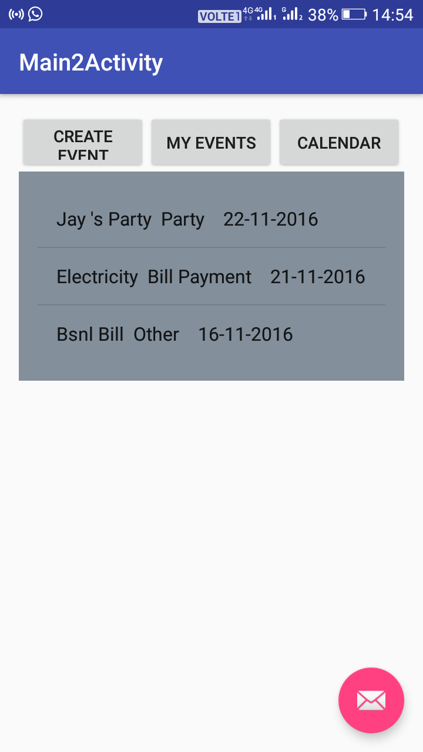

## 3) Alarm

Here in adding of events there is a provision for storing alarm along with the date and event type. Alarms (in light of the AlarmManager class) give you an approach to perform time-based operations outside the lifetime of your application.

For instance, you could utilize a caution to start a long-running operation, for example, beginning an administration once every day to download a climate conjecture.



## 4) User registration

User authentication is done in the app to provide security. Here the password is to be of minimum 8 characters and username must be of minimum 3 characters using regular expression.

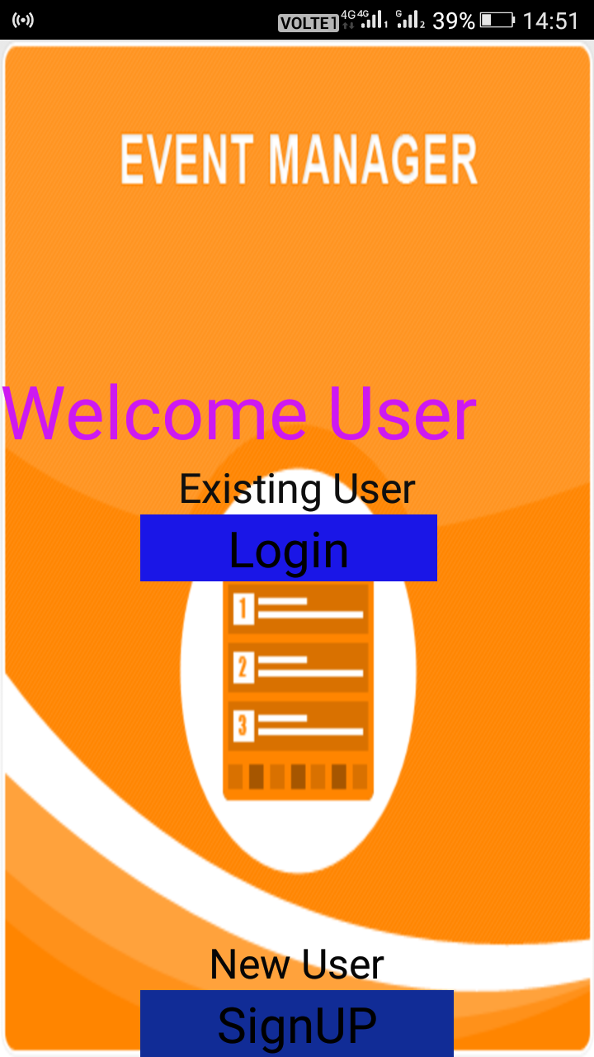

# 4) Summary and Conclusion:

## 1) Summary

Features in Event Manager App.

Android graphics using xml.

Sqlite android databse.

Alarm manager.

Login and signup.

## 2) Conclusion

From the project given to us we are able to understand the real life problem in time management. This type of software can help reduce such tiresome job of remembering things and maintaining our meetings. We are able to understand the proper software testing by this project. We are able to make our android app with its wonderful features as it is the most common platform for our daily purpose.

# References

|  |  |
| --- | --- |
| [1] | "All Android Topics - StackOverFlow," 10 09 2016. [Online]. Available: http://stackoverflow.com/documentation/android/topics. |
| [2] | "Android App Development," 5 10 2016. [Online]. Available: https://thenewboston.com/videos.php?cat=278. |
| [3] | "Develop Apps," 10 10 2016. [Online]. Available: https://developer.android.com/develop/index.html. |