
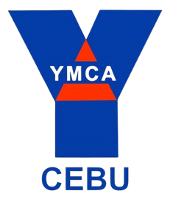
CERTIFICATE
OF COMPLETION
This certificate is given to
{{FullName}}
For completing his/her {{Hours}} hours work immersion on {{Date}} at YMCA of Cebu, Inc.

CHRISTOPHER L. CUDERA
OIC - GENERAL SECRETARY YMCA OF CEBU, INC

