LAB CBT CENTER 2
Merk/Seri | H81M-DS2
Processor | I5-4590
CPU Core | 4
CPU Thread | 4
Tipe Hardisk | SSD
Kapasitas Hardisk (GB) | 256GB
RAM (GB) | 8GB
Kecepatan LAN Card Ethernet/Kabel | 1GBPS
Sistem Operasi | Windows 10 Pro
Screenshot DxDiag | 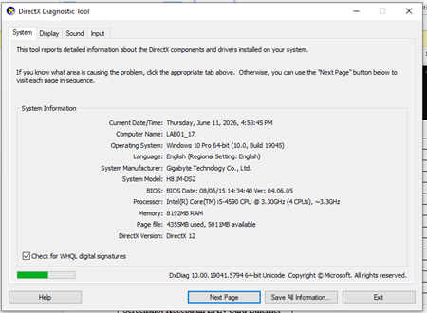
Screenshot CPU Core & Thread | 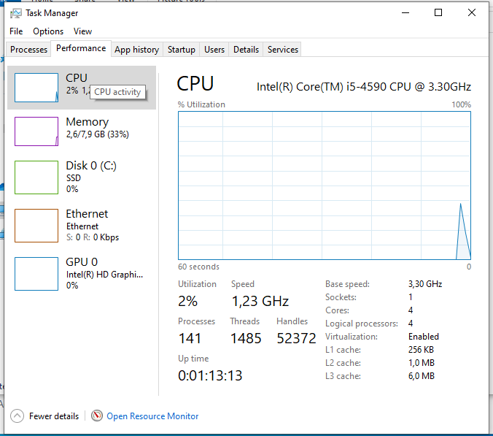
Screenshot Tipe & Kapasitas Hardisk | 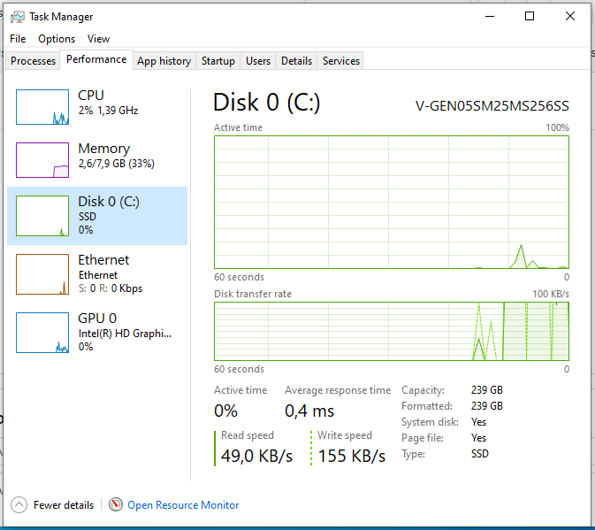
Screenshot Kecepatan LAN Card Ethernet | 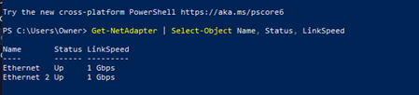

LAB CBT CENTER 1
Jenis Komputer | Rakitan
Merk/Seri | H81M-DS2
Processor | I7-4770
CPU Core | 4
CPU Thread | 8
Tipe Hardisk | SSD
Kapasitas Hardisk (GB) | 480GB
RAM (GB) | 8GB
Kecepatan LAN Card Ethernet/Kabel | 1GBPS
Sistem Operasi | Windows 10 Pro
Screenshot DxDiag | 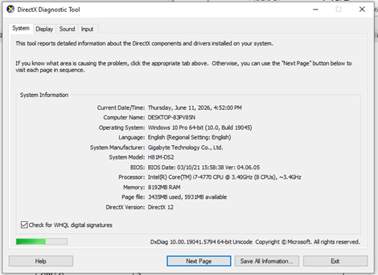
Screenshot CPU Core & Thread | 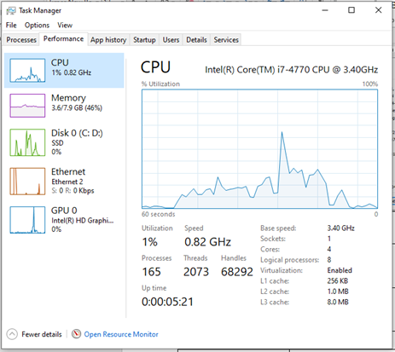
Screenshot Tipe & Kapasitas Hardisk | 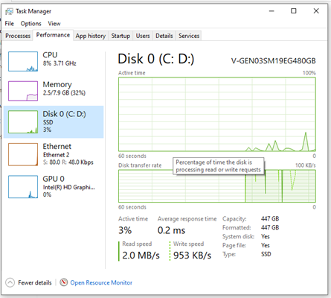
Screenshot Kecepatan LAN Card Ethernet | 