**Project Submission**

**Course Title: Management Information Systems**

**Course Code: MIS 442**

**Section:**

**Project Title: McKesson’s Database Management**

**Company Name: McKesson**

**Submitted By:**

|  |  |  |  |  |
| --- | --- | --- | --- | --- |
| **Sl. No** | **Student ID** | **Student Name** | **Position** | **Marks** |
| 1 | 2020877 | Iram Ahmed Dhrubo | Group Leader |  |
| 2 | 2022335 | Anika Tabassum | Member |  |
| 3 | 2020222 | Azwad Fawad Hasan | Member |  |
| 4 | 1731090 | Ragib Anjum Ruhin | Member |  |

**Submitted To:**

**Md. Aminul Islam, CSCA**

Lecturer

Department of Management Information Systems (MIS)

School of Business and Entrepreneurship (SBE)

Independent University, Bangladesh

**Date of Submission: August 09, 2022 at 9.00 PM**

**Description of Tables**

* **Branch:**

This table contains information about the branches of McKesson.

The entities in this table are: Branch_ID, Branch_Address, Phone_Number, Branch_Head_Name, Branch_Head_ID, Inventory_ID, No_of_employee, Opening_Time, Closing_Time and No_of_product.

The primary key of this table is Branch_ID. The secondary key of this table is Inventory_ID.

* **Customer:**

This table contains information about the customers (such as hospitals and medical centers) of McKesson.

The entities in this table are: Customer_ID, Customer_Name, Customer_Phone_Number, Customer_Address, Branch_ID and Customer_Email.

The primary key of this table is Customer_ID. The secondary key of this table is Branch_ID.

* **Employee:**

This table contains information about the employees that work in McKesson.

The entities in this table are: Employee_ID, Employee_Name, Employee_Phone_Number, Employee_Gender, Employee_Age, Employee_Email, Branch_ID, Employee_Salary and Employee_Address.

The primary key of this table is Employee_ID. The secondary key of this table is Branch_ID.

* **Inventory:**

This table contains information about the inventory of McKesson.

The entities in this table are: Inventory_ID, Product_ID, Product_Quantity, Product_Remaining and Availability.

The primary key of this table is Inventory_ID. The secondary key of this table is Product_ID.

* **OrderTable:**

This table contains the order history of McKesson.

The entities in this table are: Order_ID, Customer_ID, Customer_Name, Customer_Address, Hotline, Product_ID, Branch_ID, No_of_Product_Purchased and Total_Amount.

The primary key of this table is Order_ID. The secondary key of this table are Customer_ID, Product_ID and Branch_ID.

* **Product:**

This table contains information about the products of McKesson.

The entities in this table are: Product_ID, Product_Name, Product_Quantity, Per_Product_Price and Inventory_ID.

The primary key of this table is Product_ID. The secondary key of this table is Inventory_ID.

**Entity Relationship Diagram(ERD)**

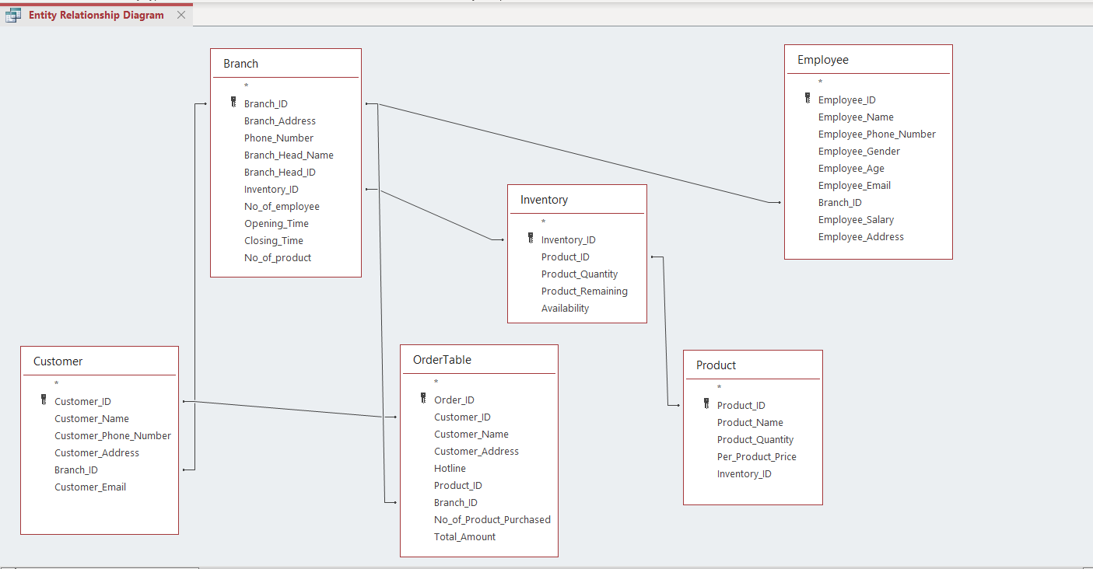

**QUESTIONS**

1. **Find the lowest per product price.**

SQL Code:

SELECT min(per_product_price)

FROM Product

OUTPUT:

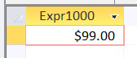

1. **List the product name and ID of products whose quantity is less than 60.**

SQL Code:

SELECT product_name, product_Id

FROM Product

WHERE product_quantity<60

OUTPUT:

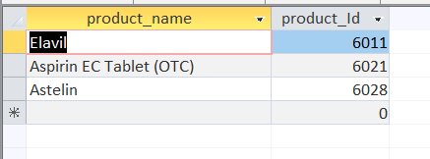

1. **What is the average per product price?**

SQL Code:

SELECT avg(per_product_price)

FROM Product

OUTPUT:

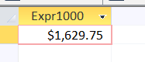

1. **Find the ratio of max product price with min product price.**

SQL Code:

SELECT max(per_product_price)/min(per_product_price)

FROM Product

OUTPUT:

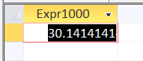

1. **What is the name of product and price of product whose product Id is 6023?**

SQL Code:

SELECT product_name, per_product_price

FROM Product

WHERE product_Id = 6023

OUTPUT:

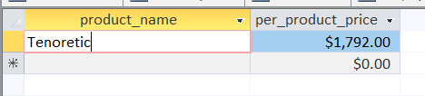

1. **How many customers did not provide their email address?**

SQL Code:

SELECT count(customer_Id)

FROM Customer

WHERE customer_email is NULL

OUTPUT:

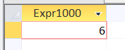

1. **Show the name and email of employees who are Male and they are below age 30.**

SQL Code:

SELECT employee_name, employee_email

FROM Employee

WHERE employee_gender = "Male" AND employee_age<30

OUTPUT:

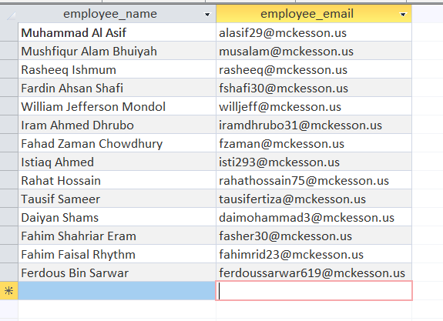

1. **Show the Opening time and Closing time of the branches along with the branch ID who has number of products greater than or equal to 700.**

SQL Code:

SELECT opening_time, closing_time, branch_Id

FROM Branch

WHERE no_of_product>=700

OUTPUT:

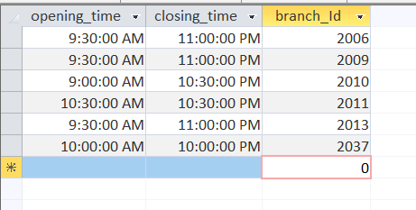

1. **Show the entire Branch Table.**

SQL Code:

SELECT *

FROM Branch

OUTPUT:

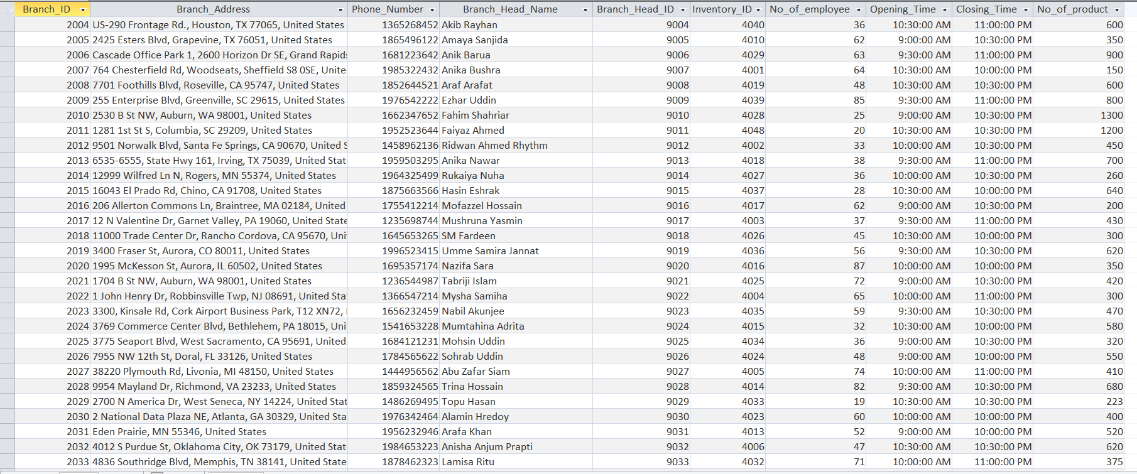

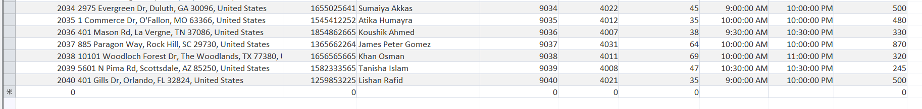

1. **Show the name of customer who ordered maximum number of product.**

SQL Code:

SELECT customer_name

FROM ordertable

WHERE no_of_product_purchased = (SELECT max(no_of_product_purchased)

FROM ordertable)

OUTPUT:

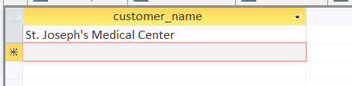

1. **Determine if the product of product ID 6016 is available in the inventory, and if it is, then how many?**

SQL Code:

SELECT availability, product_remaining

FROM Inventory

WHERE product_Id = 6016

OUTPUT:

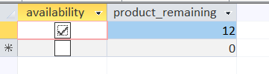

1. **Show the list of customer names and their order ID who ordered the product.**

SQL Code:

SELECT customer_name, order_ID

FROM OrderTable

OUTPUT:

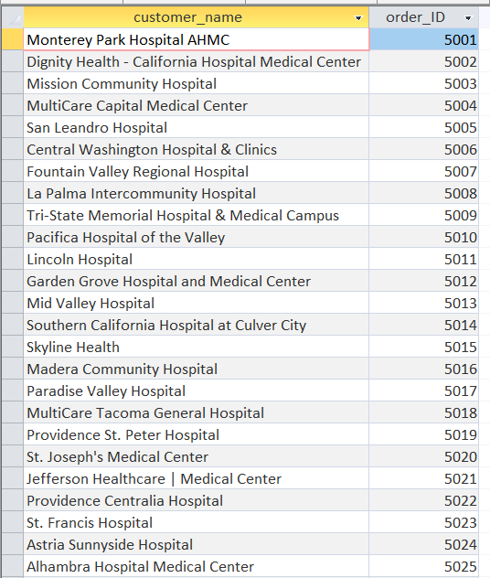

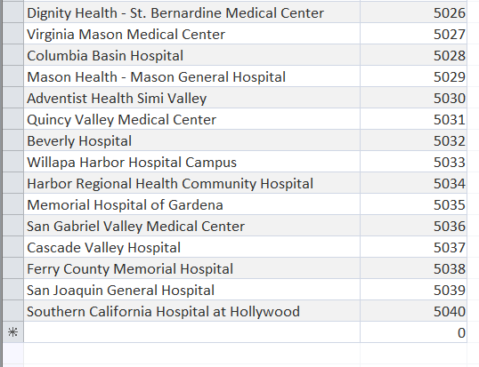

1. **List of employee names who work in branch ID 2022.**

SQL Code:

SELECT employee_name

FROM Employee

WHERE Branch_Id = 2022

OUTPUT:

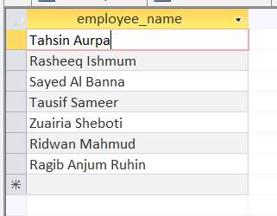

1. **Show the name and ID of the employees whose salary is greater than $500 and less than $600.**

SQL Code:

SELECT employee_name, employee_id

FROM employee

WHERE employee_salary>500 AND employee_salary<600

OUTPUT:

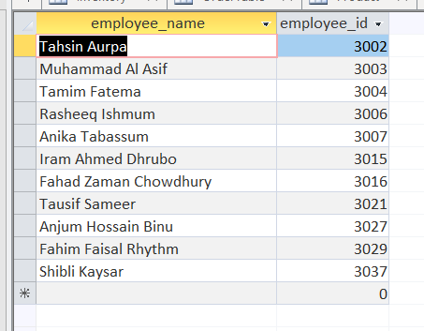

1. **Arrange the entire Employee table by listing the employee names alphabetically.**

SQL Code:

SELECT *

FROM employee

ORDER BY employee_name

OUTPUT:

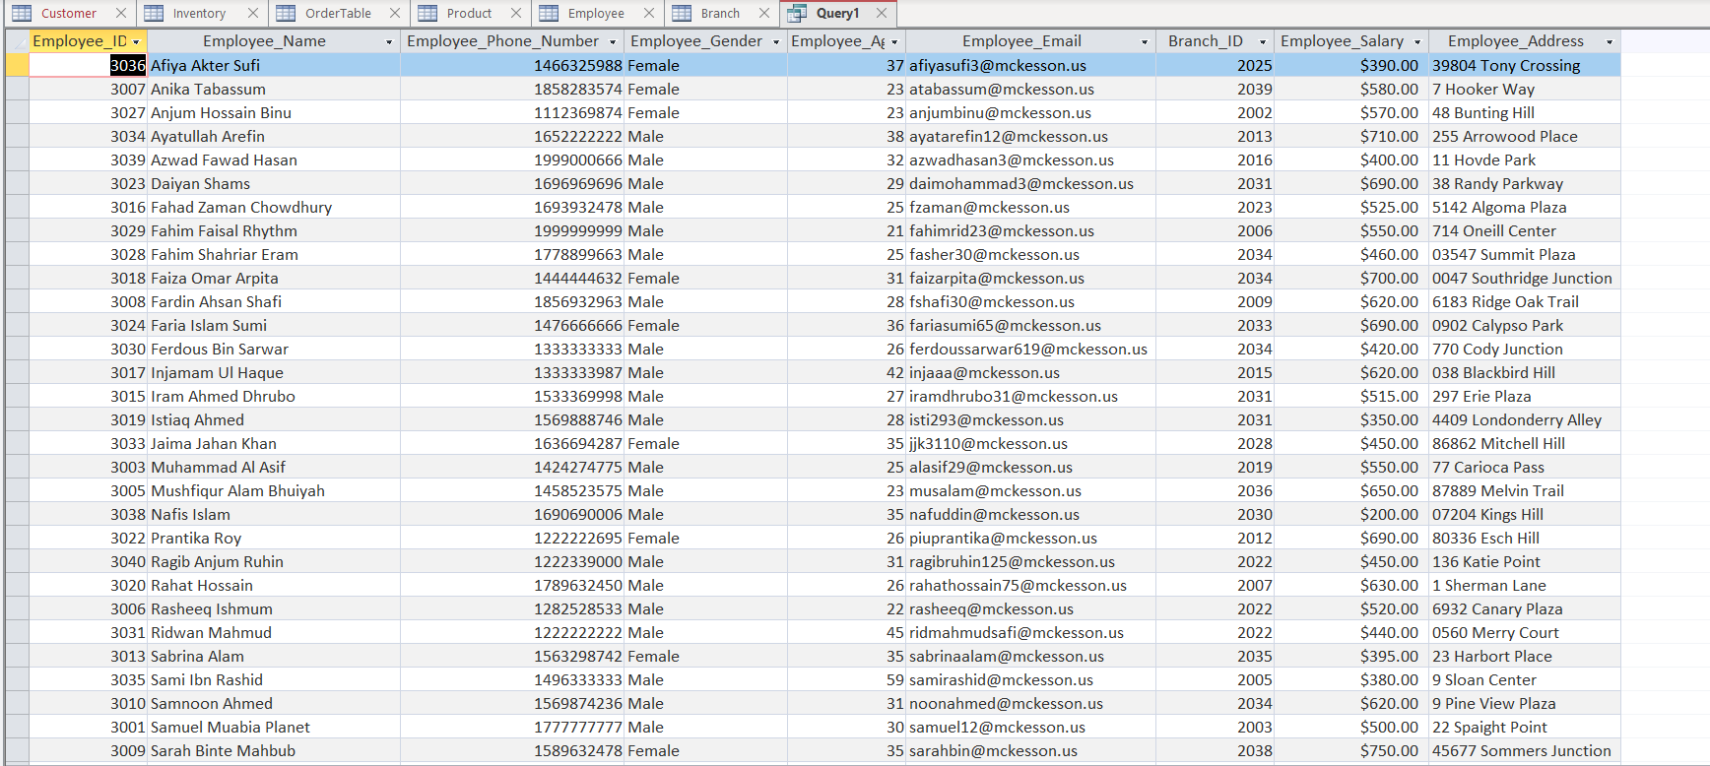

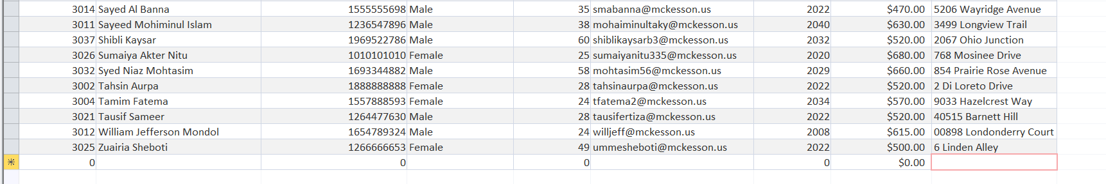

1. **Show the list of product ID of the products which are available in the inventory.**

SQL Code:

SELECT product_id

FROM inventory

Where availability = YES

OUTPUT:

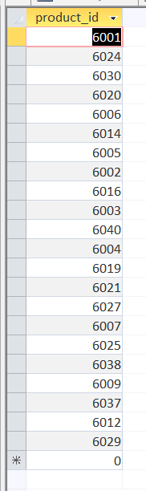

1. **Calculate the total product price of product ID 6021.**

SQL Code:

SELECT (product_quantity*per_product_price)

FROM product

Where product_id = 6021

OUTPUT:

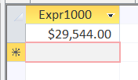

1. **Calculate the difference of employee salary of maximum salary holder and minimum salary holder.**

SQL Code:

SELECT max(employee_salary)-min(employee_salary)

FROM Employee

OUTPUT:

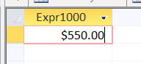

1. **Find the per unit cost of product whose Order ID is 5010.**

SQL Code:

SELECT (total_amount/no_of_product_purchased)

FROM OrderTable

Where order_id = 5010

OUTPUT:

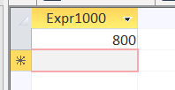

1. **Ratio of total number of product and number of products sold**

SQL Code:

SELECT sum(product_quantity)/sum(product_quantity-product_remaining)

FROM inventory

OUTPUT:

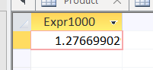

1. **Arrange the name of the employee in descending order whose salary is less than average.**

SQL Code:

SELECT employee_name

FROM employee

WHERE employee_salary < (SELECT avg(employee_salary)

FROM employee)

ORDER BY employee_name DESC

OUTPUT:

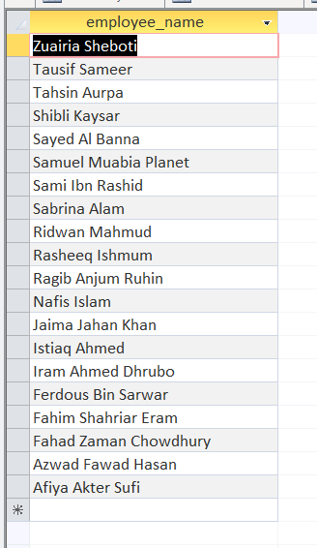

1. **Show the names of customer who did not provide their physical address but provided email address.**

SQL Code:

SELECT customer_name

FROM customer

WHERE customer_address IS NULL AND customer_email IS NOT NULL

OUTPUT:

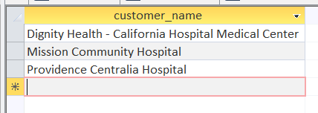

1. **Find the name of the employees who are female and of age 26 and 36.**

SQL Code:

SELECT employee_name

FROM employee

WHERE employee_gender = "Female" AND employee_age = 26 OR employee_age = 36

OUTPUT:

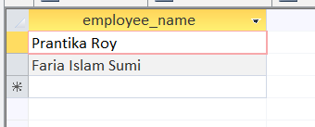

1. **Calculate the sum of per product price of all the products, excluding the product with the maximum per product price.**

SQL Code:

SELECT sum(per_product_price) - max(per_product_price)

FROM product

OUTPUT:

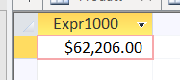

1. **Calculate the average number of employees for the branches where the ID of the Branch Head are 9011, 9017 and 9028.**

SQL Code:

SELECT avg(no_of_employee)

FROM branch

WHERE branch_head_Id = 9011 OR branch_head_Id = 9017 OR branch_head_Id = 9028

OUTPUT:

