Heughric Fernando | Section: CM3 | CSS154 | Unix Environment Setup

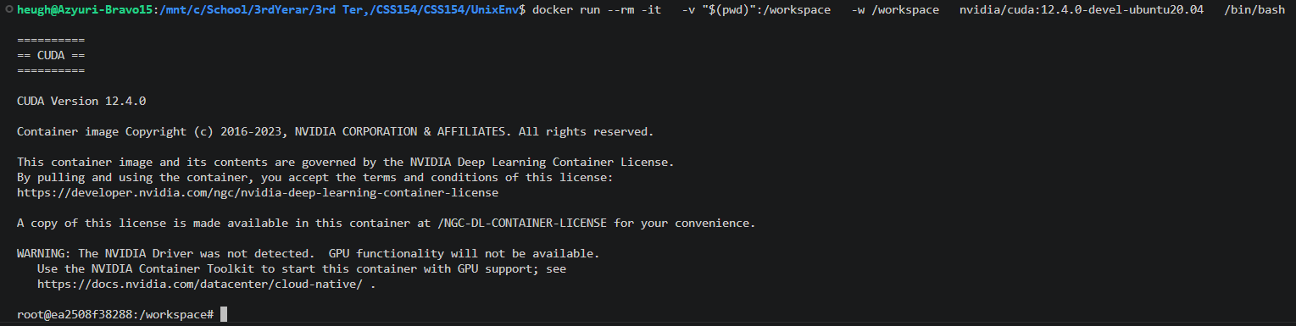
Screenshot 1:

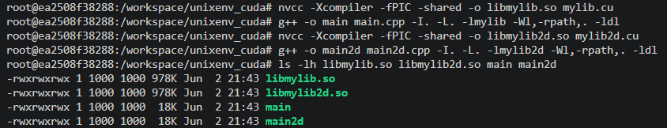
Screenshot 2:

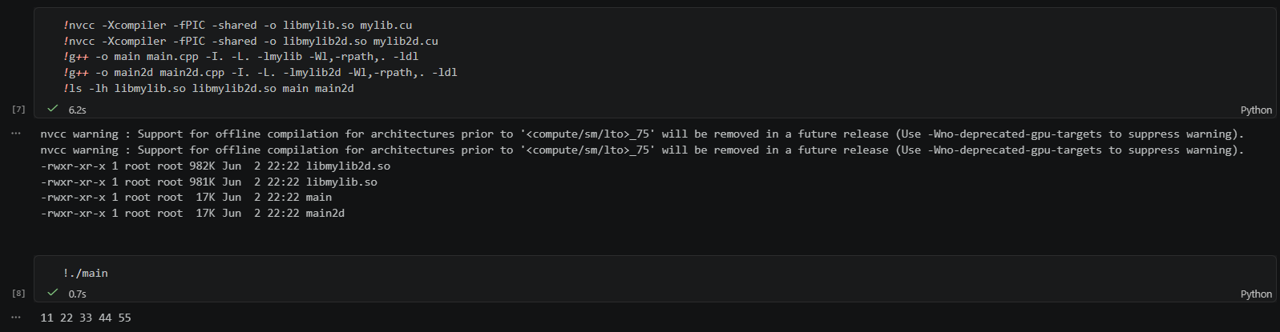

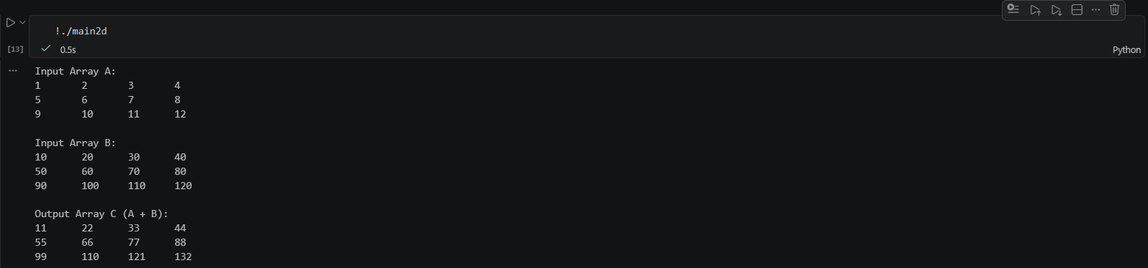
Screenshot 3:

