**LAPORAN TUGAS BESAR**

**IF3170 INTELIGENSI BUATAN**



**Disusun oleh :**

**Kelompok Ailuvyou**

**Muhammad Farhan Kemal 13513085**

**Naufal Malik Rabbani 13514052**

**Amal Qurany 13514078**

**Muhammad Azzahid A. S. 13514095**

**I Dewa Putu Deny K. A. 13514096**

**Program Studi Teknik Informatika**

**Sekolah Teknik Elektro dan Informatika**

**Institut Teknologi Bandung**

**2016**

1. **Hasil Pengujian**
   1. *Feed Forward Neural Network*

Nama file : iris.arff

1. *Full Training*

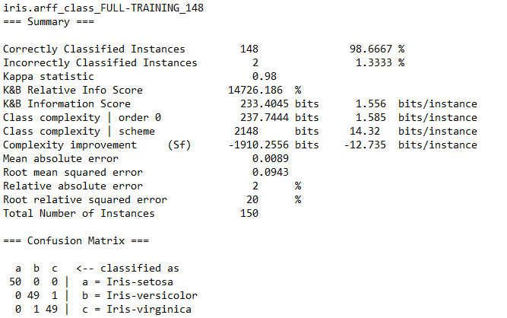

1. *10-fold Cross Validation*

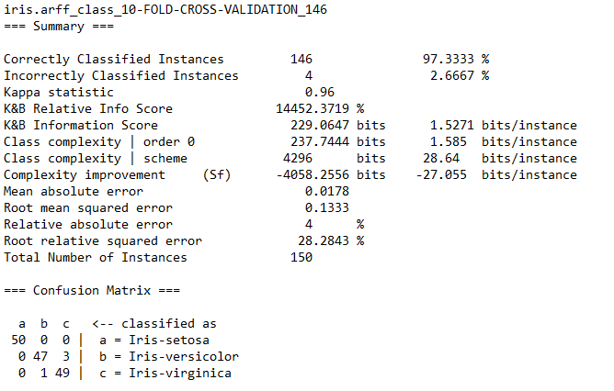

1. *Split Test*

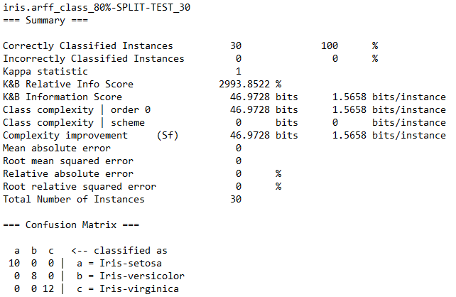

Nama file : Team.arff

1. *Full Training*

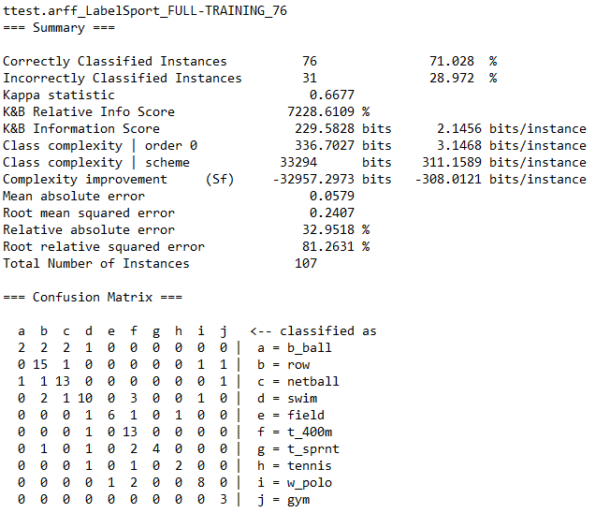

1. *10-fold Cross Validation*

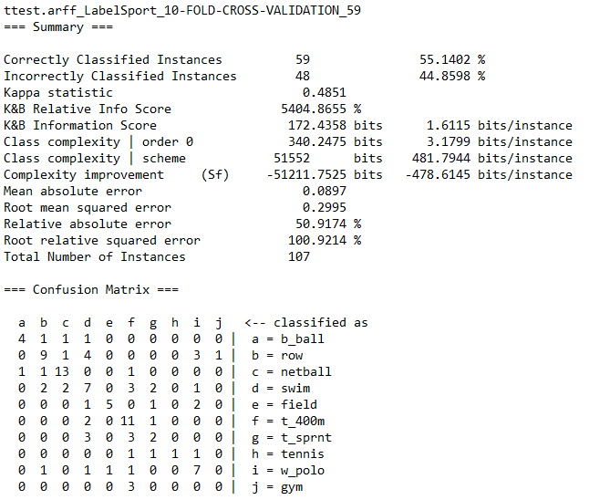

1. *Split Test*

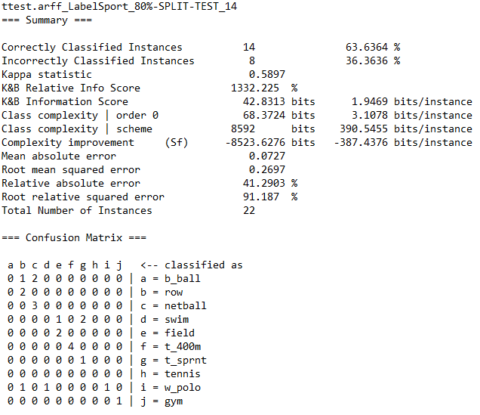

Nama file : Mush_test.arff

1. *Full Training*

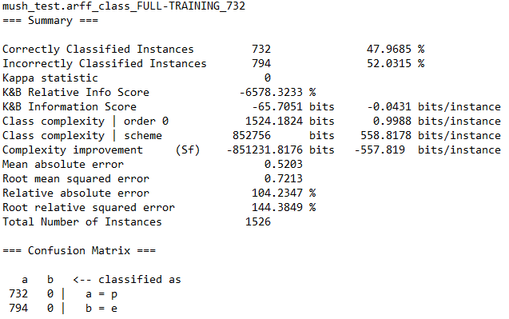

1. *10-fold Cross Validation*

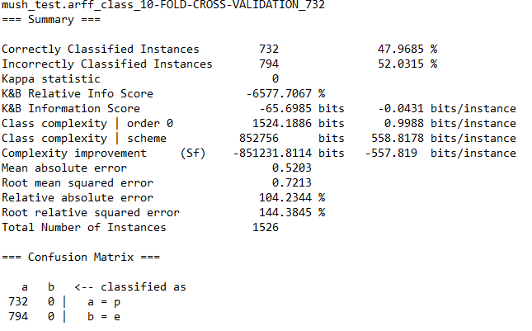

1. *Split Test*

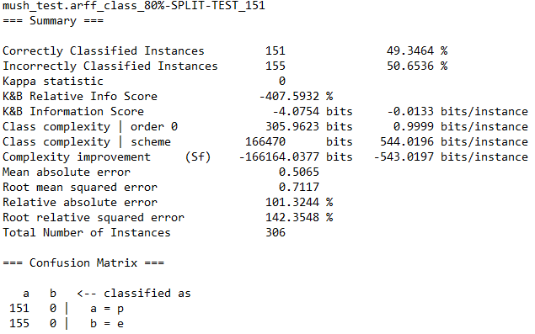

Nama file : student-math-test.arff

1. *Full Training*

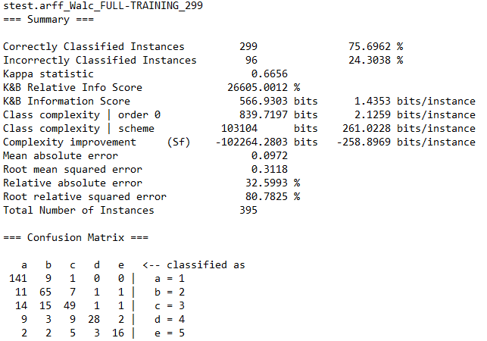

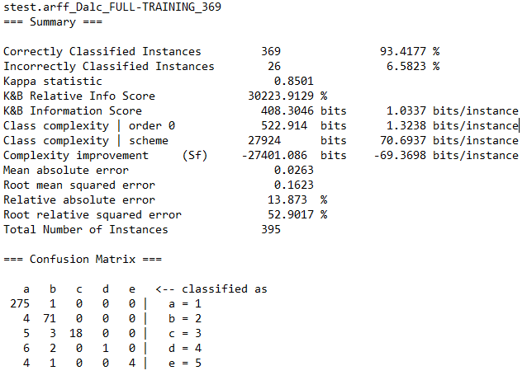

1. *10-fold Cross Validation*

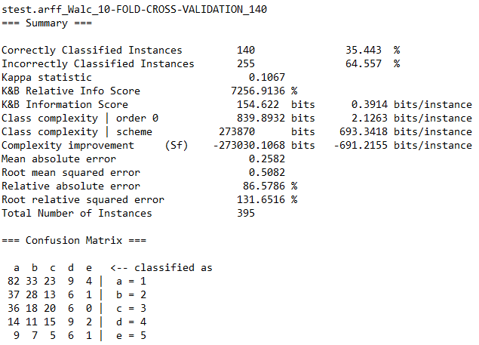

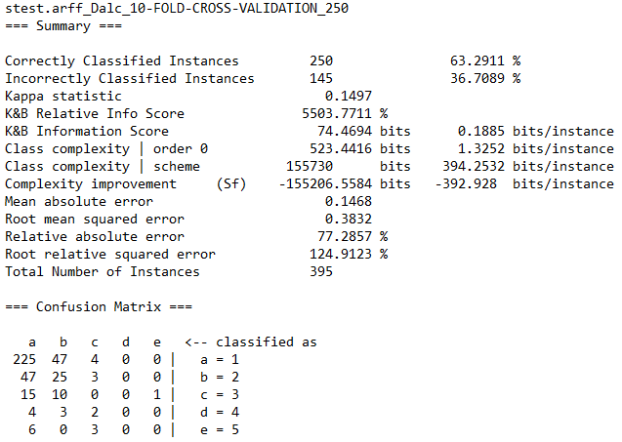

1. *Split Test*

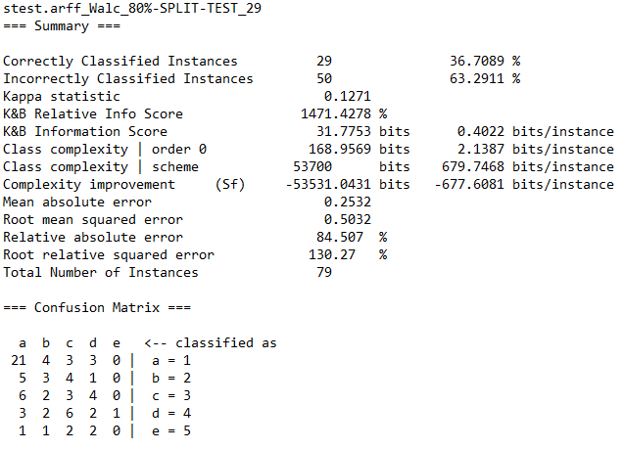

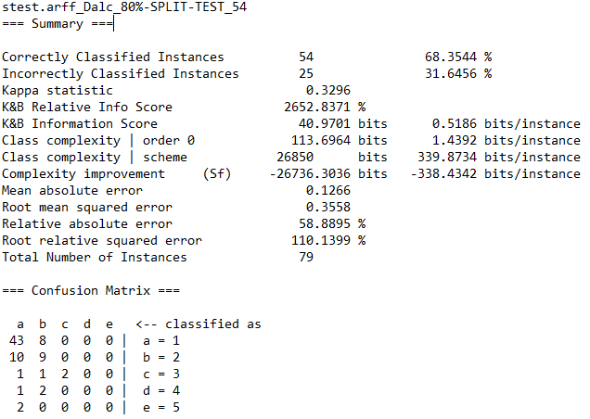

Matriks model hasil pengujian student-math-test.arrf dengan *classifier* Naïve Bayes dan *Feed Forward Neural Network* :

|  |  |
| --- | --- |
| **Walc** | **Dalc** |
| C:\Users\Deny\AppData\Local\Microsoft\Windows\INetCacheContent.Word\bayes1walc.png  Naïve Bayes Model | C:\Users\Deny\AppData\Local\Microsoft\Windows\INetCacheContent.Word\bayes1dalc.png  Naïve Bayes Model |
| Neural Network Model | Neural Network Model |