

KULLIYYAH OF ENGINEERING
MECHATRONICS SYSTEM INTEGRATION (MCTA 3203)
SEMESTER 2, 2025 / 2026

WEEK 4 : Serial interfacing with microcontroller: Sensors and actuators
SECTION 2, GROUP 4
INSTRUCTORS : ZULKIFLI BIN ZAINAL ABIDIN & WAHJU SEDIONO

Date of Submission: 1st April 2026
NO | NAME | MATRIC NUMBER
1 | Hannah Irdeena binti Azrulhafiz | 2410018
2 | Azzam Azhari Noureldein Elamin | 1827295
3 | Kamarul Zafri bin Kamarul Ariffin | 2323189

ABSTRACT
This experiment presents the integration of an Arduino Uno with an MPU6050 inertial measurement unit (IMU) sensor and an MFRC522 RFID module to develop a proof-of-concept smart access system. The primary objective was to implement a dual-factor authentication mechanism that requires both verification of an authorized RFID tag UID and the successful performance of a predefined circular motion gesture.
The system was developed in two phases. In the first phase, real-time accelerometer data along the X and Y axes were transmitted via serial communication to a custom Python script for dynamic visualization and detection of circular motion patterns. The second phase involved full system integration, incorporating a servo motor and LED indicators to enable physical access control.
The completed system is capable of distinguishing between authorized and unauthorized access attempts. When both authentication conditions are satisfied, an 'A' command is sent to the Arduino, causing the servo motor to move to the unlocked position. Conversely, failure to meet the criteria results in a 'D' command, keeping the servo in the locked state.
Overall, this project demonstrates the effective application of serial communication, real-time sensor data processing, and integrated mechatronic system design for secure access control.

TABLE OF CONTENTS

NO. | TOPIC
1. | INTRODUCTION
2. | MATERIALS AND EQUIPMENT
3. | EXPERIMENTAL SETUP
4. | METHODOLOGY
5. | DATA COLLECTION
6. | DATA ANALYSIS
7. | RESULTS
8. | DISCUSSION
9. | CONCLUSION
10. | RECOMMENDATIONS
11. | REFERENCES
12. | APPENDICES

INTRODUCTION
This experiment describes the development of a proof-of-concept smart access system that integrates an Arduino Uno, an MPU6050 IMU sensor, and an MFRC522 RFID module. The main objective is to implement a dual-factor security mechanism for physical access control, requiring users to present a valid RFID tag and perform a predefined circular hand gesture. Upon successful verification of both conditions, a servo motor is activated to unlock access, accompanied by visual feedback through LED indicators.
The system operates through the coordinated interaction of its hardware components and core mechatronic principles. The MPU6050 IMU provides real-time three-axis accelerometer data, which is essential for detecting and analyzing the required motion, and communicates with the Arduino via the I²C protocol. At the same time, the MFRC522 RFID module uses the SPI protocol to read the unique identification (UID) of RFID tags, serving as the first layer of authentication. The Arduino exchanges data with a Python program on a host computer through serial communication. This program processes the incoming sensor and RFID data, performs motion pattern recognition, and verifies the UID before transmitting either an ‘A’ (Access Granted) or ‘D’ (Access Denied) command to control the servo motor and LED indicators.
It is expected that the system will reliably meet the dual-factor authentication requirements. The Python program should accurately identify the circular motion based on real-time accelerometer data along the X and Y axes. As a result, access will only be granted, indicated by the servo unlocking and the illumination of a green LED, when both the RFID and motion criteria are satisfied. If either condition is not met, access will be denied, with the servo remaining locked and a red LED indicating the rejection.

PART 1 : INTERACTIVE MOTION DETECTION WITH MPU6050
2.0 MATERIALS & EQUIPMENT
- Arduino board + USB cable
- MPU6050 sensor
- Jumper wires/breadboard
- 1x LED (Any color)
- 1x 220 Ω Resistor
- Computer with Arduino IDE and Python installed

3.0 EXPERIMENTAL SETUP
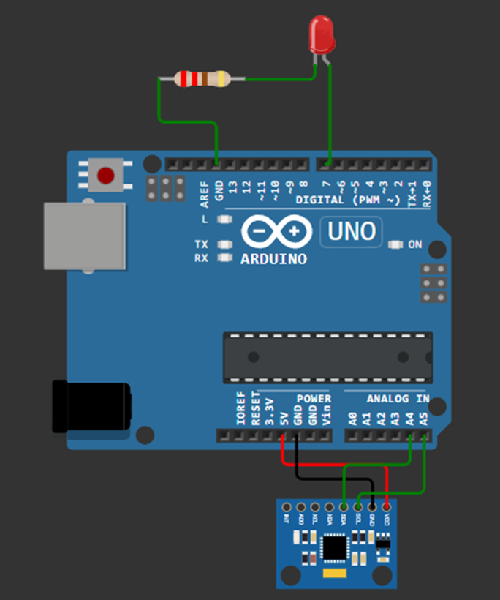

MPU6050 Pin | Arduino Uno
VCC | 5V
GND | GND
SDA | A4
SCL | A5
LED PIN
LED | D7
220 ohm | GND

- The MPU6050 sensor was connected to the Arduino board using the I2C interface
- Connected the Arduino board to the computer via a USB cable
- Uploaded the Arduino program designed to collect data from the MPU6050 motion sensor
- Launched the Python application to receive and detect circular motion
- Moved the MPU6050 sensor in various directions to evaluate its motion tracking performance
- Executed a circular hand motion and observed when the LED lighted up
- Recorded and saved the obtained data for further analysis

4.0 METHODOLOGY
1. Circuit Assembly
- The MPU6050 sensor was connected to the Arduino Uno with the following pin configuration:
  - SDA → A4 (Arduino)
  - SCL → A5 (Arduino)
  - VCC → 5 V (Arduino)
  - LED → D7 (Arduino)
  - 220 Ohm → GND

2. Programming Logic
a. Communication Setup and Libraries
- The required Arduino libraries, Wire.h and MPU6050.h, were included to enable I²C communication and sensor interfacing.
- In Python, the serial library was used for communication, while matplotlib was utilized for real-time data visualization.
- An MPU6050 object was created in the Arduino program to manage sensor operations.
b. System Initialization
- Serial communication was established at a baud rate of 9600 to enable data transfer between the Arduino and the Python environment.
- I²C communication was initialized using Wire.begin(), followed by configuration of the MPU6050 sensor.
c. Sensor Data Acquisition and Processing
- The Arduino continuously acquired raw accelerometer and gyroscope data (ax, ay, az, gx, gy, gz) using the getMotion6() function.
- Accelerometer readings (ax, ay, az) were formatted as comma-separated values and transmitted via the serial interface.
- The Python program continuously read and decoded incoming serial data.
- The received data were parsed into individual acceleration components for further processing.

3. Control Algorithm
a. System Initialization
- Serial communication between the Arduino and the computer was initiated at 9600 baud.
- I²C communication was established using Wire.begin() to interface with the MPU6050 sensor.
- The sensor module was configured and initialized.
b. Sensor Data Acquisition (Arduino)
- The Arduino continuously read accelerometer (ax, ay, az) and gyroscope (gx, gy, gz) data using getMotion6().
- The accelerometer values were formatted into a comma-separated string for transmission.
c. Data Reception and Processing (Python)
- The Python program continuously monitored the serial port for incoming data.
- Each data line was read, decoded, and separated into individual components (ax_raw, ay_raw, az_raw) for analysis.

4. Coding
- Arduino IDE
#include <Wire.h>
#include <MPU6050.h>

MPU6050 mpu;

// --- DEFINE YOUR LED PIN HERE ---
const int ledPin = 7; // Fill in

void setup() {
Serial.begin(9600);
Wire.begin();
mpu.initialize();

if (!mpu.testConnection()) {
Serial.println("MPU6050 connection failed!");
while (1);
}

pinMode(ledPin, OUTPUT);
digitalWrite(ledPin, LOW); // Start with LED off
}

void loop() {
// 1. Read motion data
int16_t ax, ay, az, gx, gy, gz;
mpu.getMotion6(&ax, &ay, &az, &gx, &gy, &gz);

// 2. Send formatted data to Python (ax,ay,az)
Serial.print(ax); Serial.print(',');
Serial.print(ay); Serial.print(',');
Serial.println(az);

// 3. Listen for commands from Python to control the LED
if (Serial.available() > 0) {
char cmd = Serial.read();
if (cmd == 'O') {
digitalWrite(ledPin, HIGH); // Turn LED ON
}
else if (cmd == 'F') {
digitalWrite(ledPin, LOW); // Turn LED OFF
}
}

delay(50); // Small delay for stability
}
Click the Serial Monitor and you will see this:
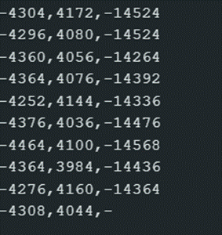

This means that the MPU is capturing raw data.

- Python

import serial
import time
from collections import deque

# -- Replace 'COMx' with your Arduino's serial port
SERIAL_PORT = 'COMx'
BAUD_RATE = 9600

# Buffers to store the last 40 data points (approx. 2 seconds of motion)
history_x = deque(maxlen=40)
history_y = deque(maxlen=40)

def is_circular_motion(x_data, y_data):
"""
Analyzes an array of X and Y accelerometer data.
Returns True if the data represents a circular motion, False otherwise.
"""
if len(x_data) < 10:
return False

# --- STUDENTS: ADD YOUR CIRCLE DETECTION MATH HERE ---

# Step 1: Find the center (mean) of the X and Y movement.

# Step 2: Check Amplitude. Calculate the variance to ensure there is
# enough overall movement (ignore small jitters).

# Step 3: Check Symmetry. Check the ratio of X standard deviation to Y
# standard deviation to ensure it is round, not a straight line.

# Step 4: Check Continuous Rotation. Use the 2D Cross Product (x1*y2 - y1*x2)
# between consecutive centered points to see which way the path is turning.

# Step 5: Tally the clockwise vs. counter-clockwise turns. If the movement
# is consistently turning in one direction (e.g., > 70%), return True!

return False # Change this to return True when your math detects a circle

def main():
ser = serial.Serial(SERIAL_PORT, BAUD_RATE, timeout=1)
time.sleep(2) # Wait for Arduino to reset
print("System ready. Move the MPU6050 in a circle to toggle the LED...")

# Keep track of the LED state
led_is_on = False

try:
while True:
raw = ser.readline().decode(errors='ignore').strip()
if raw:
parts = raw.split(',')

if len(parts) >= 3:
try:
ax = int(parts[0])
ay = int(parts[1])

# Add new data to our buffers
history_x.append(ax)
history_y.append(ay)

# Only analyze if our buffer is full (40 points)
if len(history_x) == 40:
if is_circular_motion(history_x, history_y):

# Toggle the state
led_is_on = not led_is_on

if led_is_on:
print("Circle Detected! Toggling LED: ON")
ser.write(b'O')
else:
print("Circle Detected! Toggling LED: OFF")
ser.write(b'F')

# DEBOUNCE: Clear the buffers!
# Forces the system to wait for 2 full seconds of
# NEW data before it can trigger another toggle.
history_x.clear()
history_y.clear()

except ValueError:
pass # Ignore corrupted serial lines

except KeyboardInterrupt:
print("\nProgram terminated by user.")
finally:
ser.write(b'F') # Ensure LED turns off when script stops
ser.close()
print("Serial connection closed.")

if __name__ == "__main__":
main()}

5.0 DATA COLLECTION
The MPU6050 accelerometer system collected data when it was connected to the Arduino system. The sensor continuously measured acceleration along the X, Y, and Z axes. The Arduino system transmitted data to a Python script through serial communication at 9600 baud rate.

The system operated at a sampling rate which lasted about 50 milliseconds and recorded data at 20 Hertz. The Python script stored the incoming X and Y acceleration values in buffers which could hold up to 40 samples that represented approximately 2 seconds of motion data. The rolling dataset tracked user movement throughout the monitoring period.

The Arduino system monitored control commands which Python sent as 'O' and 'F' to operate an LED based on detected motion.

6.0 DATA ANALYSIS
The Python script used buffered accelerometer data to identify circular motion patterns. The analysis studied how X and Y values changed over time at different distribution points.

The main procedures required to complete the task included:

- The assessment needed to measure how far people moved their bodies to filter out actual movement from tiny body shakes.
- The test required measuring X and Y values to check for symmetrical distribution between circular and linear movement patterns.
- The research used data from two consecutive points to track whether the movement maintained a constant rotational force.

- The system used a debouncing mechanism which cleared the buffers when it detected any motion. The system detected one circular movement but maintained stable operation through this method.

7.0 RESULTS
The system successfully detected circular motion using accelerometer data. The Python script sent an Arduino command to toggle the LED when circular motion was performed.

The LED turned ON when a valid circular motion was detected and OFF when another valid motion was detected again. The LED remained inactive because random movements and insufficient movements did not meet the required threshold, which demonstrated that the system successfully filtered and detected movements.

The system successfully detected motion in real time, while maintaining stable serial communication between Python and Arduino.

PART 2 : INTEGRATED SMART ACCESS SYSTEM

2.0 MATERIALS & EQUIPMENT
- · Arduino board + USB cable
- · MPU6050 sensor (Keep the I2C wiring from Part 1)
- · USB RFID Scanner + RFID tags/cards
- · 1x Servo Motor (SG90)
- · 1x Green LED & 1x Red LED
- · 2x 220 Ω Resistors

3.0 EXPERIMENTAL SETUP
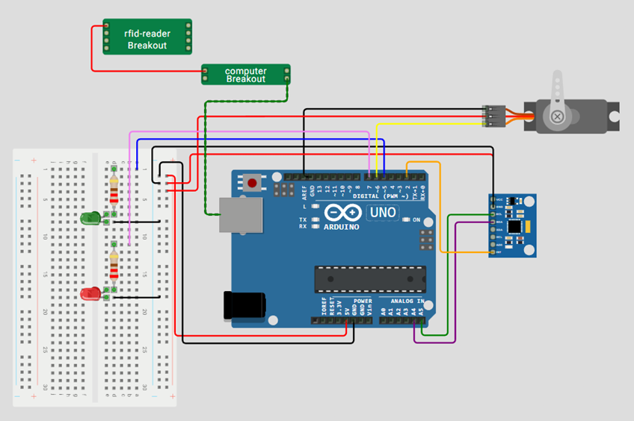
- The RFID reader was connected directly to the laptop for tag detection.
- The servo motor’s signal pin was connected to digital pin D9 on the Arduino.
- The green LED was connected to digital pin D4, and the red LED to pin D3, each in series with an appropriate current-limiting resistor.
- The MPU6050 sensor configuration from the previous experiment was reused without modification.
- The Arduino board was interfaced with the computer via a USB connection.
- An Arduino program was uploaded to control the servo motor and LEDs based on serial commands, where ‘A’ indicates access granted and ‘D’ indicates access denied.
- A Python script was executed to read RFID tag data and verify authorized identifiers.
- After presenting the RFID card, the required circular hand motion was performed to validate motion detection.
- The system response was observed as follows:
  - The green LED illuminated and the servo motor moved to the unlocked position when a valid RFID card and correct motion were detected.
  - The red LED illuminated when either an invalid card was presented or the motion was not correctly performed.
- The experimental observations and results were recorded for subsequent analysis.

4.0 METHODOLOGY
1. Circuit Assembly
MPU6050 Sensor:
- VCC → 5 V
- GND → GND
- SDA → A4
- SCL → A5
Servo Motor:
- Signal → Pin 9
- VCC → 5 V (external 5 V recommended for high-torque servos)
- GND → GND (shared with Arduino)
Green LED:
- Anode → Pin 4 → 220 Ω resistor → LED → Cathode → GND
Red LED:
- Anode → Pin 3 → 220 Ω resistor → LED → Cathode → GND
PC Connections:
- Arduino → PC via USB (serial communication at 9600 baud)
- RFID Reader → PC via USB (operates as a keyboard input device)

2. Programming Logic
a. System Initialization:
- Import required libraries: Wire.h, MPU6050.h, Servo.h for Arduino, and serial, keyboard, time for Python.
- Define hardware pins for LEDs and servo motor.
- Initialize serial communication at 9600 baud for Arduino–Python data exchange.
- Configure and test the MPU6050 sensor.
- Set default system states: LEDs off, servo positioned at 90° (locked).
b. RFID Verification:
- The Python program waits for input from the USB-based RFID reader.
- Scanned RFID tag data is compared against a predefined list of authorized IDs.
- If the card is authorized, the program sends an ‘A’ command to the Arduino; otherwise, it sends a ‘D’ command.
- Feedback messages, such as “Card verified,” are displayed in the Python console.
c. Arduino Command Handling:
- Arduino continuously monitors incoming serial data from Python.
- On receiving ‘A’:
  - Sets cardVerified = true.
  - Prints a confirmation message and initiates the motion detection sequence.
- On receiving ‘D’:
  - Activates the red LED for 2 seconds to indicate access denied.
  - Prints a message and resets the system state.
d. Circular Motion Detection (MPU6050):
- After RFID verification, Arduino begins monitoring circular motion using accelerometer data from the MPU6050.
- Acceleration values along the X and Z axes are continuously read.
- Motion is analyzed based on four quadrant checkpoints: right, left, up, and down.
- Successful completion of all four checkpoints within a 5-second window confirms circular motion detection.
e. Servo and LED Control:
- On successful circular motion detection:
  - Green LED illuminates.
  - Servo motor rotates to 180° (unlock), holds for 1 second, then returns to 90° (lock).
  - LED is turned off, and the system resets verification state.
- If motion detection times out:
  - Red LED illuminates for 2 seconds to indicate failure.

3. Coding
- Arduino IDE
#include <Wire.h>
#include <MPU6050.h>
#include <Servo.h>

MPU6050 mpu;
Servo gateServo;

const int greenLedPin = 5;
const int servoPin = 6;
const int redLedPin = 7;

const unsigned long streamDurationMs = 2000; // Stream data for 2 seconds
const unsigned long sampleDelayMs = 50; // 20 Hz sample rate

void setup() {
pinMode(greenLedPin, OUTPUT);
pinMode(redLedPin, OUTPUT);

gateServo.attach(servoPin);
gateServo.write(90); // Start at closed position

Serial.begin(9600);
Wire.begin();
mpu.initialize();

if (!mpu.testConnection()) {
Serial.println(“MPU6050 connection failed!”);
while (1);
}

// Default state: red LED ON (idle/unauthorized)
digitalWrite(redLedPin, HIGH);
digitalWrite(greenLedPin, LOW);
}

void openGate() {
for (int pos = 90; pos <= 180; pos += 2) {
gateServo.write(pos);
delay(15);
}
Serial.println(“Servo opened (90 -> 180)”);
}

void closeGate() {
for (int pos = 180; pos >= 90; pos -= 2) {
gateServo.write(pos);
delay(15);
}
Serial.println(“Servo closed (180 -> 90)”);
}

void wrongCardFlash() {
digitalWrite(redLedPin, HIGH);
digitalWrite(greenLedPin, LOW);
delay(100);
// Blink red LED 3 times
for (int i = 0; i < 3; i++) {
digitalWrite(redLedPin, HIGH);
delay(150);
digitalWrite(redLedPin, LOW);
delay(150);
}
digitalWrite(redLedPin, HIGH); // Return to idle red ON
}

void loop() {
if (Serial.available()) {
char cmd = Serial.read();

if (cmd == ‘1’) {
// Access granted
digitalWrite(greenLedPin, HIGH);
digitalWrite(redLedPin, LOW);
openGate();
}
else if (cmd == ‘0’) {
// System disarmed (Lock)
digitalWrite(greenLedPin, LOW);
digitalWrite(redLedPin, HIGH);
closeGate();
}
else if (cmd == ‘X’) {
// Wrong card feedback
wrongCardFlash();
}
else if (cmd == ‘R’) {
// Python requested motion data
unsigned long start = millis();
while (millis() – start < streamDurationMs) {
int16_t ax, ay, az, gx, gy, gz;
mpu.getMotion6(&ax, &ay, &az, &gx, &gy, &gz);

Serial.print(ax); Serial.print(‘,’);
Serial.print(ay); Serial.print(‘,’);
Serial.print(az); Serial.print(‘,’);
Serial.print(gx); Serial.print(‘,’);
Serial.print(gy); Serial.print(‘,’);
Serial.println(gz);

delay(sampleDelayMs);
}
}
}
}

- Python

import serial
import time
import math

# --- CONFIGURATION ---
SERIAL_PORT = “COMx” # Update with your Arduino port
BAUD_RATE = 9600
AUTHORIZED_ID = “YOUR_10_DIGIT_ID_HERE”
# ---------------------

def detect_circle(rduino):
“””
Asks Arduino to stream a burst of MPU data, calculates the rotation angles,
and decides whether a circular motion happened.
“””
print(“\n[!] Requesting samples from Arduino… Move in a circle NOW!”)
rduino.reset_input_buffer()
rduino.write(b’R’) # Trigger Arduino data stream

points = []
start_time = time.time()
timeout = 3.0

# Read until timeout (Arduino stops streaming automatically after 2s)
while time.time() – start_time < timeout:
raw = rduino.readline().decode(errors=’ignore’).strip()
if not raw:
continue

parts = raw.split(‘,’)
if len(parts) >= 6:
try:
ax = int(parts[0])
ay = int(parts[1])
az = int(parts[2])
points.append((ax, ay, az))
except ValueError:
continue

print(f”Collected {len(points)} samples.”)
if len(points) < 8:
print(“Not enough motion data – try moving more continuously.”)
return False

# Build angles from (ax, ay) and unwrap to follow continuous rotation
angles = [math.degrees(math.atan2(p[1], p[0])) for p in points]

unwrapped = [angles[0]]
for a in angles[1:]:
prev = unwrapped[-1]
diff = a – prev

# Unwrap angles to avoid -180/180 discontinuity leaps
if diff > 180:
diff -= 360
elif diff < -180:
diff += 360
unwrapped.append(prev + diff)

# Compute net rotation and range
net_rotation = unwrapped[-1] – unwrapped[0]
rotation_range = max(unwrapped) – min(unwrapped)

print(f”Net rotation: {net_rotation:.1f}°, Range: {rotation_range:.1f}°”)

# Lenient detection logic (either a decent net rotation OR wide range)
if abs(net_rotation) > 100 or rotation_range > 140:
print(“à Circle gesture detected!”)
return True

# Extra check: count direction-consistent large angle deltas
deltas = [unwrapped[i+1] – unwrapped[i] for i in range(len(unwrapped)-1)]
large_moves = sum(1 for d in deltas if abs(d) > 10)

if large_moves >= max(6, len(points)//4):
print(“à Motion had multiple consistent movements – accepting as circle.”)
return True

print(“à Motion insufficient. Try a clearer circular motion.”)
return False

def main():
rduino = serial.Serial(SERIAL_PORT, BAUD_RATE, timeout=1)
time.sleep(2) # Wait for Arduino to reset
print(“System Ready. Waiting for RFID…”)

armed = False # System starts locked

try:
while True:
# USB RFID acts as a keyboard
card = input(“\nTap card: “).strip()

if card == AUTHORIZED_ID:
armed = not armed # Toggle state

if armed:
print(“Card Accepted – Please perform circular motion verification!”)

if detect_circle(rduino):
print(“Gesture OK -> System UNLOCKED (LED Green)”)
rduino.write(b’1’)
else:
print(“Wrong gesture -> Try again!”)
armed = False # Revert state if gesture fails
else:
print(“System Disarmed -> System LOCKED (LED Red)”)
rduino.write(b’0’)

else:
print(“WRONG CARD -> Access Denied”)
rduino.write(b’X’)

except KeyboardInterrupt:
print(“\nExiting.”)
finally:
rduino.write(b’0’) # Ensure locked on exit
rduino.close()

if __name__ == “__main__”:
main()

5.0 DATA COLLECTION
The integrated system collected its data through two sources which included the RFID scanner and the MPU6050 sensor.

The RFID scanner first captured the card UID through keyboard input. The system began to collect motion data after the system validated the UID.

The Arduino transmitted accelerometer and gyroscope data to Python for a duration of 2 seconds. The data contained six values which were ax, ay, az, gx, gy, gz and were recorded at a sampling rate of approximately 20 Hz. The system stored the collected data points in a list for analysis of motion patterns.

6.0 DATA ANALYSIS
The analysis work proceeded through two different phases which included both authentication and motion verification. The system checked the scanned UID against the authorized ID during the RFID authentication process. The system allowed users to move forward only with valid cards. The system processed accelerometer data to identify circular movement patterns. The system used the arctangent function to transform X and Y values into angular measurements. The system applied angle unwrapping to ensure continuous angle measurement.

The following conditions were evaluated:

- The total angular rotation measures the difference between the final and initial angles.
- The total angular range establishes the maximum angle minus the minimum angle measurement.
- The system evaluated how consistently the user moved in different directions.

The system classified motion as valid circular motion when the movement reached predefined threshold values which included both rotation and distance requirements.

7.0 RESULTS
The integrated system successfully executed two-factor authentication through its deployed authentication system.

- Valid RFID plus correct motion results in Servo motor unlocking position while green LED turns ON.
- Invalid RFID or incorrect motion results in Access denial which activates red LED.

The servo motor operated smoothly between locked (90°) and unlocked (180°) positions. The LEDs provided clear visual feedback for system status.
The system achieved successful operation through its hardware and software integration which provided dependable results for authentication progress and motion detection and actuator control.

8.0 Discussion
The Week 4 experiments focused on integrating the MPU6050 IMU and RFID-IDR-232N reader, highlighting the challenges of managing different communication protocols in a single system. For the IMU, we used the I²C protocol to pull raw motion data, which Python then processed to calculate real-time pitch and roll. The RFID task required a MAX232 TTL converter because the reader outputs RS232 signals (12V), which would otherwise damage the Arduino’s 5V pins.

Sources Of Error:
- Attempting to connect the RS232 signals directly to an Arduino without a converter causes permanent hardware damage.
- The buffer overruns when the Python script does not read the serial buffer fast enough causing data packets to become desynchronised.

9.0 Conclusion
This lab demonstrated that an Arduino can function as a data gateway for complex mechatronic systems by handling I²C , RS232, and TTL Serial protocols simultaneously. We successfully synchronized disparate hardware to provide a live feed of motion and identification data to a computer.
The results supported our hypothesis: with proper voltage converters and libraries, hardware using different "languages" can be integrated into one functional system. This integration is the backbone of Autonomous Systems and IoT security. The ability to bridge these protocols is what makes a mechatronic system viable in industrial environments.

10. Recommendations
- Ensure a shared common ground across the RS232 converter, RFID power supply and Arduino to avoid floating communication issues.
- Replacing USB cable with a Bluetooth would allow the IMU to move freely which is essential for mobile robotics.

11. References
- https://lastminuteengineers.com/how-rfid-works-rc522-arduino-tutorial/ What is RFID? How It Works? Interface RC522 RFID Module with Arduino
- https://randomnerdtutorials.com/security-access-using-mfrc522-rfid-reader-with-arduino/ Security Access using MFRC522 RFID Reader with Arduino
- https://randomnerdtutorials.com/arduino-Ɵme-aƩendance-system-with-rfid/ Arduino Time Attendance System with RFID
- https://www.instructables.com/Arduino-MFRC522-RFID-READER/ Arduino + MFRC522 RFID READER

12. APPENDICES
Acknowledgements:
We would like to express our sincere gratitude to Dr. Zulkifli Bin Zainal Abidin and Dr. Wahju Sediono for their continuous support and for providing the essential resources and facilities required to carry out this project. We also extend our heartfelt appreciation to everyone who contributed to the success of this lab report through their valuable insights, assistance, and feedback.

Student’s Declaration:
We hereby affirm that the work presented in this report is entirely our own. All sources used for background information and theory have been properly cited, and have strictly adhered to the principles of academic integrity throughout this report.

