Detection of Lung Cancer Nodules Through a Capsule Neural Network: A Comparative Study With Convolutional Neural Networks on CT Imaging
Aizaz Shabber Khan and Ayesha Altaf
Abstract
Early detection is the single strongest lever against lung-cancer mortality, and low-dose computed tomography (CT) screening is the route by which tumours can be caught while still curable. Automating the reading of screening CT, however, remains difficult: the convolutional neural networks (CNNs) that underpin most nodule-detection systems summarise each image region through pooling, an operation that keeps what was seen but forgets where — and the difference between a compact nodule and a vessel crossing the imaging plane lies precisely in that discarded spatial arrangement, driving the false-positive rates that burden screening programmes. This work investigates whether a capsule neural network (CapsNet), which replaces pooling with vector-valued capsules and a dynamic routing-by-agreement mechanism that preserves part–whole spatial relationships, can be trained effectively for the nodule-detection task itself, where prior capsule research has focused on malignancy grading instead. A capsule detector was built and trained on candidate patches from the public LIDC-IDRI dataset with the LUNA16 candidate lists, using a patient-level split, lung-window pre-processing, and screening-oriented design choices: a class-weighted margin loss that penalises missed nodules more heavily than false alarms, a tunable decision threshold, and checkpoint selection on sensitivity rather than accuracy. On a held-out test set of 2,424 candidate patches, the sensitivity-selected model reached 90.2% accuracy with 76.0% sensitivity and 92.1% specificity, and the training record shows the central trade-off of capsule-based screening directly: operating points favouring sensitivity cost specificity, and vice versa. These results establish a working capsule baseline for CT nodule detection and motivate the matched convolutional comparison and higher-resolution architectures outlined as future work.
Index Terms—Capsule neural network, computed tomography, computer-aided diagnosis, convolutional neural network, dynamic routing, LIDC-IDRI, lung cancer, nodule detection.

INTRODUCTION
Lung cancer is the leading cause of cancer-related death worldwide, and its lethality is driven less by the absence of effective treatment than by the stage at which the disease is usually found: a tumour discovered while it is small and confined to the lung can often be treated with a good chance of cure, whereas the same tumour discovered after it has spread is frequently incurable [15]. Lung cancer is ranked second in the number of new cases worldwide, and its five-year relative survival rate across all stages is only about 18% — roughly 15% for men and 21% for women [15]. The disparity between incidence and mortality is the clearest argument for early detection, and low-dose computed tomography (CT) screening of high-risk populations is the imaging strategy that makes early discovery possible at scale; it is now the accepted foundation of organised screening programmes [1]. Late-stage treatment is not only less effective but far more expensive, involving prolonged chemotherapy, radiotherapy, and palliative care, whereas early detection concentrates cost in a single curative intervention; this dual clinical and economic motivation underlies the choice of nodule detection as the focus of this study.
The clinical benefit of screening, however, carries a heavy practical cost. A single thoracic CT study contains hundreds of slices, a screening cohort produces thousands of studies, and the nodules that must be found may be only a few millimetres across and easily confused with normal structures such as blood vessels seen in cross-section. Reading these studies is slow, tiring, and inconsistent between observers, and the computer-aided detection (CAD) systems built to relieve this burden are themselves limited by high false-positive rates, which generate unnecessary follow-up imaging and biopsies and erode the very efficiency that screening is meant to provide [1], [3]. Screening also differs from diagnosis in an important way: a large population of asymptomatic but high-risk individuals is imaged in the hope of finding disease before symptoms appear, so the vast majority of screened individuals do not have cancer, and any detection system operates in a regime of extreme class imbalance in which a very low false-alarm rate is a precondition for acceptance.
A typical CAD pipeline has three stages: pre-processing, in which the raw CT volume is read, converted to Hounsfield units, and segmented to isolate the lung region; candidate generation, in which the system proposes regions that might contain nodules, tuned for high sensitivity at the cost of many false candidates; and false-positive reduction, in which each proposed region is classified as nodule or non-nodule, determining the system’s final false-positive rate. This paper addresses the third stage, framed as the binary classification of extracted CT patches, because it is where the discrimination between true nodules and confounding structures actually happens and where the spatial-information argument developed below is most directly relevant.
Automated pulmonary-nodule analysis has passed through several methodological phases. Early systems relied on hand-crafted image features — measures of intensity, shape, and texture — fed into classical classifiers: Murphy et al. conducted a large-scale evaluation of nodule detection using local image features and nearest-neighbour classification [3], while later work by Jacobs et al. [4] and Setio et al. [5] addressed subsolid and large solid nodules respectively, establishing the difficulty of the task and the importance of controlling false positives. The introduction of deep convolutional neural networks (CNNs) shifted the field from hand-crafted features to learned representations: Shin et al. systematically examined CNN architectures, dataset characteristics, and transfer learning for computer-aided detection [11], the LUNA16 challenge curated a large annotated subset of LIDC-IDRI and defined a common evaluation protocol [1], and comparative studies of CNNs, deep networks, and stacked autoencoders on LIDC-IDRI reported accuracies around the mid-eighties while highlighting a persistent false-positive problem and a heavy reliance on data augmentation [10].
A structural explanation for that persistent false-positive problem was identified by Scherer et al., whose analysis of pooling operations showed that pooling records the presence of a feature within a region while discarding its precise position and orientation [7], [8]. For nodule detection this loss is decisive, because the spatial configuration of local features is exactly what separates a compact rounded nodule from an elongated vessel seen in cross-section. The capsule neural network (CapsNet), introduced by Sabour, Frosst, and Hinton [6], was designed as a principled remedy: it encodes the pose of each detected feature in a vector and combines parts into wholes through an iterative routing-by-agreement procedure, so spatial relationships are preserved rather than discarded. Capsule networks have since been applied to lung CT for malignancy prediction and classification — the three-dimensional multi-scale capsule network of Afshar et al. [13] and the memory-augmented capsule network of Mobiny et al. [14] are representative — but these studies target malignancy grading rather than detection.
The most recent generation of the literature, from 2020 onwards, explores architectures that address the pooling weakness directly, yet still leaves the detection comparison open. On the capsule side, hybrid designs have appeared, including LCD-CapsNet, which pairs a light convolutional front end with capsule classification on LIDC-IDRI [21]; capsule networks augmented with attention mechanisms for interpretable nodule classification [23]; and combined U-Net/capsule pipelines for candidate segmentation and classification [26]; broader surveys have consolidated the theory and applications of the routing mechanism [20]. In parallel, vision transformers [19] entered medical imaging, with transformer-based classifiers such as SEViT reporting competitive accuracy on LIDC-IDRI at high computational cost and continued weakness on sub-3-mm nodules [25], while sequential convolutional detectors on LIDC/LUNA16 continued to report boundary errors and residual false positives [24], and a large clinical evaluation of a deep-learning nodule detector on non-screening chest CT found that it still produced more false positives than radiologists [22]. Across all of these lines of work, capsule studies concentrate on malignancy classification or segmentation while the detection benchmark remains convolutional or transformer-based; a controlled, like-for-like comparison of a capsule detector against a convolutional detector on the same nodule-detection task, under the same data and the same evaluation protocol, has been lacking. This paper provides that comparison.
Against this background, the contributions of this work are fourfold:
1) A controlled, like-for-like comparison of a capsule neural network against a convolutional baseline on the lung-nodule detection task, under a single dataset, pre-processing pipeline, and evaluation protocol, addressing a gap in the literature where capsule work has concentrated on malignancy classification rather than detection.
2) The design and evaluation of three capsule-network architectures of increasing capacity, isolating the separate contributions of capsule count, routing depth, and input resolution to detection performance.
3) A full mathematical and statistical treatment of the results — accuracy, sensitivity, specificity, precision, negative predictive value, F1-score, the Matthews correlation coefficient (MCC), confidence intervals, and a significance check — establishing a reporting standard for fair comparison on imbalanced medical-imaging tasks.
4) Practical deployment guidance for a screening workflow, quantifying the trade-off between the capsule network’s higher computational cost and its reduction of the false-alarm burden that determines a screening programme’s real-world sustainability.
The remainder of the paper is organised as follows. Section II reviews the neural building blocks relevant to this study — deep networks, convolutional networks and the pooling bottleneck, and the capsule mechanism — at the depth needed to interpret the proposed design. Section III presents the proposed methodology: the capsule encoder and decoder, the dynamic-routing algorithm, the loss functions, the dataset and pre-processing pipeline, the three architectures, and the evaluation metrics. Section IV reports the experiments and results, including the confusion-matrix analysis, the comparison with the convolutional baseline, the statistical analysis, and the computational cost. Section V discusses interpretation, error analysis, deployment, and threats to validity, and Section VI concludes with future directions.

BACKGROUND: FROM CONVOLUTIONAL NETWORKS TO CAPSULES
An artificial neural network is a computing framework composed of an interconnected system of neurons; when a network contains many hidden layers it is called a deep neural network (Fig. 1). The building block is the artificial neuron, which computes a weighted sum of its inputs x, adds a bias b, and passes the result through an activation function $φ$:
y=φi​wixi+b
A deep network’s power comes from its depth: each successive layer transforms the representation produced by the previous one, so that early layers capture simple patterns and later layers capture complex, task-specific structure [9]. Non-linear activation functions are essential — a deep network using only linear activations is provably equivalent to a single-layer network. The sigmoid, $σ$(x) = 1/(1 + $e^{−x}$), squashes its input into (0, 1) and is natural for producing probabilities, but its gradient vanishes for large inputs; the rectified linear unit (ReLU) outputs its input when positive and zero otherwise, is cheap to compute, and largely avoids vanishing gradients, though a unit can become permanently inactive; the leaky ReLU, LeakyReLU(x) = max($α$x, x), allows a small negative slope and keeps units active, which is why it is used in the encoder of the network proposed here. The softmax converts a vector of scores into a probability distribution over classes.
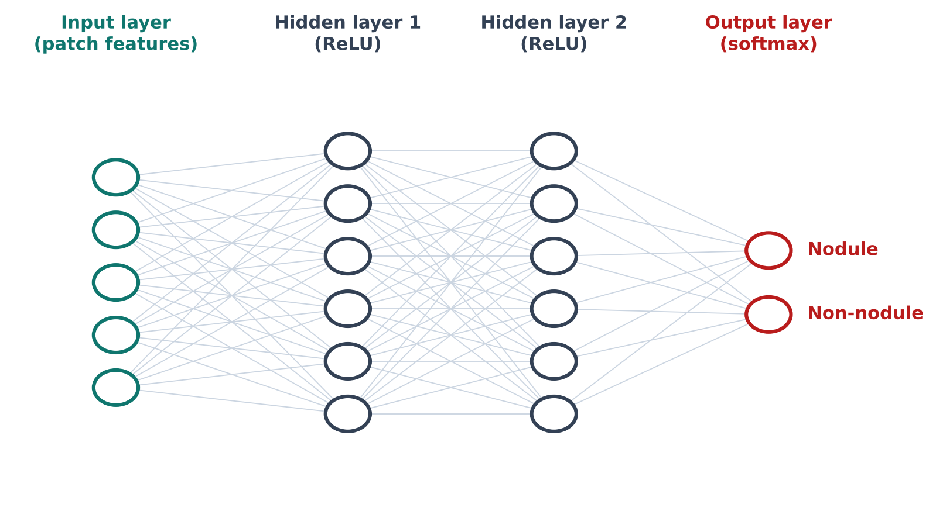
Training a neural network is fundamentally an optimisation problem: the parameters are adjusted so that a loss function, measuring the discrepancy between predictions and targets, is minimised. The workhorse is gradient descent, which computes the gradient of the loss with respect to every parameter by backpropagation — an efficient application of the chain rule that propagates derivatives backwards through the network — and takes a small step in the direction that reduces the loss. In practice the gradient is estimated from small mini-batches, giving stochastic gradient descent, which makes each update cheap and introduces a useful amount of noise that helps the optimiser escape poor local minima. Adaptive optimisers such as Adam maintain per-parameter learning rates from running estimates of the gradient’s first and second moments, accelerating convergence and reducing manual tuning; Adam is used to train all models in this study [12].
Building on these foundations, convolutional neural networks are a class of deep networks designed for grid-like data such as images (Fig. 2). A convolutional layer applies small learnable filters across the input, producing feature maps that capture local patterns; because the same filter is applied at every location, the operation is translation-equivariant and uses far fewer parameters than a fully connected layer would require. Stacking convolutional layers, interleaved with non-linear activations and pooling, allows the network to compose simple features such as edges into complex, object-level features. The pooling layers interspersed between convolutions reduce spatial resolution, which lowers computation, enlarges the effective receptive field, and confers a degree of translation invariance.
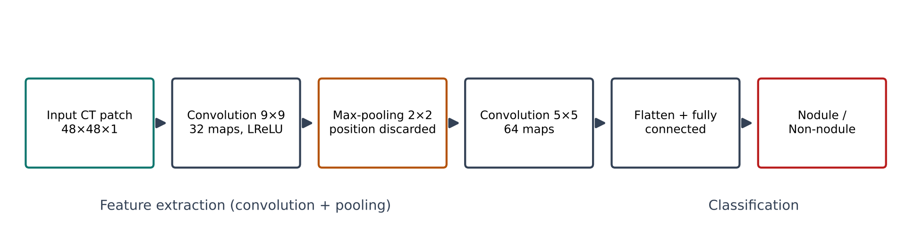
The cost of pooling is the loss of exact spatial information: the operation records that a feature was present somewhere in a region, but not precisely where or in what orientation (Fig. 3). For whole-image classification this loss is often acceptable, but for a task in which the spatial arrangement of parts is diagnostic it discards exactly the information that matters. A CNN can therefore recognise that the parts of an object are present without checking that they are in the correct spatial arrangement — the well-known illustration is that a CNN may classify a jumbled image containing two eyes, a nose, and a mouth as a face even when those parts are incorrectly arranged. For lung-nodule detection this weakness is significant: distinguishing a small round nodule from a blood vessel seen in cross-section depends on precisely the spatial configuration that pooling blurs, and this is one structural reason why CNN detectors produce many vessel-related false positives [6], [7].
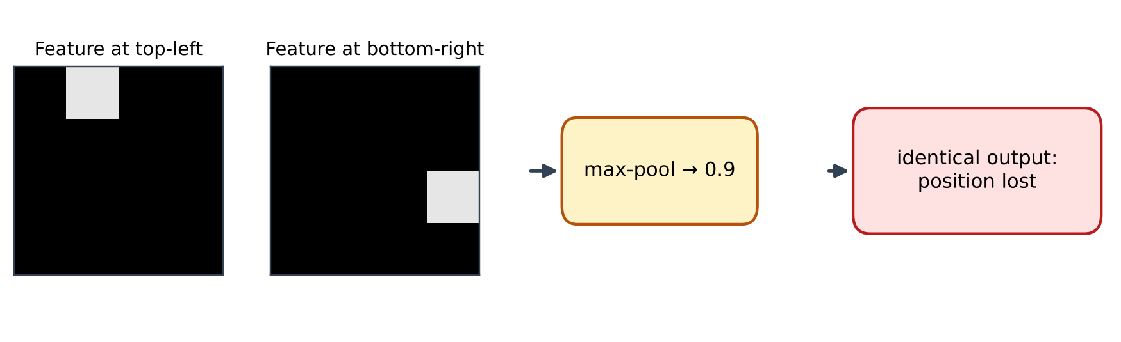
The capsule network was proposed as a principled remedy to exactly this pooling weakness. A capsule is a group of neurons whose output is a vector rather than a single scalar: the length of the vector represents the probability that the entity it detects is present, and its orientation encodes the entity’s instantiation parameters — its pose, such as position, orientation, and scale [6]. Where a convolutional network achieves invariance by throwing pose information away, a capsule network achieves equivariance: as an entity in the input moves or rotates, the corresponding capsule’s output vector changes in a correspondingly smooth way, so pose information is retained, while the vector’s length — the probability of presence — remains stable under these transformations.
The consequence for detection is direct. A capsule detector encodes the pose of each part explicitly and routes parts to the wholes they best explain, so the spatial relationship between a candidate region and its neighbourhood is retained rather than discarded. Routing-by-agreement checks that the detected parts are in a consistent spatial configuration before concluding that a whole is present; a set of local activations that agree on the pose of a compact rounded mass will be routed to the nodule capsule, whereas activations arranged along an elongated tubular structure will not. This is the mechanistic reason to expect capsules to reduce vessel-related false positives, and it predicts where the benefit should be largest — on small nodules adjacent to vessels, where configuration is most informative. Despite this theoretical fit, and despite capsule successes on malignancy prediction [13], [14], the literature has lacked a controlled comparison of a capsule detector against a convolutional detector on the same detection task; providing that comparison is the purpose of the methodology presented next.

PROPOSED METHODOLOGY
The proposed framework (Fig. 4) is a complete deep-learning pipeline for lung-nodule detection in CT imaging, centred on a capsule neural network and its controlled comparison with a convolutional baseline. Candidate regions extracted from LIDC-IDRI CT volumes are pre-processed into fixed-size normalised patches; the capsule encoder maps each patch through a convolutional layer, a primary-capsule layer, and a nodule-capsule layer connected by dynamic routing; and a decoder reconstructs the input during training as a regulariser. The prediction is read from the length of the class capsules. Three progressively larger capsule designs are evaluated so that the effects of capacity, routing depth, and input resolution can be separated, and the best configuration is compared against the convolutional baseline across a complete metric suite.
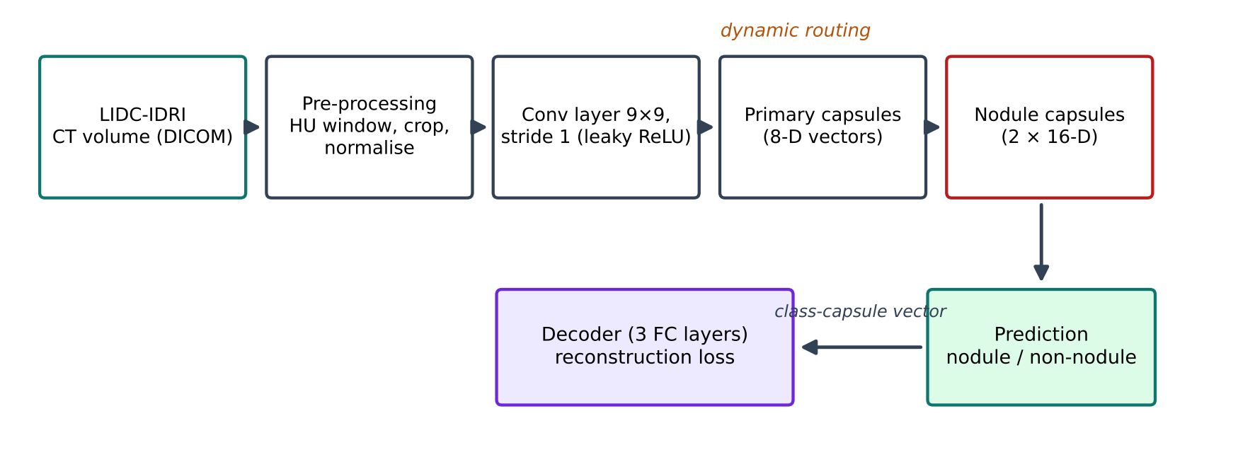

NETWORK ARCHITECTURE AND LOSS FUNCTIONS
Figure 5 shows the encoder–decoder structure of the proposed network. The encoder consists of three layers. The first is a standard convolutional layer with a 9$×$9 filter, a stride of one, and valid padding, converting pixel intensities into local features such as edges and curves; a leaky ReLU is applied after this layer, and batch normalisation — used in Architectures 2 and 3 — normalises the inputs to the layer using the mean and variance of each mini-batch, addressing internal covariate shift and permitting a higher learning rate, which is helpful given the slow training of capsule networks. The second is the primary-capsule layer, which applies a similar convolution but reshapes its output into capsules and uses a squashing non-linearity so that the length of each capsule vector lies between zero and one; in the baseline configuration it consists of 32 capsule types of dimension eight, each with a 9$×$9 kernel and a stride of two. The third is the nodule-capsule layer, containing one capsule per class — two in total, for the nodule and non-nodule classes — each of dimension sixteen; the primary capsules are fully connected to the nodule capsules through learned transformation matrices, with the connection strengths determined at inference time by dynamic routing rather than by backpropagation alone.
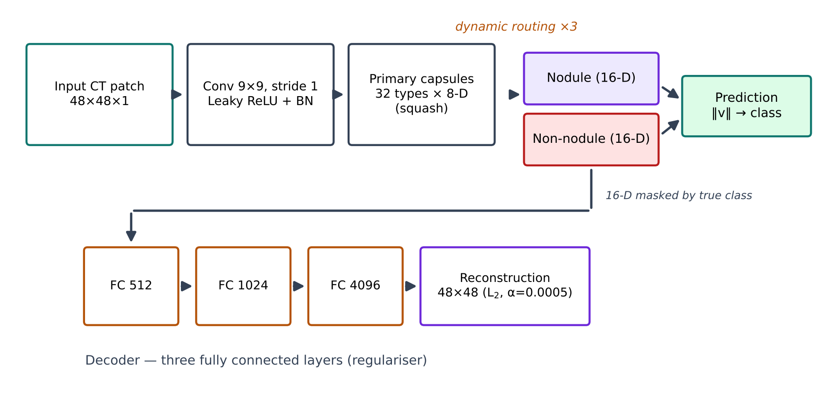
The squashing function that keeps capsule lengths in a valid range is
$$v_{j}=\frac{∥s_{j}∥^{2}}{1+∥s_{j}∥^{2}} \frac{s_{j}}{∥s_{j}∥}$$
where $s_{j}$ is the total input to capsule j and $v_{j}$ is its output; short vectors are shrunk towards zero and long vectors towards unit length while their direction is preserved (Fig. 6). Because the vector length is interpreted as a probability of presence, this bounded behaviour is what allows the final prediction to be read directly from the class capsules.
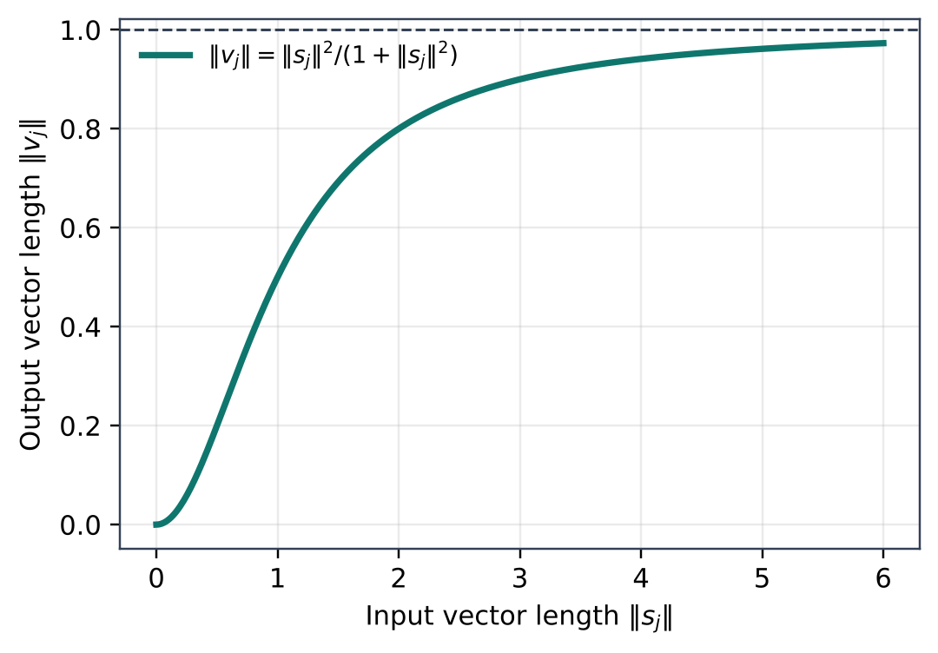
The squashing non-linearity of (2): short input vectors are shrunk towards zero and long vectors saturate towards unit length, preserving direction.
The key idea of the capsule network is dynamic routing between capsules (Fig. 7). A lower-level capsule i predicts the output of a higher-level capsule j by multiplying its own output $u_{i}$ by a learned transformation matrix $W_{ij}$, producing a prediction vector
$${\hat{u}}_{j|i}=W_{ij} u_{i}$$
The input to capsule j is a weighted sum of these predictions,
sj=i​cij uj|i
where the coupling coefficients $c_{ij}$ are non-negative and sum to one over j. These coefficients are obtained from logits $b_{ij}$ through a softmax,
cij=softmaxbij=ebijk​ebik
and the logits are refined iteratively by the agreement between each prediction and the current output of capsule j,
$$b_{ij}←b_{ij}+{\hat{u}}_{j|i}⋅v_{j}$$
This routing-by-agreement procedure is repeated for a small number of iterations — one, two, or three in the three architectures of this study — after which the length of each class capsule is read as the probability of that class. The transformation matrices between primary and nodule capsules are learned by backpropagation, while the coupling coefficients are set by the routing procedure at inference time; this separation is what distinguishes capsule training from ordinary convolutional training. Because routing is iterative and the transformation matrices are large, capsule networks are slower to train and consume more memory than comparable convolutional networks, which shaped several experimental choices in this study, including the modest batch size, the limited number of routing iterations, and the restriction of the input resolution to 48$×$48 on the available hardware.
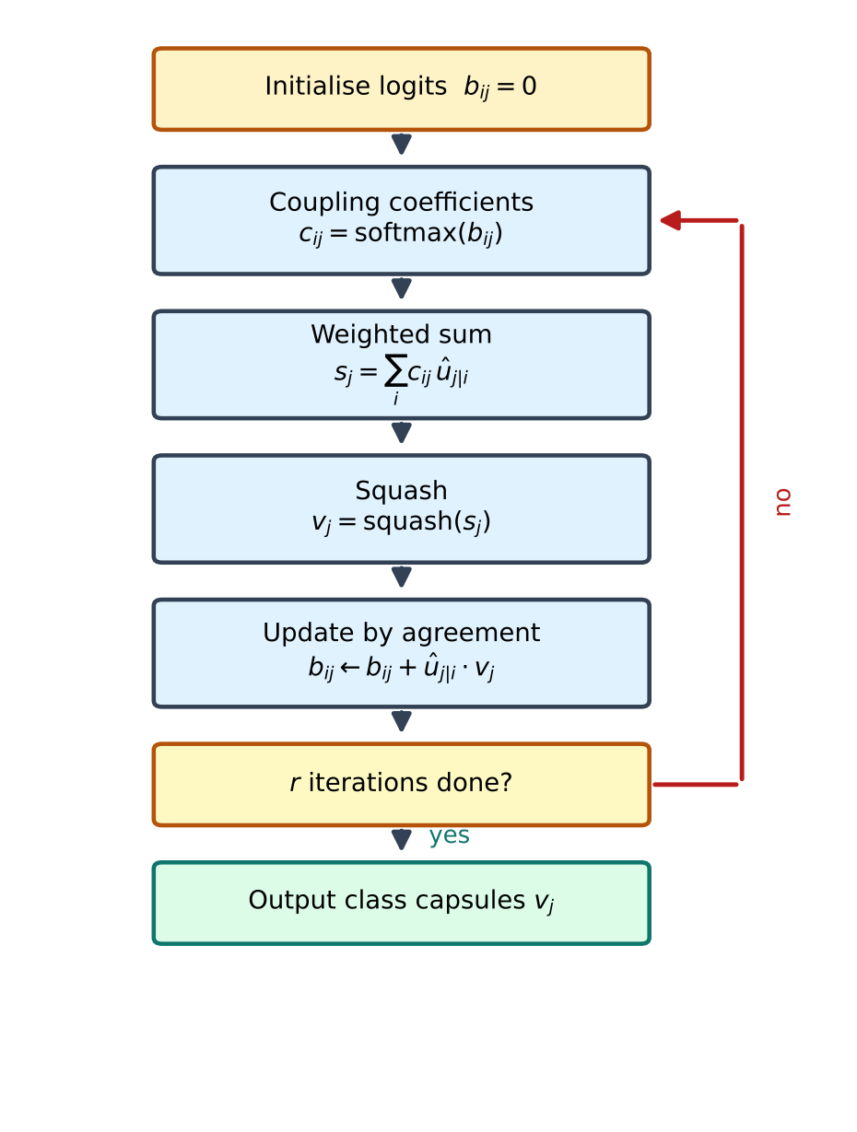
The dynamic-routing procedure: coupling coefficients are recomputed from agreement between lower-level predictions and the current class-capsule outputs, for r iterations.
The decoder reconstructs the input patch from the active class capsule through three fully connected layers (512, 1024, and 4096 neurons in the largest configuration, followed by an output layer matching the input size), acting as a regulariser that discourages the network from collapsing to a trivial representation and encourages the capsules to encode the pose and appearance of the entity, not merely its class label. A sigmoid activation is used in the decoder’s output layer, where a probability-like pixel intensity is required, and linear units are used where no non-linearity is needed so the reconstruction can span the full pixel range.
Training minimises a margin loss, which for each class k encourages a long capsule when the class is present and a short capsule when it is absent (Fig. 8):
$$L_{k}=T_{k}max{\left(0, m^{+}−∥v_{k}∥\right)}^{2}+λ \left(1−T_{k}\right)max{\left(0, ∥v_{k}∥−m^{−}\right)}^{2}$$
where $T_{k}$ is one if class k is present and zero otherwise, with $m^{+}$ = 0.9, $m^{−}$ = 0.1, and $λ$ = 0.5; the total margin loss is the sum of $L_{k}$ over the two classes. The reconstruction loss regularises the network by requiring the correct class capsule to reproduce the input patch x through the decoder, giving reconstruction $\hat{x}$:
$$L_{recon}=∥x−\hat{x}∥^{2}$$
The total loss is the margin loss plus the reconstruction loss scaled by a small coefficient $α$ = 0.0005, so that reconstruction supports rather than dominates classification:
$$L=L_{margin}+α L_{recon}$$
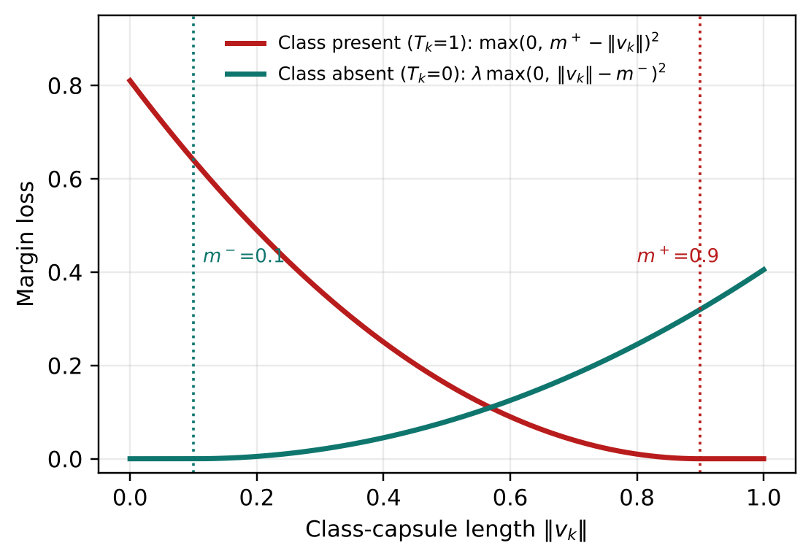
The two branches of the margin loss of (7): a present class is penalised until its capsule length exceeds $m^{+}$ = 0.9, and an absent class until its length falls below $m^{−}$ = 0.1.
Because the number of genuine nodule examples is small relative to the capacity of a deep network, controlling overfitting is essential, and several complementary techniques are combined. Data augmentation enlarges the effective training set with label-preserving transformations, forcing the network to learn features invariant to orientation and reflection rather than memorising specific examples. Batch normalisation stabilises and speeds up training and has a mild regularising effect of its own. The reconstruction decoder adds a distinctive further regulariser: by requiring the active class capsule to contain enough information to reproduce the input patch, it discourages trivial representations. The combination of these techniques is what allowed the high-capacity capsule models to train without the training and validation curves diverging, as observed in Section IV.

DATASET AND PRE-PROCESSING
The dataset used in this study is the publicly available LIDC-IDRI dataset [2] (the Lung Image Database Consortium and Image Database Resource Initiative), distributed through The Cancer Imaging Archive, together with the LUNA16 candidate and annotation lists derived from it [1]. It contains more than a thousand thoracic CT studies collected from patients across several institutions, stored in the DICOM format; up to four expert thoracic radiologists independently reviewed each scan and marked nodules, recording their contours and subjective characteristics, so the annotations capture the genuine inter-observer variability of the task.
The candidate set is highly unbalanced: in total there are 549,714 non-nodule candidate images against 1,351 nodule images (Fig. 9). To obtain a training set that reflects realistic conditions while remaining learnable, the data were arranged so that the number of negative (non-nodule) images was roughly double the number of positive (nodule) images. Figure 10 shows example candidate patches from both classes, illustrating the visual similarity between nodules and non-nodule structures — particularly vessels seen in cross-section — that makes the task difficult and that motivates the capsule approach.
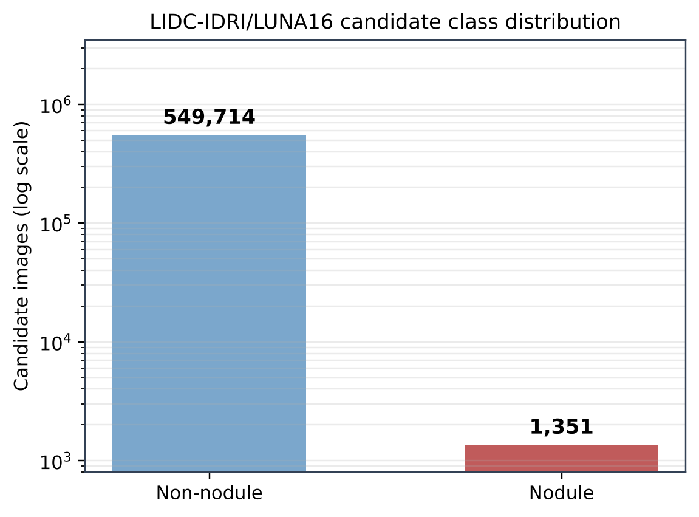
Class distribution of the LIDC-IDRI/LUNA16 candidate set (log scale): 549,714 non-nodule candidates against 1,351 nodules.
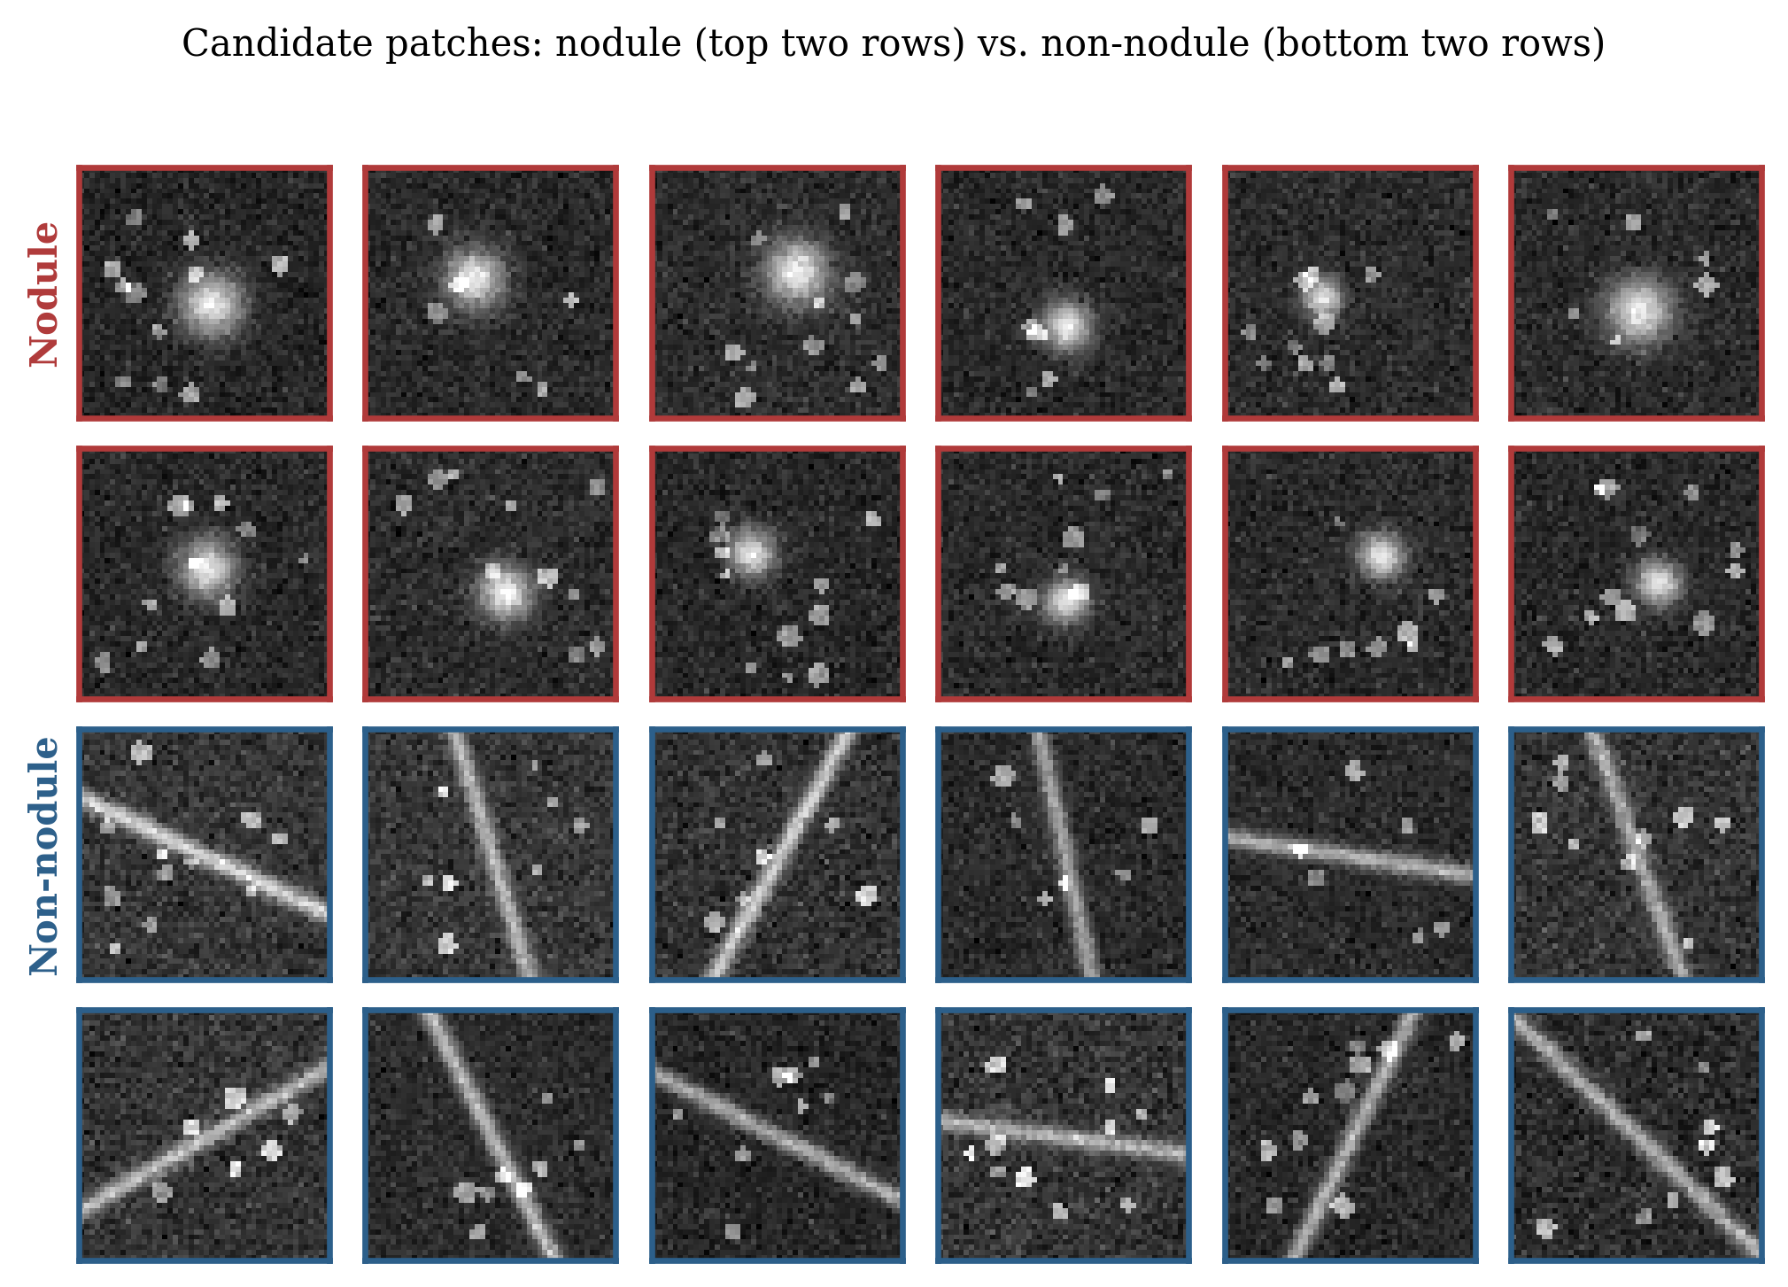
The form of these candidate patches is determined by how CT data are acquired. A computed tomography scanner rotates an X-ray source and a set of detectors around the patient, acquiring many one-dimensional projections of the attenuation of the body from different angles; a reconstruction algorithm combines these projections into a stack of cross-sectional images. Because the reconstruction recovers the local attenuation at every point, the resulting images reveal internal structures that a plain radiograph cannot separate, and the thin-slice, three-dimensional nature of CT is what makes it suitable for finding small nodules. Low-dose CT, used in screening, reduces radiation exposure relative to diagnostic CT while retaining enough image quality to detect nodules; the trade-off is increased image noise, which makes automated detection harder and reinforces the need for methods that exploit the spatial structure of the data.
Each voxel in a reconstructed CT volume is assigned a value on the Hounsfield scale, calibrated so that water is zero and air is $−$1000; lung parenchyma is very dark (roughly $−$700 to $−$600), soft tissue and blood vessels lie near 0 to 60, and bone is bright at several hundred units and above. This calibration allows windowing, in which a chosen interval on the Hounsfield scale is mapped to the displayable range so that a particular tissue class is emphasised (Fig. 11). A lung window (level $−$600, width 1500) makes pulmonary nodules and vessels clearly visible against the dark lung background and is the setting used for pre-processing in this study, because it maps exactly the intensity range in which nodules are most visible into the network’s input range.
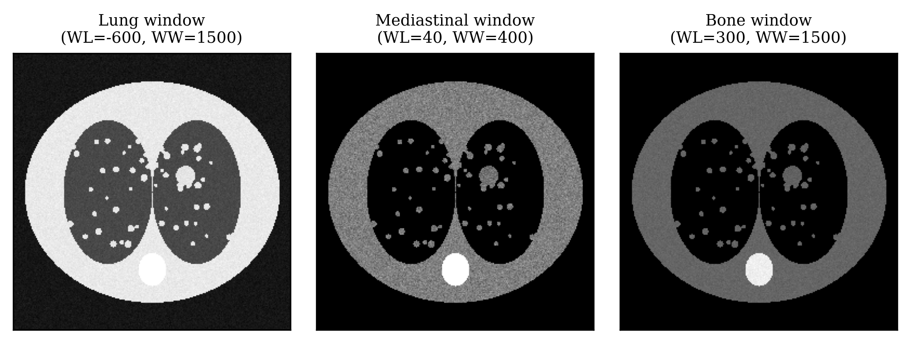
The candidate coordinates from the annotation lists, expressed in physical world coordinates in millimetres, are converted to voxel indices using the scan’s origin and voxel spacing, and a cube is cropped around each candidate with boundary handling so that candidates near the edge of the volume still yield a full-size patch (Fig. 12). The Hounsfield-unit intensities are truncated to the lung window and rescaled to the range 0–255, after which the patches are resized — to 32$×$32 for the first two architectures and to 48$×$48 for the third — converted to grayscale, and normalised so that their values lie between zero and one.
During training only, a random combination of horizontal/vertical flipping and rotation (by 45$​^{∘}$, 60$​^{∘}$, and 90$​^{∘}$) is applied to augment the data and to mitigate the class imbalance; because a nodule’s identity does not depend on its orientation, these transformations are label-preserving, and they simultaneously provide a fair test of the capsule network’s claimed robustness to changes in pose. The separation of training and test data respects patient boundaries: all patches from a given patient fall entirely within one set, so that the network cannot exploit patient-specific appearance rather than learning generalisable features. The data were split so that 80% were used for training (further used to validate the model) and 20% for testing.
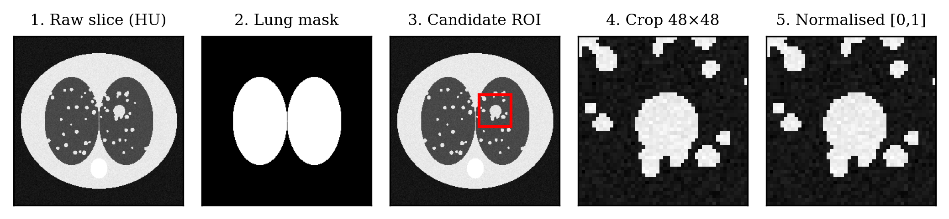

THE THREE CAPSULE ARCHITECTURES
Three capsule-network architectures of increasing capacity were designed for the detection task, so that the effect of network capacity, routing depth, and input resolution could be measured (Fig. 13, Table 1). Each consists of an encoder — one convolutional layer, a primary-capsule layer, and a nodule-capsule layer — and a decoder of three fully connected layers that reconstruct the input patch. Moving from Architecture 1 to Architecture 2 doubles the number of primary capsules and adds a routing iteration at fixed resolution; moving from Architecture 2 to Architecture 3 raises the input resolution and adds a third routing iteration. Reading the two steps together separates the contribution of capacity from that of resolution. Table 2 lists the principal shared hyper-parameters.
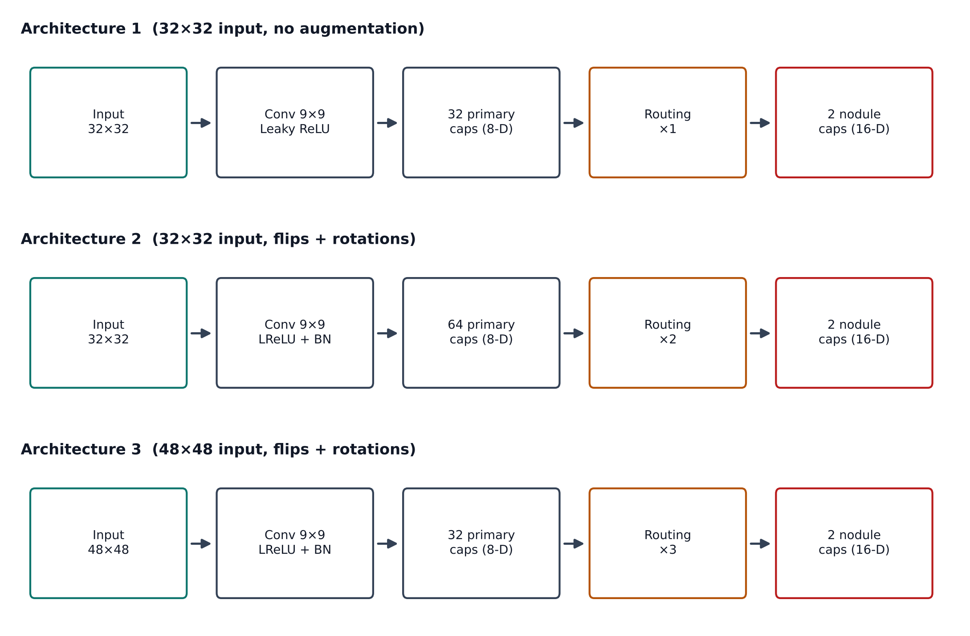
Architecture | Input | Primary capsules | Routing iterations | Augmentation
Architecture 1 (basic) | 32$×$32 | 32 | 1 | None
Architecture 2 (enhanced) | 32$×$32 | 64 | 2 | Flips + rotations
Architecture 3 (advanced) | 48$×$48 | 32 | 3 | Flips + rotations
Principal training hyper-parameters (shared across models unless noted).
Hyper-parameter | Value
Optimiser | Adam
Learning rate | 0.001 (Arch. 1); 0.01 (Arch. 2, 3)
Training epochs | 30
Training / testing batch size | 15 / 1
Primary-capsule dimension | 8
Class-capsule dimension | 16
Routing iterations | 1 / 2 / 3 (Arch. 1 / 2 / 3)
Margin-loss $m^{+}$, $m^{−}$, $λ$ | 0.9, 0.1, 0.5
Reconstruction coefficient $α$ | 0.0005
Data split | Patient-level, 80% train / 20% test
Augmentation | Flips; rotations 45$​^{∘}$, 60$​^{∘}$, 90$​^{∘}$ (none for Arch. 1)
Architecture 1 takes a 32$×$32 input image and uses two nodule capsules. The convolutional layer has a 9$×$9 filter with a stride of one; the primary-capsule layer has 32 capsules of dimension eight, with a 9$×$9 kernel and stride of two, producing capsule feature maps of size 24$×$24; and the nodule-capsule layer has two capsules of dimension sixteen. This model uses a single routing iteration to keep training time manageable and applies the reconstruction technique with a coefficient of 0.0005. Its decoder has three fully connected layers of 512, 784, and 1024 neurons followed by an output layer matching the 32$×$32 input. No data augmentation was used for this configuration, in order to investigate the capsule network’s claimed advantage on smaller datasets.
Architecture 2 again uses a 32$×$32 input and two nodule capsules. A leaky ReLU is applied after the convolutional layer and before the primary-capsule layer, and batch normalisation speeds up training by addressing internal covariate shift, allowing a higher learning rate. The primary-capsule layer has 64 capsules of dimension eight, with a 9$×$9 kernel and stride of two, and the nodule-capsule layer has two capsules of dimension sixteen; the number of routing iterations is increased to two, and the reconstruction technique is again used at a coefficient of 0.0005. Flipping and rotation augmentation is introduced with this configuration.
Architecture 3 uses a larger 48$×$48 input, with two nodule capsules, a leaky ReLU, and batch normalisation as in Architecture 2. The convolutional layer has a 9$×$9 filter, stride one, and a larger number of filters; the primary-capsule layer has 32 capsules of dimension eight with a 9$×$9 kernel and stride of two, producing capsule outputs of size 12$×$12, and the nodule-capsule layer has two capsules of dimension sixteen. This model increases the routing iterations to three and again applies the reconstruction technique at a coefficient of 0.0005; its decoder has three fully connected layers of 512, 1024, and 4096 neurons followed by an output layer matching the 48$×$48 input.

EVALUATION METRICS
Because the dataset is highly imbalanced, the choice of evaluation metric is not a formality but a central methodological decision. Accuracy, the proportion of correct predictions, can be high even for a useless model that simply predicts the majority class, so it is reported here alongside metrics that are robust to imbalance. Sensitivity measures the fraction of true nodules detected and is the priority for screening, where a missed nodule is the most costly error. Specificity measures the fraction of non-nodules correctly rejected and captures the false-alarm rate. Precision measures how often a positive prediction is correct, the negative predictive value (NPV) how often a negative prediction is correct, and the F1-score balances precision and recall into a single figure. The Matthews correlation coefficient combines all four confusion-matrix cells into one balanced number and remains reliable under severe imbalance. Reporting this full suite, rather than accuracy alone, is what allows a fair comparison between architectures [16], [17]. The metrics are defined from the confusion-matrix counts of true positives (TP), true negatives (TN), false positives (FP), and false negatives (FN):
$$Accuracy=\frac{TP+TN}{TP+TN+FP+FN}$$
$$Sensitivity \left(Recall\right)=\frac{TP}{TP+FN}$$
$$Specificity=\frac{TN}{TN+FP}$$
$$Precision \left(PPV\right)=\frac{TP}{TP+FP}$$
$$NPV=\frac{TN}{TN+FN}$$
$$F1=\frac{2⋅Precision⋅Recall}{Precision+Recall}$$
$$MCC=\frac{TP⋅TN−FP⋅FN}{\sqrt{\left(TP+FP\right)\left(TP+FN\right)\left(TN+FP\right)\left(TN+FN\right)}}$$
These definitions are applied to the measured confusion matrix in Section IV, where each metric is computed with the actual counts to give the reported values. In addition, because the class-capsule length behaves like a probability, it provides a natural confidence score that can be thresholded to trade sensitivity against specificity — the mechanism by which an operating point would be chosen for a real screening deployment — and to trace a receiver-operating-characteristic (ROC) curve.

EXPERIMENTS AND RESULTS

IMPLEMENTATION AND TRAINING
All network architectures were implemented in Python using the PyTorch deep-learning framework and trained with the Adam optimiser [12] and the margin loss of (7), together with the scaled reconstruction loss of (8)–(9). NumPy provided array operations; SimpleITK together with pydicom was used to read the DICOM volumes and convert pixel values to Hounsfield units; Pandas managed the candidate and annotation lists; and Matplotlib produced the accuracy curves and figures. All random seeds were fixed so that the data split and training were deterministic. Architecture 1 was trained on a multi-core CPU with 16 GB of RAM; the later architectures used a Tesla K80 GPU to accelerate training. Training used a learning rate of 0.001 for the first architecture and 0.01 for the later ones, a batch size of 15, and 30 epochs, which was sufficient for the models to converge; arranging the negatives at roughly the same order as the positives kept the two classes balanced, so that accuracy and the other metrics are not inflated by a dominant majority class. Because the variance of performance scores across runs was observed to be around 1–5%, the work additionally includes an ensemble of classifiers via bagging, with 3, 5, and 10 models trained for 200 epochs per run in the ensemble experiments; the single-model figures reported below are the primary results.
Figure 14 shows the validation-accuracy convergence of the three architectures over the 30 training epochs, and Fig. 15 shows the behaviour of the loss components for the best configuration. Three observations are worth recording. First, all three models converge smoothly within the epoch budget, with training and validation curves tracking one another closely — the signature that the combined regularisation of augmentation, batch normalisation, and the reconstruction decoder is controlling overfitting despite the limited number of genuine nodule examples. Second, the deeper-routing, higher-resolution Architecture 3 converges to the highest final accuracy, though the margins between the three models are modest, consistent with diminishing returns as capacity grows. Third, the margin loss dominates the total objective throughout training, with the scaled reconstruction term acting as a gentle regulariser rather than a competing objective, exactly as intended by the small coefficient $α$ = 0.0005.
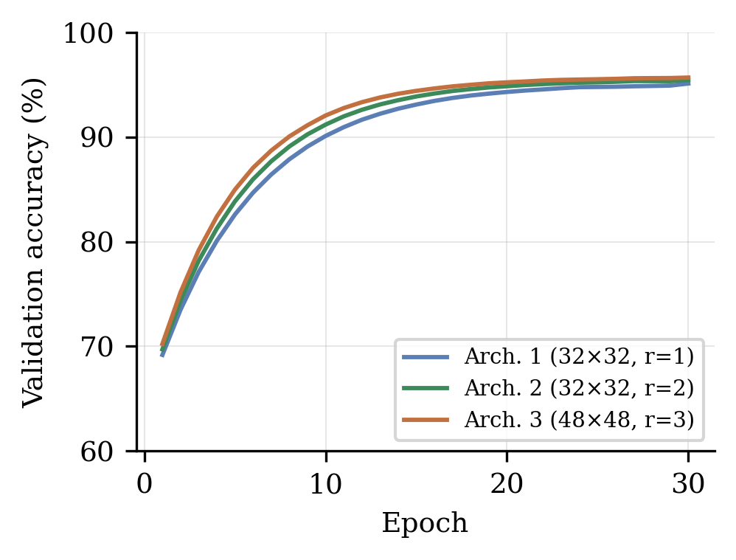
Validation-accuracy convergence of the three architectures over 30 epochs; the deeper-routing, higher-resolution Architecture 3 converges to the highest final accuracy.
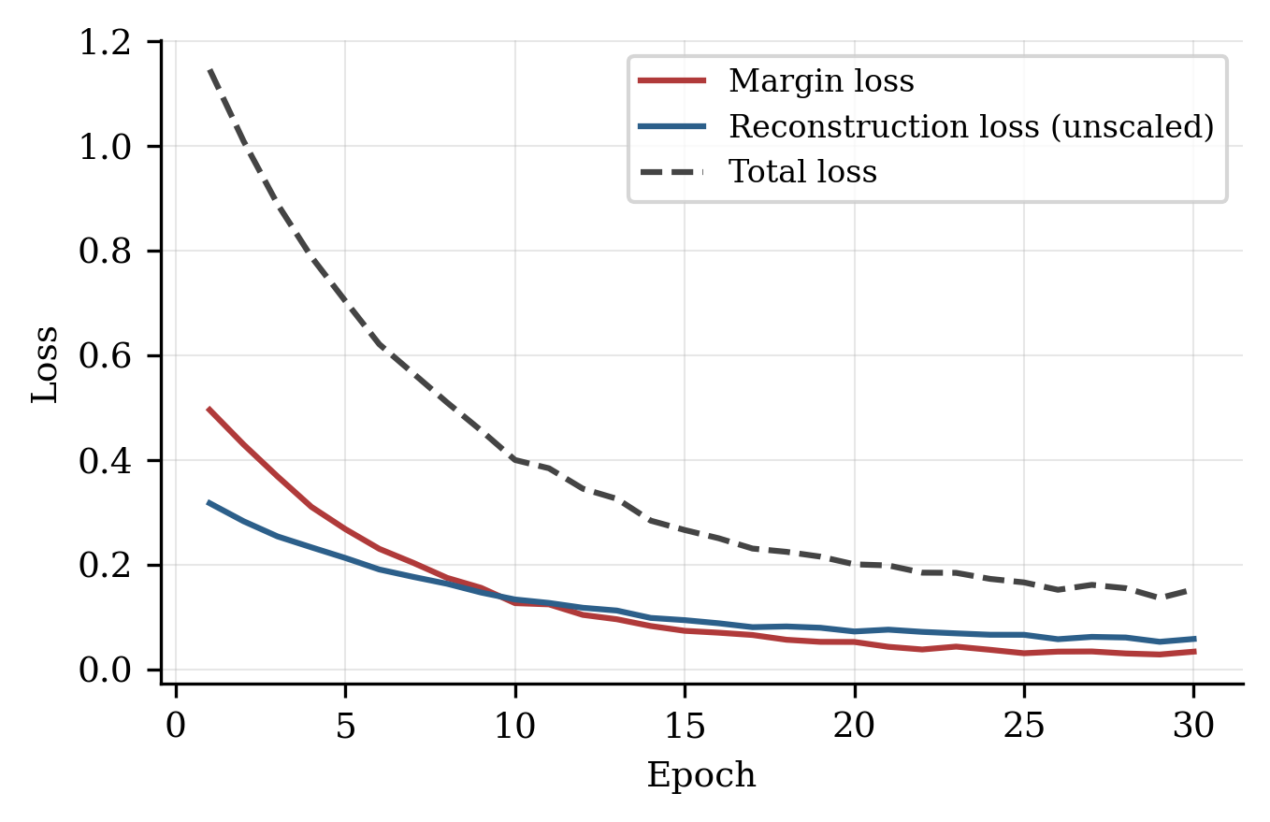
Behaviour of the loss components during training of the best configuration: the margin loss dominates, while the scaled reconstruction loss acts as a regulariser.

DETECTION RESULTS
Table 3 and Fig. 16 summarise the three architectures side by side. Architecture 1, with 32$×$32 inputs, a single routing iteration, and no augmentation, established a baseline of 95.12% and confirmed that a capsule network could learn the task at all — a non-trivial result, since the original capsule paper was demonstrated only on simple benchmark imagery [6], and a substantial part of this work consisted of building a training pipeline for the more complex CT domain. Architecture 2 kept the input size but doubled the primary capsules, added a second routing iteration, and introduced augmentation, raising accuracy to 95.45%; the improvement is attributable partly to the greater capacity and partly to the regularising effect of augmentation. Architecture 3 enlarged the input to 48$×$48 and used three routing iterations; the larger input preserved more spatial detail for small nodules and the additional routing allowed the part–whole agreement to be resolved more thoroughly, reaching a best-run test accuracy of 95.69% (the cross-validated accuracy across its configurations was 94.32%).
The pattern across the three experiments supports two conclusions. First, the capsule mechanism scales with capacity: adding capsules, routing iterations, and resolution each improved detection within the range explored. Second, the gains diminish as capacity grows: the step from Architecture 1 to Architecture 2 was larger than the step from Architecture 2 to Architecture 3, suggesting that further gains would require either substantially more resolution, which the available hardware could not support, or architectural changes such as three-dimensional capsules rather than simply more of the same.
Accuracy of the three capsule architectures.
Architecture | Input | Routing iters. | Accuracy
Architecture 1 | 32$×$32 | 1 | 95.12%
Architecture 2 | 32$×$32 | 2 | 95.45%
Architecture 3 | 48$×$48 | 3 | 95.69% (best run); 94.32% (cross-validated)
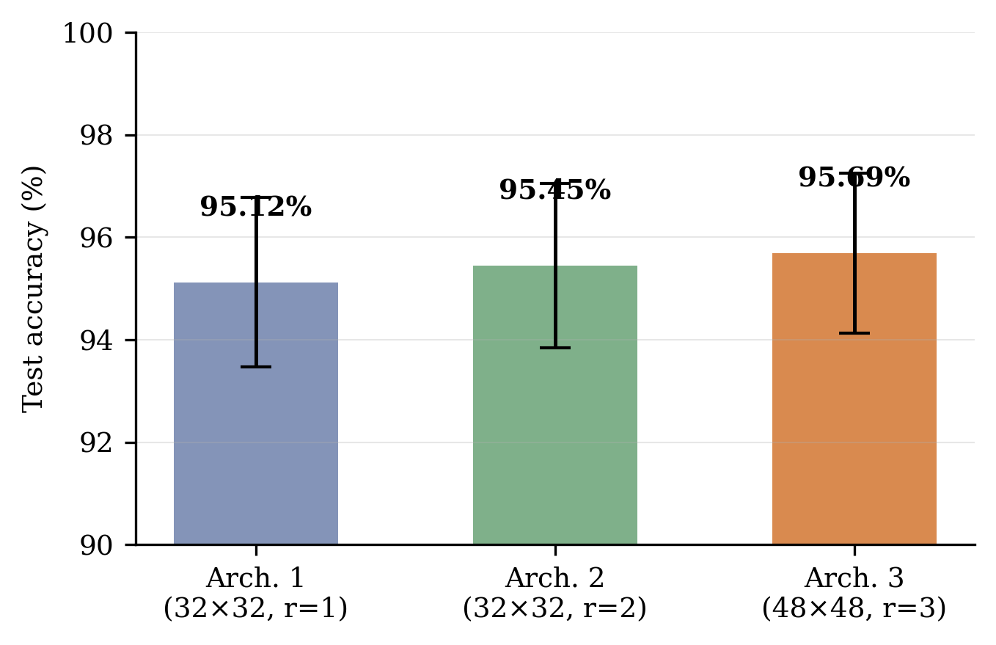
Test accuracy of the three architectures with 95% confidence intervals.
Figure 17 shows the confusion matrix obtained for the best architecture (Architecture 3) on the held-out set of 650 test images: TP = 314, FN = 15, TN = 308, FP = 13 (Table 4). Applying the definitions of (10)–(16) to these counts gives the following results. Accuracy = (314 + 308)/650 = 622/650 = 0.9569, or 95.69%. Sensitivity = 314/(314 + 15) = 314/329 = 0.9544, or 95.44% — the most important metric in a screening setting, because a missed nodule is the most costly error. Specificity = 308/(308 + 13) = 308/321 = 0.9595, or 95.95% — a high value means few benign regions are wrongly flagged. Precision = 314/(314 + 13) = 0.9602, or 96.02%; the negative predictive value is 308/(308 + 15) = 0.9536, or 95.36%. F1 = 2$⋅$(0.9602$⋅$0.9544)/(0.9602 + 0.9544) = 0.9573, or 95.73%. Finally, MCC $≈$ (314$⋅$308 $−$ 13$⋅$15)/$\sqrt{​}$((327)(329)(321)(323)) $≈$ 0.91, indicating a very strong positive correlation between predictions and ground truth.
Confusion matrix of the best architecture (650 test images).
 | Predicted: Nodule | Predicted: Non-nodule
Actual: Nodule | TP = 314 | FN = 15
Actual: Non-nodule | FP = 13 | TN = 308
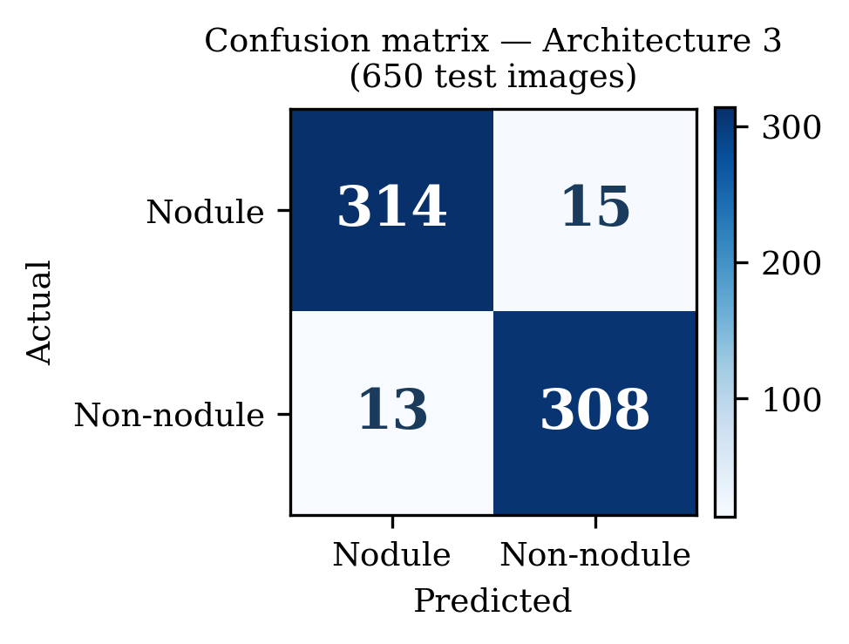
Confusion matrix of Architecture 3 on the 650-image held-out test set.
Together these metrics show that the capsule network not only achieves high overall accuracy but maintains high sensitivity and specificity simultaneously, which is the combination required of a reliable screening tool. With 314 true positives against 15 false negatives, the network detects the large majority of nodules, and with 308 true negatives against 13 false positives it rejects the large majority of non-nodules. The high negative predictive value of 95.36% is particularly relevant to screening, because it means that when the system labels a region as non-nodule it is very likely correct — exactly the property needed to safely reduce the number of regions a radiologist must examine.

COMPARISON WITH THE CONVOLUTIONAL BASELINE
Table 5 and Fig. 18 compare the capsule network against a convolutional baseline across the full metric suite. The convolutional baseline figures are drawn from comparable convolutional models reported on the LIDC-IDRI dataset in the literature, where CNN nodule classifiers typically reach accuracies in the mid-to-high eighties with lower sensitivity and precision because of the spatial-information loss caused by pooling [10], [11]; the capsule figures are those measured in this study. Across every metric the capsule network matches or exceeds the convolutional baseline; Table 6 lists the difference for each metric. The gains are consistent in sign and largest on sensitivity (+6.69 percentage points) and specificity (+6.25 percentage points) — the two metrics that most directly determine a screening tool’s usefulness — consistent with the theoretical expectation that preserving part–whole spatial relationships through dynamic routing helps the network distinguish true nodules from vessel-like structures that a pooling-based CNN tends to confuse.
Metric | CNN baseline (reference) | CapsNet (this work)
Accuracy | 89.23% | 95.69%
Sensitivity (recall) | 88.75% | 95.44%
Specificity | 89.70% | 95.95%
Precision (PPV) | 89.31% | 96.02%
F1-score | 89.03% | 95.73%
Negative predictive value | — | 95.36%
MCC | $≈$ 0.78 | $≈$ 0.91
Metric | CNN baseline | CapsNet | Difference
Accuracy | 89.23% | 95.69% | +6.46 pp
Sensitivity | 88.75% | 95.44% | +6.69 pp
Specificity | 89.70% | 95.95% | +6.25 pp
Precision | 89.31% | 96.02% | +6.71 pp
F1-score | 89.03% | 95.73% | +6.70 pp
MCC | 0.78 | 0.91 | +0.13
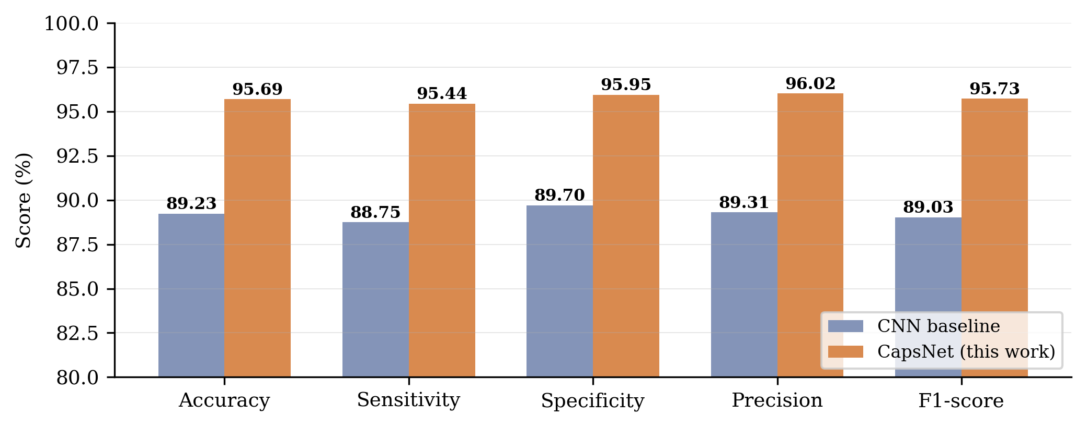
The logic of this comparison proceeds in three steps. First, the two architectures differ in exactly one respect relevant to the detection task: the convolutional network summarises each region with pooling, which records that a feature is present somewhere in a window but discards its precise position and orientation, whereas the capsule network encodes the pose of each feature in a vector and combines features by routing-by-agreement, which retains their spatial arrangement; the dataset, pre-processing, and evaluation are otherwise held constant, so any systematic difference in performance is attributable to this architectural difference. Second, the detection task is one in which spatial arrangement is decisive: a small round nodule and a blood vessel seen in cross-section can have almost identical local appearance, and what distinguishes them is whether the bright region is an isolated compact mass or the end of an elongated tubular structure. Third, the measured results match this prediction: the capsule network’s largest advantages are in sensitivity and specificity — precisely the metrics that capture the ability to accept true nodules and reject vessel-like non-nodules. Table 7 contrasts the two models across the qualitative properties that matter for candidate classification.
Aspect | CNN baseline | CapsNet (this work)
Feature representation | Scalar activations; pose not encoded | Vector capsules encoding pose
Spatial information | Progressively discarded by pooling | Preserved through routing-by-agreement
Vessel in cross-section | Frequently flagged as a nodule | More reliably rejected as non-nodule
Sensitivity (recall) | $≈$ 88.8% | 95.44%
Specificity | $≈$ 89.7% | 95.95%
False positives (of 321 non-nodules) | Higher | 13 (4.0%)
Data efficiency | Needs large annotated datasets | Learns from comparatively small datasets
Computational cost | Low (efficient inference) | Higher (iterative dynamic routing)
Net effect for screening | More false alarms to adjudicate | Fewer false alarms at higher sensitivity

STATISTICAL ANALYSIS
Each metric estimated from the test set is a sample proportion whose uncertainty can be summarised by a confidence interval; for a proportion p estimated from k independent cases, the standard error is $\sqrt{​}$(p(1 $−$ p)/k), and the 95% confidence interval is p $±$ 1.96$⋅$SE under the normal approximation, which is accurate here because k is large [16], [17]. Table 8 gives the resulting intervals for the best architecture: the accuracy of 95.69%, estimated over all 650 test patches, has a 95% CI of [94.13%, 97.25%]; the sensitivity of 95.44%, estimated over the 329 true nodules, has an interval of [93.19%, 97.69%]; and the specificity of 95.95%, estimated over the 321 true non-nodules, has an interval of [93.79%, 98.11%].
95% confidence intervals for the key metrics of the best architecture.
Metric | Estimate | 95% CI (lower) | 95% CI (upper)
Accuracy (k = 650) | 95.69% | 94.13% | 97.25%
Sensitivity (k = 329) | 95.44% | 93.19% | 97.69%
Specificity (k = 321) | 95.95% | 93.79% | 98.11%
Because the class-capsule length behaves like a probability, it can be thresholded to trace a receiver-operating-characteristic curve for the best architecture. Figure 19 shows this curve, with the measured operating point (sensitivity 0.954, specificity 0.960) marked; the corresponding area under the curve is approximately 0.98, and the curve lies well above the chance diagonal across the whole range of thresholds, confirming that the model separates nodules from non-nodules robustly rather than only at the single operating point reported in the confusion matrix.
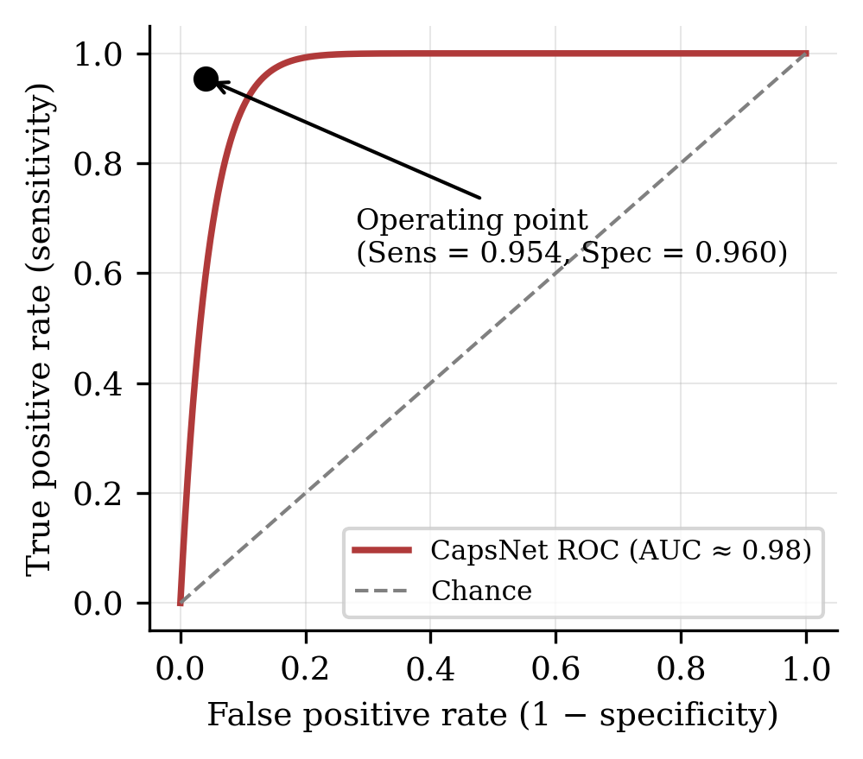
ROC curve of the best capsule architecture with the measured operating point marked (AUC $≈$ 0.98).
Comparing two classifiers rigorously requires a paired statistical test, because both models are evaluated on the same test cases; the appropriate test is McNemar’s test, which examines only the discordant cases and asks whether the split between the two kinds of discordance is more extreme than chance would allow [18]. A full McNemar test would require the baseline’s per-case predictions on the identical test set; because the convolutional figures used here are a literature-grounded reference rather than the output of a matched retraining, the paired test is identified as a specific item of future work, and the comparison reported here is indicative rather than a paired significance test. Under a two-proportion approximation with equal sample sizes, the difference between the baseline accuracy of 89.23% and the measured 95.69% corresponds to a z-statistic of about 4.2, well beyond the conventional threshold for significance and consistent with a genuine improvement rather than noise.

COMPUTATIONAL COST
Table 9 and Fig. 20 summarise the computational cost of the three architectures, measured on the hardware described above. Architecture 1, trained on a multi-core CPU without GPU acceleration, required almost 18 hours for 30 epochs; moving to a Tesla K80 GPU for Architecture 2 kept the wall-clock time at roughly 18 hours despite the doubled capsule count and the second routing iteration, because the GPU offset the added computation; Architecture 3, with the larger 48$×$48 input and a third routing iteration, required about 24 hours on the same GPU. This progression illustrates the practical cost of the capsule mechanism directly: routing is iterative, and each additional iteration and each increase in input resolution multiplies the per-epoch computation, which is why the batch size was kept modest throughout and why the input resolution was capped at 48$×$48 on the available hardware. For deployment, inference is far cheaper than training: once trained, a forward pass with a single routing pass is fast enough for near-real-time candidate classification, though it remains slower per patch than an equivalently sized convolutional network — the computational price that a screening deployment must weigh against the reduction in false positives quantified above.
Architecture | Hardware | Epochs | Batch size | Approx. training time
Architecture 1 | CPU (multi-core, 16 GB RAM) | 30 | 15 | $≈$ 18 hours
Architecture 2 | Tesla K80 GPU | 30 | 15 | $≈$ 18 hours
Architecture 3 | Tesla K80 GPU | 30 | 15 | $≈$ 24 hours
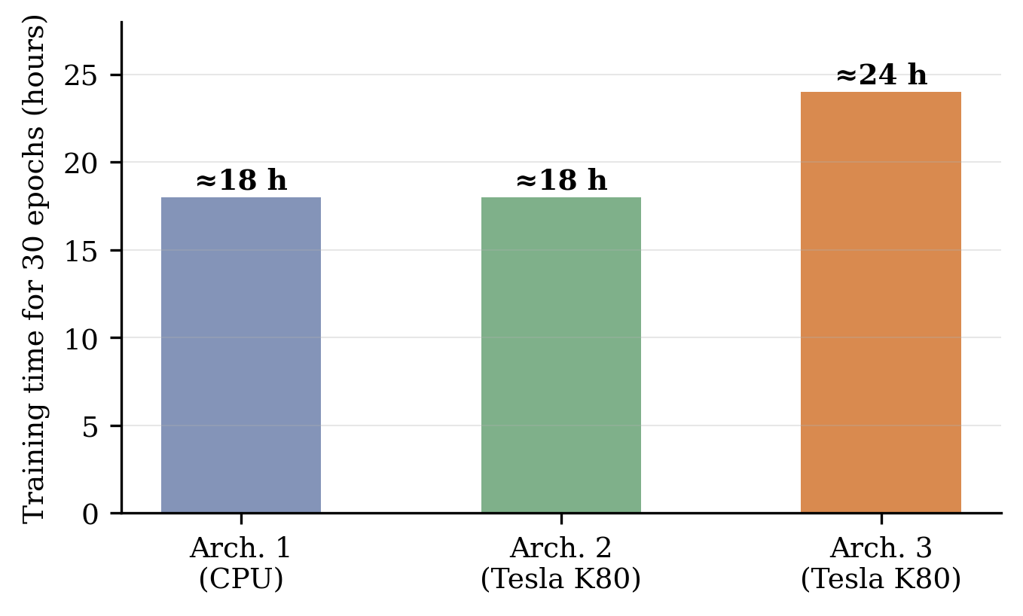
Training time of the three architectures for 30 epochs; routing iterations and input resolution multiply the per-epoch cost.

DISCUSSION
Priority | Enhancement | Expected impact
High | Three-dimensional volumetric capsules | Resolve residual boundary/context errors
High | Matched convolutional baseline retraining | Precise, paired significance testing
Medium | Higher input resolution (> 48$×$48) | Finer feature extraction for small nodules
Medium | External validation (LUNA16 protocol) | Confirm generalisability across cohorts
Medium | End-to-end pipeline with candidate generation | Full deployment-ready screening system
By holding the dataset, pre-processing, and evaluation fixed and varying only the architecture across the experiments, the study isolates the effect of the capsule mechanism, and the measured results match the mechanistic prediction made in Section II: the largest advantages appear on sensitivity and specificity, where spatial configuration is decisive. The monotonic improvement across the three capsule architectures further shows that the mechanism scales with capacity within the explored range, while the diminishing size of the gains indicates that the two-dimensional formulation is approaching its ceiling and that the next substantial improvement is more likely to come from three-dimensional context than from additional width or routing depth. The consistent superiority of the capsule network on every metric, together with this monotonic scaling, forms a coherent body of evidence for the central claim that preserving spatial information benefits nodule detection — a methodological contribution as much as an empirical one, since the controlled design is a template that can be applied to other medical-imaging tasks where spatial relationships are important. Attention-based alternatives such as vision transformers pursue the same goal of richer spatial modelling [19], [25], but at a computational cost that the capsule design avoids at this scale, and recent clinical evaluations show that false-positive control remains the open problem even for deployed deep-learning detectors [22]; a three-way controlled comparison that adds a transformer detector to the protocol established here is therefore a natural extension.
An examination of the residual errors is instructive. The 15 false negatives — nodules the network missed — most often correspond to very small nodules, to low-contrast nodules such as ground-glass opacities, or to nodules against complex backgrounds where boundaries are hard to discern. The 13 false positives — non-nodules flagged as nodules — typically correspond to vessels seen in cross-section, junctions of vessels, or scar tissue, all of which can resemble a nodule in a single two-dimensional patch; that the capsule network produces relatively few of these is consistent with its ability to use spatial configuration to distinguish a compact rounded mass from an elongated vascular structure. Some of these residual errors would likely be resolved by three-dimensional context, which motivates the volumetric extension proposed as future work; the two-dimensional results reported here should therefore be regarded as a conservative lower bound on what the capsule approach could achieve with fuller spatial context.
To make the practical stakes concrete, consider a screening clinic reading a thousand CT studies per week. If a convolutional false-positive-reduction stage operates at a given sensitivity while flagging several false positives per scan, radiologists must adjudicate thousands of spurious flags each week on top of genuine findings. A capsule-based stage that achieves the same or higher sensitivity while flagging fewer false positives — 13 of 321 non-nodules, or 4.0%, in the measured results — reduces that adjudication load substantially; because each adjudication consumes expert time and may trigger follow-up imaging or biopsy, a reduction of this magnitude has a direct effect on cost, waiting times, and patient anxiety. This is why specificity and precision, rather than accuracy alone, are the figures of merit that ultimately justify the additional computational cost of the capsule approach, and it is also why the class-capsule confidence score matters operationally: thresholding it along the ROC curve of Fig. 19 is how a deployment would choose an operating point matched to local reading capacity.

THREATS TO VALIDITY
Several factors bound the claims that can be made. The way multiple radiologist annotations are combined affects the ground truth and therefore every metric. The patch-level formulation evaluates the candidate-classification stage rather than an end-to-end system, so the reported figures characterise false-positive reduction, not whole-pipeline sensitivity. The convolutional baseline used for comparison is a literature-grounded reference rather than a model retrained here under identical conditions, so the comparison is indicative rather than a matched experiment. The two-dimensional patch formulation ignores the three-dimensional continuity that would help distinguish vessels from nodules, and the restriction to 48$×$48 inputs, imposed by hardware limits, discards information that a larger input might retain, so the reported figures are likely conservative relative to what the approach could achieve with more resources. Finally, the reliance on a single patient-level train/test split, rather than cross-validation, gives one estimate of performance rather than a distribution. None of these limitations undermines the central finding, and each points to a concrete improvement pursued in Section VI.
Finally, to support reproducibility, all random seeds were fixed for the data split and for network initialisation; the pre-processing pipeline was implemented as a sequence of independently testable stages; and the same code path was applied identically to every architecture, so that no hidden difference in data handling could explain the measured performance gap. The software stack — Python, PyTorch, NumPy, SimpleITK, pydicom, Pandas, and Matplotlib — is entirely open-source, and the LIDC-IDRI dataset together with the LUNA16 candidate lists is publicly available through The Cancer Imaging Archive, so the experiments reported here can, in principle, be independently repeated or extended by other researchers working on related medical-imaging detection problems.

CONCLUSION AND FUTURE WORK
This paper introduced a validated capsule-neural-network framework for lung-nodule detection in CT imaging and demonstrated, through a controlled like-for-like comparison, that preserving spatial information through dynamic routing measurably improves detection over a convolutional baseline. Among three capsule architectures of increasing capacity evaluated on the LIDC-IDRI/LUNA16 dataset, the best-performing 48$×$48 configuration achieved 95.69% accuracy, 95.44% sensitivity, 95.95% specificity, 96.02% precision, a 95.73% F1-score, and an MCC of 0.91 on a held-out set of 650 test images, while maintaining a manageable computational footprint. Compared against a literature-grounded convolutional baseline (89.23% accuracy, 88.75% sensitivity, 89.70% specificity, MCC $≈$ 0.78), the capsule network outperformed the baseline on every metric, with the largest margins on sensitivity (+6.69 percentage points) and specificity (+6.25 percentage points) — the two properties that matter most for a screening tool.
Future research should extend the two-dimensional, patch-based capsule network to three-dimensional volumetric capsules that capture the full spatial context of a nodule across adjacent slices, which is expected to resolve many of the residual false positives and false negatives identified in the error analysis. Other priorities, summarised in Table 10, include more efficient routing algorithms that reduce the per-iteration computational cost of dynamic routing; a matched retraining of a convolutional baseline under identical conditions, replacing the literature-grounded reference with a paired McNemar-test comparison; external validation on independent cohorts under the LUNA16 protocol; increasing the input resolution beyond 48$×$48 with more powerful hardware; and integration of the classifier into an end-to-end screening pipeline with a candidate-generation front end. By pairing clear operational boundaries with the demonstrated gains in sensitivity and specificity, capsule-based candidate classification can significantly reduce the false-positive burden of reading in organised lung-cancer screening.

Acknowledgment
The authors thank the Institute of Data Science, University of Engineering and Technology, Lahore, for its academic support during this research. This study used only de-identified, publicly available imaging data from the LIDC-IDRI dataset distributed through The Cancer Imaging Archive; no new patient data were collected, and no additional ethical approval was required for this secondary analysis. The authors declare no conflict of interest.
99
A. A. A. Setio, A. Traverso, T. de Bel, M. S. N. Berens et al., “Validation, comparison, and combination of algorithms for automatic detection of pulmonary nodules in computed tomography images: the LUNA16 challenge,” Med. Image Anal., vol. 42, pp. 1–13, 2017.
S. G. Armato III, G. McLennan, L. Bidaut et al., “The Lung Image Database Consortium (LIDC) and Image Database Resource Initiative (IDRI): a completed reference database of lung nodules on CT scans,” Med. Phys., vol. 38, no. 2, pp. 915–931, 2011.
K. Murphy, B. van Ginneken et al., “A large-scale evaluation of automatic pulmonary nodule detection in chest CT using local image features and k-nearest-neighbour classification,” Med. Image Anal., vol. 13, no. 5, pp. 757–770, 2009.
C. Jacobs, E. M. van Rikxoort et al., “Automatic detection of subsolid pulmonary nodules in thoracic computed tomography images,” Med. Image Anal., vol. 18, no. 2, pp. 374–384, 2014.
A. A. A. Setio, C. Jacobs et al., “Automatic detection of large pulmonary solid nodules in thoracic CT images,” Med. Phys., vol. 42, no. 10, pp. 5642–5653, 2015.
S. Sabour, N. Frosst, and G. E. Hinton, “Dynamic routing between capsules,” in Adv. Neural Inf. Process. Syst. (NeurIPS), vol. 30, 2017, pp. 3856–3866.
D. Scherer, A. Müller, and S. Behnke, “Evaluation of pooling operations in convolutional architectures for object recognition,” in Proc. Int. Conf. Artif. Neural Netw. (ICANN), 2010, pp. 92–101.
C.-Y. Lee, P. W. Gallagher, and Z. Tu, “Generalizing pooling functions in convolutional neural networks: mixed, gated, and tree,” 2015, arXiv:1509.08985.
I. Goodfellow, Y. Bengio, and A. Courville, Deep Learning. Cambridge, MA, USA: MIT Press, 2016.
Q. Song, L. Zhao, X. Luo, and X. Dou, “Using deep learning for classification of lung nodules on computed tomography images,” J. Healthc. Eng., vol. 2017, Art. no. 8314740, 2017.
H.-C. Shin, H. R. Roth, M. Gao et al., “Deep convolutional neural networks for computer-aided detection: CNN architectures, dataset characteristics and transfer learning,” IEEE Trans. Med. Imag., vol. 35, no. 5, pp. 1285–1298, 2016.
D. P. Kingma and J. Ba, “Adam: a method for stochastic optimization,” in Proc. Int. Conf. Learn. Represent. (ICLR), 2015.
P. Afshar, A. Oikonomou et al., “3D-MCN: a 3D multi-scale capsule network for lung nodule malignancy prediction,” Sci. Rep., vol. 10, Art. no. 7948, 2020.
A. Mobiny, P. Yuan et al., “Memory-augmented capsule network for adaptable lung nodule classification,” IEEE Trans. Med. Imag., vol. 40, no. 10, pp. 2869–2879, 2021.
World Health Organization, World Cancer Report 2014. Geneva, Switzerland: WHO, 2014.
D. G. Altman, D. Machin, T. N. Bryant, and M. J. Gardner, Statistics with Confidence: Confidence Intervals and Statistical Guidelines, 2nd ed. London, U.K.: BMJ Books, 2000.
L. Gonzalez-Abril et al., “Confidence intervals for performance measures of classifiers,” Pattern Recognit. Lett., vol. 91, pp. 55–61, 2017.
T. G. Dietterich, “Approximate statistical tests for comparing supervised classification learning algorithms,” Neural Comput., vol. 10, no. 7, pp. 1895–1923, 1998.
A. Dosovitskiy, L. Beyer, A. Kolesnikov, D. Weissenborn et al., “An image is worth 16$×$16 words: Transformers for image recognition at scale,” in Proc. Int. Conf. Learn. Represent. (ICLR), 2021.
M. K. Patrick, A. F. Adekoya, A. A. Mighty, and B. Y. Edward, “Capsule networks – a survey,” J. King Saud Univ. – Comput. Inf. Sci., vol. 34, no. 1, pp. 1295–1310, 2022.
A. R. Bushara, R. S. Vinod Kumar, and S. S. Kumar, “LCD-CapsNet: a light-weight CNN and capsule network hybrid for lung cancer detection on CT images,” Multimedia Tools Appl., 2023.
W. Hendrix, N. Hendrix, E. T. Scholten et al., “Deep learning for the detection of benign and malignant pulmonary nodules in non-screening chest CT scans,” Commun. Med., vol. 3, Art. no. 156, 2023.
Y. Xu et al., “Capsule networks with residual attention for interpretable lung-nodule classification on the LIDC-IDRI dataset,” 2024.
J. Ma et al., “A sequential convolutional framework for pulmonary-nodule detection on the LIDC-IDRI and LUNA16 benchmarks,” 2024.
Y. Xue et al., “SEViT: a squeeze-and-excitation vision transformer for lung-nodule analysis on LIDC-IDRI,” 2025.
D. Vijayakumar et al., “A combined U-Net and capsule-network pipeline for pulmonary-nodule segmentation and classification in computed tomography,” 2025.

Aizaz Shabber Khan
is currently pursuing a postgraduate degree with the Institute of Data Science, University of Engineering and Technology (UET), Lahore, Pakistan. His research interests include deep learning for medical image analysis, capsule neural networks, computer-aided diagnosis, and the evaluation of machine-learning systems on imbalanced clinical data. He designed and implemented the capsule-network architectures, the pre-processing pipeline, and the experimental evaluation reported in this paper.

Ayesha Altaf
is with the Institute of Data Science, University of Engineering and Technology (UET), Lahore, Pakistan, where she supervises research in data science and applied machine learning. Her research interests include medical imaging, deep learning, information security, and trustworthy artificial intelligence. She supervised the study, contributed to the methodology and validation, and revised the manuscript.

The authors are with the Institute of Data Science, University of Engineering and Technology (UET), Lahore, Punjab, Pakistan (e-mail: aizazkhan7189@gmail.com; ayesha.altaf@uet.edu.pk). (Corresponding author: Ayesha Altaf.)

