BIG DATA ANALYSIS WITH IBM CLOUD DATABASES
Phase- 4: Development Part 2
PROJECT 5: Big Data Analysis
Problem Statement:
- Dive into the world of big data analysis with IBM Cloud Databases.
- Uncover hidden insights from vast datasets, from climate trends to social patterns.
- Visualize your findings and derive valuable business intelligence.
- Embark on data-driven adventures, exploring the endless possibilities of big data.
Problem Definition:
- The project involves delving into big data analysis using IBM Cloud Databases.
- The objective is to extract valuable insights from extensive datasets, ranging from climate trends to social patterns.
- The project includes designing the analysis process, setting up IBM Cloud Databases, performing data analysis, and visualizing the results for business intelligence.

PHASE 4
INTRODUCTION:
In this part we will continue to built the project. Here we will use shopping trending Dataset for finding the big data analysis solution. To Continue building the big data analysis solution by applying advanced analysis techniques and visualizing the results. By applying more complex analysis techniques, such as machine learning algorithms, time series analysis, or sentiment analysis. And to visualizations to showcase the analysis results. By using tool called IBM Watson Studio for creating graphs and charts.
PROCEDURE:
STEP 1: Download the shopping trending dataset from the thesis paper.
STEP 2: Analyse the data from the given dataset.
STEP 3: If any duplicates, null value occurrence in the dataset then those errors are removed immediately from the dataset.
STEP 4: To remove those anomalies we are using processes called DATA CLEANING and DATA TRANFORMATION.
STEP 5: In this step we will visualize the given dataset by using IBM WATSON STUDIO.
MACHINE LEARNING TECHNIQUES:
To use machine learning with IBM Cloud Databases, we can use IBM Cloud Watson Machine Learning. IBM Cloud Watson Machine Learning is a suite of machine learning services that can be used to build and deploy predictive models.

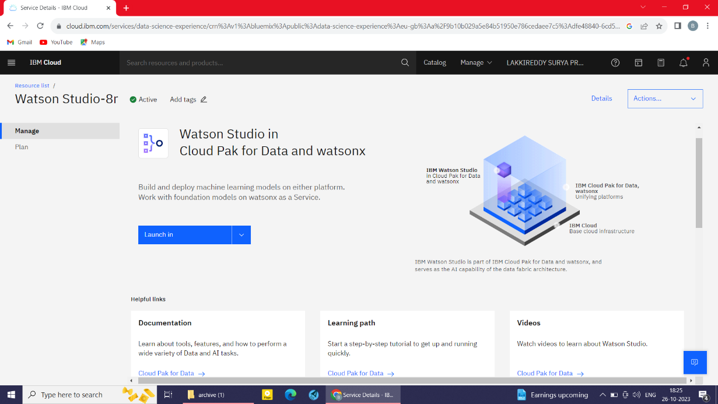

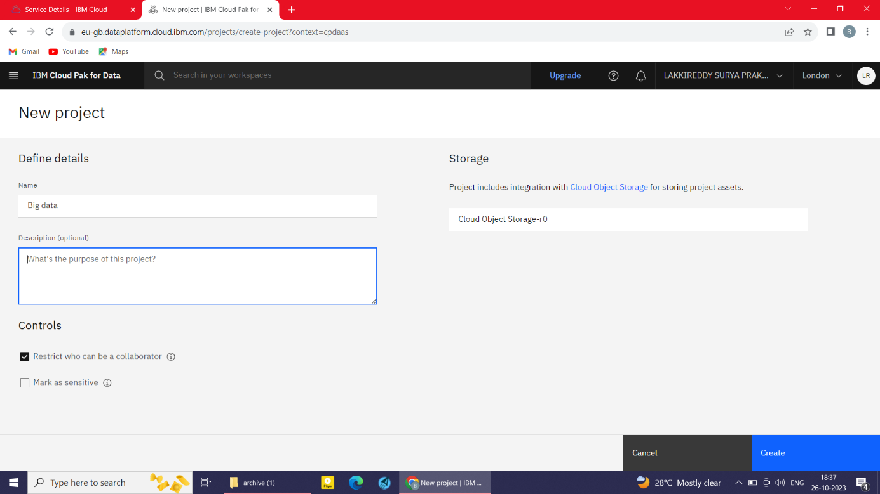

Visualization:
Once you have performed your analysis, we can visualize the results to communicate our findings to others. We can use a variety of tools and software applications to create visualizations. For example, you could use the Python library Matplotlib to create graphs and charts.
IBM Watson Studio:
IBM Watson Studio is a unified platform for data scientists, business analysts, and developers to collaborate on data preparation, machine learning, and data visualization. IBM Watson Studio provides a variety of tools and services that can help you to perform advanced analysis and to visualize your results.
To create an IBM Watson Studio project, follow these steps:
- Go to the IBM Cloud console and sign in to your account.
- Click Catalog and then click Watson Studio.
- Click Create project.
- Enter a name for your project and select a region.
- Click Create.
To add data to your project, you can:
- Upload files from your local computer.
- Connect to a database or cloud storage service.
- Use a Watson Studio service to generate data.
After Creating the IBM Watson Studio. Launch in the IBM Cloud Pak for data to visualize the results in the form of graphs and charts.
To launch the IBM Cloud Pak for Data to visualize the result in IBM Watson Studio, follow these steps:
• Go to the Catalog tab in IBM Watson Studio.
• Click IBM Cloud Pak for Data.
• Click Launch.
A new window will open with the IBM Cloud Pak for Data user interface.
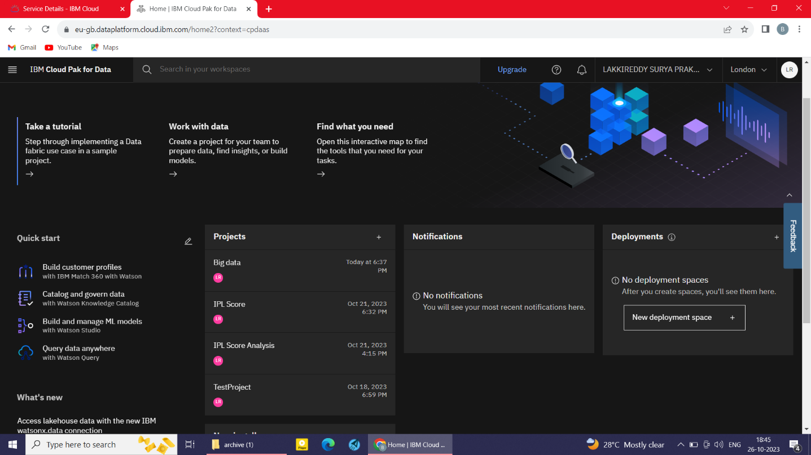
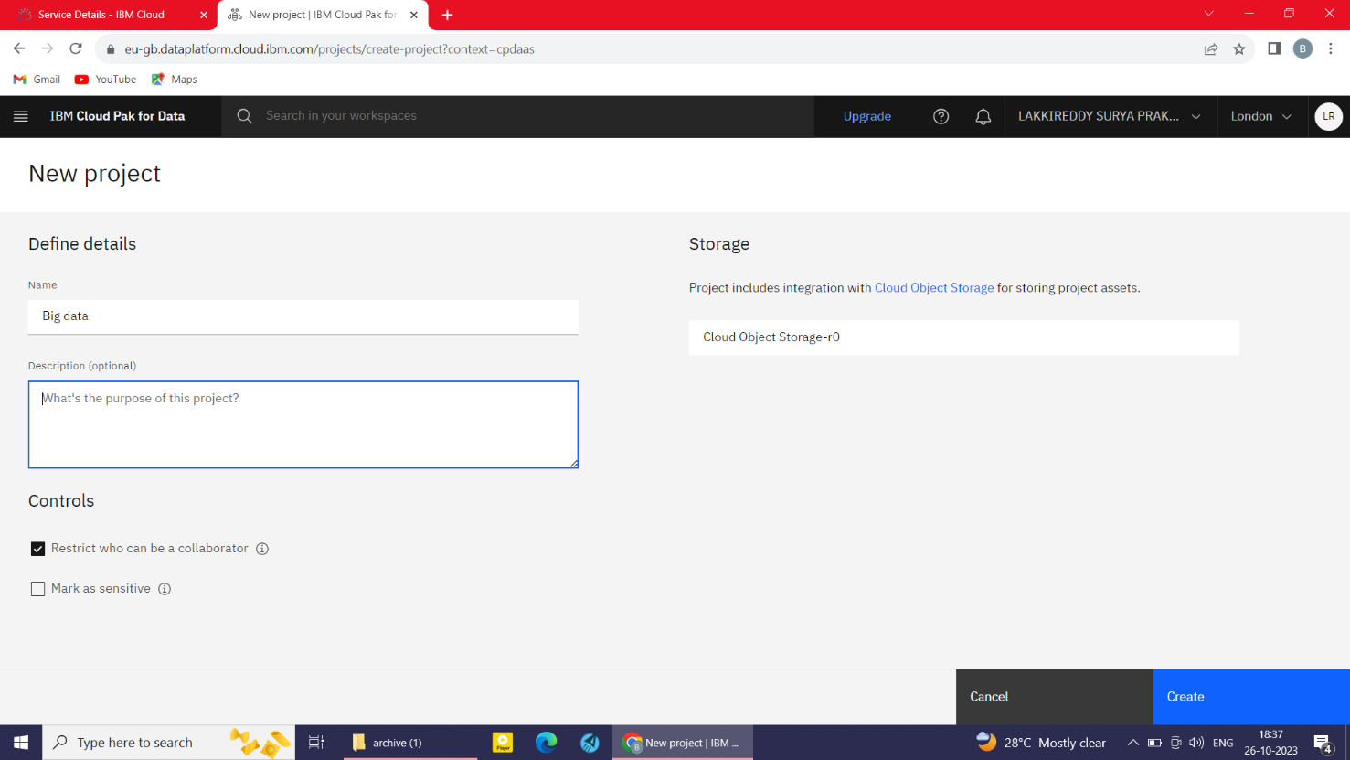

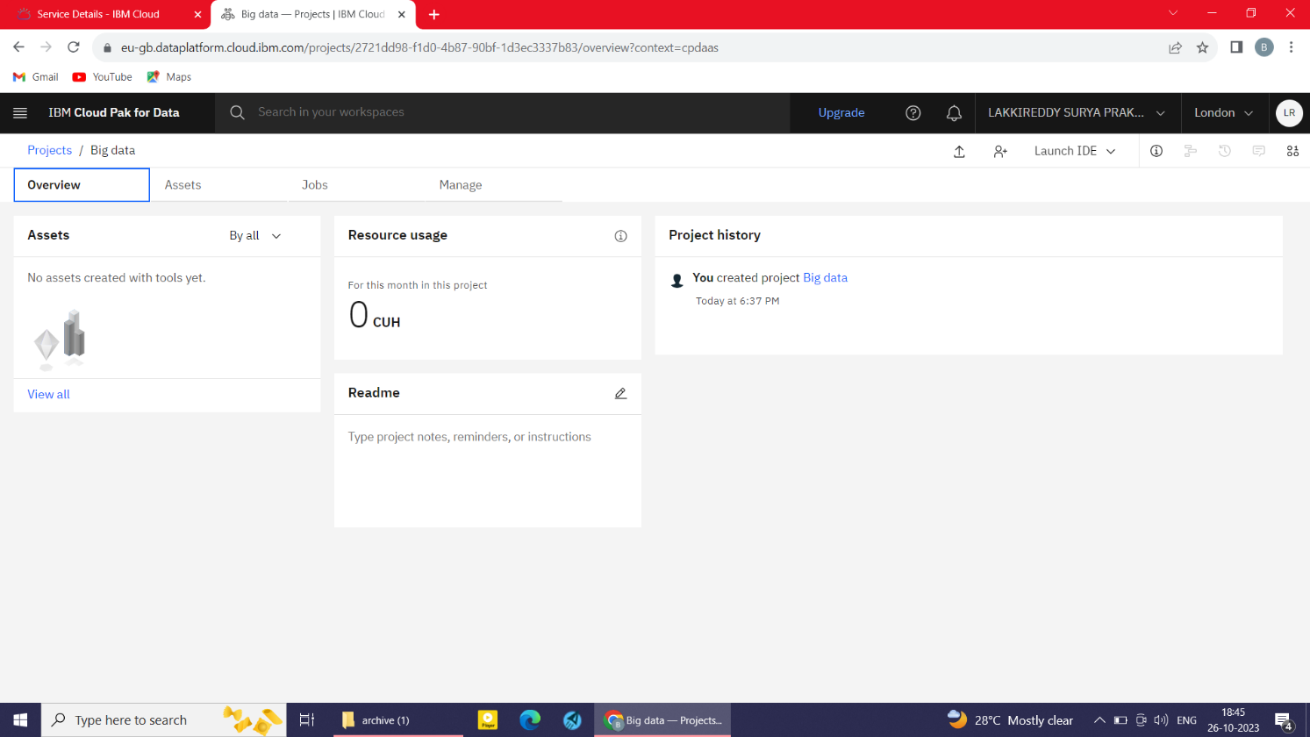

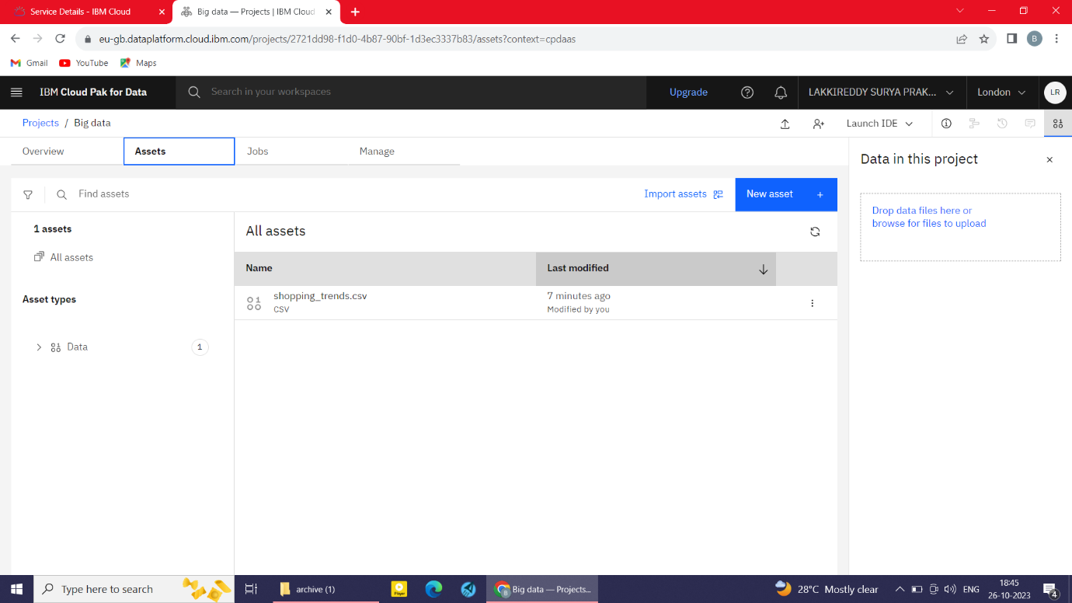

Once we have added data to your project, we can start building and deploying machine learning models ,exploring and visualizing data.
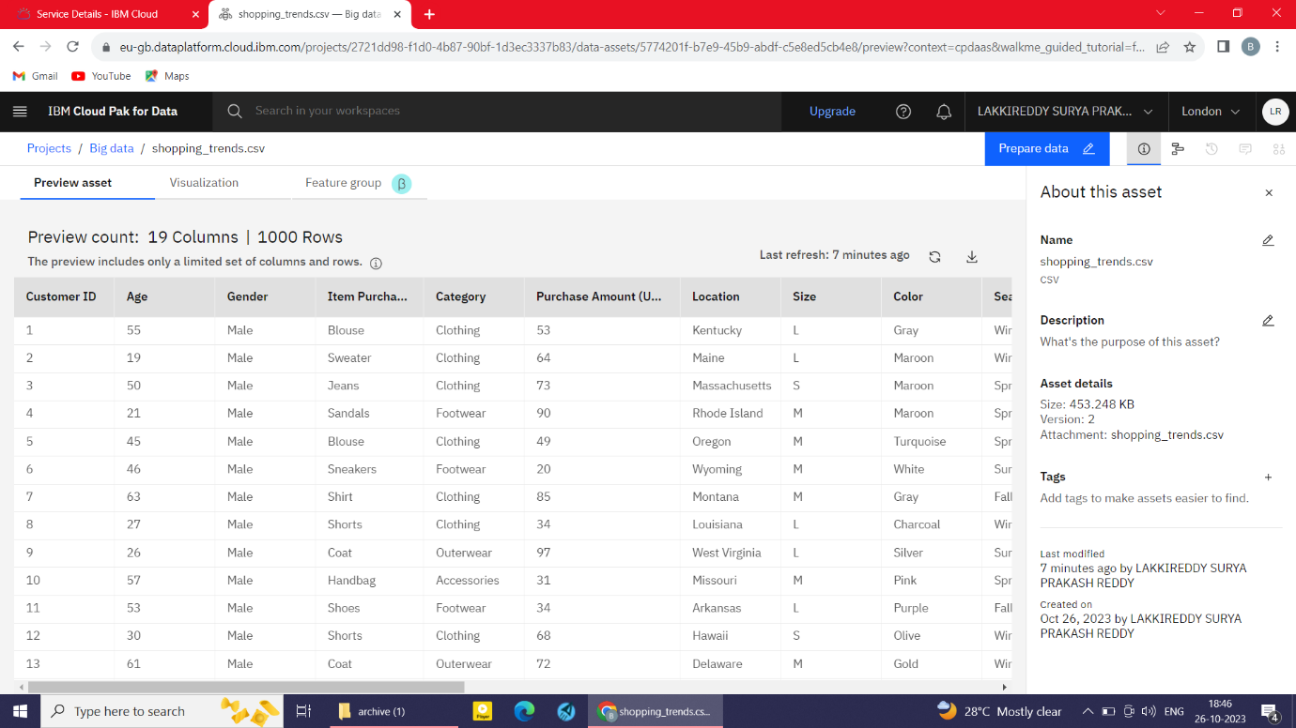

To visualize,
Click visualization tab
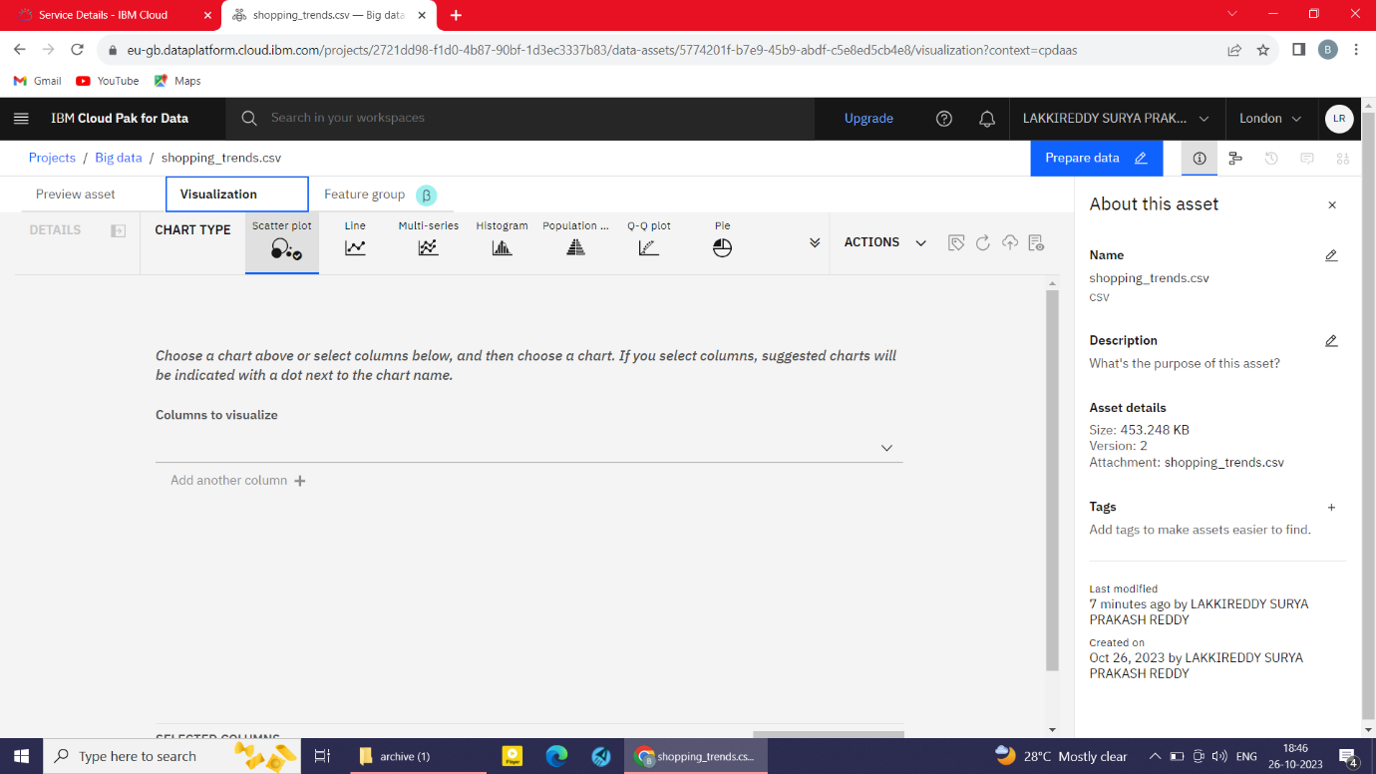

• Choose a chart above or select columns below, and then choose a chart. If you select columns, suggested charts will be indicated with a dot next to the chart name.

