**แบบฝึกหัดชุดที่ 6**

ข้อที่ 1

class Car:

    def __init__ (self, license, brand, color):

        self.license = license

        self.brand = brand

        self.color = color

        self.report = []

    def __str__(self):

        return f"{self.license}-{self.brand}{self.color}"

    def __lt__(self,  rhs):

        return self.license < rhs.license

    def add_report(self, new_report):

        self.report.append(new_report)

    def total_payment(self):

        total = 0

        for payment in self.report:

            total += payment[2]

        return total

    def max_payment(self):

        if len(self.report)<=0:

            return self.report

        else:

            for max in range(0, len(self.report)):

                if max + 2 > len(self.report):

                    break

                elif (self.report[max][2]) < (self.report[max+1][2]):

                    compare = self.report[max+1]

                elif (self.report[max][2]) > (self.report[max+1][2]):

                    compare = self.report[max]

            return compare

c = Car('AA1234', 'Honda', 'White')

c1 = Car('AA1234', 'BMW', 'Black')

c.add_report(('20 May 2017', 'chang tires', 1500))

c.add_report(('23 May 2017', 'chang tires', 3000))

c.add_report(('25 May 2017', 'chang tires', 4500))

c.add_report(('26 May 2017', 'chang tires', 5500))

print(c<c1)

print(c.report)

print(c.total_payment())

print(c.max_payment())

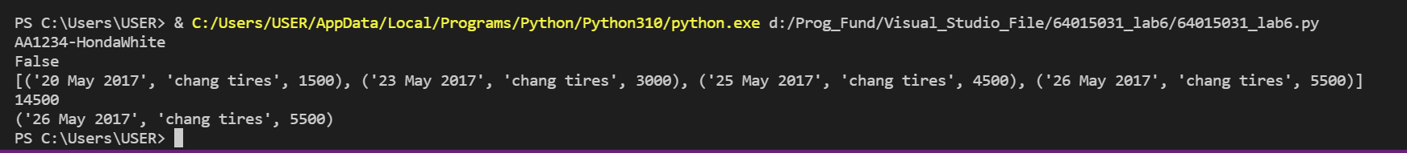

ข้อที่ 2

class ShoppingCart:

    def __init__(self, id):

        self.id = id

        self.books = []

    def add_book(self, book, n, total):

        value = 0

        if len(self.books) == 0:

            self.books.append([book, n ,total])

        else:

            for add in self.books:

                if add[0] == book:

                    add[1] += n

                    break

                else:

                    value += 1

                    if value == len(self.books):

                        self.books.append([book, n ,total])

                        break

    def delete_book(self, book):

        for dele in range(0,len(self.books)):

            if book in self.books[dele]:

                self.books.pop(dele)

                break

    def get_total(self):

        total = 0

        for cost in self.books:

            total += int(cost[2]) * int(cost[1])

        return total

    def __lt__(self, rhs):

        return self.get_total() < rhs.get_total()

chidshop = ShoppingCart(5555)

chickenshop = ShoppingCart(69)

chidshop.add_book('b1', 2, 15)

chidshop.add_book('b2', 3, 20)

chidshop.add_book('b1', 1, 15)

chidshop.add_book('b2', 2, 20)

chidshop.add_book('b3', 1, 30)

chidshop.add_book('b3', 2, 30)

chickenshop.add_book('b4', 2, 50)

print(chidshop > chickenshop)

chidshop.delete_book('b1')

print(chidshop.books)

print('ราคารวม =',chidshop.get_total(),'บาท')

