AutoCad & SolidWorks

The course is taught to the students as per the syllabus prescribed and as per the course modalities keeping in mind the bylaws set for them. Periodical tests are conducted to assess the understanding of the students in the course. Assignments are given to ensure that students gain versality in the designing. The assignments of the student are given below. These assignments which are done with high creativity and out of box thinking not only reflect the student’s innovativeness but also constitute solved exercises in the Various designs for the fresh learners to practice and gain confidence. The assignments are listed below in the order of their conducting during the course.

AutoCAD is a CAD program mainly used for architectural and construction designs, civil and structural engineering. On the other hand, SolidWorks is mainly used for mechanical parts and assembly design, technology designing, and automotive and aerospace designing.

Although AutoCAD and SolidWorks are computer-aided design software, their features differ greatly. Both have tools for 3D drawing but different aims. In AutoCAD, an object’s projected view can be drawn, but in SolidWorks, a sketch is created, which can be further made into a 3D model. 3D modeling features are more dominant in SolidWorks as compared to AutoCAD. In AutoCAD, the toolset is pretty much hidden.
ASSIGNMENTS
Assingment 1 :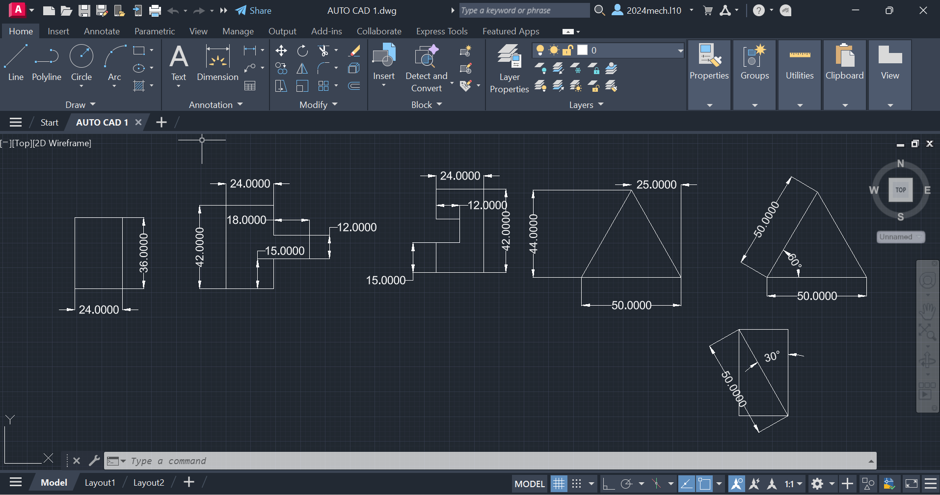

Procedure :

- First of all open autocad software in the laptop or in desktop .
- After opening, click on new the above page will appear in screen.
- If you don’t need grapical page click on ‘F7’ the grapical page will disappear in screen.
- After that press on letter ‘L’ for line command or you can directly click on line command which will be available in command box.
- Using line command draw the diagram with required dimensions.
- use the ‘trim’ and ‘arc’ commands, where it is needed.
- change the dimensions and units by clicking letters ‘Dim’ for ‘Dimensions’ and ‘U’ for ‘Units’ after clicking change the units.
- After drawing the diagram save it in laptop or in desktop.
Assingment 2 :
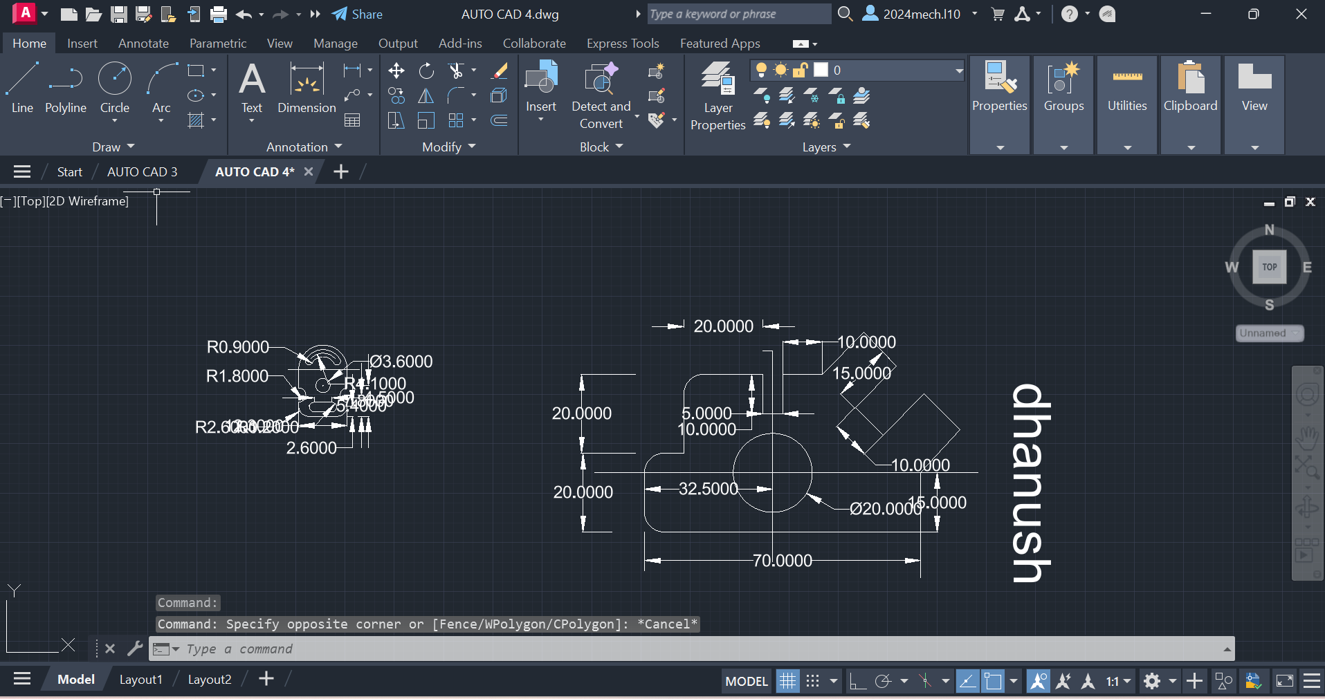

Procedure :

- First of all open autocad software in the laptop or in desktop .
- After opening, click on new the above page will appear in screen.
- If you don’t need grapical page click on ‘F7’ the grapical page will disappear in screen.
- After that press on letter ‘L’ for line command or you can directly click on line command which will be available in command box.
- Using line command draw the diagram with required dimensions.
- use the circle,trim and arc commands, where it is needed.
- change the dimensions and units by clicking letters ‘Dim’ for ‘Dimensions’ and ‘U’ for ‘Units’ after clicking change the units.
- After drawing the diagram save it in laptop or in desktop.

Assignment 3 :
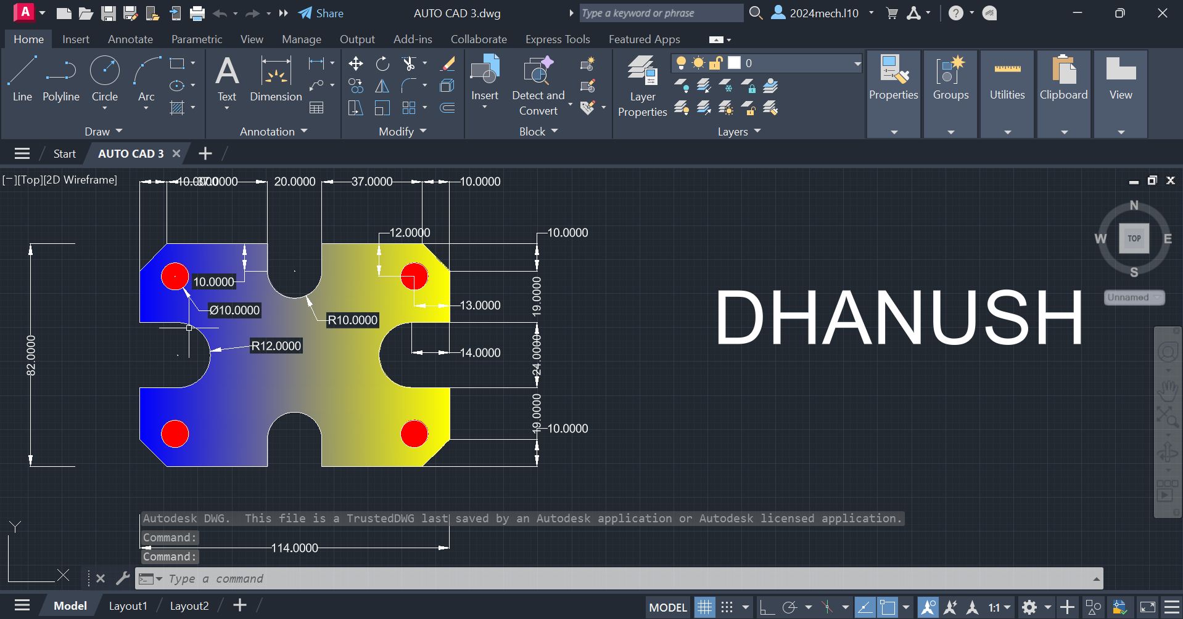

Procedure :

- First of all open autocad software in the laptop or in desktop .
- After opening, click on new the above page will appear in screen.
- If you don’t need grapical page click on ‘F7’ the grapical page will disappear in screen.
- After that press on letter ‘L’ for line command or you can directly click on line command which will be available in command box.
- Using line command draw the diagram with required dimensions.
- use the circle,trim and arc commands, where it is needed.
- change the dimensions and units by clicking letters ‘Dim’ for ‘Dimensions’ and ‘U’ for ‘Units’ after clicking change the units.
- After drawing the diagram save it in laptop or in desktop.

Assignment 4 :
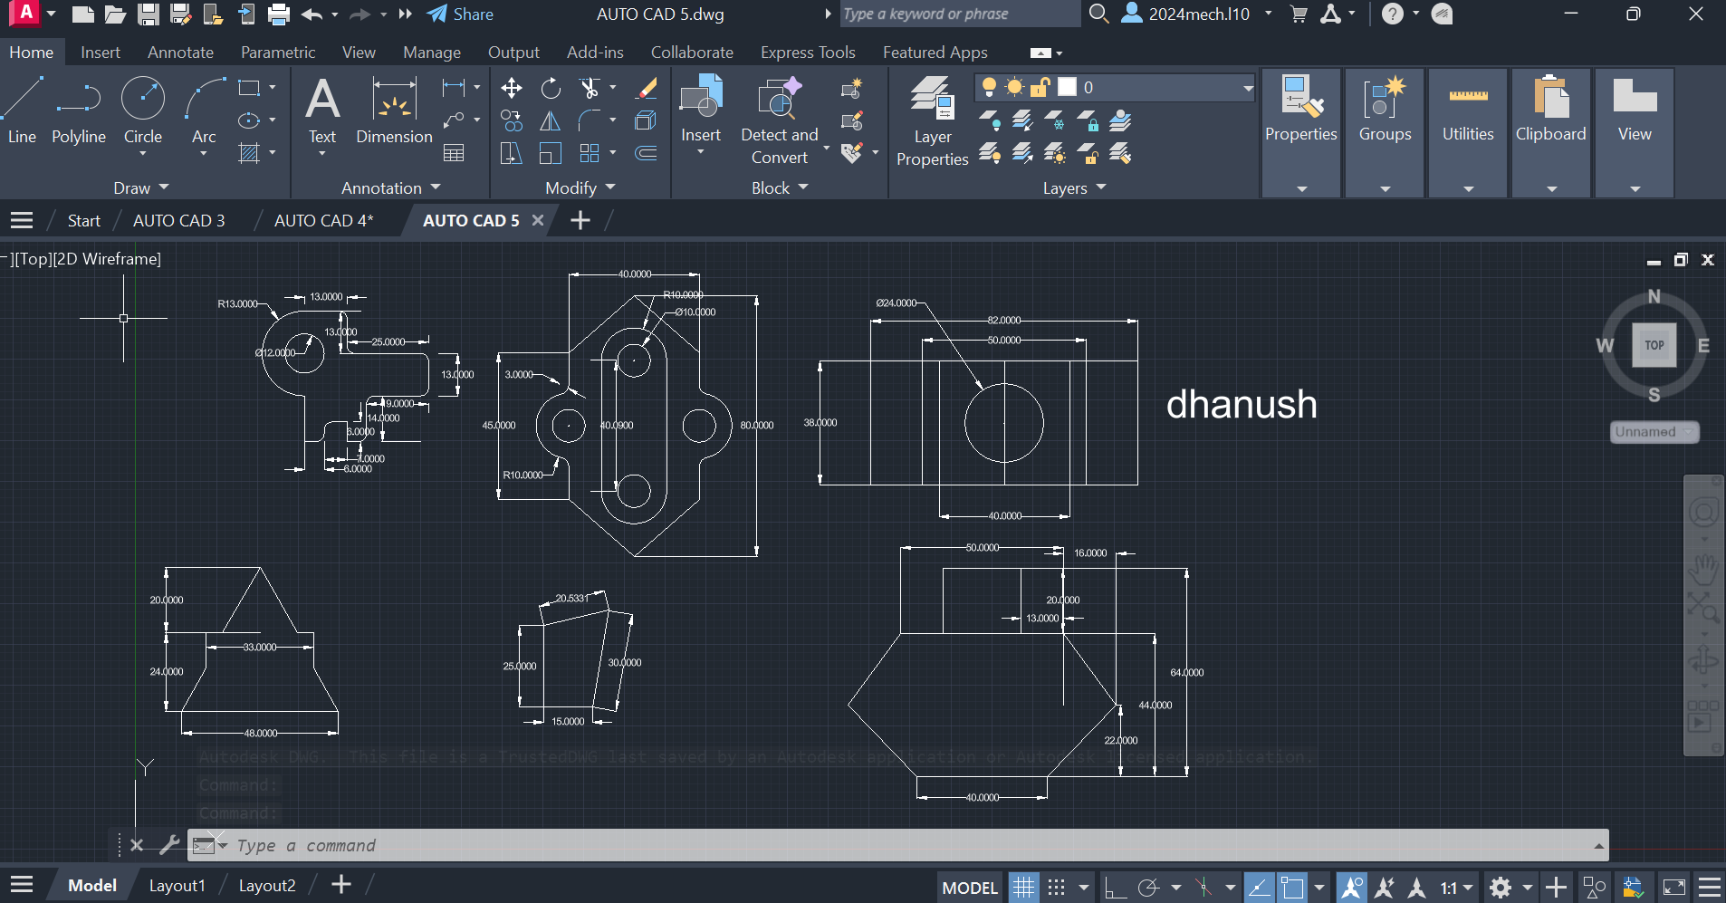

Procedure :

- First of all open autocad software in the laptop or in desktop .
- After opening, click on new the above page will appear in screen.
- If you don’t need grapical page click on ‘F7’ the grapical page will disappear in screen.
- After that press on letter ‘L’ for line command or you can directly click on line command which will be available in command box.
- Using line command draw the diagram with required dimensions.
- use the circle,trim and arc commands, where it is needed.
- change the dimensions and units by clicking letters ‘Dim’ for ‘Dimensions’ and ‘U’ for ‘Units’ after clicking change the units.
- After drawing the diagram save it in laptop or in desktop.

Assignment 5 :
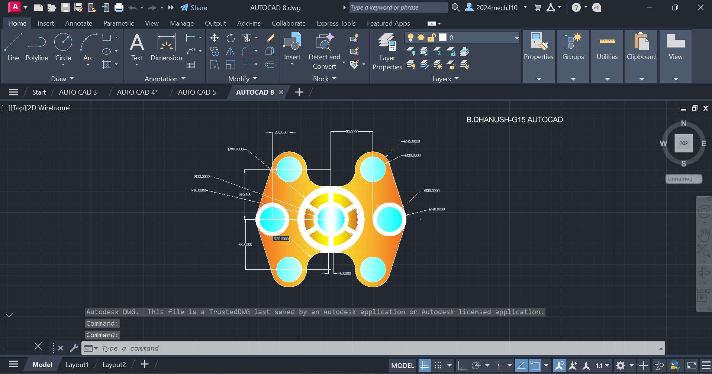

Procedure :

- First of all open autocad software in the laptop or in desktop .
- After opening, click on new the above page will appear in screen.
- If you don’t need grapical page click on ‘F7’ the grapical page will disappear in screen.
- After that press on letter ‘L’ for line command or you can directly click on line command which will be available in command box.
- Using line command draw the diagram with required dimensions.
- use the circle,trim and arc commands, where it is needed.
- change the dimensions and units by clicking letters ‘Dim’ for ‘Dimensions’ and ‘U’ for ‘Units’ after clicking change the units.
- After drawing the diagram save it in laptop or in desktop.

Assignment 6 :
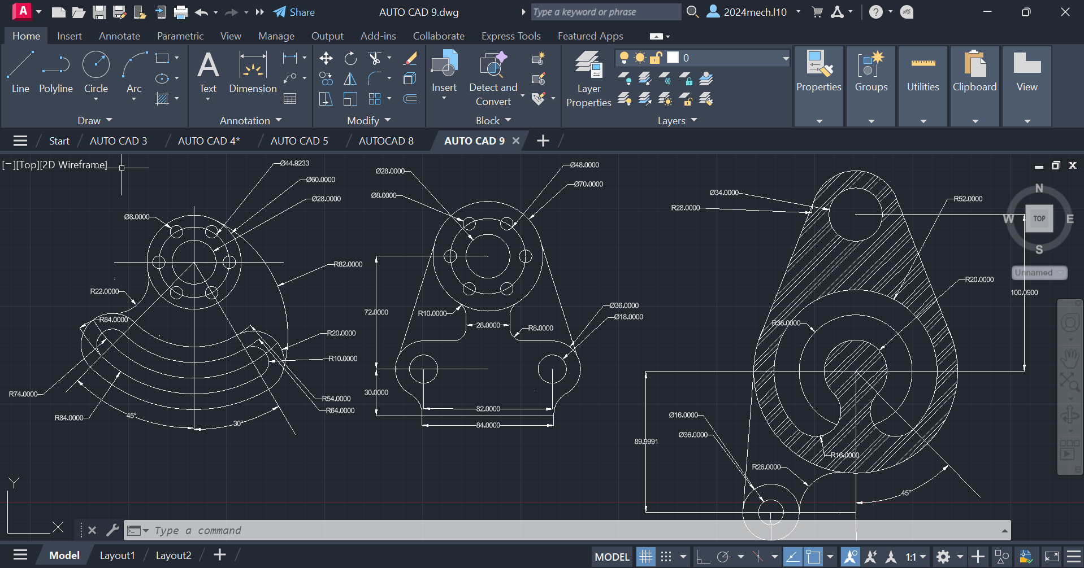

Procedure :

- First of all open autocad software in the laptop or in desktop .
- After opening, click on new the above page will appear in screen.
- If you don’t need grapical page click on ‘F7’ the grapical page will disappear in screen.
- After that press on letter ‘L’ for line command or you can directly click on line command which will be available in command box.
- Using line command draw the diagram with required dimensions.
- use the circle,trim and arc commands, where it is needed.
- change the dimensions and units by clicking letters ‘Dim’ for ‘Dimensions’ and ‘U’ for ‘Units’ after clicking change the units.
- After drawing the diagram save it in laptop or in desktop.

Assignment 7 :

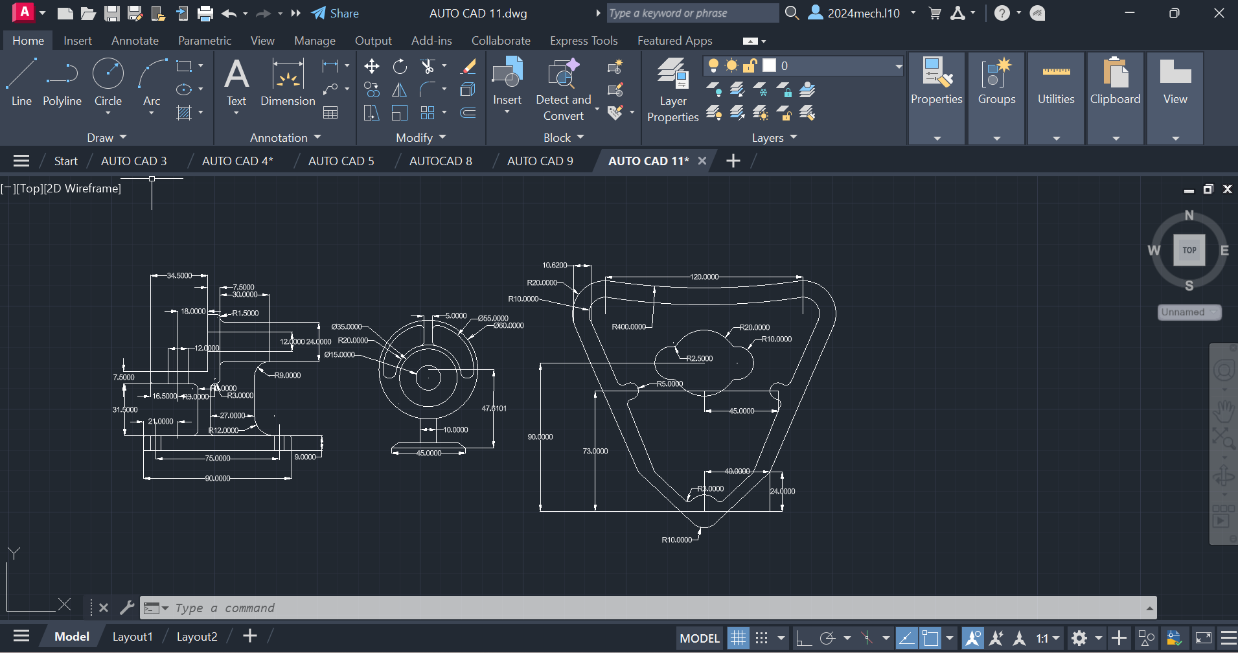

Procedure :
- First of all open autocad software in the laptop or in desktop .
- After opening, click on new the above page will appear in screen.
- If you don’t need grapical page click on ‘F7’ the grapical page will disappear in screen.
- After that press on letter ‘L’ for line command or you can directly click on line command which will be available in command box.
- Using line command draw the diagram with required dimensions.
- use the circle,trim and arc commands, where it is needed.
- change the dimensions and units by clicking letters ‘Dim’ for ‘Dimensions’ and ‘U’ for ‘Units’ after clicking change the units.
- After drawing the diagram save it in laptop or in desktop.
Assignment 8 :
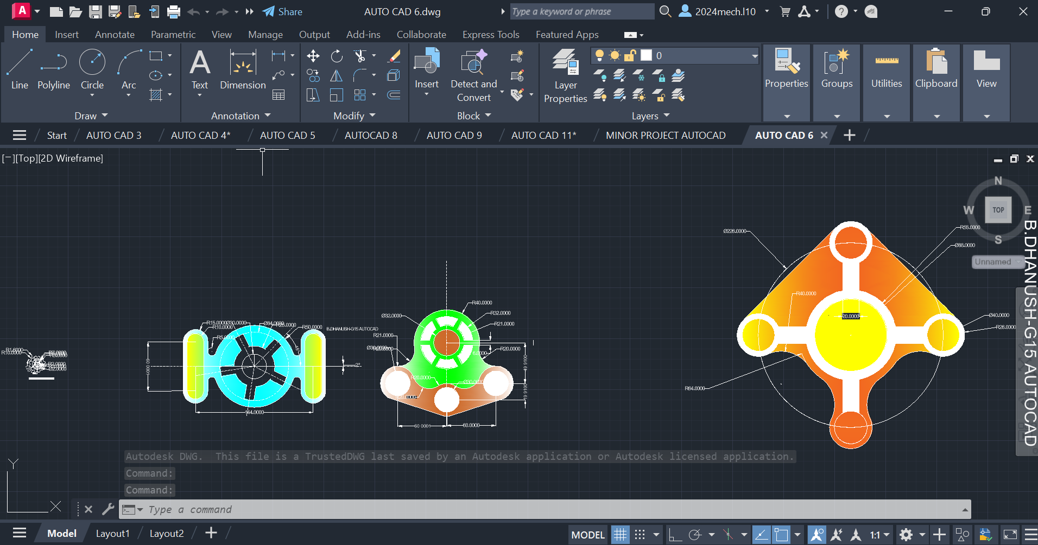

Procedure :

- First of all open autocad software in the laptop or in desktop .
- After opening, click on new the above page will appear in screen.
- If you don’t need grapical page click on ‘F7’ the grapical page will disappear in screen.
- After that press on letter ‘L’ for line command or you can directly click on line command which will be available in command box.
- Using line command draw the diagram with required dimensions.
- use the circle,trim and arc commands, where it is needed.
- change the dimensions and units by clicking letters ‘Dim’ for ‘Dimensions’ and ‘U’ for ‘Units’ after clicking change the units.
- After drawing the diagram save it in laptop or in desktop.

Assignment 9 :
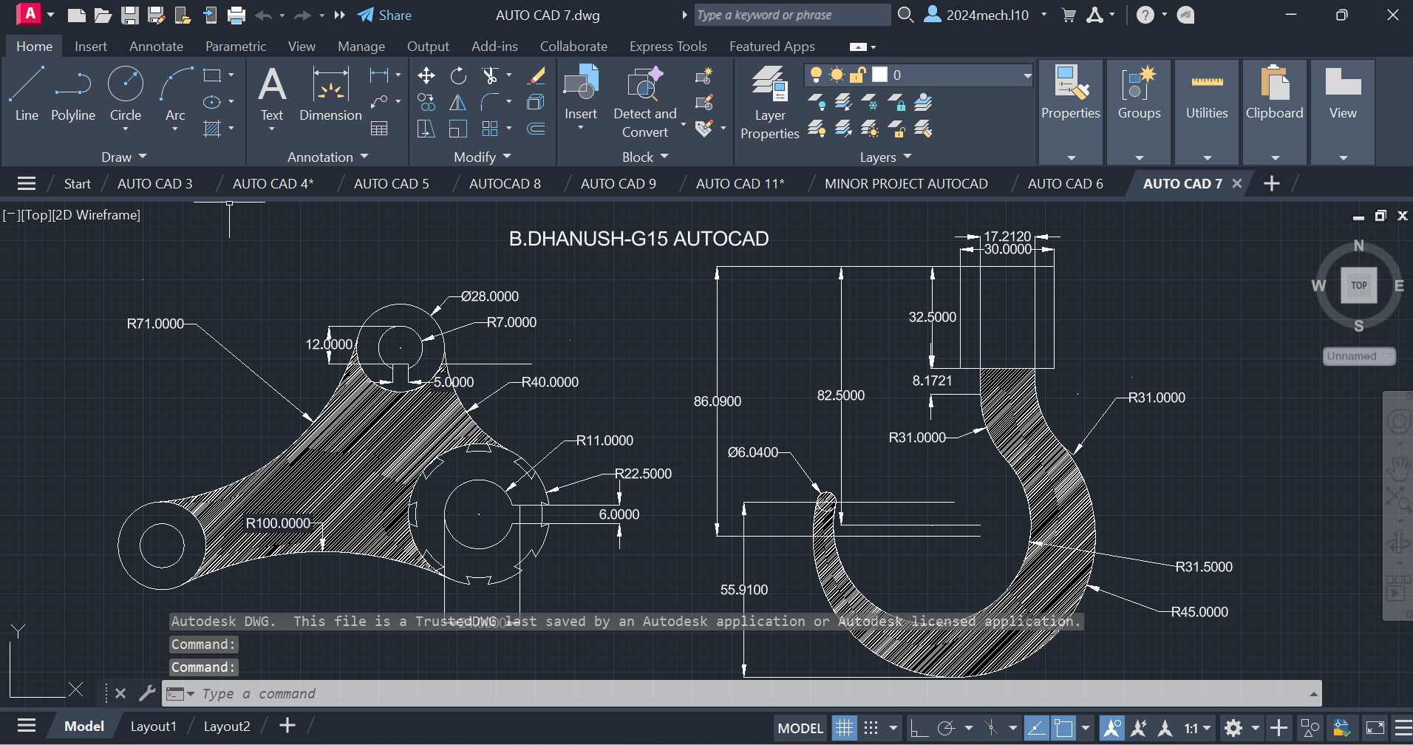
Procedure :

- First of all open autocad software in the laptop or in desktop .
- After opening, click on new the above page will appear in screen.
- If you don’t need grapical page click on ‘F7’ the grapical page will disappear in screen.
- After that press on letter ‘L’ for line command or you can directly click on line command which will be available in command box.
- Using line command draw the diagram with required dimensions.
- use the circle,trim and arc commands, where it is needed.
- change the dimensions and units by clicking letters ‘Dim’ for ‘Dimensions’ and ‘U’ for ‘Units’ after clicking change the units.
- After drawing the diagram save it in laptop or in desktop.

Assignment 10 :
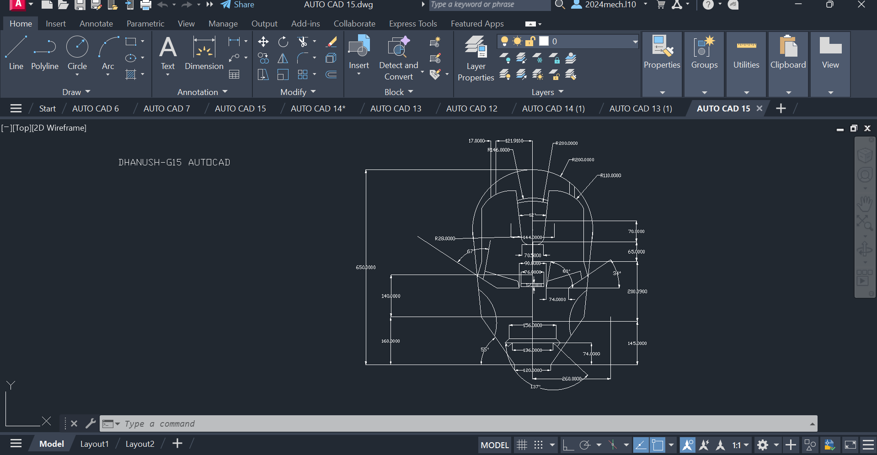

Procedure :

- First of all open autocad software in the laptop or in desktop .
- After opening, click on new the above page will appear in screen.
- If you don’t need grapical page click on ‘F7’ the grapical page will disappear in screen.
- After that press on letter ‘L’ for line command or you can directly click on line command which will be available in command box.
- Using line command draw the diagram with required dimensions.
- use the circle,trim and arc commands, where it is needed.
- change the dimensions and units by clicking letters ‘Dim’ for ‘Dimensions’ and ‘U’ for ‘Units’ after clicking change the units.
- After drawing the diagram save it in laptop or in desktop.

Assignment 11 :
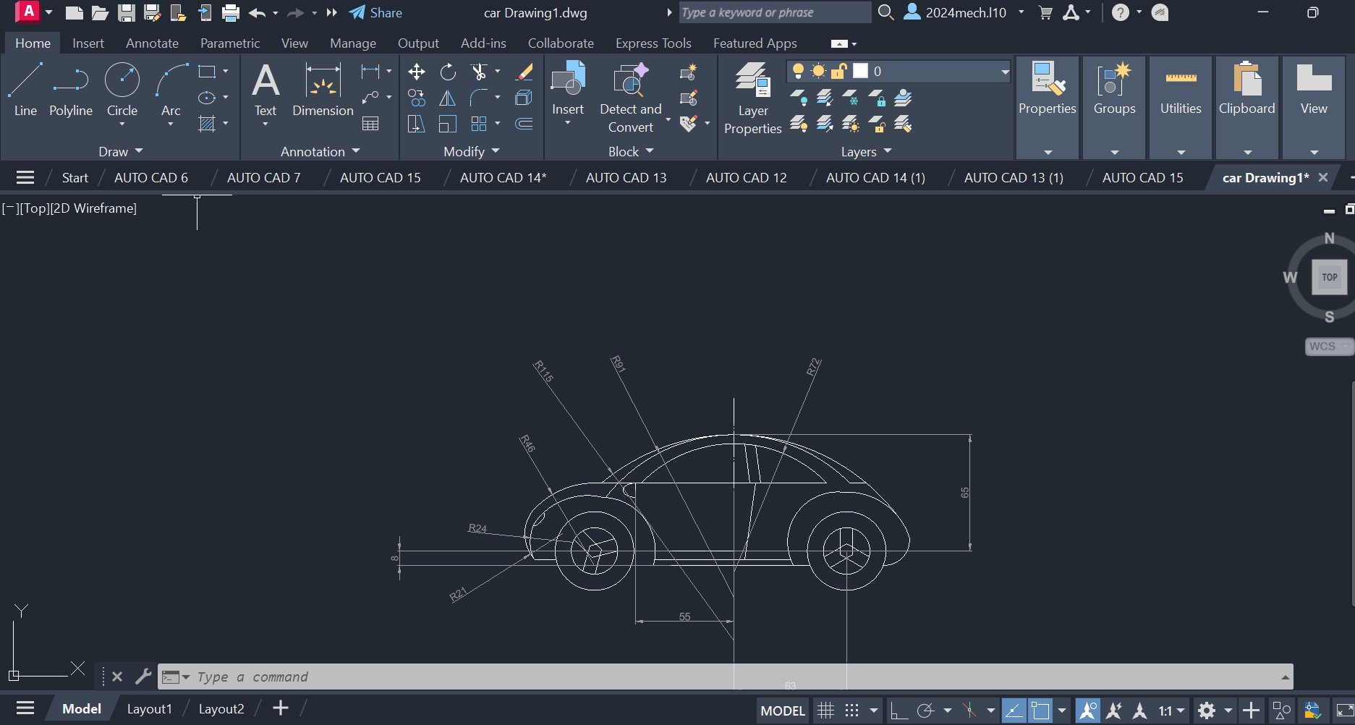

Procedure :

- First of all open autocad software in the laptop or in desktop .
- After opening, click on new the above page will appear in screen.
- If you don’t need grapical page click on ‘F7’ the grapical page will disappear in screen.
- After that press on letter ‘L’ for line command or you can directly click on line command which will be available in command box.
- Using line command draw the diagram with required dimensions.
- use the circle,trim and arc commands, where it is needed.
- change the dimensions and units by clicking letters ‘Dim’ for ‘Dimensions’ and ‘U’ for ‘Units’ after clicking change the units.
- After drawing the diagram save it in laptop or in desktop.

Assignment 12 :
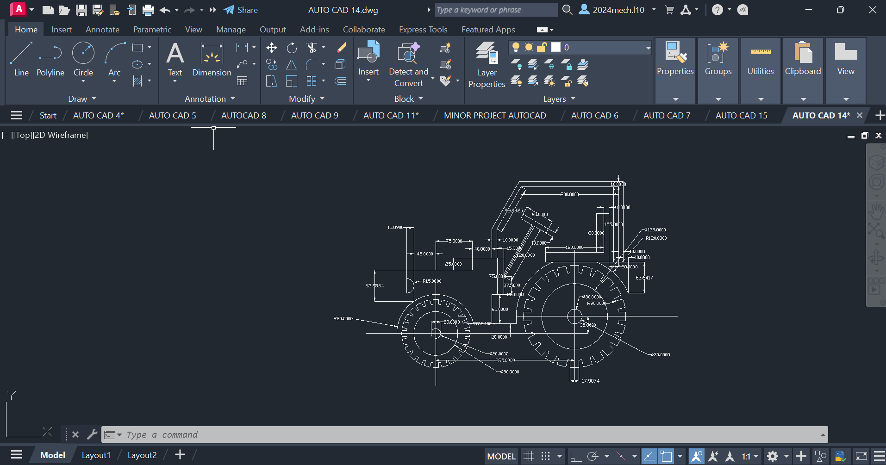

Procedure :

- First of all open autocad software in the laptop or in desktop .
- After opening, click on new the above page will appear in screen.
- If you don’t need grapical page click on ‘F7’ the grapical page will disappear in screen.
- After that press on letter ‘L’ for line command or you can directly click on line command which will be available in command box.
- Using line command draw the diagram with required dimensions.
- use the circle,trim and arc commands, where it is needed.
- change the dimensions and units by clicking letters ‘Dim’ for ‘Dimensions’ and ‘U’ for ‘Units’ after clicking change the units.
- After drawing the diagram save it in laptop or in desktop.

SOLIDWORKS
SolidWorks is a solid modeling computer-aided design (CAD) and computer-aided engineering (CAE) application published by Dassault Systems.
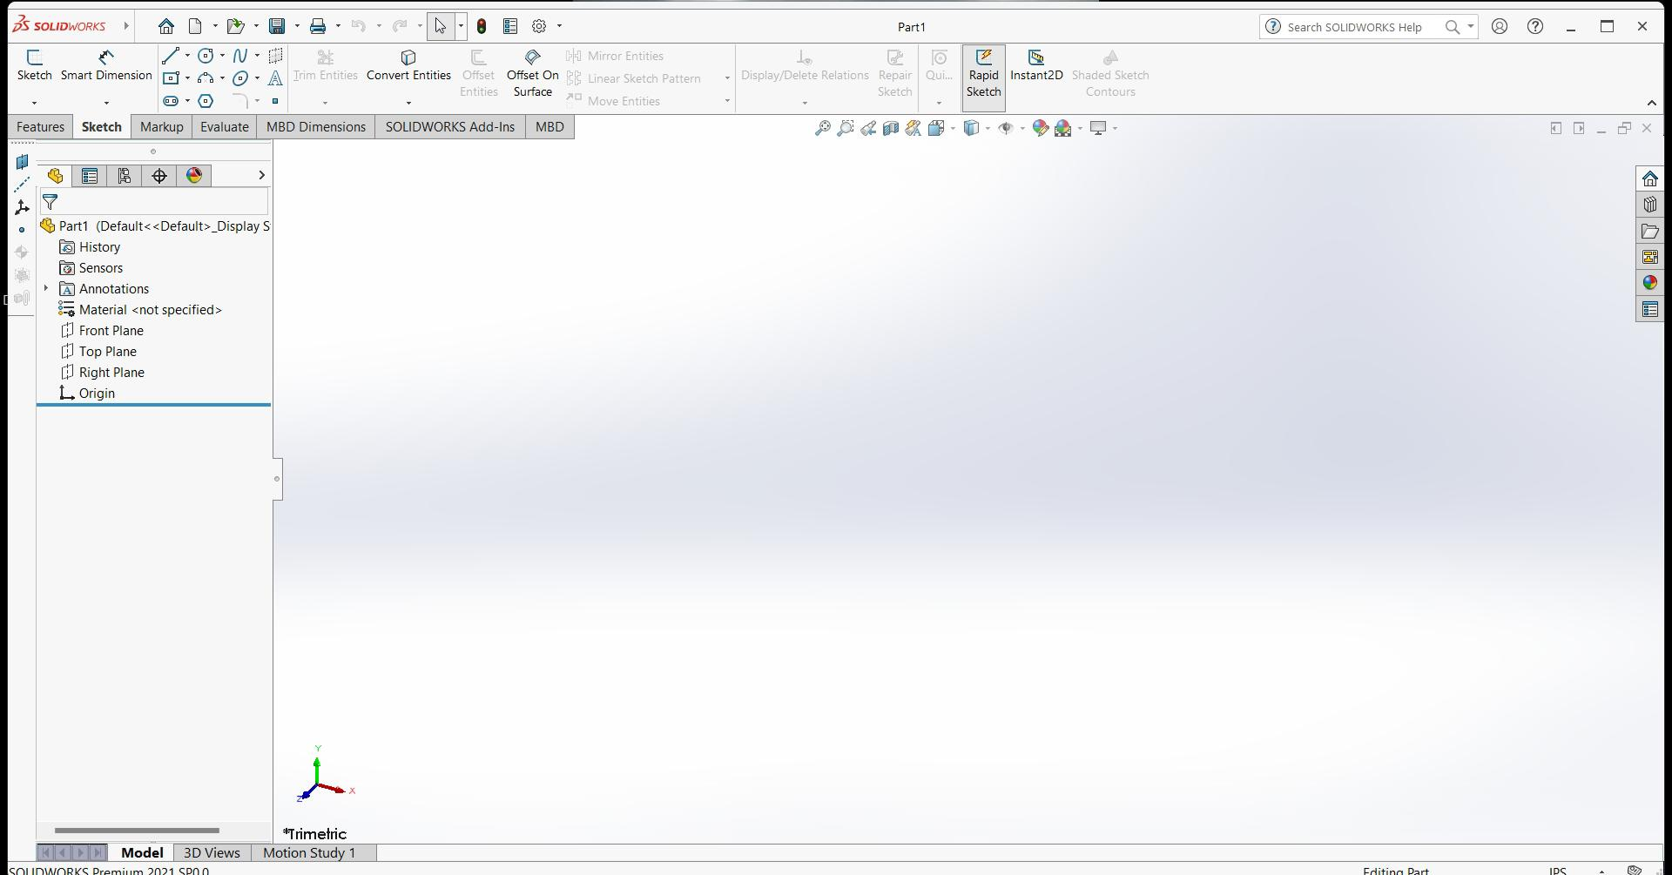
SOLIDWORKS is used to develop mechatronics systems from beginning to end. At the initial stage, the software is used for planning, visual ideation, modeling, feasibility assessment, prototyping, and project management. The software is then used for design and building of mechanical, electrical, and software elements.

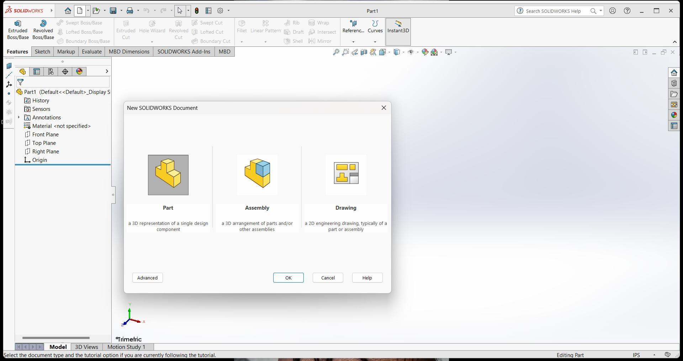
Solidworks mainly consists of
- Part Modeling,3DModeling
- Assembly, sheet metal, weld meats
- Drawing

_{Part Modeling 2D :}

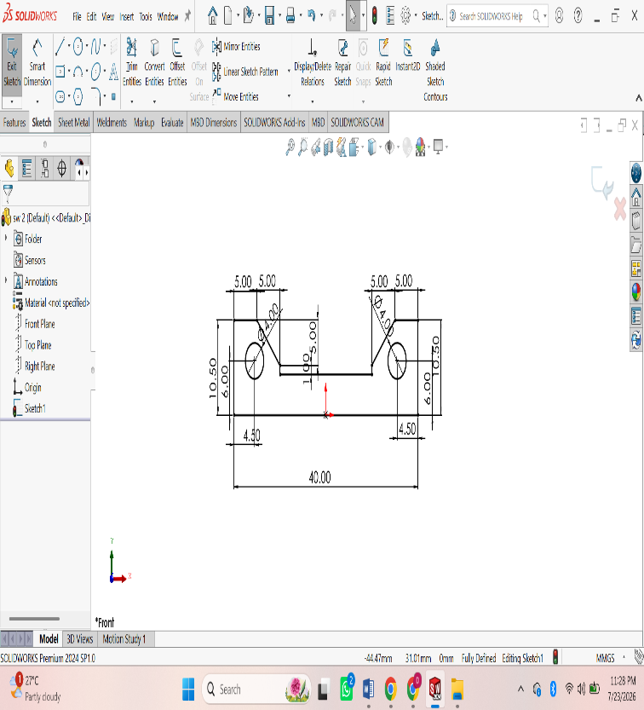
ASSIGNMENT 1:
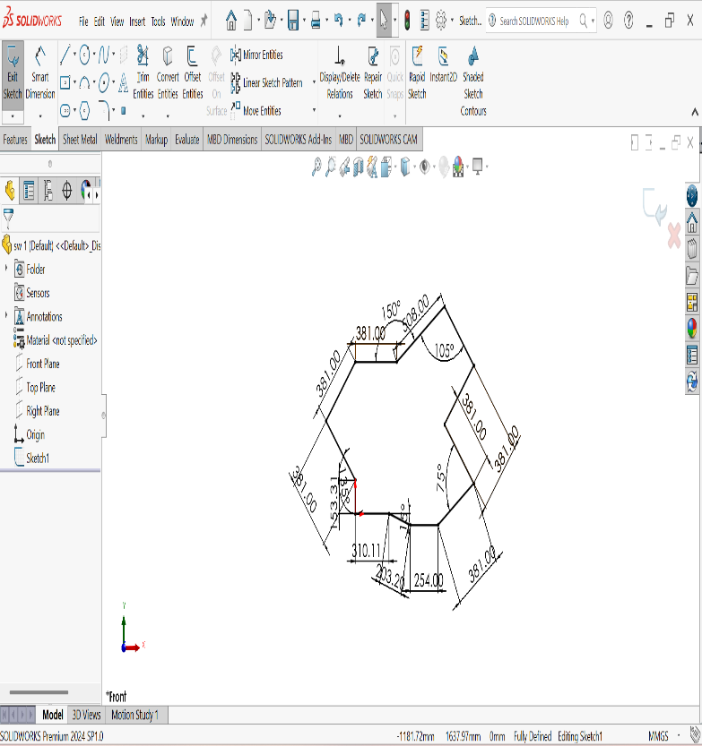
Procedure :
Open SOLIDWORKS.
• Click File → New → Part and select OK.
• Select a sketch plane (Front Plane, Top Plane, or Right Plane) from the FeatureManager.
• Click Sketch on the CommandManager to enter sketch mode.
• Use sketch tools to draw the required geometry:
- Line
- Rectangle
- Circle
- Center Rectangle
- Arc
- Polygon
- Spline (if required)
• Apply Smart Dimensions to define the size of the sketch.
• Add Sketch Relations (Horizontal, Vertical, Parallel, Perpendicular, Coincident, Tangent, Equal, etc.) to fully define the sketch.
• Ensure the sketch changes from blue (under-defined) to black (fully defined).
• Use Trim Entities or Extend Entities to modify the sketch if necessary.
• Click Exit Sketch to complete the 2D sketch.
• Save the part by selecting File → Save As and entering a file name.

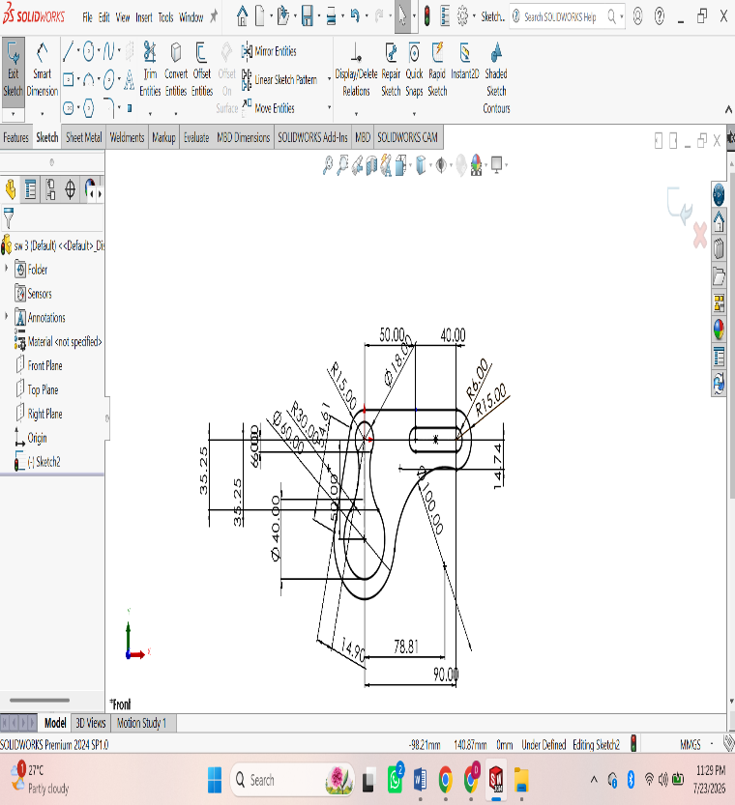
ASSIGNMENT 2:
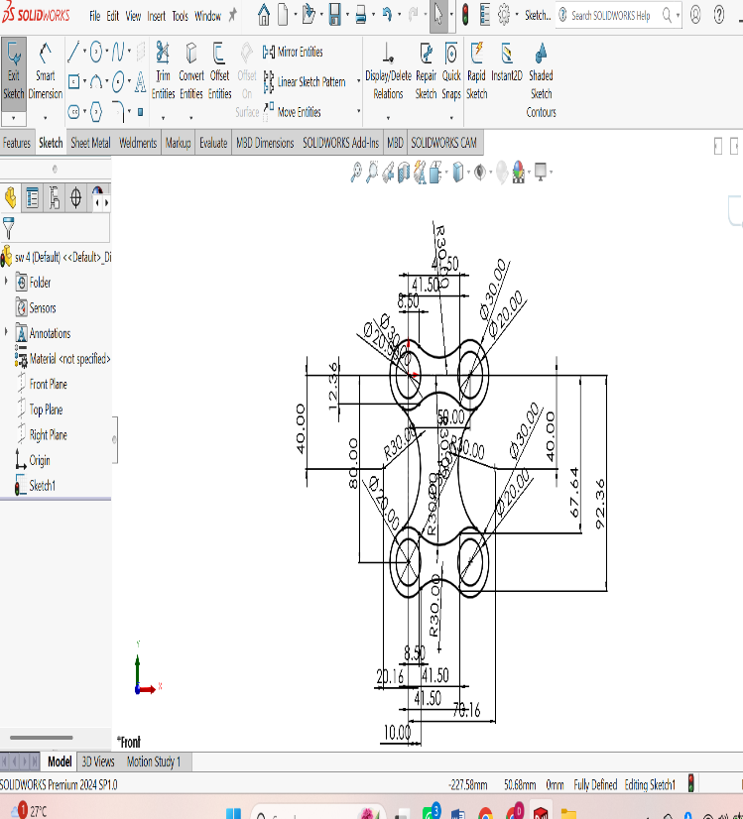
Procedure :
Open SOLIDWORKS.
• Click File → New → Part and select OK.
• Select a sketch plane (Front Plane, Top Plane, or Right Plane) from the FeatureManager.
• Click Sketch on the CommandManager to enter sketch mode.
• Use sketch tools to draw the required geometry:
- Line
- Rectangle
- Circle
- Center Rectangle
- Arc
- Polygon
- Spline (if required)
• Apply Smart Dimensions to define the size of the sketch.
• Add Sketch Relations (Horizontal, Vertical, Parallel, Perpendicular, Coincident, Tangent, Equal, etc.) to fully define the sketch.
• Ensure the sketch changes from blue (under-defined) to black (fully defined).
• Use Trim Entities or Extend Entities to modify the sketch if necessary.
• Click Exit Sketch to complete the 2D sketch.
• Save the part by selecting File → Save As and entering a file name.

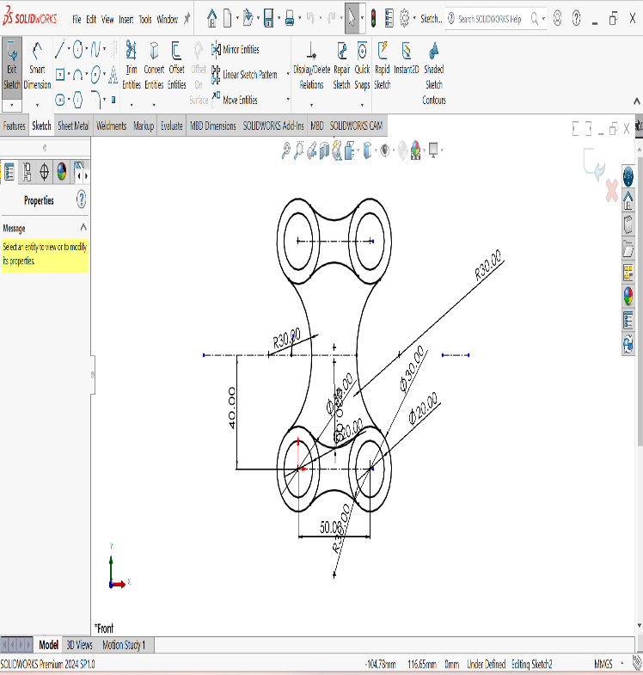
ASSIGNMENT 3:
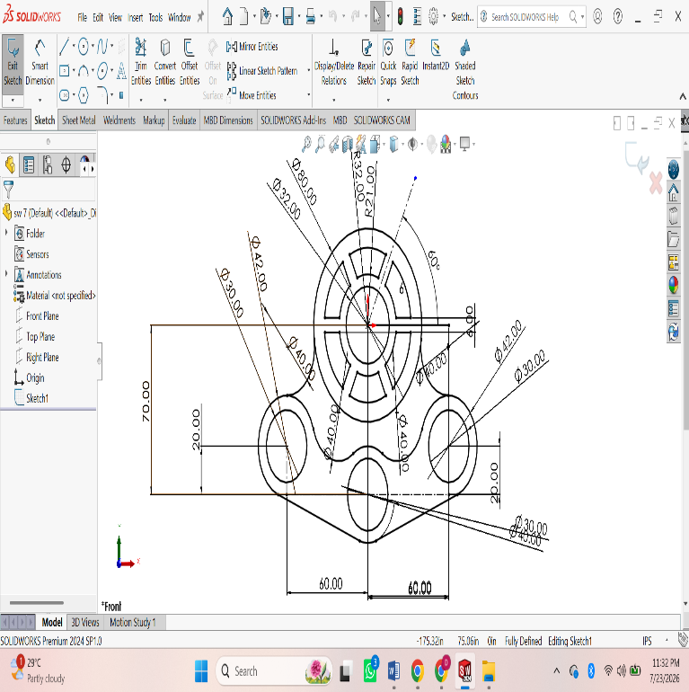
Procedure :
Open SOLIDWORKS.
• Click File → New → Part and select OK.
• Select a sketch plane (Front Plane, Top Plane, or Right Plane) from the FeatureManager.
• Click Sketch on the CommandManager to enter sketch mode.
• Use sketch tools to draw the required geometry:
- Line
- Rectangle
- Circle
- Center Rectangle
- Arc
- Polygon
- Spline (if required)
• Apply Smart Dimensions to define the size of the sketch.
• Add Sketch Relations (Horizontal, Vertical, Parallel, Perpendicular, Coincident, Tangent, Equal, etc.) to fully define the sketch.
• Ensure the sketch changes from blue (under-defined) to black (fully defined).
• Use Trim Entities or Extend Entities to modify the sketch if necessary.
• Click Exit Sketch to complete the 2D sketch.
• Save the part by selecting File → Save As and entering a file name.
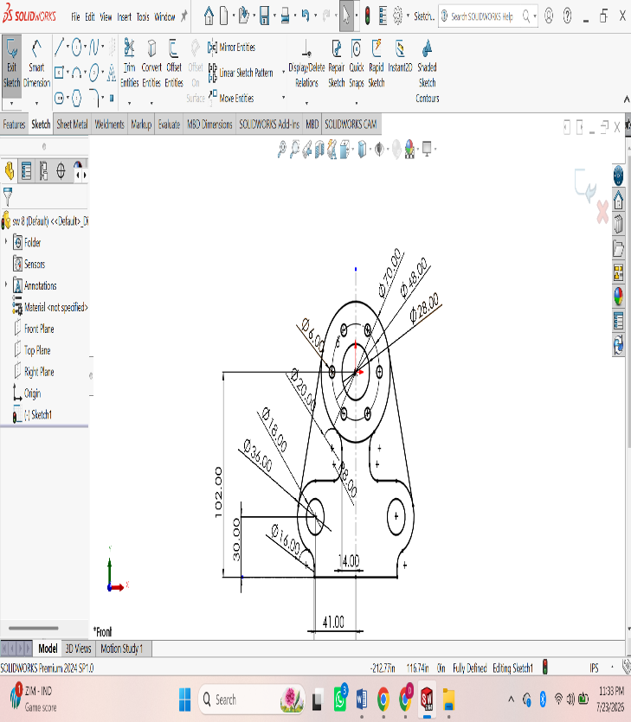
ASSIGNMENT 4:
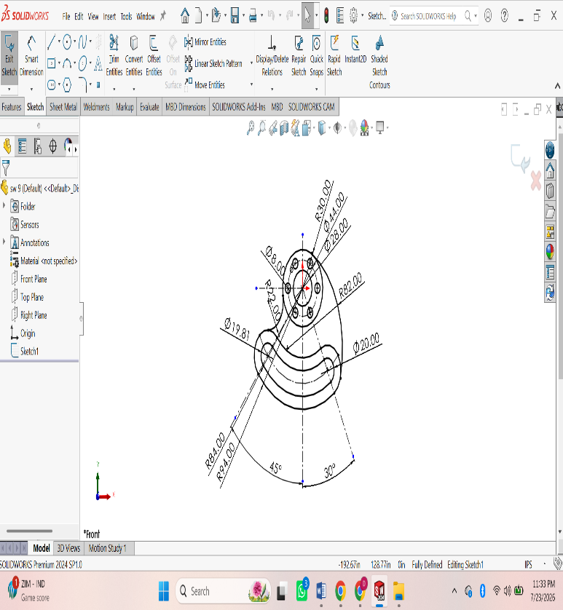
Procedure :
Open SOLIDWORKS.
• Click File → New → Part and select OK.
• Select a sketch plane (Front Plane, Top Plane, or Right Plane) from the FeatureManager.
• Click Sketch on the CommandManager to enter sketch mode.
• Use sketch tools to draw the required geometry:
- Line
- Rectangle
- Circle
- Center Rectangle
- Arc
- Polygon
- Spline (if required)
• Apply Smart Dimensions to define the size of the sketch.
• Add Sketch Relations (Horizontal, Vertical, Parallel, Perpendicular, Coincident, Tangent, Equal, etc.) to fully define the sketch.
• Ensure the sketch changes from blue (under-defined) to black (fully defined).
• Use Trim Entities or Extend Entities to modify the sketch if necessary.
• Click Exit Sketch to complete the 2D sketch.
• Save the part by selecting File → Save As and entering a file name.

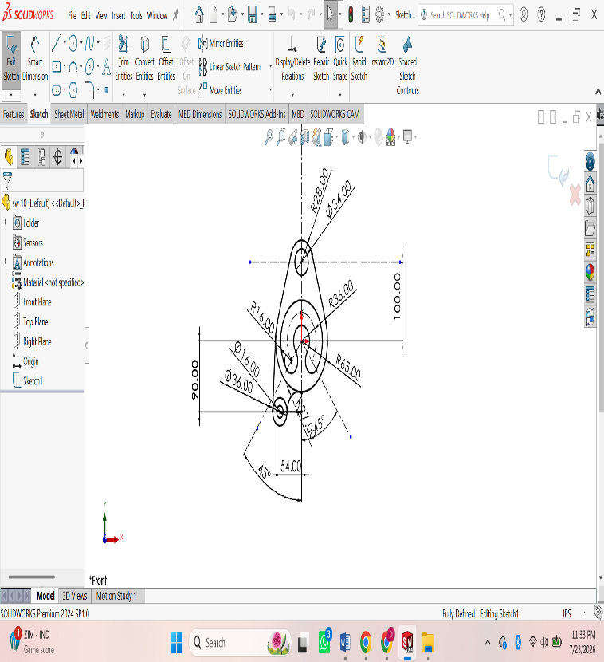
ASSIGNMENT 5:
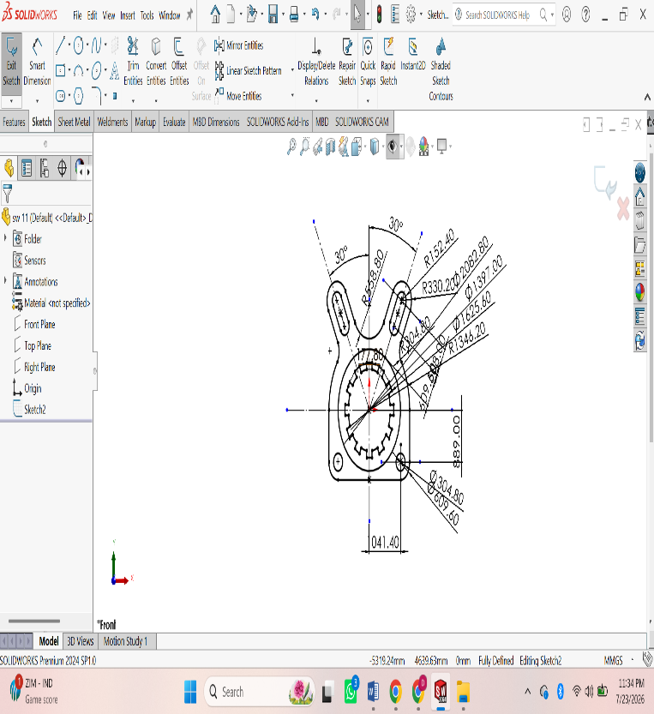
Procedure :
Open SOLIDWORKS.
• Click File → New → Part and select OK.
• Select a sketch plane (Front Plane, Top Plane, or Right Plane) from the FeatureManager.
• Click Sketch on the CommandManager to enter sketch mode.
• Use sketch tools to draw the required geometry:
- Line
- Rectangle
- Circle
- Center Rectangle
- Arc
- Polygon
- Spline (if required)
• Apply Smart Dimensions to define the size of the sketch.
• Add Sketch Relations (Horizontal, Vertical, Parallel, Perpendicular, Coincident, Tangent, Equal, etc.) to fully define the sketch.
• Ensure the sketch changes from blue (under-defined) to black (fully defined).
• Use Trim Entities or Extend Entities to modify the sketch if necessary.
• Click Exit Sketch to complete the 2D sketch.
• Save the part by selecting File → Save As and entering a file name.
ASSIGNMENT 6:
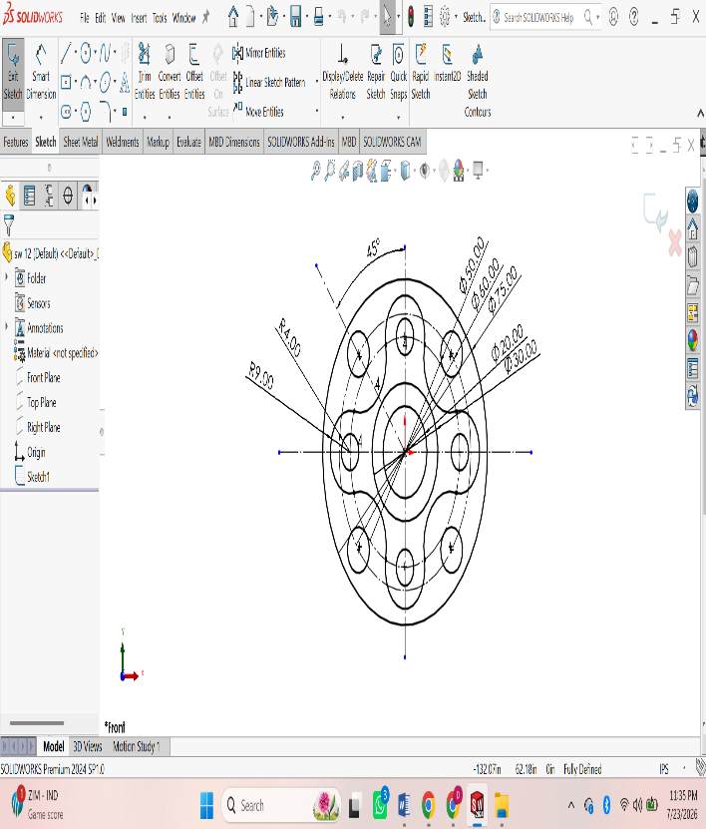
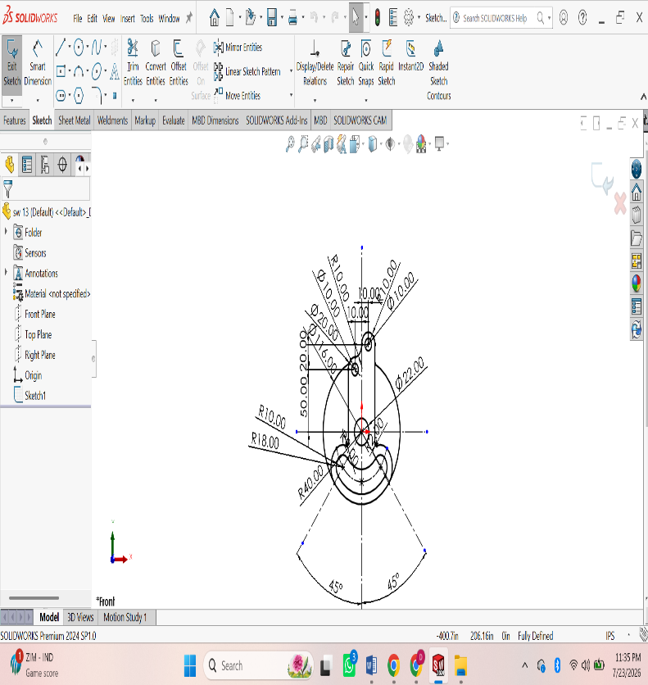
Procedure :
Open SOLIDWORKS.
• Click File → New → Part and select OK.
• Select a sketch plane (Front Plane, Top Plane, or Right Plane) from the FeatureManager.
• Click Sketch on the CommandManager to enter sketch mode.
• Use sketch tools to draw the required geometry:
- Line
- Rectangle
- Circle
- Center Rectangle
- Arc
- Polygon
- Spline (if required)
• Apply Smart Dimensions to define the size of the sketch.
• Add Sketch Relations (Horizontal, Vertical, Parallel, Perpendicular, Coincident, Tangent, Equal, etc.) to fully define the sketch.
• Ensure the sketch changes from blue (under-defined) to black (fully defined).
• Use Trim Entities or Extend Entities to modify the sketch if necessary.
• Click Exit Sketch to complete the 2D sketch.
• Save the part by selecting File → Save As and entering a file name.
ASSIGNMENT 7:
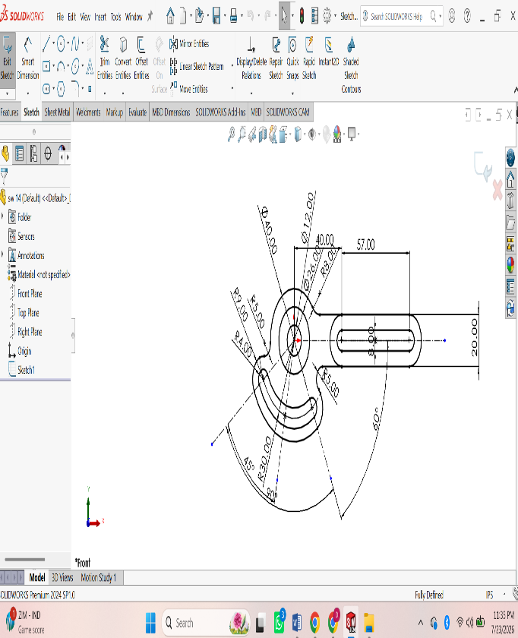
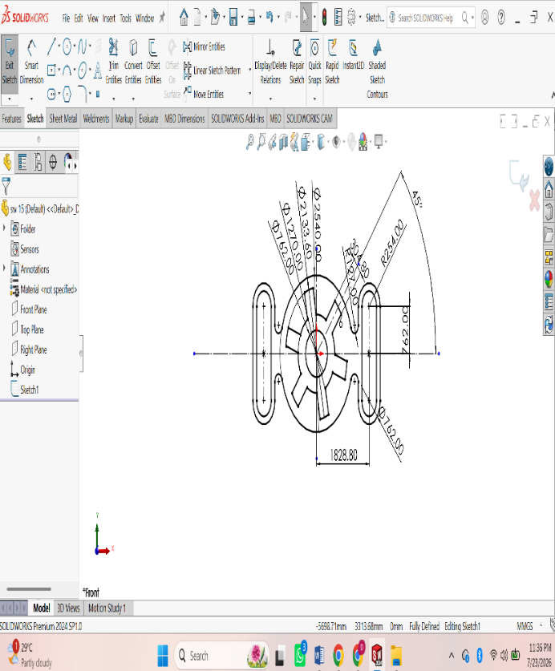
Procedure :
Open SOLIDWORKS.
• Click File → New → Part and select OK.
• Select a sketch plane (Front Plane, Top Plane, or Right Plane) from the FeatureManager.
• Click Sketch on the CommandManager to enter sketch mode.
• Use sketch tools to draw the required geometry:
- Line
- Rectangle
- Circle
- Center Rectangle
- Arc
- Polygon
- Spline (if required)
• Apply Smart Dimensions to define the size of the sketch.
• Add Sketch Relations (Horizontal, Vertical, Parallel, Perpendicular, Coincident, Tangent, Equal, etc.) to fully define the sketch.
• Ensure the sketch changes from blue (under-defined) to black (fully defined).
• Use Trim Entities or Extend Entities to modify the sketch if necessary.
• Click Exit Sketch to complete the 2D sketch.
• Save the part by selecting File → Save As and entering a file name.
ASSIGNMENT 8:
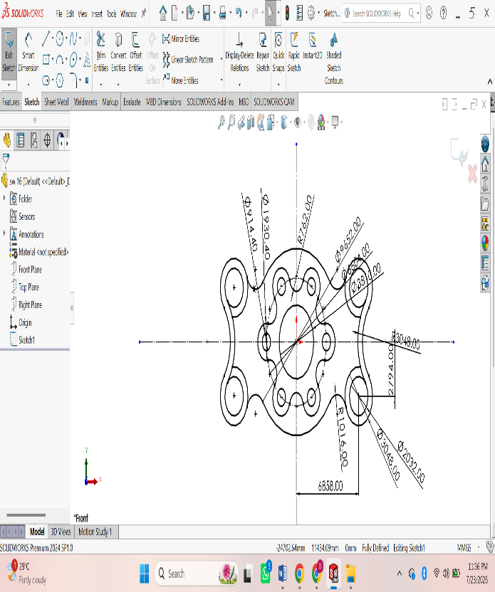
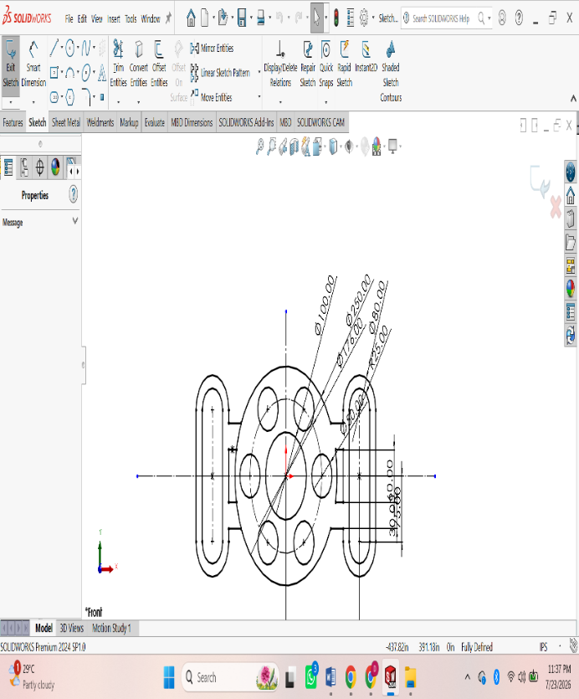
Procedure :
Open SOLIDWORKS.
• Click File → New → Part and select OK.
• Select a sketch plane (Front Plane, Top Plane, or Right Plane) from the FeatureManager.
• Click Sketch on the CommandManager to enter sketch mode.
• Use sketch tools to draw the required geometry:
- Line
- Rectangle
- Circle
- Center Rectangle
- Arc
- Polygon
- Spline (if required)
• Apply Smart Dimensions to define the size of the sketch.
• Add Sketch Relations (Horizontal, Vertical, Parallel, Perpendicular, Coincident, Tangent, Equal, etc.) to fully define the sketch.
• Ensure the sketch changes from blue (under-defined) to black (fully defined).
• Use Trim Entities or Extend Entities to modify the sketch if necessary.
• Click Exit Sketch to complete the 2D sketch.
• Save the part by selecting File → Save As and entering a file name.
ASSIGNMENT 9:
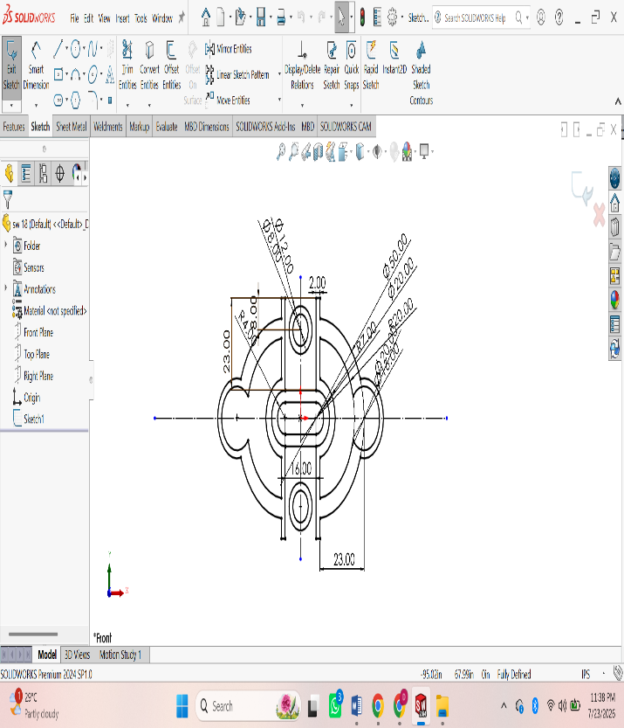
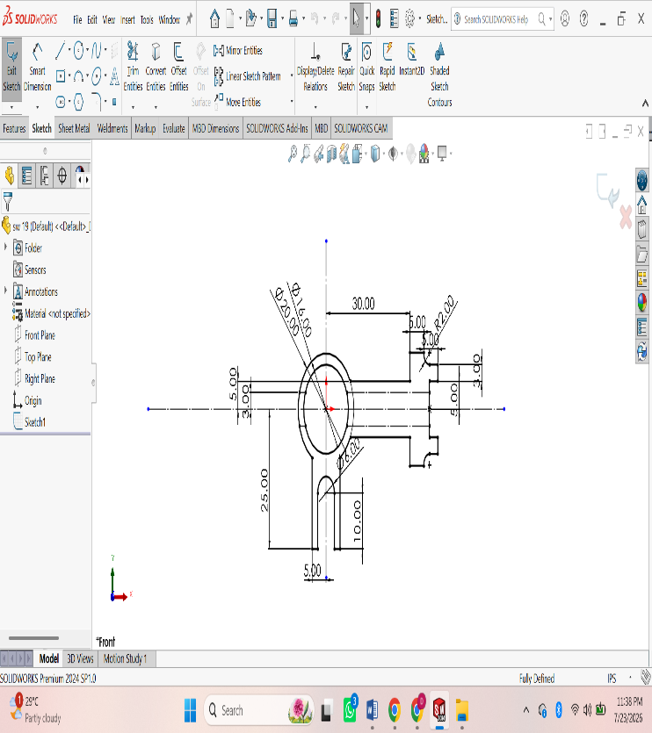
Procedure :
Open SOLIDWORKS.
• Click File → New → Part and select OK.
• Select a sketch plane (Front Plane, Top Plane, or Right Plane) from the FeatureManager.
• Click Sketch on the CommandManager to enter sketch mode.
• Use sketch tools to draw the required geometry:
- Line
- Rectangle
- Circle
- Center Rectangle
- Arc
- Polygon
- Spline (if required)
• Apply Smart Dimensions to define the size of the sketch.
• Add Sketch Relations (Horizontal, Vertical, Parallel, Perpendicular, Coincident, Tangent, Equal, etc.) to fully define the sketch.
• Ensure the sketch changes from blue (under-defined) to black (fully defined).
• Use Trim Entities or Extend Entities to modify the sketch if necessary.
• Click Exit Sketch to complete the 2D sketch.
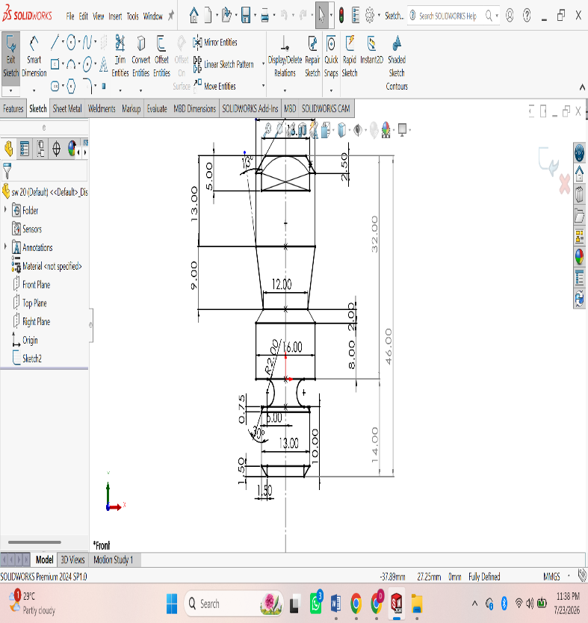
ASSIGNMENT 10:
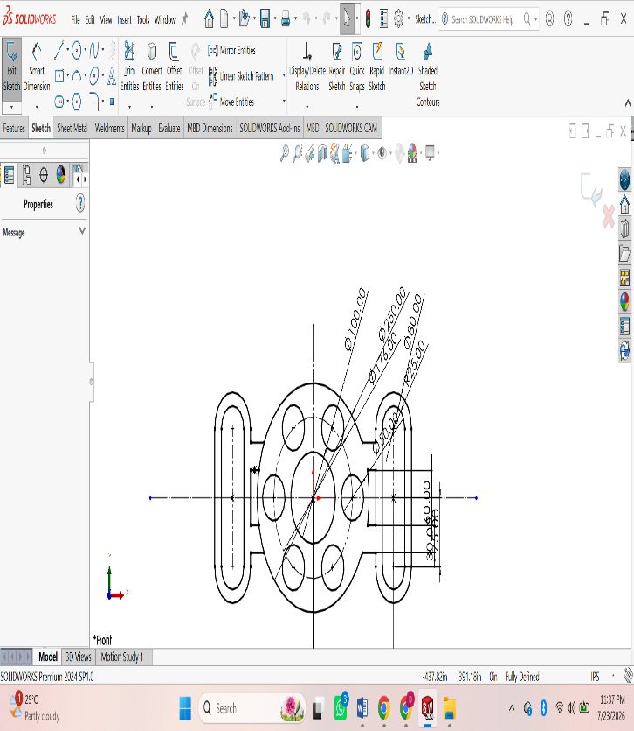
Procedure :
Open SOLIDWORKS.
• Click File → New → Part and select OK.
• Select a sketch plane (Front Plane, Top Plane, or Right Plane) from the FeatureManager.
• Click Sketch on the CommandManager to enter sketch mode.
• Use sketch tools to draw the required geometry:
- Line
- Rectangle
- Circle
- Center Rectangle
- Arc
- Polygon
- Spline (if required)
• Apply Smart Dimensions to define the size of the sketch.
• Add Sketch Relations (Horizontal, Vertical, Parallel, Perpendicular, Coincident, Tangent, Equal, etc.) to fully define the sketch.
• Ensure the sketch changes from blue (under-defined) to black (fully defined).
• Use Trim Entities or Extend Entities to modify the sketch if necessary.
• Click Exit Sketch to complete the 2D sketch.
• Save the part by selecting File → Save As and entering a file name.

3D MODELING
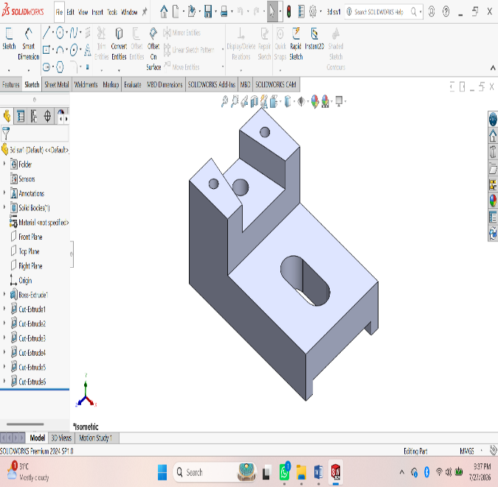
ASSIGNMENT 1:
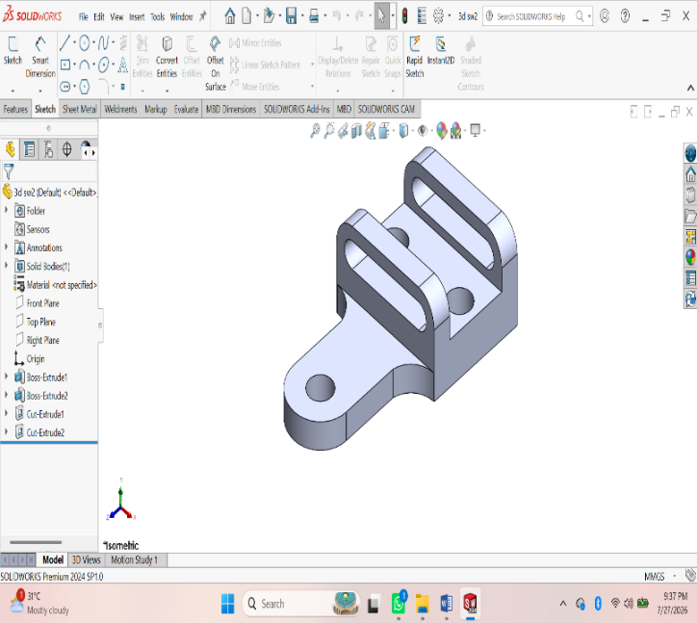Procedure :
- First of all open solidworks software in the laptop or in desktop.
- After opening, click on new the above page will appear in screen.
- After that click on frount view the sketch chuck box will be appear click on it for further step.
- In that page a small rectangular box will appear at above the date and time box, there change the units from ‘MKS’ to ‘MMGS’ units.
- Using ‘Circle’ command draw the diagram with required dimensions by giving alignments to circle.
- After drawing open ‘Extrude’ command and extrude upto required dimensions.
- After that click on top of the extrude part, a sketch box will be appear click on it.
- Again Use Line command and draw the next swept part.
- After drawing, by using ‘swept’ command draw the thread upto required dimensions.
- After drawing the diagram save it in laptop or in desktop
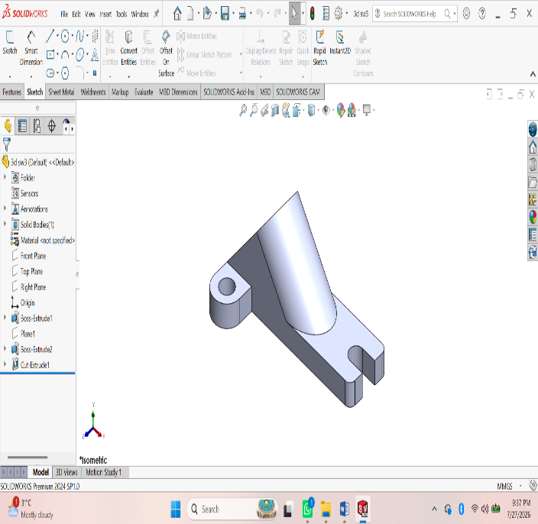
ASSIGNMENT 2:
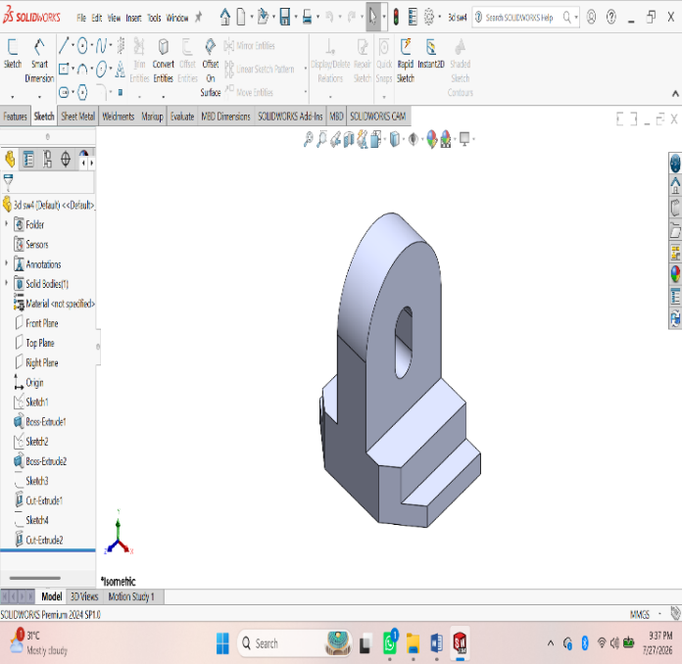Procedure :
- First of all open solidworks software in the laptop or in desktop.
- After opening, click on new the above page will appear in screen.
- After that click on frount view the sketch chuck box will be appear click on it for further step.
- In that page a small rectangular box will appear at above the date and time box, there change the units from ‘MKS’ to ‘MMGS’ units.
- Using ‘Circle’ command draw the diagram with required dimensions by giving alignments to circle.
- After drawing open ‘Extrude’ command and extrude upto required dimensions.
- After that click on top of the extrude part, a sketch box will be appear click on it.
- Again Use Line command and draw the next swept part.
- After drawing, by using ‘swept’ command draw the thread upto required dimensions.
10. After drawing the diagram save it in laptop or in desktop.
ASSIGNMENT 3:
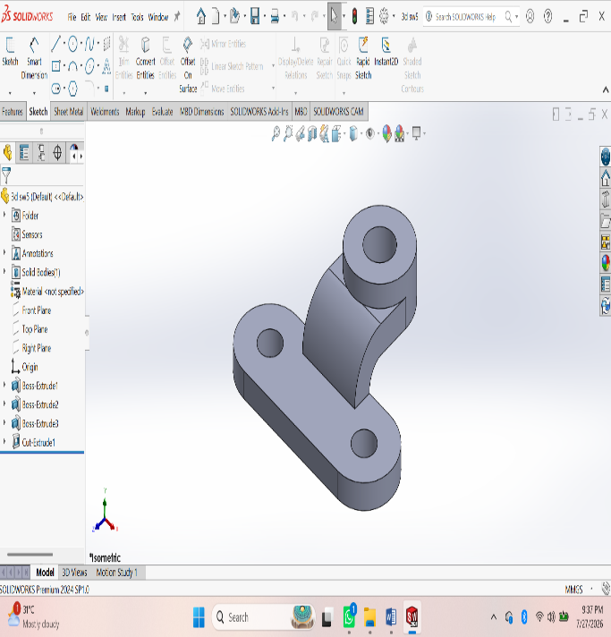
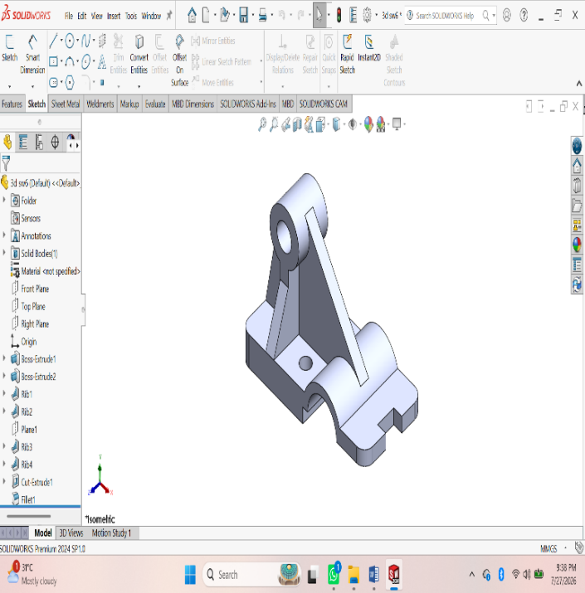Procedure :
- First of all open solidworks software in the laptop or in desktop.
- After opening, click on new the above page will appear in screen.
- After that click on frount view the sketch chuck box will be appear click on it for further step.
- In that page a small rectangular box will appear at above the date and time box, there change the units from ‘MKS’ to ‘MMGS’ units.
- Using ‘Circle’ command draw the diagram with required dimensions by giving alignments to circle.
- After drawing open ‘Extrude’ command and extrude upto required dimensions.
- After that click on top of the extrude part, a sketch box will be appear click on it.
- Again Use Line command and draw the next swept part.
- After drawing, by using ‘swept’ command draw the thread upto required dimensions.
10. After drawing the diagram save it in laptop or in desktop.
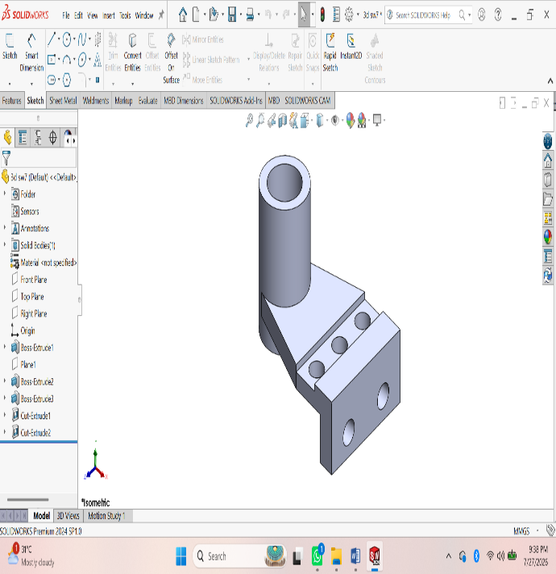
ASSIGNMENT 4:
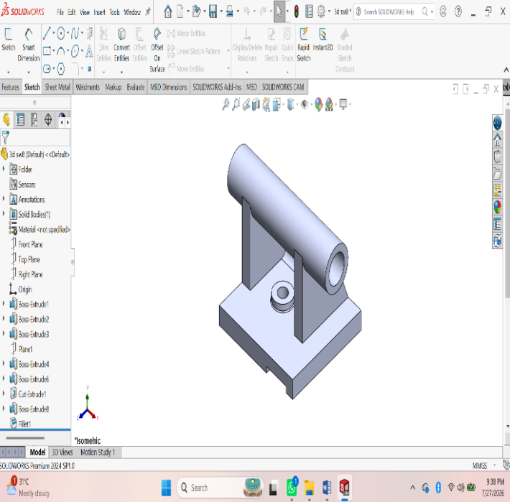Procedure :
- First of all open solidworks software in the laptop or in desktop.
- After opening, click on new the above page will appear in screen.
- After that click on frount view the sketch chuck box will be appear click on it for further step.
- In that page a small rectangular box will appear at above the date and time box, there change the units from ‘MKS’ to ‘MMGS’ units.
- Using ‘Circle’ command draw the diagram with required dimensions by giving alignments to circle.
- After drawing open ‘Extrude’ command and extrude upto required dimensions.
- After that click on top of the extrude part, a sketch box will be appear click on it.
- Again Use Line command and draw the next swept part.
- After drawing, by using ‘swept’ command draw the thread upto required dimensions.
10. After drawing the diagram save it in laptop or in desktop.
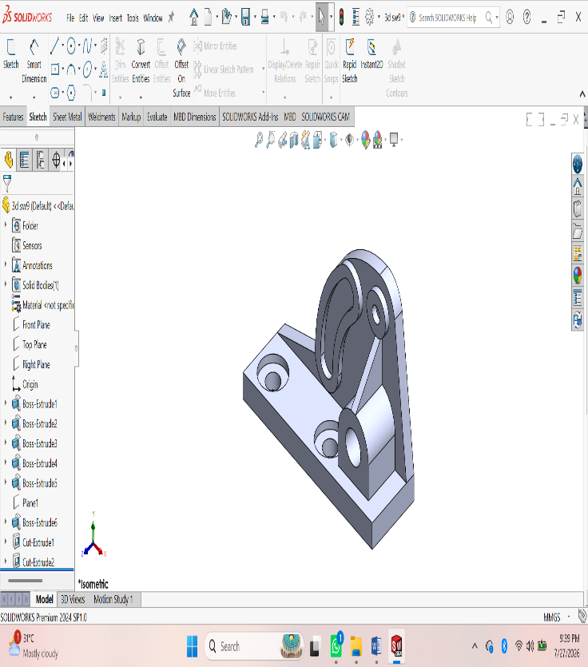
ASSIGNMENT 5:
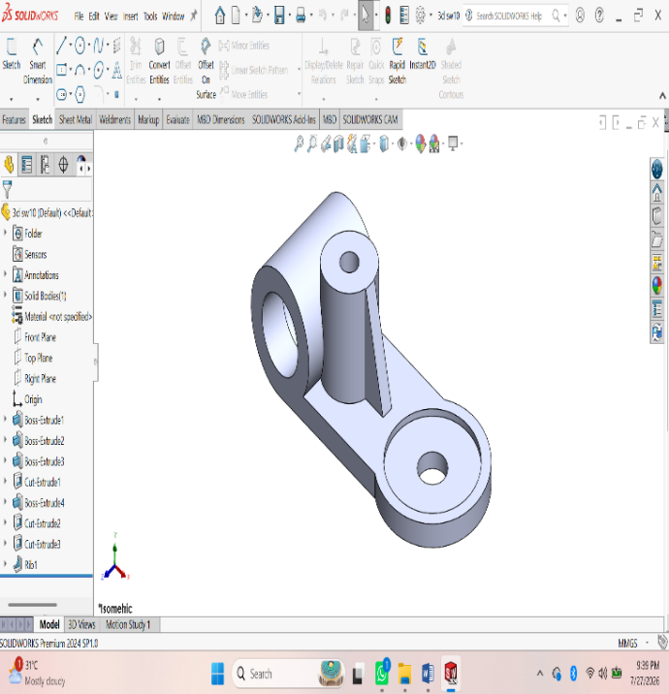Procedure :
- First of all open solidworks software in the laptop or in desktop.
- After opening, click on new the above page will appear in screen.
- After that click on frount view the sketch chuck box will be appear click on it for further step.
- In that page a small rectangular box will appear at above the date and time box, there change the units from ‘MKS’ to ‘MMGS’ units.
- Using ‘Circle’ command draw the diagram with required dimensions by giving alignments to circle.
- After drawing open ‘Extrude’ command and extrude upto required dimensions.
- After that click on top of the extrude part, a sketch box will be appear click on it.
- Again Use Line command and draw the next swept part.
- After drawing, by using ‘swept’ command draw the thread upto required dimensions.
10. After drawing the diagram save it in laptop or in desktop.
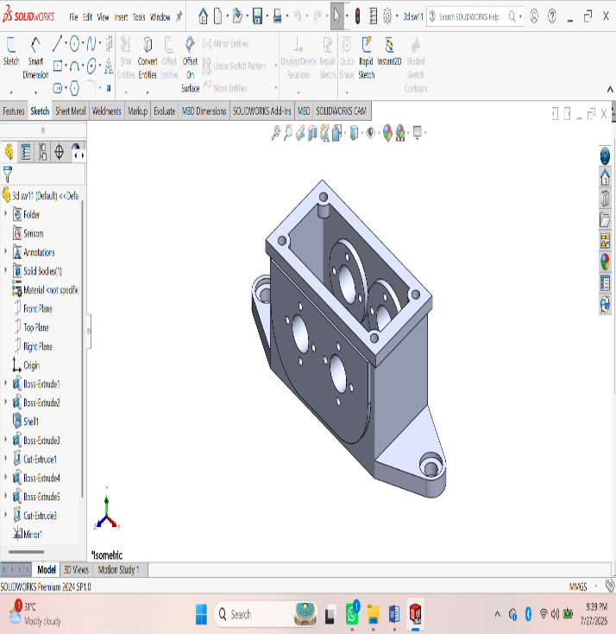
ASSIGNMENT 6:
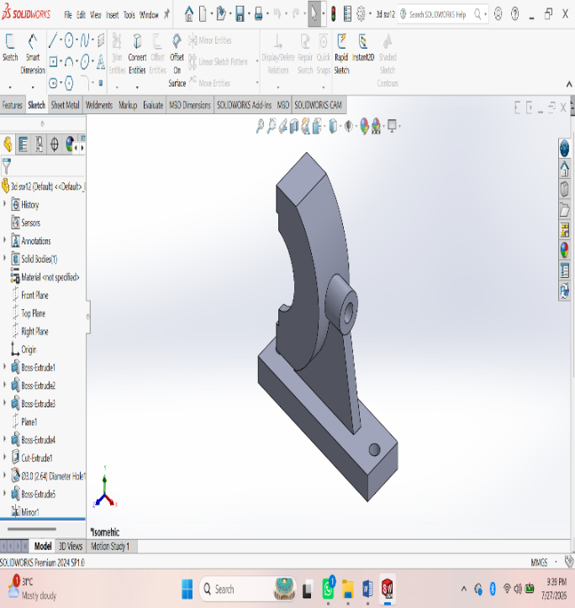Procedure :
- First of all open solidworks software in the laptop or in desktop.
- After opening, click on new the above page will appear in screen.
- After that click on frount view the sketch chuck box will be appear click on it for further step.
- In that page a small rectangular box will appear at above the date and time box, there change the units from ‘MKS’ to ‘MMGS’ units.
- Using ‘Circle’ command draw the diagram with required dimensions by giving alignments to circle.
- After drawing open ‘Extrude’ command and extrude upto required dimensions.
- After that click on top of the extrude part, a sketch box will be appear click on it.
- Again Use Line command and draw the next swept part.
- After drawing, by using ‘swept’ command draw the thread upto required dimensions.
10. After drawing the diagram save it in laptop or in desktop.
ASSESSMENT 7:
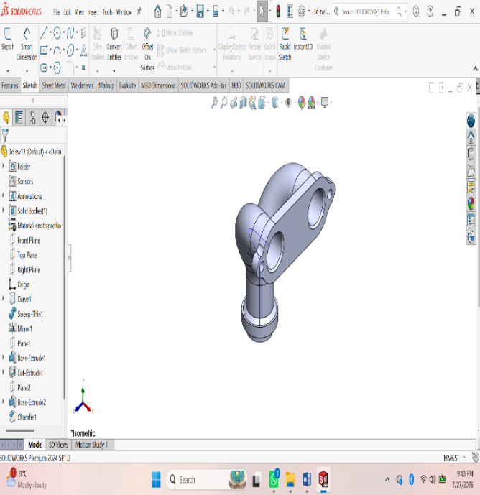
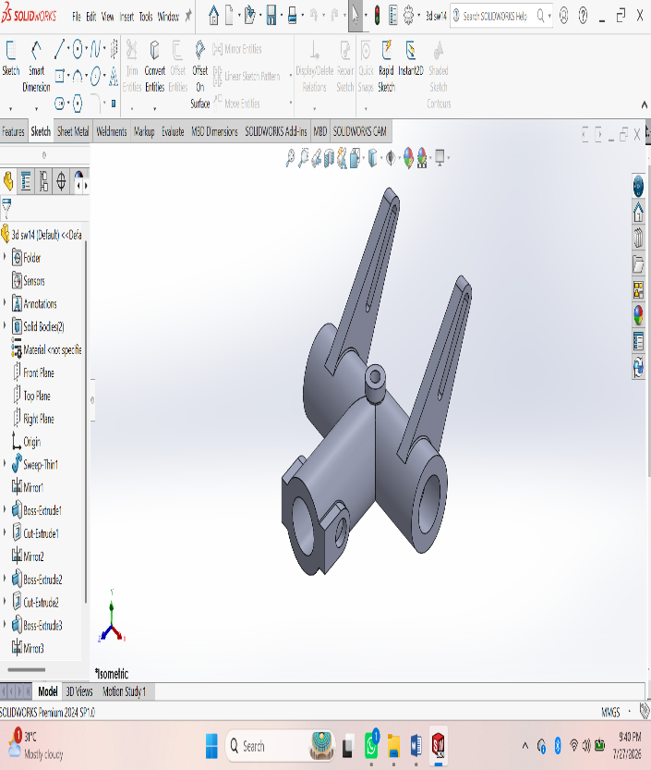Procedure :
- First of all open solidworks software in the laptop or in desktop.
- After opening, click on new the above page will appear in screen.
- After that click on frount view the sketch chuck box will be appear click on it for further step.
- In that page a small rectangular box will appear at above the date and time box, there change the units from ‘MKS’ to ‘MMGS’ units.
- Using ‘Circle’ command draw the diagram with required dimensions by giving alignments to circle.
- After drawing open ‘Extrude’ command and extrude upto required dimensions.
- After that click on top of the extrude part, a sketch box will be appear click on it.
- Again Use Line command and draw the next swept part.
- After drawing, by using ‘swept’ command draw the thread upto required dimensions.
10. After drawing the diagram save it in laptop or in desktop.
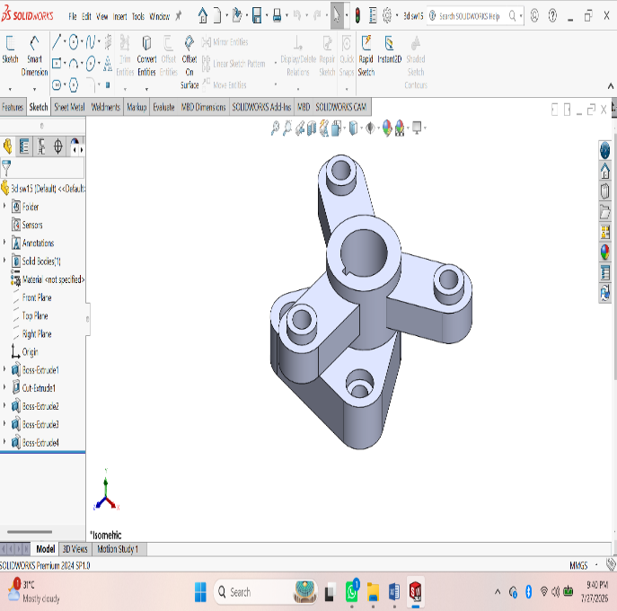
ASSESSMENT 8:
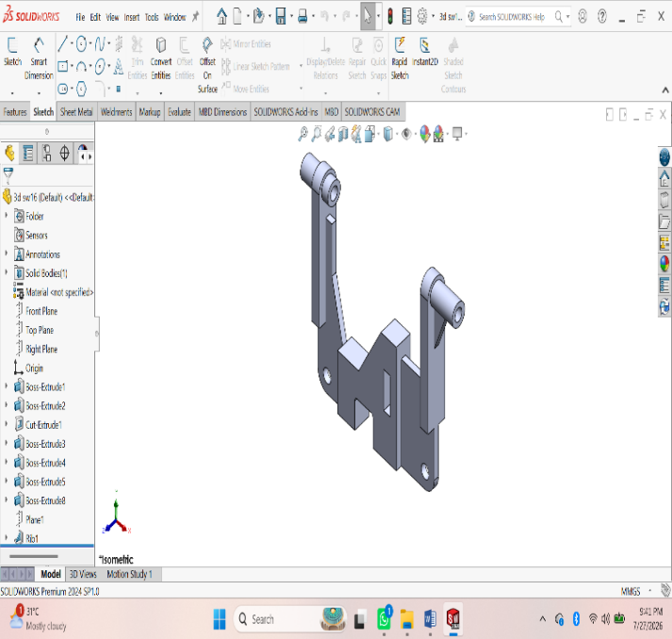Procedure :
- First of all open solidworks software in the laptop or in desktop.
- After opening, click on new the above page will appear in screen.
- After that click on frount view the sketch chuck box will be appear click on it for further step.
- In that page a small rectangular box will appear at above the date and time box, there change the units from ‘MKS’ to ‘MMGS’ units.
- Using ‘Circle’ command draw the diagram with required dimensions by giving alignments to circle.
- After drawing open ‘Extrude’ command and extrude upto required dimensions.
- After that click on top of the extrude part, a sketch box will be appear click on it.
- Again Use Line command and draw the next swept part.
- After drawing, by using ‘swept’ command draw the thread upto required dimensions.
10. After drawing the diagram save it in laptop or in desktop.
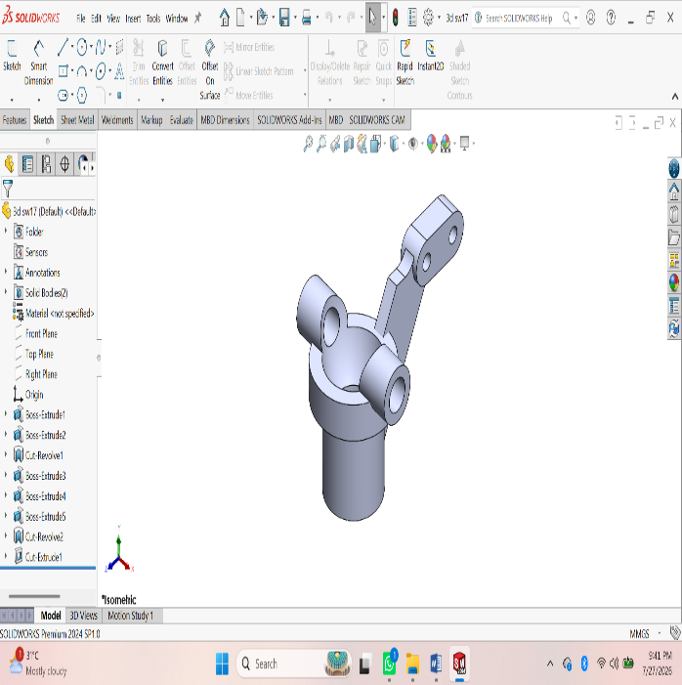
ASSESSMENT 9:
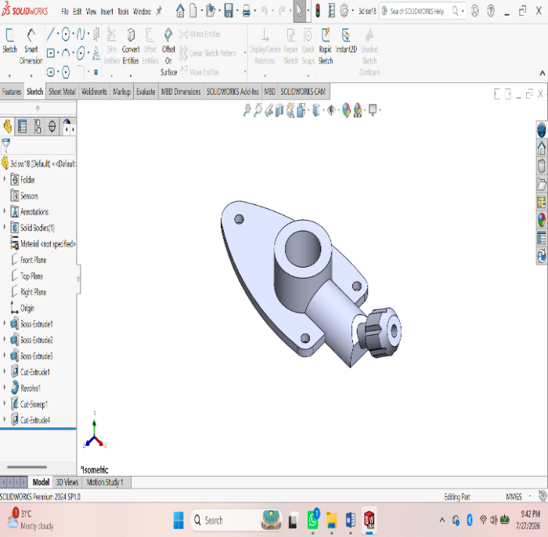Procedure :
- First of all open solidworks software in the laptop or in desktop.
- After opening, click on new the above page will appear in screen.
- After that click on frount view the sketch chuck box will be appear click on it for further step.
- In that page a small rectangular box will appear at above the date and time box, there change the units from ‘MKS’ to ‘MMGS’ units.
- Using ‘Circle’ command draw the diagram with required dimensions by giving alignments to circle.
- After drawing open ‘Extrude’ command and extrude upto required dimensions.
- After that click on top of the extrude part, a sketch box will be appear click on it.
- Again Use Line command and draw the next swept part.
- After drawing, by using ‘swept’ command draw the thread upto required dimensions.
- After drawing the diagram save it in laptop or in desktop.
ASSEMBLY

ASSESSMENT 1:
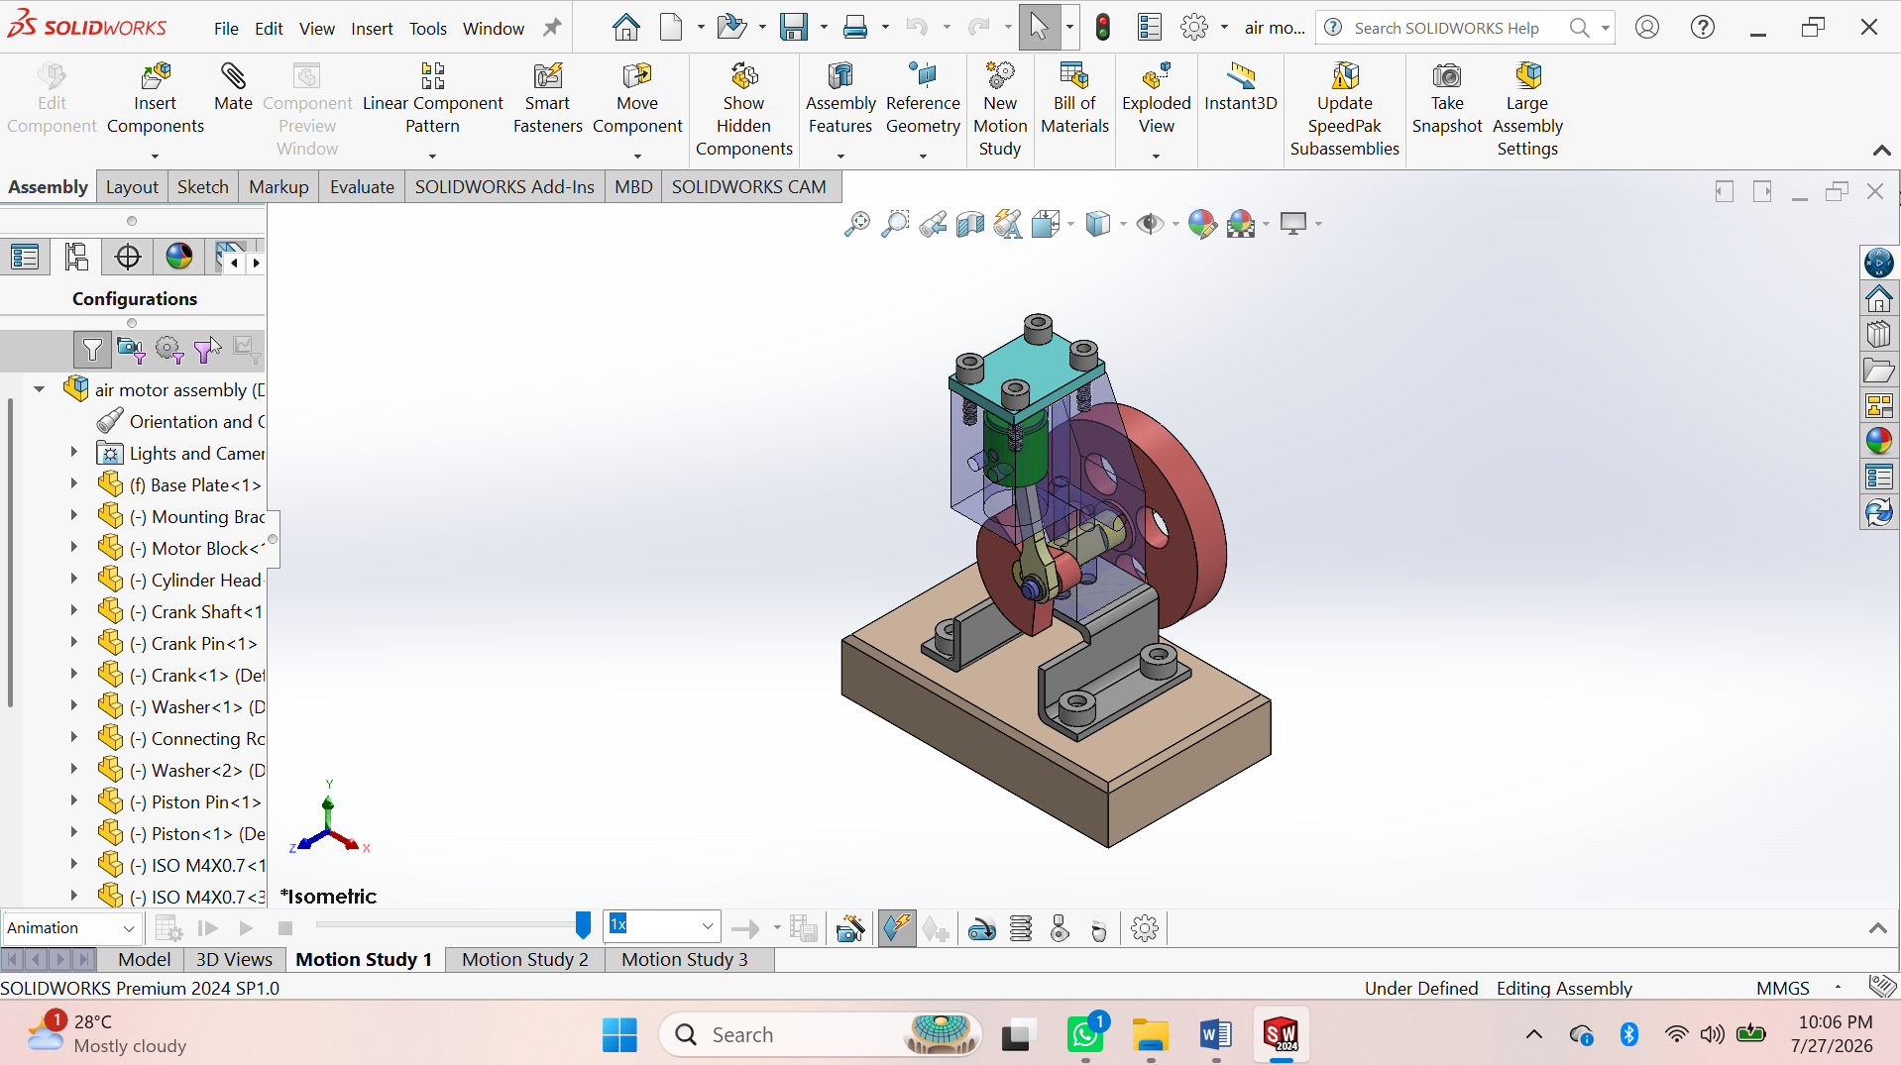
Procedure:
- Open SolidWorks → File > New > Part.
- Create Base Plate using Sketch → Extruded Boss/Base.
- Create Mounting Bracket using Sketch → Extrude → Cut holes.
- Create Motor Block using Extrude → Extruded Cut → Hole Wizard.
- Create Cylinder Head using Extrude → Hole Wizard.
- Create Flywheel using Extrude → Extruded Cut → Circular Pattern.
- Create Crankshaft using Revolved Boss/Base.
- Create Crank using Extruded Boss/Base.
- Create Connecting Rod using Extrude → Hole Wizard.
- Create Piston using Extruded Boss/Base → Cut Hole.
- Create Crank Pin using Revolved Boss/Base.
- Create Piston Pin using Revolved Boss/Base.
- Create Washer using Extruded Boss/Base.
- Insert M3 & M4 Screws from the Toolbox.
- Save all parts individually (.SLDPRT).

Assembly
- File > New > Assembly.
- Insert Base Plate and Fix it.
- Insert Mounting Bracket → Apply Coincident and Concentric Mates.
- Insert Motor Block → Apply Mates.
- Insert Cylinder Head → Apply Mates.
- Insert Crankshaft → Apply Concentric Mate.
- Insert Flywheel → Mate with the crankshaft.
- Insert Crank → Mate to the crankshaft.
- Insert Connecting Rod → Mate to the crank pin.
- Insert Piston → Mate to the connecting rod and cylinder.
- Insert Washers and Screws → Mate them in position.
- Check Interference (Evaluate > Interference Detection).
- Run Motion Study to verify the piston and flywheel movement.
- Save the Assembly (.SLDASM).
- Create the Assembly Drawing with BOM, Balloons, and Dimensions.

ASSIGNMENT 2:

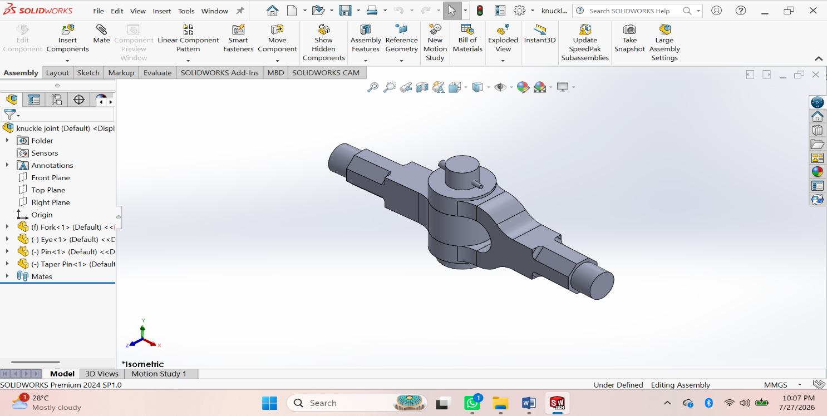
Procedure:
- Create Fork – Sketch → Extruded Boss/Base → Extruded Cut → Fillet → Save.
- Create Eye – Sketch → Extruded Boss/Base → Hole → Fillet → Save.
- Create Pin – Sketch → Revolved Boss/Base → Taper → Save.
- Create Collar – Sketch → Extruded Boss/Base → Taper → Save.
- Create Taper Pin – Sketch → Revolved Boss/Base → Save.
Assembly
- Create New Assembly – Insert Fork and Fix it.
- Insert Eye – Apply Concentric and Coincident Mates.
- Insert Pin – Apply Concentric Mate.
- Insert Collar – Apply Concentric Mate.
- Insert Taper Pin – Apply Concentric and Coincident Mates.
- Check Interference – Evaluate → Interference Detection.
- Save Assembly and create the Assembly Drawing with BOM and Balloons.

ASSESSMENT 3:

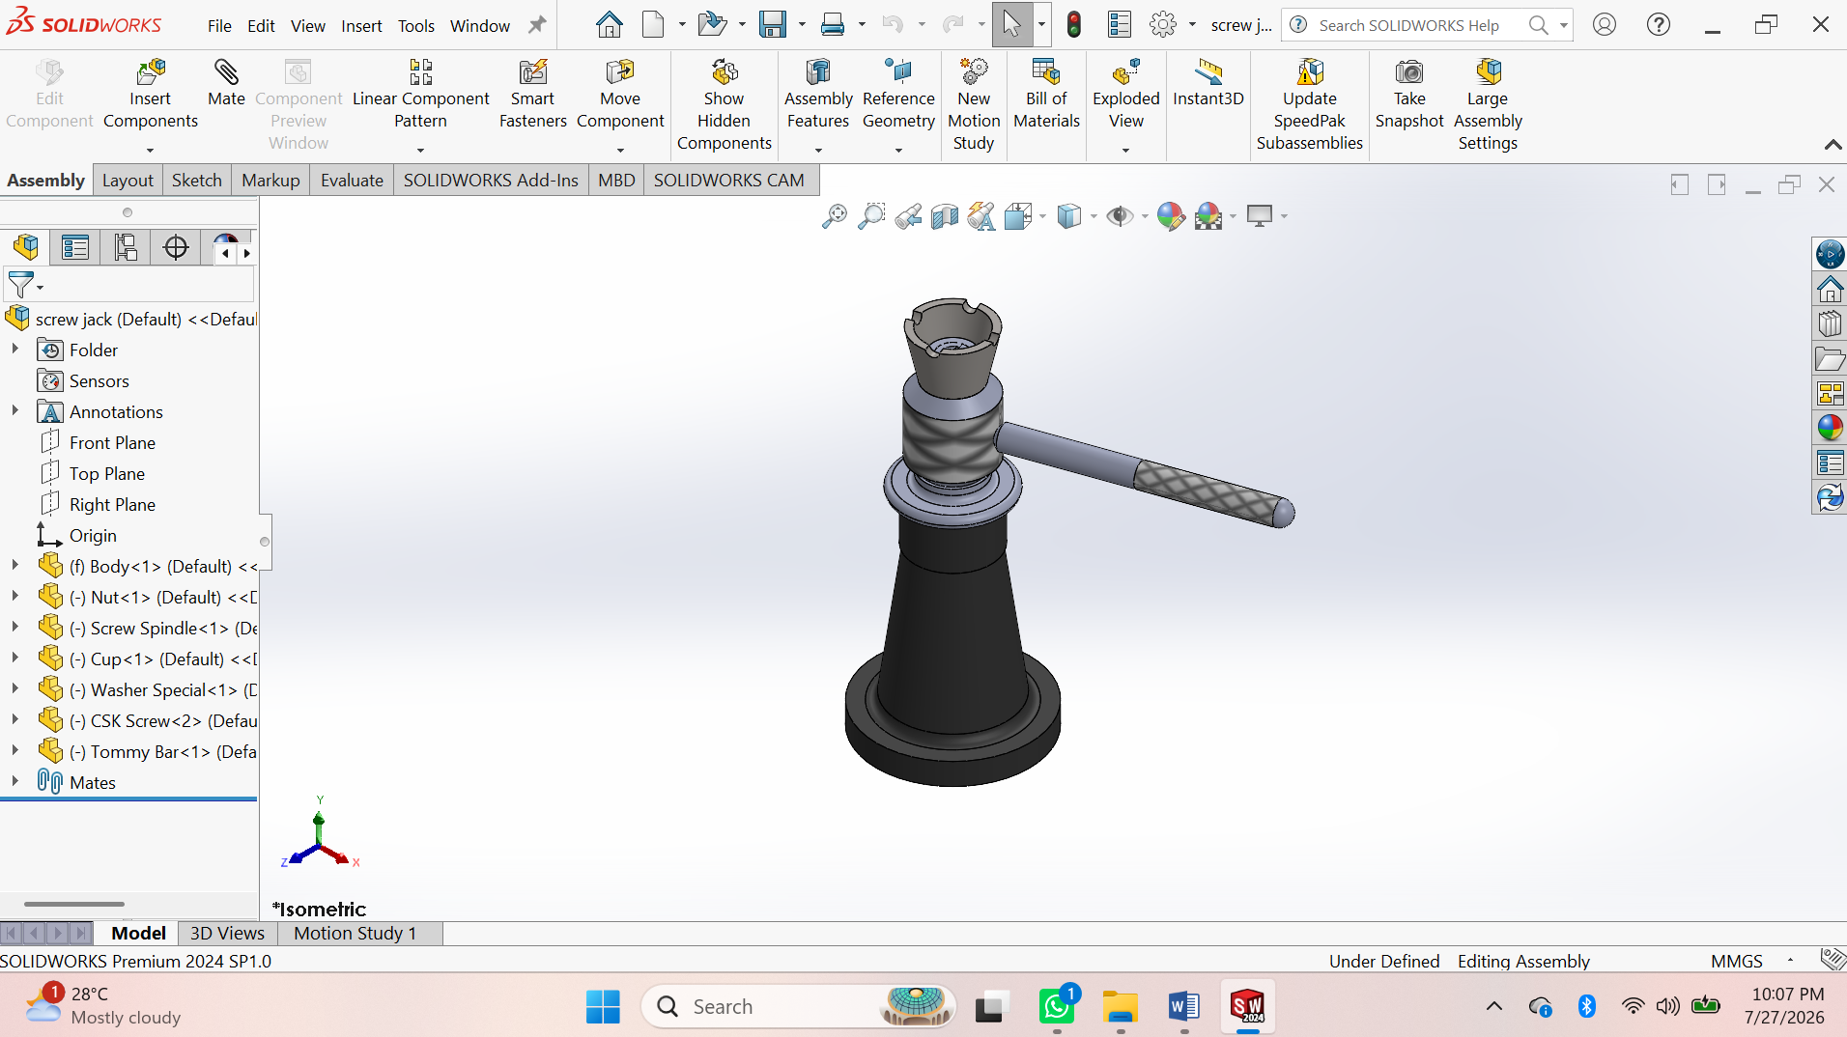
Procedure
- Create Body – Sketch → Revolved Boss/Base → Extruded Cut → Fillet → Save.
- Create Nut – Sketch → Revolved Boss/Base → Hole → Save.
- Create Screw Spindle – Sketch → Revolved Boss/Base → Helix & Thread → Knurl → Save.
- Create Cup – Sketch → Revolved Boss/Base → Extruded Cut → Save.
- Create Special Washer – Sketch → Revolved Boss/Base → Save.
- Create CSK Screw – Sketch → Revolved Boss/Base → Thread → Save.
- Create Tommy Bar – Sketch → Extruded Boss/Base → Chamfer → Save.
Assembly
- Create New Assembly – Insert Body and Fix it.
- Insert Nut – Apply Concentric and Coincident Mates.
- Insert Screw Spindle – Apply Concentric Mate.
- Insert Cup – Apply Concentric Mate.
- Insert Special Washer – Apply Concentric Mate.
- Insert CSK Screw – Apply Concentric and Coincident Mates.
- Insert Tommy Bar – Apply Concentric Mate.
- Check Interference – Evaluate → Interference Detection.
- Save Assembly and create the Assembly Drawing (BOM & Balloons).

ASSESSMENT 4:

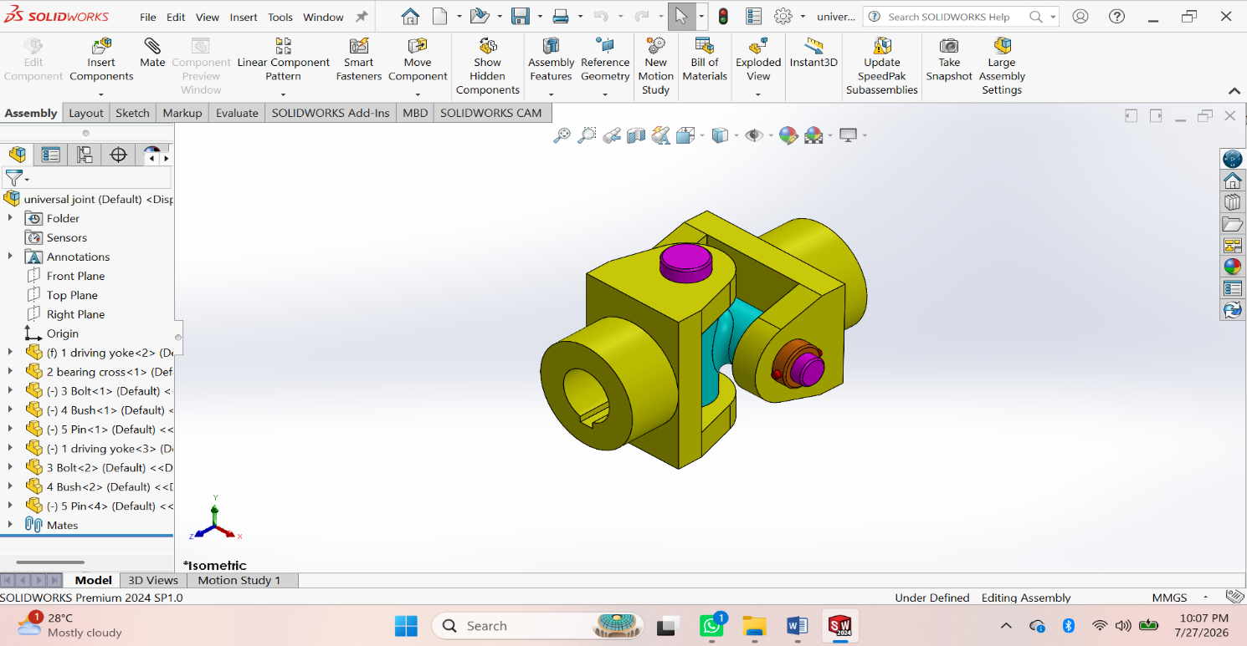
Procedure
• Create Driving Yoke – Sketch → Extruded Boss/Base → Extruded Cut → Hole → Fillet → Save.
• Create Bearing Cross – Sketch → Extruded Boss/Base → Revolved Boss/Base → Hole → Save.
• Create Bolt – Sketch → Revolved Boss/Base → Chamfer → Save.
• Create Bush – Sketch → Revolved Boss/Base → Extruded Cut → Save.
• Create Pin – Sketch → Extruded Boss/Base → Chamfer → Save.
• Create Driven Yoke – Sketch → Extruded Boss/Base → Extruded Cut → Hole → Fillet → Save.
Assembly
• Create New Assembly – Insert Driving Yoke and Fix it.
• Insert Bearing Cross – Apply Concentric and Coincident Mates.
• Insert Driven Yoke – Apply Concentric Mate.
• Insert Bushes – Apply Concentric Mate.
• Insert Pins and Bolts – Apply Concentric and Coincident Mates.
• Check Interference – Evaluate → Interference Detection.
Save Assembly and create the Assembly Drawing (BOM & Balloon

ASSESSMENT 5:

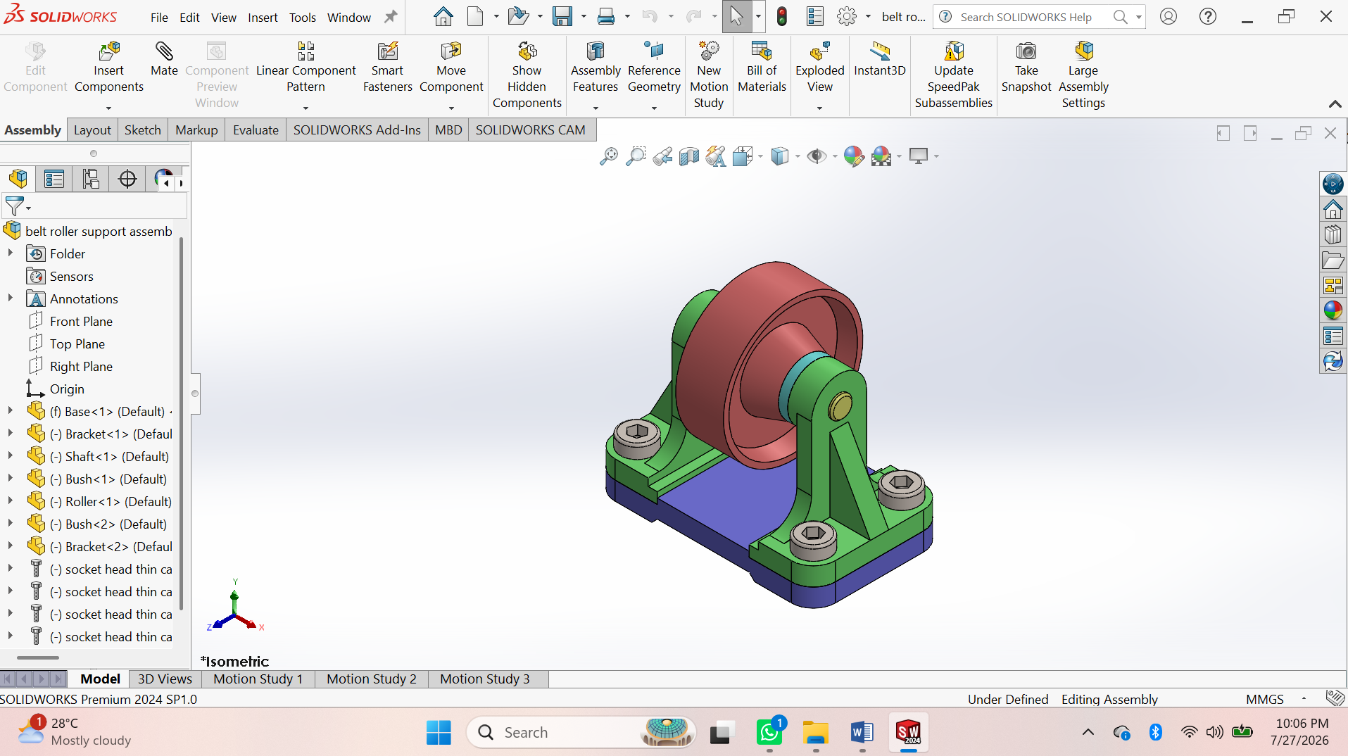
Procedure
• Create Driving Yoke – Sketch → Extruded Boss/Base → Extruded Cut → Hole → Fillet → Save.
• Create Bearing Cross – Sketch → Extruded Boss/Base → Revolved Boss/Base → Hole → Save.
• Create Bolt – Sketch → Revolved Boss/Base → Chamfer → Save.
• Create Bush – Sketch → Revolved Boss/Base → Extruded Cut → Save.
• Create Pin – Sketch → Extruded Boss/Base → Chamfer → Save.
• Create Driven Yoke – Sketch → Extruded Boss/Base → Extruded Cut → Hole → Fillet → Save.

Assembly
• Create New Assembly – Insert Driving Yoke and Fix it.
• Insert Bearing Cross – Apply Concentric and Coincident Mates.
• Insert Driven Yoke – Apply Concentric Mate.
• Insert Bushes – Apply Concentric Mate.
• Insert Pins and Bolts – Apply Concentric and Coincident Mates.
• Check Interference – Evaluate → Interference Detection.
• Save Assembly and create the Assembly Drawing (BOM & Balloon

SHEET METAL

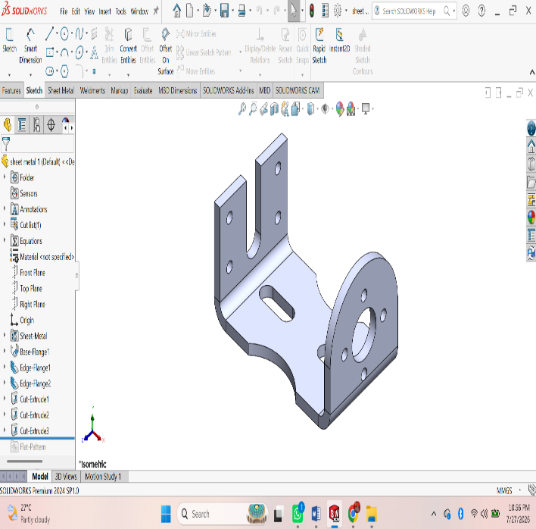
ASSESSMENT 1:

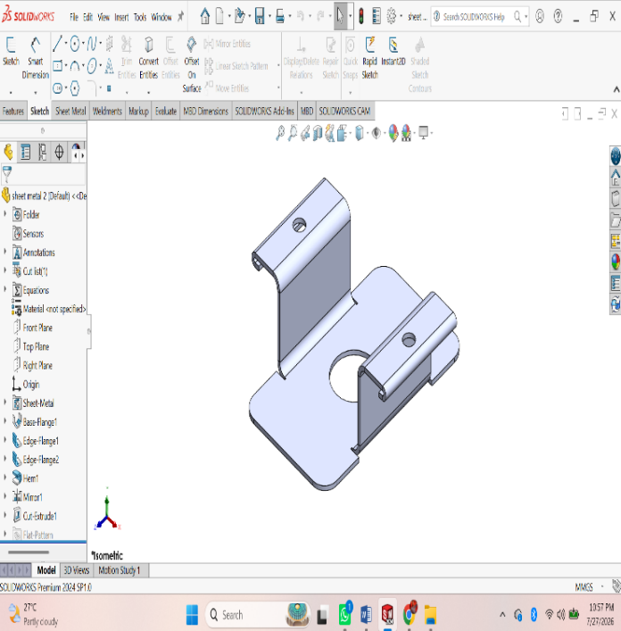

Procedure
• File → New → Part.
• Select the Sheet Metal tab.
• Sketch the base profile on a plane.
• Click Base Flange/Tab and set the sheet thickness.
• Use Edge Flange to create side flanges.
• Use Miter Flange for corner flanges (if required).
• Use Hem to fold sharp edges (optional).
• Use Sketched Bend for custom bends.
• Use Jog to create offset bends (if required).
• Create holes using Hole Wizard or Extruded Cut.
• Add Corner Trim/Corner Relief if needed.
• Apply Fillet or Chamfer to edges.
• Click Flatten to generate the flat pattern.
• Save the part (.SLDPRT).
• Create the drawing and insert the Flat Pattern View with dimensions.

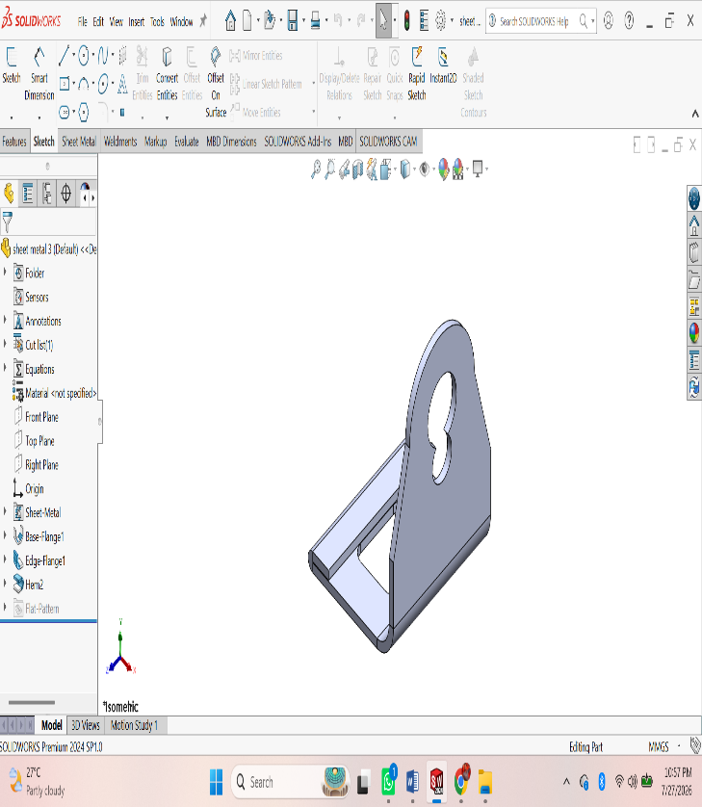
ASSESSMENT 2:
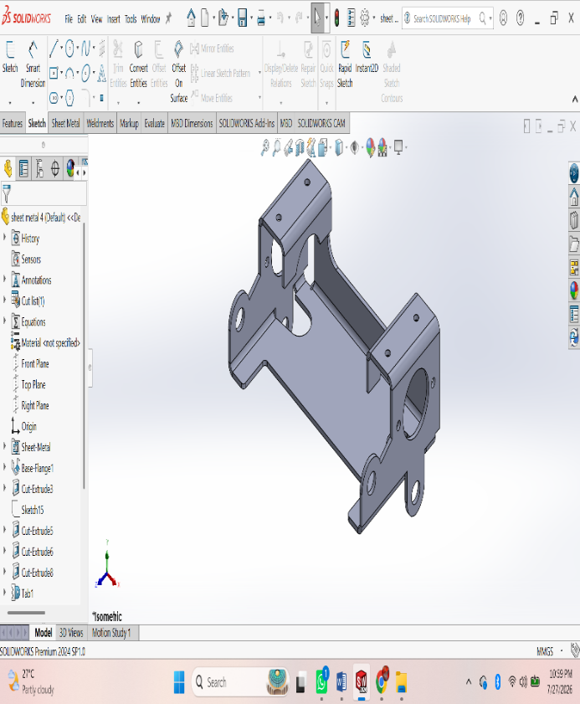
Procedure
• File → New → Part.
• Select the Sheet Metal tab.
• Sketch the base profile on a plane.
• Click Base Flange/Tab and set the sheet thickness.
• Use Edge Flange to create side flanges.
• Use Miter Flange for corner flanges (if required).
• Use Hem to fold sharp edges (optional).
• Use Sketched Bend for custom bends.
• Use Jog to create offset bends (if required).
• Create holes using Hole Wizard or Extruded Cut.
• Add Corner Trim/Corner Relief if needed.
• Apply Fillet or Chamfer to edges.
• Click Flatten to generate the flat pattern.
• Save the part (.SLDPRT).
• Create the drawing and insert the Flat Pattern View with dimensions.

ASSESSMENT 3:

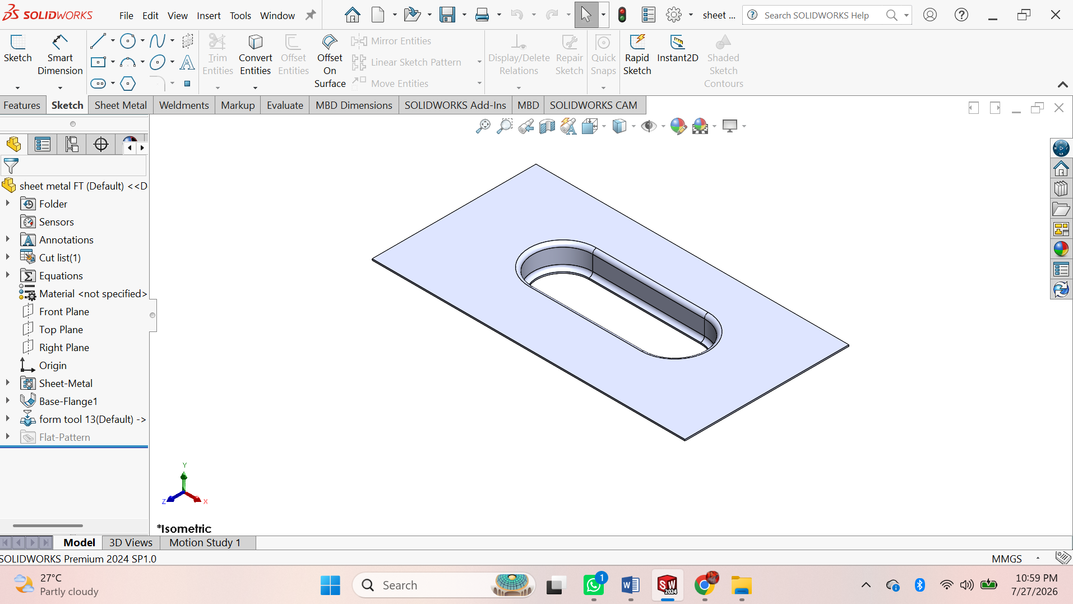
Procedure
• File → New → Part.
• Select the Sheet Metal tab.
• Sketch the base profile on a plane.
• Click Base Flange/Tab and set the sheet thickness.
• Use Edge Flange to create side flanges.
• Use Miter Flange for corner flanges (if required).
• Use Hem to fold sharp edges (optional).
• Use Sketched Bend for custom bends.
• Use Jog to create offset bends (if required).
• Create holes using Hole Wizard or Extruded Cut.
• Add Corner Trim/Corner Relief if needed.
• Apply Fillet or Chamfer to edges.
• Click Flatten to generate the flat pattern.
• Save the part (.SLDPRT).
• Create the drawing and insert the Flat Pattern View with dimensions.

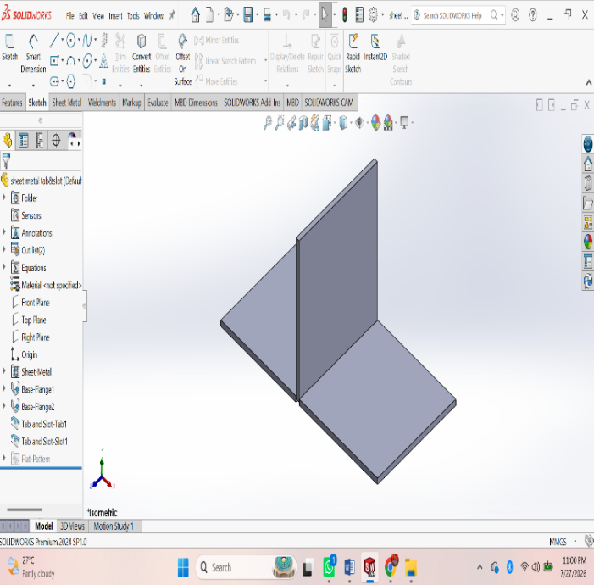
ASSESSMENT 4:

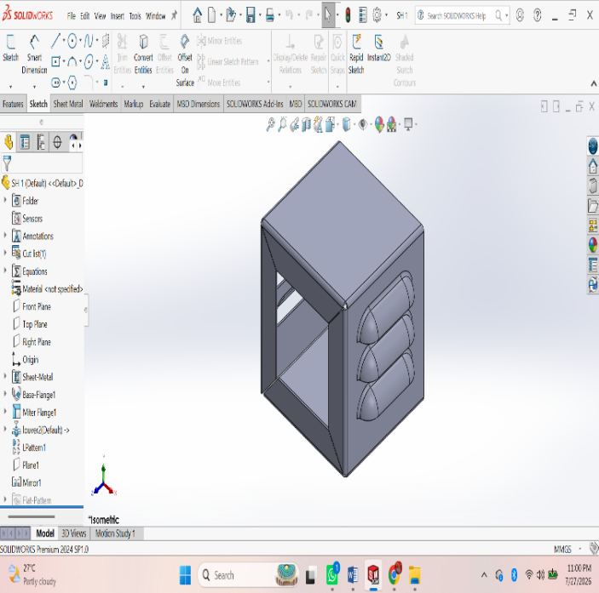
Procedure
• File → New → Part.
• Select the Sheet Metal tab.
• Sketch the base profile on a plane.
• Click Base Flange/Tab and set the sheet thickness.
• Use Edge Flange to create side flanges.
• Use Miter Flange for corner flanges (if required).
• Use Hem to fold sharp edges (optional).
• Use Sketched Bend for custom bends.
• Use Jog to create offset bends (if required).
• Create holes using Hole Wizard or Extruded Cut.
• Add Corner Trim/Corner Relief if needed.
• Apply Fillet or Chamfer to edges.
• Click Flatten to generate the flat pattern.
• Save the part (.SLDPRT).
• Create the drawing and insert the Flat Pattern View with dimensions.

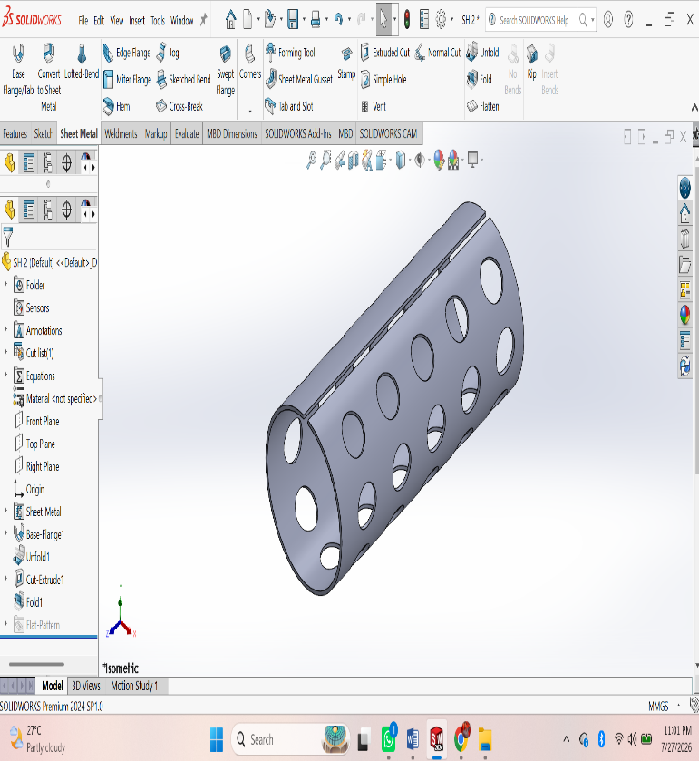
ASSESSMENT 5:
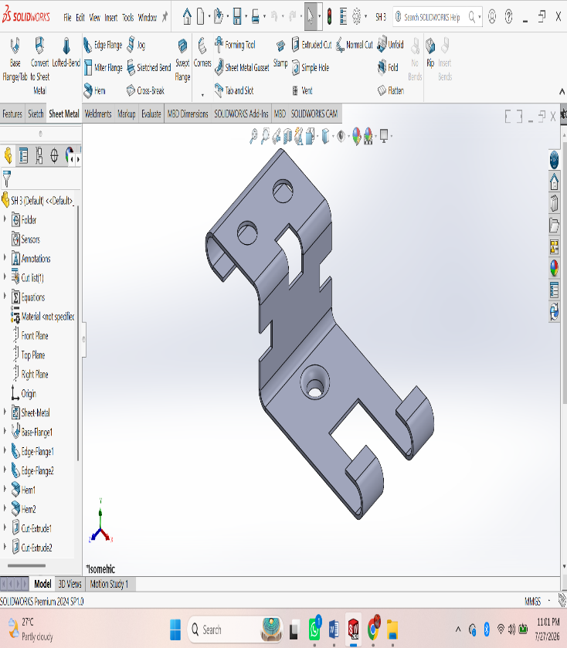
Procedure
• File → New → Part.
• Select the Sheet Metal tab.
• Sketch the base profile on a plane.
• Click Base Flange/Tab and set the sheet thickness.
• Use Edge Flange to create side flanges.
• Use Miter Flange for corner flanges (if required).
• Use Hem to fold sharp edges (optional).
• Use Sketched Bend for custom bends.
• Use Jog to create offset bends (if required).
• Create holes using Hole Wizard or Extruded Cut.
• Add Corner Trim/Corner Relief if needed.
• Apply Fillet or Chamfer to edges.
• Click Flatten to generate the flat pattern.
• Save the part (.SLDPRT).
• Create the drawing and insert the Flat Pattern View with dimensions.

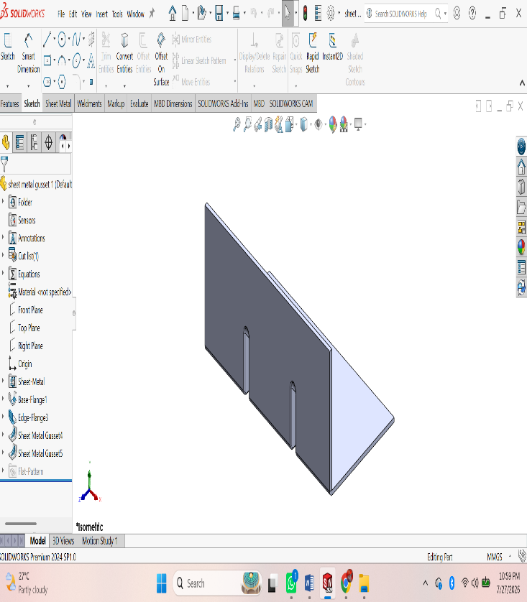
ASSESSMENT 6:

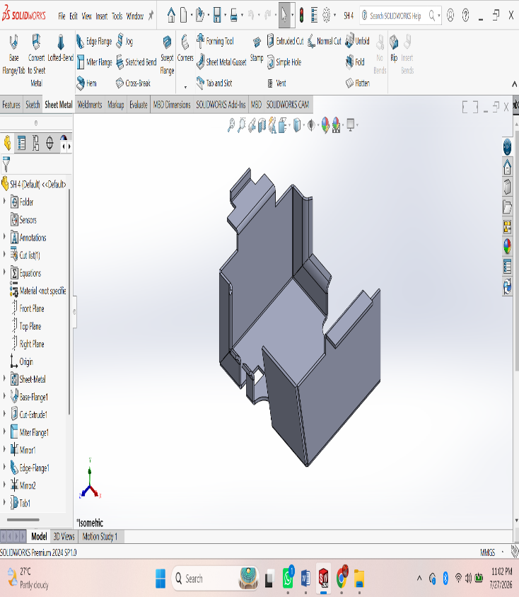

Procedure
• File → New → Part.
• Select the Sheet Metal tab.
• Sketch the base profile on a plane.
• Click Base Flange/Tab and set the sheet thickness.
• Use Edge Flange to create side flanges.
• Use Miter Flange for corner flanges (if required).
• Use Hem to fold sharp edges (optional).
• Use Sketched Bend for custom bends.
• Use Jog to create offset bends (if required).
• Create holes using Hole Wizard or Extruded Cut.
• Add Corner Trim/Corner Relief if needed.
• Apply Fillet or Chamfer to edges.
• Click Flatten to generate the flat pattern.
• Save the part (.SLDPRT).
• Create the drawing and insert the Flat Pattern View with dimensions.

ASSESSMENT 7:

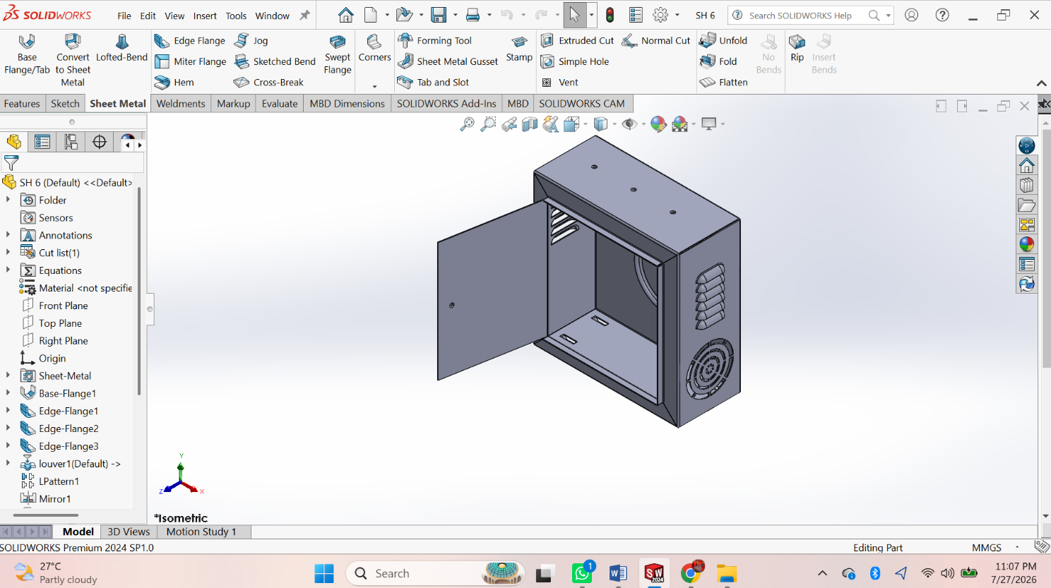
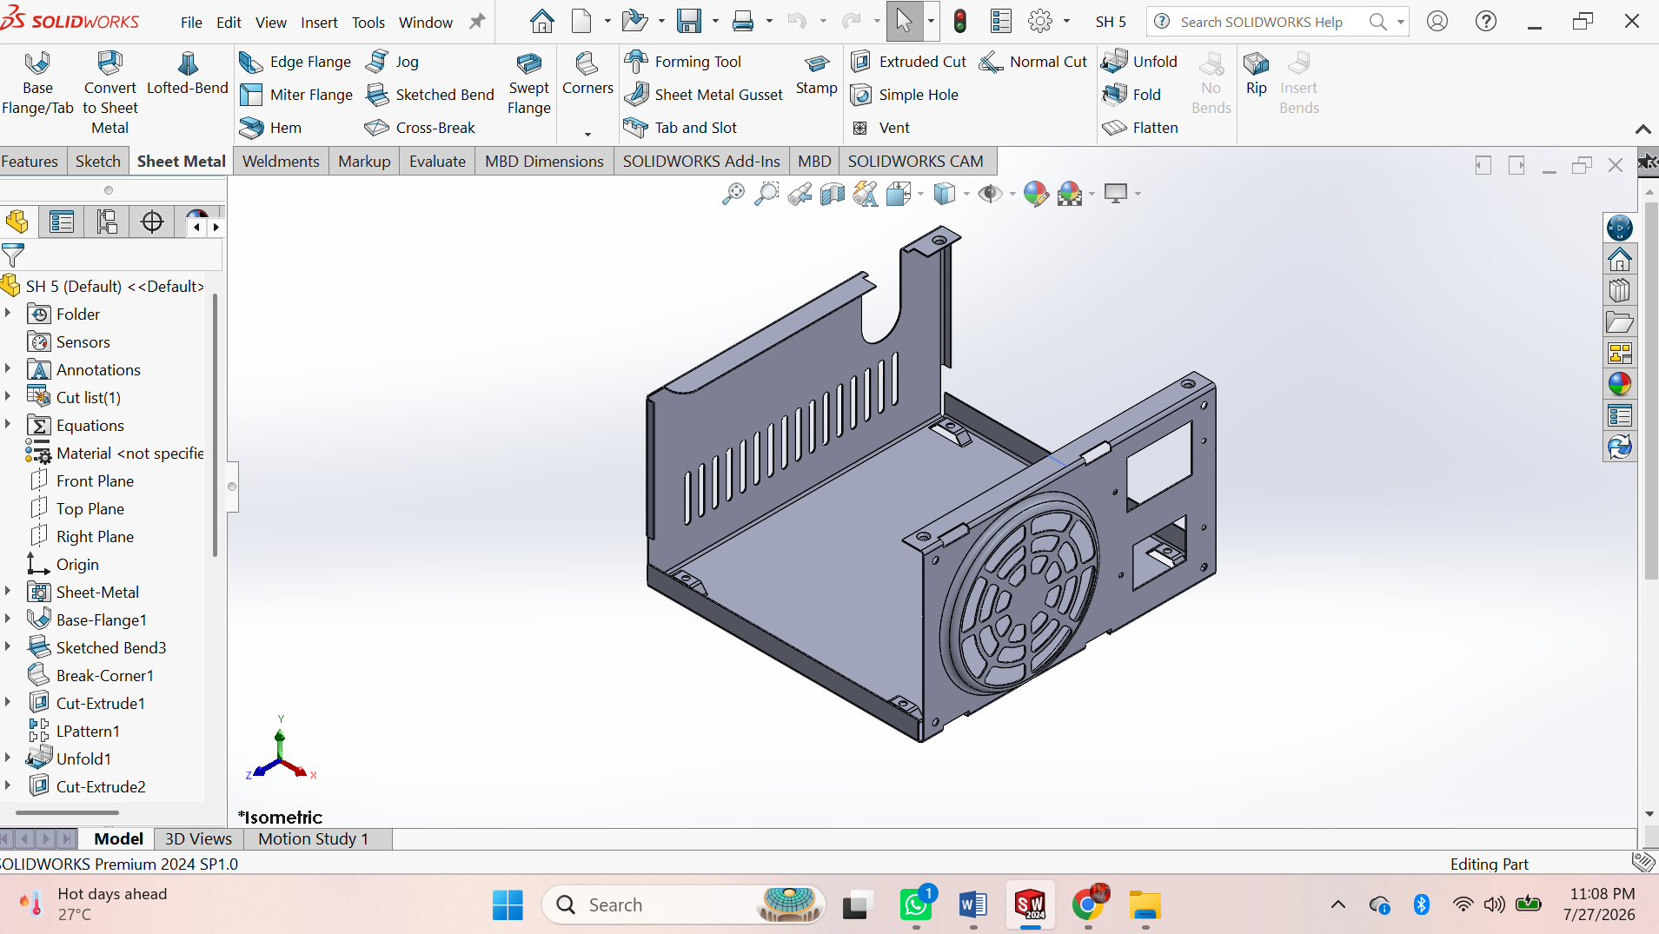

WELDMENTS

ASSESSMENT 1:
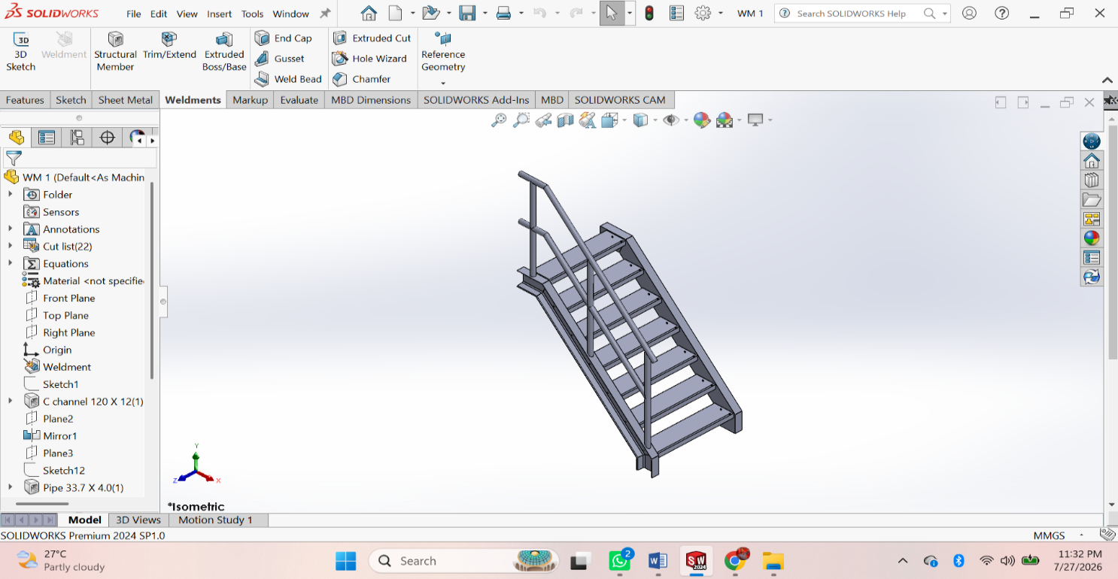
Procedure
• File → New → Part.
• Enable the Weldments tab.
• Create a 2D/3D Sketch for the frame layout.
• Click Structural Member and select the standard, type, and size.
• Apply the structural member to the sketch.
• Use Trim/Extend to trim intersecting members.
• Add Gusset where required.
• Add End Cap to open tube ends (optional).
• Use Weld Bead to create welds (if required).
• Create holes or cuts using Extruded Cut.
• Apply Fillet or Chamfer if needed.
• Check the Cut List and update it.
• Save the weldment part (.SLDPRT).
• Create the drawing and insert the Cut List with dimensions.

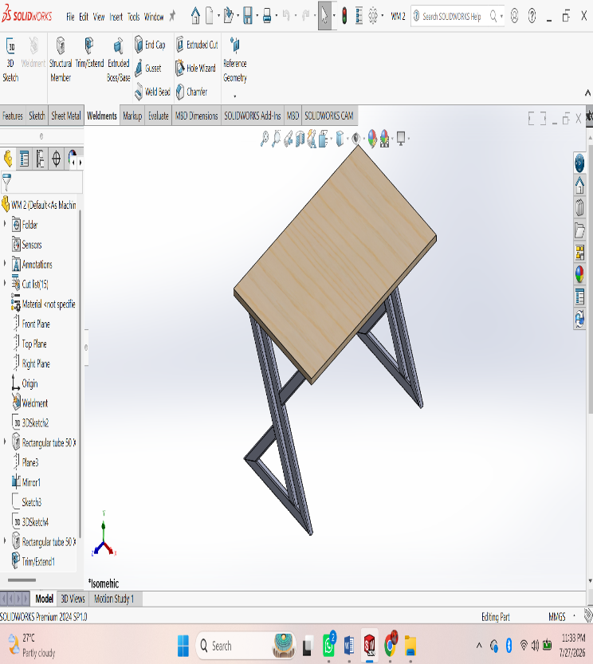
ASSESSMENT 2:
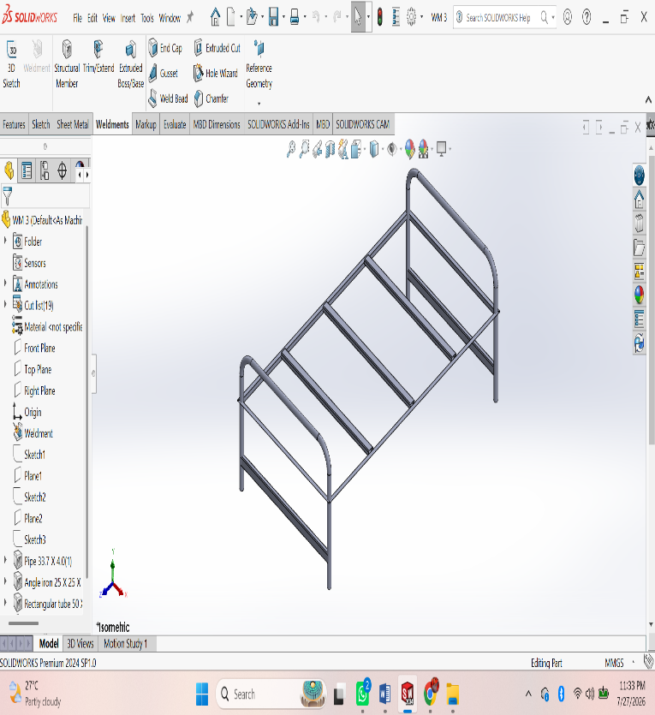
Procedure
• File → New → Part.
• Enable the Weldments tab.
• Create a 2D/3D Sketch for the frame layout.
• Click Structural Member and select the standard, type, and size.
• Apply the structural member to the sketch.
• Use Trim/Extend to trim intersecting members.
• Add Gusset where required.
• Add End Cap to open tube ends (optional).
• Use Weld Bead to create welds (if required).
• Create holes or cuts using Extruded Cut.
• Apply Fillet or Chamfer if needed.
• Check the Cut List and update it.
• Save the weldment part (.SLDPRT).
• Create the drawing and insert the Cut List with dimensions.

