Force – Vibrotactile – Belt
Setup
- Plug in the Arduino Due Programming Port to a Power supply
- Install ForceVirotactileBelt.app on an Android device
- Activate Bluetooth on the Android device
- In the Bluetooth settings pair the Android device with HC-06 using the password 1234

Operating manual
- Plug in the Arduino Due Programming Port to a Power supply
- Activate Bluetooth on the Android device
- Open ForceVibrotactileBelt.app
- Press the button CONNECT TO FSR

Arduino Setup

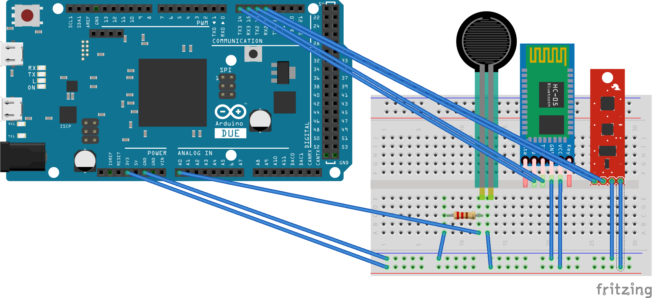

Components

- Arduino Due
- 9 Degrees of Freedom – Razor IMU
- HC-06 Bluetooth Module
- 8x Force Sensitive Resistor 0.5'
- 8x 1.2kΩ Resistor

