

AHK Framework

Project Documentation



OCTOBER 07, 2023

 **VEER NARMAD SOUTH GUJARAT UNIVERSITY**

 **ATMANAND SARASWATI SCIENCE COLLEGE**

**B.Sc. (Computer Science)**

PROJECT REPORT ON

**AHK Framework**

AS PARTIAL REQUIREMENT, FOR

B.Sc. (Computer Science) 5th Semester Year: 2023 – 2024

**GUIDED BY: SUBMITTED BY:**

**MRS. KHUSHBU SONAWANE MR. BHARGAV GHORI (CS2122)**

**MRS. VAISHNAVI BADAMI MR. SMIT MEGHANI (CS2138)**

**ACKOWLEDGMENT**



With great delight and a profound sense of accomplishment, I take immense pleasure in presenting this report on the project titled AHK Framework.'

I extend my heartfelt gratitude to our Project Advisor, Mrs. Khushabu Sonaware, for entrusting us with the opportunity to work under his guidance. We are sincerely thankful for his unwavering belief in our capabilities and for deeming us worthy of this significant project

I would also like to express our appreciation to our Principal, Mr. Shailesh Padsala, and all the esteemed faculty members at our college. Their valuable suggestions and unwavering encouragement not only aided us in the preparation of this report but also deepened our understanding of the subject matter. This project has enriched me with invaluable experiences that will continue to shape my career path.

Finally, I extend heartfelt thanks to Project Advisor for their guiding, unwavering faith that have been a constant source of strength throughout this journey.

I am also indebted to my dedicated colleagues and friends for their unceasing support and assistance. Without their contributions, this endeavor would not have been possible.

In sincere appreciation,

Bhargav Ghori,

Smit Meghani.

**COLLEGE CERTIFICATE**



**ABSTRACT**



This Framework main focus is that the there are this type of framework where no need to do coding for automation. Without coding just enter value or text for create Autohotkey Automation Script and totally open for all. There are need to installation of third party software ‘autohotkey v1’ for use this automation script This system will run on internet. The system Front-End is written in HBS handelbars, HTML, CSS, JS and The system Back-End is written in Node JS(Java Script).

Users will not need to log in. without login that they will be able to various tasks that are designed for them. In future It can be turned into a paid system for the person who is accessing the services with minor charges. Where user will get additional cloud storage & payment. AHK Framework is Framework which is helpful for Person who need create automation script without coding knowledge.

**INDEX**



|  |  |  |
| --- | --- | --- |
| **Sr No.** | Particulars. | Page no. |
| **1** | Introduction | 1 |
|  | 1.1 Project Profile | 2 |
|  |  |  |
| **2** | Environment Description | 3 |
|  | 2.1 Hardware Requirement | 4 |
|  | 2.2 Software Requirement | 5 |
|  |  |  |
| **3** | Existing System | 6 |
|  | 3.1 Manual Process | 7 |
|  | 3.2 Manual Process Drawbacks | 8 |
|  |  |  |
| **4** | Proposed System | 9 |
|  | 4.1 Scope | 10 |
|  | 4.2 Objectives | 11 |
|  |  |  |
| **5** | System Planning | 12 |
|  | 5.1 Feasibility Study | 13 |
|  | 5.2 Requirement Gathering | 14 |
| **Sr No.** | Particulars. | Page no. |
| **6** | Module Specification | 15 |
|  |  |  |
| **7** | Detail Planning | **19** |
|  | 7.1Data Flow Diagram | 20 |
|  | 7.2 Entity Relationship Diagram | 21 |
|  | 7.3 Database Design | 23 |
|  |  |  |
| **8** | System Design | 25 |
|  |  |  |
| **9** | System Testing | **35** |
|  | 9.1 Unit Testing | **36** |
|  | 9.2 Integration Testing | **37** |
|  |  |  |
| **10** | References | **40** |



**1.1 Project Profile**

1

**PROJECT PROFILE**



|  |  |
| --- | --- |
| **Project Name:** | AHK Framework |
| **Technology:** | Xampp Server |
| **Front End:** | HBS Handelbars |
| **Back End:** | Node JS |
| **Development Tool:** | Visual Studio Code 2019 |
| **Documentation Tool:** | WPS office |
| **Project Duration:** | JULY 2023 TO OCTOBER 2023 |
| **Developed By:** | -Bhargav Ghori  -Smit Meghani |

2



* 1. **Hardware Used**
  2. **Software Used**

3

* 1. **HARDWARE USED**



* + - Development time Hardware Requirement

|  |  |
| --- | --- |
| **Microprocessor:** | Intel(R) Core i5 |
| **Memory:** | 8.00 GB RAM |
| **Hard Disk Space:** | 2GB |

* + - Run time Hardware Requirement

|  |  |
| --- | --- |
| **Memory** | 2 GB Minimum |

4

* 1. **SOFTWARE USED**
     + Development time Software Requirement

|  |  |
| --- | --- |
| **Operating System:** | Windows 11 |
| **Server Side Script Language** | Node JS |
| **Database** | PhpMyAdmin |
| **Browser** | Google Chrome |
| **Server** | XAMMP Server |
| **Software** | Visual Studio Code |

* + - Run time Software Requirement

|  |  |
| --- | --- |
| **Browser:** | Google Chrome or All Brouser |
| **Software** | Internet Connection |

5



* 1. **Manual process**
  2. **Manual process drawbacks**

6

* 1. **Manual process**

Enter value for Automation: To be a create autohotkey script, you need to have a little knowledge of autohotkey or automation or set a value or text for create script.

7

* 1. **Manual process drawbacks**

There are no Manual Process drawback because of the there need user input because this framework totally work on user value what user want this framework do that without user involvement that not possible that how to create script or how to use this framework so there are no drawback of the manual process.

8



* 1. **Scope**
  2. **Objectives**

**9**

* 1. **Scope**

**The purpose of the ‘AHK Framework’ is that the there are many user who have no coding knowledge but than also user want to use automation for anything which in loop in it’s pc or it’s may be routine life process for computer that time this AHK Framework used and create automation ahk file without any coding knowledge.**

**Main scope of this framework is that there are many user on online and all want create automation file but all have not able to get information of coding and how that create file by coding so this framework help that type of user and create ahk file for them without coding knowledge and without any money because this software are currently free for all.**

**This framework very usefull for that type of user who have no knowledge in this software we provide video also for that framework that the framework how it work.**

**10**

* 1. **Objectives**

**Providing a framework where create AHK file without any cost.**

**We provide totally open and free for all who want create AHK automation file without any coding knowledge.**

**Providing video also for how to use this framework for create AHK file.**

**We provide user friendly interface or user can create file easyly that type of User Interface.**

**Our mail objective is that user create file without any coding knowledge or create file without any cost or user can simply run it in desktop or pc without any cost or coding just send text coordinate value or other information which want and download file there very easy to create AHK file and than very easy to use.**

**11**



* 1. **Feasibility Study**
  2. **Requirement Gathering**

**12**

* 1. **Feasibility Study**

**Market Analysis :**

Conduct research to identify the size and growth potential of the automation user. We study on this automation and see on network that there are no website or no software for this type of framework where user create AHK file without coding.

**Technical Feasibility :**

Determine the technical requirements and resources needed to develop and maintain the website, including hardware, software, hosting, security, and scalability.

**Legal and Regulatory Feasibility :**

Assess the legal and regulatory requirements and risks associated with operating a AHK Framework website admin panel. In future we also tie-up with this automation company which are on network.

**Risk Analysis :**

**I**dentify and assess potential risks and challenges that could impact the success of the AHK Framework website. But there are currently no risk because this are totally free or open for all.

**Conclusion:**

Based on the above analysis, determine the overall feasibility of launching and operating a AHK Framework website, and develop a detailed plan for implementation or ongoing management.

**Operational Feasibility :**

Evaluate the operational requirements and resources needed to manage the website, including staffing, customer support, project management, and administrative functions. Assess the feasibility of implementing best practices and industry standards for quality assurance, risk management, and compliance.

**14**

* 1. **Requirement Gathering**
* Before the starting project I have summarized the overall & basic functionality which can be include in this project. For this project there are multiple ways to design the project in multi platforms.
* I have looked for no websites of similar type of functionality on online network. So this is good for this project.
* After the decide of the project title as ‘AHK Framework’ because this is framework for AHK(Autohotkey) I have planned the flow of the project with our guide that almost all the thing is covered in project.
* I had several meetings & discussion with guide to build the project.

**15**



**16**

**AHK Framework Includes**

**Admin Panel :**

**Manage Admin :**

Admin can manage all admin who can work on this website.

Admin can add other admin**.**

**Manage Contact Message :**

admin can see and manage all contact message which are come from local site.

**Manage Profile :**

Admin can manage it’s profile or change it’s field which are for user

17

**Local Panel :**

**There are not panel because this software are totally free and open**

**Create file :**

User can create automation file from hear.

**Contact Us :**

User can add it’s additional information for file which want to create extra ordinary or suggest it’s for website.

**About Us :**

User can check all administrative admin information or how to work this ahk framework it’s information also includes in this file.

**18**



* 1. **Data Flow Diagram**
  2. **Entity Relationship Diagram**
  3. **Database Design**

**19**

* 1. **Data Flow Diagram**

**LEVEL 0 :**

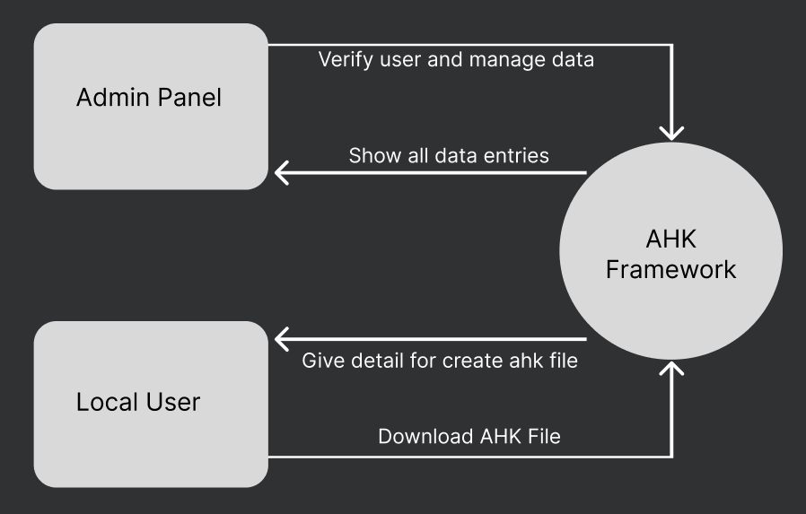

**20**

**LEVEL 1 :**

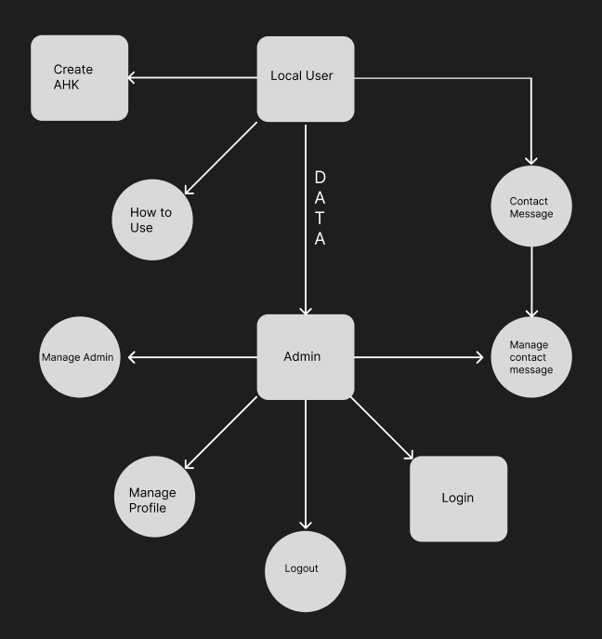

**21**

* 1. **Entity Relationship Diagram**

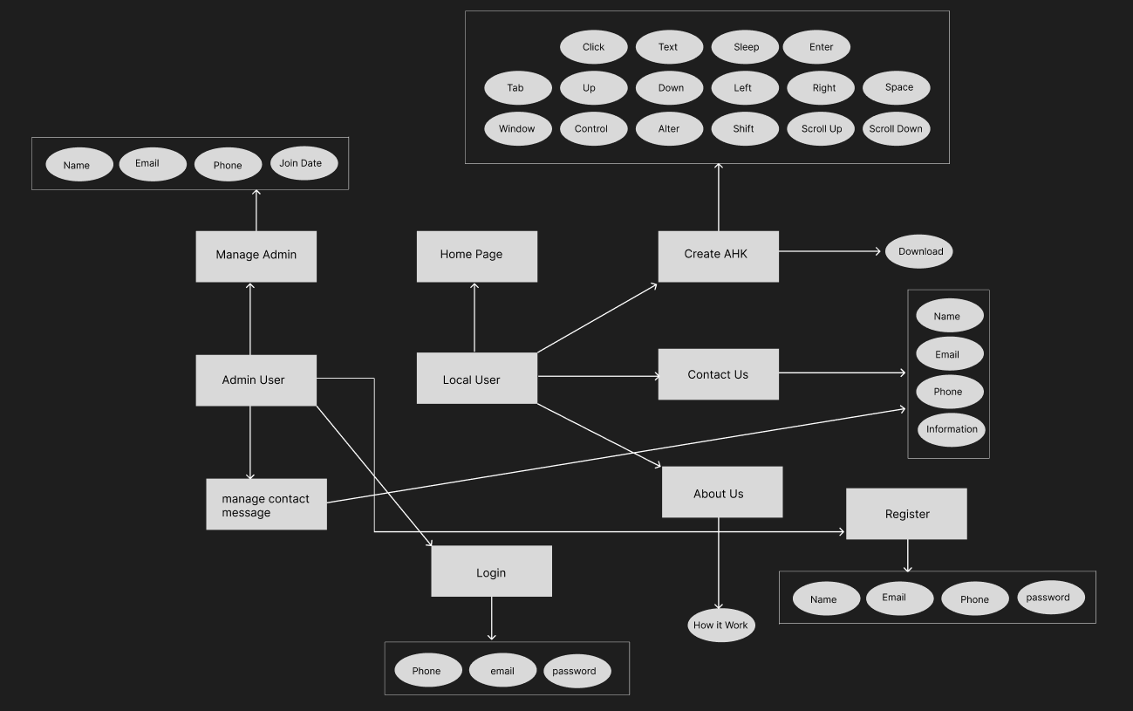

**22**

* 1. **Database Design**

**DB Host Name :**

Localhost

**DB Name :**

ahkframework

**Tables :**

users

contact_us

**Table Design :**

**Users :**

|  |  |  |  |
| --- | --- | --- | --- |
| Field name | Data type | constraint | Extra |
| id | Int(4) | PRIMARY KEY | AUTO_INCREMENT |
| name | Varchar(25) |  |  |
| type | Varchar(5) |  |  |
| Email | Varchar(55) | PRIMARY KEY |  |
| phone | Varchar(10) | PRIMARY KEY |  |
| password | text |  |  |
| Add_time | text |  |  |

**contact_us :**

|  |  |  |  |
| --- | --- | --- | --- |
| Field Name | Data Type | Constraint | extra |
| id | int(4) | Primary key | Auto_increment |
| contact_name | varchar(25) |  |  |
| contact_email | varchar(55) |  |  |
| contact_mobile | varchar(15) |  |  |
| contact_information | text |  |  |
| contact_time | text |  | current_timestamp |

**24**



**25**

**1 Home Page**

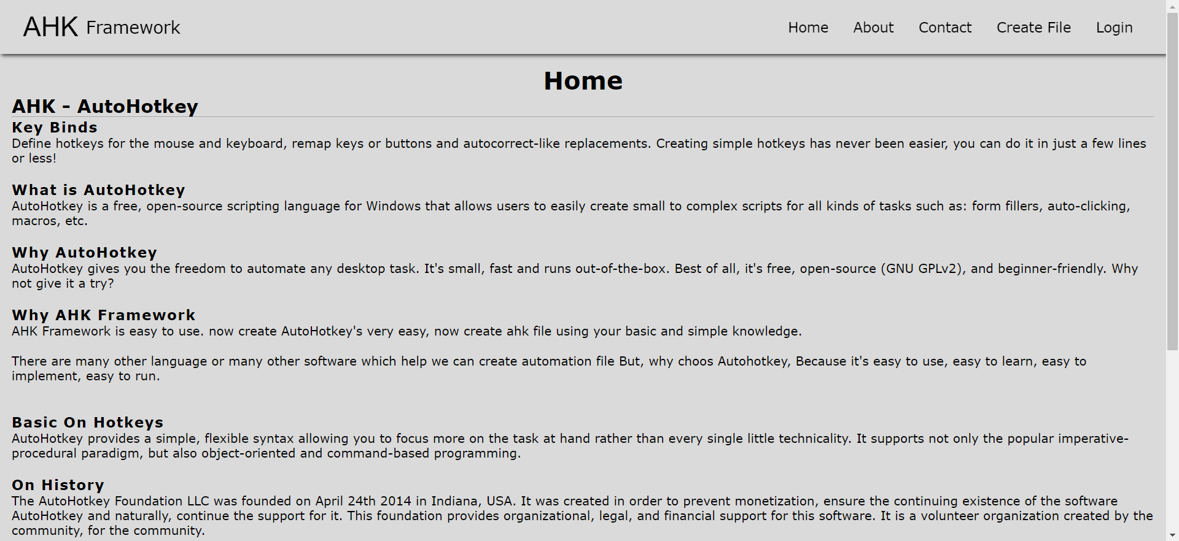

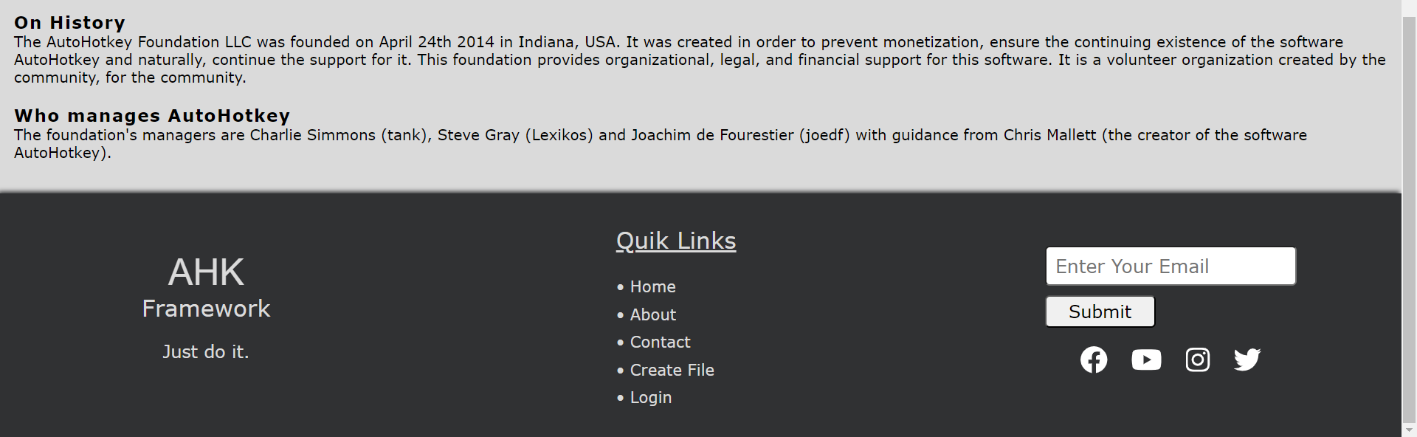

**26**

**2. About Us Page**

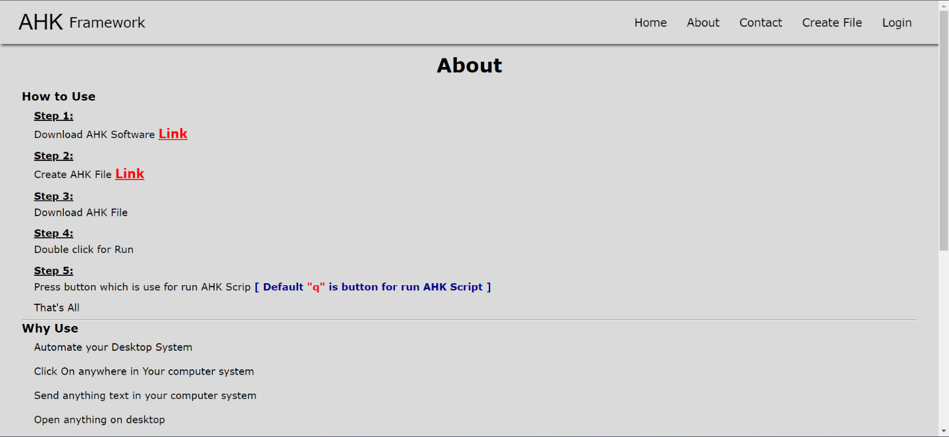

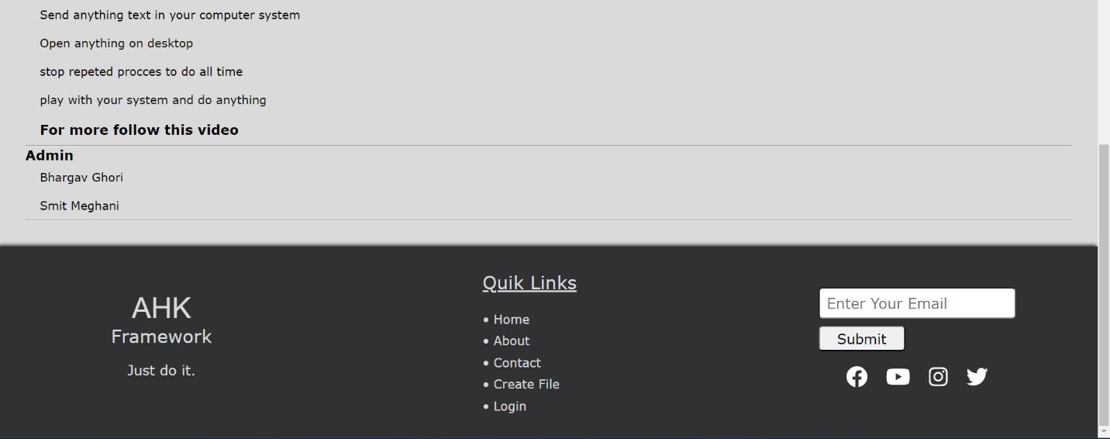

**27**

**3. Contact Us Page**

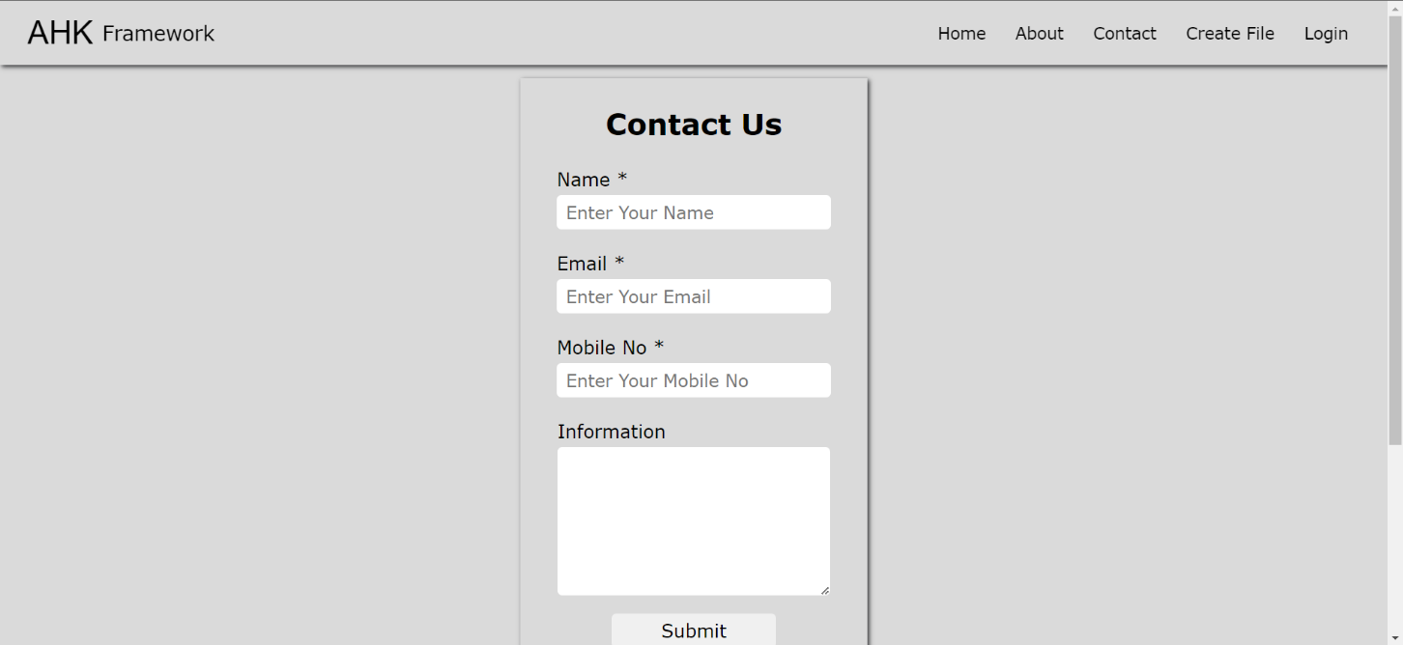

**28**

**4. Login Page**

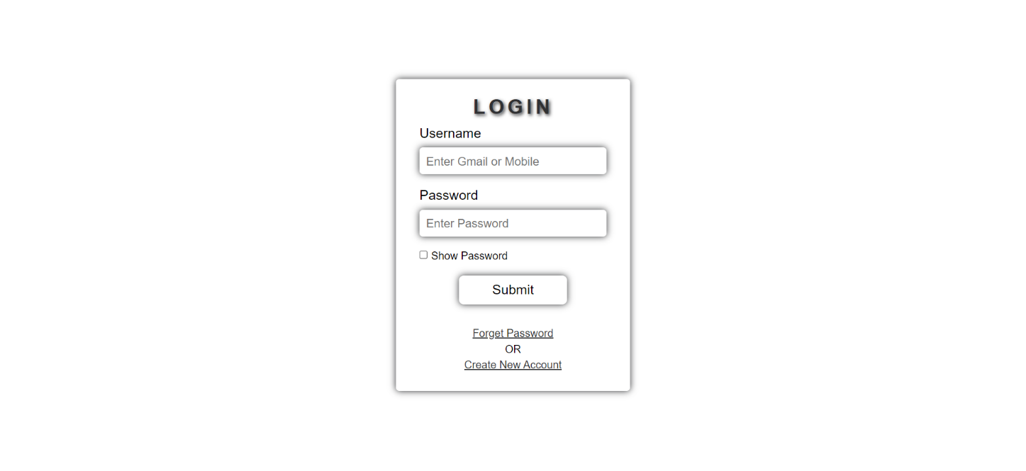

**29**

**5. Create AHK File**

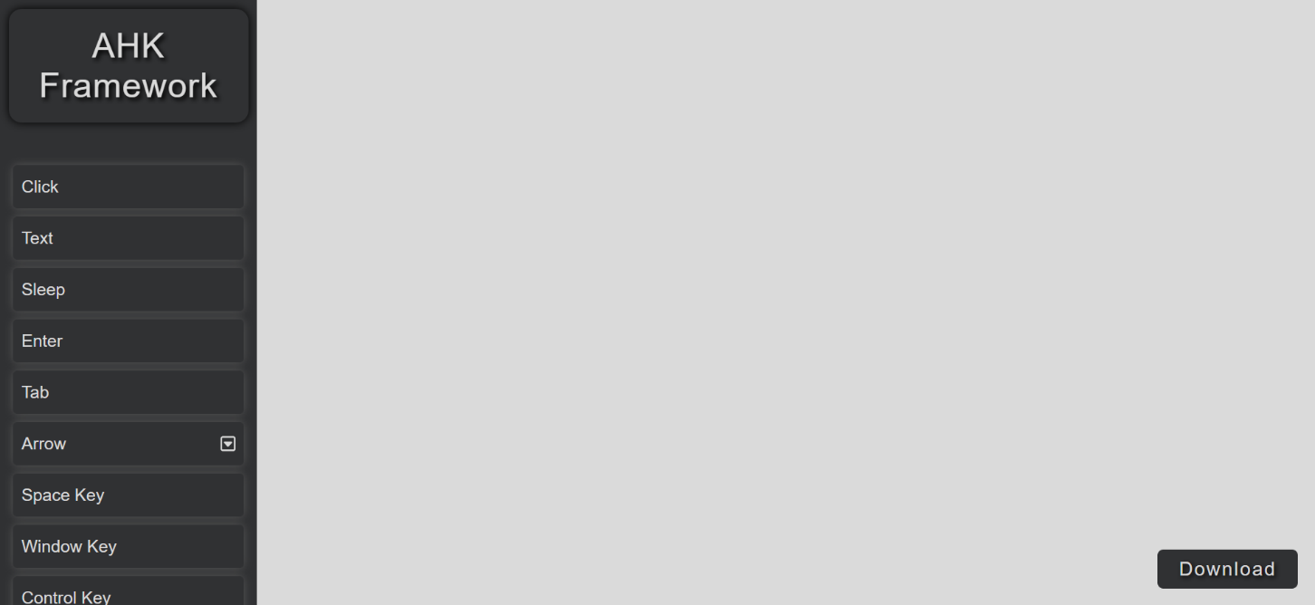

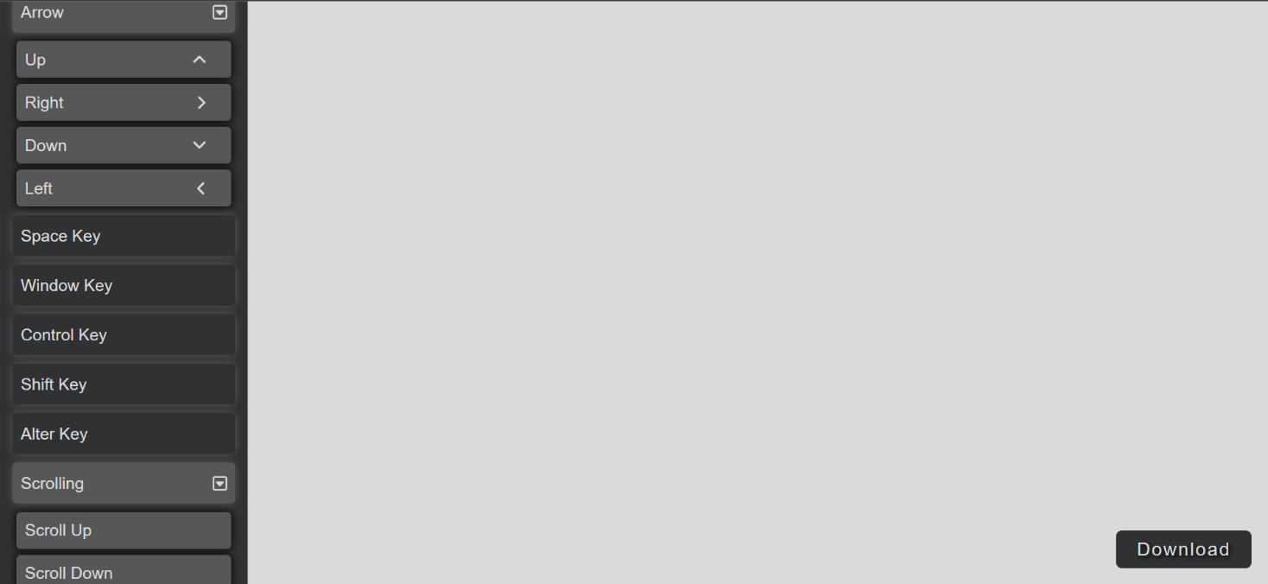

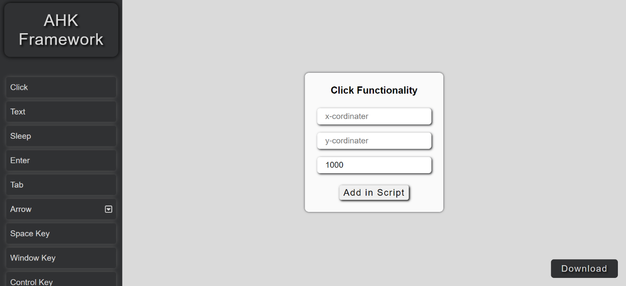

**30**

**6. Admin panel Profile**

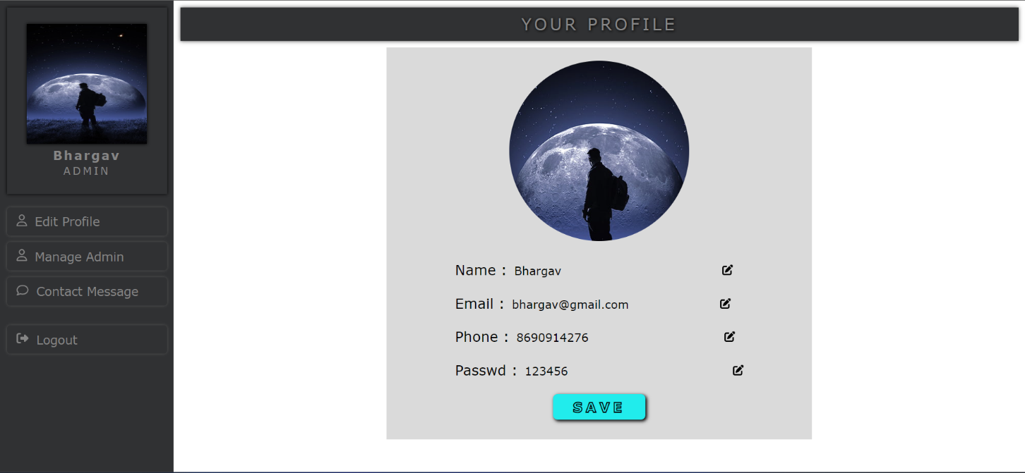

**31**

**7. Manage Admin**

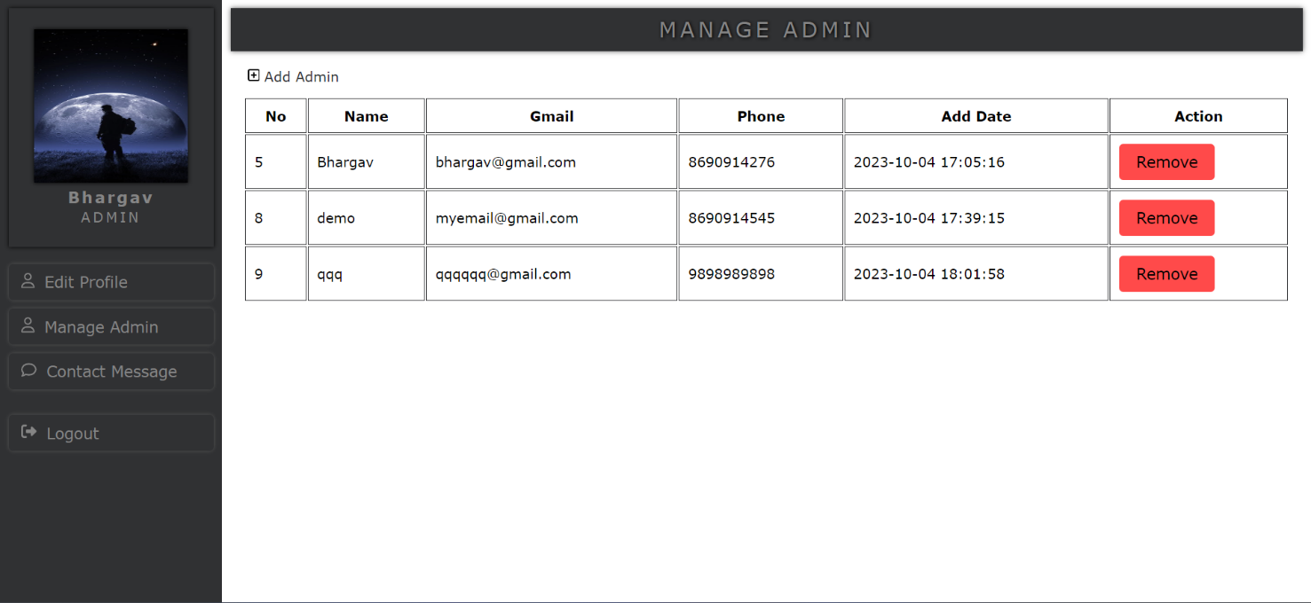

**32**

**8. Contact Message**

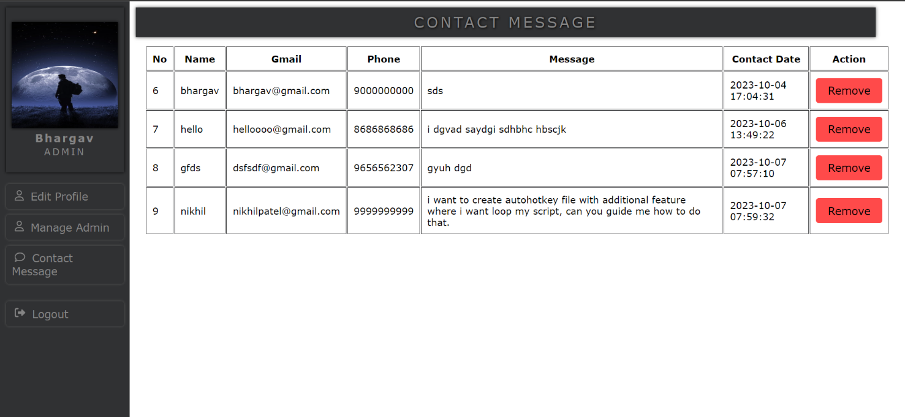

**33**

**9. Register Admin**

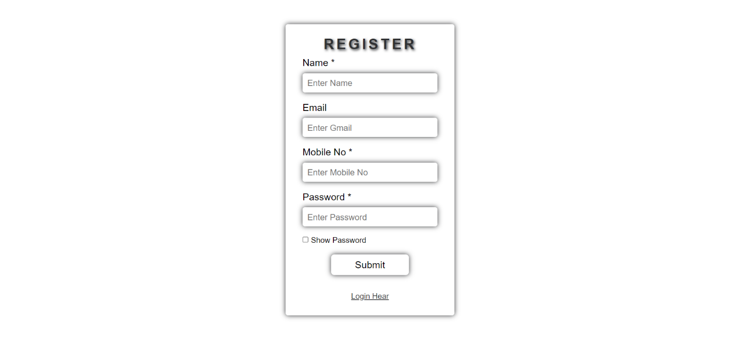

**34**



* 1. **Unit Testing**
  2. **Integration Testing**

**35**

* 1. **Unit Testing**

This is the lowest level of testing that is conducted to remove syntax & logic errors from a single unit. Individual components are tested to ensure that they operate correctly. Each component is tested independently, without other system components. This phase involves testing collection of modules, which have been integrated into sub-system. These testes for problems that arise form component interactions. This testing should begin as soon as usable version of some of the system components is available

36

* 1. **Integration Testing**

This is the final stage in the testing process before the system is accepted for operational use. The system is tested with data supplied by the system customer rather than simulated test data. Acceptance testing may reveal errors & omissions in the system requirements definition because the real data exercise the system in different ways from the test data. It may also reveal requirements problems where the system's facilities do not really meet the user's needs or the system performance is unacceptable.

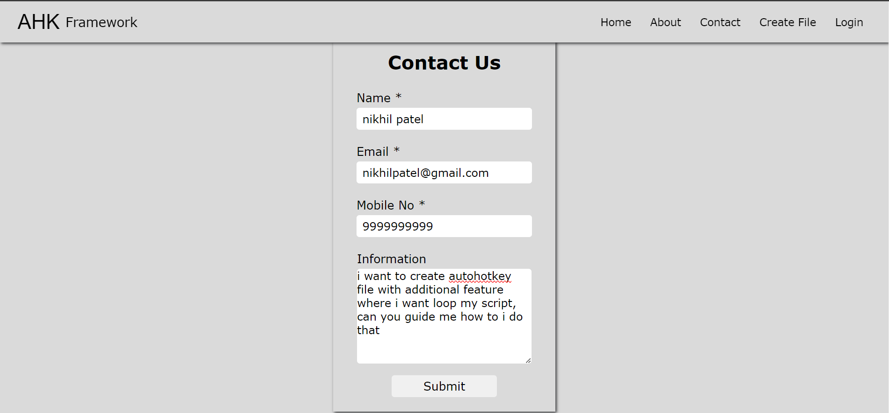

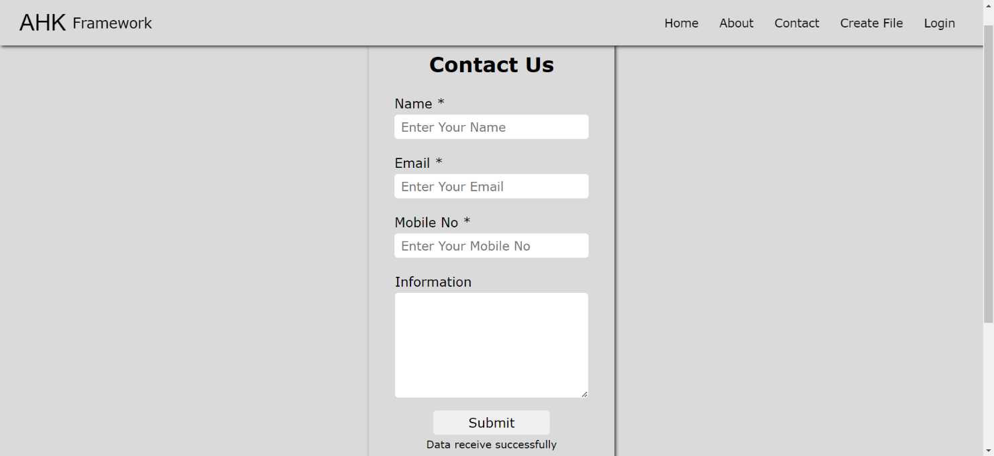

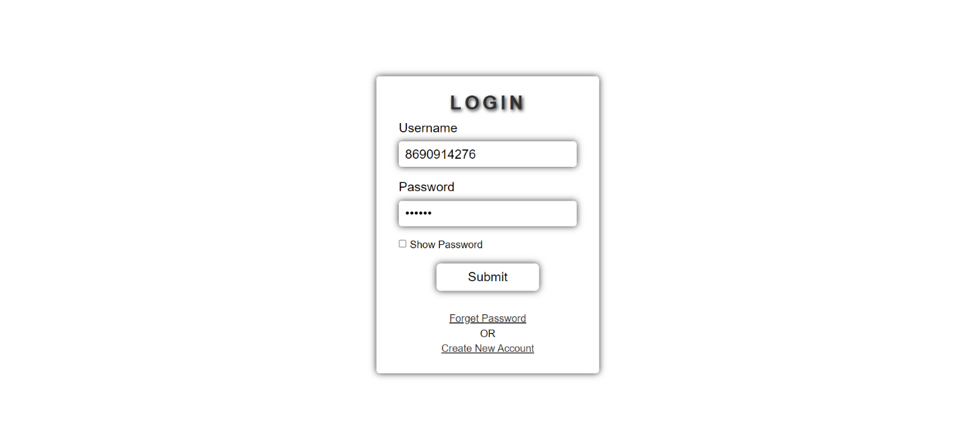

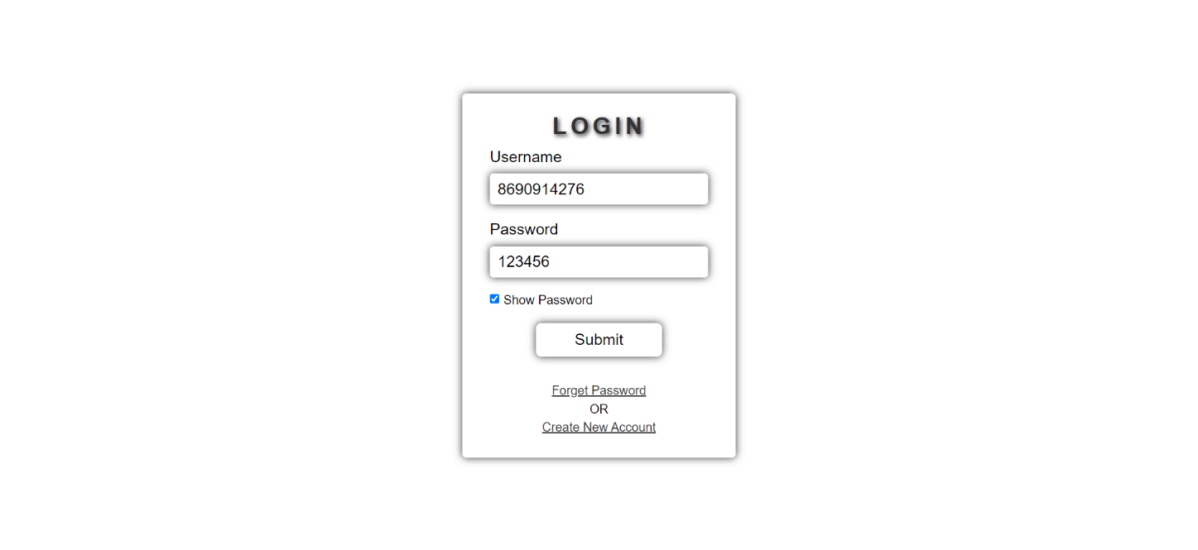

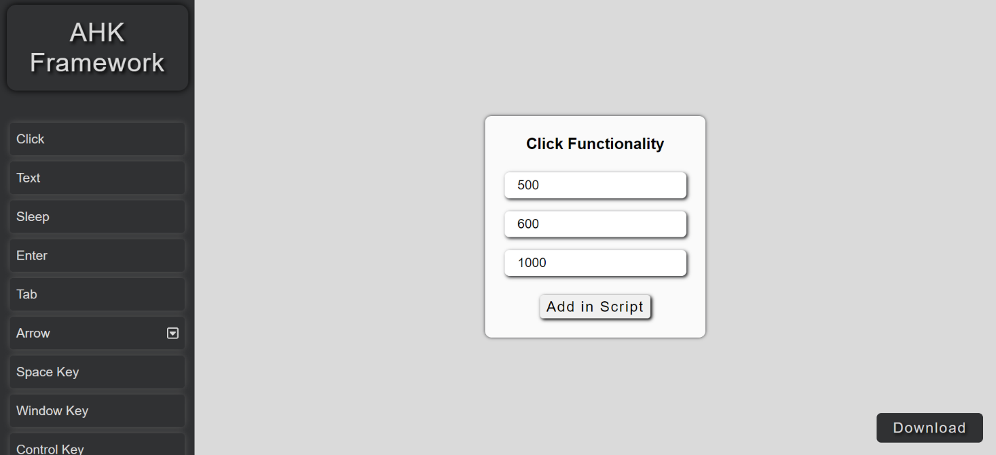

**38**

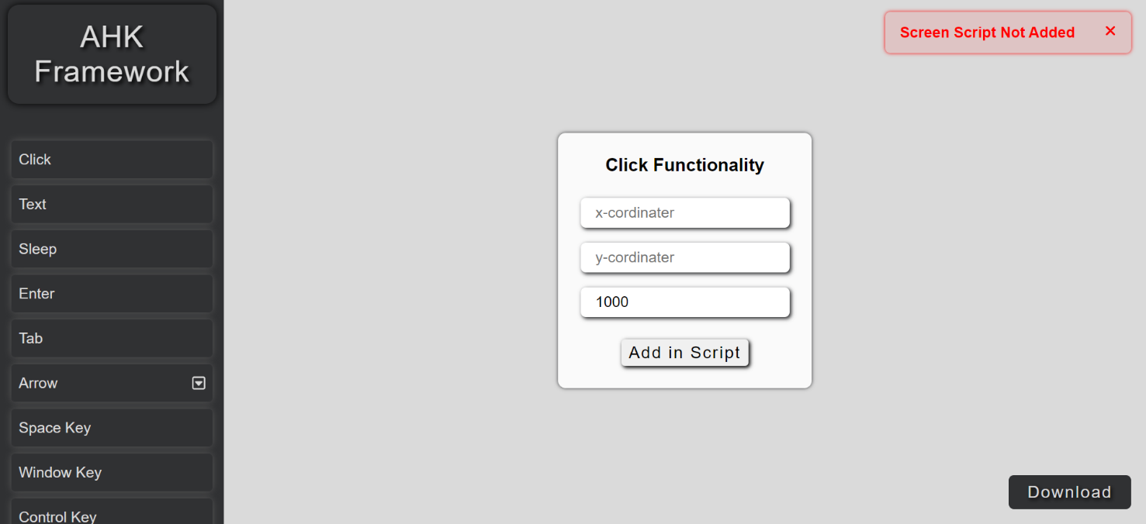

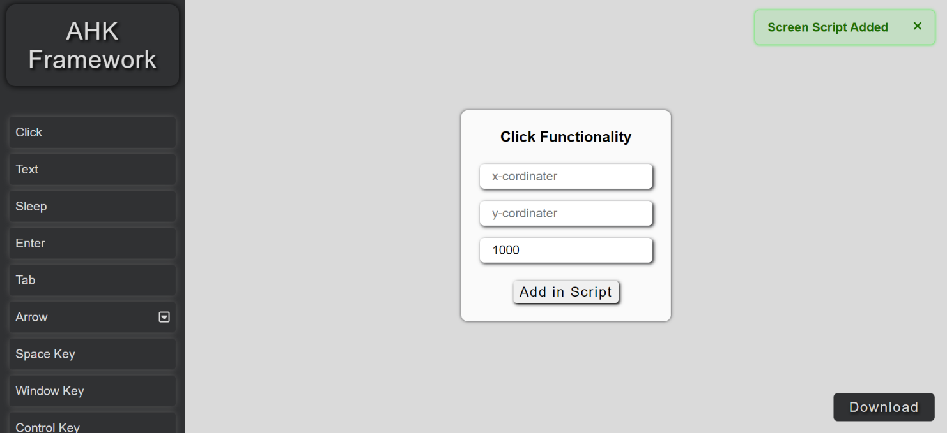

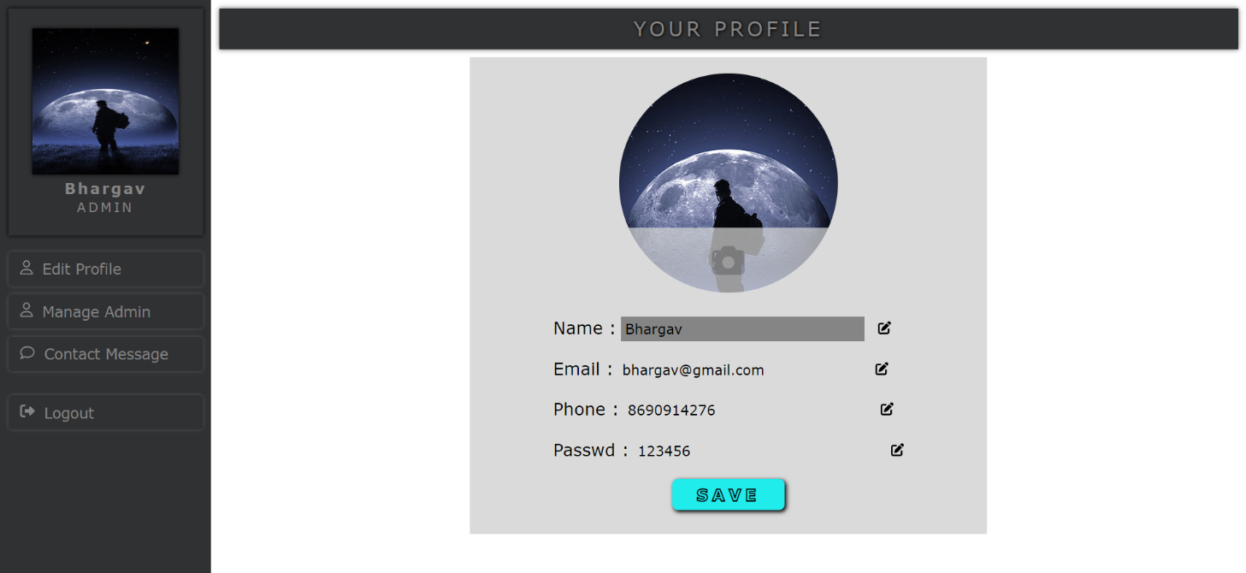

**39**



**40**

**REFERENCES**

**Websites :**

[**https://chat.openai.com/**](https://chat.openai.com/)

**41**