# EC2

EC2 stands for Elastic Compute Cloud. EC2 is an on-demand computing service on the AWS cloud platform. Under computing, it includes all the services a computing device can offer to you along with the flexibility of a virtual environment. It also allows the user to configure their instances as per their requirements i.e. allocate the RAM, ROM, and storage according to the need of the current task. Even the user can dismantle the virtual device once its task is completed and it is no more required. For providing, all these scalable resources AWS charges some bill amount at the end of every month, the bill amount is entirely dependent on your usage. EC2 allows you to rent virtual computers. The provision of servers on AWS Cloud is one of the easiest ways in EC2. EC2 has resizable capacity. EC2 offers security, reliability, high performance, and cost-effective infrastructure so as to meet the demanding business needs.

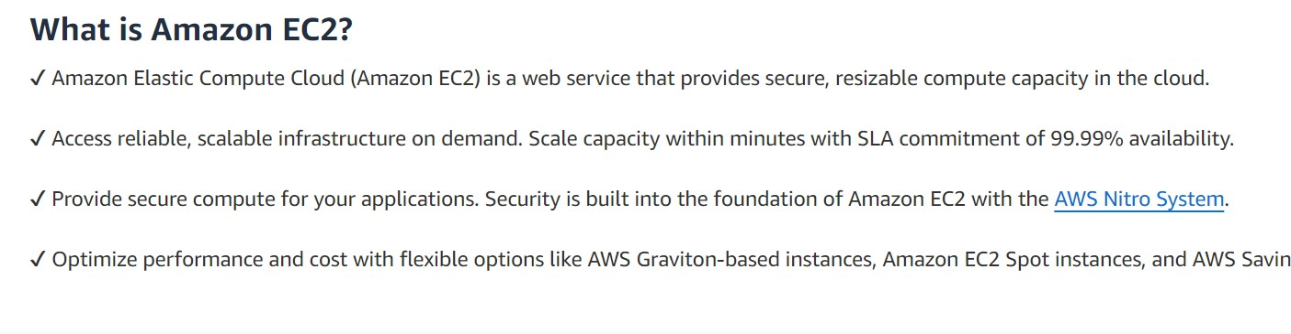

**AWS EC2 (Elastic Compute Cloud**)

Amazon Web Service EC2 is a web service which is provided by the AWS cloud which is secure, resizable, and scalable. These virtual machines are pre-configured with the operating systems and some of the required software. Instead of managing the infrastructure AWS will do that so you can just launch and terminate the EC2 instance whenever you want. You can scale up and down the EC2 instance depending on the incoming traffic. The other advantage of AWS EC2 is that you need to pay only for how much you use it is like the pay-as-you-go model.

**What is Amazon EC2 (Elastic Compute Cloud)?**

Amazon Web service offers EC2 which is a short form of Elastic Compute Cloud (ECC) it is a cloud computing service offered by the Cloud Service Provider AWS. You can deploy your applications in EC2 servers without any worrying about the underlying infrastructure. You configure the EC2-Instance in a very secure manner by using the VPC, Subnets, and Security groups. You can scale the configuration of the EC2 instance you have configured based on the demand of the application by attaching the autoscaling group to the EC2 instance. You can scale up and scale down the instance based on the incoming traffic of the application.

The following figure shows the EC2-Instance which is deployed in VPC (Virtual Private Cloud).

AWS-EC2-Instance-types

Use Cases of Amazon EC2 (Elastic Compute Cloud)

**Deploying Application**: In the AWS EC2 instance, you can deploy your application like .jar,.war, or .ear application without maintaining the underlying infrastructure.

Scaling Application: Once you deployed your web application in the EC2 instance know you can scale your application based upon the demand you are having by scaling the AWS EC2-Instance.

**Deploying The ML Models**: You can train and deploy your ML models in the EC2-instance because it offers up to 400 Gbps), and storage services purpose-built to optimize the price performance for ML projects.

**Hybrid Cloud Environment:** You can deploy your web application in EC2-Instance and you can connect to the database which is deployed in the on-premises servers.

Cost-Effective: Amazon EC2-instance is cost-effective so you can deploy your gaming application in the Amazon EC2-Instances

**AWS EC2 Instance Types**

Different Amazon EC2 instance types are designed for certain activities. Consider the unique requirements of your workloads and applications when choosing an instance type. This might include needs for computing, memory, or storage.

**The AWS EC2 Instance Types are as follows:**

General Purpose Instances

Compute Optimized Instances

Memory-Optimized Instances

Storage Optimized Instances

Accelerated Computing Instances

Features of AWS EC2 (Elastic Compute Cloud)

**AWS EC2 Functionality**

EC2 provides its users with a true virtual computing platform, where they can use various operations and even launch another EC2 instance from this virtually created environment. This will increase the security of the virtual devices. Not only creating but also EC2 allows us to customize our environment as per our requirements, at any point of time during the life span of the virtual machine. Amazon EC2 itself comes with a set of default AMI(Amazon Machine Image) options supporting various operating systems along with some pre-configured resources like RAM, ROM, storage, etc. Besides these AMI options, we can also create an AMI curated with a combination of default and user-defined configurations. And for future purposes, we can store this user-defined AMI, so that next time, the user won’t have to re-configure a new AMI(Amazon Machine Image) from scratch. Rather than this whole process, the user can simply use the older reference while creating a new EC2 machine.

**AWS EC2 Operating Systems**

Amazon EC2 includes a wide range of operating systems to choose from while selecting your AMI. Not only are these selected options, but users are also even given the privilege to upload their own operating systems and opt for that while selecting AMI during launching an EC2 instance. Currently, AWS has the following most preferred set of operating systems available on the EC2 console.

Linux OS Flavours

Amazon Linux

Windows Server

Ubuntu Server

SUSE Linux

Red Hat Linux

AWS EC2 Software

Amazon is single-handedly ruling the cloud computing market, because of the variety of options available on EC2 for its users. It allows its users to choose from various software present to run on their EC2 machines. This whole service is allocated to AWS Marketplace on the AWS platform. Numerous software like SAP, LAMP, Drupal, etc are available on AWS to use.

**AWS EC2 Scalability and Reliability**

EC2 provides us the facility to scale up or scale down as per the needs. All dynamic scenarios can be easily tackled by EC2 with the help of this feature. And because of the flexibility of volumes and snapshots, it is highly reliable for its users. Due to the scalable nature of the machine, many organizations like Flipkart, and Amazon rely on these days whenever humongous traffic occurs on their portals.

**Pricing of AWS EC2 (Elastic Compute Cloud) Instance**

The pricing of AWS EC2-instance is mainly going to depend upon the type of instance you are going to choose. The following are the pricing charges on some of the EC2-Instances.

**-Demand On Instances**: The On-Demand instance is like a pay-as-you-go model where you have to pay only for the time you are going to use if the instance is stopped then the billing for that instance will be stopped when it was in the running state then you are going to be charged. The billing will be done based on the time EC2-Instance is running.

Reserved Instances: Reversed Instance is like you are going to give the commitment to the AWS by buying the instance for one year or more than one year by the requirement to your organization. Because you are giving one year of Commitment to the AWS they will discount the price on that instance.

**Spot Instances:** You have to bid the instances and who will win the bid they are going to get the instance for use but you can’t save the data which is used in this type of instance.

AWS EC2 (Elastic Compute Cloud) Instance Types

Different Amazon EC2 instance types are designed for certain activities. Consider the unique requirements of your workloads and applications when choosing an instance type. This might include needs for computing, memory, or storage. To know more about AWS EC2-Instance types refer to Amazon EC2–Instance Types.

**Create EC2 Instance in AWS (Amazon)**

**The following are the steps for creating an EC2 instance in AWS (Amazon):**

Step 1: First, log into your AWS account and click on “services” present on the left of the AWS management console, i.e. the primary screen. From the drop-down menu of options, tap on “EC2”.

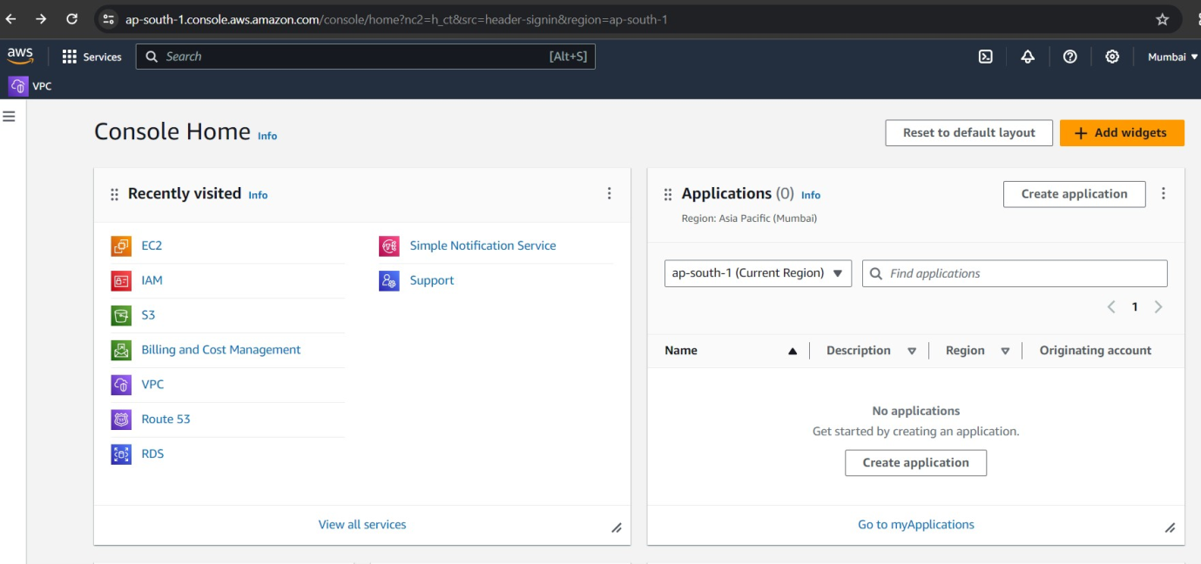

Under Resources >> Click on “Instances running” — It will show if any EC2 instances are running or not.

Step 2: Click on the launch instance click on the launch instance, after clicking on it you will be redirected to a launch page where we can create an instance. Configure all the requirements to Create a new instance like the name of the instance as shown in the figure below.

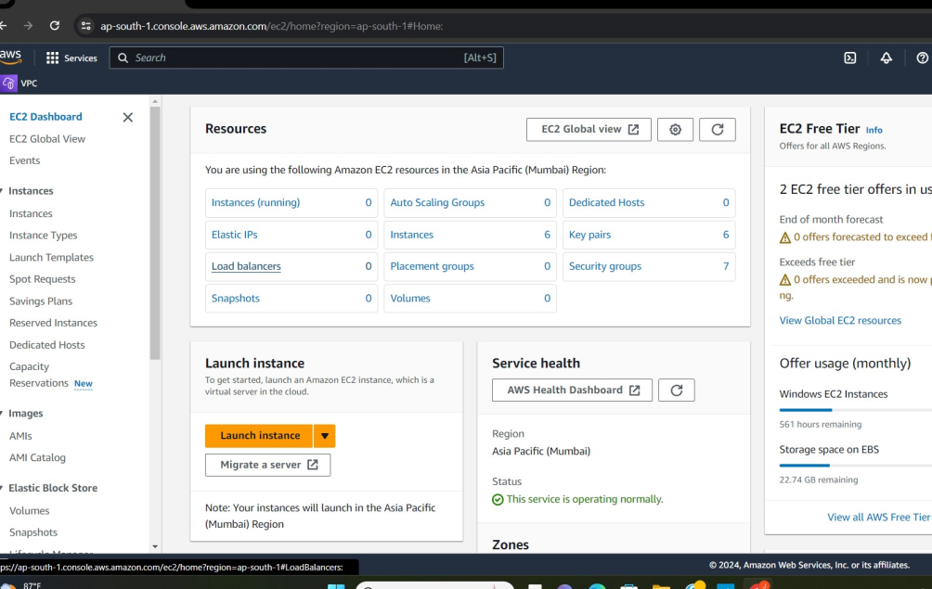

Launch Instance

Naming instance

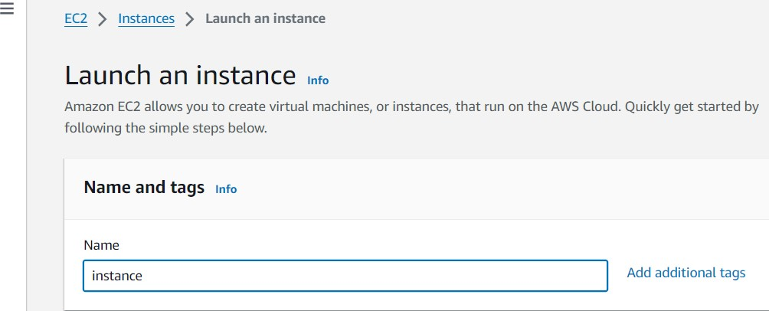

Step 3: Select AMI – Required operating system from the available. There are different types of OS available select the OS as per your requirement.

Select the OS

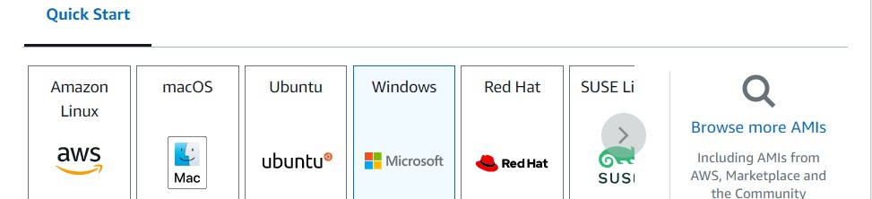

Step 4: By default, it selects a free tier of storage. (IF YOU ARE ELIGIBLE FOR THE FREE TIER). From the available storage specifications, select a free tier-eligible storage service. The instance type includes the no.of CPUs required and the Memory required for your application. By default, the instance type is “t2.micro” which is a free tier-eligible service.

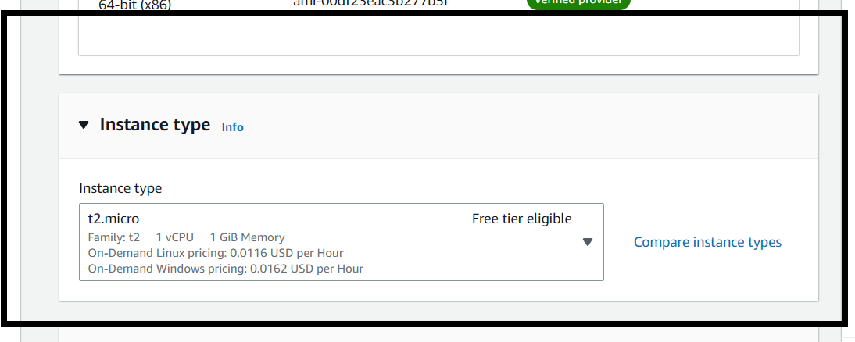

Instance type

Select instance type

Step 4: Now, create a key-value pair, by clicking on “Create new key pair”. A window will pop up for creating key pair as shown below. The key value pair plays a major role while connecting to the EC2-Instance it will act as an SSH-Key to connect to the instance. Create Key-PairEnter name>>Select “.pem” and create. Automatically key pair which was created will be downloaded. Select the created key pair.

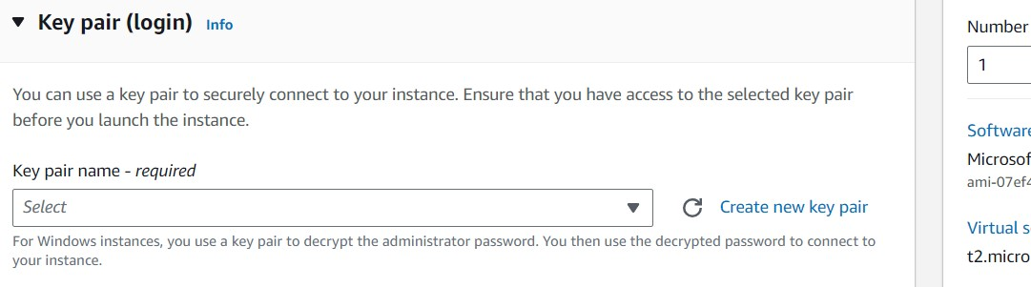

Key-Pair

Creating key pair

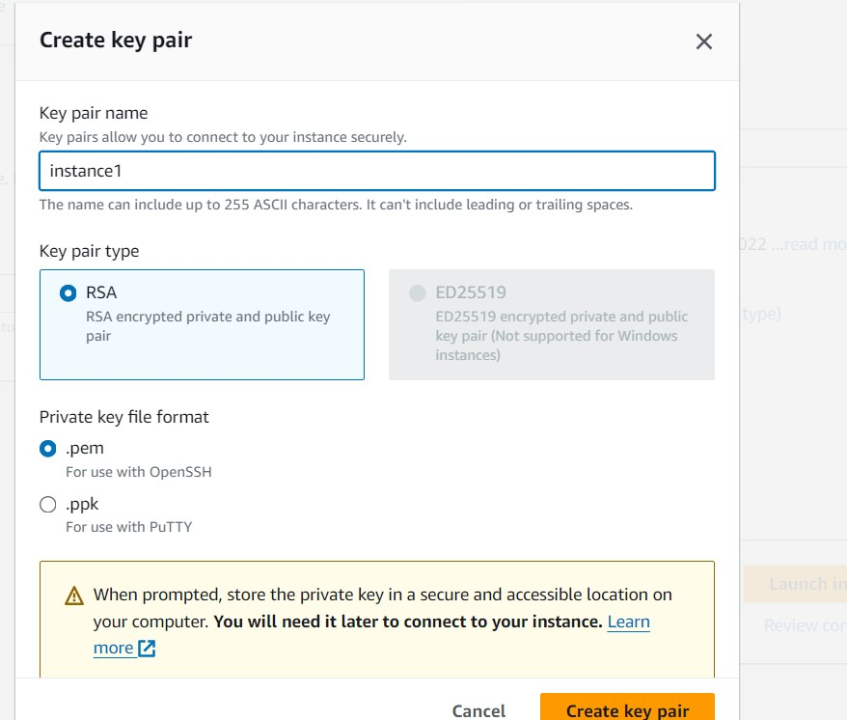

Step 5: Keep the network settings as default settings and make changes if required.StorageAs mentioned in the picture, Free tier eligible can get up to 30 GB of EBS Storage. Keep it as default.

Configuring Storage

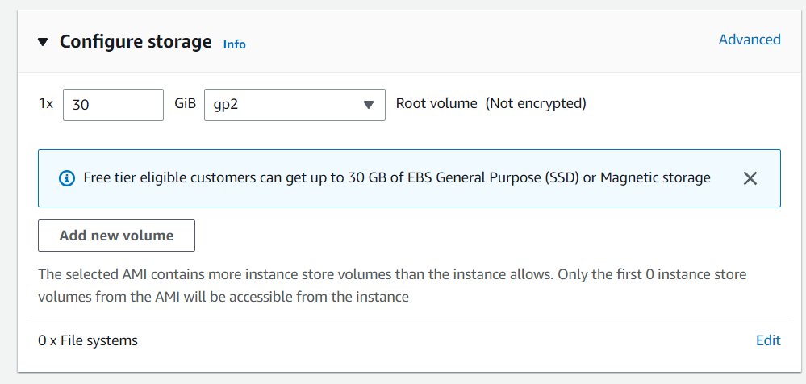

Step 6: Launching Instance At last, Check if all the selected are eligible for a free tier or not and click on “Launch instance”.That’s it, an instance will be created.

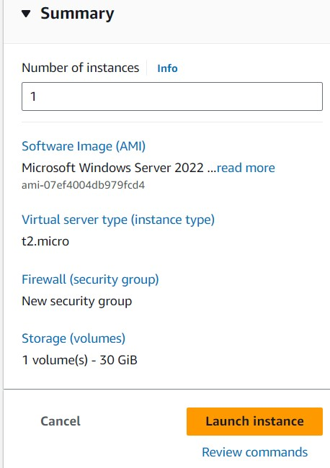

**Launching instance**

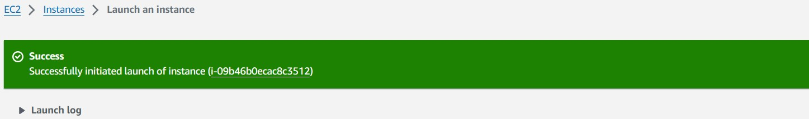

**Steps To Connect Terminal Using**

**Step 1: Select the server to which you connect and click on the connect button at the top of that instance as shown in the image below.**

**EC2-Instance.** 