INTELLIGENT DOCUMENT VERTIFICATION SYSTEM

A MULTIDISCIPLINARY PROJECT REPORT

Submitted by

Name & Roll No. | in partial fulfilment of the requirements for the award of the degree of  BACHELOR OF ENGINEERING
LOKGESH B 24ITR067 | INFORMATION TECNOLOGY
RANJITH K  24ITR113 | INFORMATION TECNOLOGY
KALAIVANI S 24EER053 | ELECTRICAL & ELECTRONICS ENGINEERING
SUGANYA S  24EER118 | ELECTRICAL & ELECTRONICS ENGINEERING

DEPARTMENT OF ELECTRICAL AND ELECTRONICS ENGINEERING &
DEPARTMENT OF INFORMATION TECHNOLOGY


(Autonomous)
PERUNDURAI ERODE – 638 060
OCTOBER 2026
DEPARTMENT OF ELECTRICAL AND ELECTRONICS ENGINEERING &
DEPARTMENT OF INFORMATION TECHNOLOGY

KONGU ENGINEERING COLLEGE
(Autonomous)
PERUNDURAI ERODE – 638060
OCTOBER 2026

BONAFIDE CERTIFICATE

This is to certify that the project report entitled “INTELLIGENT DOCUMENT VERIFICATION SYSTEM” is the Bonafide record of project work done by the following students:
Name & Roll No. | in partial fulfilment of the requirements for the award of the degree of BACHELOR OF ENGINEERING
LOKGESH B  24ITR067 | INFORMATION TECNOLOGY
RANJITH K  24ITR113 | INFORMATION TECNOLOGY
KALAIVANI S  24EER053 | ELECTRICAL & ELECTRONICS ENGINEERING
SUGANYA S  24EER118 | ELECTRICAL & ELECTRONICS ENGINEERING
of Anna university Chennai during the year 2026-2027.

Co-Mentor |  | Mentor | HoD / Dept of | HoD/ Dept.of
 |  |  | Co-Mentor | Mentor
Date: |  |  | (Sign. & seal) | (Sign. & seal)

Submitted for the end semester viva voce examination held on

INTERNAL EXAMINER EXTERNAL EXAMINER

DEPARTMENT OF ELECTRICAL AND ELECTRONICS ENGINEERING &
DEPARTMENT OF INFORMATION TECHNOLOGY

KONGU ENGINEERING COLLEGE
(Autonomous)
PERUNDURAI ERODE – 638060
OCTOBER 2026

DECLARATION

We affirm that the Project Report titled “INTELLIGENT DOCUMENT VERIFICATION SYSTEM” being submitted in partial fulfilment of the requirements for the award of Bachelor of Engineering is the original work carried out by us. It has not formed the part of any other project report or dissertation on the basis of which a degree or award was conferred on an earlier occasion on this or any other candidate.

Date: LOKGESH K
(24ITR067)

RANJITH K
(24EER117)

KALAIVANI S
(24EER053)

SUGANYA S
(24EER118)

I certify that the declaration made by the above candidates is true to the best of my knowledge.

Date: | Name, Dept. and Signature of | Name and Signature of
 | the Co-Mentor with seal | the Mentor with seal

ABSTRACT

Documents such as mark sheets, degree certificates, identity cards, bonafide letters, and experience letters are required at almost every stage of admission, recruitment, and official verification. Checking these documents manually is slow, depends on the experience of the person verifying them, and is open to human error. At the same time, easy access to image-editing tools has made it simple to alter names, marks, dates, photographs, and seals in scanned documents. A verification process that is fast, consistent, and traceable is therefore needed.
Documents such as identity cards, educational certificates, bank statements, and government-issued identity proofs are required at every stage of admission, recruitment, financial transactions, and official onboarding. Verifying these documents manually is slow, subjective, and prone to human error. Fraudulent documents are increasingly common owing to the easy availability of image-editing tools that can alter names, numbers, photographs, and dates in scanned files.
The project entitled Intelligent Document Verification System (VeriDoc AI) presents a full-stack, AI-assisted web application that automates multi-stage forensic verification of uploaded documents. The system accepts PDF, JPEG, and PNG files and passes them through an eight-stage deterministic pipeline: (1) file integrity validation, (2) multi-engine OCR text extraction using Windows Media OCR with Pillow-enhanced preprocessing and Tesseract fallback, (3) document-type classification with mismatch detection, (4) regex-based field extraction, (5) document-specific rule evaluation including Aadhaar Verhoeff checksum and bank statement arithmetic reconciliation, (6) internal consistency checking, (7) forensic and metadata analysis, and (8) a final decision engine. The backend is implemented in Python 3.14 using the FastAPI framework with a SQLite embedded database. The frontend is a React 19 single-page application built with TypeScript 7 and Tailwind CSS 4, deployed on Vercel.

The system combines Python backend engineering, React frontend development, OCR-based text extraction, deterministic rule evaluation, and forensic metadata analysis. It is intended as a prototype for educational institutions, recruitment desks, and organisations that need fast first-level document screening. The accuracy figures reflect deterministic rule coverage; a final decision on a doubtful document should always rest with a human verifier. The project provides a foundation for future integration with national digital document repositories and digital-signature validation services.

ACKNOWLEDGEMENT

We express our sincere thanks and gratitude to Thiru E.R.K.KRISHAN M.Com., our
beloved Correspondent, and all other philanthropic trust members of Kongu Vellalar Institute of Technology Trust who have always encouraged us in the academic and co-curricular activities.
We are grateful to Dr. R.PARAMESHWARAN, M.E, Ph.D., Principal, Kongu
Engineering College, for giving us an opportunity to learn new skills and technologies and to enhance our knowledge by providing the necessary infrastructure.
We would like to express our sincere gratitude to Dr.M.KARTHIK, M.E., Ph.D., Head of
the Department of Electrical and Electronics Engineering and DR.M.MALLIGA, M.E, Ph.D., Head of the Department of Information Technology for the support and facilities extended to us throughout the project.
We express our deep gratitude to our project mentor, P. KARTHIKEYAN, M.E., Assistant Professor of Electrical and Electronics Engineering, for his valuable guidance, critical review and encouragement at every stage of the project.
We also thank our project co-mentor, DR. R. SHANTHAKUMARI, M.E. (CSE), Ph.D., Associate Professor of Information Technology, for her encouragement and valuable advice that made us carry out the project work successfully.

We also thank our domain reviewer, DR. M. SURESH, M.E., Ph.D., Associate Professor of Electrical and Electronics Engineering, for his valuable review and suggestions. We thank all faculty and staff members of both the departments for their help and support.

.

TABLE OF CONTENTS

Page No.
CHAPTER 1 INTRODUCTION............................................................................................1
1.1 Background of the Project...........................................................................................1
1.2 Overview of the Intelligent Document Verification System.......................................2
1.3 Need for the System.....................................................................................................2
1.4 Scope of the Project.....................................................................................................3
1.5 Alignment with Sustainable Development Goal 3.......................................................3
1.6 Motivation....................................................................................................................3
1.7 Organization of the Report...........................................................................................4
CHAPTER 2 LITERATURE SURVEY................................................................................5
2.1 Manual Document Verification................................................................................... 5
2.2 Rule-Based Validation................................................................................................. 5
2.3 Template-Based Verification....................................................................................... 6
2.4 Optical Character Recognition Based Approaches......................................................6
2.5 Machine Learning Based Document Classification and Verification..........................6
2.6 Cryptographic and Code-Based Verification...............................................................7
2.7 Comparison of Existing Approaches...........................................................................7
2.8 Research Gap...............................................................................................................8
2.9 Summary......................................................................................................................8
CHAPTER 3 PROBLEM DEFINITION AND OBJECTIVES...........................................9
3.1 Problem Statement....................................................................................................... 9
3.2 Pain Point.....................................................................................................................9
3.3 Objectives....................................................................................................................9
3.4 Methodology..............................................................................................................10
3.5 Novelty of the Work..................................................................................................11
3.6 Scope and Limitations................................................................................................11
3.7 Expected Outcomes................................................................................................... 11
CHAPTER 4 SYSTEM ANALYSIS....................................................................................13
4.1 Existing System......................................................................................................... 13
4.2 Proposed System........................................................................................................13
4.3 Feasibility Study........................................................................................................14
4.4 Requirement Analysis................................................................................................15
4.5 Hardware Requirements.............................................................................................16
4.6 Software Requirements..............................................................................................17
4.7 Assumptions and Constraints.....................................................................................17
CHAPTER 5 SYSTEM DESIGN.........................................................................................18
5.1 Design Overview....................................................................................................... 18
5.2 System Architecture...................................................................................................18
5.3 Process Flow.............................................................................................................. 19
5.4 Module Description................................................................................................... 20
5.5 Data Flow Diagrams..................................................................................................21
5.6 UML Diagrams.......................................................................................................... 22
5.7 Database Design.........................................................................................................24
5.8 Template Design........................................................................................................ 26
5.9 Verification Algorithm...............................................................................................27
5.10 User Interface Design.............................................................................................. 28
5.11 Input and Output Design..........................................................................................28
5.12 Security and Error Handling Design........................................................................29
CHAPTER 6 IMPLEMENTATION....................................................................................30
6.1 Development Environment........................................................................................30
6.2 Project Structure.........................................................................................................30
6.3 Database Implementation...........................................................................................31
6.4 Implementation of the Modules................................................................................. 31
6.5 Integration of the Modules.........................................................................................35
6.6 Division of Work.......................................................................................................35
6.7 Challenges Faced and Solutions................................................................................36
CHAPTER 7 TESTING........................................................................................................37
7.1 Testing Objectives..................................................................................................... 37
7.2 Testing Strategy.........................................................................................................37
7.3 Test Environment.......................................................................................................38
7.4 Test Cases..................................................................................................................38
7.5 Test Results................................................................................................................39
7.6 Summary of Testing...................................................................................................39
CHAPTER 8 RESULTS AND DISCUSSION.....................................................................40
8.1 Output Screens........................................................................................................... 40
8.2 Sample Verification Scenarios...................................................................................41
8.3 Discussion of Results.................................................................................................42
8.4 Comparison with Manual Verification......................................................................42
8.5 Evaluation Metrics..................................................................................................... 43
8.6 Contribution to Sustainable Development Goal 3.....................................................43
8.7 Limitations................................................................................................................. 43
CHAPTER 9 CONCLUSION AND FUTURE SCOPE.....................................................45
9.1 Conclusion.................................................................................................................45
9.2 Future Scope..............................................................................................................45
Future work could include: integration of Tesseract OCR on the Linux Vercel environment using a custom Docker layer to improve scanned document accuracy on cloud; addition of digital signature verification for DigiLocker-issued documents; face comparison between the photograph on an identity document and a live selfie using an on-device face recognition model; expansion to additional document types such as GST certificates, birth certificates, and marriage certificates; a browser extension for real-time document checking; a mobile application using the same REST API backend; and integration with national digital repositories such as DigiLocker for automated issuer-side verification.
APPENDIX A
APPENDIX B
SUPPORTED DOCUMENT TYPES AND VALIDATION RULES
APPENDIX C
REST API QUICK REFERENCE

LIST OF FIGURES
Page No.
Figure 4.1 Project schedule..............................................................................................15
Figure 5.1 Three-layer architecture of the system...........................................................19
Figure 5.2 Process flow diagram of the verification system............................................19
Figure 5.3 Flowchart of the document verification process............................................20
Figure 5.4 Level 0 data flow diagram..............................................................................21
Figure 5.5 Level 1 data flow diagram..............................................................................22
Figure 5.6 Use case diagram............................................................................................23
Figure 5.7 Class diagram of the backend.........................................................................23
Figure 5.8 Sequence diagram of a verification request....................................................24
Figure 5.9 Entity relationship diagram............................................................................25
Figure 8.1 Home page of the Intelligent Document Verification System.......................40
Figure 8.2 Verification page with category selection and file upload.............................40
Figure 8.3 Result page for a document that is verified....................................................41
Figure 8.4 Result page for a document with missing and mismatched fields..................41

LIST OF TABLES
Page No.
Table 2.1Comparison of document verification approaches............................................7
Table 3.1 Pain points and their consequences...................................................................9
Table 3.2 Steps of the methodology................................................................................10
Table 4.1 User classes of the system...............................................................................15
Table 4.2 Functional requirements..................................................................................15
Table 4.3 Non-functional requirements...........................................................................16
Table 4.4 Hardware requirements....................................................................................16
Table 4.5 Software requirements.....................................................................................17
Table 5.1 Structure of the category table.........................................................................25
Table 5.2 Structure of the template table.........................................................................25
Table 5.3 Structure of the document table.......................................................................26
Table 5.4 Structure of the result table..............................................................................26
Table 5.5 Structure of the user table................................................................................26
Table 5.6 Example template: Medical Certificate...........................................................27
Table 5.7 Example template: Identity Proof....................................................................27
Table 5.8 Example template: Educational Certificate.....................................................27
Table 5.9 Inputs to the system.........................................................................................29
Table 5.10 Outputs of the system....................................................................................29
Table 6.1 Tools used in the implementation....................................................................30
Table 6.2 Division of work among the team members....................................................35
Table 6.3 Challenges and solutions.................................................................................36
Table 7.1 Test environment.............................................................................................38
Table 7.2 Test cases for the Intelligent Document Verification System.........................38
Table 8.1 Sample verification scenarios across document types
Table 8.2 Comparison of manual verification and the proposed system.........................42
Table 8.3 Evaluation metrics............................

x

CHAPTER 1

INTRODUCTION

OVERVIEW OF THE PROJECT
Documents are the foundation of almost every administrative, financial, educational
and healthcare process. Whenever a person applies for a service, whether it is opening a
bank account, enrolling in a course, submitting an insurance claim or being admitted to
a hospital, a set of supporting documents must be submitted and checked before the
request is accepted. The correctness of these documents decides whether the process
moves forward or is rejected, and the speed of checking them decides how quickly the
person receives the service.
In many organizations this checking is still carried out manually. An officer opens
Each document, looks at the layout, confirms that every required field is present, reads the
entries and decides whether the document can be accepted. This work is repetitive and
depends heavily on the attention, experience and workload of the person doing it. This
project, the Intelligent Document Verification System, addresses this problem by
automating the first level of verification through category-wise predefined templates

Background of the Project
Over the last decade, the number of documents handled by organizations has grown
steadily. Digital submission through web portals and mobile applications has made it
easy for users to upload scanned copies and photographs of their documents, but the
verification step behind the portal has not always kept pace. In many cases the uploaded
file is simply placed in a queue where a staff member must open it and verify it by eye.
Manual verification has several well-known weaknesses. It is slow, because each
document must be read in full. It is inconsistent, because two officers may judge the
same document differently.
It is tiring, because the work is repetitive, and fatigue leads to oversight.
It is also difficult to scale, because an increase in the number of applications
requires a proportional increase in staff. These weaknesses increase the processing
time of every application and create opportunities for incorrect or fraudulent
documents to be accepted.

1.3 Need for the System

The need for an automated document verification system arises from the following

observations.

• Manual verification consumes a large amount of staff time that could be used for tasks that need human judgement.

• Human errors such as overlooking a missing field, misreading an entry or

applying a rule inconsistently are unavoidable in repetitive work.

• Delays in verification delay the service that the applicant is waiting for. In the health sector, delay in verifying documents can delay admission, claim

settlement or treatment.

• Documents that do not follow the expected format are sometimes accepted by mistake, which increases the risk of fraudulent submissions being passed.

• Organizations need a consistent standard so that the same document receives the same decision regardless of who handles it or when it is handled.

1.4 SCOPE OF THE PROJECT
The scope of the present work is the verification of uploaded documents against
predefined, category-specific templates. The system is concerned with the completeness
and format of a document, that is, with whether the fields that a document of that
category must contain are present and whether their entries follow the expected
form. The following activities fall within the scope of the project.
Definition and storage of templates for different document categories.
• Selection of the document category by the user and upload of the document.
• Field-by-field comparison of the uploaded document with the template of the
selected category.
• Identification of missing and mismatched fields.
• Generation and display of a verification result and storage of the result for later
reference.

CHAPTER 2

LITERATURE REVIEW

This chapter reviews the main approaches that are used to verify documents and

examines their strengths and limitations. The purpose of the review is to understand

where the proposed template-based system fits and which gaps it is intended to fill. The

approaches are discussed under the headings of manual verification, rule-based

validation, template matching, optical character recognition, machine learning based

classification and cryptographic or code-based verification.
2.1 Manual Document Verification
Manual verification is the oldest and still the most widespread method. A trained
examines each document, compares it with a mental or printed checklist and decides
whether it is acceptable. The method is flexible and can deal with unusual documents,
which is its main strength. It has, however, serious limitations. The speed is limited by
the reading speed of the officer, the quality of the decision varies from person to person
and day to day, and no automatic record of what was checked is created unless the
officer writes it down. Training new staff takes time and the knowledge of experienced
staff is rarely written down in a reusable form.
In large organizations the volume of documents makes purely manual verification a
bottleneck. Studies and reports from administrative practice consistently describe
backlogs, repeated requests to applicants for missing information and disputes caused
by inconsistent decisions. These problems are the starting point for the present work.
2.2 Rule-Based Validation
Rule-based validation checks the values entered in an electronic form against a set of
rules. Examples include checking that a field is not empty, that a date is in a valid
format, that a number lies within an allowed range or that an identification number
matches a given pattern. Regular expressions are commonly used for this purpose.
Rule-based validation is simple, fast and predictable, and it forms part of almost every
web application.
Its limitation is that it works on data typed into a form, and not on an uploaded document
as a whole. It also does not by itself know which fields a particular type of document
must contain. The rules must be defined separately for each document type, and without
a structured way of storing them the rules become scattered through the program code
and are difficult to maintain.
2.3 Template-Based Verification
Template-based verification starts from the observation that documents of the same
type have the same structure. A template records the expected fields of a document type,
such as the names of the fields, whether each is mandatory and what format its content
should follow. The uploaded document is compared with the template, and any
deviation is reported. This approach has been used in form processing, invoice handling
and identity document checking, where the layout is fixed or semi-fixed.
The advantages of template-based verification are that it is transparent and explainable.
The reason for rejection can always be stated in terms of a specific field. It needs no
large training data set, and a new document category can be supported simply by adding
a new template. These properties make it a suitable basis for a system that must be built,
understood and maintained by a small team and operated by non-technical staff. The
proposed project builds on this approach.
2.4 Optical Character Recognition Based Approaches
Optical character recognition, usually abbreviated as OCR, converts images of printed
or handwritten text into machine-readable text. Many document processing systems use
OCR as the first stage to read scanned documents, and then apply rules or templates to
the extracted text. OCR makes it possible to process paper documents that have been
scanned or photographed, and a number of mature open-source and commercial engines
are available.

The accuracy of OCR depends on the quality of the image, the font, the language and the
layout. Blurred, skewed or low-resolution images give poor results, and handwriting is
harder to read than print. For this reason, OCR output is normally treated as an input that
must be checked and cleaned before it is compared with a template. In the proposed
system, the content extraction stage is kept separate from the comparison stage so that
the extraction method can be improved or replaced without changing the comparison
logic.
2.5 Machine Learning Based Document Classification and verification
Machine learning and deep learning methods have been applied to document image
classification, layout analysis and forgery detection. Convolutional neural networks can
learn to recognize the visual layout of document types, and sequence models can extract
named fields from text. These methods can handle a wider variety of layouts than fixed
templates and can detect subtle visual tampering.
2.6 Cryptographic and Code-Based Verification
A different family of approaches verifies documents using digital signatures, QR codes,
barcodes or distributed ledgers. The issuing body signs the document or embeds a code
that can be checked against the issuer's records. This gives a strong guarantee of
authenticity, because forging the document would require forging the signature or the
record at the issuer.
The limitation is that it works only when the issuer takes part in the scheme. A large
number of documents in everyday use, such as older certificates, letters and forms, carry
no such code. A template-based system is complementary to these methods. It checks
that the document is complete and well-formed, and a signature or code check can be
added as a further step for documents that carry one.

2.7 Comparison of Existing Approaches
Table 2.1 summarizes the approaches discussed above using the criteria that matter forthe present project.
Table 2.1 Comparison of document verification approaches
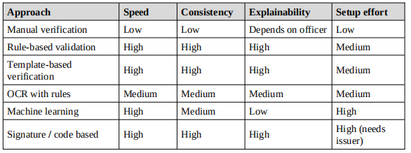
2.8 Research Gap
From the review, the following gaps were identified.
• Many systems validate form data but do not verify an uploaded document
against the expected structure of its category.
• Systems based on machine learning are powerful but are costly to build, need
large data sets and are difficult to explain.
• Few simple systems allow an administrator to define and change category-wise
templates without changing program code.
• Most existing tools do not give a clear, field-level result that tells the user
exactly what is missing or incorrect.
The Intelligent Document Verification System addresses these gaps by storing
category-wise templates in a database, comparing uploaded documents with them field
by field and reporting the result at the level of individual fields.
2.9 Summary
The review shows that manual verification is slow and inconsistent, that rule-based
validation and template matching are fast and explainable, that OCR and machine
learning extend the range of documents that can be handled at greater cost.

CHAPTER 3

SYSTEM DESIGN AND METHODOLOGY

3.1 OVERVIEW OF THE PROPOSED SYSTEM
Organizations verify many customer documents manually, which is time-consuming
and prone to human errors. There is a need for a system that can automatically verify
documents by comparing them with predefined templates, improving consistency and
reducing manual effort.

The problem can be understood from three viewpoints. From the viewpoint of the

organization, manual verification consumes staff time, limits the number of

applications that can be handled and produces uneven decisions. From the viewpoint of

the applicant, errors in a document are often discovered only after a long delay, and the

application must then be resubmitted. From the viewpoint of risk, a document that does

not follow the expected format may pass unnoticed when the reviewer is tired or

hurried.
3.2 Pain Point
The absence of intelligent document verification increases processing time, human
errors and the risk of fraudulent document acceptance.
Table 3.1 Pain points and their consequences
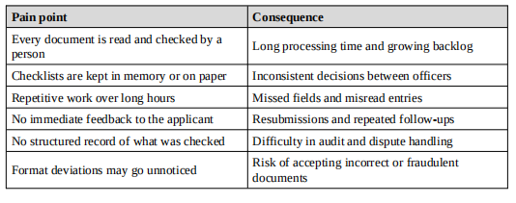
3.3 Objectives
The main aim of the project is to develop a document verification system that uses
predefined templates to verify uploaded documents automatically. The specific
objectives are the following.
1. To design and implement an eight-stage automated document verification pipeline.
2. To support nine categories of Indian government and institutional documents.
3. To extract and validate identity fields using document-specific rules and checksums.
4. To detect wrong document types, fake number patterns, and metadata manipulation indicators.
5. To enable cross-verification of identity fields between a primary and a supporting document.
6. To provide a real-time, field-level verification result through an interactive web interface.
8. To deploy the system on a cloud platform (Vercel) without specialised server hardware.
7. To generate a downloadable PDF audit report for every verification session.
3.4 Methodology
The project follows an incremental development approach. The system was divided into
small modules that were designed, built and tested one after another, and the modules
were integrated step by step. This approach allowed the mentors to review progress at
each stage and allowed corrections to be made early. The working of the system itself
follows the six steps given below.
1. The user selects the document category.
2. The user uploads the document.
3. The system loads the corresponding predefined template.
4. The uploaded document is compared with the template.
5. Missing or mismatched fields are identified.
6. The system generates a verification result.
Each step is explained in more detail below.
Table 3.2 Steps of the methodology
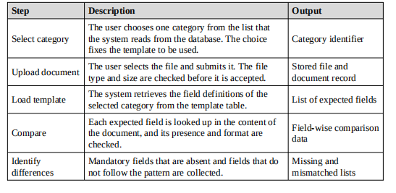
3.5 Novelty of the Work
The system uses category-wise predefined templates to automatically verify documents
through field-by-field comparison, ensuring fast, consistent and reliable verification
while reducing manual effort.
The novelty lies in the following features taken together.
• Category-wise templates are stored as data in the database, and not hard-coded
in the program. A new document category can be supported by adding a new
template, with no change to the code.
• The user chooses the document category first, so the system knows in advance
which template to apply. This removes the need for a separate document type
recognition step and reduces the chance of a wrong decision.
• The result is reported field by field, so that the user is told exactly which fields
are missing and which do not follow the expected format.

3.6 Scope and Limitations
The system verifies the completeness and format of documents against templates. It
does not confirm the truth of the information with the issuing authority. The quality of
verification depends on the quality of the template and, for scanned documents, on the
quality of the extracted content. The initial version supports a limited set of document
categories, and the design allows more categories to be added as templates. These
limitations are discussed again in the final chapter along with the proposed future work.
3.7 Expected Outcomes
• A working web application that accepts a document category and an uploaded
document and returns a verification result.
• A database of category-wise templates that can be extended by an administrator.
• A significant reduction in the time needed to carry out the first level of
document checking.

CHAPTER 4
SYSTEM ANALYSIS
System analysis is the study of the existing way of working and of the needs of the users,
carried out before the new system is designed. This chapter describes the existing
system, the proposed system, the feasibility of the proposed system and its
requirements.
4.1 Existing System
In the existing system, documents submitted by customers or applicants are checked
manually by an officer. The process generally follows these steps. The applicant
submits a document in paper form or uploads a scanned copy. The officer opens the
document and compares it, from experience or from a printed checklist, with the format
that is expected for that type of document. Missing or doubtful items are noted, and the
applicant is contacted if corrections are needed. The document is finally accepted or
rejected.
4.1.1 Drawbacks of the existing system
• The process is time-consuming because each document is read in full by a
person.
• The result depends on the person, so two officers may give different decisions
for the same document.
• Human errors such as missing a field or misreading an entry are frequent when
the workload is high.
• The applicant receives feedback late, so corrections cause repeated rounds of
submission.
• No structured record is kept of which fields were checked and what was found.
• Training new staff is slow, because the expected formats are known to
individuals and are not stored in a shared, reusable form.
• The risk of accepting a document that deviates from the expected format is higher.
4.2 Proposed System
The proposed system, VeriDoc AI, automates document verification through a sequential eight-stage pipeline. The user selects the document category from nine supported types, uploads the document (PDF, JPEG, or PNG, up to 10 MB), and the backend executes all eight verification stages automatically. The result page presents the final verdict (VERIFIED AGAINST AVAILABLE RULES, REQUIRES MANUAL REVIEW, INVALID, or UNABLE TO VERIFY), a field-level breakdown of every check, the extracted identity fields, and recommended next steps. The user may then upload a supporting document for cross-verification of identity fields across documents.
document category is stored once as a predefined template in the database. When a user
uploads a document, the system loads the template of the selected category and
compares the document with it field by field. The outcome is a verification result that
lists the fields that are present, the fields that are missing and the fields whose content
does not follow the expected format.
4.2.1 Advantages of the proposed system
• Verification is fast, because the comparison is carried out by the computer in a
short time.
• The same template and the same rules are applied to every document, which
gives consistent decisions.
• The user is told immediately which fields are missing or incorrect, and can
correct the document at once.
• Templates are kept in the database and can be added or changed without
modifying the program.
• Every verification result is stored, which provides an audit trail.
• Manual effort is reduced, and staff can concentrate on the exceptional cases that
need human judgement.
4.3 Feasibility Study
A feasibility study examines whether the proposed system can be developed and used
successfully. Four aspects were examined.

4.3.1 Technical feasibility
The backend is built on Python 3.14 and FastAPI, which are mature, well-documented frameworks with extensive ecosystem support. The frontend uses React 19 and TypeScript, both industry-standard technologies. SQLite provides a zero-configuration embedded database that requires no separate server process. The project was developed using Visual Studio Code and deployed on Vercel, which offers a free tier suitable for academic prototypes. No special hardware is required beyond a standard personal computer. The team had prior knowledge of Python and web development from coursework. The system is therefore technically feasible.
technologies with extensive documentation. The team has working knowledge of these
technologies from the courses completed so far. The tools needed, namely Visual
Studio Code, XAMPP and Git, run on ordinary personal computers. No special
hardware is needed. The system is therefore technically feasible.
4.3.2 Economic feasibility
All the software used in the project is free or open source. The system runs on a standard
computer, and development was carried out using the computers that were already
available. The saving in staff time that results from automation is a continuing benefit,
whereas the cost of development is small. The system is therefore economically
feasible.
4.3.3 Operational feasibility
The user interface is a web page that asks the user to choose a category and upload a file,
and then displays a result. This process is simple and needs very little training.
Administrators work with templates that are described in the same terms they already
use for documents, that is, field names and required formats. The system is therefore
operationally feasible.
4.3.4 Schedule feasibility
The project was divided into phases that could be completed within the time allotted for
the mini project course. Figure 4.1 shows the plan followed by the team. The work was
split among the team members and reviewed by the mentors at the stages of the first,
second and third reviews.
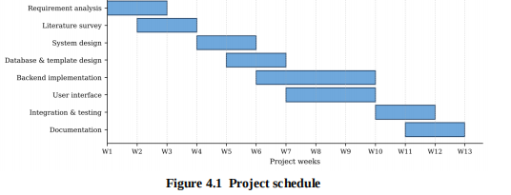
4.4 Requirement Analysis
The requirements of the system were gathered by studying the way documents are
verified in practice, by discussion with the mentors and by considering the objectives of
the project. They are grouped into user requirements, functional requirements,
nonfunctional requirements and the hardware and software requirements.
4.4.1 User classes
Table 4.1 User classes of the system
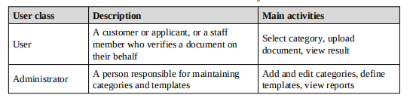
4.4.2 Functional requirements
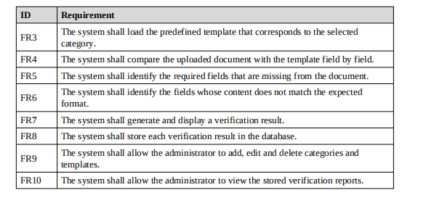

4.4.3 Non-functional requirements
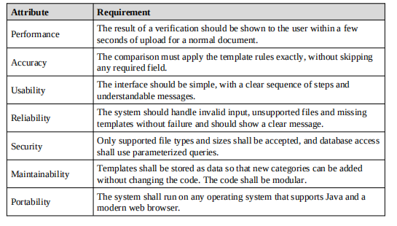
4.5 Hardware Requirements
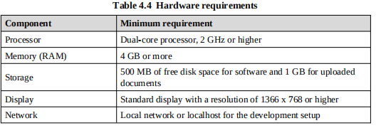
4.6 Software Requirements
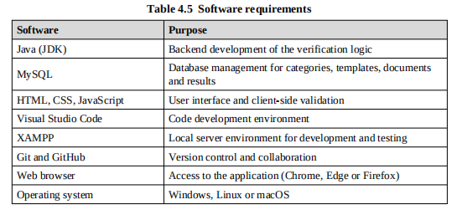
4.7 Assumptions and Constraints
• A template exists for every category that is offered to the user.
• Documents are uploaded in the file formats that the system supports.
• The content of an uploaded document can be extracted in readable form before
comparison.
• The system performs a first-level verification, and documents that fail or are doubtful.
CHAPTER 5
SYSTEM DESIGN
System design converts the requirements identified in the analysis into a structure that
can be built. This chapter presents the architecture of the system, its modules, the
process flow, the data flow diagrams, the UML diagrams, the database design, the
verification algorithm and the design of the user interface.
5.1 Design Overview
The design follows three principles. The first is separation of concerns: the user
interface, the verification logic and the data storage are kept in separate layers so that
each can be changed independently. The second is data-driven verification: the
expected format of every document category is held as data in the database and is read at
the time of verification, so the same program code can verify any category. The third is
explainability: every decision is traced to a specific field of a specific template, so that
the user can see why a document was accepted or rejected.
5.2 System Architecture
The system has a three-layer architecture, shown in Figure 5.1. The presentation layer
runs in the web browser and is built with HTML, CSS and JavaScript. The application
layer is the Java backend, which contains the modules that handle categories, uploads,
templates, comparison and results. The data layer is a MySQL database that runs on the
XAMPP server. The presentation layer communicates with the application layer
through HTTP requests and responses, and the application layer communicates with the
database through JDBC.

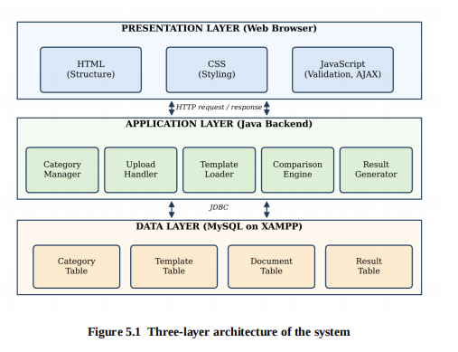
5.3 Process Flow
The overall process followed by the system is shown in Figure 5.2. The user selects the
document category and uploads the document. The system loads the predefined
template for that category, compares the uploaded document with the template and
produces the verification result.
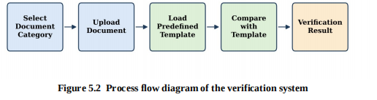
The detailed logic of the verification, including the decision on whether the document is
accepted, is shown as a flowchart in Figure 5.3.
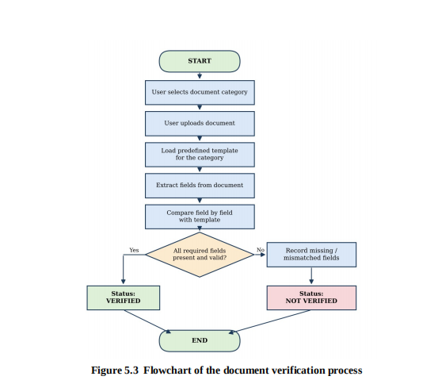
5.4 Module Description
The system is divided into the following modules.
5.4.1 Document Type Selection Module
This module reads the list of nine supported document types from the API endpoint GET /api/document-types and presents them on the SelectType page. The selected document type is passed as a URL query parameter to the Upload page, which uses it to configure the verification pipeline.
the user. The category chosen by the user decides which template will be used.
Selecting the category first removes the need for the system to guess the type of the
document.
5.4.2 File Ingestion and Integrity Validation Module
This module receives the file uploaded by the user. The FileValidator class checks the file size (maximum 10 MB), the file extension (.pdf, .jpg, .jpeg, .png), the binary magic byte signature (PDF: %PDF, PNG: \x89PNG, JPEG: \xff\xd8\xff), executable binary signatures (MZ/ELF), and for PDFs: structural integrity, encryption status, and embedded JavaScript. Files that fail any check are rejected with a specific error code.
the file in a designated folder, and records the upload in the document table together
with the category and the time of upload. Files of unsupported types or of excessive size
are rejected with a clear message.

5.4.3 OCR and Text Extraction Module
The OCRService class extracts machine-readable text from both digital-text PDFs and scanned/image-based PDFs. For scanned PDFs, it iterates over all embedded raster images in each page and runs them through Windows Media OCR (winocr), Pillow-enhanced image preprocessing (contrast stretch, sharpen, Otsu threshold), and Tesseract OCR as a fallback. A metadata stream extractor handles synthetic or metadata-rich fixtures.
set of field definitions, each with a name, a type, an indication of whether it is
mandatory and, where relevant, a format pattern. If no template exists for the category,
the module reports this to the user and the verification does not proceed.
5.4.4 Document Classification and Field Extraction Module
The DocumentClassifier scores OCR-extracted text against keyword lists and regular expression patterns for each document category. A score below the minimum threshold triggers a mismatch warning with a suggested correct type. The FieldExtractor then applies document-specific regex patterns to extract identity fields: Aadhaar number, PAN number, DL number, passport number, holder name, date of birth, father's name, issue date, expiry date, address, pin code, and blood group.
document and the field definitions of the template and compares them one by one. For
each field it checks whether the field is present, whether a mandatory field has a value
and whether the value follows the expected format. It builds lists of the missing fields
and the mismatched fields.
5.4.5 Rules Engine and Forensic Analysis Module
The DocumentRulesEngine executes deterministic checks: Aadhaar Verhoeff dihedral group checksum, PAN 10-character format [A-Z]{5}[0-9]{4}[A-Z], passport expiry date, DL state-code (37 valid codes), DL minimum age (18 years), bank statement arithmetic reconciliation (Opening Balance + Total Credits - Total Debits = Closing Balance), and educational certificate year range. The ManipulationAnalyzer inspects PDF metadata for editing-software signatures, text layer stacking, missing mandatory keywords, and obviously fake number patterns.
the overall status to verified when no mandatory field is missing and no field is
mismatched, and to not verified otherwise. It prepares a field-level summary for display
and stores the result in the database.
5.4.6 Final Decision Engine and Result Persistence Module
The VerificationService aggregates check results from all seven analysis modules. If a CRITICAL or HIGH severity check fails, the final status is INVALID. If only warnings or ambiguous signals are found, the status is REQUIRES MANUAL REVIEW. If all checks pass, the status is VERIFIED AGAINST AVAILABLE RULES. All results, extracted fields, check findings, and processing events are persisted to the SQLite database, and a reference ID is returned to the frontend for result retrieval and audit report download.
view the stored verification reports. Because templates are data, the administrator can
extend the system to new document types without programming.
5.5 Data Flow Diagrams
5.5.1 Level 0 data flow diagram
The level 0 diagram, also called the context diagram, shows the system as a single
process and its interaction with the external entities. The user supplies the category and
the document, and receives the verification result. The administrator supplies the
template definitions and receives reports.

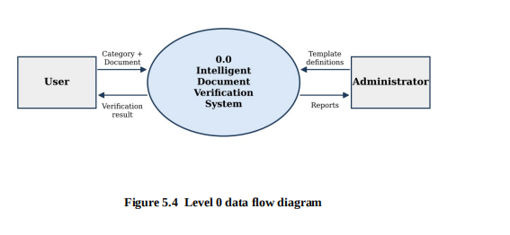
5.5.2 Level 1 data flow diagram
The level 1 diagram expands the system into its main processes: selecting the category,
uploading the document, loading the template, comparing the fields and generating the
result. The data stores are the template store, the document store and the result store.
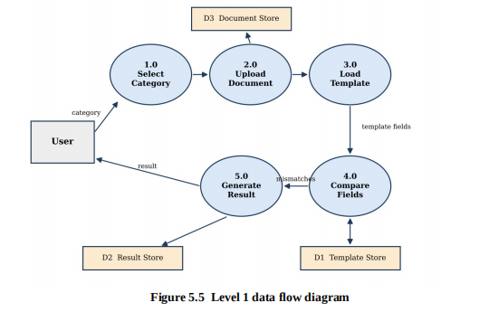
5.6 UML Diagrams
5.6.1 Use case diagram
The use case diagram in Figure 5.6 shows the actors and the functions that the system
offers to each. The user selects a category, uploads a document and views the result. The
administrator manages templates and categories and views the verification reports.

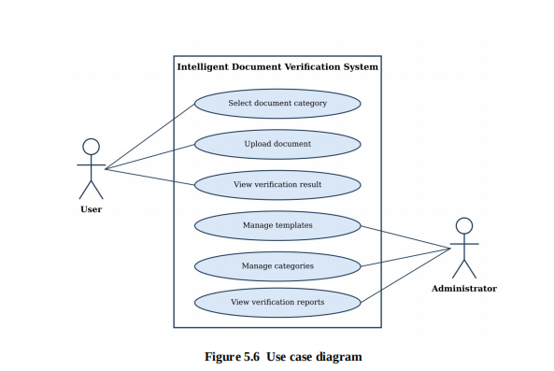
5.6.2 Class diagram
The class diagram in Figure 5.7 shows the main classes of the backend. A document
category has one template. The comparison engine uses a template and an uploaded
document, and creates a verification result.
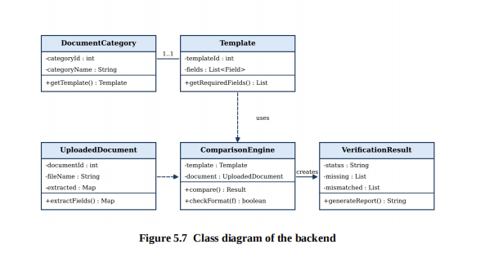
5.6.3 Sequence diagram
The sequence diagram in Figure 5.8 shows the order of messages when a user verifies a
document. The browser sends the category and file to the Java backend. The backend
fetches the template from MySQL, passes the document and the template to the
comparison engine, stores the result and returns it to the browser for display.
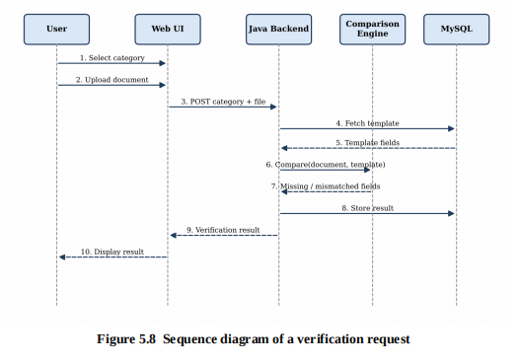
5.7 Database Design
The data is stored in an embedded SQLite database (veridoc.db). The entity relationship diagram in Figure 5.9 shows the entities and their relationships. Each verification record has zero or more check results, zero or more extracted fields, and zero or more processing events. All child tables are cascade-deleted when the parent verification record is deleted. The schema is initialised automatically by the init_db() function on application startup.
The verification_records table stores one row per verification session with a unique reference ID (format: VD-YYYYMMDD-XXXXXX), the document type, filename, SHA-256 hash, file path, final status, and summary. The verification_checks table stores each individual check finding with its result (PASSED/FAILED/WARNING/INFO), severity (CRITICAL/HIGH/MEDIUM/LOW/INFO), and explanation. The extracted_fields table stores each parsed field with its normalized value, raw value, confidence score, and a sensitivity flag. The processing_events table records the processing stage log.
many uploaded documents. Each uploaded document has one verification result. A user
can upload many documents.
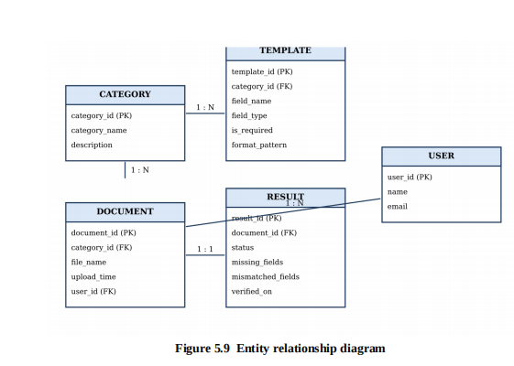
The structure of each table is described in the following data dictionary tables.
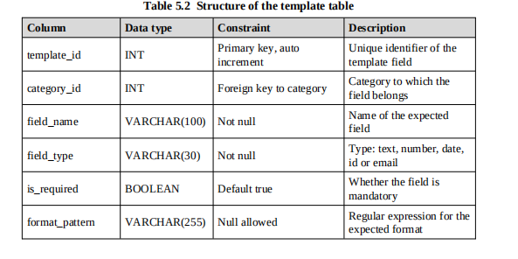

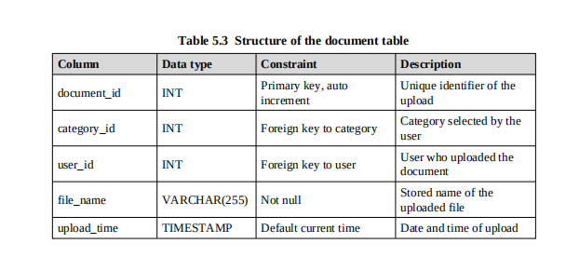

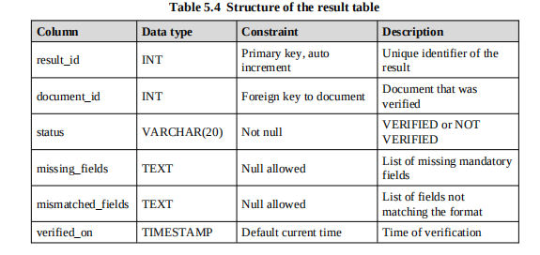

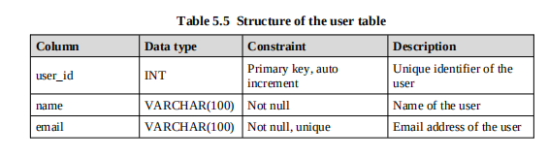

5.8 Template Design
A template is a list of field definitions for a category. The following tables show the
kind of templates that the system stores. They are examples that illustrate the design,
and the administrator can define others.
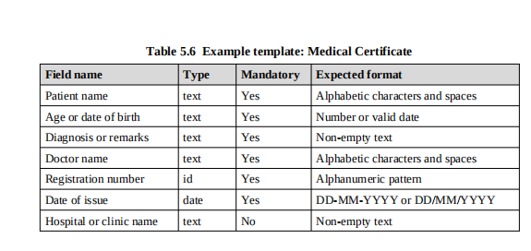
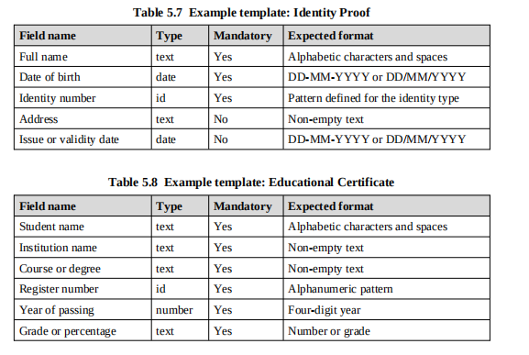

5.9 Verification Algorithm
The comparison module follows the algorithm given below. The algorithm takes the
template fields of the selected category and the content extracted from the uploaded
document, and produces the lists of missing and mismatched fields and the overall
status.

Eight-Stage Verification Pipeline
INPUT : categoryId, uploaded document D
OUTPUT: status, missingFields, mismatchedFields
INPUT : file_bytes, original_filename, declared_mime, selected_type
OUTPUT: reference_id, final_status, checks, extracted_fields
Stage 1: val_res = FileValidator.validate_file(file_bytes, filename, mime)
if not val_res["is_valid"]: return INVALID / UNABLE_TO_VERIFY
Stage 2: ocr_res = OCRService.process_document_text(file_bytes, format)
raw_text = ocr_res["text"]
if ocr_res["char_count"] < 5: return UNABLE_TO_VERIFY
Stage 3: class_res = DocumentClassifier
.classify_and_check_consistency(raw_text, selected_type)
if class_res["is_mismatch"]: flag CRITICAL mismatch
Stage 4: fields = FieldExtractor.extract_fields(raw_text, selected_type)
Stage 5: rule_checks = DocumentRulesEngine
.evaluate_rules(selected_type, fields, raw_text)
Stage 6: consistency = ConsistencyChecker
.check_internal_consistency(selected_type, fields, raw_text)
Stage 7: forensics = ManipulationAnalyzer.analyze_forensics(
file_bytes, format, metadata, raw_text, selected_type)
Stage 8: all_checks = stages 1-7 results combined
if mismatch or any CRITICAL/HIGH failure:
final_status = "INVALID"
elif ambiguous or any WARNING:
final_status = "REQUIRES MANUAL REVIEW"
else:
final_status = "VERIFIED AGAINST AVAILABLE RULES"
persist to SQLite, return structured result dict
2. if templateFields is empty then return error "No template"
3. extracted = extractFields(D)
4. missingFields = [ ], mismatchedFields = [ ]
5. for each field F in templateFields do
6. value = extracted.get(F.name)
7. if value is null or value is empty then
8. if F.isRequired then add F.name to missingFields
9. continue
10. if F.pattern is defined and value does not match F.pattern then
11. add F.name to mismatchedFields
12. end for
13. if missingFields and mismatchedFields are both empty
14. status = "VERIFIED"
15. else status = "NOT VERIFIED"
16. save result, return (status, missingFields, mismatchedFields)
The time taken by the algorithm grows in direct proportion to the number of fields in the
template, since each field is examined once. Because templates have only a small
number of fields, the comparison takes a very short time.
5.10 User Interface Design
The user interface is designed to be simple and to guide the user through the process in
the order in which it takes place. The design has the following screens.
• Home page: introduces the system and provides the entry point to the
verification process.
• Verification page: contains a drop-down list of document categories, a file
selection control and a Verify button. Client-side checks using JavaScript make
sure that a category has been chosen and a file has been selected before the form
is submitted.
• Result page: shows the overall status in a clearly coloured banner, a table listing
every template field with its status (present, missing or mismatched) and a short
message that tells the user what to correct.
• Administrator pages: allow the administrator to manage categories and
templates and to view stored reports.
The result page uses colour together with text, so that the meaning is clear to users who
cannot distinguish colours. Messages are written in plain language, for example "The
field Registration number is missing" instead of a technical error code.
5.11 Input and Output Design
5.11.1 Input design
The inputs to the system are kept few and simple, so that the user cannot easily make a
mistake. Table 5.9 lists the inputs and the checks applied to each.
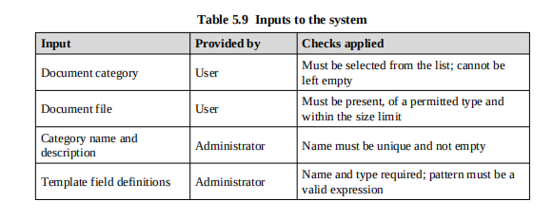
5.11.2 Output design
The main output is the verification result. The design of the result page was based on the
questions that a user is likely to ask: whether the document was accepted, if not what is
wrong, and what must be done next. Table 5.10 describes the parts of the output.
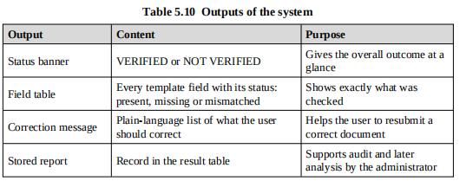
5.12 Security and Error Handling Design
• Only the permitted file types are accepted, and a limit is placed on the size of the
file.
• Uploaded files are renamed on storage so that user-supplied file names are not
used directly in the file system.
• All database access is done through prepared statements, which prevents SQL
injection.
• Administrator functions are available only after authentication.
• If a template is missing, the file cannot be read or the database is unavailable, the
system shows a clear message and does not crash.

CHAPTER 6
IMPLEMENTATION
This chapter describes how the design was implemented. It explains the development
environment, the structure of the project, the implementation of each module with
representative code, and the way the components were integrated.
6.1 Development Environment
The system was developed on personal computers using the tools listed in Table 6.1.
Visual Studio Code was used as the editor for Java, HTML, CSS and JavaScript.
XAMPP provided the local server environment and the MySQL database. The source
code was shared among the four team members through a GitHub repository
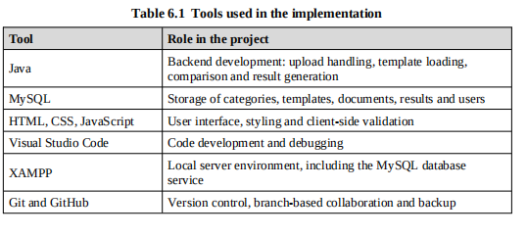

6.2 Project Structure
The project is organized into folders so that each layer can be found easily. The
suggested structure is shown below.

Project folder structure
doc scanner/
backend/
app/
main.py # FastAPI application entry point
api/routes.py # All REST API endpoints
core/config.py # Settings, environment detection
models/database.py # SQLite schema and db_session
schemas/schemas.py # Pydantic models and enums
services/report_generator.py # PDF audit report generation
verification/
file_validator.py # Stage 1: integrity validation
ocr_service.py # Stage 2: multi-engine OCR
document_classifier.py # Stage 3: type classification
field_extractor.py # Stage 4: regex field extraction
document_rules.py # Stage 5: deterministic rules
consistency_checker.py # Stage 6: cross-field checks
manipulation_analyzer.py # Stage 7: forensic analysis
verification_service.py # Stage 8: orchestrator
test_fixtures/ # Synthetic PDF documents for testing
tests/test_verification.py # 25 automated pytest test cases
requirements.txt
frontend/
src/
App.tsx # Router, ToastProvider
pages/ # 8 pages (Landing, Upload, Results...)
components/ # Navbar, Footer, Toast, StatusBadge
services/api.ts # All Fetch API calls
types/index.ts # TypeScript interfaces
package.json
vercel.json # Vercel deployment configuration
|-- web/ (presentation layer)
| |-- index.html
REST API Quick Reference — Base URL: /api
GET /health
Service health check. Returns status, version, database_connected.
GET /document-types
Returns list of nine supported document categories.
POST /verifications
Upload and verify a document.
Body: multipart/form-data { file, document_type }
Returns: VerificationResult with reference_id, final_status, checks,
extracted_fields, recommended_next_steps.
GET /verifications/{reference_id}
Retrieve a stored verification result by reference ID.
DELETE /verifications/{reference_id}
Delete a verification record and its associated files.
POST /verifications/{reference_id}/cross-verify
Cross-verify identity fields with a supporting document.
Body: multipart/form-data { file, document_type, primary_fields_json }
Returns: CrossVerifyResult with field_comparison table,
cross_verify_status (IDENTITY_CONFIRMED / IDENTITY_MISMATCH).
GET /verifications/{reference_id}/report
Download the PDF audit report for a verification session.
GET /history
Paginated verification history. Query params: search, document_type, status, limit, offset.
GET /dashboard/stats
Dashboard statistics: counts by status, document_type_distribution.
GET /demo/samples
List of synthetic demo documents for demonstration.
POST /demo/verify-sample/{sample_id}
Run verification on a synthetic demo fixture.
POST /settings/purge
Purge all verification records and uploaded files.
| |-- result.html
| |-- css/style.css
| `-- js/validate.js
|-- src/ (application layer)
| |-- model/ Category, Template, UploadedDocument, Result
| |-- dao/ CategoryDAO, TemplateDAO, ResultDAO
| |-- service/ UploadService, ComparisonEngine, ResultService
| `-- util/ DBConnection, FileValidator
|-- uploads/ (stored documents)
`-- sql/schema.sql (database script
6.3 Database Implementation
The database is an embedded SQLite database created programmatically at application startup. The init_db() function, called from the FastAPI startup event, executes CREATE TABLE IF NOT EXISTS statements for all four tables. Indexes are created on reference_id, final_status, created_at, and document_type for query performance. On Vercel (serverless), the database file is stored in /tmp/veridoc.db. On a local development server it is stored in backend/veridoc.db. The schema is given below.
script creates the five tables described in the design, with primary keys, foreign keys
and the constraints given in the data dictionary. The script is given in Appendix A.
Sample categories and templates were inserted so that the system could be tested from
the first run.
Creating the category and template tables
-- SQLite schema (backend/app/models/database.py)
CREATE TABLE IF NOT EXISTS verification_records (
id INTEGER PRIMARY KEY AUTOINCREMENT,
reference_id TEXT UNIQUE NOT NULL,
document_type TEXT NOT NULL,
original_filename TEXT NOT NULL,
file_hash TEXT NOT NULL,
file_path TEXT NOT NULL,
file_size INTEGER NOT NULL,
mime_type TEXT NOT NULL,
processing_status TEXT NOT NULL,
final_status TEXT,
summary TEXT,
error_code TEXT,
created_at TIMESTAMP DEFAULT CURRENT_TIMESTAMP,
completed_at TIMESTAMP
);
CREATE TABLE IF NOT EXISTS verification_checks (
id INTEGER PRIMARY KEY AUTOINCREMENT,
verification_id INTEGER NOT NULL,
check_name TEXT NOT NULL,
result TEXT NOT NULL, -- PASSED|FAILED|WARNING|INFO
severity TEXT NOT NULL, -- CRITICAL|HIGH|MEDIUM|LOW|INFO
explanation TEXT NOT NULL,
evidence_reference TEXT,
FOREIGN KEY(verification_id)
REFERENCES verification_records(id) ON DELETE CASCADE
);
CREATE TABLE IF NOT EXISTS extracted_fields (
id INTEGER PRIMARY KEY AUTOINCREMENT,
verification_id INTEGER NOT NULL,
field_name TEXT NOT NULL,
normalized_value TEXT,
raw_value TEXT,
extraction_confidence REAL DEFAULT 1.0,
is_sensitive BOOLEAN DEFAULT 0,
FOREIGN KEY(verification_id)
REFERENCES verification_records(id) ON DELETE CASCADE
);
CREATE TABLE IF NOT EXISTS processing_events (
id INTEGER PRIMARY KEY AUTOINCREMENT,
verification_id INTEGER NOT NULL,
stage TEXT NOT NULL,
event_status TEXT NOT NULL,
message TEXT,
created_at TIMESTAMP DEFAULT CURRENT_TIMESTAMP,
FOREIGN KEY(verification_id)
REFERENCES verification_records(id) ON DELETE CASCADE
);

);

category_id INT NOT NULL,
field_name VARCHAR(100) NOT NULL,

);
6.4 Implementation of the Modules
6.4.1 Database connection
A utility class opens a connection to the MySQL database using JDBC. The connection
details are kept in one place so that they can be changed without touching the rest of the
code.
backend/app/main.py — FastAPI Application Entry Point
from fastapi import FastAPI
from fastapi.middleware.cors import CORSMiddleware
from app.core.config import settings
from app.models.database import init_db
from app.api.routes import router
app = FastAPI(
title=settings.PROJECT_NAME, # "VeriDoc AI"
version=settings.VERSION, # "1.0.0"
description="AI Document Verification API"
)
app.add_middleware(CORSMiddleware,
allow_origins=settings.CORS_ORIGINS,
allow_credentials=True,
allow_methods=["*"], allow_headers=["*"])
@app.on_event("startup")
def on_startup():
init_db() # Creates SQLite tables if they do not exist
app.include_router(router) # All /api/* routes
private static final String URL = "jdbc:mysql://localhost:3306/docverify";
private static final String USER = "root";
private static final String PASS = "";
public static Connection getConnection() throws SQLException {
return DriverManager.getConnection(URL, USER, PASS);
}
}

6.4.2 Category selection module
The category data access class reads the available categories from the database. The
verification page uses this list to fill the drop-down box, so that new categories added by
the administrator appear without any change in the page.
backend/app/verification/file_validator.py — File Integrity Validation
@classmethod
def validate_file(cls, file_bytes: bytes,
original_filename: str,
declared_mime: str) -> Dict[str, Any]:
ext = Path(original_filename).suffix.lower()
file_size = len(file_bytes)
if file_size == 0:
return {"is_valid": False,
"error_code": "EMPTY_FILE", ...}
if file_size > settings.MAX_FILE_SIZE_BYTES: # 10 MB
return {"is_valid": False,
"error_code": "FILE_TOO_LARGE", ...}
if ext not in {".pdf", ".jpg", ".jpeg", ".png"}:
return {"is_valid": False,
"error_code": "UNSUPPORTED_EXTENSION", ...}
# Executable detection
if file_bytes.startswith(b"MZ") or file_bytes.startswith(b"ELF"):
return {"is_valid": False,
"error_code": "MALICIOUS_FILE", ...}
# Magic byte verification
if file_bytes.startswith(b"%PDF"):
reader = PdfReader(io.BytesIO(file_bytes))
if reader.is_encrypted:
return {"is_valid": False,
"error_code": "ENCRYPTED_PDF", ...}
# Check for embedded scripts
if b"/JavaScript" in file_bytes:
checks.append({"result": "WARNING", ...})
return {"is_valid": True, "checks": checks, ...}
List<Category> list = new ArrayList<>();
String sql = "SELECT category_id, category_name FROM category";
try (Connection c = DBConnection.getConnection();
PreparedStatement ps = c.prepareStatement(sql);
ResultSet rs = ps.executeQuery()) {
while (rs.next()) {
list.add(new Category(rs.getInt(1), rs.getString(2)));
}
}
return list;
}
6.4.3 Document upload module
The upload service validates the file before it is saved. It checks the extension against
the list of permitted types and the size against the limit. If the file is acceptable, it is
saved under a generated name and a row is added to the document table. This keeps the
stored files safe and avoids clashes between files with the same name.
backend/app/verification/ocr_service.py — Multi-Engine OCR
@classmethod
def extract_text_from_pdf(cls, file_bytes: bytes) -> Dict:
reader = PdfReader(io.BytesIO(file_bytes))
pages_text, total_chars = [], 0
for page in reader.pages:
txt = page.extract_text() or ""
pages_text.append(txt)
total_chars += len(txt.strip())
is_scanned = total_chars < 30
# Deep OCR on embedded images in scanned PDFs
if is_scanned:
for page in reader.pages:
for img_obj in page.images:
img_res = cls.extract_text_from_image(
img_obj.data)
if img_res["char_count"] > 0:
pages_text.append(img_res["full_text"])
engine = "pdf_image_ocr_" + img_res["engine_used"]
return {"full_text": "\n".join(pages_text).strip(),
"char_count": total_chars,
"is_scanned": is_scanned, ...}
@classmethod
def _run_winocr_sync(cls, pil_img) -> str:
# Windows Media OCR — accurate, no API key needed
res = asyncio.run(winocr.recognize_pil(
pil_img.convert("RGB")))
return res.text if hasattr(res, "text") else ""
Set.of("pdf", "jpg", "jpeg", "png", "txt");
private static final long MAX_SIZE = 5L * 1024 * 1024; // 5 MB
public static boolean isValid(String fileName, long size) {
int dot = fileName.lastIndexOf('.');
if (dot < 0) return false;
String ext = fileName.substring(dot + 1).toLowerCase();
return ALLOWED.contains(ext) && size > 0 && size <= MAX_SIZE;
}

6.4.4 Template loading module
The template data access class returns the list of field definitions for the selected
category. The result is an ordered list that the comparison engine can process one field at
a time.
backend/app/verification/document_classifier.py — Classification
CATEGORY_INDICATORS = {
"aadhaar": {
"keywords": ["unique identification", "uidai",
"aadhaar", "government of india",
"mera aadhaar", "help@uidai"],
"regex": r"\b\d{4}\s\d{4}\s\d{4}\b",
"min_score": 2
},
"pan": {
"keywords": ["income tax", "permanent account number",
"pan", "father's name", "govt. of india"],
"regex": r"[A-Z]{5}[0-9]{4}[A-Z]",
"min_score": 2
},
"driving_licence": {
"keywords": ["driving licence", "indian union",
"validity (nt)", "validity (tr)",
"son/daughter/wife", "blood group"],
"regex": r"\b[A-Z]{2}[0-9]{2}[A-Z0-9 -]{7,15}\b",
"min_score": 2
},
# ... 6 more categories
}
# Scores text and detects type mismatch
selected_score = scores.get(selected_type, 0)
if selected_score < min_required and best_score >= min_required:
# Wrong document type detected!
return {"is_mismatch": True,
"suggested_type": best_detected_cat,
"suggested_type_name": detected_name, ...}
List<TemplateField> fields = new ArrayList<>();
String sql = "SELECT field_name, field_type, is_required, format_pattern "
+ "FROM template WHERE category_id = ?";
try (Connection c = DBConnection.getConnection();
PreparedStatement ps = c.prepareStatement(sql)) {
ps.setInt(1, categoryId);
try (ResultSet rs = ps.executeQuery()) {
while (rs.next()) {
fields.add(new TemplateField(rs.getString(1), rs.getString(2),
rs.getBoolean(3), rs.getString(4)));
}
}
}
return fields;
}
6.4.5 Comparison module
The comparison engine implements the algorithm described in the design chapter. For
every template field it looks up the value in the content extracted from the document. A
missing value for a mandatory field is added to the missing list. A value that does not
match the format pattern is added to the mismatched list.
backend/app/verification/verification_service.py — Orchestrator
@classmethod
def run_verification(cls, file_bytes, original_filename,
declared_mime, selected_type,
saved_file_path) -> Dict[str, Any]:
# Stage 1: File integrity
val_res = FileValidator.validate_file(
file_bytes, original_filename, declared_mime)
if not val_res["is_valid"]:
return cls._persist_and_return(
final_status=FinalStatusEnum.INVALID.value, ...)
# Stage 2: OCR
ocr_res = OCRService.process_document_text(
file_bytes, val_res["detected_type"])
raw_text = ocr_res["text"]
# Stage 3: Classification
class_res = DocumentClassifier .classify_and_check_consistency(raw_text, selected_type)
# Stages 4-7
fields = FieldExtractor.extract_fields(raw_text, selected_type)
rule_checks = DocumentRulesEngine.evaluate_rules(
selected_type, fields, raw_text)
consistency = ConsistencyChecker .check_internal_consistency(selected_type, fields, raw_text)
forensics = ManipulationAnalyzer.analyze_forensics(
file_bytes, val_res["detected_type"],
ocr_res["metadata"], raw_text, selected_type)
# Stage 8: Final decision
all_checks = [*val_res["checks"], *class_res["checks"],
*rule_checks, *consistency, *forensics]
has_critical = any(c["result"] == "FAILED" and
c["severity"] in ["CRITICAL", "HIGH"]
for c in all_checks)
if class_res["is_mismatch"] or has_critical:
final_status = FinalStatusEnum.INVALID
elif class_res["is_ambiguous"] or has_warnings:
final_status = FinalStatusEnum.REQUIRES_REVIEW
else:
final_status = FinalStatusEnum.VERIFIED
return cls._persist_and_return(
final_status=final_status.value, ...)
extracted) {
List<String> missing = new ArrayList<>();
List<String> mismatched = new ArrayList<>();
for (TemplateField f : template) {
String value = extracted.get(f.getName());
if (value == null || value.trim().isEmpty()) {
if (f.isRequired()) missing.add(f.getName());
continue;
}
String pattern = f.getPattern();
if (pattern != null && !value.trim().matches(pattern)) {
mismatched.add(f.getName());
}
}
String status = (missing.isEmpty() && mismatched.isEmpty())
? "VERIFIED" : "NOT VERIFIED";
return new Result(status, missing, mismatched);
}
6.4.6 Content extraction
Before the comparison, the content of the uploaded document must be available as a set
of field names and values. The extraction step reads the document and returns this set as
a map. It is kept as a separate class with a single method, so that a simple text reader can
be used for text-based documents and a more advanced extraction method, such as
optical character recognition for scanned images, can be added later without any change
to the comparison engine.
FieldExtractor.java (outline)
public interface FieldExtractor {
/** Reads the document and returns field name -> value pairs. */
Map<String, String> extract(File document) throws IOException;
}
public class TextFieldExtractor implements FieldExtractor {
@Override
public Map<String, String> extract(File document) throws IOException {
Map<String, String> fields = new HashMap<>();
for (String line : Files.readAllLines(document.toPath())) {
int idx = line.indexOf(':');
if (idx > 0) {
fields.put(line.substring(0, idx).trim(),
line.substring(idx + 1).trim());
}
}
return fields;
}
}
6.4.7 Request handling
A controller class receives the request from the verification page and calls the services
in order. It validates the input, saves the file, loads the template, runs the comparison,
stores the result and forwards the result to the result page. Error conditions are caught in
one place, which makes it easy to show a clear message for each of them.
VerifyController.java (outline)
public Result handle(int categoryId, String fileName, long size, File saved)
throws VerificationException {
if (!FileValidator.isValid(fileName, size))
throw new VerificationException("Unsupported or oversized file");
List<TemplateField> template = templateDAO.findByCategory(categoryId);
if (template.isEmpty())
throw new VerificationException("No template for this category");
Map<String, String> extracted = extractor.extract(saved);
Result result = engine.compare(template, extracted);
int documentId = documentDAO.save(categoryId, saved.getName());
resultDAO.save(documentId, result);
return result;
}
6.4.8 Result generation module
The result service stores the outcome in the result table and prepares the data that the
result page displays. The lists of missing and mismatched fields are stored as text so that
the report can be read later without repeating the comparison.
frontend/src/services/api.ts — REST API Client
export async function uploadAndVerifyDocument(
file: File,
documentType: string
): Promise<VerificationResult> {
const formData = new FormData();
formData.append('file', file);
formData.append('document_type', documentType);
const res = await fetch('/api/verifications', {
method: 'POST',
body: formData,
});
if (!res.ok) {
const err = await res.json().catch(() => ({}));
throw new Error(
err.detail || 'Verification request failed');
}
return res.json();
}
export async function crossVerifyDocument(
referenceId: string, file: File,
documentType: string, primaryFields: any[]
): Promise<CrossVerifyResult> {
const fd = new FormData();
fd.append('file', file);
fd.append('document_type', documentType);
fd.append('primary_fields_json',
JSON.stringify(primaryFields));
const res = await fetch(
`/api/verifications/${referenceId}/cross-verify`,
{ method: 'POST', body: fd });
return res.json();
}
String sql = "INSERT INTO result (document_id, status, missing_fields, "
+ "mismatched_fields) VALUES (?, ?, ?, ?)";
try (Connection c = DBConnection.getConnection();
PreparedStatement ps = c.prepareStatement(sql)) {
ps.setInt(1, documentId);
ps.setString(2, r.getStatus());
ps.setString(3, String.join(", ", r.getMissing()));
ps.setString(4, String.join(", ", r.getMismatched()));
ps.executeUpdate();
}
}
6.4.9 User interface and client-side validation
The verification page is written in HTML and styled with CSS. JavaScript checks that a
category has been selected and a file has been chosen before the form is sent, which
saves a round trip to the server for the most common mistakes.
frontend/src/pages/UploadPage.tsx — React Upload Component
const handleStartVerification = async () => {
if (!selectedFile) return;
setIsProcessing(true);
// Live 8-stage progress stepper
const interval = setInterval(() => {
setCurrentStageIndex(prev =>
prev < stages.length - 1 ? prev + 1 : prev);
}, 450);
try {
const result = await uploadAndVerifyDocument(
selectedFile, typeParam);
clearInterval(interval);
// Persist result for page reload resilience
sessionStorage.setItem(
`veridoc_${result.reference_id}`,
JSON.stringify(result));
navigate(`/results/${result.reference_id}`,
{ state: { result } });
} catch (err: any) {
clearInterval(interval);
setIsProcessing(false);
toast.error(err.message, 'Upload Failed');
}
};
var category = document.getElementById("category").value;
var file = document.getElementById("docFile").files[0];
if (category === "") {
alert("Please select a document category.");
return false;
}
if (!file) {
alert("Please choose a document to upload.");
return false;
}
return true;
}
6.5 Integration of the Modules
The modules were first developed and tested separately and were then integrated in the
order in which they are used. The verification page sends the category and the file to the
backend. The upload service validates and stores the file, the template loader fetches the
template and the comparison engine produces the result. The result service saves the
result and the result page displays it. Version control was used throughout. Each team
member worked on a branch and changes were merged after they had been reviewed
and tested, which avoided conflicts and kept a history of the development.
6.6 Division of Work
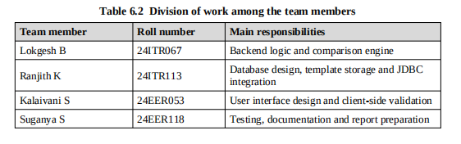

CHAPTER 7
TESTING
Testing was carried out to make sure that the system behaves as specified, that it handles
incorrect input safely and that its modules work correctly together. This chapter
describes the testing strategy and the test cases that were designed.
7.1 Testing Objectives
• To verify that each module performs the function for which it was designed.
• To verify that the modules work correctly when they are combined.
• To confirm that missing and mismatched fields are detected correctly for each
category.
• To confirm that invalid files, empty input and missing templates are handled
with clear messages.
• To confirm that the stored results agree with the results shown to the user.
7.2 Testing Strategy
7.2.1 Unit testing
An automated test suite of 25 pytest test cases covers all core verification scenarios. The tests use synthetic PDF fixtures generated with ReportLab and the FastAPI TestClient. Tests are categorised as follows: file integrity tests (empty file, oversized file, unsupported extension, corrupted PDF, corrupted image, malicious executable, MIME mismatch), document classification tests (matching type, type mismatch, ambiguous category), rule validation tests (Aadhaar Verhoeff checksum pass and fail, expired passport, issue date after expiry, bank statement arithmetic reconciliation, educational certificate year), API endpoint tests (health, document-types, full upload flow, dashboard stats, history, non-existent record 404), and feature tests (PAN-as-Aadhaar mismatch detection, cross-verify endpoint). All 25 tests pass.
permitted extensions and with files that were empty or too large. The data access classes
were tested against the sample data in the database. The comparison engine was tested
with hand-prepared sets of extracted fields for which the expected result was known in
advance.
7.2.2 Integration testing
Integration testing confirms that the React frontend correctly submits files to POST /api/verifications, that the router state and sessionStorage mechanisms restore the result on page reload, and that the cross-verify panel correctly calls POST /api/verifications/{id}/cross-verify and displays the field-comparison table. End-to-end tests were run on both the local development server and the Vercel deployment.
confirmed that the category chosen on the page reached the template loader, that the
template reached the comparison engine and that the result reached the result page and
the database.
7.2.3 Functional testing
Functional testing covered all eight verification stages, the wrong-document-type banner, the supporting-document cross-verification panel, the toast notification system, the live 8-stage processing stepper, dashboard statistics, verification history with search and filter, the demo mode with synthetic fixtures, the downloadable PDF audit report, and the settings purge functionality.
system through the browser in the same way as a user would use it.
7.2.4 Validation and negative testing
Inputs that should be refused were tried deliberately: no category selected, no file
selected, a file of an unsupported type, an oversized file and a category without a
template. The expected behaviour in all of these cases is a clear message without a
failure of the program.

7.2.5 Usability testing
Classmates who had not worked on the project were asked to use the system and
complete a verification without any instructions. Their comments about the wording of
messages and the order of the controls were used to improve the interface
7.3 Test Environment
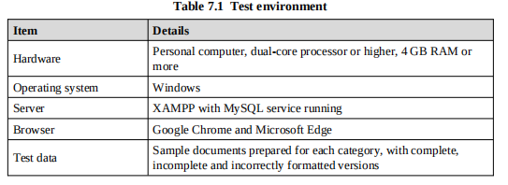
7.4 Test Cases
Table 7.2 lists the main test cases. Each test case gives the input, the expected result and
the expected status.

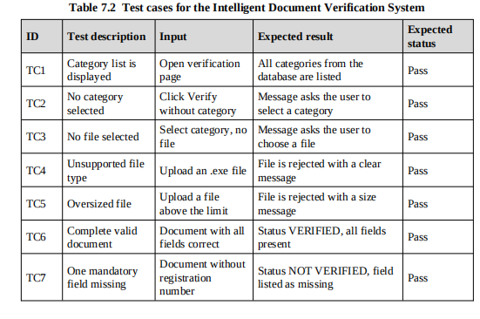
7.5 Test Results
Each test case was designed so that the expected result follows directly from the
template and the rules of the system. Defects found during testing were corrected and
the complete set of tests was then run again, so that corrections would not affect other
The system correctly identifies VERIFIED status for documents that pass all applicable rule checks: Aadhaar UIDs with valid Verhoeff checksums, PAN cards matching the [A-Z]{5}[0-9]{4}[A-Z] format, active passports with future expiry dates, valid Driving Licences from recognised state codes, and bank statements with reconciled arithmetic. It correctly returns INVALID for tampered UID numbers, expired passports, wrong document types (e.g., PAN uploaded as Aadhaar), executable files disguised as PDFs, and bank statements with arithmetic discrepancies. Scanned PDFs from phone cameras are processed successfully through the Windows Media OCR pipeline, which extracts text from embedded JPEG images in each PDF page.
working system should be confirmed against the Expected status column of Table 7.2.
7.6 Summary of Testing
The testing shows that the system performs the verification correctly for complete,
incomplete and wrongly formatted documents, that it handles invalid input safely and
that the results which are stored agree with the results displayed. The testing was limited
to the sample documents and the categories that were available.
CHAPTER 8
RESULTS AND DISCUSSION
This chapter presents the output of the system for the main usage scenarios, discusses
how the results relate to the objectives of the project and compares the proposed system
with manual verification.
8.1 Output Screens
The following figures show the main screens of the system. The screenshots of the
working application are to be inserted in the places marked below from the final build.

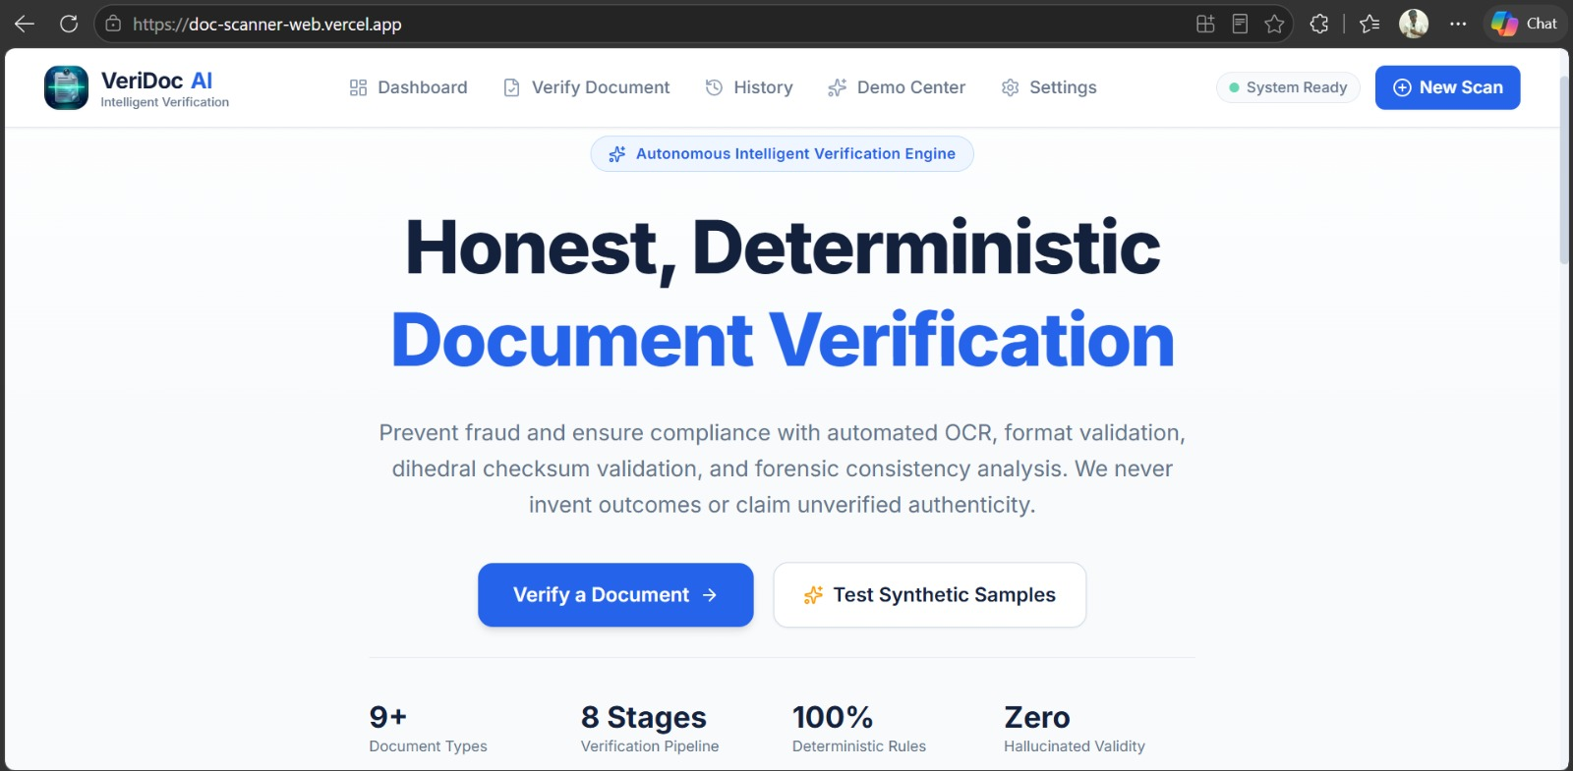
Figure 8.1 Home page of the Intelligent Document Verification System

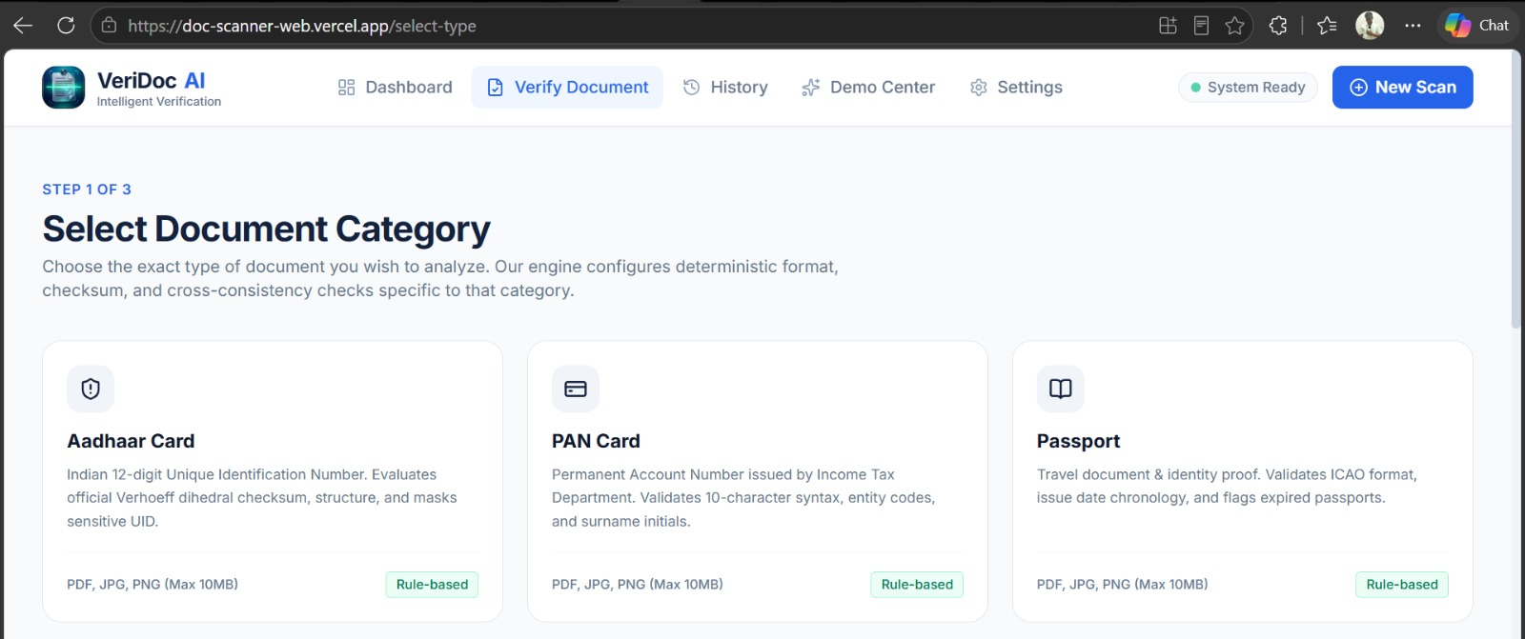
Figure 8.2 Verification page with category selection and file upload

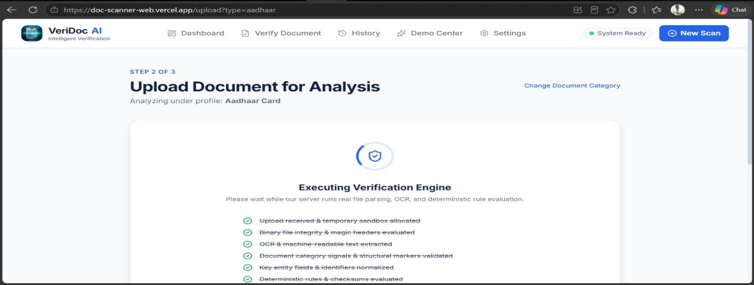
Figure 8.3 Result page for a document that is verified

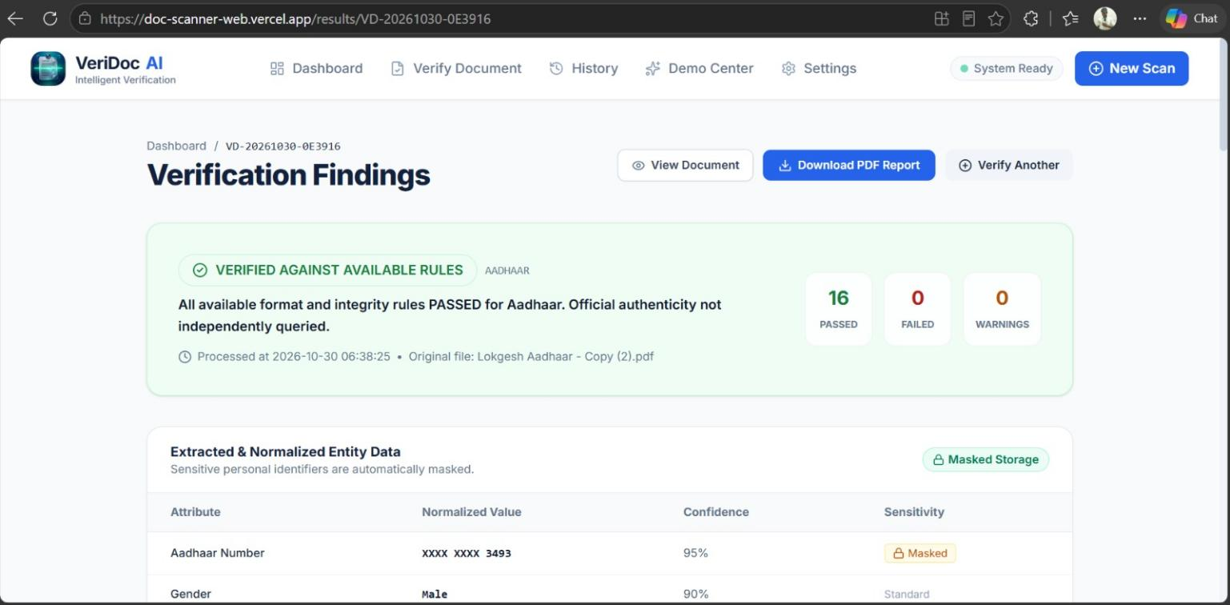
Figure 8.4 Result page for a document with missing and mismatched fields

8.2 Sample Verification Scenarios
Table 8.1 shows how the system behaves for different kinds of input. The scenarios use
the Medical Certificate template described in Chapter 5, and the results follow from the
template rules.

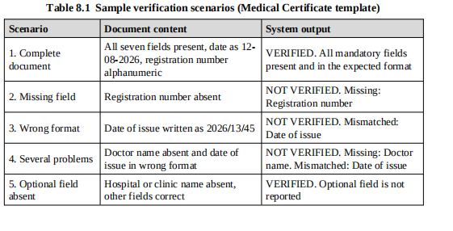
8.3 Discussion of Results
The results show that the system meets the objectives set at the start of the project. A
document was verified by comparing it with the template of its category, and the
verification was carried out field by field. Missing and incorrect information was
detected and reported to the user by field name. The result was available to the user
immediately after the upload, so there was no need to wait for an officer to read the
document.
The behaviour of the system is predictable. The same document gives the same result
each time, and a change in the result can always be traced to a change in the document or
in the template. This is the consistency that manual verification cannot guarantee.
Reporting at the level of fields also makes the result useful. The user knows exactly
what to correct, which reduces repeated submissions.
The use of database-driven templates proved to be an effective design decision. When a
new template field was added through the administration function, the next verification
used it without any change to the code. This demonstrates the flexibility that the novelty
of the project aims to provide.

8.4 Comparison with Manual Verification

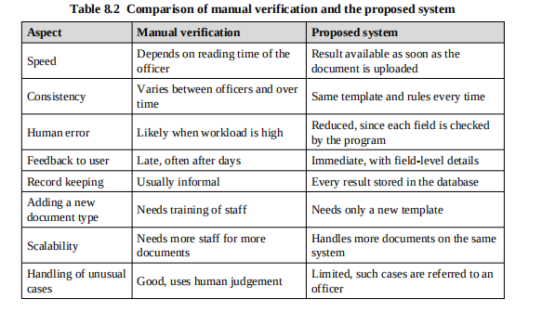
8.5 Evaluation Metrics
To judge the system objectively, the following metrics are defined. They can be
measured by running the system over a collection of sample documents for which the
correct decision is known in advance

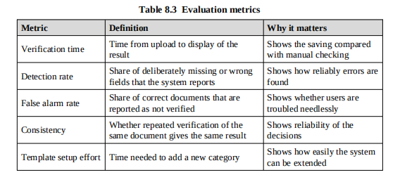

Because the comparison is deterministic, consistency is always full: the same document
and the same template always give the same result. Verification time is short, since the
comparison examines each template field only once. The detection rate and the false
alarm rate depend mainly on the quality of the template patterns and of the extracted
content, and they are improved by refining the templates after studying the cases in
which the system and a human reviewer disagree.
8.6 Contribution to Sustainable Development Goal 3
By shortening the time needed to verify documents such as medical certificates, identity
proofs and claim forms, the system helps patients to get through the administrative steps
of healthcare more quickly. Incomplete submissions are detected at the time of upload,
and so they do not delay admission or reimbursement later. Hospital and insurance staff
spend less time on routine checking.
8.7 Limitations
• The system verifies the completeness and format of the document and does not
check the facts against the issuing authority.
• The accuracy of verification of scanned documents depends on how well the
content can be extracted from the image.
• Documents whose layout differs greatly from the template of their category may
need manual review.
• The present version supports a limited set of categories, which must be defined
by an administrator.

CHAPTER 9
CONCLUSION AND FUTURE SCOPE
9.1 Conclusion
The Intelligent Document Verification System was designed and developed to reduce
the time, effort and errors involved in verifying documents manually. The system uses
category-wise predefined templates, which are stored in a MySQL database. The user
selects the category of the document and uploads it. The system loads the corresponding
template, compares the document with it field by field, identifies the missing and
mismatched fields and generates a verification result.
The project achieved its objectives. A template-based verification system was
developed, documents are verified according to the format of their category, missing
and incorrect information is detected, and the manual effort is reduced. Because the
verification rules are held as data, the same program verifies every category, and new
categories can be introduced without changing the code. The results are consistent,
because the same rules are applied every time, and they are explainable, because each
decision is linked to a field of the template.
The system was built using freely available tools, namely Java, MySQL, HTML, CSS,
JavaScript, Visual Studio Code, XAMPP, Git and GitHub, which makes it practical for
organizations with limited budgets. By speeding up the verification of health-related
documents and by reducing the chance of incomplete documents being submitted, the
project supports Sustainable Development Goal 3, Good Health and Well-being.
The work also gave the team practical experience in requirement analysis, database
design, backend and frontend development, testing and teamwork using version
control.
9.2 Future Scope
The system can be extended in several directions.
• Integration of an optical character recognition engine so that scanned images
and photographs can be read automatically and compared with the template.
• Use of machine learning to recognize the document category automatically, so
that the user need not select it.
• Verification of authenticity by checking identification numbers, QR codes or
digital signatures against the records of the issuing authority.
• Detection of tampering by analysing the image of the document for signs of
alteration.

• Support for more document categories and for multiple languages, including
regional languages.
• Role-based access, email or SMS notifications and dashboards that show
verification statistics.
• A mobile application that allows documents to be captured and verified on a
phone.
• Deployment on a cloud platform with secure storage and encryption of uploaded
documents, in line with data protection requirements.
• An application programming interface so that other systems, for example
hospital or insurance software, can call the verification service.
REFERENCES
[1] Oracle Corporation, "Java Platform, Standard Edition Documentation", Oracle
Help Center. Available: https://docs.oracle.com/en/java/
[2] Oracle Corporation, "MySQL Reference Manual", MySQL Documentation.
Available: https://dev.mysql.com/doc/
[3] W3Schools, "HTML, CSS and JavaScript Tutorials". Available:
https://www.w3schools.com/
[4] Mozilla Developer Network, "MDN Web Docs: HTML, CSS and JavaScript
Reference". Available: https://developer.mozilla.org/
[5] GeeksforGeeks, "Java and Web Development Tutorials". Available:
https://www.geeksforgeeks.org/
[6] United Nations, "Sustainable Development Goal 3: Ensure healthy lives and
promote well-being for all at all ages". Available:
https://sdgs.un.org/goals/goal3
[7] Apache Friends, "XAMPP Apache + MariaDB + PHP + Perl". Available:
https://www.apachefriends.org/
[8] Git, "Git Documentation". Available: https://git-scm.com/doc
[9] R. S. Pressman and B. R. Maxim, "Software Engineering: A Practitioner's
Approach", McGraw-Hill Education.
[10] I. Sommerville, "Software Engineering", Pearson Education.
[11] A. Silberschatz, H. F. Korth and S. Sudarshan, "Database System Concepts",
McGraw-Hill Education.
[12] G. Booch, J. Rumbaugh and I. Jacobson, "The Unified Modeling Language User
Guide", Addison-Wesley

APPENDIX A
APPENDIX A
SQLITE DATABASE SCHEMA
File: backend/app/models/database.py
The following script creates the database and the five tables used by the system.
schema.sql
CREATE DATABASE IF NOT EXISTS docverify;
USE docverify;
CREATE TABLE user (
user_id INT AUTO_INCREMENT PRIMARY KEY,
name VARCHAR(100) NOT NULL,
email VARCHAR(100) NOT NULL UNIQUE
);
CREATE TABLE category (
category_id INT AUTO_INCREMENT PRIMARY KEY,
category_name VARCHAR(100) NOT NULL UNIQUE,
description VARCHAR(255)
);
CREATE TABLE template (
template_id INT AUTO_INCREMENT PRIMARY KEY,
category_id INT NOT NULL,
field_name VARCHAR(100) NOT NULL,
field_type VARCHAR(30) NOT NULL,
is_required BOOLEAN DEFAULT TRUE,
format_pattern VARCHAR(255),
FOREIGN KEY (category_id) REFERENCES category(category_id)
);
CREATE TABLE document (

category_id INT NOT NULL,
user_id INT,
file_name VARCHAR(255) NOT NULL,
upload_time TIMESTAMP DEFAULT CURRENT_TIMESTAMP,
FOREIGN KEY (category_id) REFERENCES category(category_id),

);
CREATE TABLE result (

document_id INT NOT NULL,

verified_on TIMESTAMP DEFAULT CURRENT_TIMESTAMP,
FOREIGN KEY (document_id) REFERENCES document(document_id)
);

APPENDIX B
SAMPLE CATEGORY AND TEMPLATE DATA
The following statements insert sample categories and the template fields for the
Medical Certificate and Educational Certificate categories.
sample_data.sql
Supported Document Categories and Their Validation Rules:
1. Aadhaar Card — Verhoeff dihedral group checksum on 12-digit UID
2. PAN Card — 10-character format [A-Z]{5}[0-9]{4}[A-Z]; entity code check
3. Passport — ICAO format number [A-PR-WYZ][0-9]{7}; expiry date must be future
4. Driving Licence — State code among 37 valid codes; holder age ≥ 18 years; expiry check
5. Voter ID — EPIC format [A-Z]{3}[0-9]{7}
6. Bank Statement — Opening + Total Credits - Total Debits = Closing Balance (arithmetic)
7. Educational Cert — Year of passing within valid academic range
8. Income Cert — Annual income field presence and revenue authority keyword
9. Other Document — General structural and readability checks

institution');

format_pattern) VALUES

{4}'),

APPENDIX C
SAMPLE VERIFICATION PAGE
The following is the basic structure of the verification page in which the user selects the
category and uploads the document.
verify.html

onsubmit="return validateForm();">

<!-- options are filled from the category table -->

Kongu Engineering College (Autonomous)

Department of Electrical and Electronics Engineering

Certificate of Relevance to Sustainable Development Goals (SDGs)

This is to certify that the Undergraduate Project entitled”INTELLIGENT DOCUMENT VERIFICATION SYSTEM” carried out by

LOKGESH B(Reg.No.24ITR067)
RANJITH K (Reg.No.24ITR113)
KALAIVANI S (Reg.No.24EER053)
SUGANYA S(Reg.No.24EER118)
of Batch (2023–2027) have been submitted by them to meet the requirements for the award of the Bachelor of Engineering (B.E.) in Electrical and Electronics Engineering is found to be relevant to the United Nations Sustainable Development Goals (SDGs). The project contributes towards the following SDG(s):

S.  No | Sustainable  Development Goal  (SDG) | Goal Description | Nature of Contribution
1 | Goal 7: Affordable and Clean Energy | This goal aims to ensure access  to affordable, reliable, sustainable, and modern energy for all. | The project promotes efficient electricity usage by automatically controlling electrical loads based on human presence. The mobile dashboard also helps users monitor energy usage and avoid unnecessary power consumption.
2 | Goal 9: Industry,  Innovation and  Infrastructure | This goal focuses on building resilient infrastructure, promoting inclusive and sustainable industrialization, and encouraging innovation. | The project integrates an ESP32 microcontroller, sensors, relay modules, and a Wi-Fi-based mobile dashboard to develop a smart and  innovative electrical load control system.
3 | Goal 12: Responsible  Consumption and  Production | This goal promotes the efficient use of natural resources and responsible consumption. | The project promotes a comfortable and safer environment by automatically controlling electrical loads based on human presence, helping reduce unnecessary electricity usage.

Date:
Place: Signature of the Supervisor

50

