WEEK – 4
SPRING REST USING SPRING BOOT 3

CREATE A SPRING WEB PROJECT USING MAVEN
SME Walkthrough
src/main/java:
- The main class SpringLearnApplication.java is inside the package: com.cognizant.springlearn
- The src/main/java folder contains the main source code of the Spring Boot application, including the entry point class and all functional components.
src/main/resources:
- application.properties – to define settings like server port, logging level, database URL, etc.
- The src/main/resources folder is used to store configuration and property files required for application setup.
src/test/java:
- It contains package : com.cognizant.springlearn
- Uses JUnit testing libraries
- The src/test/java folder contains test cases to validate the application logic and ensure code reliability.
SpringLearnApplication.java:
package com.cognizant.spring_learn;
import org.springframework.boot.SpringApplication;
import org.springframework.boot.autoconfigure.SpringBootApplication;
@SpringBootApplication
public class SpringLearnApplication {
public static void main(String[] args) {
System.out.println("SpringLearnApplication main method started...");
SpringApplication.run(SpringLearnApplication.class, args);
}
}
SpringLearnApplicationTests.java:
package com.cognizant.spring_learn;
import org.junit.jupiter.api.Test;
import org.springframework.boot.test.context.SpringBootTest;
@SpringBootTest
class SpringLearnApplicationTests {
@Test

void contextLoads() {
}
}
Dependencies on pom.xml:
<dependencies>
<dependency>
<groupId>org.springframework.boot</groupId>
<artifactId>spring-boot-starter-web</artifactId>
</dependency>
<dependency>
<groupId>org.springframework.boot</groupId>
<artifactId>spring-boot-devtools</artifactId>
<scope>runtime</scope>
</dependency>
</dependencies>
DEPENDENCY HIERARCHY
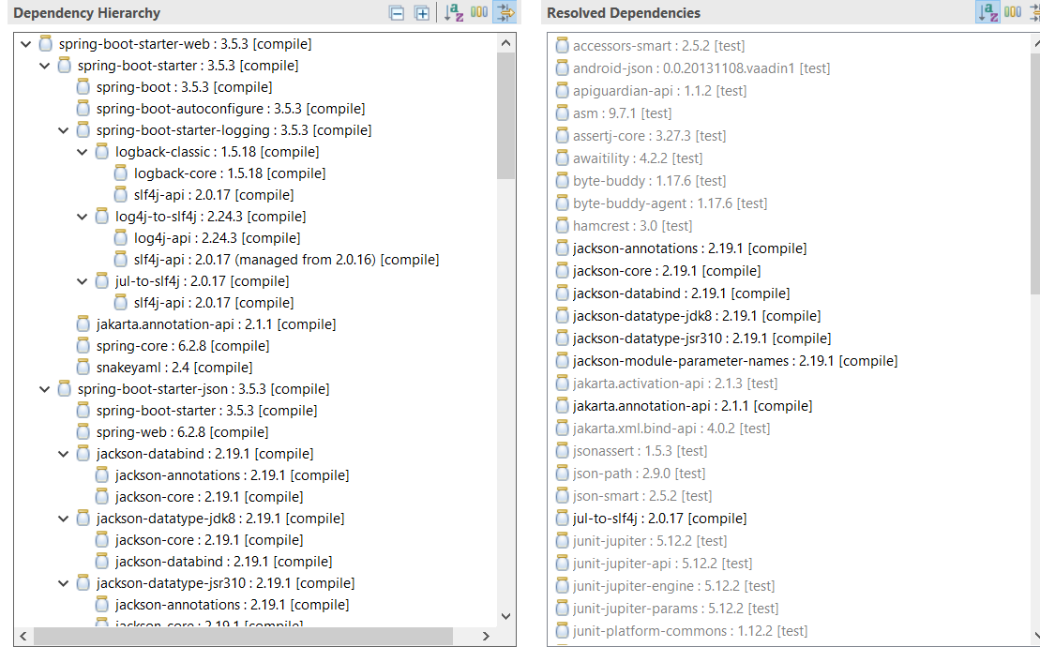
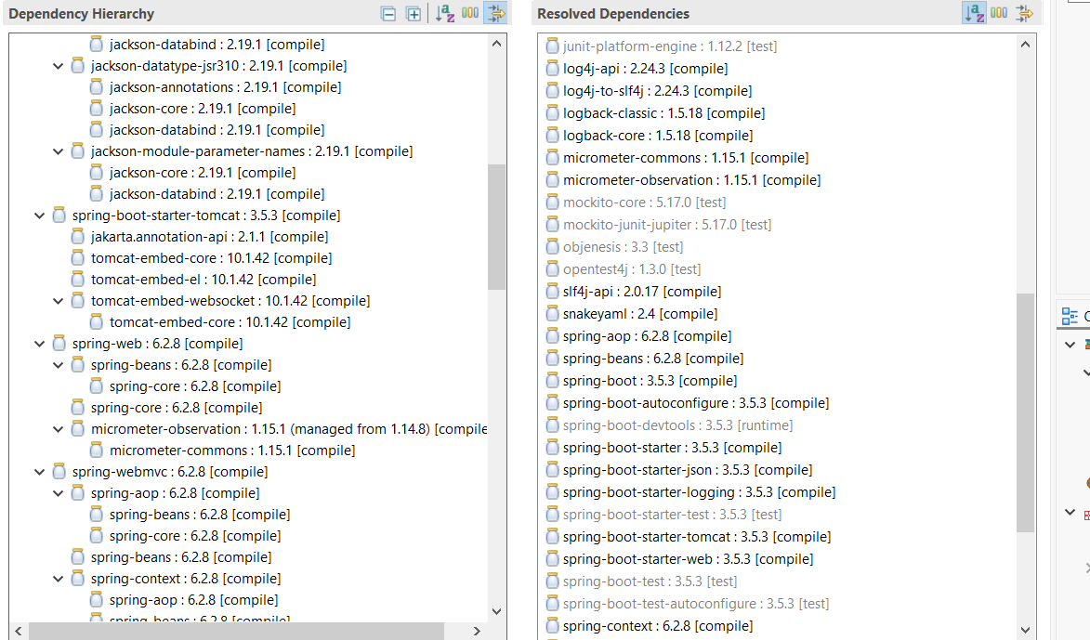
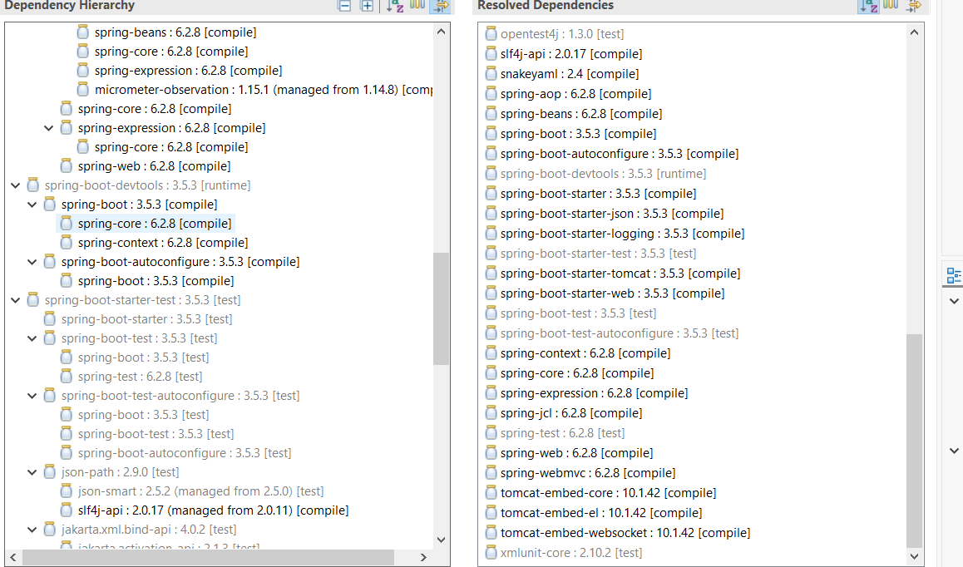
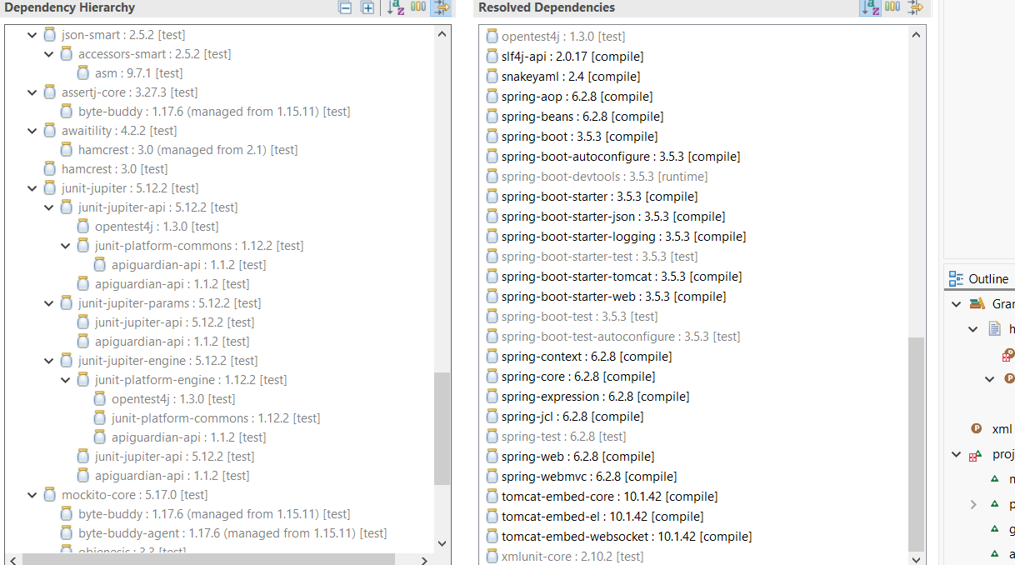
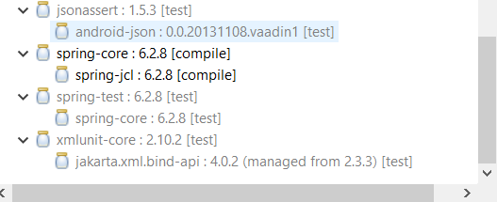
OUTPUT
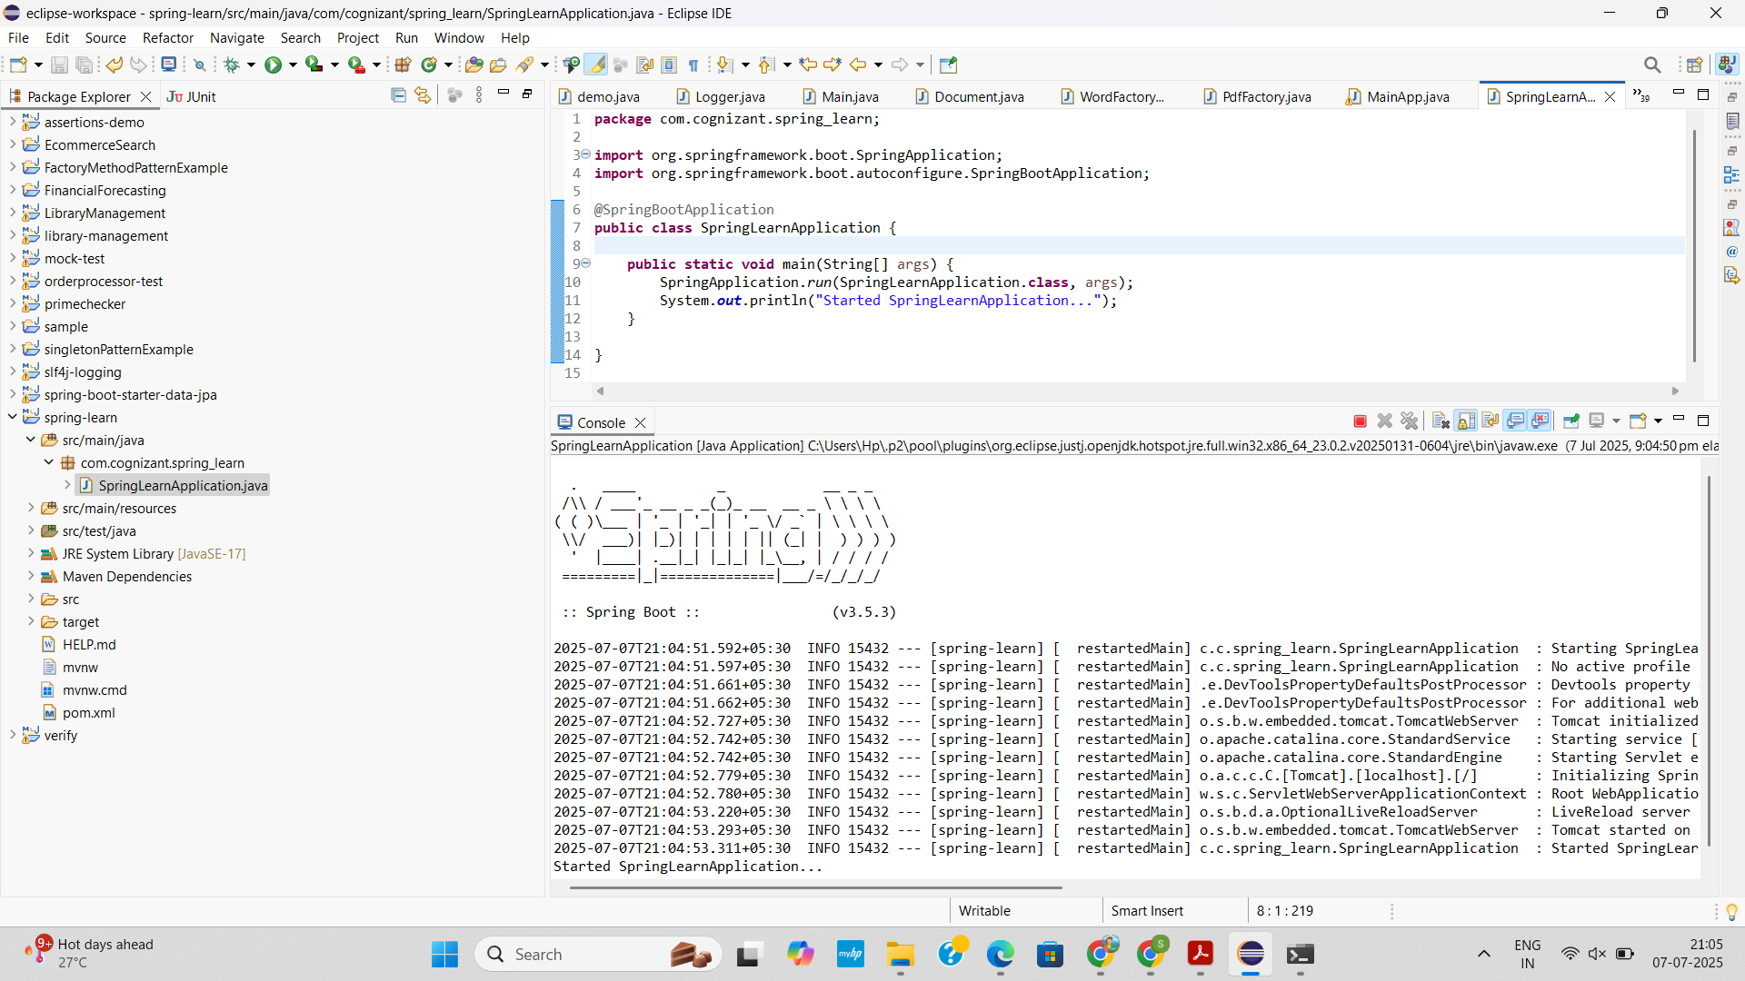

SPRING CORE – LOAD COUNTRY FROM SPRING CONFIGURATION XML
CODE
Country.java
package com.cognizant.spring_learn;
import org.slf4j.Logger;
import org.slf4j.LoggerFactory;
public class Country {
private static final Logger LOGGER = LoggerFactory.getLogger(Country.class);
private String code;
private String name;
public Country() {
LOGGER.debug("Inside Country Constructor.");
}
public String getCode() {
LOGGER.debug("Inside getCode()");
return code;
}
public void setCode(String code) {
LOGGER.debug("Inside setCode()");
this.code = code;
}

public String getName() {
LOGGER.debug("Inside getName()");
return name;
}
public void setName(String name) {
LOGGER.debug("Inside setName()");
this.name = name;
}
@Override
public String toString() {
return "Country{" +
"code='" + code + '\'' +
", name='" + name + '\'' +
'}';
}
}
SpringLearnApplication.java
package com.cognizant.spring_learn;
import org.slf4j.Logger;
import org.slf4j.LoggerFactory;
import org.springframework.boot.SpringApplication;
import org.springframework.boot.autoconfigure.SpringBootApplication;
import org.springframework.context.ApplicationContext;
import org.springframework.context.support.ClassPathXmlApplicationContext;
@SpringBootApplication
public class SpringLearnApplication {
private static final Logger LOGGER = LoggerFactory.getLogger(SpringLearnApplication.class);
public static void main(String[] args) {
SpringApplication.run(SpringLearnApplication.class, args);
displayCountry();
}
public static void displayCountry() {
ApplicationContext context = new ClassPathXmlApplicationContext("country.xml");
Country country = context.getBean("country", Country.class);
LOGGER.debug("Country : {}", country.toString());
}
}
application.properties
logging.level.com.cognizant.spring_learn=DEBUG
server.port=9090
country.xml
<?xml version="1.0" encoding="UTF-8"?>
<beans xmlns="http://www.springframework.org/schema/beans"
xmlns:xsi="http://www.w3.org/2001/XMLSchema-instance"
xsi:schemaLocation="http://www.springframework.org/schema/beans http://www.springframework.org/schema/beans/spring-beans.xsd">
<bean id="country" class="com.cognizant.spring_learn.Country">
<property name="code" value="IN"/>
<property name="name" value="India"/>
</bean>
</beans>

SpringLearnApplicationTests.java
package com.cognizant.spring_learn;
import org.junit.jupiter.api.Test;
import org.springframework.boot.test.context.SpringBootTest;
@SpringBootTest
class SpringLearnApplicationTests {
@Test
void contextLoads() {
}
}
pom.xml
<?xml version="1.0" encoding="UTF-8"?>
<project xmlns="http://maven.apache.org/POM/4.0.0"
xmlns:xsi="http://www.w3.org/2001/XMLSchema-instance"
xsi:schemaLocation="
http://maven.apache.org/POM/4.0.0
https://maven.apache.org/xsd/maven-4.0.0.xsd">
<modelVersion>4.0.0</modelVersion>
<parent>
<groupId>org.springframework.boot</groupId>
<artifactId>spring-boot-starter-parent</artifactId>
<version>3.5.3</version> <!-- latest GA as of Jul 2025 -->
<relativePath/> <!-- look up in Maven Central -->
</parent>
<groupId>com.cognizant</groupId>
<artifactId>spring-learn</artifactId>
<version>0.0.1-SNAPSHOT</version>
<name>spring-learn</name>
<description>Learning project for Spring Boot Web</description>
<packaging>jar</packaging>
<properties>
<java.version>17</java.version> <!-- Boot 3.x requires ≥17 -->
<!-- <native.image.enabled>true</native.image.enabled> # GraalVM, optional -->
</properties>
<dependencies>
<!-- Web (Spring MVC + embedded Tomcat) -->
<dependency>
<groupId>org.springframework.boot</groupId>
<artifactId>spring-boot-starter-web</artifactId>
</dependency>
<dependency>
<groupId>org.springframework.boot</groupId>
<artifactId>spring-boot-starter-thymeleaf</artifactId>
</dependency>
<dependency>
<groupId>org.projectlombok</groupId>
<artifactId>lombok</artifactId>
<optional>true</optional>
</dependency>
<dependency>
<groupId>org.springframework.boot</groupId>
<artifactId>spring-boot-devtools</artifactId>
<scope>runtime</scope>
</dependency>

<dependency>
<groupId>org.springframework.boot</groupId>
<artifactId>spring-boot-starter-test</artifactId>
<scope>test</scope>
</dependency>
- spring-boot-starter-data-jpa
- mysql-connector-j
- spring-boot-starter-security
- etc. -->
</dependencies>
<build>
<plugins>
<plugin>
<groupId>org.springframework.boot</groupId>
<artifactId>spring-boot-maven-plugin</artifactId>
<!-- No extra config needed; Boot 3 handles layers & aot automatically -->
</plugin>
</plugins>
</build>
</project>

OUTPUT
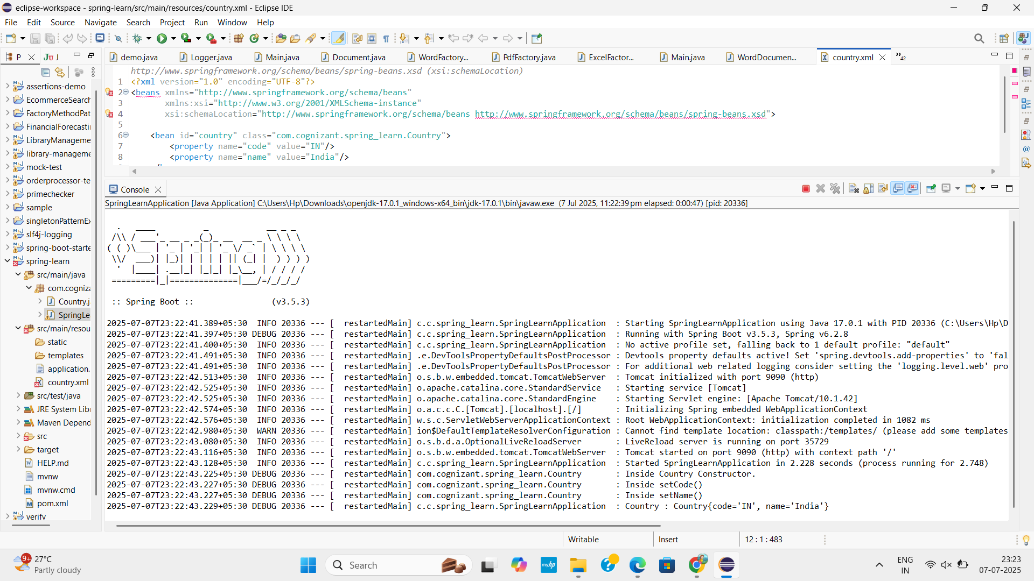

HELLO WORLD RESTFUL WEB SERVICE
Write a REST service in the spring learn application created earlier, that returns the text "Hello World!!" using Spring Web Framework. Refer details below:
Method: GET URL: /hello
Controller: com.cognizant.spring-learn.controller.HelloController
Method Signature: public String sayHello()
Method Implementation: return hard coded string "Hello World!!" Sample Request: http://localhost:8083/hello
Sample Response: Hello World!!
APPROACH
- Configure Port in application.properties with server.port=8083.
- Create HelloController in com.cognizant.spring_learn.controller with @RestController.
- Define sayHello() method using @GetMapping("/hello") to return "Hello World!!".
- Add Logging with Logger to log start and end of the method.
- Run and Test via browser/Postman at http://localhost:8083/hello and check headers/logs.
CODE
HelloController.java
package com.cognizant.spring_learn.controller;
import org.slf4j.Logger;
import org.slf4j.LoggerFactory;
import org.springframework.web.bind.annotation.GetMapping;
import org.springframework.web.bind.annotation.RestController;
@RestController
public class HelloController {
private static final Logger LOGGER = LoggerFactory.getLogger(HelloController.class);

@GetMapping("/hello")
public String sayHello() {
LOGGER.info("START sayHello()");
LOGGER.info("END sayHello()");
return "Hello World!!";
}
}
SpringLearnApplication.java
package com.cognizant.spring_learn;
import org.springframework.boot.SpringApplication;
import org.springframework.boot.autoconfigure.SpringBootApplication;
@SpringBootApplication
public class SpringLearnApplication {
public static void main(String[] args) {
SpringApplication.run(SpringLearnApplication.class, args);
}
}
application.properties
logging.level.com.cognizant.spring_learn=DEBUG
server.port=8083
OUTPUT
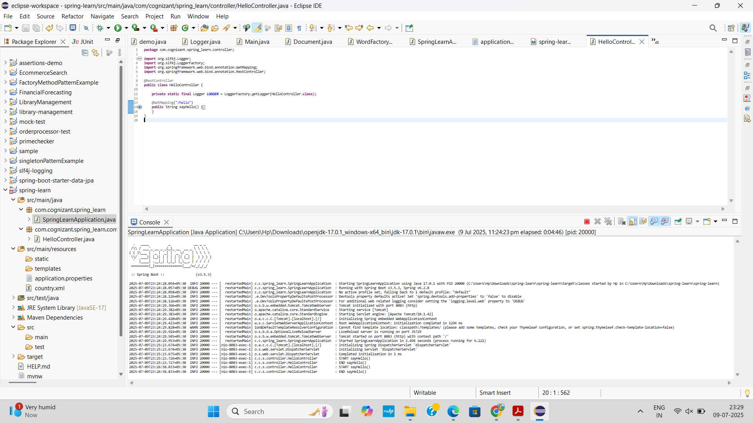

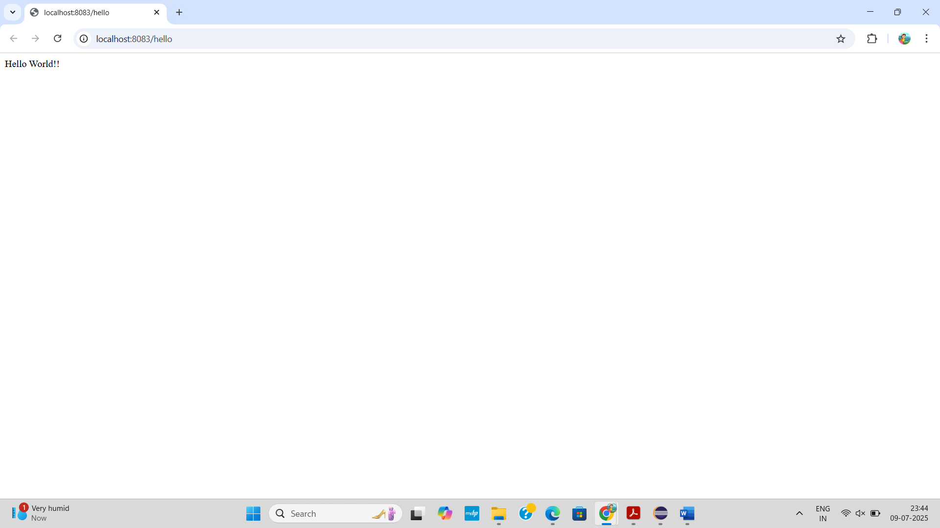

REST - COUNTRY WEB SERVICE
Write a REST service that returns India country details in the earlier created spring learn application.
URL: /country Controller: com.cognizant.spring-learn.controller.
CountryController Method Annotation: @RequestMapping
Method Name: getCountryIndia()
Method Implementation: Load India bean from spring xml configuration and return
Sample Request: http://localhost:8083/country
Sample Response:
{
"code": "IN",
"name": "India"
}
APPROACH
- Create POJO Country with code and name fields and getter/setter methods.
- Define XML Bean in in src/main/resources/country.xml with values "IN" and "India".
- Create REST Controller CountryController with @RestController and @RequestMapping("/country").
- Load XML Bean using ClassPathXmlApplicationContext and return the Country object in getCountryIndia().
- Run App and Test at http://localhost:8083/country to receive JSON response via browser or Postman.

CODE
Country.java
package com.cognizant.spring_learn;
public class Country {
private String code;
private String name;
public Country() {}
public String getCode() {
return code;
}
public void setCode(String code) {
this.code = code;
}
public String getName() {
return name;
}
public void setName(String name) {
this.name = name;
}
}
SpringLearnApplication.java
package com.cognizant.spring_learn;
import org.springframework.boot.SpringApplication;
import org.springframework.boot.autoconfigure.SpringBootApplication;
@SpringBootApplication
public class SpringLearnApplication {
public static void main(String[] args) {
SpringApplication.run(SpringLearnApplication.class, args);
}
}
CountryController.java
package com.cognizant.spring_learn.controller;
import com.cognizant.spring_learn.Country;
import org.slf4j.Logger;
import org.slf4j.LoggerFactory;
import org.springframework.context.ApplicationContext;
import org.springframework.context.support.ClassPathXmlApplicationContext;
import org.springframework.web.bind.annotation.RequestMapping;
import org.springframework.web.bind.annotation.RestController;
@RestController
public class CountryController {
private static final Logger LOGGER = LoggerFactory.getLogger(CountryController.class);
@RequestMapping("/country")
public Country getCountryIndia() {
LOGGER.info("START getCountryIndia()");
ApplicationContext context = new ClassPathXmlApplicationContext("country.xml");
Country country = (Country) context.getBean("in");
LOGGER.info("END getCountryIndia()");
return country;
}
}

HelloController.java
package com.cognizant.spring_learn.controller;
import org.slf4j.Logger;
import org.slf4j.LoggerFactory;
import org.springframework.web.bind.annotation.GetMapping;
import org.springframework.web.bind.annotation.RestController;
@RestController
public class HelloController {
private static final Logger LOGGER = LoggerFactory.getLogger(HelloController.class);
@GetMapping("/hello")
public String sayHello() {
LOGGER.info("START sayHello()");
LOGGER.info("END sayHello()");
return "Hello World!!";
}
}
application.properties
logging.level.com.cognizant.spring_learn=DEBUG
server.port=8083
country.xml
<?xml version="1.0" encoding="UTF-8"?>
<beans xmlns="http://www.springframework.org/schema/beans"
xmlns:xsi="http://www.w3.org/2001/XMLSchema-instance"
xsi:schemaLocation="http://www.springframework.org/schema/beans
https://www.springframework.org/schema/beans/spring-beans.xsd">
<bean id="in" class="com.cognizant.spring_learn.Country">
<property name="code" value="IN"/>
<property name="name" value="India"/>
</bean>
</beans>
OUTPUT
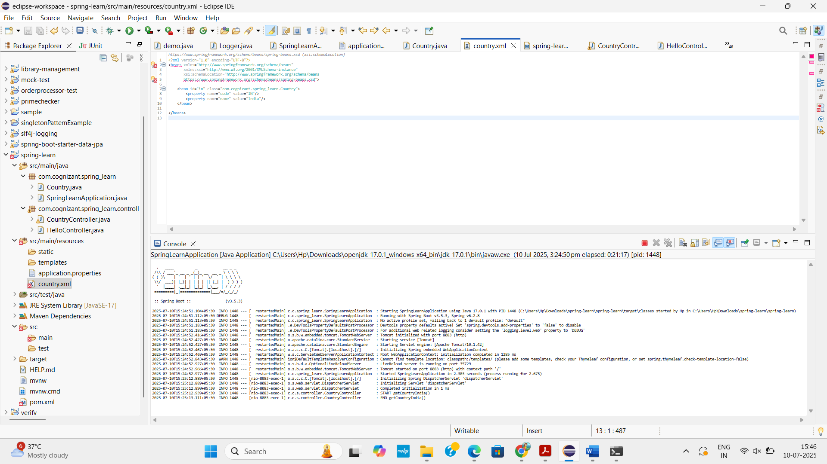

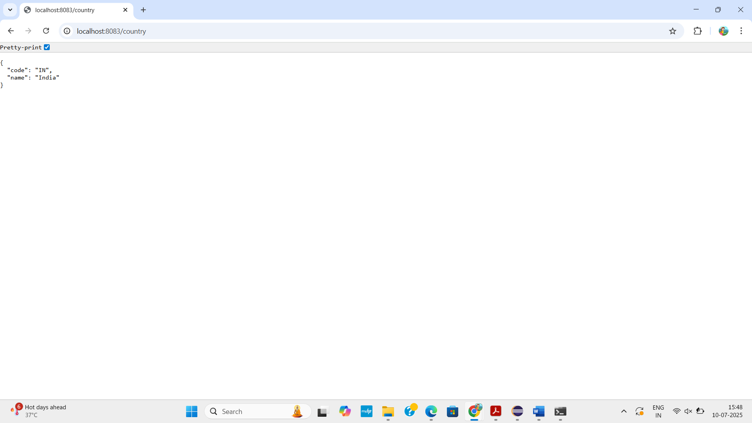

REST - GET COUNTRY BASED ON COUNTRY CODE
Write a REST service that returns a specific country based on country code. The country code should be case insensitive.
Controller: com.cognizant.spring-learn.controller.CountryController Method Annotation: @GetMapping("/countries/{code}")
Method Name: getCountry(String code)
Method Implemetation: Invoke countryService.getCountry(code)
Service Method: com.cognizant.spring-learn.service.CountryService.getCountry(String code)
Service Method Implementation:
· Get the country code using @PathVariable
· Get country list from country.xml
· Iterate through the country list
· Make a case insensitive matching of country code and return the country.
· Lambda expression can also be used instead of iterating the country list
Sample Request: http://localhost:8083/country/in
Sample Response:
{
"code": "IN",
"name": "India"
}
APPROACH
- Create POJO Country with code and name fields and provide getters/setters.
- Define country.xml in src/main/resources containing a list of Country beans using <bean> and <list> tags.
- Create CountryService class in service package, load the XML list using ClassPathXmlApplicationContext, and use a stream to match country code (case-insensitive).
- Create CountryController class in controller package with endpoint @GetMapping("/country/{code}"), inject CountryService, and return the matched country.
- Run the application and test with URL http://localhost:8083/country/in in browser or Postman to get a JSON response of the matching country.
CODE
Country.java
package com.cognizant.spring_learn;
public class Country {
private String code;
private String name;
public Country() {}
public String getCode() {
return code;
}
public void setCode(String code) {
this.code = code;
}
public String getName() {
return name;
}
public void setName(String name) {
this.name = name;
}
}

SpringLearnApplication.java
package com.cognizant.spring_learn;
import org.springframework.boot.SpringApplication;
import org.springframework.boot.autoconfigure.SpringBootApplication;
@SpringBootApplication
public class SpringLearnApplication {
public static void main(String[] args) {
SpringApplication.run(SpringLearnApplication.class, args);
}
}
CountryController.java
package com.cognizant.spring_learn.controller;
import com.cognizant.spring_learn.Country;
import com.cognizant.spring_learn.service.CountryService;
import org.slf4j.Logger;
import org.slf4j.LoggerFactory;
import org.springframework.beans.factory.annotation.Autowired;
import org.springframework.web.bind.annotation.*;
@RestController
public class CountryController {
private static final Logger LOGGER = LoggerFactory.getLogger(CountryController.class);
@Autowired
private CountryService countryService;
@GetMapping("/country/{code}")
public Country getCountry(@PathVariable String code) {
LOGGER.info("START getCountry()");
Country country = countryService.getCountry(code);
LOGGER.info("END getCountry()");
return country;
}
}
HelloController.java
package com.cognizant.spring_learn.controller;
import org.slf4j.Logger;
import org.slf4j.LoggerFactory;
import org.springframework.web.bind.annotation.GetMapping;
import org.springframework.web.bind.annotation.RestController;
@RestController
public class HelloController {
private static final Logger LOGGER = LoggerFactory.getLogger(HelloController.class);
@GetMapping("/hello")
public String sayHello() {
LOGGER.info("START sayHello()");
LOGGER.info("END sayHello()");
return "Hello World!!";
}
}

CountryService.java
package com.cognizant.spring_learn.service;
import com.cognizant.spring_learn.Country;
import org.springframework.context.ApplicationContext;
import org.springframework.context.support.ClassPathXmlApplicationContext;
import org.springframework.stereotype.Service;
import java.util.List;
@Service
public class CountryService {
public Country getCountry(String code) {
ApplicationContext context = new ClassPathXmlApplicationContext("country.xml");
List<Country> countries = (List<Country>) context.getBean("countryList");
return countries.stream()
.filter(c -> c.getCode().equalsIgnoreCase(code))
.findFirst()
.orElse(null);
}
}
country.xml
<?xml version="1.0" encoding="UTF-8"?>
<beans xmlns="http://www.springframework.org/schema/beans"
xmlns:xsi="http://www.w3.org/2001/XMLSchema-instance"
xsi:schemaLocation="http://www.springframework.org/schema/beans
https://www.springframework.org/schema/beans/spring-beans.xsd">
<bean id="countryList" class="java.util.ArrayList">
<constructor-arg>
<list>
<bean class="com.cognizant.spring_learn.Country">
<property name="code" value="IN"/>
<property name="name" value="India"/>
</bean>
<bean class="com.cognizant.spring_learn.Country">
<property name="code" value="US"/>
<property name="name" value="United States"/>
</bean>
<bean class="com.cognizant.spring_learn.Country">
<property name="code" value="FR"/>
<property name="name" value="France"/>
</bean>
</list>
</constructor-arg>
</bean>
</beans>
application.properties
logging.level.com.cognizant.spring_learn=DEBUG
server.port=8083
OUTPUT
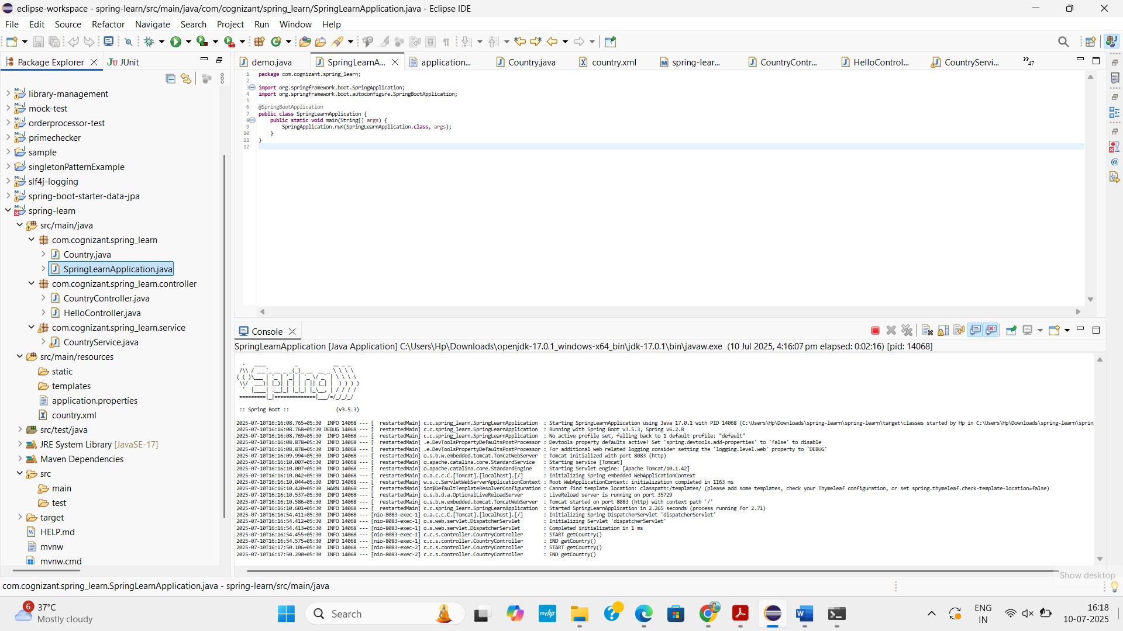

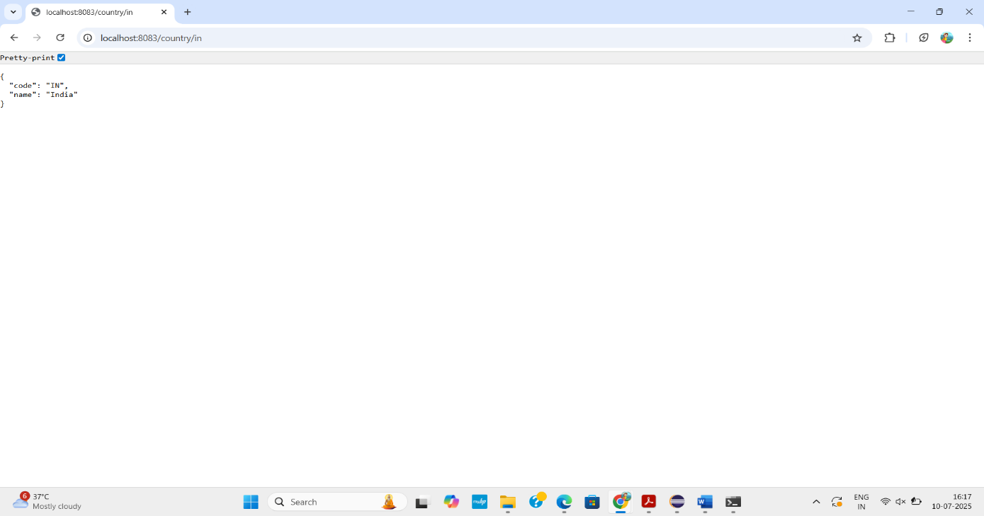

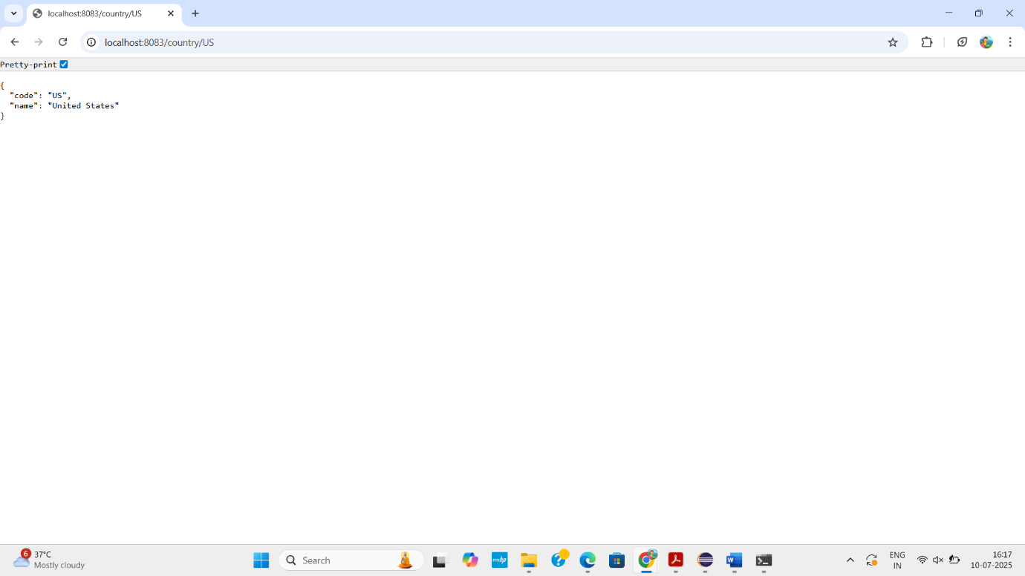

CREATE AUTHENTICATION SERVICE THAT RETURNS JWT
APPROACH
- Create a Spring Boot Maven project with Web, Security, and JJWT dependencies.
- Configure SecurityConfig with SecurityFilterChain and in-memory user details.
- Implement AuthenticationController to generate JWT using Keys.secretKeyFor(SignatureAlgorithm.HS256).
- Set application.properties (e.g., spring.application.name, server.port=8083).
- Run the project and test the /authenticate endpoint using Basic Authentication to receive a JWT token.
CODE
AuthenticationController.java
package com.cognizant.spring_learn.controller;
import io.jsonwebtoken.Jwts;
import io.jsonwebtoken.SignatureAlgorithm;
import io.jsonwebtoken.security.Keys;
import org.slf4j.Logger;
import org.slf4j.LoggerFactory;
import org.springframework.web.bind.annotation.GetMapping;
import org.springframework.web.bind.annotation.RequestHeader;
import org.springframework.web.bind.annotation.RestController;
import java.security.Key;
import java.util.Base64;
import java.util.Date;
import java.util.HashMap;
import java.util.Map;

@RestController
public class AuthenticationController {
private static final Logger LOGGER = LoggerFactory.getLogger(AuthenticationController.class);
private final Key key = Keys.secretKeyFor(SignatureAlgorithm.HS256);
@GetMapping("/authenticate")
public Map<String, String> authenticate(@RequestHeader("Authorization") String authHeader) {
LOGGER.info("START authenticate()");
String user = getUser(authHeader);
String token = generateJwt(user);
Map<String, String> map = new HashMap<>();
map.put("token", token);
LOGGER.info("END authenticate()");
return map;
}
private String getUser(String authHeader) {
LOGGER.info("START getUser()");
String base64Credentials = authHeader.substring("Basic ".length());
byte[] credDecoded = Base64.getDecoder().decode(base64Credentials);
String credentials = new String(credDecoded);
String user = credentials.split(":")[0];
LOGGER.info("Decoded User: {}", user);
LOGGER.info("END getUser()");
return user;
}

private String generateJwt(String user) {
LOGGER.info("START generateJwt()");
String token = Jwts.builder()
.setSubject(user)
.setIssuedAt(new Date())
.setExpiration(new Date(System.currentTimeMillis() + 1200000)) // 20 minutes
.signWith(key)
.compact();
LOGGER.info("END generateJwt()");
return token;
}
}
SecurityConfig.java
package com.cognizant.spring_learn.config;
import org.springframework.context.annotation.Bean;
import org.springframework.context.annotation.Configuration;
import org.springframework.security.config.annotation.web.builders.HttpSecurity;
import org.springframework.security.config.annotation.web.configuration.EnableWebSecurity;
import org.springframework.security.core.userdetails.User;
import org.springframework.security.core.userdetails.UserDetails;
import org.springframework.security.core.userdetails.UserDetailsService;
import org.springframework.security.provisioning.InMemoryUserDetailsManager;
import org.springframework.security.web.SecurityFilterChain;

@Configuration
@EnableWebSecurity
public class SecurityConfig {
@Bean
public SecurityFilterChain filterChain(HttpSecurity http) throws Exception {
http.csrf().disable()
.authorizeHttpRequests(authz -> authz
.requestMatchers("/authenticate").hasAnyRole("USER", "ADMIN")
.anyRequest().authenticated())
.httpBasic();
return http.build();
}
@Bean
public UserDetailsService userDetailsService() {
UserDetails user = User.withDefaultPasswordEncoder()
.username("user")
.password("pwd")
.roles("USER")
.build();
return new InMemoryUserDetailsManager(user);
}
}
application.properties
server.port=8083

SpringLearnApplication.java
package com.cognizant.spring_learn;
import org.springframework.boot.SpringApplication;
import org.springframework.boot.autoconfigure.SpringBootApplication;
@SpringBootApplication
public class SpringLearnApplication {
public static void main(String[] args) {
SpringApplication.run(SpringLearnApplication.class, args);
}
}
OUTPUT
