Bailey Maynard 9/5/18

Purpose: Calculate the total cost of a purchase including sales tax

Input: Cost of the items purchased and the tax rate

Output: Total cost of the items including tax

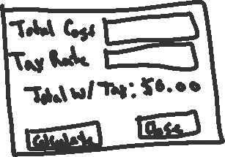

**Controls and their values**

|  |  |  |  |
| --- | --- | --- | --- |
| Form | (Default) | The default form for the application | “Tax Calculator” |
| Label | (Default) | Displays “Total Cost” | “Total Cost” |
| Label | (Default) | Displays “Tax Rate” | “Tax Rate” |
| Label | (Default) | Displays “Total w/ Tax:” | “Total w/ Tax:” |
| Label | totalCost | Displays the total cost after calculation by the “Calculate” button | “$0.00” |
| TextBox | costOfItems | Allows the user to input the total cost of the purchase before tax | “” |
| TextBox | taxRate | Allows the user to input the tax rate as a percentage | “” |
| Button | calcButton | Will take the total cost the user inputs and multiply it by the tax rate, then add the product with the total cost of the purchase before tax | “Calculate” |
| Button | closeButton | Will close the application | “Close” |

**Event Handlers**

|  |  |
| --- | --- |
| calcButton_Click | Takes the total cost given by the user and multiplies it by the tax rate also given by the user. Then, it will take the product and add it to the total cost supplied by the user and output it to the totalCost label. |
| closeButton_Click | Closes the application |

**Flow Chart**

