Bailey Maynard

Purpose: Take user input for how many of each ticket has been sold, calculate the total revenue generated for each ticket, add them all up, and output the total.

Input: Total tickets sold of classes A, B, and C.

Output: Total revenue generated from all ticket sales.

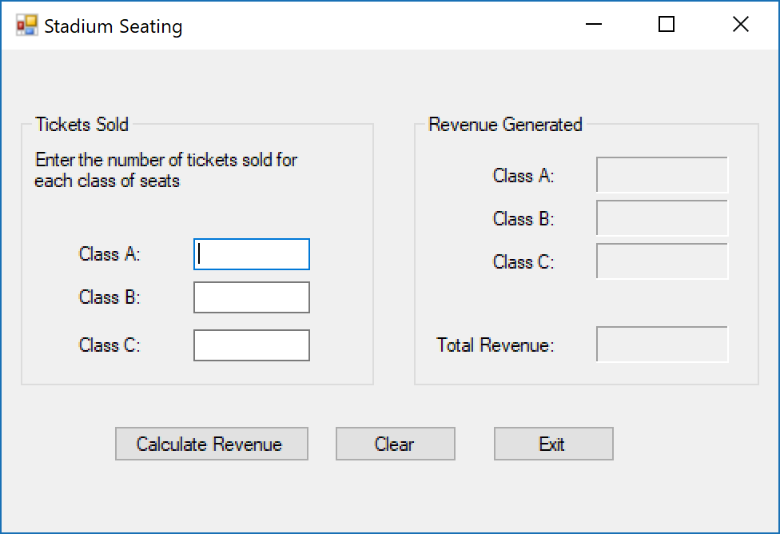

**Controls and their values**

|  |  |  |  |
| --- | --- | --- | --- |
| Form | (Default) | The default form for the application | “Stadium Seating” |
| GroupBox | (Default) | Holds the labels and text boxes needed for user input | “Tickets Sold” |
| Label | (Default) | Displays what information the user has to input | “Enter the number of tickets sold for each class of seats” |
| Label | (Default) | Displays “Class A” | “Class A:” |
| Label | (Default) | Displays “Class B” | “Class B:” |
| Label | (Default) | Displays “Class C” | “Class C:” |
| GroupBox | (Default) | Holds the labels required to output the total revenue generated | “Revenue Generated” |
| Label | (Default) | Displays “Class A” | “Class A:” |
| Label | (Default) | Displays “Class B” | “Class B:” |
| Label | (Default) | Displays “Class C” | “Class C:” |
| Label | (Default) | Displays “Total Revenue” | “Total Revenue:” |
| TextBox | txtClassA | Allows the user to input a number for class A | “” |
| TextBox | txtClassB | Allows the user to input a number for class B | “” |
| TextBox | txtClassC | Allows the user to input a number for class C | “” |
| Label | lblClassA | Outputs the total revenue from class A tickets | “” |
| Label | lblClassB | Outputs the total revenue from class B tickets | “” |
| Label | lblClassC | Outputs the total revenue from class C tickets | “” |
| Label | lblTotalRevenue | Outputs the total revenue from all classes’ tickets | “” |
| Button | btnCalc | Does the calculations necessary to get the revenue generated from the tickets | “Calculate Revenue” |
| Button | btnClear | Clears all the labels and text boxes | “Clear” |
| Button | btnExit | Exits the program | “Exit” |

**Event Handlers**

|  |  |
| --- | --- |
| btnCalc_Click | Will do the necessary calculations to output the total revenue generated from each classes sales, as well as the total revenue out of all the classes |
| btnClear_Click | Will clear all labels and text boxes from calculations and user input |
| btnExit_Click | Closes the application |

**Pseudocode**

Var classATotalSold = user input for class A

Var classBTotalSold = user input for class B

Var classCTotalSold = user input for class C

Var classATotalCost = classATotalSold * 15

Var classBTotalCost = classBTotalSold * 12

Var classCTotalCost = classCTotalSold * 9

Var totalRevenue = classATotalSold + classBTotalSold + classCTotalSold

Output classATotalCost to lblClassA

Output classBTotalCost to lblClassB

Output classCTotalCost to lblClassC

Ouput totalRevenue to lblTotalRevenue