­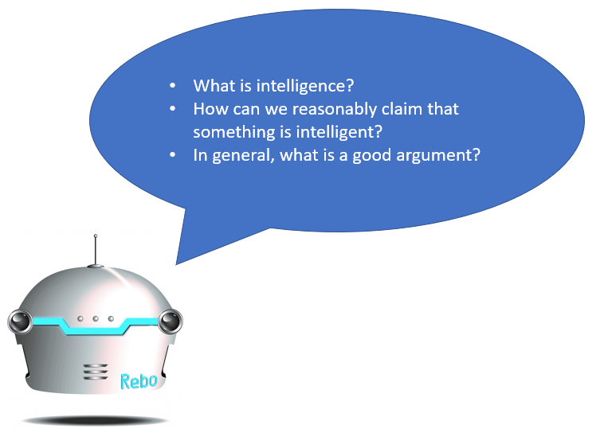

Welcome to the research study.

In this study, you need to complete three different tasks. But first, you need to read the content below. It is the summary of what you already learn in the course, “Introduction to Data Science and Artificial Intelligence". You are allowed to download the content as a PDF file, so you don't need to keep them in your mind during the research study.

After Reading the content, you can find two textboxes, in which you need to enter an arbitrary username and the password sent to you, and a button. After entering your username and password, you need to click the button to commence the tasks. The three tasks that are needed to complete sequentially are:

1. Having a conversation about with Rebo4AI (a conversational agent),
2. Answering a question about intelligence in a text field,
3. Answering a question about an ethical dilemma in a text field.

Please keep this in your mind that **you have only one chance to finish the tasks.** In other word, your password will be expired after the first use. If you encounter any problem during the experiment, please send an email with this title ***IDSAI21 + [YOUR PASSWORD]*** to **bmirzababaei [AT] know-center [DOT] at**.

What does an entity need to be intelligent?

First of all, an entity needs to perceive, think and act. These three features are the building blocks of an intelligent entity. These functionalities are achieved differently in living or digital entities. For example, humans and animals perceive the surrounding environment by the organs that used for seeing, hearing, tasting, and touching, thinking by their brain, and acting by their body. But in digital entity such as Google search engine perceives the world by keywords that we enter as inputs, thinks by using the knowledge that Google's programmers import to the system as databases, indexes, and graphs, and acts by suggesting the most relevant webpages to users. However, these three abilities aren't enough to call an entity intelligent. In addition to them, to call an entity intelligent, the entity needs to:

1. Act rationally,
2. Think rationally,
3. Act humanly,
4. Think humanly,
5. Have the capability of leaning from experience.

How can we reasonably claim that something is intelligent or not?

To call whether an entity is intelligent or not, first of all, our assertion needs to be explicitly mentioned. Then, we should refer to some of the entity's behaviors or actions that match with the definitions of intelligence. For instance, if somebody asks us "*Is Google search engine intelligent or not? Why?*", we can simply say "*yes*" or "*no*" but in this case, we didn't answer the "why" part of question. So, to tackle the "why" part, we need to add something to our answer which refers to entity's behaviors or actions and, in the end, use the definitions of intelligent as a bridge to connect our assertion to our explanation. That's how we can have a good argument.

Toulmin's model of argument

Toulmin's model of argument is a style of argumentation that breaks down an argument into 6 different components:

* **Claim**: the conclusion being made,
* **Data, Evidence, or Ground**: is offered to support the claim,
* **Warrant**: logically connects the data to the claim,
* **Qualifier**: shows the strength of the claim,
* **Rebuttal**: exception to the claim,
* **Backing**: supports the warrant.

Here you can see how they are connected to each other.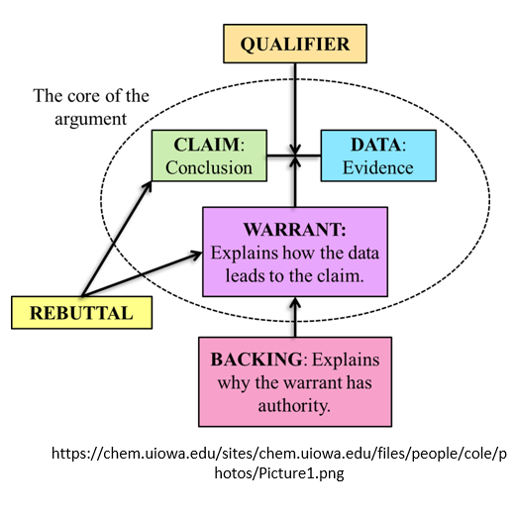

As you can see in this figure, the main components are the claim, warrant, and data or evidence. So, when we need to pick a side and need to justify it, we can use this model to offer more structural argument. As you notice, the focus of the model is on the structure of a good argument. Besides that, out argumentation needs to be meaningful and valid which related to our background knowledge.

Now it's time to begin the tasks. To recap:

* You only have one chance to finished the tasks.
* If you encounter a bug or a problem, please send en email with this title ***IDSAI21 + [YOUR PASSWORD]*** to **bmirzababaei [AT] know-center [DOT] at**.
* The password will be expired after the first use.
* The username is arbitrary.
* Do not share tour password with other peers.
* You can access the content during the experiment by downloading these files: [SLIDES](http://rebo4ai.know-center.tugraz.at/bazaar/data/IDSAI/1a_Introduction.pdf), [CONTENT](http://rebo4ai.know-center.tugraz.at/bazaar/data/IDSAI/1a_Introduction.pdf).