I Could Really Use a Pie Right New

GAME DESIGN DOCUMENT



***‘Pie is nice….’*** – Brittany Hughes

This page: Table of Contents and Team Member Listing

|  |  |  |
| --- | --- | --- |
| Table of Contents  [1 Game Overview](https://n-xovwktmtjsnaxyc2mwes2xu7pohqedmdm6zjw5q-2lu-script.googleusercontent.com/userCodeAppPanel)  [2 High Concept](https://n-xovwktmtjsnaxyc2mwes2xu7pohqedmdm6zjw5q-2lu-script.googleusercontent.com/userCodeAppPanel)  [3 Unique Selling Points](https://n-xovwktmtjsnaxyc2mwes2xu7pohqedmdm6zjw5q-2lu-script.googleusercontent.com/userCodeAppPanel)  [4 Platform Minimum Requirements](https://n-xovwktmtjsnaxyc2mwes2xu7pohqedmdm6zjw5q-2lu-script.googleusercontent.com/userCodeAppPanel)  [5 Competitors / Similar Titles](https://n-xovwktmtjsnaxyc2mwes2xu7pohqedmdm6zjw5q-2lu-script.googleusercontent.com/userCodeAppPanel)  [6 Synopsis](https://n-xovwktmtjsnaxyc2mwes2xu7pohqedmdm6zjw5q-2lu-script.googleusercontent.com/userCodeAppPanel)  [7 Game Objectives](https://n-xovwktmtjsnaxyc2mwes2xu7pohqedmdm6zjw5q-2lu-script.googleusercontent.com/userCodeAppPanel)  [8 Game Rules](https://n-xovwktmtjsnaxyc2mwes2xu7pohqedmdm6zjw5q-2lu-script.googleusercontent.com/userCodeAppPanel)  [9 Game Structure](https://n-xovwktmtjsnaxyc2mwes2xu7pohqedmdm6zjw5q-2lu-script.googleusercontent.com/userCodeAppPanel)  [10 Game Play](https://n-xovwktmtjsnaxyc2mwes2xu7pohqedmdm6zjw5q-2lu-script.googleusercontent.com/userCodeAppPanel)  [10.1 Game Controls](https://n-xovwktmtjsnaxyc2mwes2xu7pohqedmdm6zjw5q-2lu-script.googleusercontent.com/userCodeAppPanel)  [10.2 Game Camera](https://n-xovwktmtjsnaxyc2mwes2xu7pohqedmdm6zjw5q-2lu-script.googleusercontent.com/userCodeAppPanel)  [10.2.1 HUD](https://n-xovwktmtjsnaxyc2mwes2xu7pohqedmdm6zjw5q-2lu-script.googleusercontent.com/userCodeAppPanel)  [10.2.2 Maps](https://n-xovwktmtjsnaxyc2mwes2xu7pohqedmdm6zjw5q-2lu-script.googleusercontent.com/userCodeAppPanel)  [11 Players](https://n-xovwktmtjsnaxyc2mwes2xu7pohqedmdm6zjw5q-2lu-script.googleusercontent.com/userCodeAppPanel)  [11.1 Characters](https://n-xovwktmtjsnaxyc2mwes2xu7pohqedmdm6zjw5q-2lu-script.googleusercontent.com/userCodeAppPanel)  [11.2 Metrics](https://n-xovwktmtjsnaxyc2mwes2xu7pohqedmdm6zjw5q-2lu-script.googleusercontent.com/userCodeAppPanel)  [11.3 States](https://n-xovwktmtjsnaxyc2mwes2xu7pohqedmdm6zjw5q-2lu-script.googleusercontent.com/userCodeAppPanel)  [11.4 Weapons](https://n-xovwktmtjsnaxyc2mwes2xu7pohqedmdm6zjw5q-2lu-script.googleusercontent.com/userCodeAppPanel)  [12 Player Line-up](https://n-xovwktmtjsnaxyc2mwes2xu7pohqedmdm6zjw5q-2lu-script.googleusercontent.com/userCodeAppPanel)  [13 NPC](https://n-xovwktmtjsnaxyc2mwes2xu7pohqedmdm6zjw5q-2lu-script.googleusercontent.com/userCodeAppPanel)  [13.1 Enemies](https://n-xovwktmtjsnaxyc2mwes2xu7pohqedmdm6zjw5q-2lu-script.googleusercontent.com/userCodeAppPanel)  [13.1.1 Enemy States](https://n-xovwktmtjsnaxyc2mwes2xu7pohqedmdm6zjw5q-2lu-script.googleusercontent.com/userCodeAppPanel)  [13.1.2 Enemy Spawn Points](https://n-xovwktmtjsnaxyc2mwes2xu7pohqedmdm6zjw5q-2lu-script.googleusercontent.com/userCodeAppPanel)  [13.2 Allies / Companions](https://n-xovwktmtjsnaxyc2mwes2xu7pohqedmdm6zjw5q-2lu-script.googleusercontent.com/userCodeAppPanel)  [13.2.1 Ally States](https://n-xovwktmtjsnaxyc2mwes2xu7pohqedmdm6zjw5q-2lu-script.googleusercontent.com/userCodeAppPanel)  [13.2.2 Ally Spawn Points](https://n-xovwktmtjsnaxyc2mwes2xu7pohqedmdm6zjw5q-2lu-script.googleusercontent.com/userCodeAppPanel)  [14 Art](https://n-xovwktmtjsnaxyc2mwes2xu7pohqedmdm6zjw5q-2lu-script.googleusercontent.com/userCodeAppPanel)  [14.1 Setting](https://n-xovwktmtjsnaxyc2mwes2xu7pohqedmdm6zjw5q-2lu-script.googleusercontent.com/userCodeAppPanel)  [14.2 Level Design](https://n-xovwktmtjsnaxyc2mwes2xu7pohqedmdm6zjw5q-2lu-script.googleusercontent.com/userCodeAppPanel)  [14.3 Audio](https://n-xovwktmtjsnaxyc2mwes2xu7pohqedmdm6zjw5q-2lu-script.googleusercontent.com/userCodeAppPanel)  [15 Procedurally Generated Content](https://n-xovwktmtjsnaxyc2mwes2xu7pohqedmdm6zjw5q-2lu-script.googleusercontent.com/userCodeAppPanel)  [15.1 Environment](https://n-xovwktmtjsnaxyc2mwes2xu7pohqedmdm6zjw5q-2lu-script.googleusercontent.com/userCodeAppPanel)  [15.2 Levels](https://n-xovwktmtjsnaxyc2mwes2xu7pohqedmdm6zjw5q-2lu-script.googleusercontent.com/userCodeAppPanel)  [15.3 Artificial Intelligence NPC](https://n-xovwktmtjsnaxyc2mwes2xu7pohqedmdm6zjw5q-2lu-script.googleusercontent.com/userCodeAppPanel)  [15.4 Visual Arts](https://n-xovwktmtjsnaxyc2mwes2xu7pohqedmdm6zjw5q-2lu-script.googleusercontent.com/userCodeAppPanel)  [15.5 Audio](https://n-xovwktmtjsnaxyc2mwes2xu7pohqedmdm6zjw5q-2lu-script.googleusercontent.com/userCodeAppPanel)  [15.6 Minimum Viable Product (MPV)](https://n-xovwktmtjsnaxyc2mwes2xu7pohqedmdm6zjw5q-2lu-script.googleusercontent.com/userCodeAppPanel)  [16 Wish List](https://n-xovwktmtjsnaxyc2mwes2xu7pohqedmdm6zjw5q-2lu-script.googleusercontent.com/userCodeAppPanel)   |  | | --- | |  | | Game Development Team Members    PRODUCER  Brittany Hughes    PRODUCTION MANAGER  Brittany Hughes    PRODUCTION COORDINATOR  Brittany Hughes  GAME DESIGNERS  Brittany Hughes  SYSTEMS/IT COORDINATOR  Brittany Hughes  PROGRAMMERS  Brittany Hughes  TECHNICAL ARTISTS  Brittany Hughes  AUDIO ENGINEERS  Brittany Hughes  UX TESTERS  Brittany Hughes |

|  |
| --- |
|  |

# 1 Game Overview

Title: I could really use a pie right noew

Platform: PC Standalone + iOS

Genre: Fantasy RPG

Rating: (10+) ESRB

Target: Casual gamer (aging from 12 - 30)

Release date: April 11, 2016

Publisher: Your Company Name

I Could Really Use A Pie Right Now is a top down 2D role playing game where the Player is a girl who has a sister who wants to make a pie. The player must survive the ghosts that have mysteriously spawned outside in order to get the 4 apples and defeat the boss. The may also collect coins along the way and attack the ghosts using their dagger weapon.

# 2 High Concept

PIE sets the player in their bedroom where she receives a note from her sister asking her to come downstairs. Once downstairs the you will be requested by your sister to collect the apples. Venture outside and complete the request battling monsters along the way in the epic quest for pie.

# 3 Unique Selling Points

* Short
* Simple
* Nice art

# 4 Platform Minimum Requirements

PC, MAC AND LINUX STANDALONE

# 5 Competitors / Similar Titles

Legend of Zelda (1986)

# 6 Synopsis

Your sister wants pie, you want pie. Venture outside into a world filled with monsters in a epic quest to satisfy your desire to make a pie.

# 7 Game Objectives

Survive and defeat the monsters as you gather the apples needed to make pie.

# 8 Game Rules

The game takes place in three locations: the home , outdoors and in the boss cave. The player can move around the world and attack enemies with their dagger. In the outdoors level ghosts can follow the player around when the player gets close enough.

# 9 Game Structure

Title screen 🡪 home 🡪 outdoors 🡪loosing screen

Title screen 🡪 home 🡪 outdoors🡪 cave🡪 loosing screen

Title screen🡪 home🡪 outdoors🡪 cave🡪winning screen

# 10 Game Play

## 10.1 Game Controls

(PC)

[esc] Pause the game

[x] interact with signs, doors and people

[space] shoot dagger

[arrow keys] move

## 10.2 Game Camera

When the game starts the camera will focus on the area with the player in it. The camera will follow the player as the player moves about.

### 10.2.1 HUD

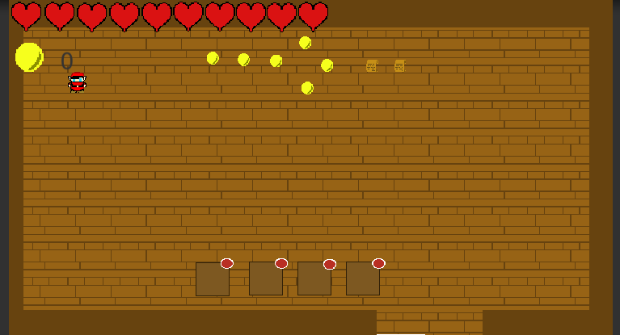

PLAYER HEARTS – indicates the amount of life the player has left

COIN COUNTER – indicates the number of coins the player has collected

INVENTORY – displays the apples collected

# 11 Players

## 11.1 Characters

Main character

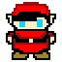

Sister of the main character



## 11.2 Metrics

Speed: 5

Attack Damage: 2

Max health: Max hearts (10) + 2 = 20

## 11.3 States

Idle: the player remains still

Move: the movement animation will cause the character to move in the direction of which ever arrow key is pressed

## 11.4 Weapons

Dagger

# 13 NPC

## 13.1 Enemies

**the circle is the projectile the enemies shoot at the player

### 13.1.1 Enemy States

Idle

Attacking

Death

# 14 Art

## 14.1 Setting

The game takes place primary outdoors where the player will interact with coins, apples, health potions and enemies.

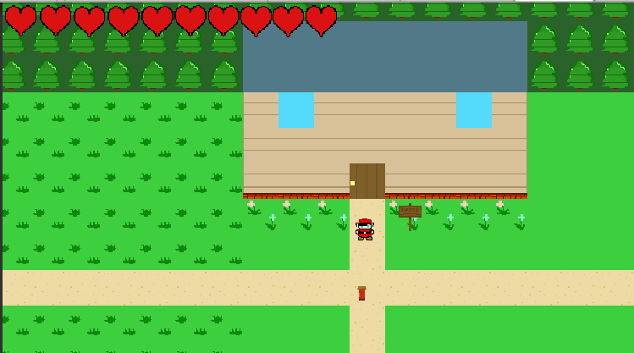

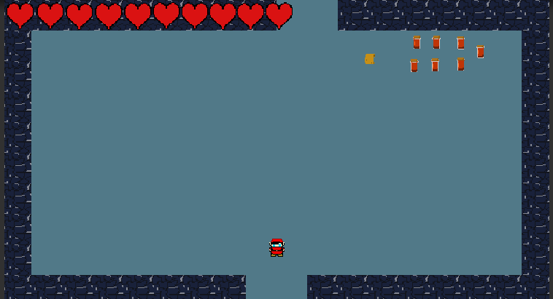

## 14.2 Level Design

The outdoor level consists of a grassy area with items such as health potions, coins, apples and enemies. As the player walks along the path they will come across enemies that will attack and follow the player.

## 14.3 Audio

Sonatina for Piano and Cello by Martijn de Boer - Menu Music

Goddess of Flowers by Dee Yan-Key – Background music

PingBing - FX

## 15.6 Minimum Viable Product (MPV)

- One player

- Built for the PC platform

# 16 Wish List

ADD MORE OBJECTS IN HOUSE

Add more items to interact with in the house

POLISH INVENTORY SYSTEM

ADD LEVELS WITH DIFFERENT MOOD TRANSITIONS

CREATE MORE DIVERSE ENEMY TYPES