## Overview:

We will use Amazon’s CloudFormation to provision the following resources:

* a VPC, including
  + two Public subnets
  + an Internet Gateway
  + a Route Table, allowing access to the Public Internet
* a Web Server Security Group
* a Web Server Auto Scaling Group
* a Web Server ELB Security Group
* a Web Server ELB

The resources reference each other, as examples:

* the Web Server Security Group allows only the Web Server ELB in on port 80
* the Web Server Auto Scaling Group is associated with the Web Server ELB

## Create the VPC and Web Server Stack:

1. Go to the AWS CloudFormation Console and click “Create Stack”
2. Select a Template:
   1. Name: cloudformation-yourname
   2. Source:
      1. Upload a template to Amazon S3:
         1. Click “Choose File” and browse to the file “vpc-with-webserver-asg.json”
   3. Click “Next”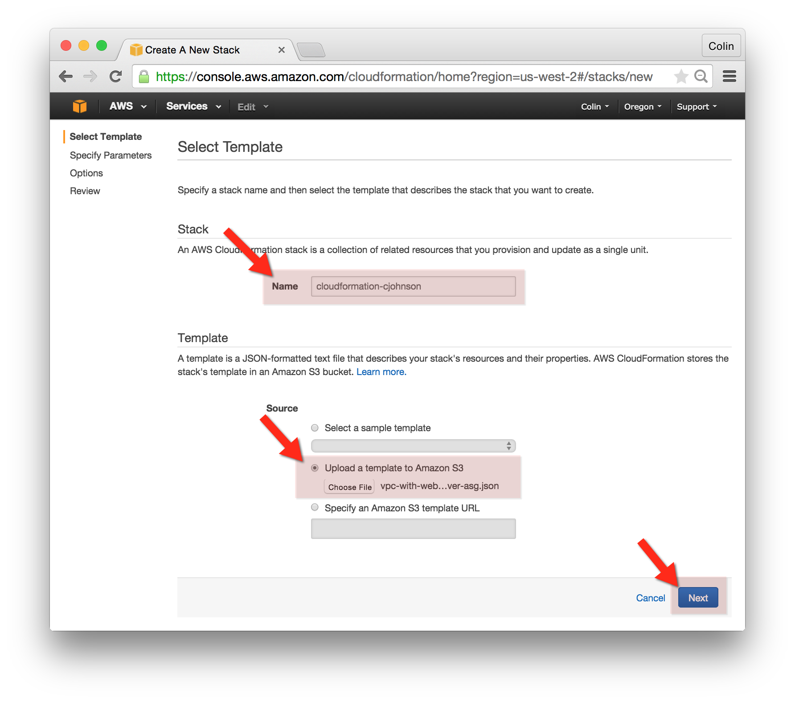
3. Specific Parameters:
   1. KeyName: <your key name>
   2. webServerInstanceType: t2.micro

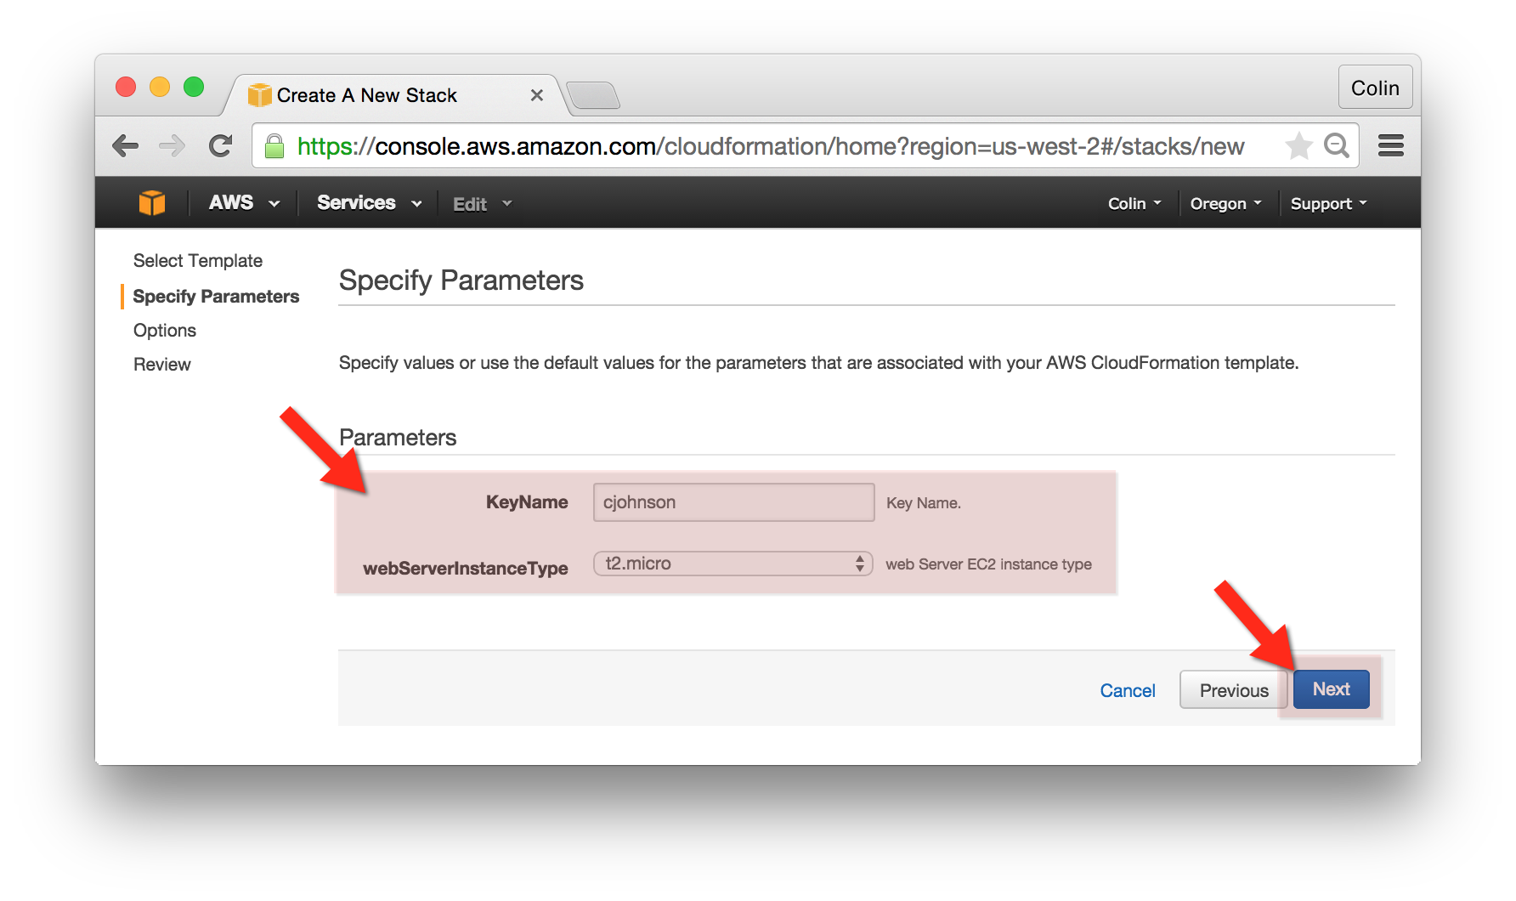

1. Options:
   1. Key: Owner
   2. Value: cjohnson
   3. Advanced: <leave unset>
2. Review:
   1. Click “Create”

## Update VPC and Web Server Stack:

1. Go to the AWS CloudFormation Console and locate the stack that you created in the previous step. Click “Update Stack”.
2. Select a Template:
   1. Name: cloudformation-yourname
   2. Template:
      1. Source: Use existing template.
   3. Click “Next”
3. Specify Parameters:
   1. webServerInstanceType: t2.small
   2. Click “Next
4. Options:
   1. Click “Next”
5. Review:
   1. Click “Update”

*Note: some stack updates (and some AWS resource updates) do not take place immediately – this is the case with an Auto Scaling Group’s Launch Configuration – to complete the resize of these instances they’ll need to be “cycled” by terminating the given instances.*

## Delete VPC and Web Server Stack:

1. Go to the AWS CloudFormation Console and locate the stack that you created in the previous step. Click “Delete Stack.”