## Overview:

We will be creating a CloudFront Distribution using S3 as an origin server.

## Create an S3 Bucket to Serve as an Origin:

1. Go to the AWS S3 Console
2. Click “Create Bucket”
   1. Bucket Name: cloudfront-yourname
   2. Region: Oregon
   3. Click Create

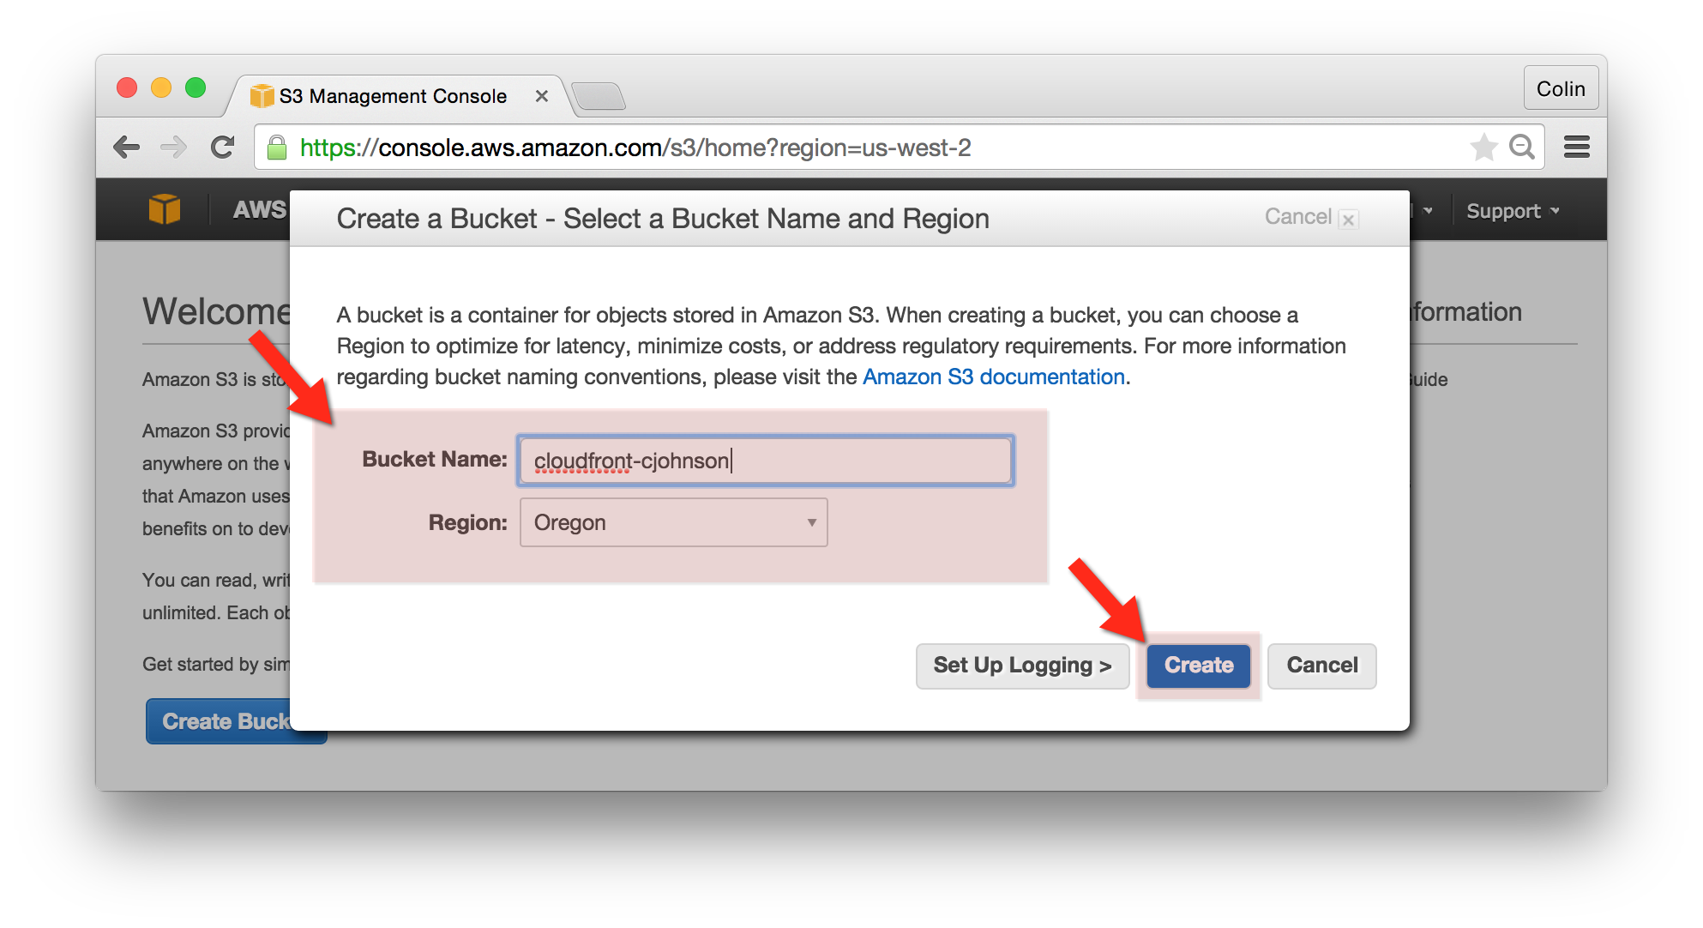

## Upload an Object to your S3 Bucket:

1. Select the S3 Bucket You Created in the Previous Step.
2. Go to the “Actions” menu and select “Upload”
   1. Choose a file to upload.
3. Once the file is uploaded, right click on the file and choose “Make Public.”  
   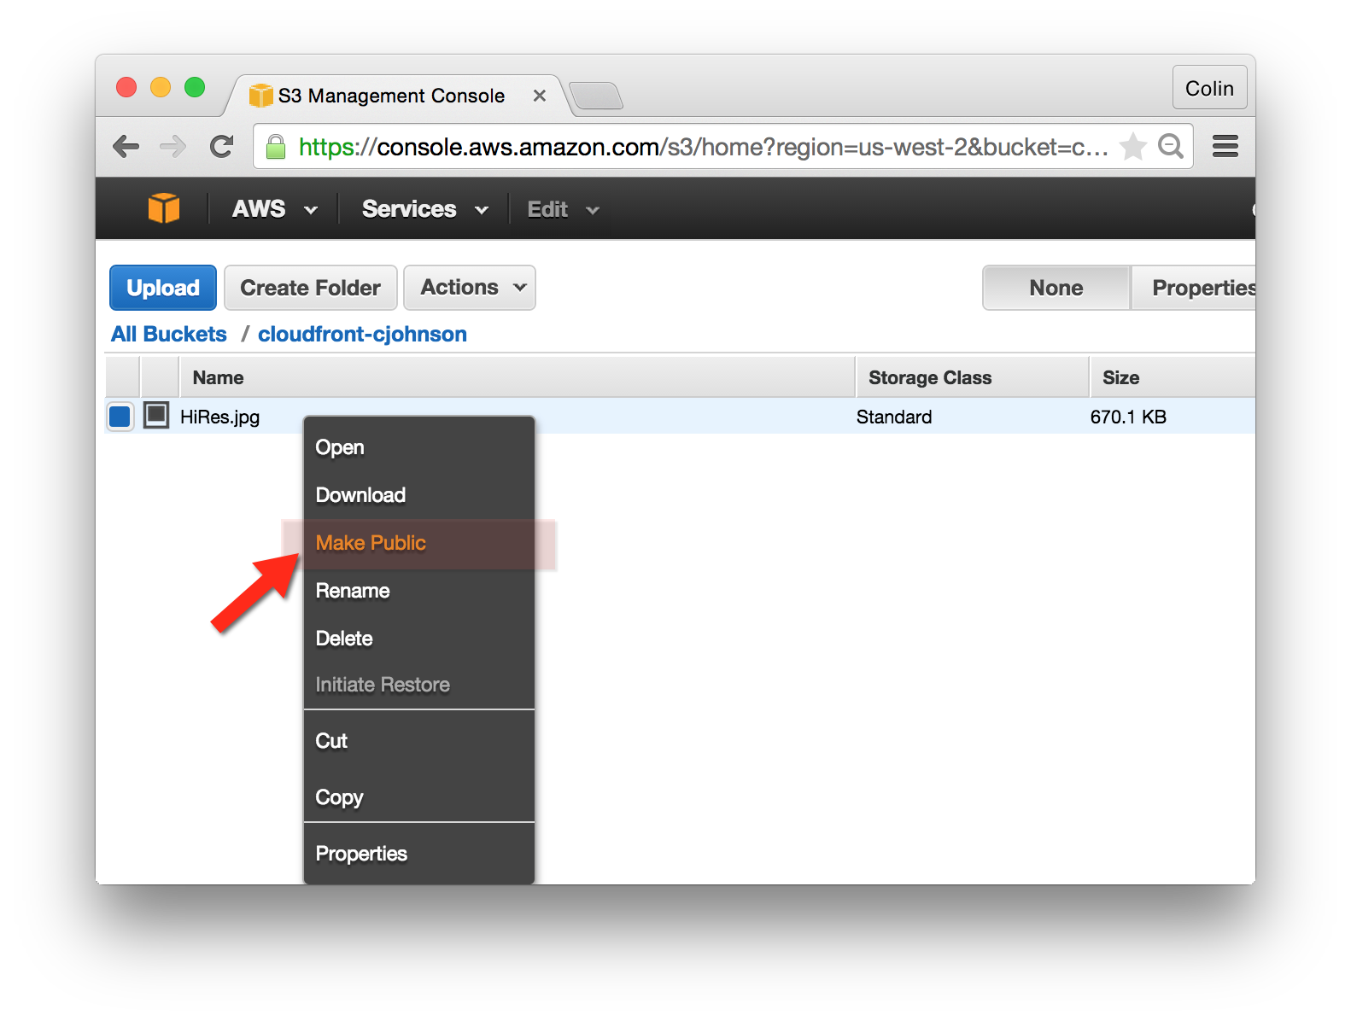

## Create an CloudFront Distribution

1. Go to the AWS CloudFront Console
2. Click “Create Distribution”  
   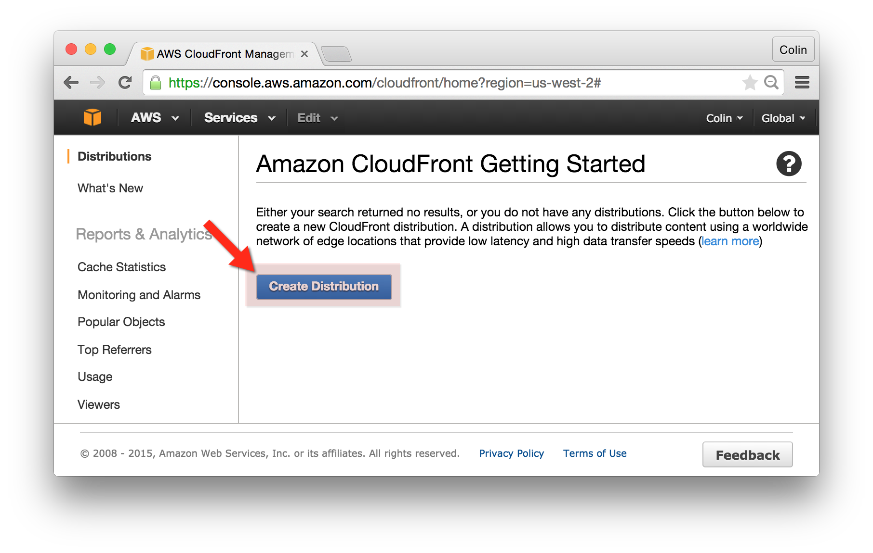
3. Select delivery method:
   1. Select “Web” Distribution and click “Get Started”
4. Create Distribution Settings:
   1. Origin Settings:
      1. Origin Domain Name: cloudfront-yourname (the S3 Bucket selected previously)
      2. Origin Path: <null>
      3. Origin ID: S3-cloudfront-yourname
      4. Restrict Bucket Access: No

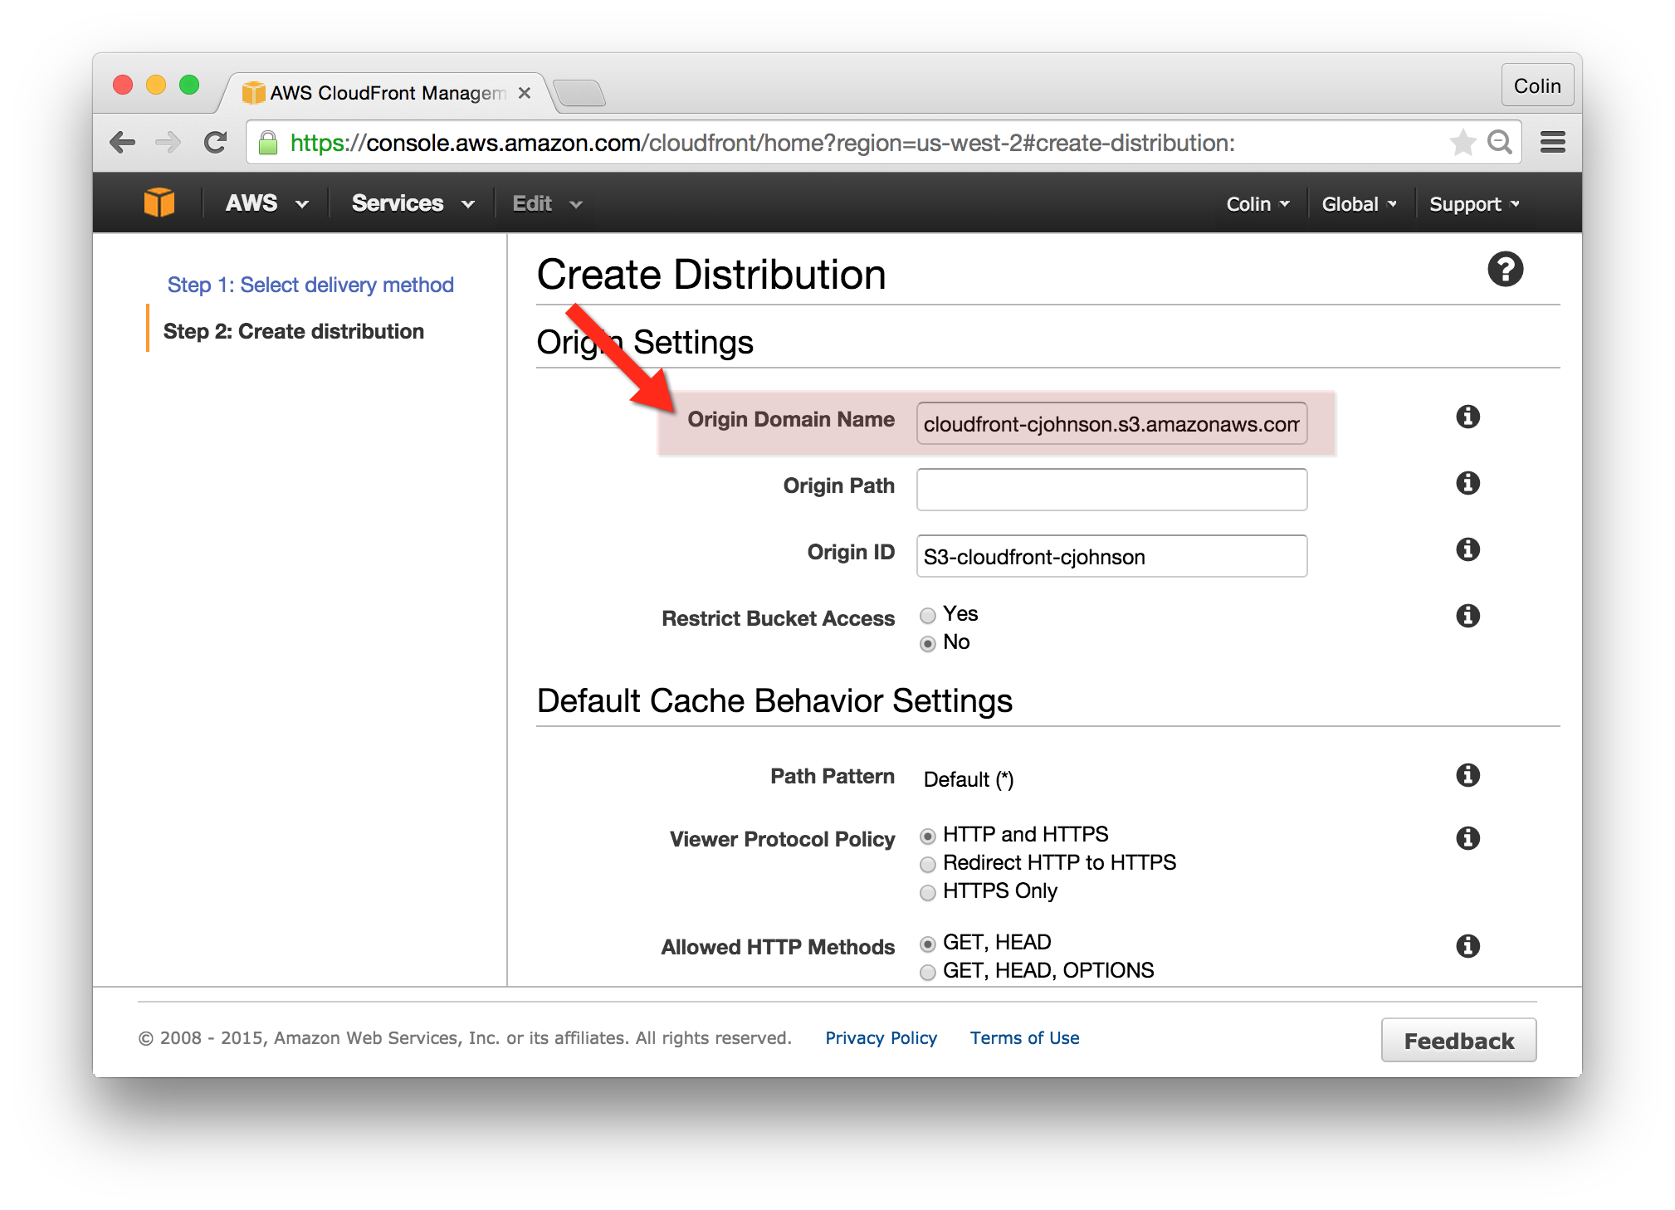

* 1. Default Cache Behavior Settings:
     1. Path Pattern: Default (*)
     2. Viewer Protocol Policy: HTTP and HTTPS
     3. Allowed HTTP Methods: GET, HEAD
     4. Cached HTTP Methods: GET, HEAD (Cached by default)
     5. Forward Headers: None
     6. Object Caching: Use Origin Cache Headers
     7. Minimum TTL: 0 (only an option if Object Caching is set to Custom)
     8. Forward Cookies: None
     9. Forward Query Strings: No
     10. Smooth Streaming: No
     11. Restrict Viewer Access: No
  2. Distribution Settings:
     1. Price Class: Use Only US and Europe
     2. Alternate Domain Names: (you would typically enter domain names from which you wish to serve content from here)
     3. SSL Certificate: Default CloudFront Certificate
     4. Default Root Object: <null>
     5. Logging: Off
     6. Bucket for Logs: <null>
     7. Log Prefix: <null>
     8. Cookie Logging: Off
     9. Comment: <null>
     10. Distribution State: “Enabled”
     11. Click “Create Distribution”!

## Access an Item using a CloudFront Distribution:

1. Go to the AWS CloudFront Console
2. Locate the CloudFront Distribution you previously created.
3. Copy the “Domain Name”
4. Open a web browser and enter the domain name of the CloudFront origin followed by the name of the object that you had uploaded to S3.
   1. Example URL: <http://d2u3mzxzn1fepw.cloudfront.net/test.txt>
5. The item that you uploaded will be served to you via CloudFront.

## A Few Notes:

1. Time to setup a CloudFront distribution is typically about 5 minutes.
2. The first access of an object will likely not benefit from being served via CloudFront as the CloudFront service must get the object from S3 and then return it to the requester.