## Go to the AWS EC2 Console:

In the AWS Console, select the “Oregon” Region, select “EC2” and select “Volumes” from the left-hand navigation bar, then click “Create Volume”:

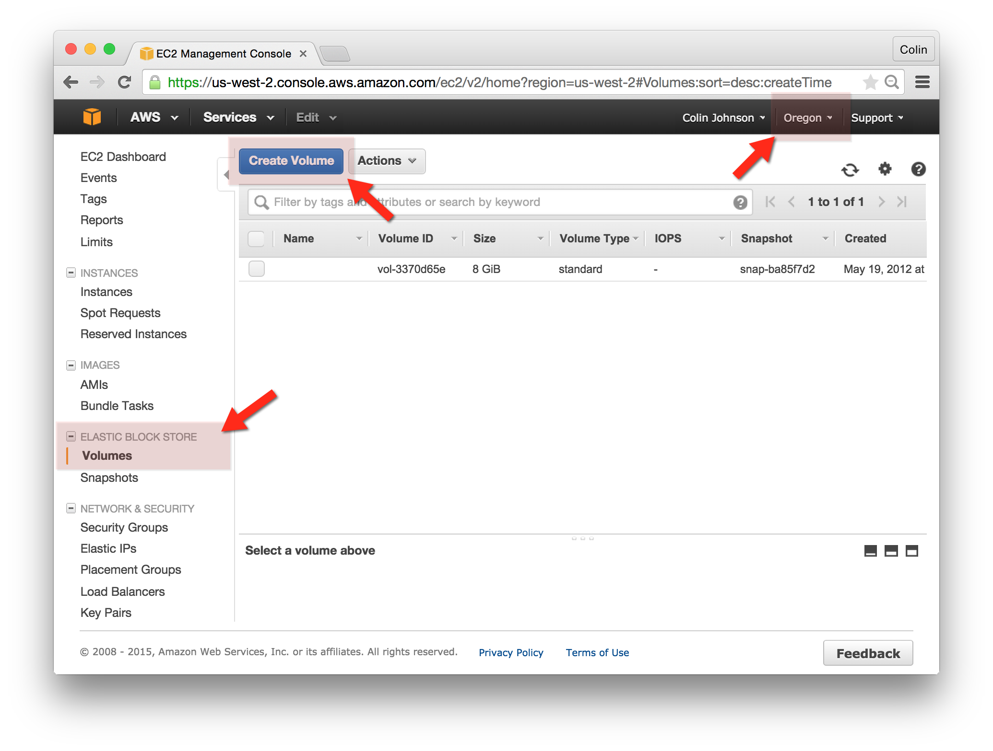

## Create the new EBS Volume:

First: note the Availability Zone that the www-yourname instance is in. We will need to create our new EBS volume in this same Availability Zone.

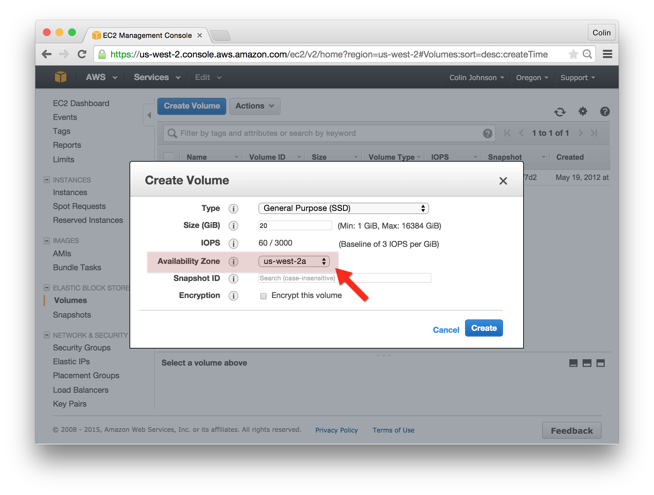

## Locate and Tag your new EBS Volume:

We should tag the newly created volume – some information about the volume is available, however it would be best to “Tag” this volume so that other AWS users know who it belongs to.

1. Locate your volume in the “Volumes” list.
2. Select the tab “Tags” and click “Add/Edit” Tags.
3. Create a tag with the Key/Value pair “Name=yourname”

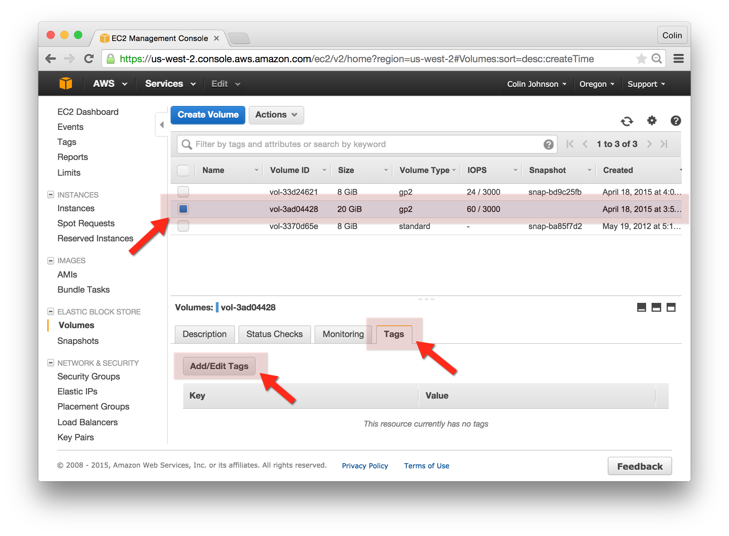

## Attach the new EBS Volume to your www-yourname EC2 Instance:

1. Right-click on your EBS Volume and select “Attach Volume”
2. For the “Instance” value you can input either the “Name Tag” or Instance ID of your instance.

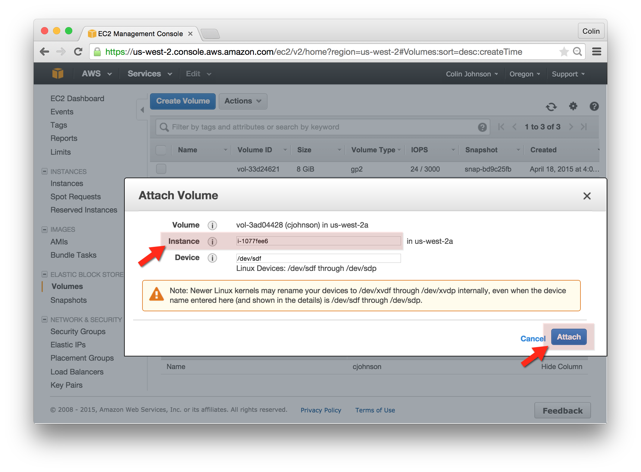

## Login to your www-yourname Instance and format the new EBS Volume:

1. ssh into your www-yourname Instance.
2. Run the following commands:

sudo su -

mkfs -t ext4 /dev/xvdf

mkdir -p /srv/yourname

mount /dev/xvdf /srv/yourname

The result should like similar to the screenshot below:

