## Go to the AWS EC2 Console:

1. In the AWS Console, select the “Oregon” Region, select “EC2” and select “Security Groups” from the left-hand navigation bar, then click “Create Security Group”

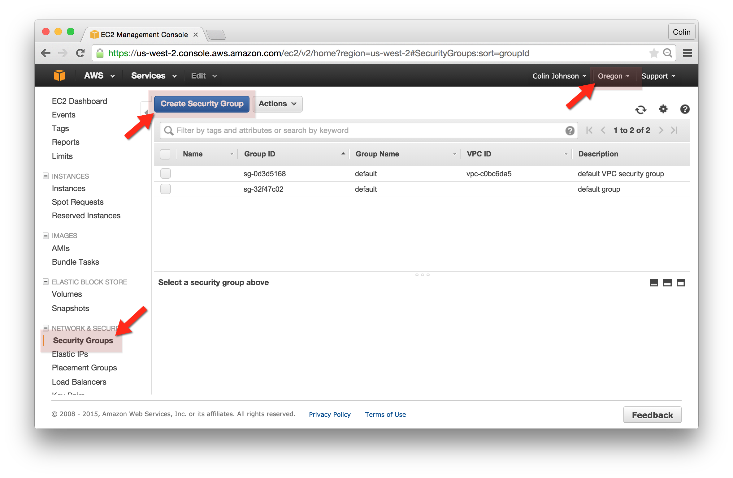

## Create the Gateway Security Group:

After clicking “Create Security Group” enter the following:

* Security group name: gateway-cjohnson
* Description: gateway-cjohnson
* Inbound Rule (SSH):
  + Type: SSH
  + Protocol: TCP
  + Port Range: 22
  + Source: Anywhere (feel free to use “My IP”) if you wish

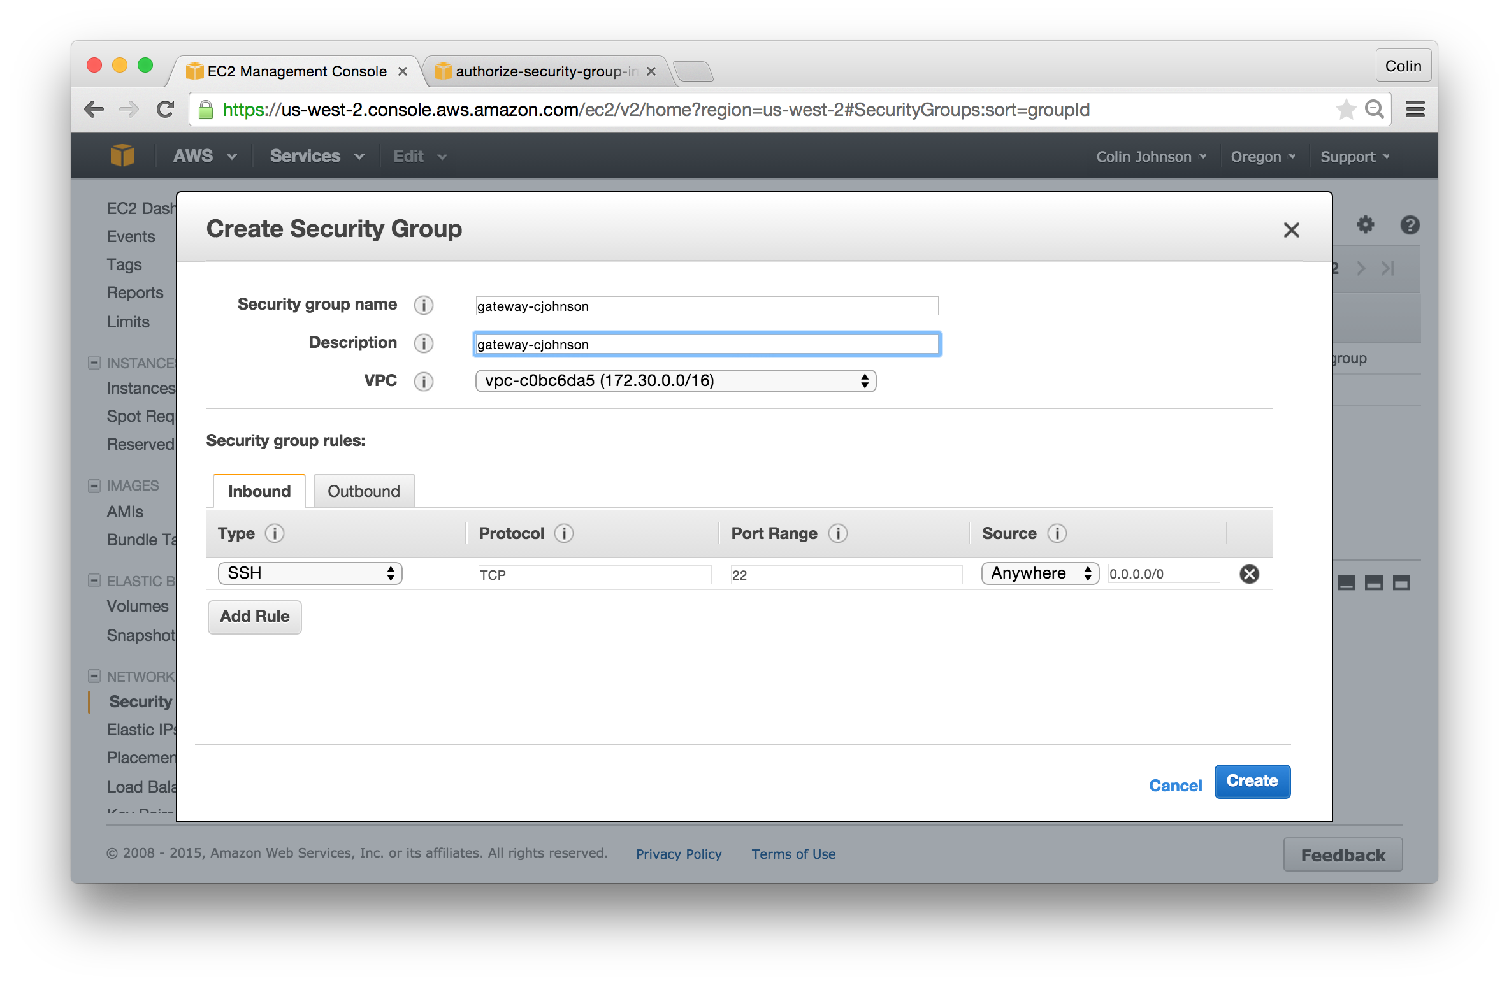

## Create the base Security Group:

Next, we will create the base Server Security Group. If this group were to be applied to all instances in our infrastructure, each instance would allow in port 22 from the “gateway” EC2 instance, and we could also make sweeping changes across our infrastructure. *Note that you may need to refresh the AWS Console in order for the “gateway-yourname” Security Group to be available as a Security Group Source.*

After clicking “Create Security Group” enter the following:

* Security group name: base
* Description: base
* Inbound Rule (SSH):
  + Type: SSH
  + Protocol: TCP
  + Port Range: 22
  + Source: gateway-yourname

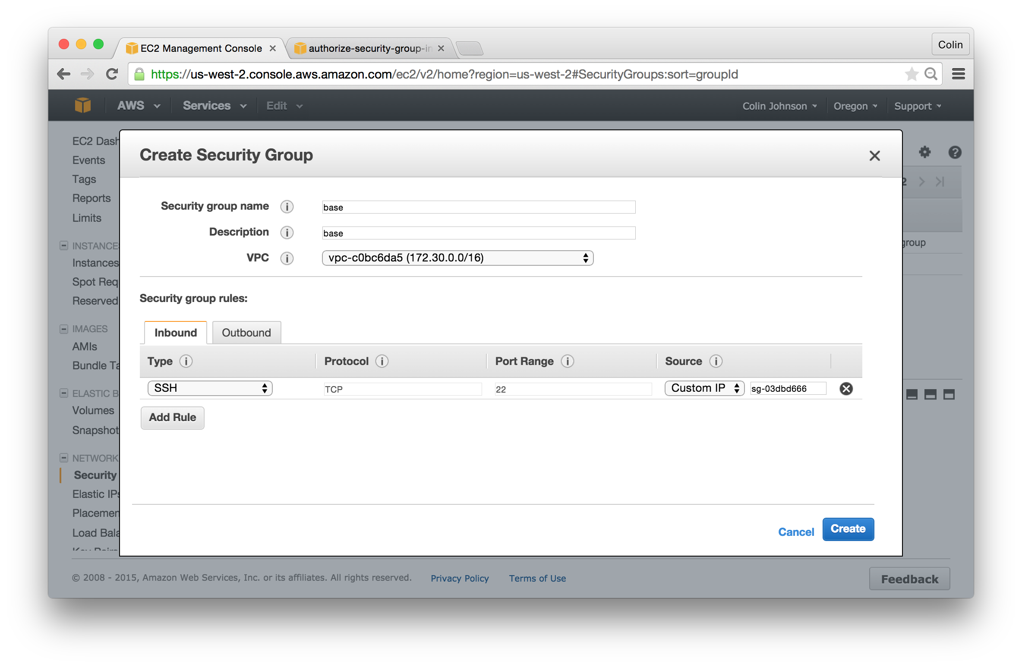

## Create the www Security Group:

Next, we will create the www Server Security Group. *Note that you may need to refresh the AWS Console in order for the “base” Security Group to be available as a Security Group Source.*

After clicking “Create Security Group” enter the following:

* Security group name: www-yourname
* Description: www-yourname
* Inbound Rule:
  + Type: HTTP
  + Protocol: TCP
  + Port Range: 80
  + Source: Anywhere (feel free to use “My IP”) if you wish

## Macintosh HD:Users:cjohnson:Box Sync:cloudavail-awstraining:aws-ec2:exercises:assets:Step 3 - create www Security Group.png

## Confirm all three groups have been created:

Notice that the gateway-yourname, www-yourname and base Security Groups have been created.

