## Go to the AWS EC2 Console:

In the AWS Console, select the “Oregon” Region, select “EC2” and select “Volumes” from the left-hand navigation bar.

## Snapshot your EBS Volume:

1. Since you tagged your EBS volume in the previous step, enter your EBS volume name (hint: it is “yourname”) in the Search bar.

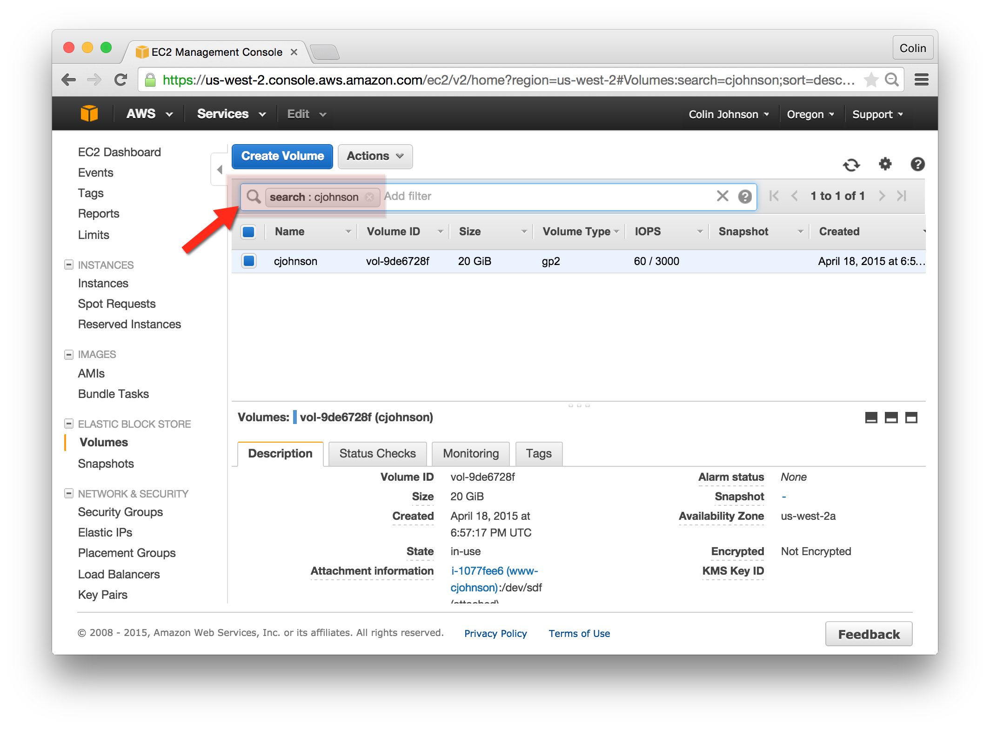

## Snapshot Your EBS Volume:

1. Once you’ve located your EBS volume, right click and select “Create Snapshot”  
   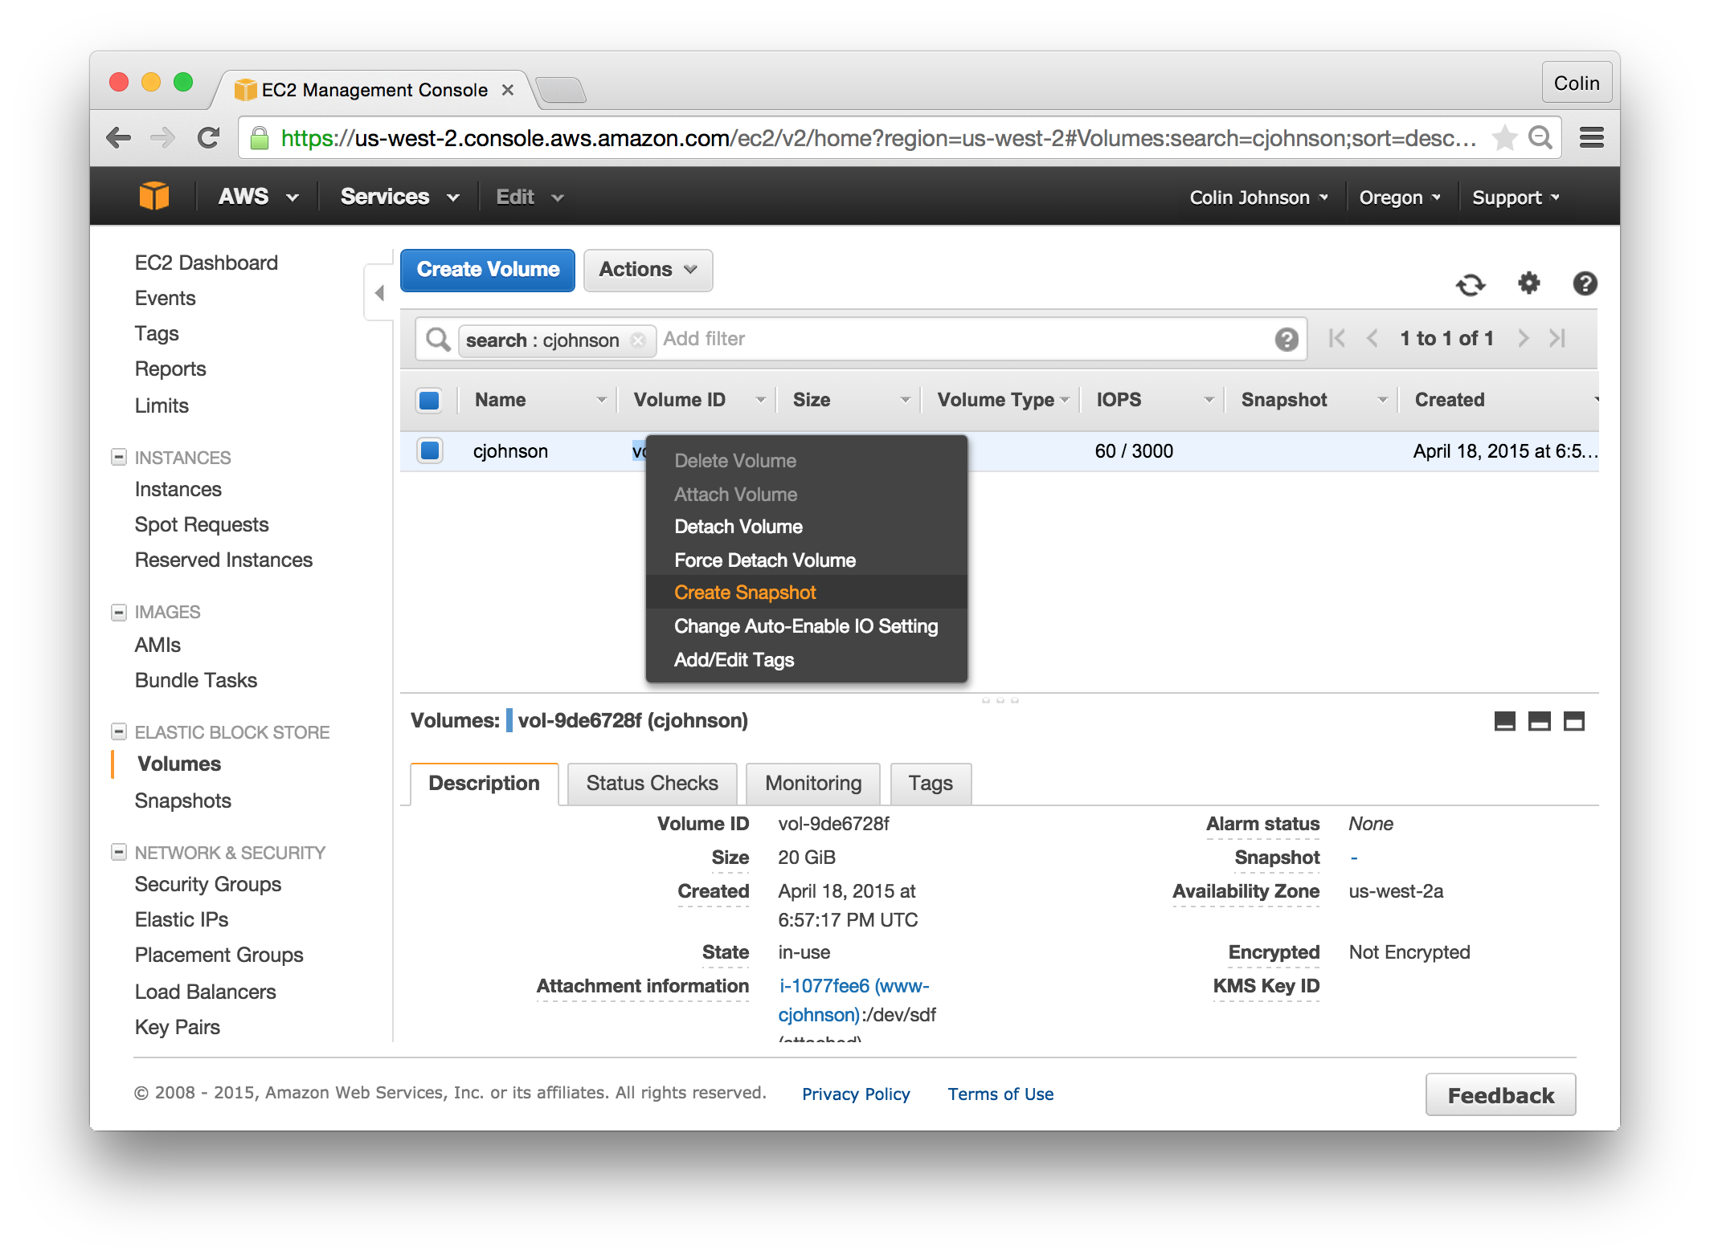
2. When creating the Snapshot, use the following values:
   1. Name: yourname
   2. Description: yourname-date

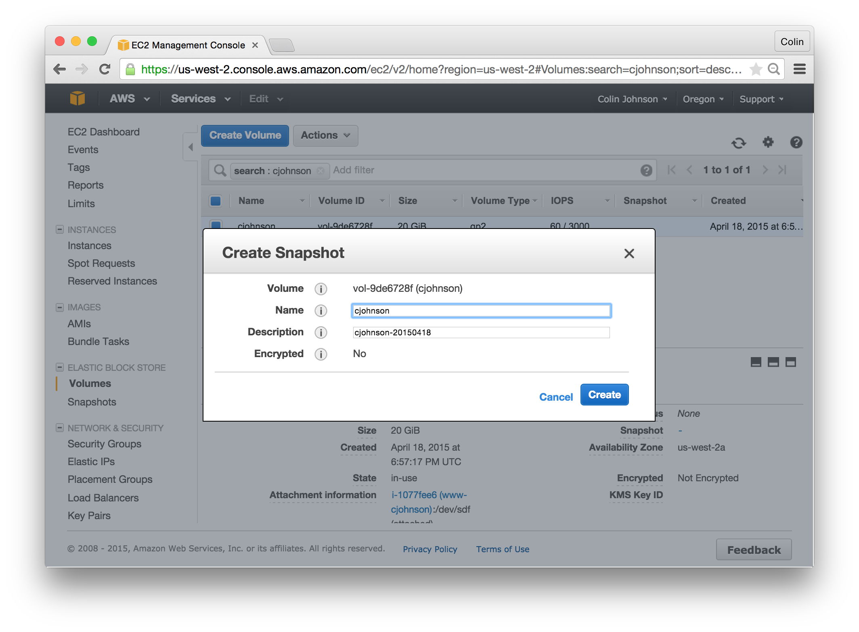

## Restore Your Snapshot:

1. Click on the “Snapshots” link in the left-hand navigation.
2. Locate the snapshot that you had created in the previous step – you can filter based on the “Name” that you had previously used.  
   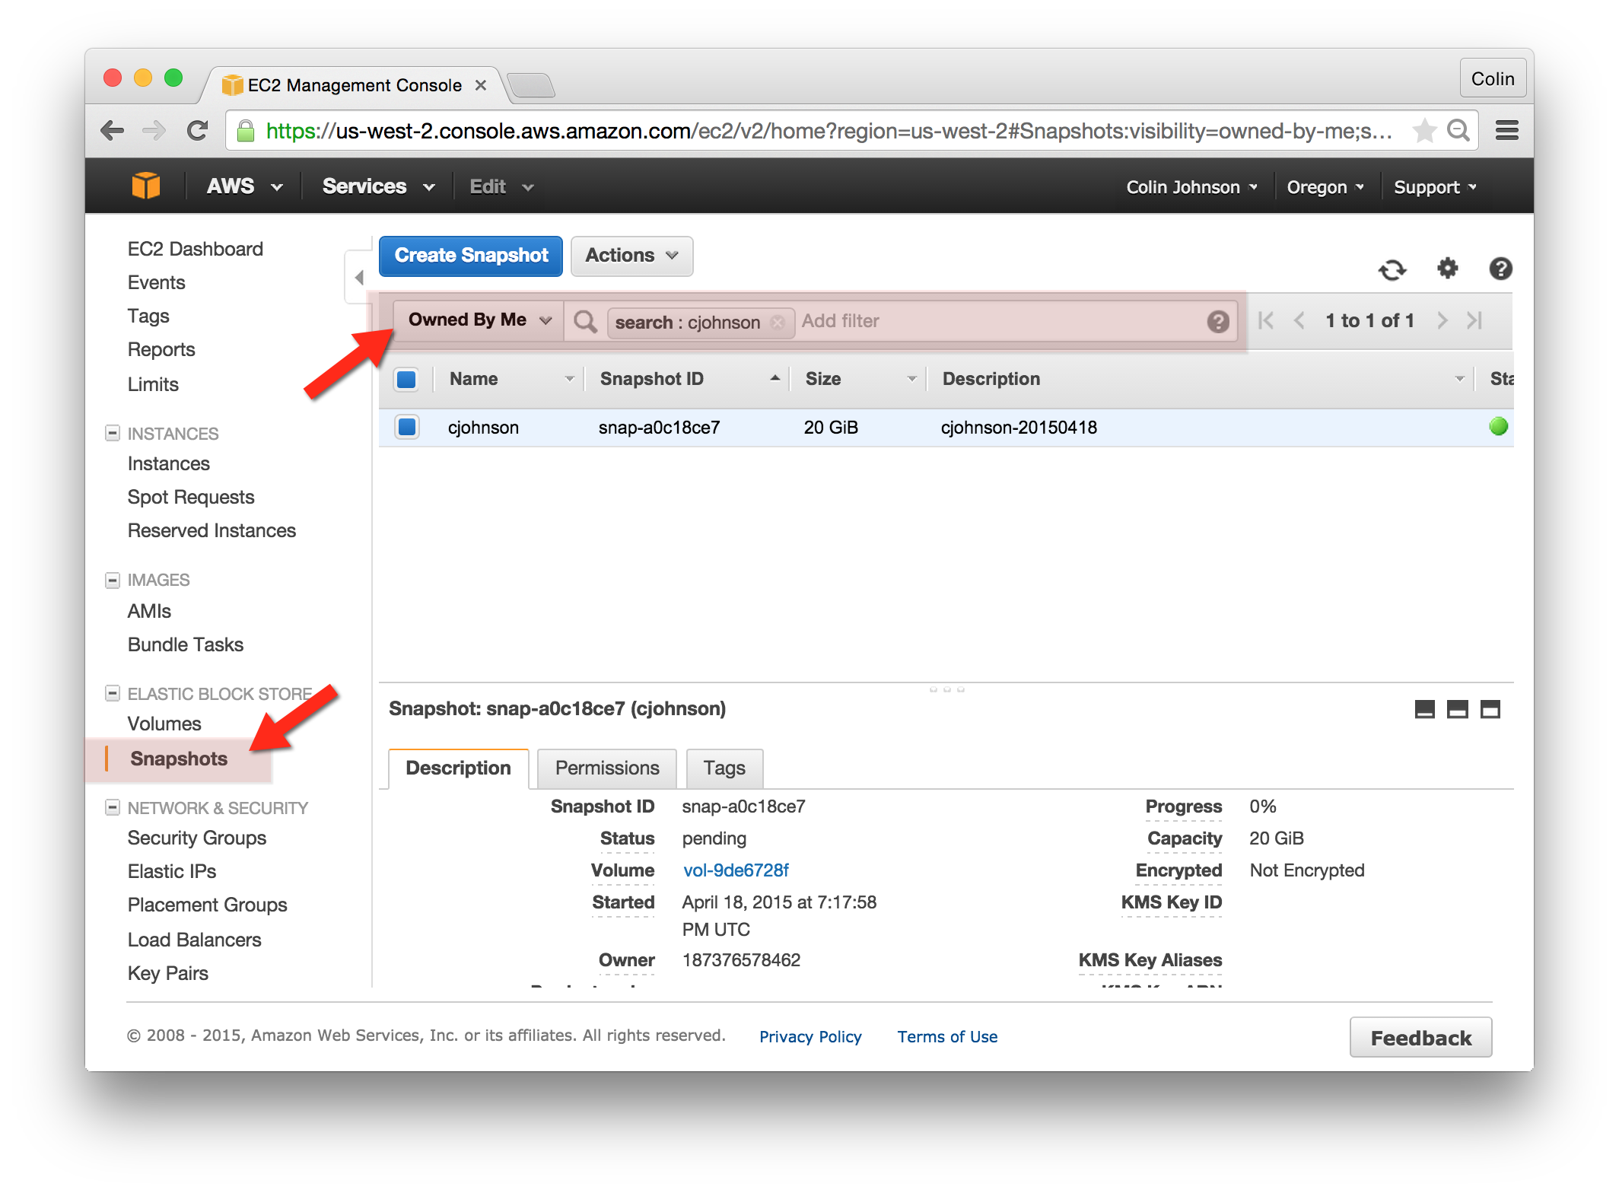
3. And, lastly, right click on your snapshot and select “Create Volume”. In this case, we will restore the volume with a different size and performance characteristics than the previous volume:
   1. Type: Provisioned IOPS
   2. Size: 60 GB
   3. IOPS: 1800

