## Overview:

In this exercise we will need to automate the creation of a web server and simple web page. We will call this server “wwwauto.”

You should use the instructions from the “AWS – Introduction” model to create the wwwauto instance. We will configure this instance to install Apache and serve a simple web page as well. The one difference between this and previous server builds will be the user of user-data to “bootstrap” (or configure) the instance when the instance is being brought up.

## User-Data:

When creating the wwwauto-yourname EC2 instance, you’ll want to do one thing differently than the previous server builds. When selecting “Configure Instance Details” (shown below):

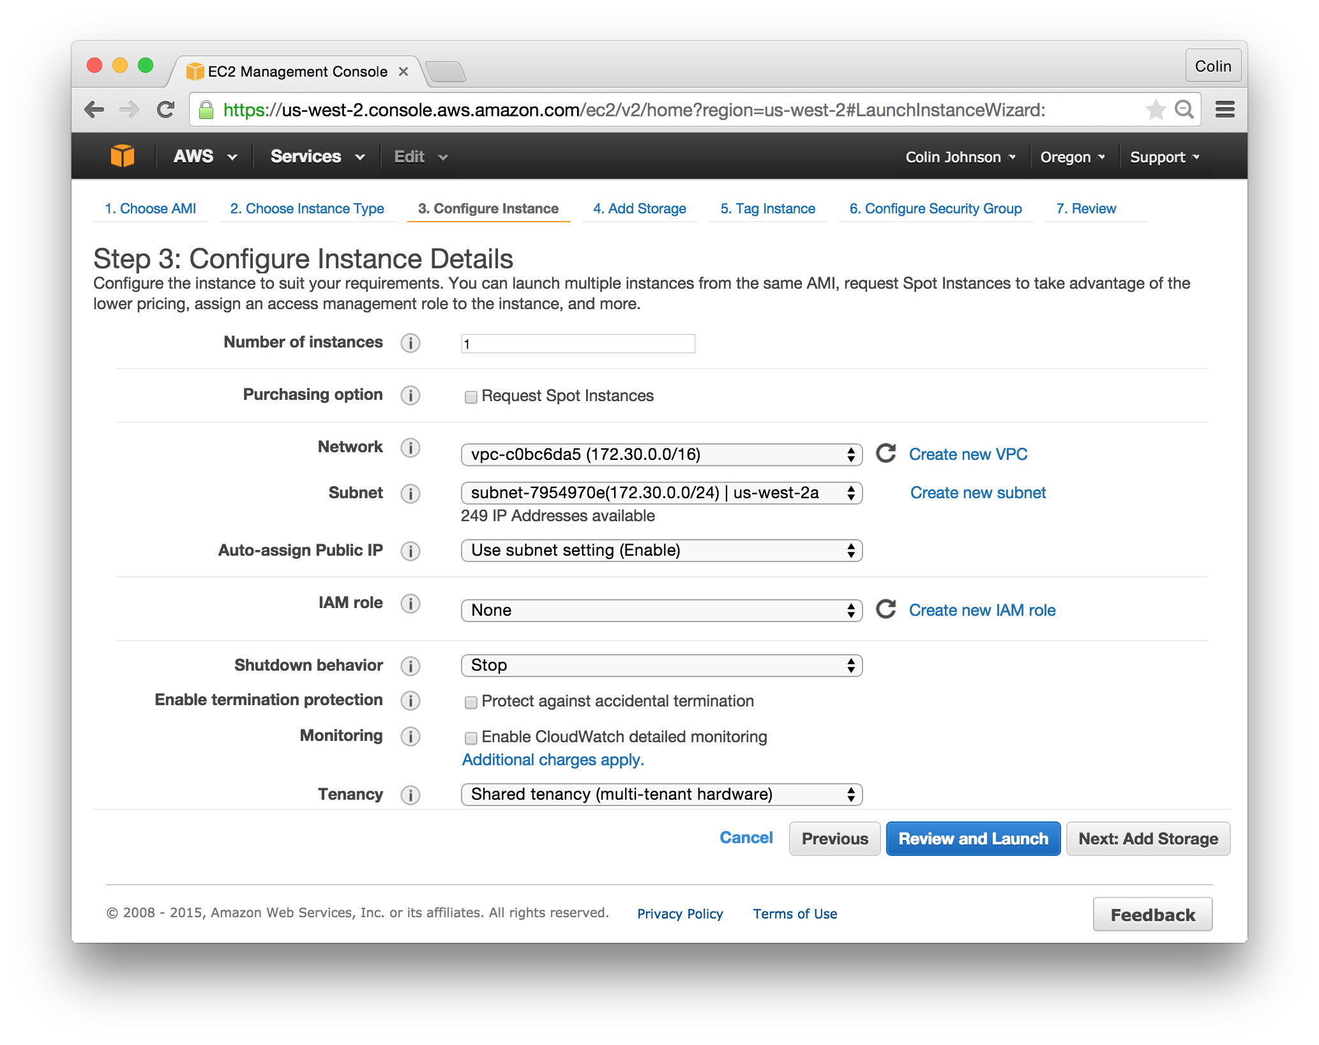

You’ll want to scroll to the bottom of the screen and paste the contents of the file “ec2-user-data.sh.” Your end result will look as follows:

## Macintosh HD:Users:cjohnson:Box Sync:cloudavail-awstraining:aws-ec2:exercises:assets:ec2-build-user-data - Step 3 - User-Data.png

## Complete and Launch Instance:

* Click “Next: Add Storage”
* Click “Next: Add Instance”
  + Tag Instance as: “Name=wwwauto-yourname”
* Click “Next: Configure Security Group”
  + Select the “base” and “www-yourname” Security Groups.
* Click “Review and Launch”
  + Review Settings, if needed
* Click “Launch”

## Confirm Everything Working:

**View the Instance’s User-Data:**

In the AWS Console, locate the wwwauto-yourname instance, right-click and select “Instance Settings -> View/Change User Data” – you should see the following:

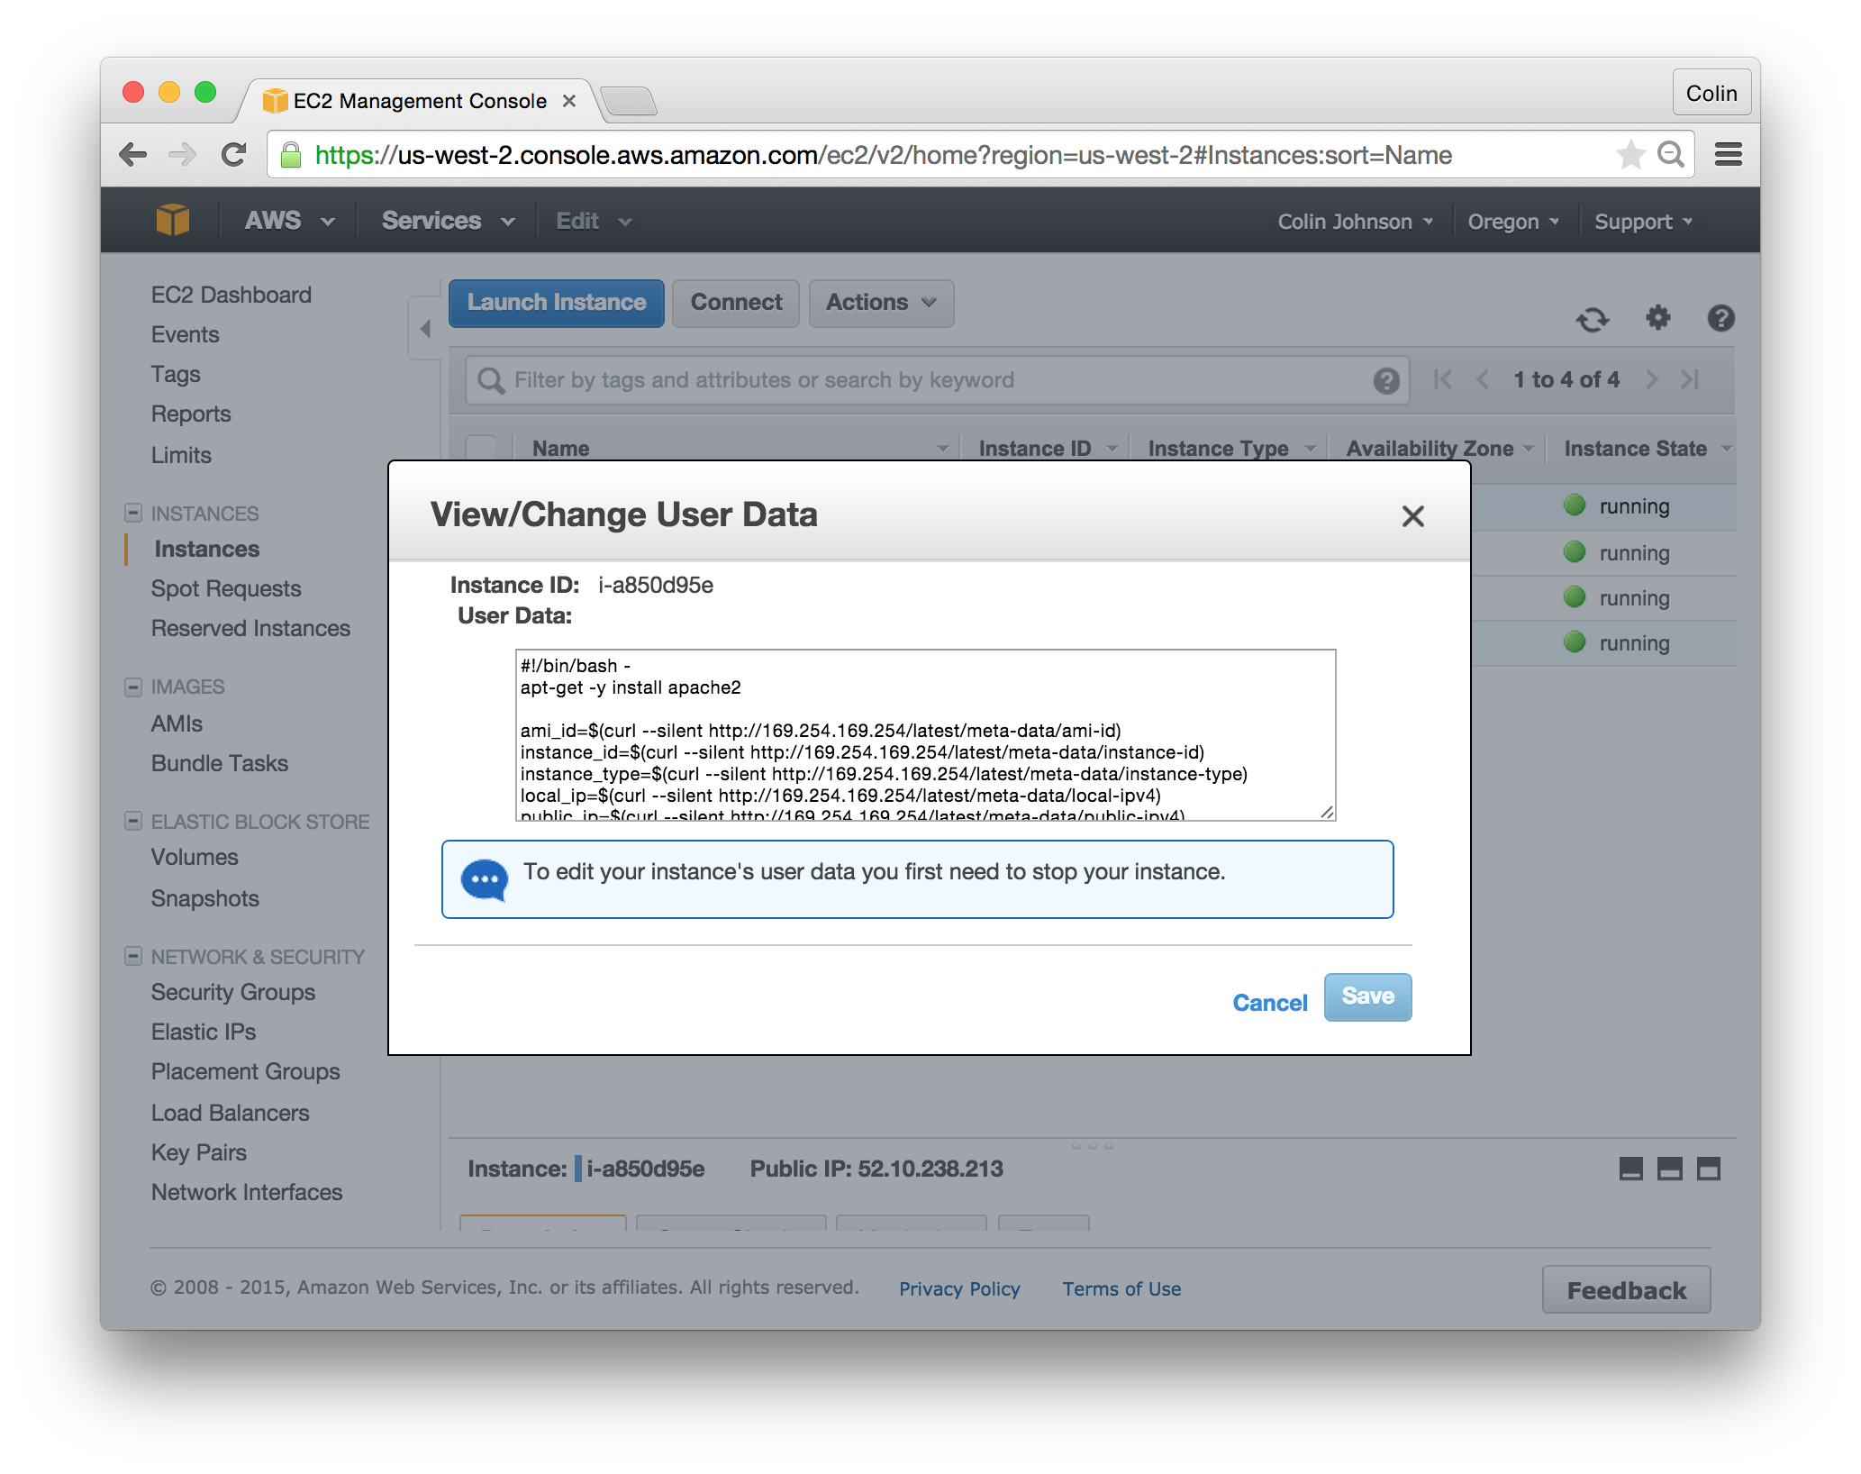

**Confirm Apache Running:**

Browse to the public IP address of the running server, you should see a web page with information about the running instance.

