## Create a Security Group for the RDS Database:

1. Go to the AWS EC2 Console and select “Security Groups”
2. Click “Create Security Group”
   1. Security group name: api-db-youname
   2. Description: api-db-yourname
   3. VPC: vpc-f38d3796
   4. Inbound Rules:
      1. Type: MYSQL
      2. Protocol: TCP
      3. Port Range: 3306
      4. Source: gateway-yourname

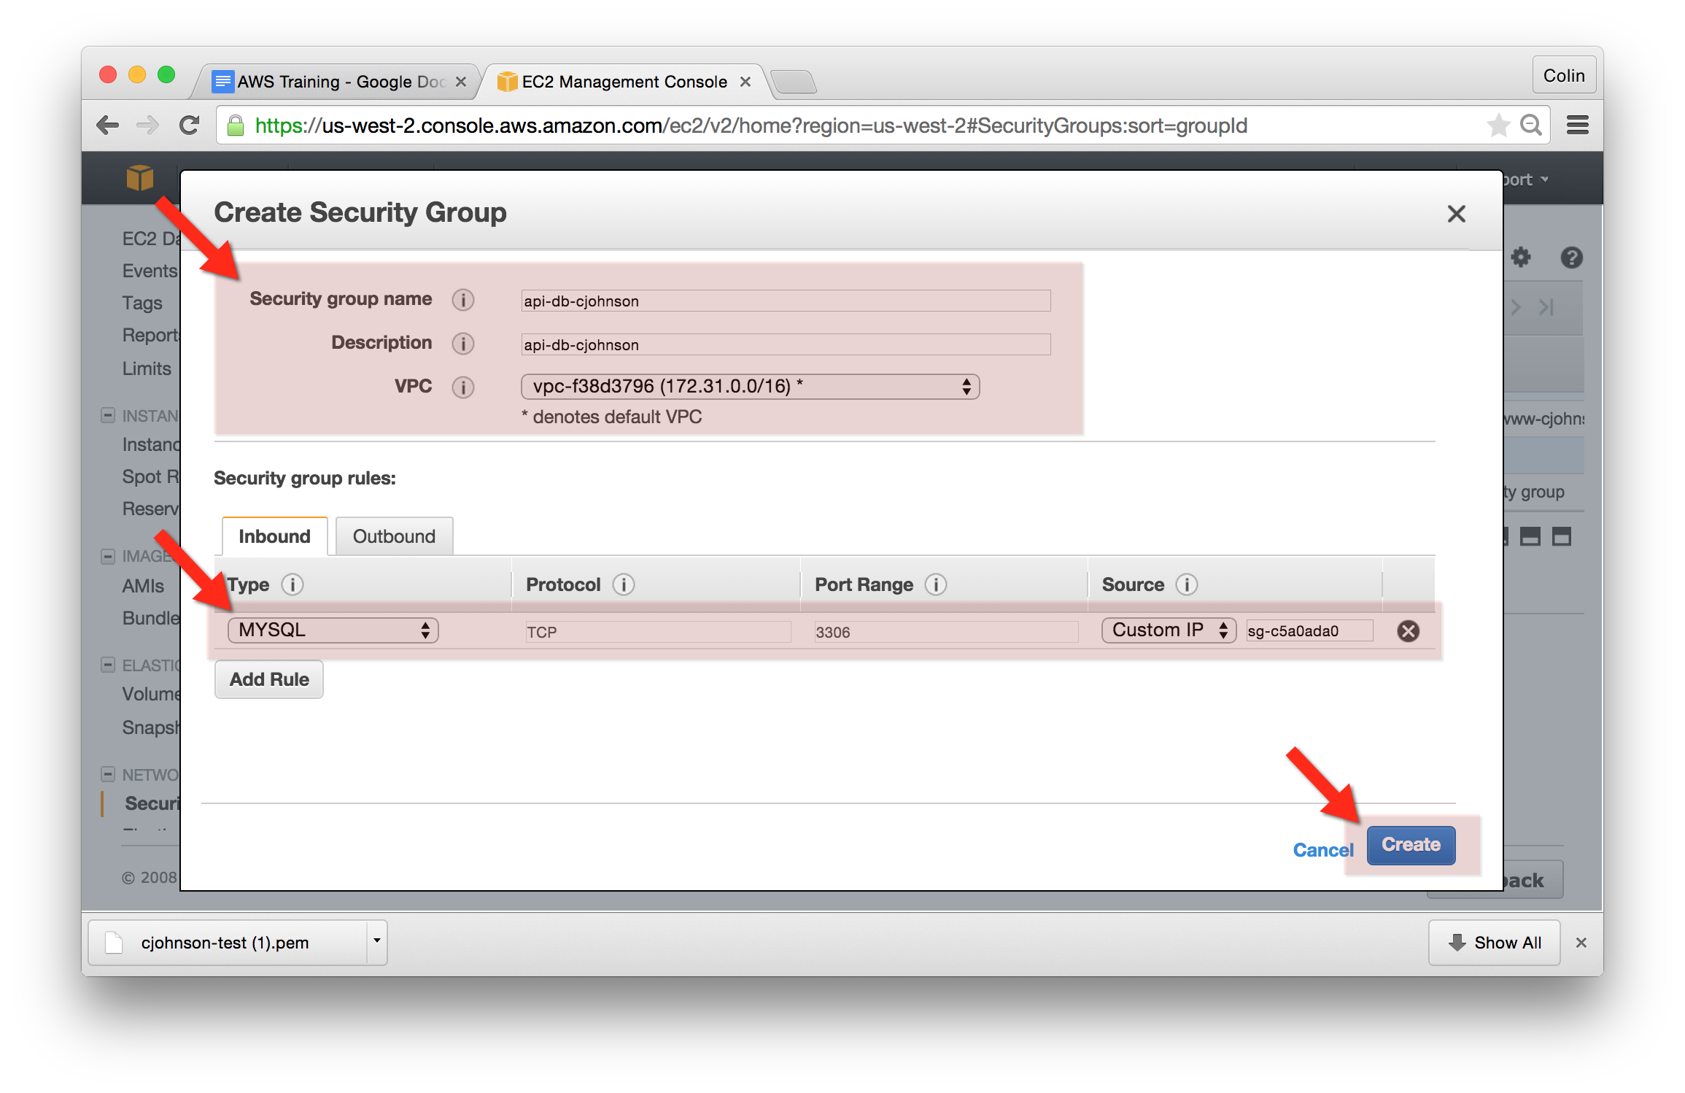

## Create an RDS Database:

1. Go to the AWS RDS Console, select “Instances” from the left-hand navigation and choose “Launch Instance”
2. Select Engine:
   1. Choose “MySQL” and press “Select”
3. Production?:
   1. Choose: “No, this instance is intended for use outside of production or under the RDS Free Usage Tier”
   2. Click “Next Step”
4. Specify DB Details:
   1. DB Engine: mysql
   2. License Model: general-license-model (*this is the only option for mysql databases*)
   3. DB Engine Version: 5.6.22
   4. DB Instance Class: db.t2.micro
   5. Multi AZ Deployment: No
   6. Storage Type: General Purpose (SSD)
   7. Allocated Storage: 10 GB
   8. DB Instance Identifier: api-yourname
   9. Master Username: yourname
   10. Master Password: <your choice>
   11. Confirm Password: <repeat above>
5. Configure Advanced Settings:
   1. Network and Security:
      1. VPC: Default VPC (vpc-f38d3796)
      2. Subnet Group: default
      3. Publicly Accessible: No
      4. Availability Zone: No Preference
      5. VPC Security Groups: api-db-yourname
   2. Database Options:
      1. Database Name: yourname
      2. DB Parameter Group: default:mysql5.6
      3. Option Group: default: mysql-5-6
      4. Enable Encryption: No (not available on t2.micro instance types)
   3. Backup:
      1. Backup Retention: 7 days
      2. Backup Window: No Preference (note that backups impact performance)
   4. Maintenance:
      1. Auto Minor Version Upgrade: Yes
      2. Maintenance Window: No Preference
   5. Press “Launch DB Instance”

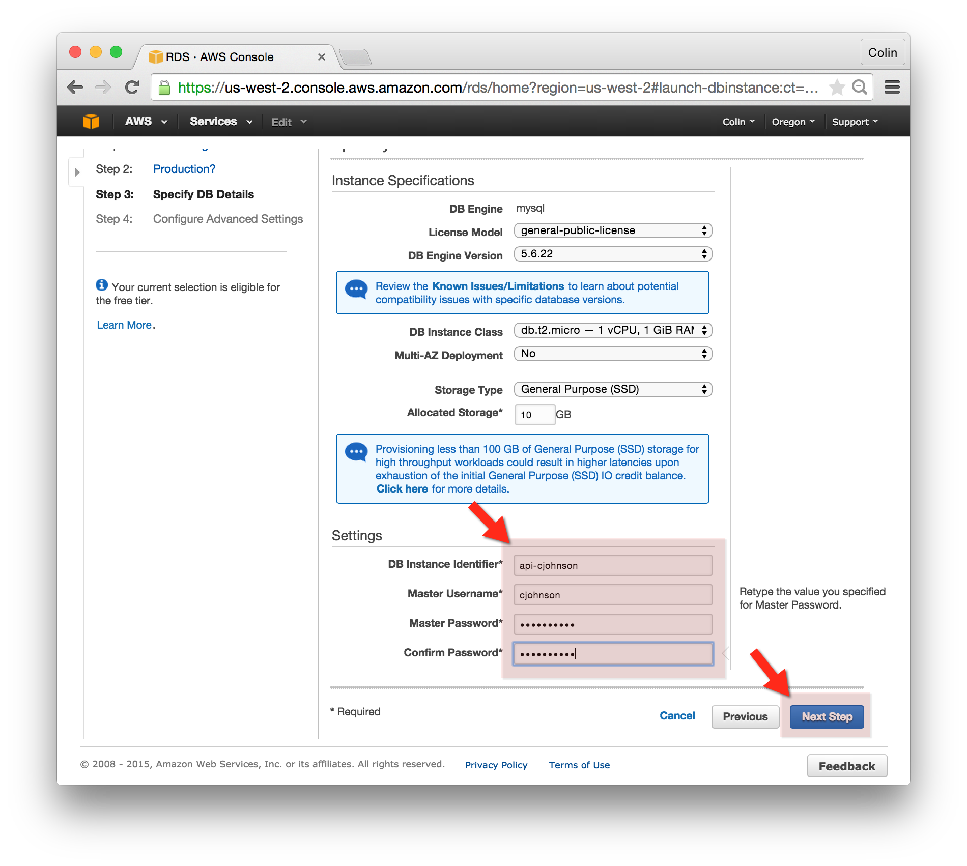

## Connect to your RDS Database:

1. From the AWS RDS Console, locate your database and copy the “Endpoint”
2. Login to your gateway-yourname server.
3. Install the MySQL client by running the following command:
   1. sudo apt-get -y install mysql-client-5.6
4. Connect to your MySQL host as follows:
   1. mysql -h api-cjohnson.cnn1tkhekekc.us-west-2.rds.amazonaws.com -u cjohnson -pmypassword
   2. You’ll be presented with the MySQL Command Prompt, run the show tables command and you’ll notice that AWS has created a database for you:
   3. show tables;
   4. Disconnect from the RDS database.
   5. exit;