## Create an RDS Parameter Group:

AWS Customers that utilize RDS often have the need to modify RDS parameters. In one particular case, the value of “max_connections” is set based on amount of RDS memory – and some customers may wish to change this value. To do so:

1. From the AWS RDS Console, select “Parameter Groups” and choose “Create Parameter Group”
2. Create a parameter group with the following options:
   1. Parameter Group Family: mysql5.6
   2. Group Name: api-yourname
   3. Description: api-yourname
   4. Click “Create”  
      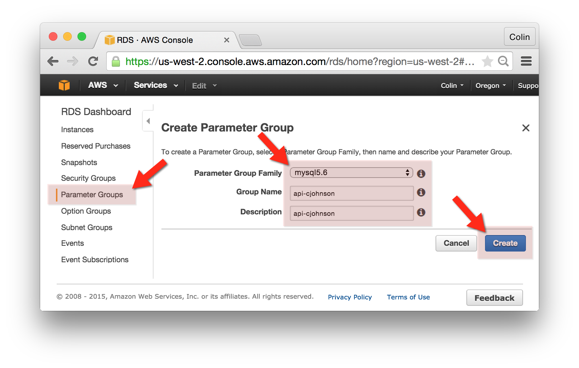
3. Select the api-yourname Parameter Group and click “Edit Parameters”
   1. In the filter field, enter “max_connections”
   2. Click the “Edit Parameters” button
   3. Enter the value 1000 in the “max_connections” Field and Click “Save Changes”  
      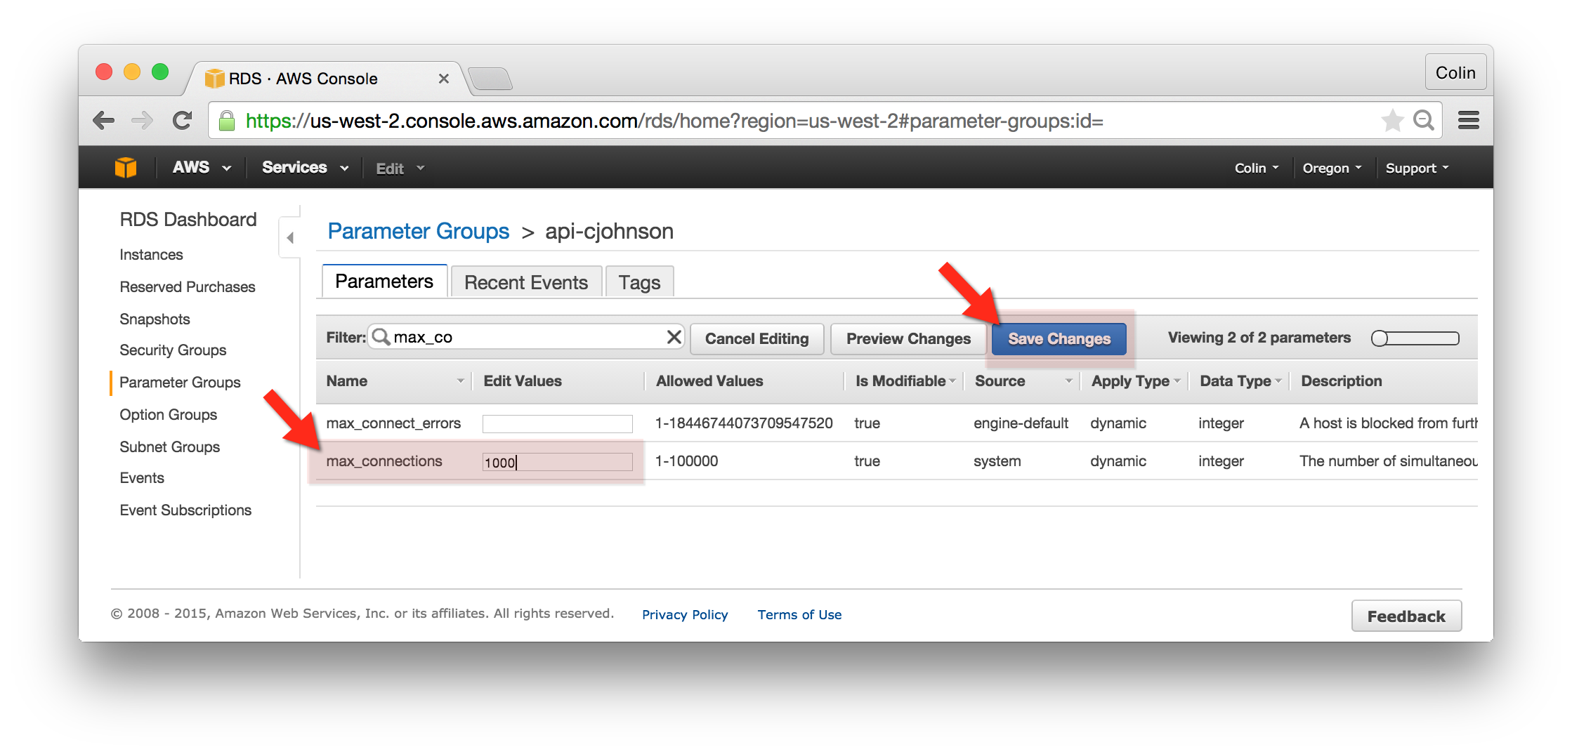

## Modify RDS Database Settings:

We will be making database changes en masse – changing the instance type, storage and max_connections parameters. To make these changes:

1. Go to the AWS RDS Console, select “Instances”, right-click on your database and click “Modify”  
   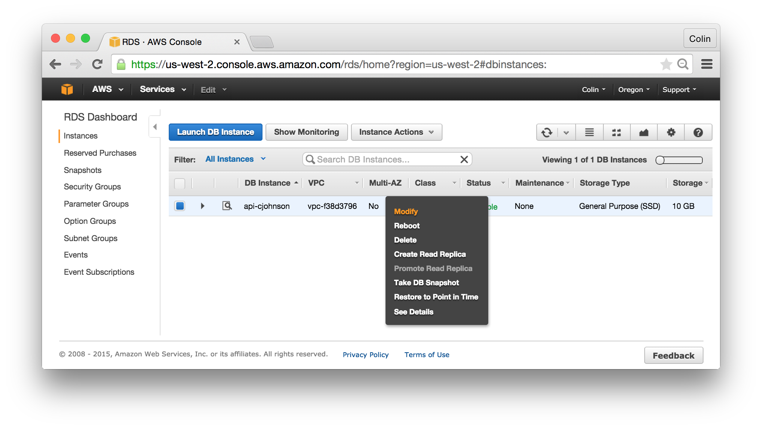
2. Change the following options:
   1. DB Instance Class: db.t2.micro
   2. Allocated Storage: 20
   3. DB Parameter Group: api-yourname
   4. Apply Immediately: checked
3. Click “Continue”
4. You’ll be prompted to review the configuration changes.
5. Click “Modify DB Instance”

## Confirm RDS Database Settings have Changed:

Confirmation of RDS database changes can typically be performed either through the RDS console or on the RDS instance itself. In many cases, I prefer confirming changes on the RDS instance itself. To confirm changes, do the following:

1. Login to your gateway-yourname server.
2. Connect to your MySQL host as follows:
   1. mysql -h api-cjohnson.cnn1tkhekekc.us-west-2.rds.amazonaws.com -u cjohnson -pmypassword
   2. You’ll be presented with the MySQL Command Prompt, where you can verify that the max_connections variable has been changed:
   3. show variables like "max_connections";
   4. Disconnect from the RDS database.
   5. exit;  
      