## Create an RDS Snapshot:

Snapshots of an RDS Instance are a snapshot of the entire RDS instance at a point in time. Instructions for taking a snapshot are below:

1. From the AWS RDS Console, select “Instances” and right-click on your database (your database should be named api-yourname)
2. From the drop-down menu, select “Take DB Snapshot”  
   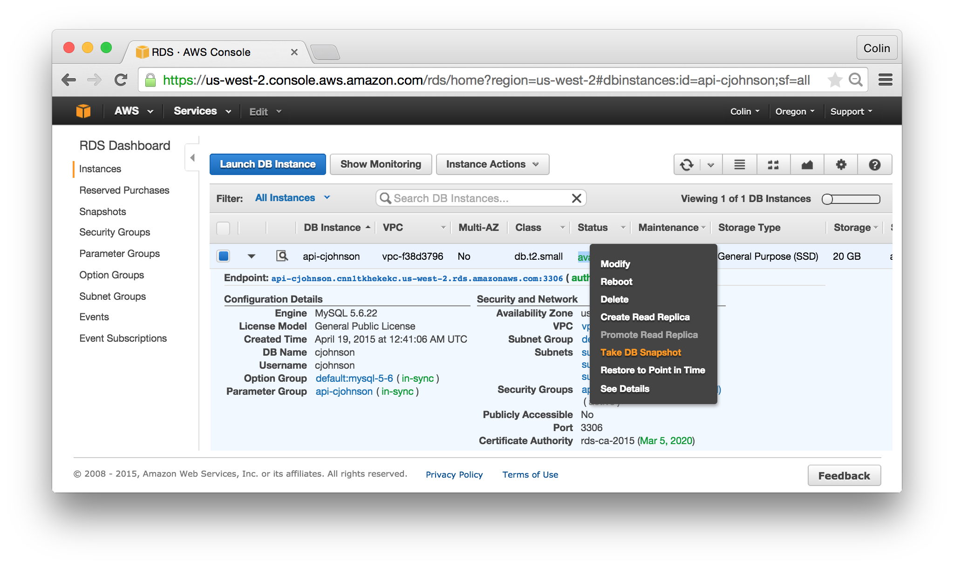
3. Enter a Snapshot Name:
   1. api-yourname-$date
   2. Click “Take Snapshot”  
      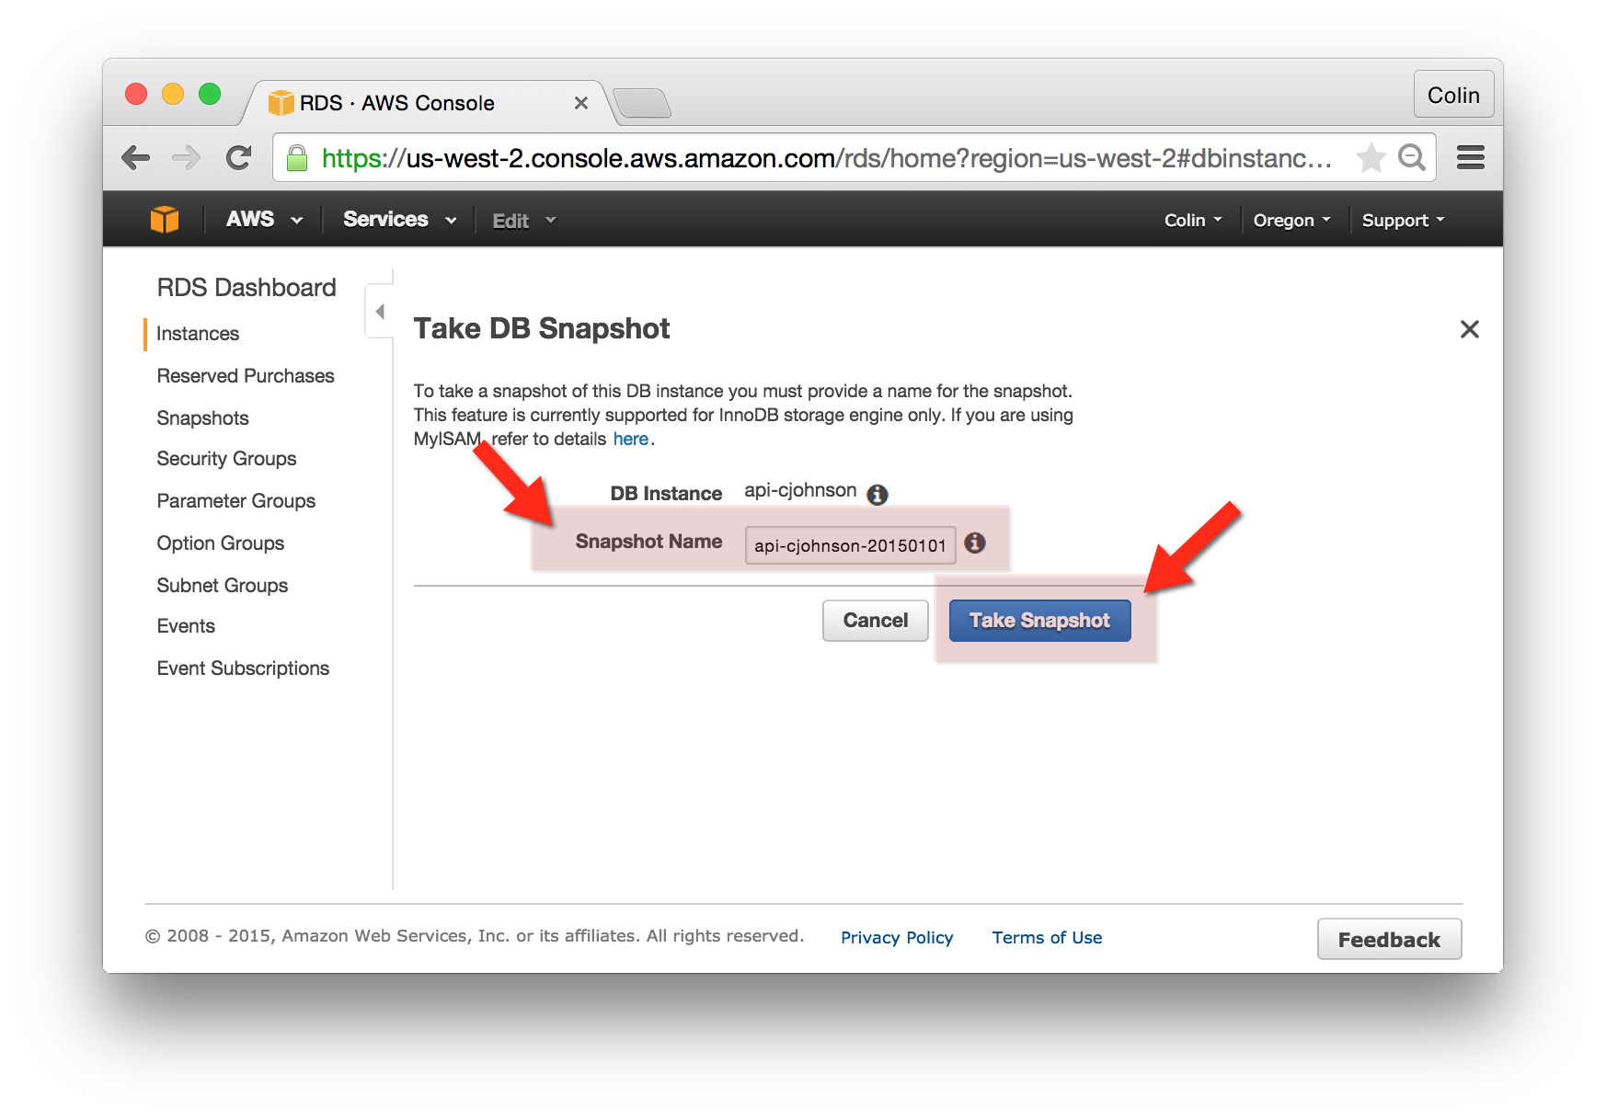
4. Snapshot progress can be viewed in the RDS Dashboard

