## Create an S3 Bucket in the us-west-2 (Oregon) Region:

1. Go to the AWS S3 Console
2. Click “Create Bucket”
   1. Bucket Name: cross-region-test-yourname-us-west-2
   2. Region: Oregon
   3. Click Create
3. Select the Bucket “cross-region-test-yourname-us-west-2” and click “Enable Versioning”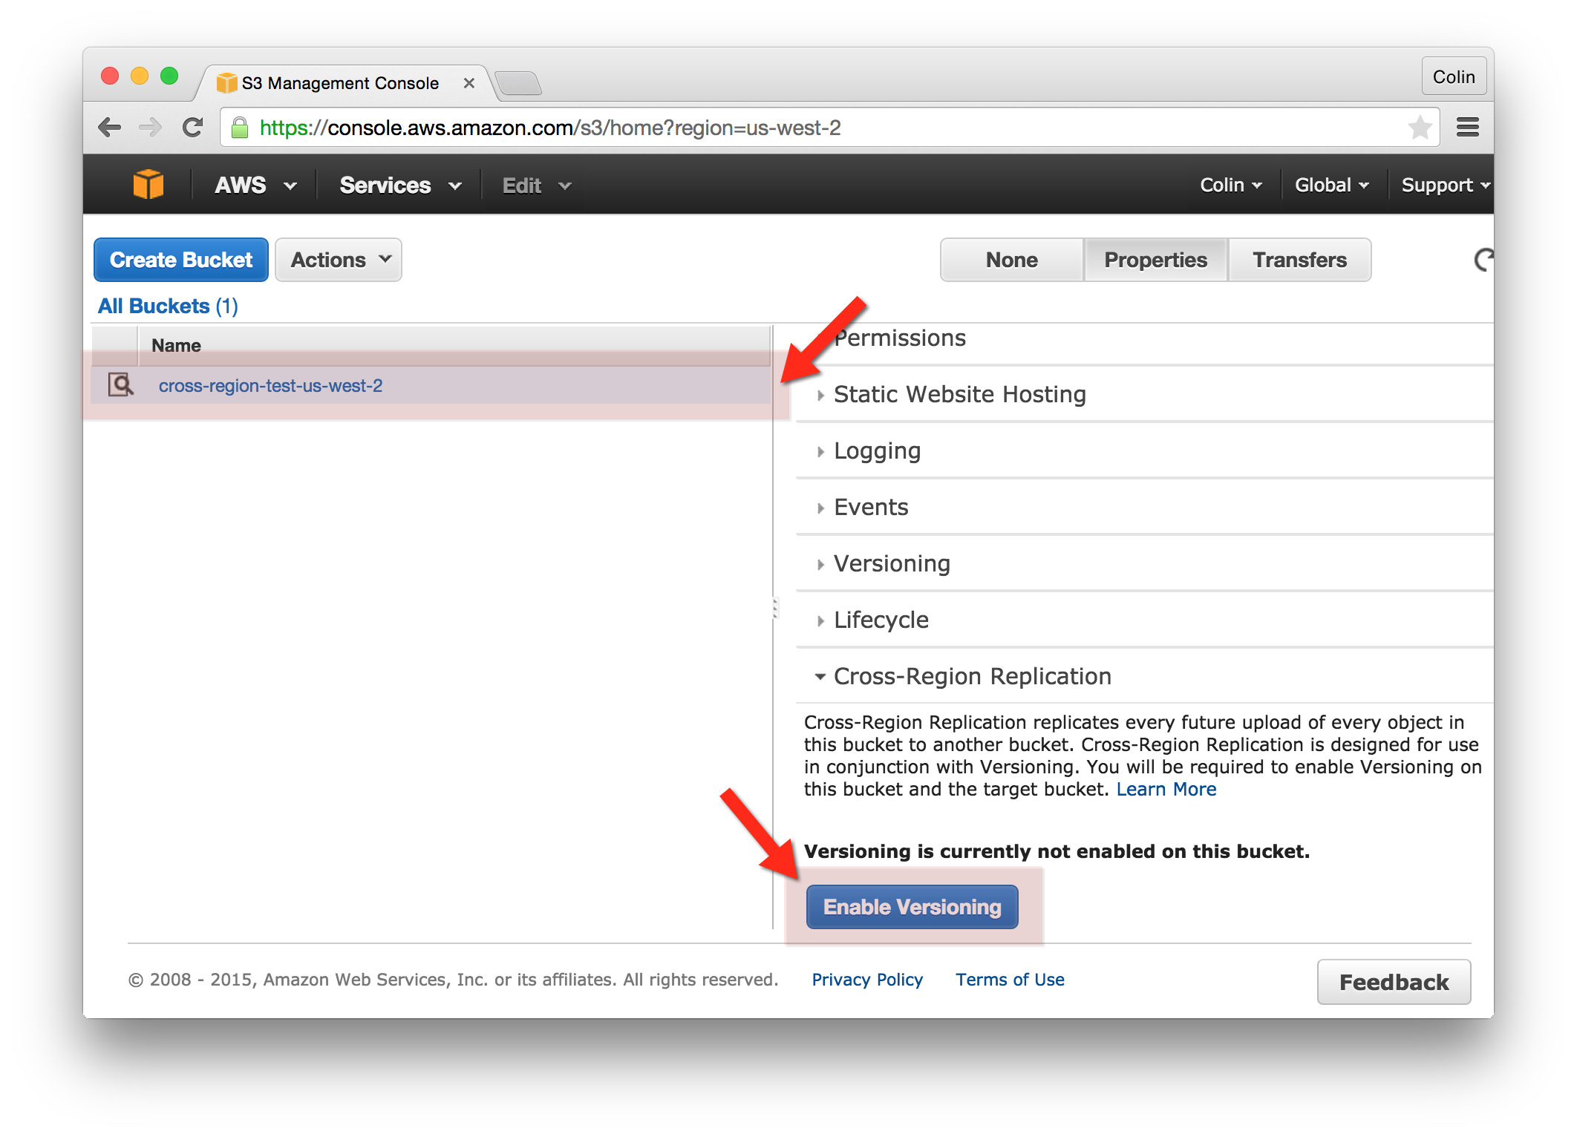
4. Click “Enable Cross-Region Replication” and select the following: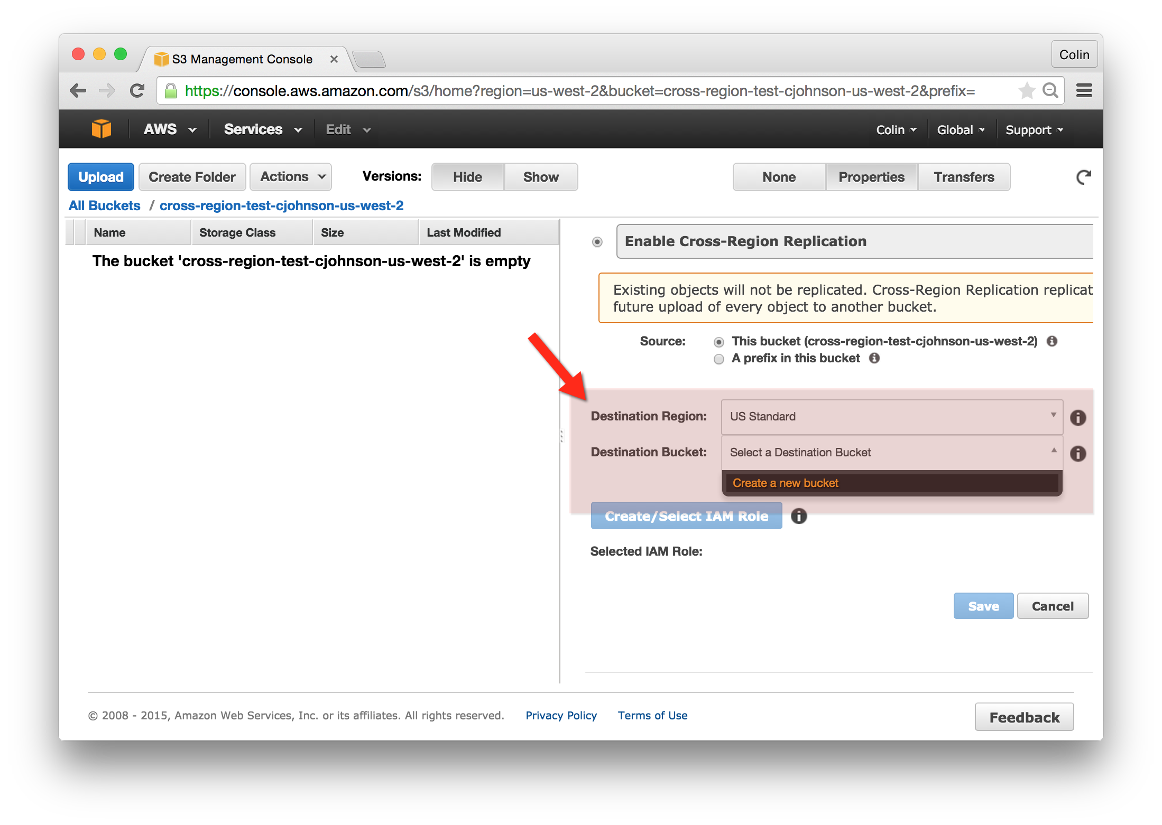
   1. Source: This Bucket
   2. Destination: US Standard
   3. Destination: New Bucket:
      1. Bucket Name: cross-region-test-yourname-us-standard
   4. Click “Create/Select IAM Role”
   5. Press “Save”

## Upload an Object to your Oregon S3 Bucket:

1. Go to the AWS S3 Console
2. Go to the “cross-region-test-yourname-us-west-2” bucket.
3. Select “Actions” and select “Upload”
4. Drag and Drop a file to the “Upload” window and click “Start Upload”

## Confirm the Object has been replicated to US-Standard S3 Bucket:

1. Go to the AWS S3 Console
2. Go to the “cross-region-test-yourname-us-standard” bucket.
3. Locate the uploaded object.