## Overview:

We’ll be creating the following an S3 bucket, uploading an S3 object and making the uploaded object public.

## Create an S3 Bucket in the us-west-2 (Oregon) Region:

1. Go to the AWS S3 Console
2. Click “Create Bucket”
   1. Bucket Name: training-s3-yourname
   2. Region: Oregon
   3. Click Create

## Select the Newly Created S3 Bucket:

1. Click on the S3 bucket you created in a previous step – you’ll be presented with the bucket content screen (note that the bucket won’t have any content).  
   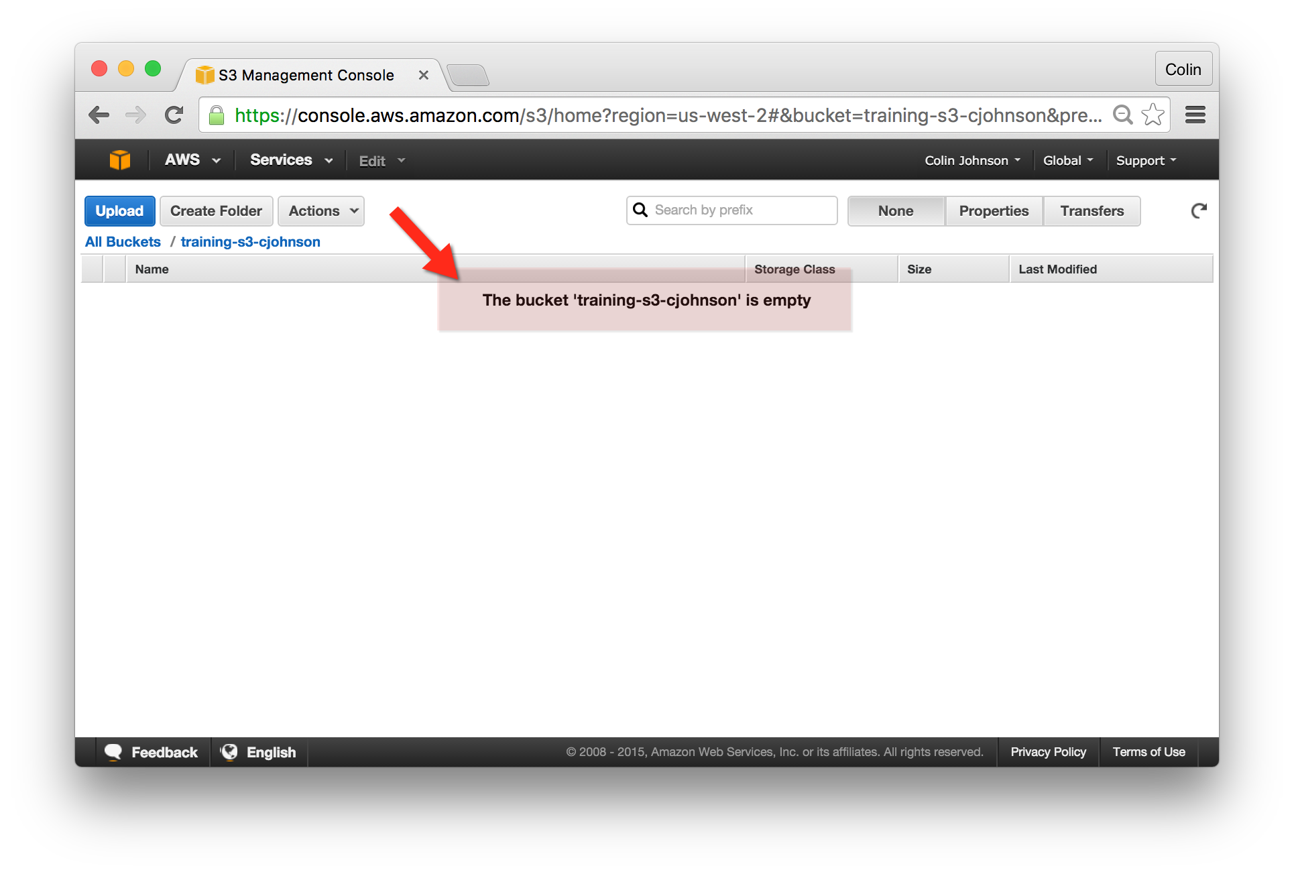

## Upload an Object:

1. Click on the “Actions” button and select “Upload.”  
   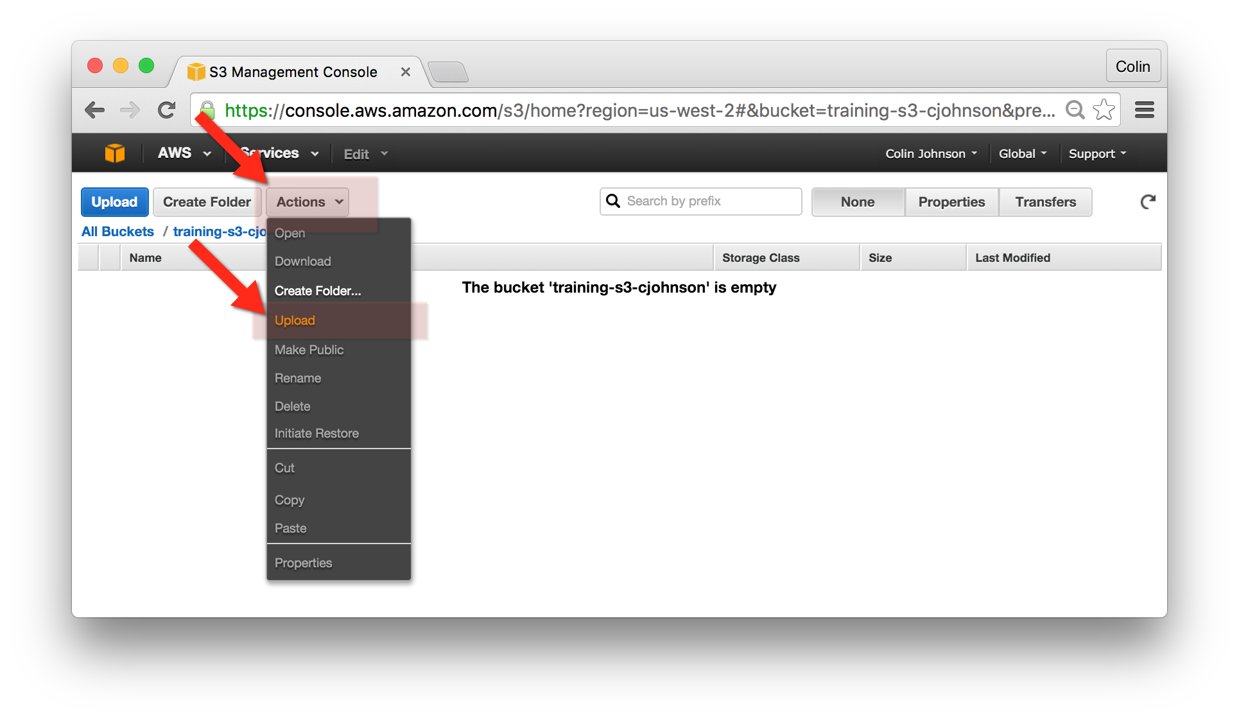
2. Drag and Drop a File onto the Upload tool. Ideally the file will be an image file in a format such as png or jpeg. Once a file is selected, click “Start Upload”  
   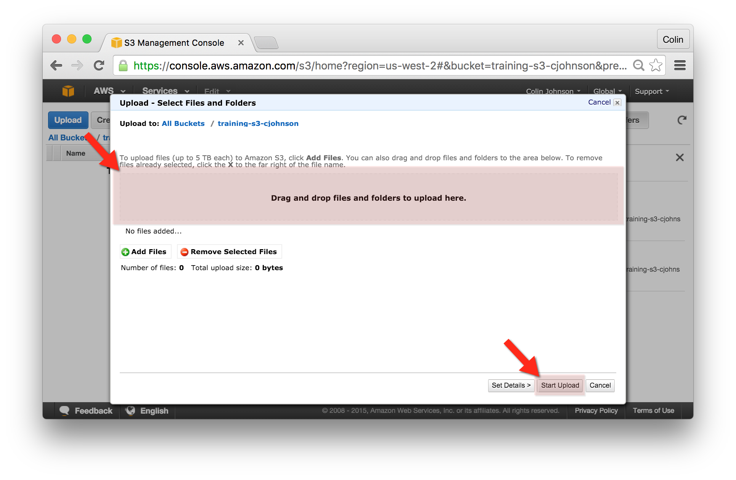

## Make the Uploaded Object Public:

1. Select the uploaded object and select “Properties” from the upper navigation bar.
2. Select “Permissions” from the left-hand drop down.
3. Under “Permissions” click “Add more permissions.”
4. For “Grantee” type “Everyone”, click “Open/Download” and press the “Save” button to commit these changes to the Object ACL.  
   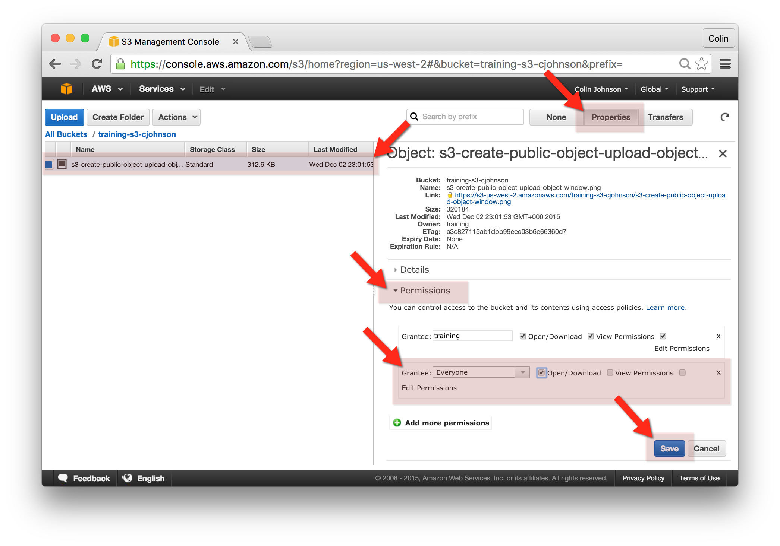

## View the Uploaded Object:

1. Select the uploaded object and select “Properties” from the upper navigation bar.
2. Copy the “Link” property from the right hand-navigation and paste this into a new web browser window. The uploaded object should be served directly from AWS S3.  
   