## Overview:

We will build out a simple VPC with all resources required for an instance to access the Internet – consider this instance a VPN or SSH gateway host.

## Create a VPC:

1. Go to the AWS VPC Console and click “Your VPCs” from the left-hand navigation bar.
2. Click “Create VPC”
3. In the Create VPC window, enter the following:
   1. Name tag: yourname
   2. CIDR block: 10.0.0.0/16
   3. Tenancy: Default
   4. Click “Create”

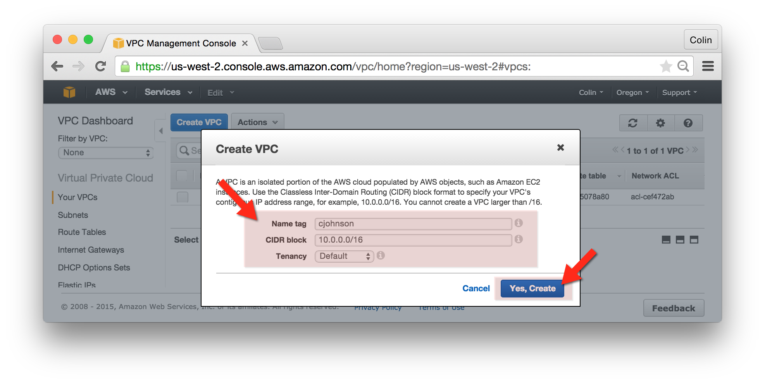

## Create an Internet Gateway:

1. Go to the AWS VPC Console and click “Internet Gateways” from the left-hand navigation bar.
2. Click the “Create Internet Gateway” button.
3. In the Create Internet Gateway window, enter the following:
   1. Name tag: yourname
   2. Click “Yes, Create”
   3. The Internet Gateway will be created, in state detached.
4. Right-click your newly created Internet Gateway and select “Attach”
   1. Attach your newly created Internet Gateway to your VPC.

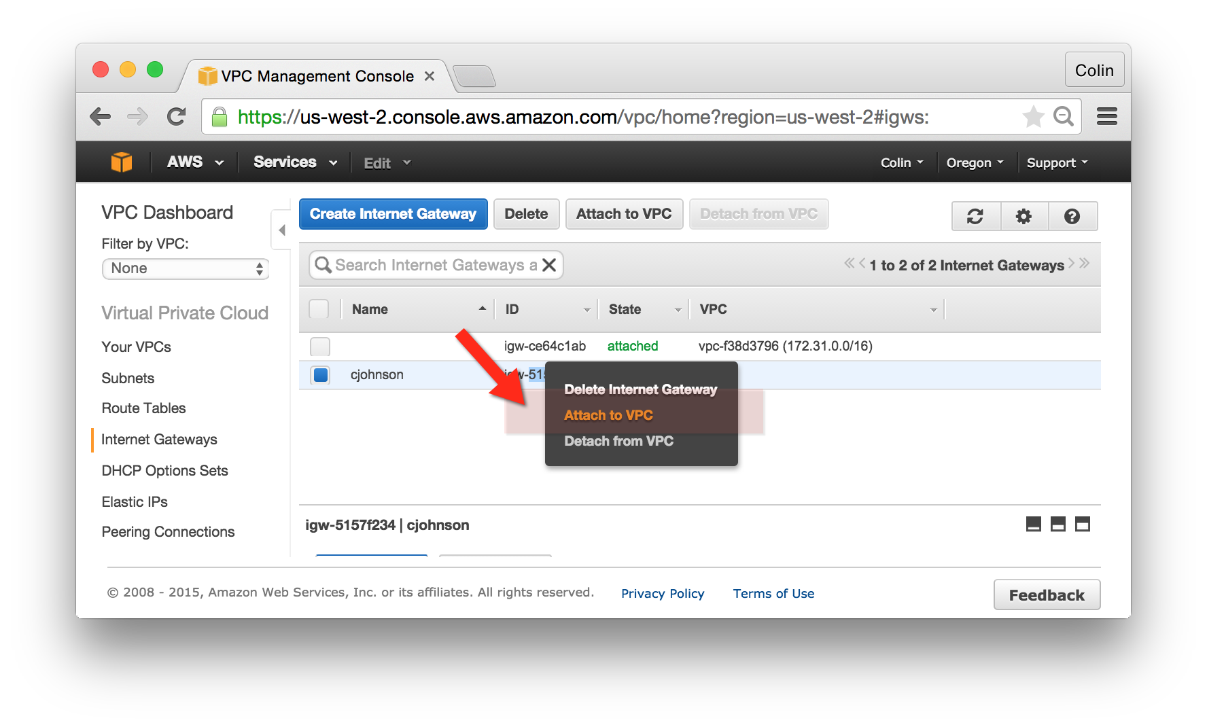

## Create VPC “Public” Subnets:

Note: the use of “Public” and “Private” subnets can confuse – when AWS documentation refers to a “Public” subnet they are referring to a subnet where instances have a Public IP address.

1. Go to the AWS VPC Console and click “Subnets” from the left-hand navigation bar.
2. Click the “Create Subnet” button and enter attributes as follows:
   1. Name tag: yourname-public-A
   2. VPC: <choose your VPC>
   3. Availability Zone: choose the “us-west-2a” Availability Zone
   4. CIDR block: 10.0.0.0/24
3. Click the “Create Subnet” button and enter attributes as follows:
   1. Name tag: yourname-public-B
   2. VPC: <choose your VPC>
   3. Availability Zone: choose the “us-west-2b” Availability Zone
   4. CIDR block: 10.0.1.0/24

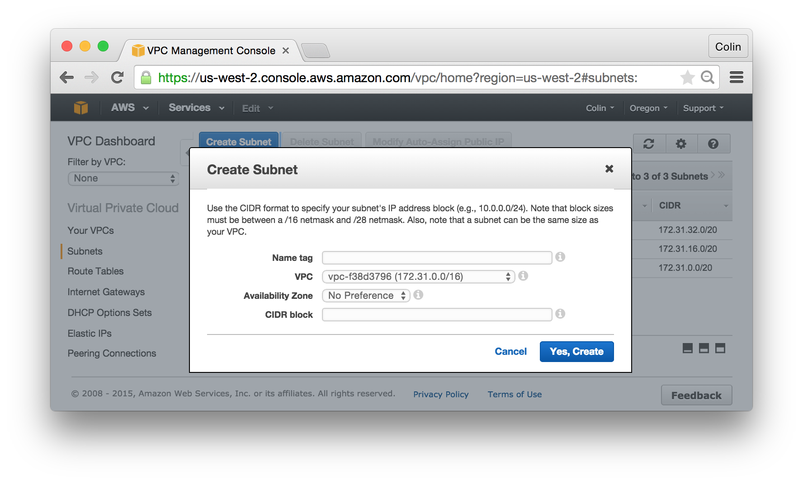

## Create Route to Public Internet:

1. Go to the AWS VPC Console and click “Route Tables” from the left-hand navigation bar.
2. Click “Create Route Table” and enter attributes as follows:
   1. Name tag: yourname-public
   2. VPC: <choose your VPC>
3. Select the Route Table you just created:
   1. Click on the “Routes” tab and click “Edit”
   2. Click “Add another route” and enter information as follows:
      1. Destination: 0.0.0.0/0
      2. Target: <Internet Gateway ID from previous step>

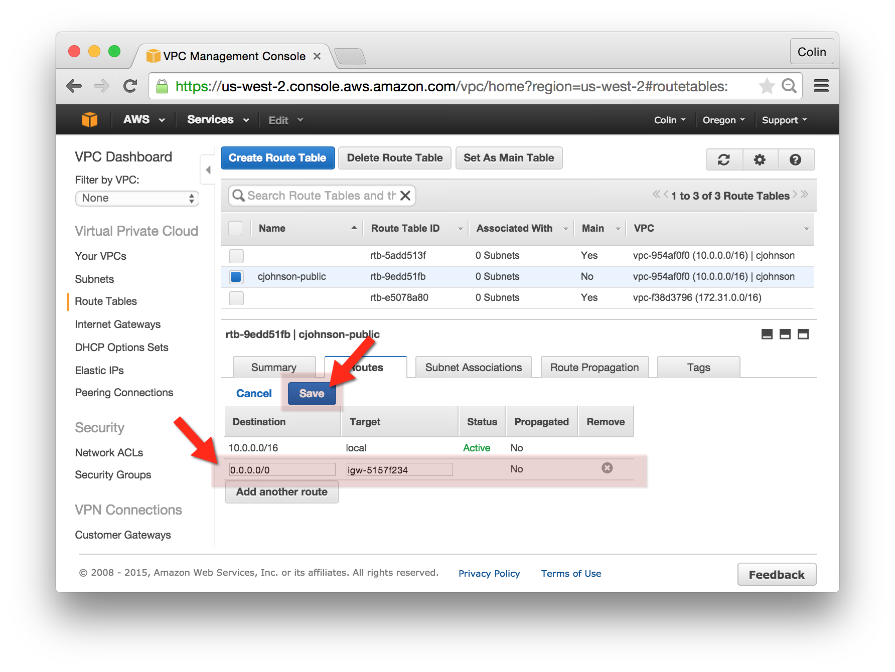

* 1. Click on the “Subnet Associations” tab and click “Edit”
     1. Associate this Route Table with both of the previously created Public Subnets

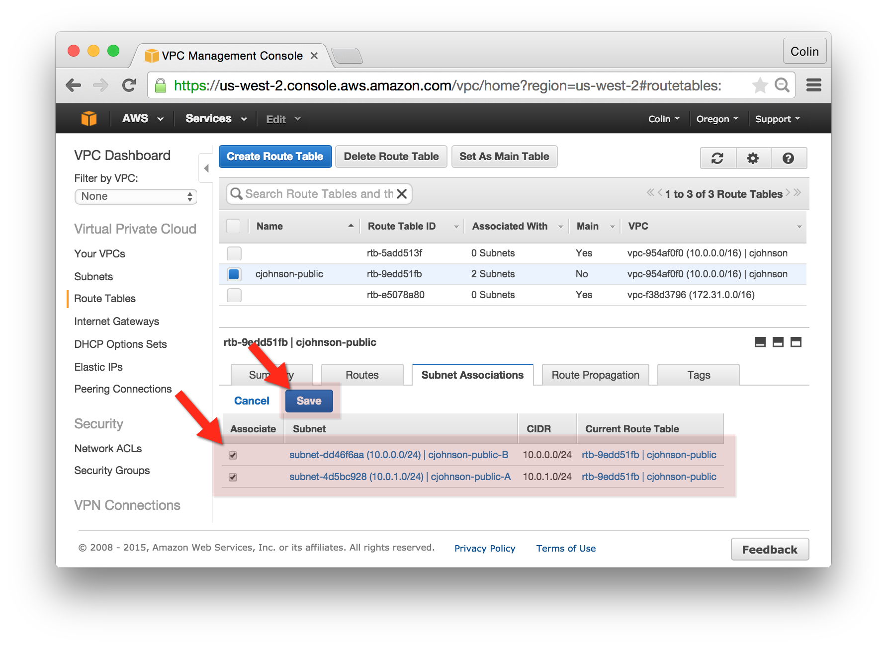

* + 1. Press Save