# FIGURES

## Figure 1. Our study areas: the managed forests of Saskatchewan and the Prince Albert Forest Management Area.

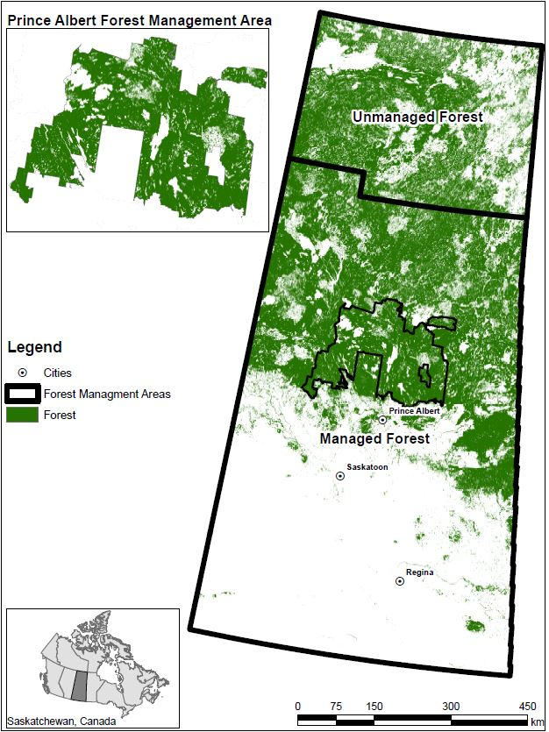

## Figure 2. Analyses inputs and flow.

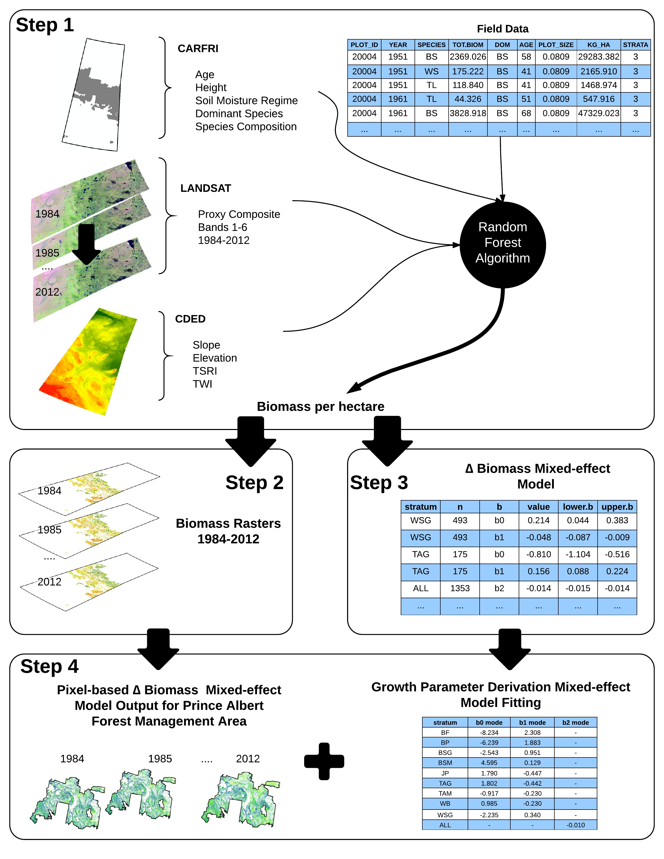

## Figure 3. Tree-level measurements over plot age, by species for plots used for biomass prediction.

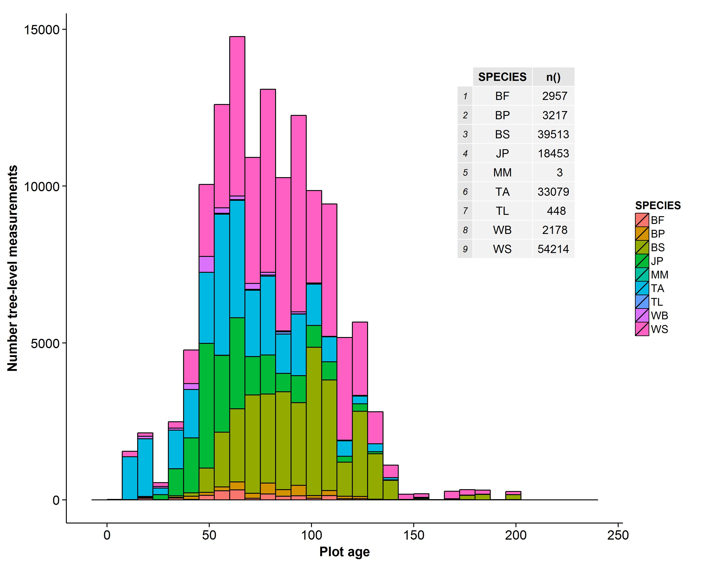

## Figure 4. Number of plots measured in each measurement year.

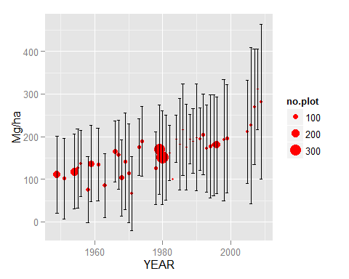

## Figure 5. Average yearly biomass across all pixels of the combined-data estimates for each year from 1984-2012.

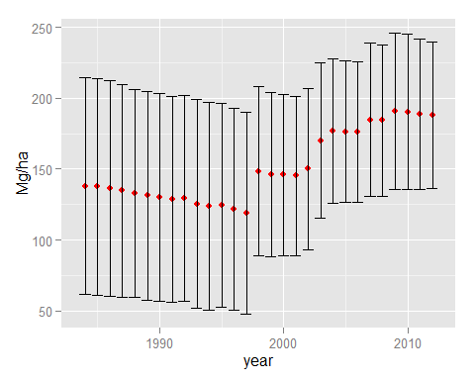

## Figure 6. Model residuals for mixed effect model fit to field plot data.

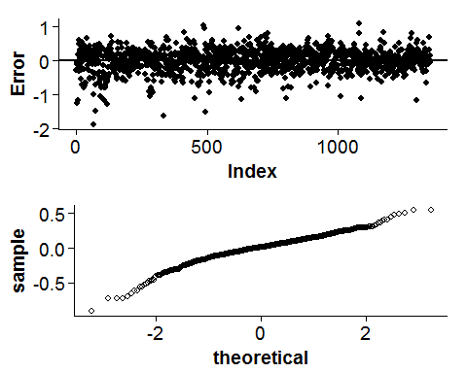

## Figure 7. Model residuals for mixed effect model fit to the combined field and remote sensing data.

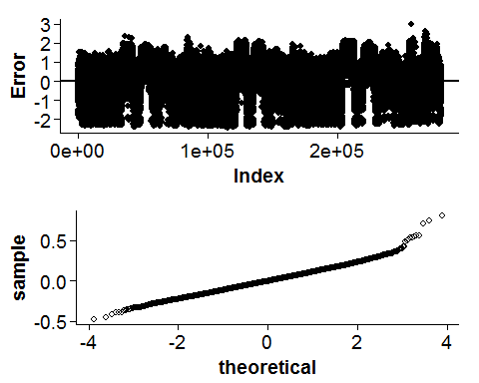

## Figure 8. Confidence interval around parameter estimates of a TYPE II combined exponential and power function with random effect on plot, fit for predicting change in biomass in the field plots as a function of age.

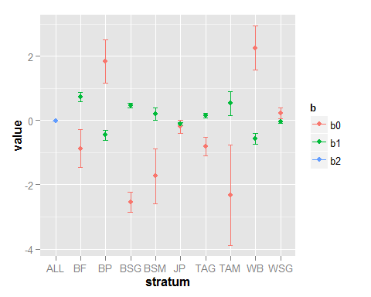

## Figure 9. Parameter comparison between parameters fit with the same methods on the same model form but with two different data sets, one with only field plots information and with with compbined field and remote sensing data. The first panel is for the intercept, and the second for the first slope.