## Шайма бидан ALGORITHMS FUNDAMENTALS THEORY

КН 220 i.в

### **Laboratory Training 2**

*BASIC DATA STRUCTURES. HASH TABLES*

**Objective:**

Explore hash functions and hash tables and get programming skills of algorithms that process them.

**Task**:

Develop a program that reads integers N, M (1 pairs (key is an integer, floating point number or a string, depending on the variant, value is a string, all strings up to 255 characters), none of which is repeated, and M keys. All strings separated by a space or a new line. The program stores pairs of strings into a hash table, and displays the values corresponding to listed keys.

**Variant 5:** (Key is a string; hash is a remainder of characters sum.)

*Hash table:*

In computing, a hash table (hash map) is a data structure that implements an associative array abstract data type, a structure that can map keys to values. A hash table uses a hash function to compute an index, also called a hash code, into an array of buckets or slots, from which the desired value can be found.

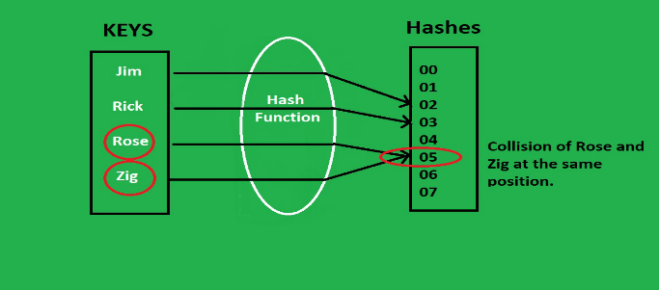

Suggested Code:

GitHub: