## Шайма бидан ALGORITHMS FUNDAMENTALS THEORY

КН 220 i.в

### **Laboratory Training 3**

*BASIC DATA STRUCTURES. RED-BLACK TREES*

**Objective:**

Explore red-black trees and get programming skills of algorithms that process them.

**Task**:

Develop a program that reads numbers N, M (1 <N, M <256), a sequence of N keys (integers, real numbers or strings (up to 255 characters) depending on the variant), and a sequence of M keys. The program saves the first sequence to red-black trees. Whenever a new element is added to tree, statistics must be display according to variant.

1. The minimum element and its color;
2. The maximum element and its color.

After building a tree, results of the following operations must be shown for the tree and for every element x of the second sequence (according to variant).

1. Does item x exist in the tree and what is its color.
2. Successor(x) and its color.
3. Predecessor(x) and its color.

**Variant 5:** (*2.2*)

*Red–black tree:*

In computer science, a red–black tree is a kind of self-balancing binary search tree. Each node stores an extra bit representing "color", used to ensure that the tree remains balanced during insertions and deletions.

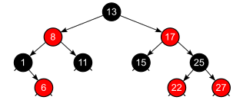

Suggested Code for this lab: