## Шайма бидан ALGORITHMS FUNDAMENTALS THEORY

КН 220 i.в

### **Laboratory Training 7**

*GEOMETRICAL ALGORITHMS*

**Objective:**

Get acquainted with the basic geometric algorithms.

**Task**:

Develop a program that reads from the keyboard number N (1 <N <256) and N pairs of real numbers - the coordinates of points on plane. It executes an algorithm on them.

**Variant 5:** (*Construct a convex hull using Jarvis' algorithm*)

*Convex hull using Jarvis' algorithm:*

Given a set of points in the plane. The convex hull of the set is the smallest convex polygon that contains all the points of it. Suggested Code for this lab:

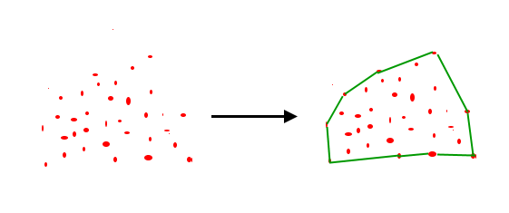

Suggested Code for this lab: