MINISTRY OF EDUCATION AND SCIENCE OF UKRAINE NATIONAL TECHNICAL UNIVERSITY

“KHARKIV POLYTECHNIC INSTITUTE”

DEPARTMENT OF SOFTWARE ENGINEERING AND MANAGEMENT INFORMATION TECHNOLOGIES

Report of laboratory work № 1

*Modeling of Domain*

Discipline « **SOFTWARE ENGINEERING**»

Executed by: Шайма бидан of group КН-220 i.в.e

Melnyk Karina, associate professor

Kharkov

2022

**Goal:**

Learning Use Case and Activity Diagrams by using Visual paradigm.

**Task**:

* Get the task and analyze the computational algorithms;
* Develop the Activity diagram;
* Develop the Use Case diagram;
* Prepare the report of the work;

**Variant 7:**

$$y=\left\{ \begin{aligned}\sum_{i=0}^{n-1}{\sum_{j=0}^{n-1}{\frac{1}{x-i+j} , x≤0}} \\ \prod_{i=1}^{n}{(\frac{1}{x}- \frac{1}{i}}), x >0\end{aligned}\right.$$

1. **Get the task and analyze the computational algorithms:**

In this equation we have two variables n and x. Therefore, we have to request from user to input these variables. After that, the program should check if x is “less than 0” or “more or equal 0”,

*If $( x >0$):*

In this case we have a loop inside another loop, Therefore the program should calculate the **sum** and check if the condition is true or not if not we increment “j” by 1 (in case of the second loop step completed), and “i” by 1 (in case of completing second loop).

Finally, outputting result.

*If $( x≤ 0$):*

This case is similar to the first one. But, we have only one loop, and, we need to calculate the **product,** and “i” is initialized at 1.

1. **Develop the Activity diagram:**

Diagram suggested:

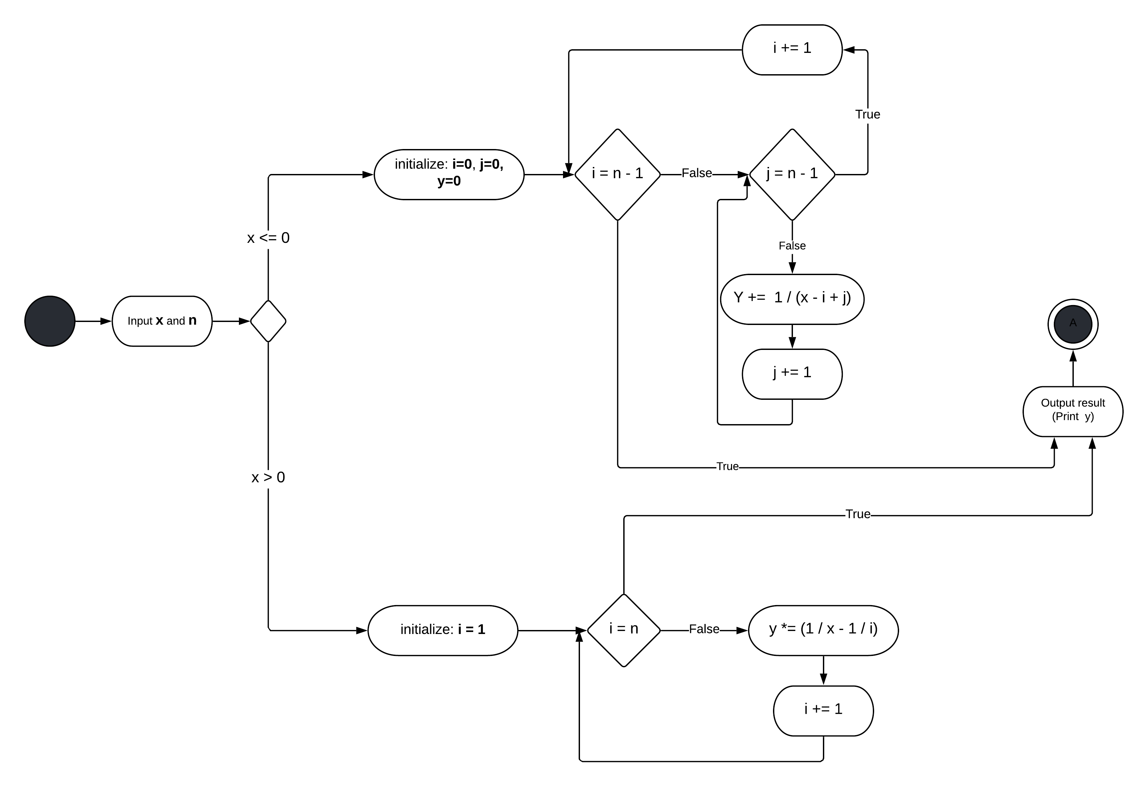

1. **Develop the Use Case diagram:**

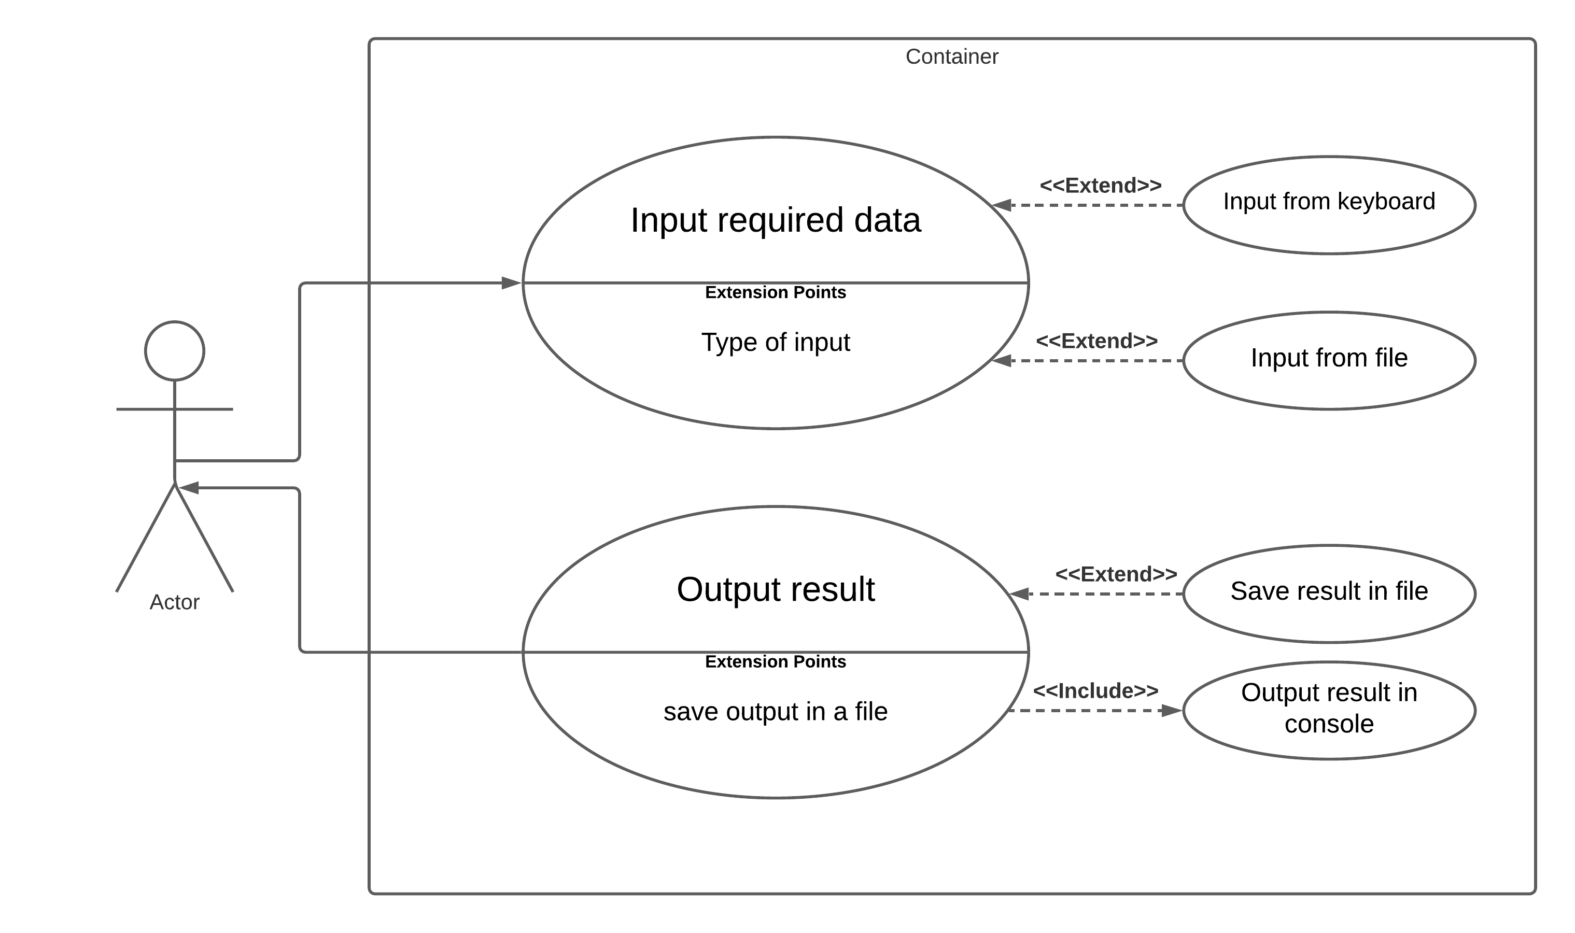

**Conclusion**

During this Training Lab using Visual Paradigm, I’ve attempt to represent algorithms step by step using Activity Diagram, and how to describe a set of actions using the Use Case Diagram, Which is helpful to understand the actions in a simple way.