Brandon Timok

CS 422 Machine Learning

Junggab Son

Homework 1

Used libraries and their purposes**:**

**pandas**: I used the pandas library to load the data and grab specific columns from the csv files provided.

**numpy**: The numpy library was used to handle the numerical operations, such as selecting the correct label for matching in the scatter plot.

**matplotlib**: I used the matplotlib library to create the different plots for each task, labeling the axis, and saving them to their own png files.

**sklearn**: The sklearn library was used to reduce the dimensions of the data down to 2 principle components in the scatterplot.

Execution Results: (below)

Task 1: 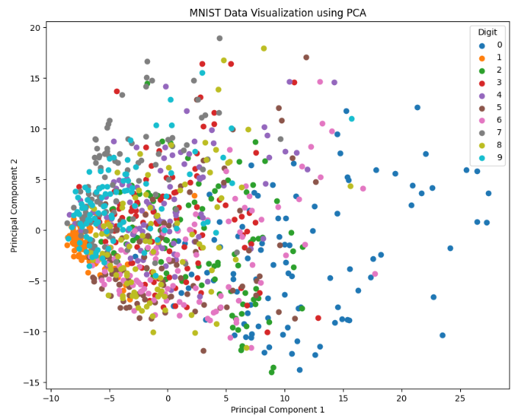

Task 2:

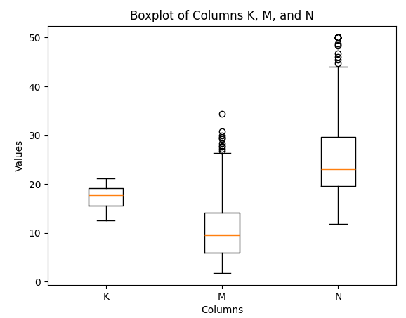

Task 3:

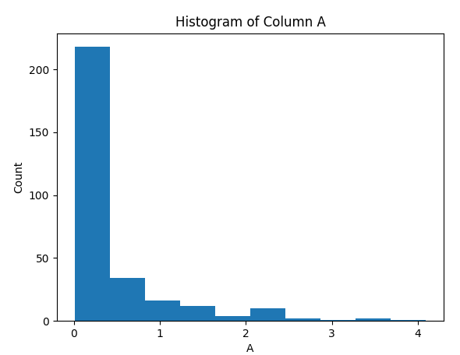

What I learned from this assignment:

Working on this assignment helped me get a little more familiar with python as well as some useful libraries that I can use to visualize data. If I am ever presented with some data, I’ll have a good idea of how to manipulate the data and represent it in a visually and informationally appealing way.