Brandon Timok

CS422 Machine Learning

Junggab Son

Homework 2

# K-Nearest Neighbors (KNN) Implementation

## Explanation

This program implements K-nearest neighbors (KNN) algorithm from scratch using Python.   
It takes two datasets, MNIST_training.csv and MNIST_test.csv, and follows the steps below:  
   
1. Load the training and test data using pandas.  
2. Calculate the Euclidean distance between test and training data using numpy.  
3. Finds the K-nearest neighbors and decide the majority class using numpy and Counter.  
4. Compares the prediction with the ground truth in the test data using numpy.  
5. Computes accuracy by counting correctly and incorrectly classified samples using numpy.  
6. Stores the results in a DataFrame and prints it using pandas.  
7. Saves the results in a Word document using the python-docx library.

## Results

|  |  |  |  |
| --- | --- | --- | --- |
| K | Correctly Classified | Incorrectly Classified | Accuracy |
| 1 | 42 | 8 | 84.0% |
| 3 | 44 | 6 | 88.0% |
| 5 | 43 | 7 | 86.0% |
| 7 | 45 | 5 | 90.0% |
| 9 | 45 | 5 | 90.0% |

## Screenshots

The program output is shown below:

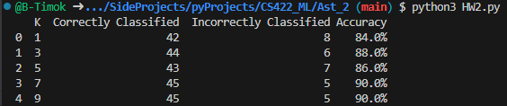

## What I Learned

In this assignment, I learned how to implement the K-nearest neighbors (KNN) algorithm from scratch using Python.  
- Calculating the Euclidean distance between test and training data using numpy.  
- Finding the K-nearest neighbors and deciding the majority class using numpy and Counter.  
- Comparing the prediction with the ground truth in the test data using numpy.  
- Creating a Word document using the python-docx library and adding tables and images to it.(This was actually pretty cool!)